

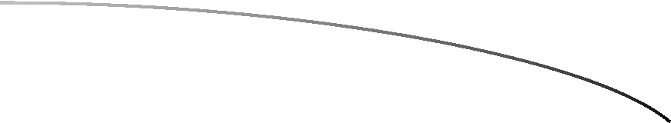
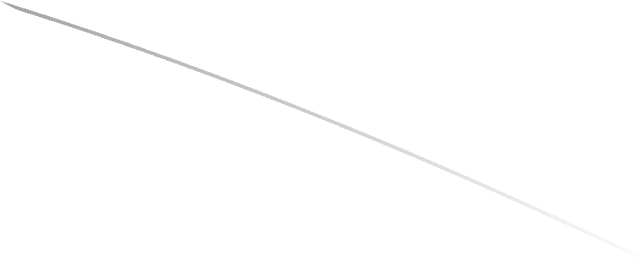



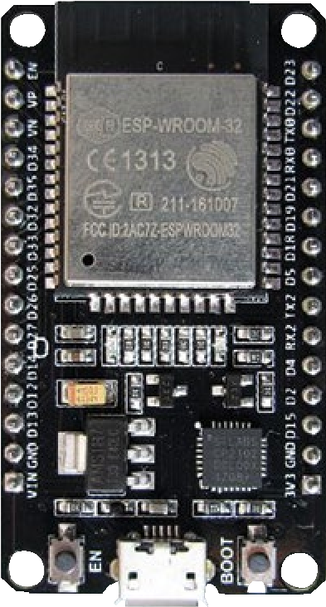
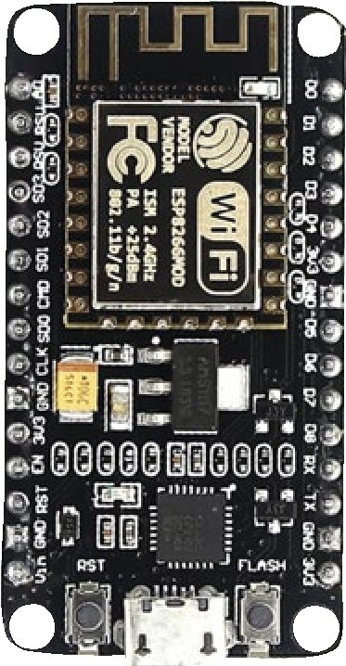
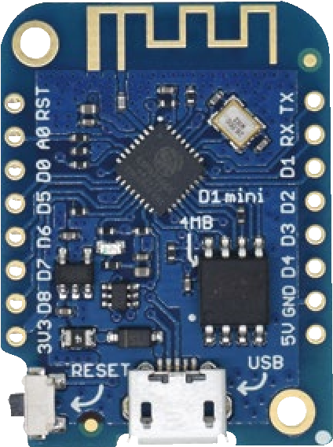
TECHNOLOGY IN AC TION™
El
cts
e
ctronics
P
roj
e
with th
6
6
2
8
P
ES
e

a
nd ES
P
32
Building Web Pages, Applications,
and WiFi Enabled Devices
—
Neil Cameron

Electronics Projects with the ESP8266 and ESP32
Building Web Pages,
Applications, and
WiFi Enabled Devices
Neil Cameron

Electronics Projects with the ESP8266 and ESP32: Building Web Pages, Applications, and WiFi Enabled Devices
Neil Cameron
Edinburgh, UK
ISBN-13 (pbk): 978-1-4842-6335-8 ISBN-13 (electronic): 978-1-4842-6336-5 https://doi.org/10.1007/978-1-4842-6336-5
Copyright © 2021 by Neil Cameron
This work is subject to copyright. All rights are reserved by the Publisher, whether the whole or part of the material is concerned, specifically the rights of translation, reprinting, reuse of illustrations, recitation, broadcasting, reproduction on microfilms or in any other physical way, and transmission or information storage and retrieval, electronic adaptation, computer software, or by similar or dissimilar methodology now known or hereafter developed.
Trademarked names, logos, and images may appear in this book. Rather than use a trademark symbol with every occurrence of a trademarked name, logo, or image we use the names, logos, and images only in an editorial fashion and to the benefit of the trademark owner, with no intention of infringement of the trademark.
The use in this publication of trade names, trademarks, service marks, and similar terms, even if they are not identified as such, is not to be taken as an expression of opinion as to whether or not they are subject to proprietary rights.
While the advice and information in this book are believed to be true and accurate at the date of publication, neither the authors nor the editors nor the publisher can accept any legal responsibility for any errors or omissions that may be made. The publisher makes no warranty, express or implied, with respect to the material contained herein.
Managing Director, Apress Media LLC: Welmoed Spahr
Acquisitions Editor: Natalie Pao
Development Editor: James Markham
Coordinating Editor: Jessica Vakili
Distributed to the book trade worldwide by Springer Science+Business Media New York, 1 NY Plaza, New York, NY 10004. Phone 1-800-SPRINGER, fax (201) 348-4505, e-mail orders-ny@springer-sbm.com, or visit www.springeronline.com. Apress Media, LLC is a California LLC and the sole member (owner) is Springer Science + Business Media Finance Inc (SSBM Finance Inc). SSBM Finance Inc is a Delaware corporation.
For information on translations, please e-mail booktranslations@springernature.com; for reprint, paperback, or audio rights, please e-mail bookpermissions@springernature.com.
Apress titles may be purchased in bulk for academic, corporate, or promotional use. eBook versions and licenses are also available for most titles. For more information, reference our Print and eBook Bulk Sales web page at http://www.apress.com/bulk-sales.
Any source code or other supplementary material referenced by the author in this book is available to readers on GitHub via the book’s product page, located at www.apress.com/ 978-1-4842-6335-8. For more detailed information, please visit http://www.apress.com/ source-code.
Printed on acid-free paper
Table of Contents
About the Author xi About the Technical Reviewer xiii Preface xv
Chapter 1: Internet radio 1
Station display and selection 9
Minimal Internet radio 24
Summary25
Components List 25
Chapter 2: Intranet camera 27
Save images to the SD card 30 Load images on a web page 36
Stream images to a web page 40
PIR trigger to stream images to a web page 45
Summary49
Components List 50
Chapter 3: International weather station 51
ILI9341 SPI TFT LCD touch screen 52 Touch screen calibration 57
Painting on-screen 60
ESP8266-specific touch screen calibration and paint 62
Weather data for several cities 69

Summary84
Components List 84
Chapter 4: Internet clock 85
WS2812 RGB LEDs responsive to sound 90 ESP8266 and multiplexer 94
LED rings clock 99
Network Time Protocol 105
ESP32 and Internet clock 109
Summary110
Components List 111
Chapter 5: MP3 player 113
Control command for the MP3 player 115 MP3 player control with a microcontroller 117
Infrared remote control of an MP3 player 126
Creating sound tracks and two alarm systems 132
Movement detection alarm 138
Speaking clock 141
Voice recorder 147
Summary149
Components List 150
Chapter 6: Bluetooth speaker 151
Summary157
Components List 157
Chapter 7: Wireless local area network 159
HTTP request 162
HTML code 168 XML HTTP requests, JavaScript, and AJAX 171
Summary180
Components List 180
Chapter 8: Updating a web page 181
XML HTTP requests, JavaScript, and AJAX 188 JSON 192
Accessing WWW data196
MQTT broker and IFTTT 202
Parsing text 216
Console log 219
Wi-Fi connection 220
Access information file 221
Summary222
Components List 222
Chapter 9: WebSocket 223
Remote control and WebSocket communication 229 WebSocket and AJAX 237
Access images, time, and sensor data over the Internet 243
Summary255
Components List 255
Chapter 10: Build an app 257
Control and feedback app 259 Install the app 271
Servo-robot control app 271
Speech recognition app 281
Summary286
Components List 287
Chapter 11: App database and Google Maps 289
MIT App Inventor database 289
MIT App Inventor and Google Maps 296
Summary303
Components List 303
Chapter 12: GPS tracking app with Google Maps 305
GPS position transmit 315 GPS position receive 321
Validate transmission of GPS position 323
Improve GPS position signal 336
Summary344
Components List 345
Chapter 13: USB OTG communication 347
App receive 348 App transmit 354
App receive and transmit 360
Summary363
Components List 363
Chapter 14: ESP-NOW and LoRa communication 365
ESP-NOW 365
LoRa communication 382
Summary396
Components 397
Chapter 15: Radio frequency communication 399
Transmitting and receiving text403
Decode remote control signals 410 Control pan-tilt servos with RF communication 415
Control relay with RF communication 423
Relays 428
Solid-state relay 433
Summary435
Components List 436
Chapter 16: Signal generation 437
Signal generation 441 Digital to analog converter 444
Generating waves 451
ESP32 8-bit DAC 457
12 -bit DAC 458
Summary465
Components List 466
Chapter 17: Signal generation with 555 timer IC 467
555 timer IC 468
Monostable mode 471
Bistable mode 474
Astable mode 475
Variable duty cycle 480
50 % duty cycle 483
PWM mode 486
Function generator 488
Square wave to sine wave 493
Bipolar junction transistor as a switch 495 MP3 player and PIR sensor application498 Summary502
Components List 502
Chapter 18: Measuring electricity 505
Voltage divider 505
Analog to digital converter 507
Voltage meter 509
Voltage meter with a load 513
Resistance meter (ohmmeter) 519
Capacitance meter 522
Current meter (ammeter) 527
Current sensor 534
Current and voltage sensor 536
Solar panel and battery meter 540
Inductance meter 551
Summary557
Components List 558
Chapter 19: Rotary encoder control 559
Debouncing 564
Interrupts 564
Square wave states 567
State switching 575
Incrementing a value 577
Summary583
Components List 583
Chapter 20: OTA and saving data to EEPROM, SPIFFS, and Excel 585
OTA updating 586
Saving data 589
Saving to EEPROM 591
Saving to SPIFFS 596
Downloading SPIFFS files 602
Saving data directly to Excel 605
Summary609
Components List 610
Chapter 21: Microcontrollers 611
Arduino Uno 617
Arduino Nano 618
Arduino Pro Micro 619
ESP8266 development board 621
ESP8266 analog input 624
ESP8266 interrupts 625
ESP8266 watchdog timer 628
ESP32 development board 629
ESP32 digital input 632
ESP32 analog input 632
ESP32 pulse width modulation 634
ESP32 serial input 635
Wi-Fi communication and web server 636
ESP8266 and ESP32 interrupts 637 ESP8266 and ESP32 and an OLED screen 637
ESP32 and servo motors 638
Summary639
Components List 639
Chapter 22: ESP32 microcontroller features 641
Microcontroller CPU and memory 642 ESP32 cores 643
Bluetooth communication 653
Bluetooth Low Energy communication 656
Timers 672
Real-time clock and sleep mode 675
Digital to analog converter 678
Capacitive touch sensor 679
Hall effect sensor 680
Summary681
Components List 682 Appendix: Libraries683
Index 689

About the Author
Neil Cameron is an experienced analyst and programmer with a deep interest in understanding the application of electronics. Neil wrote the book Arduino Applied: Comprehensive Projects for Everyday Electronics by Apress. He was a research scientist and has previously taught at the University of Edinburgh and Cornell University.
About the Technical Reviewer
Mike McRoberts is the author of Beginning Arduino by Apress. He is winner of Pi Wars 2018 and member of Medway Makers. He is an Arduino and Raspberry Pi enthusiast.
C/C++, Arduino, Python, Processing, JS, Node-Red, NodeJS, Lua.
xiii
Preface
It's never been so easy and practical to access information over the Internet, develop web pages to update sensor information, build mobile apps to remotely control devices with speech recognition, or incorporate Google Maps in a GPS route tracking app. The combination of Wi-Fi functionality, high computing power, and low cost of the ESP8266 and ESP32 development boards extends the range of opportunities for microcontrollers. Communicating with devices and accessing information over the Internet with the ESP8266 and ESP32 microcontrollers is the focus of Electronics Projects with the ESP8266 and ESP32.
The first section (Chapters 1 to 6) of the book demonstrates the ease of use and the power of the ESP8266 and ESP32 microcontrollers to access and display information on the Internet. Projects include building an Internet radio, an Internet-based clock, and an international weather station and a project with the ESP32-CAM camera to upload pictures to a web page.
The book's second section (Chapters 7 to 9) covers web page design projects for updating your web page with sensor information using realtime graphics or controlling a remote device through a web page. You'll learn about AJAX (Asynchronous JavaScript and XML), which combines XML (eXtensible Markup Language) HTTP (Hypertext Transfer Protocol) requests for updating a web page with JavaScript to manage those requests, JSON (JavaScript Object Notation) to combine information transmitted by a server to the client, the two-way fast communication WebSocket protocol, MQTT brokers, and IFTTT (If This, Then That) for communication between devices on different networks. The practical projects include uploading information to the Internet and controlling
xv
PrefaCe
devices from anywhere in the world with the ESP8266 and ESP32 microcontrollers.
Mobile apps are now ubiquitous, making the app build projects in the book's third section (Chapters 10 to 13) very relevant. An app to control remotely located motors connected to an ESP8266 or ESP32 development board mimics robotics used in the automotive industry; a speech recognition app controls devices; and a GPS tracking app, incorporating Google Maps, displays the current position and route information. Each project with the ESP8266 and ESP32 microcontrollers is fully described, as no previous experience in mobile app design and build is required.
Communication between ESP8266 and ESP32 microcontrollers is described in the fourth section (Chapters 14 to 18) of the book. The built-in ESP-NOW communication system, LoRa (long range), and RF (Radio Frequency) communication are applied to controlling remotely located devices with the device information updated on a web page by the ESP8266 and ESP32 microcontrollers. Communication protocols are extended to signal generation with the ESP8266 and ESP32 microcontrollers transmitting alphanumeric text or signals to produce sounds, as used in electronic music. Signal generation without a microcontroller is illustrated with an electronic piano, a motor control project, and an alarm system including an MP3 player with a movement detector. The book’s fourth section spans the built-in communication protocol of the ESP8266 and ESP32 microcontrollers to communication with back-to-basics electronics. A chapter on measuring electricity with an ESP8266 or ESP32 microcontroller, applied to a solar panel project, continues the electronics theme to understand the methodology behind sensors.
The ESP32 microcontroller is more powerful than the ESP8266 microcontroller and also includes Bluetooth and Bluetooth Low Energy (BLE) communication. Chapters on practical differences between the ESP8266 and ESP32 microcontrollers and on specific features of the ESP32 microcontroller form the last section (Chapters 21 and 22) of the book.
xvi
PrefaCe
Throughout the book, all differences in libraries or instructions for the ESP8266 and ESP32 microcontrollers are described, as each project is compatible with both microcontrollers.
All sections of the book are stand-alone, so you can delve into a section of the book rather than having to start from the beginning. Several chapters build on information from earlier chapters. For example, Chapter 12 (GPS tracking app with Google Maps) incorporates mobile app design, Bluetooth communication, sourcing information from the Internet, and updating a web page. Some programming experience with the Arduino IDE is assumed, although all sketches are completely described and comprehensively commented. The book Arduino Applied: Comprehensive Projects for Everyday Electronics is recommended as an introduction to microcontrollers ranging from blinking an LED to building a robot car. Schematic diagrams were produced with Fritzing software (www.fritzing.org), with an emphasis on maximizing the clarity of component layout and minimizing overlapping connections. Authors of libraries used in the book are acknowledged in each chapter, with library details included in the Appendix. All the Arduino IDE sketches and MIT App Inventor source code for the apps are available to download at GitHub (github.com/Apress/ESP8266-andESP32). The Arduino programming environment and libraries are constantly being updated, so information on consequences of the updates is also available on the GitHub website.
xvii
CHAPTER 1
Internet radio
Internet radio is the continuous streaming of digital audio over the
Internet. Digital audio, in MP3 format, is received by the ESP8266 or
ESP32 microcontroller through a Wi-Fi connection. The ESP8266 or
ESP32 microcontroller communicates with a VS1053 audio decoder by Serial Peripheral Interface (SPI), and the MP3-formatted data is decoded by an 18-bit digital to analog converter (DAC) to an audio signal that is amplified for a loudspeaker. ESP8266 and ESP32 microcontrollers have Wi-Fi functionality and sufficient processor speed for an Internet radio. Connection to the wireless local area network (WLAN) requires the Wi-Fi network SSID (Service Set Identifier) and password.
© Neil Cameron 2021 1
N. Cameron, Electronics Projects with the ESP8266 and ESP32, https://doi.org/10.1007/978-1-4842-6336-5_1

Internet radIo
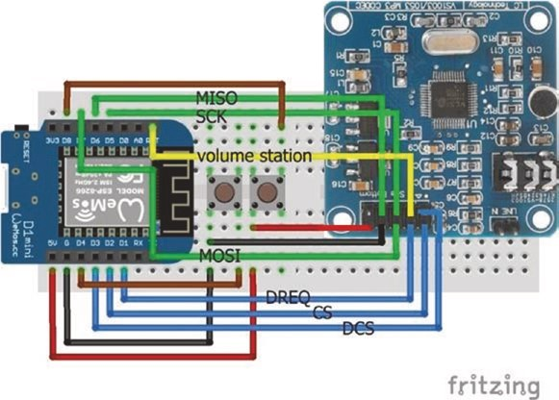
Figure 1-1. Internet radio with volume and station switches and a
LOLIN (WeMos) D1 mini
Connections for the ESP8266 development board and the VS1053 audio decoder are shown in Figure 1-1, with a detail in Figure 1-2, and listed in Table 1-1. Connections for SPI communication are indicated in green, with data connections in blue. Two switches, attached to interrupts, control the volume and Internet radio station selection. For the ESP8266 development board, the volume and station switches on pins D4 and D8 are connected to GND and 5V, as pins D4 and D8 are connected to internal pull-up and pull-down resistors, respectively. Connections for an ESP32 development board are also given in Table 1-1. When using an ESP32 development board, the volume and station switches are both connected to GND.
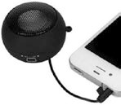
An amplifier and loudspeaker, or a mini-loudspeaker as used with a mobile phone, are connected to the VS1053 audio decoder by plugging into the audio jack socket of the VS1053 audio decoder.
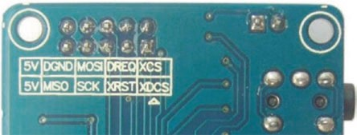
Figure 1-2. VS1053 connections
Table 1-1. Internet radio and switches
Component | Connect to ESP8266 | Connect to ESP32
VS1053 5V | 5V | VIn or V5
VS1053 dGnd | Gnd | Gnd
VS1053 MoSI | (MoSI) d7 | (MoSI) GpIo 23
VS1053 dreQ (data request) | d1 | GpIo 4
VS1053 XCS (chip select) | d2 | GpIo 0
VS1053 MISo | (MISo) d6 | (MISo) GpIo 19
VS1053 SCK | (SCK) d5 | (CLK) GpIo 18
VS1053 XrSt (reset) | rSt | GpIo en
VS1053 XdCS (data chip select) | d3 | GpIo 2
Switch volume left | Gnd | Gnd
Switch volume right | d4 | GpIo 26
Switch station left | 5V | Gnd
Switch station right | d8 | GpIo 27
Internet radIo
The URL (Uniform Resource Locator) or web address of an Internet radio station is obtained from the website www.radio.de. Search for the required station, click the play button, and select View Page Source. In the displayed HTML (HyperText Markup Language) file, search for streams, which precedes the radio station URL. The URL is formatted as host:port/ path. For example, The UK 1940s Radio Station has URL 1940sradio1.
co.uk:8100/stream/1/ with host equal to the text before the first backslash: 1940sradio1.co.uk – and path equal to the remaining text: stream/1/. If the port is not equal to default value of 80, which is the web browsing port, then it follows the colon after host, such as 8100.
The sketch for an Internet radio with an ESP8266 development board (see Listing 1-1) uses the VS1053 library by Ed Smallenburg and James Coliz that is downloaded as a .zip file from github.com/baldram/
ESP_VS1053_Library. The first section of the sketch defines the number of Internet radio stations and URLs, initializes the audio decoder, establishes a Wi-Fi connection, and defines the interrupts. The variables newStation and newVolume are defined as volatile, as they are accessed by both the main sketch and the interrupts. With an ESP32 development board, the station change switch pin is set HIGH with an internal pull-up resistor using the instruction pinMode(statPin, INPUT_PULLUP), and the interrupt attached to the station switch is set to FALLING. The ESP8266 and ESP32 microcontrollers store compiled code in internal RAM (IRAM), rather than in the slower flash memory, by prefixing code with the IRAM_ATTR attribute. The interrupt ISR (Interrupt Service Routine) is defined as IRAM_ATTR void ISR() rather than void ISR().
In the loop function, a connection is made to an Internet radio station website, and the VS1053 audio decoder processes data in 32-byte batches. The two interrupt service routines, chan and vol, move to the next radio station and increase the volume, respectively. The volume scale is from 0 to 100%. The VS1053 library references the SPI library, and the #include <SPI.h> instruction is not required.
Connection to the Internet radio station server with the instruction connect(host[station], port[station]) is followed by an HTTP (Hypertext Transfer Protocol) request. The VS1053 library uses HTTP for communication between the client, which is the web browser, and the Internet radio station server. The client submits an HTTP request to the server for audio data, and the server sends a response to the client with the required data. The HTTP request instructions "GET pathname HTTP/1.1" and "Host: hostname" are followed by an instruction to close the connection "Connection: close". Using the example of “The UK 1940s Radio Station,” the request instructions are
GET stream/1/HTTP/1.1
Host: 1940sradio1.co.uk
Connection: close
<\r\n>
Note that the fourth instruction of carriage return, \r, and new line, \n, is required, which is equivalent to a println() instruction.
Listing 1-1. Internet radio with volume and station switches and an
ESP8266 board
#include <VS1053.h> // include VS1053 library #include <ESP8266WiFi.h> // include ESP8266WiFi library int CS = D2;
int DCS = D3; // define VS1053 decoder pins int DREQ = D1;
VS1053 decoder(CS, DCS, DREQ); // associate decoder with VS1053 int statPin = D8; // define switch pins for int volPin = D4; // station and volume WiFiClient client; // associate client and library char ssid[] = "xxxx"; // change xxxx to Wi-Fi ssid char password[] = "xxxx"; // change xxxx to Wi-Fi password
Internet radIo
const int maxStat = 4; // number of radio stations String stationName[] = {"1940 UK", "Bayern3", "ClassicFM", "BBC4"}; char * host[maxStat] = {"1940sradio1.co.uk", // station host
"streams.br.de",
"media-ice.musicradio.com",
"bbcmedia.ic.llnwd.net"};
char * path[maxStat] = {"/stream/1/", // station path
"/bayern3_2.m3u",
"/ClassicFMMP3",
"/stream/bbcmedia_radio4fm_mf_q"}; int port[] = {8100,80,80,80}; // default station port is 80 unsigned char mp3buff[32]; // VS1053 loads data in 32 bytes int station = 0;
int volume = 0; // volume level 0-100 volatile int newStation = 2; // station number at start up volatile int newVolume = 80; // volume at start up
void setup ()
{
Serial.begin(115200); // Serial Monitor baud rate SPI.begin(); // initialise SPI bus decoder.begin(); // initialise VS1053 decoder decoder.switchToMp3Mode(); // MP3 format mode decoder.setVolume(volume); // set decoder volume WiFi.begin(ssid, password); // initialise Wi-Fi while (WiFi.status() != WL_CONNECTED) delay(500);
Serial.println("WiFi connected"); // wait for Wi-Fi connection pinMode(volPin, INPUT_PULLUP); // switch pin uses internal
// pull-up resistor
attachInterrupt(digitalPinToInterrupt(statPin), chan, RISING); attachInterrupt(digitalPinToInterrupt(volPin), vol, FALLING);
} // define interrupts for changing station and volume
void loop()
{
if(station != newStation) // new station selected
{ station = newStation; // display updated station name Serial.print("connecting to CH"); Serial.print(station);
Serial.print(" ");Serial.println(stationName[station]); if(client.connect(host[station], port[station])) { // connect to radio station URL client.println(String("GET ")+ path[station] + " HTTP/1.1"); client.println(String("Host: ") + host[station]); client.println("Connection: close");
client.println(); // new line is required
}
} if(volume != newVolume) // change volume selected
{ volume = newVolume; // display updated volume Serial.print("volume ");Serial.println(volume); decoder.setVolume(volume); // set decoder volume
} if(client.available() > 0) // when audio data available { // decode data 32 bytes at a time uint8_t bytesread = client.read(mp3buff, 32); decoder.playChunk(mp3buff, bytesread);
}
}
Internet radIo
IRAM_ATTR void chan() // ISR to increment station number
{
newStation++;
if(newStation > maxStat-1) newStation = 0; } // stations numbered 0, 1, 2...
IRAM_ATTR void vol() // ISR to increase volume
{
newVolume = newVolume + 5; if(newVolume > 101) newVolume = 50;
} // maximum volume is 100
Connections for the ESP32 development board and to the VS1053 audio decoder are shown in Figures 1-3 and 1-2, respectively, and given in Table 1-1. Both switch pins are connected to internal pull-up resistors, so both interrupts are activated by a FALLING signal. The only changes to Listing 1-1, other than defining the decoder, station, and volume control pins, are inclusion of the WiFi library rather than the ESP8266WiFi library and the instruction pinMode(statPin, INPUT_PULLUP) to change the interrupt on the station switch pin from RISING to FALLING.

Internet radIo
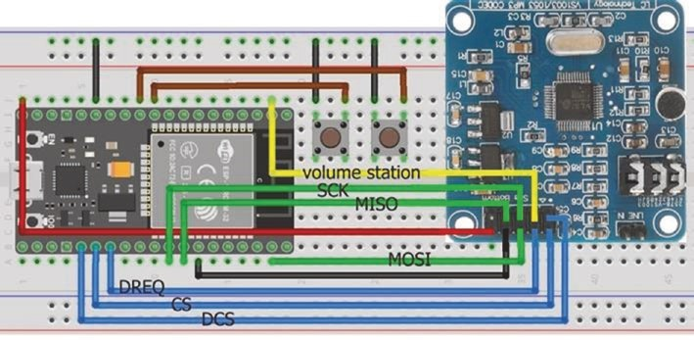
Figure 1-3. Internet radio with volume and station switches and an
ESP32 board
Station display and selection
In Listing 1-1, station selection and volume control are activated by switches, with station and volume information displayed on the Serial Monitor. For a portable Internet radio, station and volume information is displayed on an ST7735 TFT LCD (Thin-Film Transistor Liquid Crystal Display) screen, and a station is selected or the volume is controlled with a rotary encoder (see Figures 1-4 and 1-5 with connections in Table 1- 2). Note that both the rotary encoder and ST7735 TFT LCD screen are connected to 3.3V, with only the VS1053 audio decoder connected to 5V. The ESP32 microcontroller communicates with both the VS1053 audio decoder and ST7735 TFT LCD screen by SPI, so the microcontroller has the same MOSI (Main-Out Secondary-In) and SCK (Serial Clock) connections to the audio decoder and screen, but the CS (Chip Select) connections are device specific.
Internet radIo
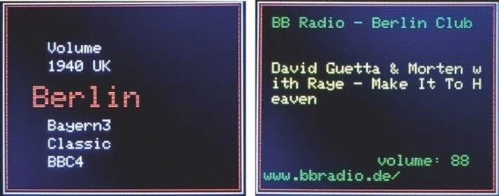
Figure 1-4. Internet radio screenshots
The sketch uses the ESP32 vs1053_ext library by Wolle that is downloaded as a .zip file from github.com/schreibfaul1/ESP32-vs1053_ext. The ESP32 vs1053_ext library is for the ESP32 microcontroller, while the VS1053 library by Ed Smallenburg and James Coliz is compatible with both the ESP8266 and ESP32 microcontrollers. The ESP32 vs1053_ext library provides station and track information, such as the streamed track title. The instruction to connect to an Internet radio station server is connecttohost("host:port/stream"), for example, connecttohost("1940sradio1.co.uk:8100/stream/1/"). The port number is only required when it does not equal the default value of 80. The functions vs1053_showstation, vs1053_icyurl, vs1053_bitrate, and vs1053_ showstreamtitle hold the Internet radio station name and homepage URL, the bit rate, and the streamed track title. When a new track is streamed, the vs1053_showstreamtitle function is automatically updated. The volume variable has 22 levels of 0,50,60,65,70,75,80,82…90,91…100%, with volume level 10 equal to 88%, as volume level 0 has value 0%.
Listing 1-2 demonstrates the output of the ESP32 vs1053_ext library functions that are used in Listing 1-3 to display information about the Internet radio station and the streamed track.
Internet radIo
Listing 1-2. ESP32 vs1053_ext library functions
#include <vs1053_ext.h> // include ESP32 VS1053_ext lib #include <WiFi.h> // include Wi-Fi library int CS = 0;
int DCS = 2; // define VS1053 decoder pins int DREQ = 4;
VS1053 decoder(CS, DCS, DREQ); // associate decoder with VS1053 char ssid[] = "xxxx"; // change xxxx to Wi-Fi ssid char password[] = "xxxx"; // change xxxx to Wi-Fi password int volume = 10; // volume level
void setup()
{
Serial.begin(115200); // Serial Monitor baud rate
SPI.begin(); // initialise SPI bus WiFi.begin(ssid, password); // initialise Wi-Fi while (WiFi.status() != WL_CONNECTED) delay(500); decoder.begin(); // initialise VS0153 decoder decoder.setVolume(volume); // set decoder volume level decoder.connecttohost
("media-ice.musicradio.com:80/ClassicFMMP3");
}
void loop()
{
decoder.loop();
}
void vs1053_showstation(const char * info)
{ // display radio station name
Serial.print("Station: ");
Serial.println(info);
}
Internet radIo
void vs1053_bitrate(const char * info)
{ // display streaming bit rate
Serial.print("Bit rate: ");
Serial.println(String(info)+"kBit/s");
}
void vs1053_icyurl(const char * info)
{ // display radio station URL
Serial.print("Homepage: ");
Serial.println(info);
}
void vs1053_showstreamtitle(const char * info)
{ // title of streamed track
Serial.print("Stream title: ");
Serial.println(info);
}
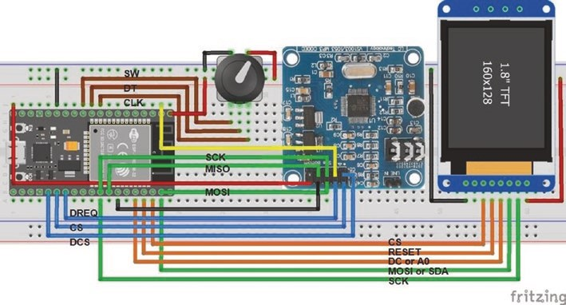
Figure 1-5. Internet radio with screen and rotary encoder and an ESP32 board
Internet radIo
Table 1-2. Internet radio with screen and rotary encoder and an ESP32 board
Component | Connect to ESP32
VS1053 audio decoder | See table 1-1
rotary encoder CLK | GpIo 25
rotary encoder dt | GpIo 26
rotary encoder SW | GpIo 27
rotary encoder VCC | 3V3
rotary encoder Gnd | Gnd
St7735 tFt LCd Gnd | Gnd
St7735 tFt LCd CS | GpIo 22
St7735 tFt LCd reSet | GpIo 1
St7735 tFt LCd dC or a0 | GpIo 3
St7735 tFt LCd Sda | GpIo 23
St7735 tFt LCd SCK | GpIo 18
St7735 tFt LCd Led | 3V3
The sketch for a portable Internet radio is given in Listing 1-3. Pressing the rotary encoder switch once displays the menu of available radio stations, with volume control as the first menu item. Turning the rotary encoder moves the menu of radio stations up or down the ST7735 TFT LCD screen. The mid-screen station, which is highlighted in RED, is selected by pressing the rotary encoder for a second time; and an HTTP request is made to the Internet radio station server for audio data. When Volume is selected on the menu, the current volume level is displayed
Internet radIo
and turning the rotary encoder decreases or increases the volume level, which is selected by pressing the rotary encoder switch. The ST7735 TFT LCD screen is refreshed with the current radio station information and the updated volume level displayed, but the station menu is still positioned at the current radio station.
The sketch in Listing 1-3 consists of several functions to compartmentalize the instructions. The lengthy first section of the sketch defines the libraries, the Internet radio station URLs, pin numbers for the VS1053 audio decoder, the ST7735 TFT LCD screen, and the rotary encoder, with initial values for the station and volume level and the rotary encoder parameters. The Adafruit ST7735 library is available in the Arduino IDE. The ESP32 vs1053_ext and Adafruit ST7735 libraries reference the SPI and Adafruit GFX libraries, so the #include <SPI. h> and #include <Adafruit_GFX.h> instructions are not required. The setup function establishes the Wi-Fi connection, initializes the VS1053 audio decoder and the ST7735 TFT LCD screen, attaches internal pull- up resistors to the rotary encoder, and defines interrupts for the rotary encoder. The direction and number of turns of the rotary encoder are determined by the change interrupt, as described in Chapter 19 (Rotary encoder control).
On pressing the rotary encoder switch, the loop function calls the screen function to display the volume and station menu, the readMenu function to determine the selected radio station or the readValue function function to obtain the new volume level, and then the radio function. The radio function either connects to the selected radio station server or changes the volume on the VS1053 audio decoder. The readMenu and readValue functions determine the selected row number of the menu, which is a list of stations, and the selected volume level, when the rotary encoder is turned. The vs1053_icyurl function obtains a string, starting with https:// and followed by the station URL, and extracts a substring starting two positions after the location of the first backslash. The vs1053_showstation and vs1053_showstreamtitle functions obtain

the radio station name and the title of the streamed track and then call the showStation function, which displays the station name, streamed track title, volume value, and station URL information on the ST7735 TFT LCD screen. Some text, such as the station name or title of the streamed track, will be longer than the width of the ST7735 TFT LCD screen, so the lines function splits the station name or title into screen-sized substrings for display. The encoder and swPress functions count the direction and number of turns of the rotary encoder and the number of presses of the rotary encoder switch.
Listing 1-3. Internet radio with screen and rotary encoder and an ESP32 board
#include <vs1053_ext.h> // include ESP32 VS1053_ext,
#include <WiFi.h> // WiFi and
#include <Adafruit_ST7735.h> // Adafruit_ST7735 libraries int CS = 0;
int DCS = 2; // define VS1053 decoder pins int DREQ = 4;
VS1053 decoder(CS, DCS, DREQ); // associate decoder with VS1053 char ssid[] = "xxxx"; // change xxxx to Wi-Fi ssid char password[] = "xxxx"; // change xxxx to Wi-Fi password const int maxStation = 11; // number of radio stations
String stationName[] = {"Volume", // first item on menu
"1940 UK", "Berlin", "Bayern3", "Classic", "BBC4",
"Vermont", "Ketchikan", "Kathmandu", "Ithaca", "Trondeim",
"Virgin"}; char * URL[maxStation] = { // radio station URLs
"1940sradio1.co.uk:8100/1",
"streambbr.ir-media-tec.com/berlin/mp3-128/vtuner_web_mp3/",
"streams.br.de/bayern3_2.m3u",
"media-ice.musicradio.com:80/ClassicFMMP3", "bbcmedia.ic.llnwd.net/stream/bbcmedia_radio4fm_mf_q",
"vpr.streamguys.net/vpr64.mp3",
"96.31.83.94:8082/stream",
"streaming.softnep.net:8037/stream.nsv",
"17993.live.streamtheworld.com/WITHFM.mp3",
"stream.radiometro.no/metro128.mp3",
"radio.virginradio.co.uk/stream"
};
int TFT_CS = 22;
int DCpin = 3; // define ST7735 TFT screen pins int RSTpin = 1; // associate tft with Adafruit ST7735 Adafruit_ST7735 tft = Adafruit_ST7735(TFT_CS, DCpin, RSTpin); int CLKpin = 25; int DTpin = 26;
int SWpin = 27; // define rotary encoder pins int oldRow = 0; int newRow = 1; int menuItem, val, upLimit; int displayVol[] = // define volume values for 22 levels
{0,50,60,65,70,75,80,82,84,86,88,90,91,92,93,94,95,96,97,98,
99,100}; int volume = 0;
int newVolume = 10; // volume level at start up int station = 0;
int newStation = 3; // station level at start up
int textlen, textrows;
String showstatn, showtitle, showurl, text, text1, text2; volatile int change = 0; // rotary encoder variables
volatile int pressed = 0; volatile int vals[] = {0,-1,1,0,1,0,0,-1,-1,0,0,1,0,1,0,-1,0}; volatile int score = 0;
volatile int oldState = 0; volatile int turn;
void setup()
{
SPI.begin(); // initialise SPI bus WiFi.begin(ssid, password); // initialise Wi-Fi while (WiFi.status() != WL_CONNECTED) delay(500); decoder.begin(); // initialise VS0153 decoder decoder.setVolume(volume); // set decoder volume level tft.initR(INITR_BLACKTAB); // initialise screen tft.fillScreen(ST7735_BLACK); // clear screen tft.setRotation(1); // orientate ST7735 screen tft.setTextSize(2); // set screen text size tft.drawRect(0,0,158,126,ST7735_WHITE); // draw white frame line tft.drawRect(2,2,154,122,ST7735_RED); // and second frame line
pinMode(CLKpin, INPUT_PULLUP);
pinMode(DTpin, INPUT_PULLUP); // rotary encoder uses pinMode(SWpin, INPUT_PULLUP); // internal pull-up resistors
attachInterrupt(CLKpin, encoder, CHANGE); attachInterrupt(DTpin, encoder, CHANGE);
// attach rotary encoder interrupts attachInterrupt(SWpin, swPress, CHANGE); }
void loop()
{ if(pressed == 1) // switch pin pressed first time { // to change station or volume clearScreen(); // call clearScreen function screen(); // call screen function
menuItem = readMenu(maxStation); // selected row in menu
} else if (pressed == 2) // switch pin pressed second time
{ // to select station if(menuItem > 0) // station selected
{
newStation = menuItem-1; // selected station in menu clearScreen(); // call clearScreen function showStation(volume, showstatn, showtitle);
// call showStation function if(newStation == station) showStation(volume, showstatn, showtitle);
} // volume change selected else if(menuItem== 0) newVolume = readValue("volume: ", volume, 21, 1);
pressed = 0; // reset variable
}
else if(pressed > 2) pressed = 0; // volume changed radio(); // call radio function
}
void radio() // function to connect to { // selected radio station server if(station != newStation) // new station selected
{
clearScreen(); // call clearScreen function
station = newStation; showurl = "";
decoder.connecttohost(URL[station]);
} // connect to radio station server if(volume != newVolume) // new volume level selected
{
volume = newVolume;
newRow = station+1; // retain station number on menu decoder.setVolume(volume); // update VS1053 volume clearScreen(); // call clearScreen function showStation(volume, showstatn, showtitle); } // call showStation function decoder.loop(); }
int readMenu (int rows) // function to obtain station { // number on menu while(pressed < 2) // while station not selected
{ if(change != 0) // rotary encoder turned
{
newRow = oldRow + change; // retain row number on menu newRow = constrain(newRow, 0, rows);
clearScreen(); // call clearScreen function screen(); // call screen function
oldRow = newRow; change = 0;
} delay(10);
} return newRow; // return row number on menu
}
// function to obtain volume level int readValue(String text, int current, int upLimit, int gain)
{
val = current; // current volume level clearScreen(); // call clearScreen function
tft.setTextColor(ST7735_WHITE); tft.setTextSize(2); tft.setCursor(10, 50);
tft.print(text); // display text and tft.print(displayVol[val]); // current volume value while(pressed < 3) // while switch pin is not pressed
{ if(change != 0) // rotary encoded turned
{
val = val + change * gain; // increment volume level val = constrain(val, 0, upLimit);
// constrain volume level clearScreen(); // call clearScreen function
tft.setCursor(10, 50);
tft.print(text); // display text and tft.print(displayVol[val]); // new volume value change = 0;
} delay(10);
} return val; // return new volume level
}
void vs1053_showstation(const char * info)
{ // function to obtain station name showstatn = String(info); // station name showtitle = "";
i f(showstatn == "No Name") showstatn = stationName[station+1]; clearScreen();
showStation(volume, showstatn, showtitle);
} // call showStation function
void vs1053_showstreamtitle(const char * info)
{ // function to obtain streamed title showtitle = String(info); clearScreen(); showStation(volume, showstatn, showtitle); }
void vs1053_icyurl(const char * info)
{ // function to obtain station URL showurl = String(info);
int i = showurl.indexOf("/"); // position of first / in string showurl = showurl.substring(i+2); // station URL as substring clearScreen(); showStation(volume, showstatn, showtitle); }
void showStation(int volume, String showstatn, String showtitle)
{ // function to display station name, streamed title
// and station URL on screen
tft.setTextColor(ST7735_GREEN); tft.setTextSize(1);
lines(showstatn, 10); // lines function to display station
tft.setTextColor(ST7735_YELLOW);
lines(showtitle, 40); // lines function to display title tft.setTextColor(ST7735_GREEN);
tft.setCursor(80, 100); // display volume value tft.print("volume: ");tft.print(displayVol[volume]); tft.setCursor(5, 110); tft.print(showurl); // display URL
}
void lines(String text, int line)
{ // function to split string into screen sized substrings textlen = text.length(); // get string length
textrows = 1+textlen/23; // required number of screen rows
for(int i=0; i<textrows; i++)
{
tft.setCursor(10, line + i*10); // move cursor to next row
tft.println(text.substring(i*23, (i+1)*23));
} // display substring
}
void screen() // function to display station menu
{
tft.setTextSize(2);
tft.setTextColor(ST7735_RED); // selected station in RED tft.setCursor(20, 55);
tft.print
(stationName[newRow]); // display station name tft.setTextSize(1);
tft.setTextColor(ST7735_WHITE); // all other stations in WHITE for (int i=1; i<4; i++) // display other station names
{
tft.setCursor(30, 50 - i*12); // above selected station if(newRow-i >=0) tft.print(stationName[newRow-i]); tft.setCursor(30, 65 + i*12); // below selected station if(newRow+i < maxStation+1) tft.print(stationName [newRow+i]);
}
} void clearScreen() // function to clear screen { // by displaying a BLACK rectangle tft.fillRect(3,3,152,120,ST7735_BLACK); }
IRAM_ATTR void encoder() // function to count rotary { // encoder turns
int newState = (oldState<<2)+(digitalRead(CLKpin)<<1)
+digitalRead(DTpin); score = score + vals[newState]; // allocate score from array oldState = newState % 4; // remainder to leave new CLK and DT if(score == 2 || score == -2) // 2 steps for complete rotation
{
change = score/2; // unit change per two steps score = 0; // reset score
}
}
IRAM_ATTR void swPress() // function to count switch presses { // pressed = 1, 2, 3 to change station,
// station selected, volume changed
if(digitalRead(SWpin) == HIGH) pressed = pressed + 1;
}

Internet radIo
Minimal Internet radio
The sketch in Listing 1-3 that included an ST7735 TFT LCD screen to display radio station name and URL, streamed track title, and volume level with a rotary encoder for station selection and volume control consisted of 250 lines of code. In contrast, Listing 1-4 for a minimal Internet radio preset to one radio station with one volume value has only 21 lines of code. Just change the Internet radio station URL to the required URL!
Listing 1-4. Minimal Internet radio
#include <vs1053_ext.h> // include ESP32 VS1053_ext #include <WiFi.h> // and WiFi libraries int CS = 0;
int DCS = 2; // define VS1053 decoder pins int DREQ = 4;
VS1053 decoder(CS, DCS, DREQ); // associate decoder with VS1053 char ssid[] = "xxxx"; // change xxxx to Wi-Fi ssid char password[] = "xxxx"; // change xxxx to Wi-Fi password
void setup()
{
SPI.begin(); // initialise SPI bus WiFi.begin(ssid, password); // initialise Wi-Fi while (WiFi.status() != WL_CONNECTED) delay(500); decoder.begin(); // initialise VS0153 decoder decoder.setVolume(10); // pre-set decoder volume level decoder.connecttohost
("media-ice.musicradio.com:80/ClassicFMMP3");
} // connect to pre-set radio station server
void loop()
{
decoder.loop(); }
Summary
An Internet radio was built with a VS1053 audio decoder and an ESP8266 or ESP32 microcontroller, with radio station selection and volume controlled using tactile switches. A portable Internet radio consisted of the VS1053 audio decoder, an ESP32 development board, and an ST7735 TFT LCD screen to display the radio station details, the title of the streamed track, and the volume level, with a rotary encoder to control station selection and volume. The sketch for a minimal Internet radio consisted of only 21 lines of code.
Components List
- ESP8266 microcontroller: LOLIN (WeMos) D1 mini or NodeMCU board
- ESP32 microcontroller: ESP32 DEVKIT DOIT or NodeMCU board
- VS1053 audio decoder module
- Mini-loudspeaker
- Tactile switch: 2×
- Rotary encoder: KY-040
- TFT LCD screen: ST7735, 1.8 inches
CHAPTER 2
Intranet camera
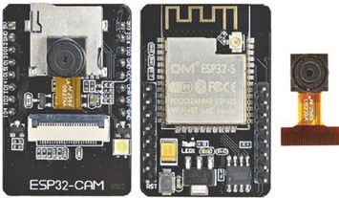
The ESP32-CAM module is based on the ESP32-S microcontroller and includes a 2M-pixel OV2640 camera and a micro-SD (Secure
Digital) card slot. JPEG files of images are stored on the micro-SD card or loaded to a
web page or streamed to a web page on a computer, Android tablet, or mobile phone.
The ESP32-CAM module (see Figure 2-1) contains serial TX and RX pins, six pins associated with the micro-SD card, and a COB (Chip on Board) LED, which flashes when taking a photo, and a red LED, which is active LOW, accessed with GPIO (General-Purpose Input-Output) 4 and 33 pins, respectively. A COB LED includes many LED chips bonded directly to a substrate to form a single module. There are three GND pins, a 3.3V and a 5V input pin, and the VCC pin outputs 3.3V or 5V with the jumper closed. GPIO 0 pin determines the flashing mode of the ESP32-CAM microcontroller, with the pin connected to GND when loading a sketch as the pin has a built-in pull-up resistor. GPIO pins 2, 4, 12, 13, 14, and 15 are associated with the micro-SD card functionality. When the micro-SD card is not in use, the GPIO pins are available as output pins. The pin layout of the ESP32-CAM module is shown in Figure 2-1 with Rup indicating the built-in pull-up resistor.
© Neil Cameron 2021 27
N. Cameron, Electronics Projects with the ESP8266 and ESP32, https://doi.org/10.1007/978-1-4842-6336-5_2

Intranet Camera
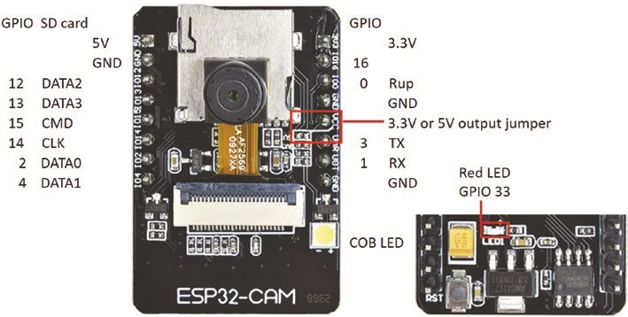
Figure 2-1. ESP32-CAM module pins
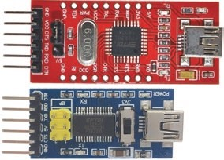
The ESP32-CAM module does not have a USB connector, and the module is connected to a computer or laptop with a USB to serial UART (Universal Asynchronous Receiver-Transmitter) interface, such as an FT232RL FTDI USB to TTL Serial converter module. The Serial
communication voltage of the USB to serial UART interface must be set at 3.3 V, with USB to serial UART interface RX and TX pins connected to the ESP32-CAM module TX and RX pins, respectively (see Figure 2-2 with connections in Table 2-1). The USB to serial UART interface 5V pin is connected to the ESP32-CAM module 5V pin. Details on installing the CP210x USB to UART Bridge driver for the ESP32 microcontroller, with the additional Boards Manager URLs and libraries for ESP32, are included in Chapter 21 (Microcontrollers). The camera module is attached to the ESP32-CAM module by lifting the black tab on the ESP32-CAM module, sliding the camera module into the connector, and closing the black tab.
Intranet Camera
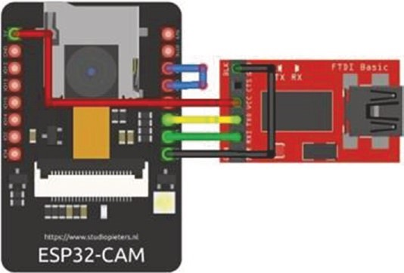
Figure 2-2. USB to serial UART interface with the ESP32-CAM module
Table 2-1. USB to serial UART interface with the ESP32-CAM module
Component | Connect to
USB to serial Uart rXD | eSp32-Cam tX pin
USB to serial Uart tXD | eSp32-Cam rX pin
USB to serial Uart VCC | eSp32-Cam 5V
USB to serial Uart GnD | eSp32-Cam GnD | eSp32-Cam GpIO 0 pin
In the Arduino IDE, from the Tools ➤ Board drop-down list, select ESP32
Wrover Module; in Tools ➤ Partition Scheme, select Huge APP (3MB no OTA/1MB SPIFFS); and in Tools ➤ Port, select the appropriate COM port.
Prior to loading a sketch onto the ESP32-CAM module, the module
GPIO 0 pin is connected to the module GND pin, and then the module
RESET button is pressed. After the sketch is uploaded, the GPIO 0 pin of the ESP32-CAM module is disconnected from the module GND pin, and then the module RESET button is pressed.
Intranet Camera
Save images to the SD card
With the sketch in Listing 2-1, the ESP32-CAM module takes a photo every two seconds, and the resulting JPEG file is stored on the micro-SD card. The number of photos taken is held in EEPROM (Electrically Erasable Programmable Read-Only Memory) to sequentially number the JPEG files as /pictureN.jpg for the Nth photo. When the sketch is rerun, JPEG files of images are numbered from with the last JPEG file stored, rather than from /picture0.jpg, which would overwrite existing JPEG files stored in the micro-SD card. Saving data on EEPROM is described in Chapter 20 (OTA and saving data to EEPROM, SPIFFS, and Excel). Pressing the ESP32-CAM module RESET button, after uploading a sketch, causes vibration to the camera module, so a two-second delay allows the camera module time to stabilize. The number of photos to take is entered on the Serial Monitor, and after the camera and micro-SD card are initialized, the camera takes the required number of photos. The Arduino IDE built-in SD-MMC library uses the faster ESP32 SDMMC hardware bus instead of SPI, as used by the SD library. Note that the ESP32-CAM module supports a baud rate of 115200 Bd.
The JPEG files, in UXGA format with 1200 × 1600 pixels, have an average size of 100 kB; and a 4 GB micro-SD card, in FAT32 format, stores thousands of images. A 16 GB micro-SD card was used in this chapter. Time-lapse photography is possible with the ESP32-CAM module by storing JPEG images on the micro-SD card with intervals of 2–30 s between photographs. In Listing 2-1, setting the variable maxPhoto to 3000 will generate sufficient images for a two-minute video with a 25 FPS (frames per second) frame rate, which only requires 300 MB of the micro-SD card storage.
Intranet Camera
The ESP32-CAM camera configuration instructions are included in the config_pins.h tab rather than in the main sketch, to make the sketch easier to interpret. The additional tab is created in the Arduino IDE by selecting the triangle below the Serial Monitor button, on the right side of the IDE, and choosing New Tab from the drop-down menu. The New Tab is titled config_pins.h.
The sketch in Listing 2-1 loads the libraries for the ESP32-CAM, with the config_pins.h tab (see Listing 2-2) including instructions to configure the ESP32-CAM camera with the configCamera function. The micro-SD card is initialized with the initSDcard function, which determines the SD card type. After the required time interval between photos has elapsed, the takePhoto function is called. A JPEG file of the image is saved to the micro-SD card with the file name incremented after each photo and the image number written to EEPROM. The takePhoto function uses the ampersand, &, and asterisk, *, characters to relate to the memory address of a variable, with spacing to emphasize the characters. In Chapter 14 (ESP-NOW and LoRa communication), Listing 14-3 illustrates use of a memory address pointer.
Listing 2-1. Taking a photo and saving to the micro-SD card
#include <esp_camera.h> // include esp_camera library
#include <SD_MMC.h> // include SD_MMC library
#include <EEPROM.h> // include EEPROM
#include "config_pins.h" // configure instructions tab uint8_t SDtype;
int SDpics; // number of pictures on SD card int maxPhoto = 0; // maximum number of photos int Nphoto = 0; // number of photos taken int photoTime = 2000; // delay (ms) between photos
Intranet Camera
String filename;
unsigned long nowTime, lastTime = 0;
void setup()
{
Serial.begin(115200); // baud rate for Serial Monitor
Serial.println("\n\nenter number of required photos");
Serial.println("\n\nsettling down for 2s");
// time to settle vibration delay(2000);
Serial.println("initialising camera, then take photos"); configCamera(); // functions to configure camera initSDcard(); // and to initialise micro-SD card EEPROM.begin(1); // EEPROM with one record
SDpics = EEPROM.read(0); // number of saved pictures
}
void loop()
{
while (Serial.available()>0)
{ // maximum photo number maxPhoto = Serial.parseInt(); // parsed from Serial buffer
Nphoto = 0;
} // if photo number < maximum
// photo number
nowTime = millis(); // take photo after photoTime ms if((nowTime - lastTime > photoTime) && (Nphoto < maxPhoto))
{
Nphoto++; // increment photo number takePhoto(); // call function to take photo
Intranet Camera
lastTime = millis(); // update time of photo
}
}
void initSDcard() // function to initialise SD card
{ if(!SD_MMC.begin()) // check SD card in position
{
Serial.println("error loading SD card"); return;
}
SDtype = SD_MMC.cardType(); // obtain SD card type
if(SDtype == CARD_NONE)
{
Serial.println("insert SD Card"); return;
}
Serial.print("SD card type: ");
if(SDtype == CARD_MMC) Serial.println("MMC"); else if(SDtype == CARD_SD) Serial.println("SDSC"); else if(SDtype == CARD_SDHC) Serial.println("SDHC"); else Serial.println("UNKNOWN"); }
void takePhoto() // function to take and save photo
{
camera_fb_t * frame = NULL; // associate fb with esp_camera frame = esp_camera_fb_get(); // take photo with camera

if(!frame)
{
Serial.println("photo capture error"); return;
}
SDpics ++; // increase picture number filename = "/picture" + String(SDpics) +".jpg";
// generate JPEG filename fs::FS & fs = SD_MMC;
File file = fs.open(filename.c_str(), FILE_WRITE);
// access SD card if(!file) Serial.println("file save error"); else
{ file.write(frame->buf, frame->len); // save file to SD card
Serial.print("Picture filename: ");
Serial.println(filename);
EEPROM.write(0, SDpics); // update EEPROM
EEPROM.commit(); // with picture number
}
file.close(); // close file on SD card
esp_camera_fb_return(frame); // return frame buffer to driver for } // reuse
The ESP32-CAM camera configuration instructions are included in the config_pins.h tab rather than in the main sketch (see Listing 2-2). The JPEG pixel format is selected from the available options of YUV422,
GRAYSCALE, RGB565, and JPEG. If a microcontroller does not support PSRAM (pseudostatic RAM), which is dynamic RAM that behaves like static RAM, then a lower picture frame size; lower JPEG quality, with a value between to either 0 and 63; and lower frame count must be set.
Intranet Camera
Listing 2-2. Camera configuration instructions tab
camera_config_t config; // store camera configuration parameters void configCamera()
{
config.ledc_channel = LEDC_CHANNEL_0; config.ledc_timer = LEDC_TIMER_0; config.pin_d0 = 5; config.pin_d1 = 18;
config.pin_d2 = 19; // GPIO pin numbers config.pin_d3 = 21; config.pin_d4 = 36; config.pin_d5 = 39; config.pin_d6 = 34; config.pin_d7 = 35; config.pin_xclk = 0; config.pin_pclk = 22; config.pin_vsync = 25; config.pin_href = 23; config.pin_sscb_sda = 26; config.pin_sscb_scl = 27; config.pin_pwdn = 32; config.pin_reset = -1;
config.xclk_freq_hz = 20000000; // clock speed of 20MHz config.pixel_format = PIXFORMAT_JPEG; // JPEG file format config.frame_size = FRAMESIZE_SVGA; // 800x600 pixels config.jpeg_quality = 10; // image quality index config.fb_count = 1; // frame buffer count esp_err_t err = esp_camera_init(&config); // initialize camera if (err != ESP_OK)
{
Serial.print("Camera initialise failed with error");
Serial.println(err); return;
}
}
Load images on a web page
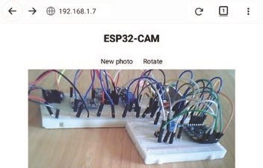
A photo taken by the ESP32-CAM module is uploaded to a web page using an HTTP request. Once the Wi-Fi connection is made and the WLAN web page loaded, clicking the New photo button calls the newPhoto function, which initiates a client HTTP request with the /photoURL URL for the server camera to take a photo and send the JPEG image to the client. The web page is reloaded with the location.reload() instruction to update the web page with the new photo. Clicking the Rotate button rotates the image on the web page through 90°. Rotating the image covers the buttons, so the button positions are redefined if the image is portrait (rotation of 90° or 270°) or landscape. Loading an ESP32-CAM image directly to a webpage is based on the method of Nuno Santos (techtutorialsx.com).
The sketch in Listing 2-3 includes HTTP GET requests, with corresponding URLs, and references the buildpage.h tab containing the HTML code for the web page (see Listing 2-4). The underscore P in the instruction request->send_P identifies that the JPG image is stored in
PROGMEM, as flash (or program) memory has more capacity than RAM.
Intranet Camera
The photo size is displayed on the Serial Monitor, for information only. The ESPAsyncWebServer and AsyncTCP libraries by Hristo Gochkov are required, and .zip files containing the libraries are downloaded from github.com/me-no-dev/ESPAsyncWebServer and github.com/me-no-dev/ AsyncTCP, respectively. The ESPAsyncWebServer library references the AsyncTCP and WiFi libraries, so the instructions #include <AsyncTCP.h> and #include <WiFi.h> are not required. The WiFi library is included in the Arduino IDE when the ESP32 driver is installed. There is no change to the content of the config_pins.h tab (see Listing 2-2).
Listing 2-3. Taking a photo and loading to a web page
#include <esp_camera.h> // include esp_camera,
#include <ESPAsyncWebServer.h> // ESPAsyncWebServer libraries
AsyncWebServer server(80); // associate server with library
#include "config_pins.h" // configure instructions tab #include "buildpage.h" // HTML code for webpage char ssid[] = "xxxx"; // change xxxx to Wi-Fi ssid char password[] = "xxxx"; // change xxxx to Wi-Fi password String pSize; // photo size (bytes)
void setup()
{
Serial.begin(115200); // Serial Monitor baud rate
Serial.println("\n\nsettling down for 2s");
// time to settle vibration delay(2000);
Serial.println("initialising camera, then take photos"); configCamera(); // function to configure camera WiFi.begin(ssid, password); // initialise Wi-Fi while (WiFi.status() != WL_CONNECTED) delay(500);
Serial.print("IP Address: ");
Serial.println(WiFi.localIP()); // display WLAN IP address server.begin(); // initialise server server.on("/", HTTP_GET, [](AsyncWebServerRequest * request)
{ request->send_P(200, "text/html", page);});
server.on("/photoURL", HTTP_GET, [](AsyncWebServerRequest *
request)
{
camera_fb_t * frame = NULL;
frame = esp_camera_fb_get(); // take photo as JPEG request->send_P(200, "image/jpeg", // send JPEG image to client (const uint8_t *)frame->buf, frame->len); esp_camera_fb_return(frame); // clear photo buffer pSize = String(frame->len); // display photo size
Serial.print("pSize ");Serial.println(pSize);
});
}
void loop() // nothing in loop function
{}
The HTML code for the web page, stored as a string literal, is contained in the buildpage.h tab (see Listing 2-4). HTML instructions for XML HTTP requests are described in Chapter 8 (Updating a web page). The location. reload() instruction reloads the web page, exactly as the reload button in a browser. An image is rotated through N degrees with the instruction rotate(Ndeg) with the transform attribute.
The HTML code displays the two buttons in a table row and allocates functions to each button. In the AJAX code, the newPhoto function makes an XML HTTP request with the /photoURL URL to initiate taking a photo and then reloading the web page.
Intranet Camera Listing 2-4. AJAX code for the web page with a ESP32-CAM photo
char page[] PROGMEM = R"( <!DOCTYPE HTML><html><head>
<title>ESP32-CAM</title>
<style>
body {text-align:center; font-size: 25px;}
.vert {margin-bottom: 10%}
.hori {margin-bottom: 0%}
.btn {background-color:White; font-size: 25px} table {margin: auto} td {padding: 10px}
</style></head>
<body>
<h2>ESP32-CAM</h2>
<div id='buttons'>
<table><tr>
<td><button onclick='newPhoto()' class='btn'>New photo
</button></td>
<td><button onclick='turn()' class='btn'>Rotate</button></td>
</tr></table></div>
<img src='/photoURL' id='photo' width='80%'>
<script>
function newPhoto()
{
var xhr = new XMLHttpRequest(); xhr.open('GET', '/photoURL', true); xhr.send(); location.reload();
} var deg = 0; function turn() {
deg = deg + 90; var img = document.getElementById('photo'); img.style.transform = 'rotate(' + deg + 'deg)'; if((deg/90)%2 == 1) document.getElementById('buttons').className = 'vert'; else document.getElementById('buttons').className = 'hori';
}
</script>
</body></html>
)";
Including the instruction var rpt = setInterval(newPhoto, 5000) in the <script> section of Listing 2-4 calls the newPhoto function every five seconds, which is a very basic form of streaming images. The next section streams images to a web page.
Stream images to a web page
The ESP32-CAM module streams images to a web page, and the streaming frame rate ranges from 3 FPS (frames per second) with UXGA (1600 × 1200 pixels) format to 30 FPS with QQVGA (160 × 120 pixels) format. Several image formats are shown in Table 2-2. The smaller the image size, the faster the frame rate. The CameraWebServer sketch, accessed in the Arduino IDE by File ➤ Examples ➤ ESP32 ➤ Camera, includes face recognition and face detection functions, with options to change numerous image characteristics.
Intranet Camera Table 2-2. Image pixel size options
Frame | UXGA | SXGA | XGA | SVGA | VGA | CIF | QVGA | HQVGA | QQVGA
Width | 1600 | 1280 | 1024 | 800 | 640 | 400 | 320 | 240 | 160
Height | 1200 | 1024 | 768 | 600 | 480 | 296 | 240 | 176 | 120
The sketch in Listing 2-5 manages streaming of images to a web page. The sketch loads the required libraries, which are available in the ESP32 Arduino IDE, establishes a Wi-Fi connection, configures the camera in the config_pins.h tab (see Listing 2-2), and calls the startCameraServer function, which accesses the stream_handler function (see Listing 2-6) in the stream_handler tab. The delay() instruction in the loop function may be required to prevent the watchdog timer from initiating a software reset.
Listing 2-5. Real-time viewing on a web page
#include <esp_http_server.h> // include esp http_server,
#include <esp_camera.h> // camera and Wi-Fi libraries
#include <WiFi.h>
#include "config_pins.h" // configure instructions tab #include "stream_handler.h" // code to stream images char ssid[] = "xxxx"; // change xxxx to Wi-Fi ssid char password[] = "xxxx"; // change xxxx to Wi-Fi password
void setup()
{
Serial.begin(115200); // Serial Monitor baud rate
Serial.setDebugOutput(false); // no debug information WiFi.begin(ssid, password); // initialise Wi-Fi while (WiFi.status() != WL_CONNECTED) delay(500);
Serial.print("IP Address: ");
Serial.println(WiFi.localIP()); // display WLAN IP address configCamera();
sensor_t * s = esp_camera_sensor_get(); // reduce frame size s->set_framesize(s, FRAMESIZE_VGA); // to 640x480 pixels startCameraServer(); }
void startCameraServer() // function to start camera server
{
httpd_handle_t stream_httpd = NULL; httpd_config_t config = HTTPD_DEFAULT_CONFIG(); config.server_port = 80; httpd_uri_t index_uri = {.uri="/", .method=HTTP_GET, .handler=stream_handler,
.user_ctx=NULL};
if (httpd_start(&stream_httpd, &config) == ESP_OK) httpd_register_uri_handler(stream_httpd, &index_uri); }
void loop() // nothing in loop function
{}
Listing 2-6 is derived from sections of the CameraWebServer sketch which specifically manage streaming images to a web page. The instruction httpd_resp_send_chunk() returns the JPEG buffer as 64- bit sections in response to the client HTTP request, with the instruction snprintf((char *)part_buf, 64,...) generating the 64-bit sections of the JPEG buffer. The static keyword creates a variable specific to a function, and the value of the variable is maintained between repeated calls to the function. Several instructions in Listing 2-6 are identical to those in the takePhoto function of Listing 2-1, as indicated by the comments for Listing 2-6.
Intranet Camera
Listing 2-6. Streaming real-time images
#define Boundary "123456789000000000000987654321" static const char* ContentType =
"multipart/x-mixed-replace;boundary=" Boundary; static const char* StreamBound = "\r\n--" Boundary "\r\n"; static const char* StreamContent =
"Content-Type: image/jpeg\r\nContent-Length: %u\r\n\r\n"; static esp_err_t stream_handler(httpd_req_t *req)
{
camera_fb_t * frame = NULL; // as in Listing 2-1 esp_err_t res = ESP_OK; // error status uint8_t * jpgBuffer = NULL; // JPEG buffer size_t jpgLength = 0; // length of JPEG buffer char * part_buf[64]; res = httpd_resp_set_type(req, ContentType); if(res != ESP_OK) return res;
while(true)
{
frame = esp_camera_fb_get(); // as in Listing 2-1 if (!frame) // as in Listing 2-1
{
Serial.println("Camera capture failed");
// as in Listing 2-1 res = ESP_FAIL;
} else {
if(frame->width > 400)
{
jpgLength = frame->len; // set JPEG buffer length jpgBuffer = frame->buf; // set JPEG buffer
}
}

Intranet Camera
if(res == ESP_OK) // no error, stream image
{
size_t hlen = snprintf((char *)part_buf, 64,
StreamContent, jpgLength); res = httpd_resp_send_chunk(req, (const char *) part_buf, hlen);
}
if(res == ESP_OK) res =
httpd_resp_send_chunk(req, (const char *)jpgBuffer, jpgLength);
if(res == ESP_OK) res =
httpd_resp_send_chunk(req, StreamBound, strlen (StreamBound)); if(frame)
{
esp_camera_fb_return(frame); // as in Listing 2-1 frame = NULL; jpgBuffer = NULL; // reset to NULL value
} else if(jpgBuffer)
{
free(jpgBuffer); // reset to NULL value jpgBuffer = NULL;
}
if(res != ESP_OK) break;
} return res;
}
PIR trigger to stream images to a web page
The ESP32-CAM module requires 130 mA to stream images to a web page, which rapidly drains a battery. If the ESP32-CAM module is in sleep mode, when not streaming images, and a PIR (passive infrared) sensor on the HC-SR501 PIR module triggers the ESP32-CAM module from sleep mode to start taking photos and stream images to a web page, then a battery- powered module is feasible (see Figure 2-3 with connections in Table 2- 3). The ESP32 sleep mode is described in Chapter 22 (ESP32 microcontroller features); and a HIGH or LOW signal on a GPIO pin wakes the microcontroller from sleep mode, with the instruction esp_sleep_enable_ ext0_wakeup(pin, state), when the state of pin is equal to state. When no movement is detected by the PIR sensor, the value of state is zero, as the PIR pin is pulled down by an ESP32 microcontroller pull-down resistor. ESP32 microcontroller pull-down resistors are disabled during sleep, so the instruction rtc_gpio_pulldown_en(pin) enables a pull-down resistor on the GPIO pin connected to the PIR sensor pin. When the PIR sensor is activated by infrared radiation, such as a person moving in the range of the sensor, the signal pin of the PIR sensor module is set HIGH, which wakes the microcontroller from sleep mode. After the ESP32-CAM module has streamed images to a web page for the required time, the microcontroller is moved to sleep mode, with the instruction esp_deep_sleep_start().
An HC-SR501 or HC-SR505 PIR module requires up to 50 s to stabilize, particularly the HC-SR505 module. If the PIR module triggers with no movement after the stabilization period, then the PIR module should be powered independently from the ESP32-CAM, but with a common GND.
Intranet Camera
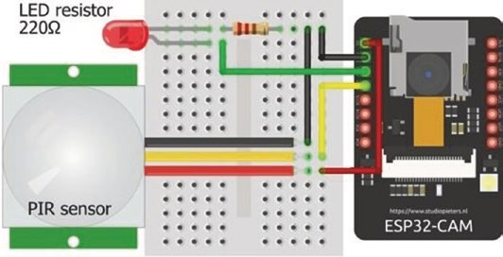
Figure 2-3. PIR trigger to stream ESP32-CAM images to a web page
Table 2-3. PIR trigger to stream images to a web page
Component | Connect to | And to
eSp32-Cam 5V | hC-Sr501 5V
eSp32-Cam GnD | hC-Sr501 GnD
eSp32-Cam GpIO 12 | LeD long leg
eSp32-Cam GpIO 13 | hC-Sr501 OUt
LeD short leg | 220 Ω resistor | GnD
In the sketch in Listing 2-7, the ESP32-CAM is triggered by the PIR sensor, the LED is flashed to indicate detected movement, the Wi-Fi connection is established, and the ESP32-CAM camera is configured. The LED is again flashed to indicate the start of image streaming, images are streamed to the web page for camTime seconds, and the LED is again flashed to indicate the end of image streaming. The sketch in Listing 2-7 is based on Listing 2-5, with only the addition of the real-time clock (RTC) input-output (rtc_io) library, the flash function to flash the LED, the esp_sleep instructions, and the loop function, which determines the elapsed time since image streaming started. There is no change to the content of the config_pins.h and stream_handler.h tabs. Only the additional instructions to Listing 2-5 are annotated in Listing 2-7, to emphasize the few changes required to the sketch.
Listing 2-7. PIR trigger to stream images to a web page
#include <esp_http_server.h>
#include <esp_camera.h>
#include <WiFi.h>
#include "config_pins.h"
#include "stream_handler.h"
#include <driver/rtc_io.h> // include rtc input-output library int PIRpin = 13; // define PIR and LED pins int LEDpin = 12; unsigned long startTime,
lastTime = 0; // timer variables
int camTime = 10; // define image streaming time (s) int count = 0; // counter for steaming time char ssid[] = "xxxx"; char password[] = "xxxx";
void setup()
{
pinMode(LEDpin, OUTPUT); // LED pin as output flash(); // call function to flash LEDs
Serial.begin(115200);
Serial.setDebugOutput(false);
WiFi.begin(ssid, password);
while (WiFi.status() != WL_CONNECTED) delay(500);
Serial.print("IP Address: ");
Serial.println(WiFi.localIP()); configCamera();
Intranet Camera
sensor_t * s = esp_camera_sensor_get(); s->set_framesize(s, FRAMESIZE_VGA); startCameraServer(); rtc_gpio_pulldown_en
((gpio_num_t)PIRpin); // pull-down PIR pin esp_sleep_enable_ext0_wakeup((gpio_num_t)PIRpin, 1); } // wakeup on PIR pin with state 1
void startCameraServer()
{
httpd_handle_t stream_httpd = NULL; httpd_config_t config = HTTPD_DEFAULT_CONFIG(); config.server_port = 80; httpd_uri_t index_uri = {.uri="/", .method=HTTP_GET, .handler=stream_handler,
.user_ctx=NULL};
if (httpd_start(&stream_httpd, &config) == ESP_OK) httpd_register_uri_handler(stream_httpd, &index_uri); }
void loop()
{
if(count < 1) flash(); // call function to flash LEDs startTime = millis(); // start of image streaming time if(startTime - lastTime > 1000 && count < camTime)
{ // display seconds elapsed Serial.print("camera ");Serial.println(count); count++; // update counter
lastTime = startTime; // reset image streaming time
}
if(count == camTime) // defined streaming time elapsed { flash();
Serial.print("sleep mode on PIR pin ");
Serial.println(PIRpin); esp_deep_sleep_start(); // ESP32 in sleep mode
}
}
void flash() // function to flash LEDs
{ for (int i=0; i<3; i++) // flash LED three times
{
digitalWrite(LEDpin, HIGH); // turn on LED delay(200);
digitalWrite(LEDpin, LOW); // turn off LED delay(100);
}
}
When the sketches in Listings 2-1 and 2-7 are combined, the ESP32- CAM is triggered by the PIR sensor to take photos and store the image JPEG files on the micro-SD card.
Summary
The ESP32-CAM module includes an ESP32-S microcontroller, a 2M-pixel OV2640 camera, and a micro-SD card slot. Images are stored on the micro-SD card, loaded to a web page, or streamed to a web page on a computer, Android tablet, or mobile phone. Images are stored on the micro-SD card at timed intervals, for use with time-lapse photography.
Intranet Camera
Images are remotely uploaded to a web page on an Android tablet or mobile phone, where the image is rotated and also saved to the Android tablet or mobile phone. Real-time images are streamed from the ESP32CAM module to a web page, with frame rates of up to 30 FPS. A PIR sensor is used to wake the microcontroller from sleep mode, which then streams images to a web page for a defined time period. The ESP32-CAM module is then returned to the energy-saving sleep mode.
Components List
- ESP32-CAM module
- USB to serial UART interface: FT232RL FTDI USB to TTL Serial converter module
- Passive infrared (PIR) sensor: HC-SR501 or HC-SR505
- LED
- Resistor: 220 Ω

CHAPTER 3
International weather station
International weather information is displayed on a touch screen where the user selects weather information for different cities and chooses between two screens of displayed information. Initially, this chapter describes displaying text and shapes on the screen, calibrating the touch function of the screen, and creating images by pressing the touch screen. Once sketches are developed to display information and utilize the touch function of the touch screen, the focus shifts to accessing international weather data from OpenWeatherMap.org and the reformatting of the OpenWeatherMap data to display on a touch screen.
Displaying text and shapes on a touch screen or creating images by pressing the touch screen does not require Internet access. An Arduino Uno or Nano is sufficient to run the sketches, but a logic-level converter is required to reduce the voltage to the touch screen to 3.3 V, as the Arduino Uno and Nano operate at 5 V. Accessing OpenWeatherMap data requires connection to the local Wi-Fi network, which is provided by an ESP8266 or ESP32 microcontroller.
© Neil Cameron 2021 51
N. Cameron, Electronics Projects with the ESP8266 and ESP32, https://doi.org/10.1007/978-1-4842-6336-5_3
ILI9341 SPI TFT LCD touch screen
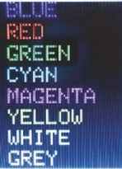
The 2.4-inch ILI9341 SPI TFT LCD touch screen with 240 × 320 pixels has touch screen functionality for displaying text and drawing shapes with different colors on the screen. The acronyms SPI, TFT, and LCD represent Serial Peripheral Interface, Thin-Film Transistor, and
Liquid Crystal Display, respectively. The ILI9341 SPI TFT
LCD screen and the ESP8266 and ESP32 microcontrollers
operate at 3.3 V, so a logic-level converter is not required. Connections for the ILI9341 SPI TFT LCD screen with the ESP8266 and ESP32 development boards are shown in Figures 3-1 and 3-2 and given in Table 3-1. Note that the microcontroller SPI MOSI, MISO (Main-In Secondary-Out), and serial clock (SCL) pins are connected to both the display and the touch function pins of the ILI9341 SPI TFT LCD screen.
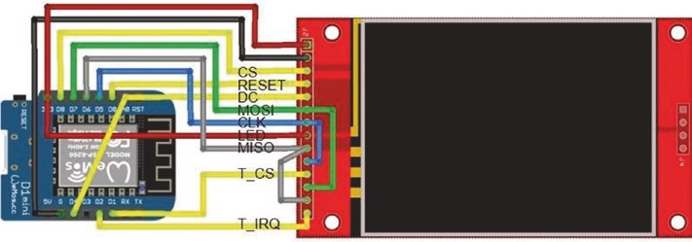
Figure 3-1. ILI9341 SPI TFT LCD screen and the LOLIN (WeMos) D1 mini development board
InternatIonal weather statIon
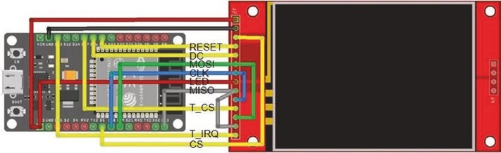
Figure 3-2. ILI9341 SPI TFT LCD screen and the ESP32 DEVKIT DOIT development board
Table 3-1. ILI9341 SPI TFT LCD screen and ESP8266 and ESP32 development boards
Component | Pin Function | ESP8266 Pin | ESP32 Pin
IlI9341 tFt screen VCC 3.3V |  | 3V3 | 3V3
IlI9341 tFt screen GnD |  | GnD | GnD
IlI9341 tFt screen Cs | Chip select | D8 | GpIo 5
IlI9341 tFt screen reset |  | D0 | GpIo 25
IlI9341 tFt screen DC | Data command | D4 | GpIo 26
IlI9341 tFt screen sDa (MosI) | serial data in (DI) | D7 | GpIo 23
IlI9341 tFt screen sCl (ClK) | serial clock | D5 | GpIo 18
IlI9341 tFt screen leD |  | 3V3 | 3V3
IlI9341 tFt screen sDo (MIso) | serial data out | D6 | GpIo 19
"touch"  IlI9341 tFt screen t_ClK | serial clock | D5 | GpIo 18
IlI9341 tFt screen t_Cs | Chip select | D1 | GpIo 27
(continued)
Table 3-1. (continued)
Component | Pin Function | ESP8266 Pin | ESP32 Pin
IlI9341 tFt screen t_DIn | Data input | D7 | GpIo 23
IlI9341 tFt screen t_Do | Data output | D6 | GpIo 19
IlI9341 tFt screen t_IrQ | Interrupt | D2 | GpIo 13
Listing 3-1 demonstrates displaying text and drawing shapes on the ILI9341 SPI TFT LCD screen. The Adafruit ILI9341 and Adafruit GFX libraries are installed within the Arduino IDE. The Adafruit GFX and SPI libraries are referenced by the Adafruit ILI9341 library, so are not explicitly included in the sketch. Color codes are available within the Adafruit ILI9341 library, so HEX codes for colors are not defined in the sketch. The screen orientation is set as portrait or landscape with the instruction setRotation(N) with value of 0 or 1, respectively, or the value of 2 or 3 to rotate the screen image by 180° for portrait or landscape, respectively. For example, portrait orientation with pin connections at the top of the ILI9341 SPI TFT LCS screen is set with setRotation(2). The default font size is 5 × 8 pixels per character that is increased to 5N × 8N pixels with the setTextSize(N) instruction.
Listing 3-1. Display text and shapes
#include <Adafruit_ILI9341.h> // include ILI9341 library int tftCS = D8; // screen chip select pin int tftDC = D4; // data command select pin int tftRST = D0; // reset pin
// associate tft with ILI9341 lib
Adafruit_ILI9341 tft = Adafruit_ILI9341(tftCS, tftDC, tftRST);
String texts[] = // color names
{"BLUE","RED","GREEN","CYAN","MAGENTA","YELLOW","WHITE","GREY"};
InternatIonal weather statIon
unsigned int colors[ ] = // color codes
{ILI9341_BLUE, ILI9341_RED, ILI9341_GREEN, ILI9341_CYAN,
ILI9341_MAGENTA, ILI9341_YELLOW, ILI9341_WHITE,
ILI9341_LIGHTGREY};
String text;
unsigned int color, chkTime; void setup()
{
tft.begin(); // initialise screen tft.setRotation(2); // portrait, connections at top tft.fillScreen(ILI9341_BLACK); // fill screen in black tft.drawRect(0,0,239,319,ILI9341_WHITE); // draw white frame line tft.drawRect(1,1,237,317,ILI9341_WHITE); // and second frame line tft.setTextSize(4); // set text size
}
void loop()
{ // clear screen apart from frame
tft.fillRect(2,2,235,314,ILI9341_ BLACK); for (int i=0; i<8; i++) // for each color
{
color = colors[i]; // set color text = texts[i]; // set text for color tft.setTextColor(color); // set text color tft.setCursor(20,40*i+2); // position cursor tft.print(text); // print color text (name) delay(250); // delay 250ms between colors }
for (int i=0; i<8; i++) // for each color
{
color = colors[i]; text = texts[i]; tft.fillRect(2,2,235,314,ILI9341_BLACK);
tft.setCursor(20,25); // cursor to position (20, 25) tft.setTextColor(color);
tft.print(text); // draw filled- in triangle if ((i+1) % 3 == 0) tft.fillTriangle(20,134,64,55,107,134,color); // draw open rectangle else if ((i+1) % 2 == 0) tft.drawRect(20,55,88,80,color); else tft.fillCircle(64,95,39,color); // draw filled- in circle delay(250);
}
tft.fillRect(2,2,235,314,ILI9341_BLACK); tft.drawLine(2,158,236,158,ILI9341_RED );
// draw horizontal RED line
delay(250); }
In Listing 3-1, SPI pins are defined for an ESP8266 development board, which must be changed for an ESP32 development board. Alternatively, the instructions in Listing 3-2 can be included at the start of a sketch. See Chapter 21 (Microcontrollers) for more information.
Listing 3-2. Pin definitions for ESP8266 and ESP32 development boards
#ifdef ESP32
int tftCS = 5; // screen chip select pin int tftDC = 26; // data command select pin int tftRST = 25; // reset pin
InternatIonal weather statIon
#elif ESP8266 int tftCS = D8; int tftDC = D4; int tftRST = D0;
#else // Arduino IDE error message
#error "ESP8266 or ESP32 microcontroller only"
#endif
Touch screen calibration
A library for the touch screen function with the ESP8266 and ESP32 microcontrollers, TFT_eSPI by Bodmer, is available within the Arduino IDE. Prior to using the TFT_eSPI library in sketches, the touch screen driver, pin connections to the ESP8266 or ESP32 development board, and SPI frequencies must be defined in the file User_Setup.h, which is located in the TFT-eSPI library folder. Listing 3-3 includes the settings used in this chapter for ESP8266 and ESP32 microcontrollers, with the settings for the ESP32 microcontroller commented out. Note that default pin connections for the ESP8266 SPI MOSI, MISO, and CLK are not required, but pin numbers for the ESP8266 development board are preceded with PIN_, while the ESP32 microcontroller GPIO numbers are sufficient.
Listing 3-3. TFT-eSPI library User_Setup settings for ESP8266 and ESP32 development boards
#define TFT_CS PIN_D8 // ESP8266 SPI and touch screen
#define TFT_DC PIN_D4
#define TFT_RST PIN_D0
#define TOUCH_CS PIN_D1
/* // lines between /* and */ are commented out
#define TFT_MISO 19 // ESP32 SPI and touch screen
#define TFT_MOSI 23
#define TFT_SCLK 18
#define TFT_CS 5
#define TFT_DC 26
#define TFT_RST 25
#define TOUCH_CS 27
*/
#define ILI9341_DRIVER // ILI9341 SPI TFT LCD screen
#define TFT_RGB_ORDER TFT_BGR // color order Blue- Green- Red
#define LOAD_GLCD // font 1: Adafruit 8-pixel high
#define LOAD_FONT2 // font 2: small 16-pixel high
#define LOAD_FONT4 // font 4: medium 26-pixel high
#define SPI_FREQUENCY 40000000 // SPI 40MHz
#define SPI_READ_FREQUENCY 20000000 // SPI read 20MHz
#define SPI_TOUCH_FREQUENCY 2500000 // SPI touch 2.5MHz
Before using the touch screen facility of the ILI9341 SPI TFT LCD screen, the screen must be calibrated (see Listing 3-4). Arrows are displayed on the ILI9341 SPI TFT LCD screen, which the user presses with a screen pen. Five calibration parameters are displayed on the ILI9341 SPI TFT LCD screen, which are included in the calData array of subsequent sketches. The SPI library is referenced by the TFT_eSPI library, so is not explicitly included in the sketch. Listing 3-4 is adapted from the Touch_calibrate sketch in the TFT-eSPI ➤ Generic library.
Listing 3-4. Calibration of the ILI9341 SPI TFT LCD screen
#include <TFT_eSPI.h> // include TFT_eSPI library TFT_eSPI tft = TFT_eSPI(); // associate tft with TFT-eSPI lib uint16_t calData[5]; // calibration parameters String str;
InternatIonal weather statIon
void setup()
{
tft.init(); // initialise ILI9341 TFT screen tft.setRotation(1); // landscape, connections on right tft.setTextFont(1); // set text font and size tft.setTextSize(1); calibrate(); // call calibration function
}
void calibrate() // function to calibrate ILI9341 TFT screen
{
tft.fillScreen(TFT_BLACK); // fill screen in black tft.setTextColor(TFT_WHITE, TFT_B LACK);
// set text color, white on black
tft.setCursor(30, 0); // move cursor to position (0, 30)
tft.println("Touch corners as indicated"); tft.calibrateTouch(calData, TFT_RED, TFT_ BLACK, 15);
// calibrate screen
tft.fillScreen(TFT_BLACK); tft.setCursor(0, 50); tft.setTextSize(2); tft.print("Calibration parameters");
str = ""; // display calibration parameters for (int i=0; i<4; i++) str = str + String(calData[i])+","; str = str + String(calData[4]); tft.setCursor(0, 90); tft.print(str);
} void loop() // nothing in loop function {}
For example, the calibration parameters for the ILI9341 SPI TFT LCD screen used in this chapter of 450, 3400, 390, 3320, and 3 are copied into the calDat array of the instruction uint16_t calData[] = {450, 3400, 390, 3320, 3} of subsequent sketches. However, the calibration parameters for your ILI9341 SPI TFT LCD screen would be included in the sketches.
Painting on-screen
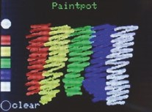
The sketch in Listing 3-5 draws images on the ILI9341 SPI TFT LCD screen when the screen is pressed with a screen pen, with colors selected from a color palette. The first section of the sketch installs libraries and defines the touch screen pins and the paintbrush size. The setup function sets the
touch screen orientation and incorporates the touch screen calibration parameters obtained in Listing 3-4. When a screen press is detected, the touch position is identified; and if the x co-ordinate is less than 20, then the screen was pressed on the color palette and the selected color, mapped to the y co-ordinate, is subsequently used for drawing on the screen. Color codes are available in the file TFT_eSPI.h of the TFT_eSPI library. The clear function resets the screen, displays the title, and redraws the color palette. Have fun painting!
Listing 3-5. Paintpot with TFT-eSPI library
#include <TFT_eSPI.h> // include TFT-eSPI library TFT_eSPI tft = TFT_eSPI(); // associate tft with TFT-eSPI lib
uint16_t calData[] = {450, 3400, 390, 3320, 3};
// calibration parameters
InternatIonal weather statIon
uint16_t x = 0, y = 0;
int radius = 2; // define paintbrush radius unsigned int color;
void setup()
{
tft.init(); // initialise ILI9341 TFT screen tft.setRotation(1); // landscape, connections on right tft.setTouch(calData); // include calibration parameters clear(); // call function to reset screen
}
void loop()
{ if (tft.getTouch(&x, &y)>0) // if screen pressed
{
if(x>20) tft.fillCircle(x, y, radius, color); // draw point if(x>0 && x<20) // select color from color palette
{
if(y>75 && y<95) color = TFT_RED; else if(y>100 && y<120) color = TFT_YELLOW; else if(y>125 && y<145) color = TFT_GREEN; else if(y>150 && y<170) color = TFT_BLUE; else if(y>175 && y<195) color = TFT_WHITE; // display selected color if(y>75 && y<195) tft.fillCircle(10, 50, 10, color); else if(y>215) clear(); // clear screen
}
}
}
void clear() // function to reset screen
{
tft.fillScreen(TFT_BLACK); // fill screen tft.setTextColor(TFT_GREEN); // set text color tft.setTextSize(2); // set text size tft.setCursor(110,5); // position cursor tft.print("Paintpot"); // screen title
tft.fillRect(0,75,20,20, TFT_RED); tft.fillRect(0,100,20,20,TFT_YELLOW);
tft.fillRect(0,125,20,20,TFT_GREEN); // build color palette
tft.fillRect(0,150,20,20, TFT_BLUE); tft.fillRect(0,175,20,20, TFT_WHITE);
tft.drawCircle(10,225,10, TFT_WHITE); // select to clear screen tft.setCursor(25,217); tft.setTextColor(TFT_WHITE); tft.print("clear"); color = TFT_WHITE; }
ESP8266-specific touch screen calibration and paint
The advantage of the TFT-eSPI library is that one library incorporates screen display and touch functionality, with the applicability to both ESP8266 and ESP32 microcontrollers in conjunction with the ILI9341 SPI TFT LCD screen. The Adafruit_ILI9341esp library, adapted specifically for the ESP8266 microcontroller, has an excellent touch screen painting function. The Adafruit_ILI9341esp library by NailBuster Software is contained in the tft28esp.zip file that is downloaded from nailbuster.com/?page_id=341. The Adafruit_ILI9341esp library requires the XPT2046 library by Spiros
Papadimitriou, which is downloaded from github.com/spapadim/XPT2046.
InternatIonal weather statIon
Calibration for the ILI9341 SPI TFT LCD screen with the XPT2046 library differs from calibration with the TFT-eSPI library. In the calibration sketch (see Listing 3-6), two crosses, at 20-pixel margins from the screen edges, are displayed on the ILI9341 SPI TFT LCD screen, which the user presses with a screen pen. Four calibration parameters are then displayed on the ILI9341 SPI TFT LCD screen, that are included in the touch.setCalibration instruction of subsequent sketches.
The getPoints function determines the touched screen position, with the & parameter referencing a pointer to a whole array, rather than a pointer to the first element of the array. A touched position, (p, q), is mapped to a display position, (np, nq), of the 240 × 320–pixel ILI9341 SPI TFT LCD screen. For the screen used in this chapter, the regression equations, np = (150 - p) × 240/145 and nq = (115 - q) × 320/100, were determined from a series of marked positions on the ILI9341 SPI TFT LCD screen and the corresponding touched positions identified by the XPT2046 library.
Listing 3-6. Calibration of the ILI9341 SPI TFT LCD screen for the XPT2046 library
#include <Adafruit_ILI9341esp.h> // include ILI9341esp and #include <XPT2046.h> // XPT2046 libraries int tftCS = D8; int tftDC = D4;
int tftRST = D0; // define screen and touch pins int touchCS = D1;
int touchIRQ = D2; // associate tft with ILI9341 lib Adafruit_ILI9341 tft = Adafruit_ILI9341(tftCS, tftDC, tftRST); XPT2046 touch(touchCS, touchIRQ); // associate touch with XPT2046 uint16_t p,q, np, nq; // co-ordinates of touched point String str;

InternatIonal weather statIon
void setup()
{
tft.begin(); // initialise ILI9341 screen tft.setRotation(0); // portrait connections at bottom touch.begin(tft.height(), tft.width()) ;
// XPT2046 orientated y, x
touch.setRotation(XPT2046::ROT0); // no screen rotation tft.fillScreen(ILI9341_BLACK); // fill screen tft.setTextColor(ILI9341_WHITE); // set text color tft.setTextSize(1); // set text size tft.setCursor(0, 100); // position cursor str = "width: "+String(tft.width())+", height:"
+String(tft.height()); tft.print(str); calibrate(); // calibrate touch screen
}
void calibrate() // function to calibrate screen
{
uint16_t x1,y1,x2,y2,i1,j1,i2,j2; // uint16_t is unsigned integer tft.setCursor(0, 50); // position cursor tft.print("press screen on crosses"); touch.getCalibrationPoints(x1, y1, x 2, y2);
// values pre-set in library at 20
getPoints(x1, y1, i1, j1); // function to get touch position delay(500);
getPoints(x2, y2, i2, j2); // get second touch position touch.setCalibration(i1, j1, i2, j2); // string with parameters str = String(i1)+","+String(j1)+","+String(i2)+","+String(j2); tft.setTextColor(ILI9341_WHITE); tft.setCursor(0, 175);
InternatIonal weather statIon
tft.print("calibration parameters"); tft.setCursor(0, 200);
tft.setTextSize(2); // reset text size tft.print(str); // display calibration parameters
}
void getPoints(uint16_t x, uint16_t y, uint16_t &i, uint16_t &j)
{
marker(y, x, ILI9341_WHITE); // draw white cross on screen while (!touch.isTouching()>0) delay(10); // wait for screen touch touch.getRaw(i, j);
marker(y, x, ILI9341_BLACK); // over-write cross touch.getPosition(p, q); // get position of screen touch np = (150.0-p)*240.0/145.0; // transform from touch to tft nq = (115.0-q)*320.0/100.0;
tft.fillCircle(np, nq, 2, ILI9341_ GREEN);
} // indicated touch position
void marker(unsigned short x, uint16_t y, int col)
{
tft.setTextColor(col); // set marker color tft.drawLine(x-8, y, x+8, y, col); // draw horizontal line tft.drawLine(x, y-8, x, y+8, col); // draw vertical line
}
void loop() // nothing in loop function
{}
The sketch in Listing 3-7 has the same structure as Listing 3-5, which uses the TFT_eSPI library. The differences between the sketches are that screen pins, touch pins, and rotation parameters are defined in the sketch, rather than in an external file with the TFT_eSPI library, and that
InternatIonal weather statIon
colors are referenced to the Adafruit_ILI9341 and TFT_eSPI libraries. The paint function with the XPT2046 library is more responsive than with the TFT-eSPI library, which is more suited for a screen pointer. The sketch in Listing 3-7 operates with any screen rotation position, but either landscape orientation is recommended.
Listing 3-7. Paintpot with the XPT2046 library
#include <Adafruit_ILI9341esp.h> // include ILI9341esp and #include <XPT2046.h> // XPT2046 libraries int tftCS = D8; int tftDC = D4;
int tftRST = D0; // define screen and touch pins int touchCS = D1;
int touchIRQ = D2; // associate tft with ILI9341 lib Adafruit_ILI9341 tft = Adafruit_ILI9341(tftCS, tftDC, tftRST);
XPT2046 touch(touchCS, touchIRQ); // associate touch with XPT2046 String str; uint16_t x, y;
int radius = 2; // define paintbrush radius unsigned int color; // rotation: 0, 1, 2 or 3 refers to int rotate = 1; // rotation of 0, 90, 180 or 270°
void setup()
{
tft.begin(); // initialise ILI9341 screen setRotation(); // function for rotation parameters touch.setCalibration(1850,1800,3 20,300);
// calibration parameters
clear(); // call function to reset screen }
InternatIonal weather statIon
void loop()
{ if (touch.isTouching()>0) // if screen pressed
{
touch.getPosition(x, y);
if(x>20) tft.fillCircle(x, y, radius, color); // draw point if(x>0 && x<20) // select color from color palette
{
if(y>75 && y<95) color = ILI9341_RED; else if(y>100 && y<120) color = ILI9341_YELLOW; else if(y>125 && y<145) color = ILI9341_GREEN; else if(y>150 && y<170) color = ILI9341_BLUE; else if(y>175 && y<195) color = ILI9341_WHITE; // display selected color if(y>75 && y<195) tft.fillCircle(10, 50, 10, color); else if(y>215) clear(); // clear screen
}
}
}
void clear() // function to reset screen
{
tft.fillScreen(ILI9341_BLACK); // fill screen tft.setTextColor(ILI9341_GREEN); // set text color tft.setTextSize(2); // set text size tft.setCursor(110,5); // position cursor tft.print("Paintpot"); // screen title
tft.fillRect(0,75,20,20, ILI9341_RED); tft.fillRect(0,100,20,20,ILI9341_YELLOW);
tft.fillRect(0,125,20,20,ILI9341_GREEN); // build color palette
tft.fillRect(0,150,20,20, ILI9341_BLUE); tft.fillRect(0,175,20,20, ILI9341_WHITE);
InternatIonal weather statIon
tft.drawCircle(10,225,10, ILI9341_WHITE); // select to clear screen tft.setCursor(25,217); tft.setTextColor(ILI9341_WHITE); tft.print("clear"); color = ILI9341_WHITE; }
void setRotation() // function to set rotation parameters
{
tft.setRotation(rotate); switch (rotate)
{
case 0: // no rotation touch.begin(tft.width(), tft.height()); // portrait touch.setRotation(XPT2046::ROT0); // connections at bottom break;
case 1: // rotation through 90° touch.begin(tft.height(), tft.width()); // landscape touch.setRotation(XPT2046::ROT90); // connections on right break;
case 2: // rotation through 180° touch.begin(tft.width(), tft.height()); // portrait touch.setRotation(XPT2046 ::ROT180); // connections at top break;
case 3: // rotation through 270° touch.begin(tft.height(), tft.width()); // landscape touch.setRotation(XPT2046::ROT270); // connections on left break;
}
}
InternatIonal weather statIon
Weather data for several cities
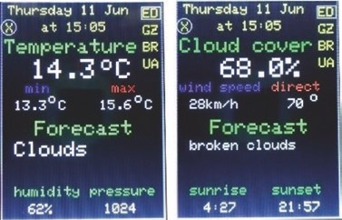
Another example of using the ILI9341 SPI TFT LCD touch screen displays detailed weather information for several cities, with weather data from OpenWeatherMap.org. OpenWeatherMap data is free to access within limits defined on
the website. The OpenWeatherMap data requires a username, a password, an API (Application Programming Interface) key, and the city identity (ID) code. Details on opening an account and obtaining an API key for OpenWeatherMap are available at openweathermap.org/appid. The API key identifies the client to the web server. The city ID is obtained, from the OpenWeatherMap.org website, by entering the city name in the Your city name search box. Select the relevant city, and the city ID is the number at the end of the URL. For example, the Berlin URL is openweathermap.org/city/2950159.
The ESP8266WiFi or WiFi, ArduinoJson, and Time libraries are required for Wi-Fi communication, interpreting JSON (JavaScript Object Notation) formatted data, and calculating the date and time. Both the ArduinoJson library by Benoît Blanchon and the TimeLib library by Michael Margolis are available in the Arduino IDE, with the latter listed under Time. Several data providers format the date and time as the number of seconds since January 1, 1970, the Unix epoch time. The Time library converts the Unix epoch time to the corresponding minute, hour, day, month, and so on.
An example sketch (see Listing 3-8) obtains and displays the ultraviolet (UV) index for Edinburgh from OpenWeatherMap data. If there are problems with the Wi-Fi connection, HTTP request, or data receipt, then a message is displayed. The message instructions are optional and not incorporated in the connect function of Listing 3-9, but the client instructions in bold must be retained. If the instructions
InternatIonal weather statIon
if (!client.find("\r\n\r\n"))
{
Serial.println("Received data not complete"); return; }
regarding a data error are deleted, then they must be replaced with the instruction client.find("\r\n\r\n").
The URL is api.openweathermap.org/data/2.5/uvi?lat=55.95& lon=-3.19&appid="+APIkey which displays the following data:
lat 55.95 // latitude lon - 3.19 // longitude date_iso "2020-06-13T12:00:00Z" // date date 1592049600 // Unix epoch time value 6.94 // UV index
The JSON formatted data consists of the name and value pairs, such as lat and 55.95, that form the JSON document, which is defined as the character array, jsonDoc[], in the sketch. The value of a name and value pair is identified by the name and extracted with the instruction jsonDoc['name'].as<x>(), where x refers to float, long, or char* for a real number, an integer, or a string, respectively. For example, latitude = jsonDoc['lat'].as<float>().
In Listing 3-8, the libraries are installed, a Wi-Fi connection is established, and an HTTP request is sent to the OpenWeatherMap server for the Edinburgh UV index. The latitude, longitude, date, and UV index are extracted from the JSON document, received in response to the HTTP request. A comprehensive set of error checks are made regarding establishing the Wi-Fi connection, the HTTP request, the response to the HTTP request, the receipt of the JSON document in the HTTP response, and the extraction of the JSON document.
InternatIonal weather statIon
Listing 3-8. OpenWeatherMap data example
#include <ESP8266WiFi.h> // library to connect to Wi-Fi network
#include <ArduinoJson.h>
WiFiClient client; // create client to connect to IP address char ssid[] = "xxxx"; // change xxxx to your Wi-Fi SSID char password[] = "xxxx"; // change xxxx to your Wi-Fi password String APIkey = "xxxx"; // and xxx to openweathermap API key char server[]="api.openweathermap.org"; String output;
void setup()
{
Serial.begin(115200); // Serial Monitor baud rate WiFi.begin(ssid, password); // initialise Wi-Fi and wait while (WiFi.status() != WL_CONNECTED) delay(500);
// for Wi- Fi connection Serial.print("IP address: ");
Serial.println(WiFi.localIP()); // Wi-Fi network IP address Serial.println("Connecting...");
client.connect(server, 80); // connect to server on port 80 if (!client.connect(server, 80)) // connection error message
{
Serial.println("Connection failed"); return;
}
Serial.println("Connected!"); client.println("GET /data/2.5/uvi?lat=55.95&lon=-3.19&" "appid="+APIkey+" HTTP/1.1"); // send HTTP request client.println("Host: api.openweathermap.org"); client.println("User-Agent: ESP8266/0.1"); client.println("Connection: close");
InternatIonal weather statIon
client.println(); if (client.println() == 0) // HTTP request error message
{
Serial.println("HTTP request failed"); return;
}
char status[32] = {0}; client.readBytesUntil('\r', status, sizeof(status)); if (strcmp(status, "HTTP/1.1 200 OK") != 0)
{ // HTTP status error message
Serial.print("Response not valid: ");
Serial.println(status); return;
}
else Serial.println("HTTP status OK"); if (!client.find("\r\n\r\n")) // received data error request
{
Serial.println("Received data not complete"); return;
}
// client.find("\r\n\r\n");
DynamicJsonDocument jsonDoc(1024);
DeserializationError error = deserializeJson(jsonDoc, client);
if (error)
{ // JSON error message
Serial.print("deserializeJson() failed: ");
Serial.println(error.c_str()); return;
}
InternatIonal weather statIon
serializeJson(jsonDoc, output); // display all data Serial.print("data length: ");Serial.println(output.length());
Serial.println(output);
Serial.println("extracted text");
Serial.println(jsonDoc["lon"].as<float>(), 2);
// display specific data
Serial.println(jsonDoc["lat"].as<float>(), 2);
Serial.println(jsonDoc["date_iso"].as<char*>());
Serial.println(jsonDoc["date"].as<long>());
Serial.print("UV ");
Serial.println(jsonDoc["value"].as<float>(), 2);
}
void loop() // nothing in loop function
{}
Listing 3-9 displays OpenWeatherMap data for a selected city with weather information displayed on different screens. The first screen displays the current minimum and maximum temperature and the forecasted weather, with the current humidity and pressure. The second screen displays cloud cover, the wind speed and direction, and more details on forecasted weather, with sunrise and sunset times. A city is selected from the city abbreviations on the right of the screen, and the screen displays are alternated by touching the ⊕ symbol on the left of the screen. The sketch is lengthy, due to processing the comprehensive weather data, and is split into functions to make the sketch more readily interpretable. The weather information is reduced by deleting the secondScreen function and the reference to it in the getWeather function.
The first section of the sketch includes the libraries and defines the screen and touch pins, OpenWeatherMap API key, and city identity codes. The first element of the days and mths arrays is a blank, so that days[1] and mths[1] correspond to Sunday and January, respectively. The setup function establishes the Wi-Fi connection, initializes the touch screen,
InternatIonal weather statIon
and incorporates the touch screen calibration parameters obtained in Listing 3-4. The loop function calls the checkTime function to determine if the required time has elapsed since the screen was last refreshed and the selected city. The connect function sends a GET HTTP request to the OpenWeatherMap server, incorporating the API key, and downloads the JSON-formatted data for display on the ILI9341 SPI TFT LCD screen. The JSON-formatted data from OpenWeatherMap is displayed with the following instructions:
String output
serializeJson(jsonDoc, output) Serial.println(output.length())
Serial.println(output)
An example of OpenWeatherMap JSON-formatted data is
{“coord”:{“lon”:-3.2,“lat”:55.95},
“weather”:[{“id”:803,“main”:“Clouds”, “description”:“broken clouds”, “icon”:“04d”}],
“base”:“stations”,
“main”:{ “temp”:14.38,“feels_like”:7.99,“temp_min”:12.78,
“temp_max”:15.56, “pressure”:1024,“humidity”:62},
“visibility”:10000,“wind”:{“speed”:8.2,“deg”:80},“clouds”:{“all”:68},
“dt”:1591882710,
“sys”:{“type”:1,“id”:1442,“country”:“GB”, “sunrise”:1591846048,
“sunset”:1591909066},
“timezone”:3600,“id”:2650225,“name”:“Edinburgh”, “cod”:200}
Values are referenced according to the class outside the curly brackets, {}, the category within the curly brackets, and the variable name, with each term enclosed by square brackets, [ ]. For example, the humidity value of 62 is referenced as [“main”][“humidity”]. The weather class may have
InternatIonal weather statIon
two levels, referenced as [0] and [1]. Times are expressed in Unix epoch time. For example, the sunrise value of 1591846048, referenced as [“sys”] [“sunrise”], is 04:27 GMT on June 11, 2020.
JSON-formatted data is equated to a string, float, or unsigned long, such as
String weather = jsonDoc["weather"][0]["main"] float temp = jsonDoc["main"]["temp"] unsigned long srise = jsonDoc["sys"]["sunrise"]
and displayed with a print instruction, for example, Serial.
println(weather). JSON-formatted data is displayed directly by including the data reference and the output format in the print instruction, for example
Serial.println(jsonDoc["weather"][0]["main"].as<char*>())
Serial.println(jsonDoc["main"]["temp"].as<float>(), 2) // for 2 DP Serial.println(jsonDoc ["sys"]["sunrise"].as<long>())
The structures of the firstScreen and secondScreen functions are the same (see Figure 3-3). The citySquare function clears the screen; displays the list of city abbreviations, using the screen function that positions and displays strings; and draws a rectangle around the selected city abbreviation. The Unix epoch time for the weather update is converted to day, date, and time and displayed on the screen. Weather data is extracted from the JSON document, and the screen function positions and displays the string in the required color. To maintain text positioning, text is padded with blanks using the addb function. To make the functions in Listing 3-9 more readily interpretable, the first part of the instruction screen("variable" is in bold.

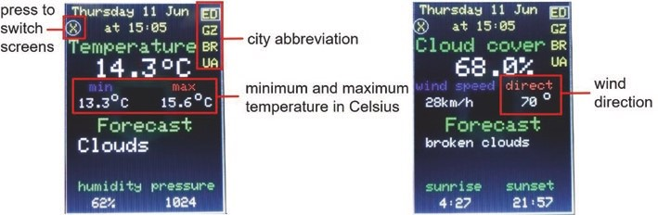
Figure 3-3. OpenWeatherMap information by screen
Listing 3-9. OpenWeatherMap information
#include <ESP8266WiFi.h> // include ESP8266WiFi library
#include <ArduinoJson.h> // include JSON library
#include <TimeLib.h> // include TimeLib library
#include <TFT_eSPI.h> // include TFT_eSPI library TFT_eSPI tft = TFT_eSPI(); // associate tft with TFT-eSPI lib uint16_t calData[] = {450, 34 00, 390, 3320, 3};
// calibration parameters
uint16_t x = 0, y = 0;
WiFiClient client; // create client to connect to IP address char ssid[] = "xxxx"; // change xxxx to your Wi-Fi SSID char password[] = "xxxx"; // change xxxx to your Wi-Fi password String APIkey = "xxxx"; // change xxxx to weathermap API key
String city[] = {"ED", "GZ","BR","UA"};
// Edinburgh, Günzburg, Brisbane, Ushuaia // openweathermap city identity codes String cityID[] = {"2650225","2913555","2174003","3833367"};
int Ncity = 4; // number of cities int cityNow = 0; // current city, initially set at 0 int count = 99; // run getWeather function at start char server[] = "api.openweathermap.org";
int screenFlag = 0; // flag for first or second screen int touchFlag = 0; // to indicate screen pressed
String days[] = {"",
"Sunday","Monday","Tuesday","Wednesday","Thursday","Friday",
"Saturday"};
String mths[] = {"",
"Jan","Feb","Mar","Apr","May","Jun","Jul","Aug","Sep","Oct",
"Nov","Dec"};
String wkdy, mth, addb, text;
int sunriseh, sunrisem, sunseth, sunsetm, dy, hr, mn; unsigned int chkTime;
DynamicJsonDocument jsonDoc(1024); // JSON formatted data
void setup()
{
WiFi.begin(ssid, password); // initialise Wi-Fi and wait while (WiFi.status() != WL_CONNECTED) delay(500); // for WiFi connection tft.init(); // initialise screen for graphics tft.setTouch(calData); // calibration parameters tft.setRotation(2); // portrait, connections on top tft.fillScreen(TFT_BLACK); // fill screen in black tft.drawRect(0,0,239,319,TFT_WHITE); // draw white frame line tft.drawRect(1,1,237,317,TFT_WHITE); // and second frame
}
void loop()
{
checkTime(); // check if time to refresh screen
if(tft.getTouch(&x, &y)>0 && touch Flag == 0)
// if screen pressed
{
touchFlag = 1; if(y > 290) // city to be selected
{
screenFlag = 0; // start with first screen
if(x > 215) cityNow = 0; else if(x > 195 && x<216) cityNow = 1;
else if(x > 175 && x<196) cityNow = 2; // select city else if(x > 155 && x<176) cityNow = 3;
}
if(y < 20) screenFlag = 1-screenFlag; // change screen count = 99; // run getWeather function immediately
}
}
void checkTime() // check for screen refresh
{ if(count > 4) // update screen every 5 minutes
{
getWeather(); // call weather report function count = 0; // reset counter
} else if(millis()-chkTime>60000) // increment counter after 60s
{
chkTime = millis(); // reset timer count++; // increment counter
}
}
void getWeather() // function to get weather data
{
connect(); // call Wi- Fi connection function if(screenFlag == 0) firstScreen(); // select screen to be displayed else secondScreen(); touchFlag = 0; // reset touch indicator
}
void connect() // function for Wi-Fi connection
{
client.connect(server, 80); // connect to server on port 80 client.println("GET /data/2.5/weather?id="+cityID[cityNow]+ "&units=metric&appid="+APIkey+" HTTP/1.1"); // send HTTP
// request
client.println("Host: api.openweathermap.org"); client.println("User-Agent: ESP8266/0.1"); client.println("Connection: close"); client.println(); client.find("\r\n\r\n"); // essential instruction
DeserializationError error = deserializeJson(jsonDoc, client);
}
void firstScreen() // weather data for first screen
{ citySquare(); // call function to display header
String weather = jsonDoc["weather"][0]["main"];
String weather2 = jsonDoc["weather"][1]["main"];
String id1 = jsonDoc["weather"][1]["id"]; float temp = jsonDoc["main"]["temp"];
float pres = jsonDoc["main"] ["pressure"];
// convert JavaScript objects
float humid = jsonDoc["main" ]["humidity"];
// to strings or real numbers
float tempMin = jsonDoc["main"]["temp_min"]; float tempMax = jsonDoc["main"]["temp_max"]; if(id1.length()<1) weather2 = " "; screen("Temperature",TFT_GREEN,5, 55,3);
// display weather variable name
text = String(temp,1); // convert value to string if(temp<9.95) text = " "+text; // add space if less than 10 screen(text,TFT_WHITE,45,85,4); // display string on screen screen("o", TFT_WHITE,148,80,3); // add °symbol screen("C", TFT_WHITE,170,85,4); // add C for Celsius screen("min",TFT_BLUE,37,120,2); // minimum temperature text = String(tempMin,1); if(tempMin<10) text = " "+text; screen(text,TFT_WHITE,20,145,2); screen("o",TFT_WHITE,70,135,2); screen("C",TFT_WHITE,85,145,2);
screen("max",TFT_RED,163,120,2); // maximum temperature text = String(tempMax,1); if(tempMax<10) text = " "+text; screen(text,TFT_WHITE,145,145,2); screen("o",TFT_WHITE,197,135,2); screen("C",TFT_WHITE,212,145,2);
screen("Forecast",TFT_GREEN,50,175,3); // forecast weather addb = blank(weather); // add spaces after text weather=weather+addb; screen(weather,TFT_WHITE,20,205,3); if(weather2 == "null") weather2=""; addb = blank(weather2); weather2=weather2+addb;
screen(weather2,TFT_WHITE,20,235,3); // forecast weather detail
screen("humidity",TFT_GREEN,20,270,2); // humidity text = String(humid,0)+"% "; screen(text,TFT_WHITE,40,295,2);
screen("pressure",TFT_GREEN,130,270,2); // pressure text = String(pres,0);
if(pres<1000) text = " "+text; screen(text,TFT_WHITE,150,295,2); }
void secondScreen() // weather data for second screen
{ citySquare(); // call function to display header
String desc = jsonDoc["weather"][0]["description"];
String desc2 = jsonDoc["weather"][1]["description"];
String id1 = jsonDoc["weath er"][1]["i d"];
// convert JavaScript objects
float windspd = jsonDoc["wi nd"]["spee d"];
// to strings or real numbers
float winddeg = jsonDoc["wind"]["deg"]; float cloud = jsonDoc["clouds"]["all"]; unsigned long srise = jsonDoc["sys"]["sunrise"]; unsigned long sset = jsonDoc["sys"]["sunset"]; if(id1.length()<1) desc2 = " ";
screen("Cloud cover",TFT_GREEN,5,55,3); // cloud cover text = String(cloud,1)+"%"; screen(text,TFT_WHITE,65,85,4);
screen("wind speed",TFT_BLUE,5,120,2); // wind speed windspd = windspd*3.6; // convert m/s to km/h text = String(windspd,0)+"km/h"; screen(text,TFT_WHITE,20,145,2);
screen("direct",TFT_RED,140,120,2); // wind direction text = String(winddeg,0); if(winddeg<10) text = " "+text; if(winddeg<100) text = " "+text; screen(text,TFT_WHITE,152,145,2); screen("o",TFT_WHITE,197,135,2);
screen("Forecast",TFT_GREEN,50,175,3); // weather forecast (2) addb = blank(desc); desc=desc+addb; if(desc.length()<13) screen(desc,TFT_WHITE,20,205,3); else screen(desc,TFT_WHITE,20, 205,2);
// font size depends on text length
if(desc2 == "null") desc2=""; addb = blank(desc2); desc2=desc2+addb; if(desc.length()<13 && desc2.length()<13) screen(desc2,TFT_WHITE,5,235,3); else screen(desc2,TFT_WHITE,5,235,2);
screen("sunrise",TFT_GREEN,20,270,2); // sunrise time text = String(minute(srise)); if(minute(srise)<10) text = "0"+text; text = String(hour(srise)+1)+":"+text; screen(text,TFT_WHITE,40,295,2);
screen("sunset",TFT_GREEN,140,270,2); // sunset time text = String(minute(sset)); if(minute(sset)<10) text = "0"+text; text = String(hour(sset)+1)+":"+text; screen(text,TFT_WHITE,150,295,2); }
void citySquare() // display header and city abbreviations
{
tft.fillRect(2,2,235,315,TFT_BLACK );
// clear screen apart from frame
// display city abbreviations
for (int i=0; i<Ncity; i++) screen(city[i],
TFT_YELLOW,210,10+i*25,2);
f or (int i=0; i<Ncity; i++) tft.drawRect(208,8+i*25,29,19, TFT_BLACK);
// draw rectangle for selected city
tft.drawRect(208,8+cityNow*25,29,19,TFT_WHITE); screen("X",TFT_YELLOW,7,31,2); // draw X with circle
tft.drawCircle(11,37,11,TFT_WHITE);
unsigned long stime = jsonDoc["dt"]; // t ime in secs since 1 Jan 1970 hr = hour(stime)+1; mn = minute(stime);
dy = day(stime); // convert time wkdy = days[weekday(stime)]; mth = mths[month(stime)];
text = wkdy+" "+String(dy)+" "+mth; // display day, date and time screen(text,TFT_YELLOW,10,5,2); text = "at "+String(hr)+":"+String(mn); if(mn<10) text = "at "+String(hr)+":0"+String(mn); screen(text,TFT_YELLOW,60,30,2);
}
// function to position and display strings void screen(String text, unsigned int color, int x, int y, int size)
{
tft.setCursor(x, y); // position cursor tft.setTextColor(color,TFT_BLACK); // background color: black tft.setTextSize(size); tft.print(text);
}
String blank(String txt) // function to add spaces to text
{
String addb = "";
int len = 12-txt.length(); // add up to 11 spaces for (int i=0;i<len;i++) addb=addb+" "; return addb; }
Summary
The Wi-Fi functionality of the ESP8266 and ESP32 microcontrollers enabled Internet access to weather data from OpenWeatherMap. The ILI9341 SPI TFT LCD touch screen function enabled a city to be selected from the touch screen menu. The JSON-formatted weather data was extracted and displayed on the ILI9341 SPI TFT LCD screen. Use of the TFT-eSPI and XPT2046 libraries illustrated two screen calibration processes and differences in ILI9341 SPI TFT LCD touch screen function applied to a screen painting example.
Components List
- ESP8266 microcontroller: LOLIN (WeMos) D1 mini or NodeMCU board
- ESP32 microcontroller: DEVKIT DOIT or NodeMCU board
- SPI TFT LCD touch screen: ILI9341, 2.4 inches, 240 × 320 pixels

CHAPTER 4
Internet clock
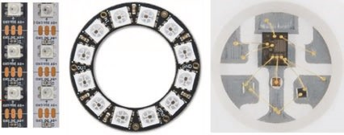
Each LED (Light- Emitting
Diode) in an RGB (Red Green Blue) LED strip or ring is individually addressed using only one microcontroller pin for
all the LEDs in the strip or ring. The term WS2812 5050 RGB LED refers to a strip or ring consisting of RGB LEDs with a WS2812 controller chip incorporated in each LED, and 5050 refers to the LED dimensions of 5.0 × 5.0 mm. NeoPixel is the Adafruit brand name for individually addressable RGB LEDs.
The Adafruit NeoPixel library is applicable to WS2812 RGB LED strips and rings as well as NeoPixel products. The number of RGB LEDs in the strip or ring, LEDnumber, and the microcontroller pin, LEDpin, are defined with the instruction
Adafruit_NeoPixel strip(LEDnumber, LEDpin, NEO_GRB + NEO_KHZ800)
which associates strip with the Adafruit NeoPixel library, as the WS2812 RGB LED strips and rings are wired for a GRB (Green Red Blue) 800 kHz bit stream. Alternatively, the NEO_RGB + NEO_KHZ800 settings may be required. RGB LED display instructions are followed with the show() instruction to activate display instructions.
© Neil Cameron 2021 85
N. Cameron, Electronics Projects with the ESP8266 and ESP32, https://doi.org/10.1007/978-1-4842-6336-5_4
Internet CloCk
The RGB LED brightness is defined in the setup function, but not in the loop function, by the brightness(N) instruction with the parameter between 1 and 255, for low to full brightness. The instruction unsigned long col = strip.Color(R, G, B) converts the three 8-bit red (R), green (G), and blue (B) components of a color into a 32-bit number, as required by the Adafruit NeoPixel library with RGB values for each color stored in arrays. The RGB color is calculated as 16⁴R + 16²G + B, with the instruction pow(16,4)*R + pow(16,2)*G + B. The RGB LEDs in a strip or ring are numbered from zero, and the instruction strip.setPixelColor(n, col) sets the color of the (n + 1)^{th} RGB LED. The color of number sequential RGB LEDs is set with the instruction strip.fill(col, n, number), starting at the (n + 1)^{th} RGB LED. If the number of LEDs is not included in the fill instruction, then all RGB LEDs from the (n + 1)^{th} RGB LED to the end of the strip or ring are set. Likewise, if the starting RGB LED is omitted, then the whole strip or ring is set. The instruction strip.clear() turns off all RGB LEDs in a strip or ring.
An RGB LED uses up to 60 mA with all three LEDs at full brightness. When an ESP8266 development board is powered by USB, the 5V pin supplies 400 mA, so an absolute maximum of six RGB LEDs at full brightness are powered by the ESP8266 development board 5V pin. An RGB LED strip should be powered by an external 5V, as shown in Figure 4- 1 with connections in Table 4-1. To protect the RGB LEDs from a current surge, when the power supply is switched on, a 100 μF capacitor is fitted across the power supply 5V and GND pins. Fitting a 470 Ω resistor between the data in pin of the RGB LED strip or ring and the ESP8266 development board data pin prevents voltage spikes on the data line that could damage the first RGB LED on the strip or ring. Connections to the RGB LED strip should be checked with a multimeter continuity function, as the data and GND wires may be green and white, respectively.
Internet CloCk
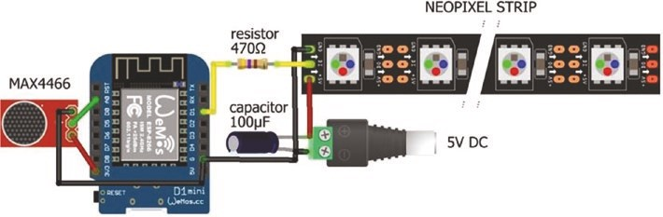
Figure 4-1. WS2812 RGB LED strip and microphone
Table 4-1. WS2812 RGB LED strip and MAX4466 microphone with the ESP8266 development board
Component | Connect to | And to | And to
leD strip VCC | external power 5V |  | 100 μF capacitor positive
leD strip GnD | external power GnD | eSp8266 GnD | 100 μF capacitor negative
leD strip DI (data in) | 470 Ω resistor | eSp8266 D1
MaX4466 VCC | eSp8266 3V3
MaX4466 oUt | eSp8266 a0
MaX4466 GnD | eSp8266 GnD
The only change to Listing 4-1 for an ESP32 microcontroller, rather than an ESP8266 microcontroller, is the definition of the ESP32 development board data pin int LEDpin = x.
The sketch in Listing 4-1 demonstrates sweeping colors along a RGB LED strip.
Internet CloCk
Listing 4-1. Sweeping colors along an RGB LED strip
#include <Adafruit_NeoPixel.h> // include Adafruit NeoPixel library int LEDpin = D1; // define data pin int LEDnumber = 30; // number of LEDS in strip
// associate strip with NeoPixel library
Adafruit_NeoPixel strip(LEDnumber, LEDpin, NEO_GRB + NEO_KHZ800);
// color white, red, lime, blue, yellow, cyan, magenta, // grey, maroon, olive, green, purple, teal, navy
int R[ ] = {255,255, 0, 0,255, 0,255,128,128,128, 0,128, 0, 0}; int G[ ] = {255, 0,255, 0,255,255, 0,128, 0,128,128, 0,128, 0}; int B[ ] = {255, 0, 0,255, 0,255,255,128, 0, 0, 0,128,128,128}; uint32_t color; // color is 32-bit or unsigned long
void setup()
{
strip.begin(); // initialise LED strip strip.setBrightness(10); // define LED brightness (1 to 255) strip.show(); // sets all pixels to “off” as no color set
}
void loop()
{ for (int i=0; i<14; i++) // cycle through the RGB colors { // convert RGB values to 32-bit number
color = strip.Color(R[i],G[i],B[i]); sweep(color, 40); // sweep color through the LED strip
} rainbow(3, 10); // rainbow colors for three cycles } // with a 10ms time lag for each color
Internet CloCk
void sweep(uint32_t color, int lag) // color sweep function
{ for (int i=0; i<strip.numPixels(); i++) // for each LED in strip
{ strip.setPixelColor(i, color); // set the LED color
// strip.setPixelColor
// (strip.numPixels()-i-1, color); // reverse direction strip.show(); // update LED strip
delay(lag); // time lag between color changes
}
}
void rainbow(int cycle, int lag)
{ // from Adafruit NeoPixel>strandtest for (long Pixel1Hue = 0; Pixel1Hue < cycle*65536; Pixel1Hue += 256)
{
for (int i=0; i<strip.numPixels(); i++)
{
int pixelHue = Pixel1Hue + (i * 65536L / strip.numPixels()); strip.setPixelColor(i, strip.gamma32(strip.ColorHSV(pixelHue)));
}
strip.show(); // update LED states and colors delay(lag);
}
}
Internet CloCk
WS2812 RGB LEDs responsive to sound
Controlling the WS2812 RGB LED strip with a MAX4466 electret microphone amplifier module produces a light display responsive to sounds, such as speech or music. The sound level detected by the microphone determines the number of WS2812 RGB LEDs to turn on with the LED color dependent on the sound level (see Figure 4-1). The MAX4466 electret microphone amplifier module is powered with 3.3 V and not 5 V. Sound or peak-to-peak values for the MAX4466 electret microphone amplifier module are defined as the difference between the maximum and minimum sound values recorded during the sample time.
The MAX4466 electret microphone amplifier module, used in this chapter, detected noise, particularly when the sketch included instructions to control the RGB LED strip. On the left side of Figure 4-2, there was minimal sound for the MAX4466 electret microphone amplifier module to detect, while the right side of Figure 4-2 reflected music being played. In both cases, the noise was obvious, and a median filter excluded the noise values from the sound sample. The median filter selects the median value of a sample in contrast to a circular buffer, which selects the mean value of a sample. For example, if three sample sequences with five values per sample are 3, 4, 5, 6, 80; 4, 5, 6, 80, 7; and 5, 6, 80, 7, 8, then the three median values are 5, 6, and 7, respectively. Median filtering may lag behind the actual sample sequence, but extreme values are excluded. Figure 4-2 illustrates that median filtering effectively removed the noise, both at low and medium sound volumes. Median filtering is used in Listing 4-2, with the RunningMedian library by Rob Tillaart, which is available within the Arduino IDE.
Internet CloCk
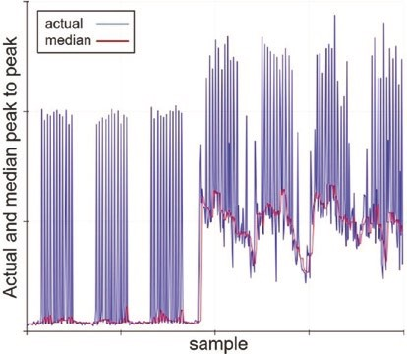
Figure 4-2. Median filter of peak-to-peak values
For the sketch in Listing 4-2, the MAX4466 electret microphone amplifier module samples sound over a 50 ms time period, corresponding to a sampling frequency of 20 Hz, to determine the number of RGB LEDs to turn on. A median filter with sample size of seven removed noise. The sensitivity of the electret microphone is adjusted with the adjustVol variable, to increase or decrease the number of RGB LEDs to turn on. Changing the sensitivity results in a number of RGB LEDs being permanently turned on, which is adjusted to zero with the baseline variable. The adjustVol and baseline variables are entered on the Serial Monitor with the Serial buffer string converted to two integers by the parseInt() instruction. For a strip containing 30 RGB LEDs, seven colors were selected with four RGB LEDs for each color. The RGB values for each color are stored in arrays with the RGB LED color set by the instructions strip.color() and strip.setPixelColor().
In Listing 4-2, the ESP32 development board data and analog input pins are defined, by updating the instructions int LEDpin = D1 and sound = analogRead(A0). The ESP32 microcontroller has a 12-bit ADC (analog to digital converter), in contrast to the 10-bit ADC of the ESP8266
Internet CloCk
microcontroller. For the ESP32 microcontroller, the instructions soundMin = 1024 and peak2peak = soundMax - soundMin are changed to soundMin = 4096 and peak2peak = (soundMax - soundMin)/4.
The noise experienced with the ESP8266 microcontroller was not evident with the ESP32 microcontroller, so median filtering was not required. The number of LEDs to turn on or off was determined directly from the peak2peak variable with the instruction LEDs = adjustVol*(pea k2peak/1024.0)*LEDnumber-baseline.
Listing 4-2. RGB LED strip and sound
#include <Adafruit_NeoPixel.h> // include Adafruit NeoPixel lib int LEDpin = D1; // define data pin int LEDnumber = 30; // number of LEDS in strip // associate strip with NeoPixel lib
Adafruit_NeoPixel strip(LEDnumber, LEDpin, NEO_GRB + NEO_KHZ800);
// colors red, orange, yellow, green, blue, indigo, violet int R[ ] = {255, 255, 255, 0, 0, 75, 238}; int G[ ] = { 0, 102, 153, 255, 0, 0, 130}; int B[ ] = { 0, 0, 0, 0, 255, 130, 238}; uint32_t color; // color is 32- bit or unsigned long
#include <RunningMedian.h> // include Running Median lib
RunningMedian samples = RunningM edian(7);
// median filter sample size of 7
int sound, soundMax, soundMin, peak2peak, median, LEDs, val; int adjustVol = 1; // initial volume and baseline int baseline = 0;
int soundTime = 50; // sample sound time (ms) unsigned long startTime; void setup()
{
Serial.begin(115200); // Serial Monitor baud rate
Serial.println("\nenter volume adjustment , baseline");
Internet CloCk
strip.begin(); // initialise LED strip strip.setBrightness(10); // define LED brightness (1 - 255) strip.show(); // sets all pixels to "off" as no color set
}
void loop()
{ while(Serial.available()>0) // adjust volume and baseline
{
adjustVol = Serial.parseInt(); // convert Serial buffer to integers baseline = Serial.parseInt();
Serial.print("\nVolume ");Serial.print(adjustVol);
Serial.print("\tBaseline ");Serial.println(baseline); } // get new peak to peak value getSound(); // number of LEDs to turn on LEDs = adjustVol*(median/1024.0)*LEDnumber-baseline; strip.clear(); // turn all LEDs off delay(10); // allow time to switch off LEDs for (int i=0; i<LEDs; i++)
{
val = i/4; // four LEDs have the same color color = strip.Color(R[val], G[val],B[val]);
// convert RGB values to color
strip.setPixelColor(i, color); // set the LED color
} strip.show(); // update LED states and colors
}
void getSound() // function for peak to peak value
{
soundMax = 0; // initial values for minimum and soundMin = 1024; // maximum sound values startTime = millis(); // start of sampling period
Internet CloCk
while(millis() - startTime < soun dTime)
// during sampling period { // determine minimum and sound = analogRead(A0); // maximum sound values if(sound > soundMax) soundMax = sound; else if(sound < soundMin) soundMin = sound;
}
peak2peak = soundMax - soundMin; // peak to peak value samples.add(peak2peak); median = samples.getMedian(); // median peak to peak value
}
For a portable RGB LED strip display, values of the adjustVol and baseline variables are determined by the output voltage from two potentiometers, instead of entering the adjustVol and baseline variables on the Serial Monitor. The ESP32 microcontroller has several analog input pins, but the ESP8266 microcontroller has only one analog input pin, which is resolved by connecting a multiplexer.
ESP8266 and multiplexer
The ESP8266 microcontroller has one analog pin, which limits the number of analog input devices simultaneously connected to the ESP8266 development board. The 74HC4051 eight-channel analog multiplexer enables connection, to the ESP8266 development board, of up to eight analog input devices. Signals from analog input devices are routed through the multiplexer output channel, which is managed by three switch pins on the multiplexer, and the switch pin states are controlled by the ESP8266 microcontroller. Three switch pins are required to manage eight channels, as 8 = 2³.
Internet CloCk
The 74HC4051 multiplexer pins are numbered 1–16, with the cut-out or dot at the end of the multiplexer indicating the end with pins 1 and 16. Connections to the 74HC4051 multiplexer are shown in Table 4-2, with the over-line on E (input enabled) indicating that the pin is active LOW. The 5V pin of the ESP8266 development board powers the 74HC4051 multiplexer, which has an operating voltage of 2–10 V. Voltage of the input channel signals is between VCC and VEE, with the latter connected to GND. Analog input devices connected to the 74HC4051 multiplexer cannot be powered at 5 V, as the ESP8266 microcontroller pins are not 5 V tolerant. In Figure 4-3, the potentiometers are supplied by the 3.3V output pin of the ESP8266 microcontroller, so the maximum voltage on the microcontroller analog input pin will also be 3.3 V.
Table 4-2. 74HC4051 multiplexer and ESP8266 development board
Component | Connect to
74hC4051 pin 3 output | eSp8266 a0
74hC4051 pin 6 e (input enable)  74hC4051 pin 7 Vee | eSp8266 GnD
74hC4051 pin 8 GnD | eSp8266 GnD
74hC4051 pin 9 switch S2 | eSp8266 D2
74hC4051 pin 10 switch S1 | eSp8266 D1
74hC4051 pin 11 switch S0 | eSp8266 D0
74hC4051 pin 16 VCC | eSp8266 5V
potentiometer left pin | eSp8266 GnD
potentiometer signal pins | 74hC4051 pins 13, 14, 15
potentiometer right pin | eSp8266 3V3

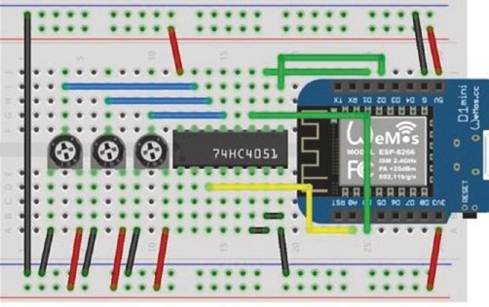
Figure 4-3. 74HC4051 multiplexer and LOLIN (WeMos) D1 mini
The three switch pins, 13, 14, and 15, of the multiplexer enable signals of up to eight analog input devices to be routed through the multiplexer output channel. If only two input devices are connected to the multiplexer, then switch pins 14 and 15 are connected to GND. Similarly, if at most four input devices are connected to the multiplexer, then switch pin 15 is connected to GND. Noise on multiplexer input channels that are not connected to an analog input device is significantly reduced by a delay of 10 ms between setting the multiplexer switch pins and reading the multiplexer output channel. If the 10 ms delay is not included in the sketch, then the multiplexer VEE pin must be connected to GND, but there will still be substantial noise.
A multiplexer input channel is routed to the multiplexer output channel, when the switch settings equal the binary representation of the multiplexer input channel number. For example, an analog input signal on multiplexer input channel 3 is output by the multiplexer with switch settings of 011. Multiplexer input channels 0–7 correspond to multiplexer pins 13, 14, 15, 12, 1, 5, 2, and 4, respectively.
Connection of three potentiometers to an ESP8266 development board demonstrates use of the 74HC4051 multiplexer (see Figure 4-3). The sketch in Listing 4-3 sets the multiplexer switch pin states to the corresponding
Internet CloCk
binary representation of the multiplexer input channel for routing to the multiplexer output channel. The bitRead(number, j) instruction reads the j^{th} bit of number, starting with the least significant bit (LSB), which is bit zero. A bit value of one corresponds to a HIGH pin state. The 74HC4051 multiplexer enables the three potentiometer analog values to be read "simultaneously" by the ESP8266 microcontroller.
Listing 4-3. 74HC4051 multiplexer and ESP8266 development board
int Spin[] = {D0, D1, D2}; // multiplexer S0, S1 and S2
// switch pins void setup()
{
Serial.begin(115200); // Serial Monitor baud rate for (int i=0; i<3; i++)
{
pinMode(Spin[i], OUTPUT); // multiplexer pins as OUTPUT digitalWrite(Spin[i], LOW); // set multiplexer pins to LOW
}
}
void loop()
{ for (int i=0; i<8; i++) // 8 multiplexer pin combinations { // set pins from bit sequence for (int j=0; j<3; j++) digitalWrite(Spin[j], bitRead(i, j)); delay(10); // display readings Serial.print(analogRead(A0));S erial.print("\t"); for (int j=0; j<3; j++) digitalWrite(Spin[j], LOW);
} // reset pins
Serial.println();
delay(1000); // delay between readings
}
For mobile control of the sound-based RGB LED strip display, values of the adjustVol and baseline variables are determined by the output voltages from two potentiometers. The MAX4466 electret microphone amplifier module and potentiometers are accessible to the ESP8266 microcontroller, by connecting the analog devices to a 74HC4051 multiplexer (see Figure 4- 4). Instead of entering the adjustVol and baseline variables on the Serial Monitor, as in Listing 4-2, the potentiometer output voltages control the sound-based RGB LED strip display. For example, the adjustVol potentiometer connected to multiplexer pin 13, which is multiplexer input channel 0, is read with the
instructions
for (int j=0; j<3; j++) digitalWrite(Spin[j], bitRead(0, j)) adjustVol = analogRead(A0)/50
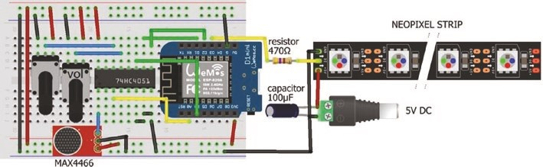
Figure 4-4. Mobile control of RGB LED strip display with potentiometers and microphone
The adjustVol potentiometer will result in adjustVol values between 0 and 20. Similarly, baseline values are obtained from the baseline potentiometer connected to multiplexer pin 14, which is input channel 1.
Internet CloCk
LED rings clock
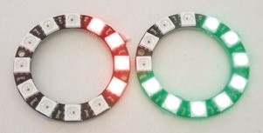
Two 12–RGB LED rings display the hours and minutes on a clock, for example, at 16:40, with the clock turning on another LED every five minutes. When the hour changes, a Piezo transducer makes a
phone ringtone of two rings, and a rainbow display is shown on the minute RGB LED ring. The colors of the hour and minute RGB LED rings alternate each hour. The RGB LED rings clock is powered from the ESP8266 development board 5V pin and includes a 100 μF capacitor and 470 Ω resistor as recommended (see Figure 4-5 with connections in Table 4-3).
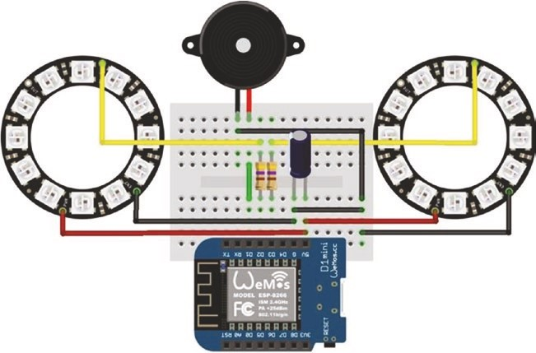
Figure 4-5. LED rings clock
Table 4-3. LED rings clock
Component | Connect to | And to
leD ring VCC | eSp8266 5V | 100 μF capacitor positive
leD ring GnD | eSp8266 GnD | 100 μF capacitor negative
leD ring In | 470 Ω resistor | eSp8266 D2, D3
piezo transducer VCC | eSp8266 D1
piezo transducer GnD | eSp8266 GnD
If the red, green, and blue LEDs are turned on at brightness level of 1, 40, or 100, with a scale of 1–255, then the current usage of a 12–RGB LED ring is 15, 75, or 160 mA, respectively, so two 12–RGB LED rings with maximum brightness of 100 are safely powered by the ESP8266 development board 5V pin.
The sketch in Listing 4-4 calculates the number of hour and minute LEDs to turn on based on the time that is initially set with the Unix epoch time, which is the number of seconds since January 1, 1970. The Unix epoch time is obtained from www.epochconverter.com with the GMT option, if required, and 15 s should be allowed for the sketch to compile and upload. For example, the Unix epoch time corresponding to May 31, 2020, 17:20:51 GMT was 1590945651s. The Time library by Michael Margolis calculates the number of hours and minutes, based on the elapsed Unix epoch time, with the library hour and minute functions. The number of RGB LEDs to turn on to display hours and minutes is the remainder when the Time library hours is divided by 12, as the clock is not a 24-hour clock, and the Time library minutes divided by 5, as the clock turns on another LED every five minutes. An arbitrary delay of 22 s is included after the minute LEDs are updated, as the hour display takes 13 s to complete, so up to 35 s elapses before the Time library hours and
Internet CloCk
minutes are updated. The display variable prevents the hour display being repeated during the five-minute period after the hour.
The first section of Listing 4-4 sets the Unix epoch time, includes the libraries, and defines the RGB LED ring pins. Two instances of the Adafruit NeoPixel library are required, one for each of the two RGB LED rings. The setup function calls the Time library function setTime to convert the Unix epoch time to hours and minutes and the getTime function to convert hours and minutes to the number of RGB LEDs to turn on, with the LEDhours and LEDminutes functions. Note that instructions for the RGB LED rings are activated by the show() instruction. In the loop function, the getTime function is called; and on the hour, the phonering function is called with the playTone function generating the phone ringtone. A ringtone consists of a 400 ms pulse, a 200 ms pause, a 400 ms pulse, and a two-second pause, with a pulse generated by five cycles of a square wave, with the frequency alternating between 300 Hz for 40 ms and 350 Hz for 40 ms. The Adafruit rainbow function displays a variety of colors for two cycles on the minute RGB LED ring.
In the playTone function, the analogWriteFreq() instruction has a default PWM (pulse with modulation) frequency of 1 kHz, which is altered by defining the required frequency as the function parameter. The 50% duty cycle of the square wave, used to generate sound, is obtained by setting the variable value in the instruction analogWrite(pin, value) to 512, which is half of 1023 or 2¹⁰-1, as the ESP8266 microcontroller digital to analog converter has 10-bit resolution.
Listing 4-4. LED rings clock
#include <TimeLib.h> // include Time library unsigned long pctime = 1590945651; // set Unix epoch time #include <Adafruit_NeoPixel.h> // include NeoPixel library int LEDpinM = D3; // ring to display minutes int LEDpinH = D2; // ring to display hours

Internet CloCk
int piezoPin = D1; // Piezo transducer pin int LEDnumber = 12; // number of LEDs on ring unsigned long interval = 1000; // one sec time interval int color = 0; // color flag for hour LED ring int display = 0; // indicator hour display completed String text; int minutes, hours;
// associate ringM and ringH with Neopixel library
Adafruit_NeoPixel ringM(LEDnumber, LEDpinM, NEO_GRB + NEO_KHZ800); Adafruit_NeoPixel ringH(LEDnumber, LEDpinH, NEO_GRB + NEO_KHZ800); void setup()
{
setTime(pctime); // set time to Unix epoch time getTime(); // get time parameters ringH.begin(); // initialise hours LED ring ringH.setBrightness(1); // set LED brightness (1 to 255) LEDhours(); // function to display hours ringH.show(); // update hours LED ring ringM.begin(); ringM.setBrightness(1);
LEDminutes(); ringM.show(); // update minutes LED ring
}
void loop()
{
getTime(); // calculate hours and minutes if(minutes == 0 && display ==0) // on the hour, run the display
{
display = 1; // flag to prevent repeat hour display phonering(); // sound of phone ringtones rainbow(); // rainbow of LED colors ringM.clear(); // clear minutes LED ring
Internet CloCk
ringM.show();
color = 1 - color; // change color flag
ringH.clear(); ringH.show();
LEDhours(); // update hours LED ring
}
if(minutes > 0) LEDminutes(); // update minutes LEDs for(int i=0; i<22; i++) delay(interval); // 22s delay
}
void getTime() // function to calculate hours and minutes
{
hours = hour() % 12; // convert 24hr time to 12hr time minutes= int(minute()/5); // number of 5min intervals if(minutes > 0 ) display = 0; // reset hour display flag
}
void LEDminutes() // function to turn on minute LEDs
{
for(int i=0; i<minutes; i++)
{ // set LED RGB values ringM.setPixelColor(i, ringM.Color(255*color, 255*(1-color), 0));
}
ringM.show(); }
void LEDhours() // function to turn on hour LEDs
{
for(int i=0; i<hours; i++)
{
ringH.setPixelColor(i, ringH.Color(255*(1-color), 255*color, 0));
}
Internet CloCk
ringH.show(); }
void rainbow() // Adafruit rainbow function
{
int cycle = 2; // two cycles of colors
for(long Pixel1Hue=0; Pixel1Hue<cycle*65536; Pixel1Hue += 256)
{
for(int i=0; i<ringM.numPixels(); i++) { int pixelHue = Pixel1Hue + (i * 65536L / ringM. numPixels());
ringM.setPixelColor(i, ringM.gamma32(ringM. ColorHSV(pixelHue)));
} ringM.show(); delay(10);
}
}
void phonering() // function for phone ringtone
{ for(int k=0; k<2; k++) // two cycles
{ for(int j=0; j<2; j++) // of two rings
{ for(int i=0; i<5; i++) // with five repeats
{
playTone(300, 40); // frequency 300Hz for 40ms playTone(350, 40); // frequency 350Hz for 40ms }
Internet CloCk
delay(200); // 200ms delay between rings
}
delay(2000); // 2s delay between cycles
}
}
void playTone(int freq, int duration)
{
analogWriteFreq(freq); // frequency and duty cycle analogWrite(piezoPin, 512); // to generate square wave delay(duration); // for duration (ms) analogWrite(piezoPin, 0); // disable PWM on pin }
Network Time Protocol
Using the internal ESP8266 or ESP32 microcontroller clock to measure time is convenient, but the internal clock is not consistently accurate, with drifting over time and the extent of the drift depending on the individual chip and the ambient temperature. The internal microcontroller clock is updated with the Network Time Protocol (NTP) service, arbitrarily at 08:30 and 20:30, with the time information obtained from a local server pool. Details of server pools are available at www.pool.ntp.org, and the IP address of the local server pool is required in the sketch. The NTP data is accessed using the NTPtimeESP library by Andreas Spiess that is downloaded as a .zip file from github.com/SensorsIot/NTPtimeESP. The LOLIN (WeMos) D1 mini board is smaller than an ESP32 development board, but an ESP32 development board is an alternative (see end of this chapter).
Internet CloCk
Listing 4-5 contains additional instructions to the first section of Listing 4-4 for connection to a Wi-Fi network and accessing the local NTP pool with the NTPtimeESP library. Only the additional or replacement instructions are commented, to emphasize the few changes required to the sketch. In the setup function, the setTime(pctime) instruction is replaced by calling the getEpoch function, which is also called in the loop function with the instruction if(hours == 8 && minutes == 30) getEpoch().
The getEpoch function establishes a Wi-Fi connection, accesses the NTP service for the Unix epoch time, disconnects the Wi-Fi connection, and resets the internal microcontroller clock. The Wi-Fi connection codes and their values are
WL_CONNECTED 3
WL_CONNECT_FAILED 4
WL_CONNECTION_LOST 5
WL_DISCONNECTED 6
which are accessed with the instruction WiFi.status().
Listing 4-5. LED rings clock with NTP time updating for the
ESP8266 board
#include <Adafruit_NeoPixel.h>
int LEDpinL = D2; // left ring to display hours int LEDpinR = D3; // right ring to display minutes int piezoPin = D1; // Piezo transducer pin
int LEDnumber = 12; unsigned long interval = 1000; int color = 0; String text;
Adafruit_NeoPixel ringM(LEDnumber, LEDpinR, NEO_GRB + NEO_KHZ800);
Adafruit_NeoPixel ringH(LEDnumber, LEDpinL, NEO_GRB + NEO_KHZ800);
Internet CloCk
#include <ESP8266WiFi.h> // library to connect to Wi-Fi network
#include <ESP8266WebServer.h> // library for web server functionality ESP8266WebServer server;
// associate server with ESP8266WebServer library
char ssid[] = "xxxx"; // replace xxxx with Wi-Fi ssid char password[] = "xxxx"; // replace xxxx with Wi-Fi password #include <NTPtimeESP.h> // include NTPtime library
// associate NTP with NTPtime library NTPtime NTP("uk.pool.ntp.org"); // UK server pool for NTPtime strDateTime dateTime; unsigned long epoch; // Unix epoch time #include <TimeLib.h> // include Time library int minutes, hours; int display = 0;
void setup()
{
pinMode(piezoPin, OUTPUT); // Piezo transducer pin as output getEpoch(); // get Epoch time from NTP getTime(); ringH.begin(); ringH.setBrightness(1);
LEDhours(); ringH.show(); ringM.begin(); ringM.setBrightness(1);
LEDminutes(); ringM.show();
}
Internet CloCk
void loop()
{ getTime(); if(minutes == 0 && display ==0)
{ display = 1; phonering(); rainbow(); ringM.clear(); ringM.show(); color = 1 - color; ringH.clear(); ringH.show(); LEDhours();
}
if(minutes > 0) LEDminutes();
if(hours == 8 && minutes == 30) getEpoch(); // update Epoch time delay(interval); // delay between time calculations
} void getTime() // as in Listing 4-4
void getEpoch() // function to get NTP time {
WiFi.begin(ssid, password); // wait for Wi-Fi connect while (WiFi.status() != WL_CONNECTED) delay(500); epoch = 0; for (int i=0; i<5; i++) // five attempts to access NTP
{
delay(500); // delay between Wi-Fi connect dateTime = NTP.getNTPtime(0, 1); // and sourcing NTP data
Internet CloCk
if(dateTime.valid)
{
epoch = dateTime.epochTime; // NTP Epoch time obtained i = 5; // stop attempting connect to NTP
}
}
WiFi.disconnect(true); // disconnect Wi-Fi connection WiFi.mode(WIFI_OFF); // switch off Wi-Fi connection setTime(epoch); // set internal clock to Epoch time
} void LEDminutes() // as in Listing 4-4 void LEDhours() // as in Listing 4-4 void rainbow() // as in Listing 4-4 void phonering() // as in Listing 4-4
void playTone(int freq, int duration) // as in Listing 4-4
ESP32 and Internet clock
Listing 4-5 is for an Internet clock controlled by an ESP8266 microcontroller. For an ESP32 microcontroller, the Wi-Fi and web server library instructions
#include <ESP8266WiFi.h> // library to connect to Wi-Fi network
#include <ESP8266WebServer.h> // l ibrary for web server functionality ESP8266WebServer server; // associate server with library are changed to
#include <WiFi.h> // library to connect to Wi-Fi network
#include <WebServer.h> // library for web server functionality
WebServer server (80); // associate server with WebServer lib
Internet CloCk
Sound generation with a Piezo transducer differs for the ESP8266 and ESP32 microcontrollers, so the playTone function for the ESP8266 microcontroller is replaced with the playToneESP32 function:
void playToneESP32(int freq, int duration)
{
ledcSetup(channel, freq, 10); // 10-bit resolution
ledcWrite(channel, 512); // square wave with 50% duty cycle delay(duration); // for duration (ms)
ledcWrite(channel, 0); }
The third parameter of the ledcSetup instruction is the resolution level, 8, 10, 12, or 15 bits, for PWM. For consistency with Listing 4- 5, the playToneESP32 function uses 10-bit resolution, with 1024 values, and a 50% duty cycle obtained with a value of 512. The Piezo transducer pin is mapped to the channel variable with the instruction ledcAttachPin(piezoPin, channel) in the setup function, with channel defined by int channel = 0. The Piezo transducer and LED ring pin numbers D1, D2, and D3 are changed to ESP32 development board pins 25, 26, and 27, respectively.
Summary
The color of each LED on a WS2812 5050 RGB LED strip was individually defined, with a range of colors swept through the RGB LED strip. An electret microphone amplifier module measured sound levels to determine the number and color of RGB LEDs to turn on in the RGB LED strip. The limitation of one analog input pin of the ESP8266 microcontroller was resolved by incorporating a 74HC4051 multiplexer to access several analog input devices. The ESP8266 microcontroller "simultaneously" accessed voltages from two potentiometers, to control settings on the RGB LED strip and the electret microphone amplifier
Internet CloCk
module. An Internet clock was built with two RGB LED rings to display the hours and minutes. On the hour, a Piezo transducer makes a phone ringtone of two rings, which is followed by a rainbow display on one RGB LED ring. The Wi-Fi functionality of the ESP8266 and ESP32 microcontrollers enabled access to the Network Time Protocol (NTP) service, twice every 24 hours, to update the internal microcontroller clock and maintain the RGB LED clock accuracy.
Components List
- ESP8266 microcontroller: LOLIN (WeMos) D1 mini or NodeMCU board
- ESP32 microcontroller: DEVKIT DOIT or NodeMCU board
- RGB LED ring: 2×
- RGB LED strip
- Resistor: 2× 470 Ω
- Capacitor: 100 μF
- Piezo transducer
- Electret microphone amplifier module: MAX4466
- Multiplexer: 74HC4051

CHAPTER 5
MP3 player
The DFPlayer Mini MP3 player with built-in micro-SD card module is either used as a battery-powered stand-alone module with push-button controls or connected to a microcontroller for more comprehensive control features. The MP3 player has audio output channels for earphone or amplifier input (DAC R and DAC L) and for loudspeaker input (SPK1 and SPK2), UART Serial communication (RX and TX), and four control pins (IO1, IO2, ADKEY1, and ADKEY2) that are active LOW (see Figure 5- 1). The BUSY pin is LOW when an audio file is playing, but otherwise HIGH. The MP3 has a music equalizer with six settings.
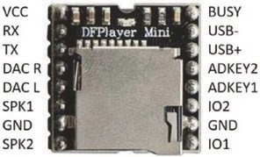
Figure 5-1. DFPlayer Mini MP3 player
When the MP3 player is stand-alone, a short press on tactile switches connected to the control pins, IO1 or IO2, plays the previous or next track, respectively, while a long press decreases or increases the volume. Pressing the ADKEY1 or ADKEY2 control pin plays the first or fifth track, respectively.
© Neil Cameron 2021 113
N. Cameron, Electronics Projects with the ESP8266 and ESP32, https://doi.org/10.1007/978-1-4842-6336-5_5
For this chapter, mp3 audio files are stored on a micro-SD card, FAT32 formatted with up to 32 GB storage, within a folder named mp3. Folder names of 01–99 are permitted with the audio files, within a folder, named 001.mp3 to 255.mp3.
Figure 5-2 illustrates tactile button control of a stand-alone MP3 player with a loudspeaker, of less than 3W, connected to the SPK1 and SPK2 pins through the audio and GND pins of an audio jack socket (connections given in Table 5-1). Instead of controlling the MP3 player with tactile buttons, the GND pin is directly connected to the appropriate control pin. Note that when power is applied to the MP3 player, the red indicator LED turns on after the IO1 or IO2 pin is connected to GND and turns off when the track has finished playing.
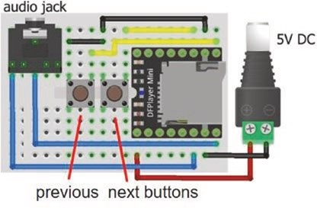
Figure 5-2. Stand-alone MP3 player
Table 5-1. Stand-alone MP3 player
Component | Connect to
Mp3 player VCC | Battery 5V
Mp3 player GND | Battery GND
Mp3 player SpK1 | audio output
Mp3 player SpK2 | audio output
Mp3 player IO1 (previous track and decreases volume) | Switch right pin
Mp3 player IO2 (next track and increases volume) | Switch right pin
Switch left pins | GND
Control command for the MP3 player
The MP3 player is operated by control commands transmitted using UART (Universal Asynchronous Receiver-Transmitter) Serial communication. The ten components of a control command are start bit, version, number of bytes, command, feedback, parameter[1,2], checksum[1,2], and finish bit. The start and finish bits, in HEX format, are 0x7E and 0xEF, the number of bytes is 0x06, feedback is 0x00, and version is 0xFF. A control command has two parameters, but generally the value of parameter[1] is zero. The checksum is the negative sum of all the components, omitting the start and finish bits. The checksum is formatted as a high and a low byte. When a control command is transmitted to the MP3 player, the response buffer contains ten components, of which parameter[2] contains data.
For example, the control command to play the fourth track is 0x03 with parameter[2] equal to 0x04 (see Table 5-2). The checksum is –(0xFF + 0x06 + 0x03 + 0x00+ 0x00 + 0x04) = –(255 + 6 + 3 + 0 + 0 + 4) = –268 that maps to 2¹⁶ – 268 = 65268 = 0xFEF4, with high and low bytes of 0xFE and 0xF4, respectively. The control command components in HEX format are start
bit, 0x7E; version, 0xFF; length, 0x06; command, 0x03; feedback, 0x00; parameter[1], 0x00; parameter[2], 0x04; checksum[1], 0xFE; checksum[2], 0xF4; and finish bit, 0xEF.
A selection of MP3 player control commands is given in
Table 5-2, with a manual available at usermanual.wiki/Pdf/
DFPlayer20Mini20Manual.1647715389/pdf. The command 0x03 plays the N^{th} track with tracks ordered by the time that they were loaded onto the micro-SD card. The command 0x12 plays the track with file name 000N XXX, irrespective of the time order that the audio file was loaded on the micro-SD card. The audio file name does not need to reflect the order that audio files were loaded on the micro-SD card. For example, four audio files were loaded on the micro- SD card in the order of 0014 ABC, 0012 AAA, 0011 XYZ, and 0013 PQR, which the MP3 player catalogues as tracks 1, 2, 3, and 4, respectively. The commands (0x12, 13) and (0x03, 4) will both play the audio file 0013 PQR, which is track 4 for the MP3 player.
Table 5-2. MP3 player control commands
Command | Action
0x01 | Next track
0x02 | previous track
0x03 | play track number N
0x04 | Increase volume by one level
0x05 | Decrease volume by one level
0x06 | Set volume level to N, between 0 and 30
0x07 | equalizer (Normal, pop, rock, Jazz, Classic, Base)
0x0D | play current track
0x0e | pause current track
0x12 | play track number N
(continued)
Table 5-2. (continued)
Command | Action
0x18 | random play order, starting at track 1
0x43 | Get volume level
0x46 | Get software version number
0x48 | Get number of files on the SD card
0x4C | Get track number
MP3 player control with a microcontroller
Connecting the MP3 player to an ESP8266 or ESP32 microcontroller provides significantly more functionality than the stand-alone MP3 player. The MP3 player is powered by the ESP8266 or ESP32 development board 3V3 pin, as the MP3 player operates at 3.3–5 V and the transmit (TX) and receive (RX) Serial communication functions at 3.3 V. If the MP3 player is powered by 5 V, then a logic-level converter is required to reduce the 5 V voltage on the MP3 player TX pin to 3.3 V on the ESP8266 or ESP32 microcontroller RX pin. The voltage is also reduced with a voltage divider consisting of a 5 kΩ resistor and a 10 kΩ resistor, as described in Chapter 16 (Signal generation).
The ESP8266 development board RX and TX pins are required for communication with the Serial Monitor, as information is displayed on the Serial Monitor to ensure that the sketch is performing as expected. The ESP8266 microcontroller communicates with the MP3 player with software Serial, using the built-in SoftwareSerial library. The advantage of the compact LOLIN (WeMos) D1 mini with a powerful CPU and Wi- Fi functionality is offset, to an extent, by the constraint of available pins, as pin D8 has a pull-down resistor and pin D0 has no interrupt function. The ESP8266 development board pins D4, D3, D2, and D8 are defined as control pins to play the next track, to increase the volume, to decrease the volume, and to change the music equalizer, respectively (see Figure 5-3 with connections in Table 5-3). Pins D4, D3, and D2 are connected to GND for the required change, while pin D8, which has a built-in pull-down resistor, is connected to 3V3 to change the music equalizer.
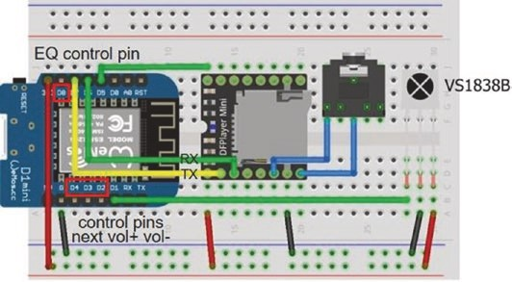
Figure 5-3. MP3 player with LOLIN (WeMos) D1 mini
Table 5-3. MP3 player connections for ESP8266 and ESP32 development boards
Component | ESP8266 | ESP32
Mp3 player VCC | 3V3 | 3V3
Mp3 player rX | D7 | tX2 (GpIO 17)
Mp3 player tX | D6 | rX2 (GpIO 16)
Mp3 player SpK1 | audio output | audio output
Mp3 player GND | GND | GND
Mp3 player SpK2 | audio output | audio output
Mp3 player BUSy | D5 | GpIO 34
Ir sensor OUt | D1 | GpIO 23
Ir sensor GND | GND | GND
Ir sensor VCC | 3V3 | 3V3
In contrast, the ESP32 development board has an abundance of GPIO pins, with the ESP32 DEVKIT DOIT 30-pin and NodeMCU 36-pin development boards having two and three Serial communication ports, respectively (see Chapter 21 (Microcontrollers)). The MP3 player with an ESP32 DEVKIT DOIT development board is shown in Figure 5-4, with connections in Table 5-3.
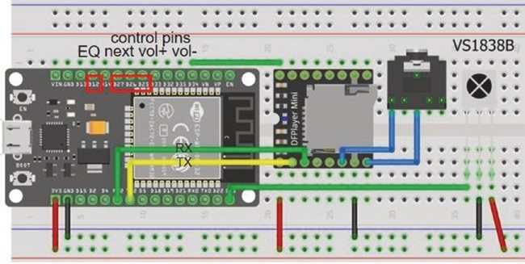
Figure 5-4. MP3 player with the ESP32 DEVKIT DOIT development board
The sketch in Listing 5-1 is the base for a subsequent sketch (Listing 5-3) using infrared signals to control the MP3 player. In the setup function of the sketch, the minimum and maximum file numbers are defined. For example, if the files titled 0009 abc.mp3 and 0013 xyz.mp3 have the lowest and highest file numbers, then the variables fileMin and fileMax are set to 9 and 13, respectively.
The first section of the sketch defines the control pins, the music equalizer level names, the control command template, and the audio file names. The setup function attaches internal pull-up resistors to the control pins and defines the interrupt activated by the MP3 player BUSY pin changing from LOW to HIGH when a track finishes playing. The interrupt service routine (ISR) sets the variable finish to the value of one, which indicates that an audio file has finished playing. To determine if the micro- SD card is inserted in the MP3 player, the number of files on the micro-SD card is counted with the command 0x48; and if no audio files are present, then a message is displayed on the Serial Monitor. The volume value is set, the first file is played, and the timer is reset to measure the audio file play time.
The loop function monitors the control pins for activity and calls the cmd (command) function. The four control pins use the commands 0x12 to play the next audio file and 0x4C to obtain the corresponding track number, the command 0x04 or 0x05 to increase or decrease the volume level, the command 0x43 to obtain the volume value, and the command 0x07 to increment the music equalizer level.
The next audio file is played when the nextPin is connected to GND or the current file has finished with the instruction if(digitalRead(nextPin) == LOW || finish == 1). Audio files are checked by playing each audio file for a fixed time period, for example, 5 s, by changing the first instruction of the loop function to if(digitalRead(nextPin) == LOW || millis()-timed > 5000).
The cmd function builds the checksum based on the command and parameter[2], as parameter[1] is zero, and splits the checksum into a high byte and a low byte for transmission to the MP3 player. The highByte and lowByte functions are functions within the Arduino IDE. The response from the MP3 player is held in the buffer[ ] array, and buffer[6] contains the data value. When the command 0x4C, to obtain the corresponding track number, is called, both the track number and the audio file name are displayed.
Listing 5-1 is for an ESP8266 microcontroller. The ESP32 development board Serial ports enable Serial communication with more than one device, without having to utilize libraries to provide the Serial communication functionality. The instruction Serial2.begin(baud, SERIAL_8N1, RXD2, TXD2) establishes Serial communication on the second Serial port with the baud rate defined by the parameter baud on

pins RXD2 and TXD2. When using an ESP32 microcontroller, the following instructions for the ESP8266 microcontroller
#include <SoftwareSerial.h> // include SoftwareSerial library
SoftwareSerial SoftSer(D6, D7); // define SoftSer RX, TX pins SoftSer.begin(9600); // SoftwareSerial baud rate for (int i=0; i<10; i++) SoftSer.wr ite(serialCom[i]);
// transmit to or receive from MP3
for (int i=0; i<10; i++) buffer[i] = SoftSer.read();
are replaced with the instructions
Serial2.begin(9600, SERIAL_8N1, 16, 17); // define RX2, TX2 for (int i=0; i<10; i++) Serial2.write(serialCom[i]); // transmit to or receive from MP3 for (int i=0; i<10; i++) buffer[i] = Serial2 .read();
and the instruction pinMode(busyPin, INPUT) is included in the setup function. The BUSY pin, D5, and control pin definitions D4, D3, and D2 are changed to GPIO 34 and to three suitable GPIO pins, such as GPIO 27, GPIO 26, and GPIO 25. For consistency with the sketch for an ESP8266 microcontroller, the music equalizer pin, D8, is changed to GPIO 12, which has a built-in pull-down resistor.
Listing 5-1. MP3 player
#include<SoftwareSerial.h> // include SoftwareSerial library SoftwareSerial SoftSer(D6, D7); // define SoftSer RX, TX pins int nextPin = D4; int volUp = D3;
int volDown = D2; // define control pins int EQpin = D8;
Mp3 player
int busyPin = D5; int EQstate = 0; // equaliser settings String EQ[] = {"Normal","Pop","Rock","Jazz","Classic","Bass"}; unsigned long timed = 0; unsigned int checksum;
byte highChk, lowChk; // control command template byte serialCom[10] = {0x7E,0xFF,0x06,0x00,0x00,0x00,0x00,0x00,
0x00,0xEF};
// start version length CMD feedback para[1, 2] checksum[high, low] end byte buffer[10];
int fileMin = 9; // lowest and highest file number int fileMax = 13; // on micro SD card int file = fileMin;
String fileName[] = { // file names in order loaded on SD card
"0012 Nina Simone - My baby just cares for me",
"0011 Reamonn - Supergirl",
"0013 Spider Murphy Gang - Ich Grüsse Alle Und Den Rest Der Welt",
"0009 Proclaimers - I'm Gonna Be (500 Miles)",
"0010 Railroad Earth - The Good Life"
};
volatile int finish; // variable in loop and ISR functions int track;
void setup()
{
Serial.begin(115200); // Serial Monitor baud rate SoftSer.begin(9600); // software Serial baud rate pinMode(nextPin, INPUT_PULLUP); // control pins use internal pinMode(volUp, INPUT_PULLUP); // pull-up resistors
pinMode(volDown, INPUT_PULLUP);
// interrupt finished, BUSY pin HIGH attachInterrupt(digitalPinToInterrupt(busyPin), finished,
RISING); cmd(0x48, 0); // get number of files on SD card cmd(0x06, 10); // set volume to 10 (range 0 - 30) cmd(0x43, 0); // get volume value cmd(0x12, file); // play first audio file finish = 0; // set finish variable cmd(0x4C, 0); // get track number timed = millis(); // start timer
}
void loop()
{ // next file selected or current file ended if(digitalRead(nextPin) == LOW || finish == 1)
{
file = file+1; // increment file name if(file > fileMax) file = f ileMin;
// constrain file name <= fileMax
cmd(0x12, file); // play next audio file finish = 0; // set finish variable cmd(0x4C, 0); // get track number
} else if(digitalRead(volUp) == LOW) // increase volume is selected
{
cmd(0x04, 0); // increase volume cmd(0x43, 0); // get volume value
}
else if(digitalRead(volDown) == LOW)
{ // decrease volume is selected cmd(0x05, 0); // decrease volume cmd(0x43, 0);
}
Mp3 player
else if(digitalRead(EQpin) == HIGH) // change equaliser is selected
{ // when pin state is HIGH EQstate = EQstate+1; // increment equaliser if(EQstate > 5) EQstate = 0; // constrain equaliser value Serial.println(EQ[EQstate]); cmd(0x07, EQstate); // change equaliser setting
}
}
void cmd(byte CMD, byte param2) // command function
{
delay(100); // delay to debounce button checksum = -(0xFF + 0x06 + CMD + 0x0 0 + 0x00 + param2);
// build checksum
highChk = highByte(checksum); // split checksum into lowChk = lowByte(checksum); // high byte and low bytes serialCom[3] = CMD;
serialCom[6] = param2; // command components serialCom[7] = highChk;
serialCom[8] = lowChk; // transmit command to MP3 for (int i=0; i<10; i++) SoftSer.write(serialCom[i]); delay(100); // receive command from MP3 for (int i=0; i<10; i++) buffer[i] = SoftSer.read(); delay(100); if(CMD == 0x12) // play next audio file
{
Serial.print("finished track ");Serial.print(track);
Serial.print("\ttime");
Serial.print((millis() - timed)/1000);
Serial.println("s"); // display audio play time timed= millis(); // reset timer }
else if(CMD == 0x43) // get volume {
Serial.print("volume "); // display volume value
Serial.println(buffer[6]);
} else if(CMD == 0x48) // get number of files on SD card
{ if(buffer[6]<2) // no audio files present
{
Serial.println("SD card not inserted ");
Serial.println("insert SD card and reset microcontroller"); for(;;) delay(1000); // do nothing
}
} else if(CMD == 0x4C) // get track number
{ track = buffer[6]; // display track number of file Serial.print("playing track ");Serial.print(track);
Serial.print("\t\t");Serial.println(fileName[track-1]);
} // array starts at [0], but track starts at [1] }
IRAM_ATTR void finished() // ISR
{ finish = 1; // set finish variable }
Mp3 player
Infrared remote control of an MP3 player
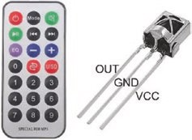
The MP3 player is controlled by an infrared remote control and the VS1838B infrared sensor, instead of connecting control pins to GND, as in Listing 5-1. Connections for the VS1838B infrared sensor are given in Table 5-3 and shown in Figures 5-3 and 5-4. The IRremoteESP8266
library by David Conran, Sebastien Warin, Mark Szabo, and Ken Shirriff is recommended and is available within the Arduino IDE. For an ESP32 microcontroller, the IRremote library by Ken Shirriff is recommended. A .zip file containing the IRremote library is downloaded from github. com/z3t0/Arduino-IRremote. The IRremote library that is available in the Arduino IDE is not always the latest version. When a remote button is pressed, the infrared sensor receives the signal, which is decoded and mapped to the corresponding control pin. For example, the decoded 32bit infrared signal, 0xFF18E7, for button 2 of an infrared remote control is shown in Figure 5-5.
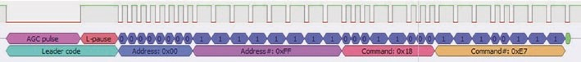
Figure 5-5. IR remote control signal
Listings 5-2 and 5-3 decode infrared signals and display the received signals in HEX format for an ESP8266 and ESP32 microcontroller, respectively. Listing 5-3 only includes the NEC and Sony decode types, but the library file IRremote.h includes a comprehensive list of decode types, for inclusion in a sketch. Listing 5-4 uses the HEX codes corresponding to pressing the next audio file, increasing volume, decreasing volume, and the stop button on a Sony infrared remote control of 0x8D1, 0x491, 0xC91, and 0x1D1, respectively. Similarly, the HEX codes for the remote control buttons 1–5 were 0x011, 0x811, 0x411, 0xC11, and 0x211, which are used for the command to play tracks 1–5.
Listing 5-2. Decoding infrared signals with an ESP8266 development board
#include <IRutils.h> // include IRutils library int IRpin = D1; // IR receiver pin int BufferSize = 1024; // longer signal length int Timeout = 50; // block repeat signals IRrecv irrecv(IRpin, BufferSize, Timeout, true); decode_results reading; // IRremote reading
void setup()
{
Serial.begin(115200); // Serial Monitor baud rate irrecv.enableIRIn(); // initialise the IR receiver
}
void loop()
{ if (irrecv.decode(&reading)) // read pulsed signal Serial.print(resultToHumanReadableBasic(&reading));
} // display signal information
Listing 5-3. Decoding infrared signals with an ESP32 development board
#include <IRremote.h> // include IRremote library int IRpin = 23; // IR receiver pin IRrecv irrecv(IRpin); decode_results reading;
Mp3 player
void setup()
{
Serial.begin(115200); irrecv.enableIRIn(); }
void loop()
{
if (irrecv.decode(&reading))
{
if(reading.decode_type == NEC) Serial.print("NEC: "); else if(reading.decode_type == SONY) Serial.print("Sony: "); else Serial.print("Other: ");
Serial.print(reading.value, HEX);
Serial.print("\tBits: "); // display signal HEX code Serial.println(reading.bits); // and bit number delay(200); // delay before next IR signal irrecv.resume(); // receive the next value
}
}
The infrared signals are mapped to control pin functions using the instructions associated with a control pin in Listing 5-1. For example, the instruction for increasing volume if(digitalRead(volUp) == LOW) is replaced with the instruction if(reading.value == 0x491). Mapping a remote control button to playing a specific track uses switch case instructions rather than if else instructions, with each case instruction mapping an infrared signal to a track number. Instructions to replace the control pin commands in Listing 5-1 by remote control signals are given in Listing 5-4.
In the first section of the sketch, replace
Listing 5-4. Infrared remote control of an MP3 player
int nextPin = D4; int volUp = D3;
int volDown = D2; // define control pins int EQpin = D8; with
#include <IRutils.h> // include IR library int IRpin = D1; // IR receiver pin int BufferSize = 1024; // longer signal length int Timeout = 50; // block repeat signals IRrecv irrecv(IRpin, BufferSize, Timeout, true); decode_results reading; // IRremote reading
for an ESP8266 microcontroller, and for an ESP32 microcontroller, the new instructions are
#include <IRremote.h> int IRpin = 23;
IRrecv irrecv(IRpin); decode_results reading;
For both microcontrollers, replace the instruction int track with int track, oldTrack.
In the setup function, replace
pinMode(nextPin, INPUT_PULLUP); // control pins use internal pinMode(volUp, INPUT_PULLUP); // pull-up resistors pinMode(volDown, INPUT_PULLUP);
Mp3 player
with
irrecv.enableIRIn(); // initialise the IR receiver
The complete loop function is replaced with the following instructions, noting that the instruction irrecv.resume() is required only for the ESP32 microcontroller:
void loop()
{ if(finish == 1) // current audio file ended
{
cmd(0x01, 0); // play next track finish = 0; // set finish variable cmd(0x4C, 0); // get track number
} if(irrecv.decode(&reading)) // read pulsed signal
{ if(reading.value == 0x8D1) // next audio file is selected
{
file = file+1; // increment file name if(file > fileMax) file = fi leMin;
// constrain file name < fileMax
cmd(0x12, file); // play next audio file finish = 0; // set finish variable cmd(0x4C, 0); // get track number
} else if(reading.value == 0x491) // i ncrease volume is selected
{
cmd(0x04, 0); // increase volume cmd(0x43, 0); // get volume value }
else if(reading.value == 0xC91) // decrease volume is selected
{
cmd(0x05, 0); // decrease volume cmd(0x43, 0); // get volume value
} else if(reading.value == 0x1D1) // change equaliser is selected {
EQstate = EQstate+1; // increment equaliser if(EQstate > 5) EQstate = 0; // constrain equaliser value Serial.println(EQ[EQstate]); cmd(0x07, EQstate); // change equaliser setting
} else
{ switch(reading.value) // switch case for selected track { // map remote signal to play track
case 0x011: track = 1; break; case 0x811: track = 2; break; case 0x411: track = 3; break; case 0xC11: track = 4; break; case 0x211: track = 5; break;
}
cmd(0x03, track); // play track finish = 0; // set finish variable cmd(0x4C, 0); // get track number }
// irrecv.resume(); // for ESP32, receive next value
}
delay(100);
}
Mp3 player
In the cmd function, the instruction if(CMD == 0x12) to play the next audio file is replaced with the instruction if(CMD == 0x01 ||CMD == 0x03 || CMD == 0x12) to play the next track or the selected track or the selected audio file. Two instructions further on, the instruction Serial.print(track) is replaced with Serial.print(oldTrack). In the instruction group to get the track number, the instruction oldTrack = track is added after the instruction track = buffer[6].
Creating sound tracks and two alarm systems
The website www.fromtexttospeech.com creates MP3 files for speech corresponding to text entered into the online textbox, with different voices in several languages available. The audio files are named with a number and text combination, for example, "0001 alarm on", so that audio files are accessed independently of the order that the audio files were loaded on the micro-SD card. An application of user-defined sound tracks is an alarm system with an HC-SR04 ultrasonic distance sensor or a passive infrared (PIR) sensor to detect movement, with specific announcements from the MP3 player when the sensor is triggered (see Figures 5-6 and 5-7).
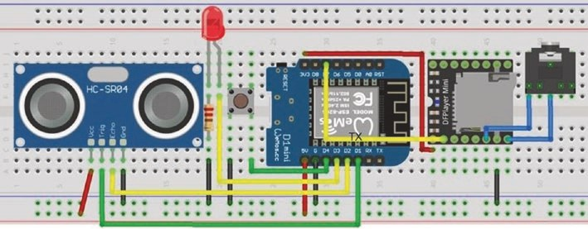
Figure 5-6. MP3 player with alarm and LOLIN (WeMos) D1 mini

Mp3 player
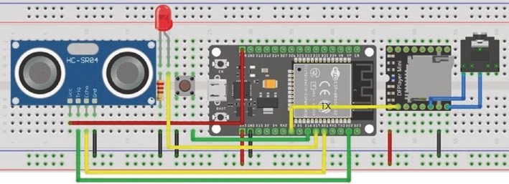
Figure 5-7. MP3 player with alarm and the ESP32 DEVKIT DOIT development board
The sketch in Listing 5-5 includes an HC-SR04 ultrasonic distance sensor to detect a distance change, such as when a door is opened, and if the alarm is on, then the MP3 player makes an announcement. The distance, in centimeters, between the sensor and an object is half the echo time, measured in microseconds, multiplied by 0.0343, assuming the speed of sound of 343 m/s. The first section of the sketch defines the HC- SR04 ultrasonic distance sensor and switch pins with the switch activating the interrupt alarmISR, which turns on or off the alarm and the indicator LED, with the MP3 player playing the corresponding audio file. In the loop function, the HC-SR04 ultrasonic distance sensor measures the distance every 2 s. When the measured distance is less than a threshold, the play function is activated with an MP3 player announcement, and the alarm is turned off. There is a time interval between playing the audio files, rather than sequential tracks being played immediately, when triggered by the MP3 player BUSY pin state changing to HIGH.
Connections for the MP3 player with alarm are given in Table 5-4. There is no MP3 player TX nor BUSY connection to the ESP8266 or ESP32 microcontroller as the MP3 player does not transmit a signal. Listing 5-5 is for an ESP8266 microcontroller, and the NewPing8266 library is downloaded from github.com/jshaw/NewPingESP8266. For an ESP32 microcontroller, the NewPing library by Tim Eckel is available in the
Mp3 player
Arduino IDE. The focus of the layouts in Figures 5-6 and 5-7 is to minimize overlapping connections, as in practice access is required to the MP3 player micro-SD card holder and to the ESP8266 and ESP32 development boards to provide power.
Table 5-4. MP3 player with alarm and ESP8266 and ESP32 development boards
Component | ESP8266 | ESP32
Mp3 player VCC | 3V3 | 3V3
Mp3 player rX | D7 | tX2 (GpIO 17)
Mp3 player SpK1 | audio output | audio output
Mp3 player GND | GND | GND
Mp3 player SpK2 | audio output | audio output
hC-Sr04 VCC | 5V | VIN
hC-Sr04 trig | D1 | GpIO 22
hC-Sr04 echo | D2 | GpIO 21
hC-Sr04 GND | GND | GND
leD long leg | D3 | GpIO 19
leD short leg | 220 Ω resistor and to GND
Switch right | D4 | GpIO 18
Switch left | GND | GND
Listing 5-5 is for an ESP8266 microcontroller. When using an ESP32 microcontroller, the ESP8266 microcontroller instructions
#include<SoftwareSerial.h> // include SoftwareSerial library
SoftwareSerial SoftSer(D6, D7); // define SoftSer TX pin
#include <NewPingESP8266.h> // include NewPingESP8266 lib
Mp3 player
NewPingESP8266 sonar (trigPin, echoPin, maxdist); SoftSer.begin(9600); // software Serial baud rate for (int i=0; i<10; i++) SoftSer.write(serialCom[i]);
are replaced with
#include <NewPing.h> // include NewPing library
NewPing sonar (trigPin, echoPin, maxdist);
Serial2.begin(9600, SERIAL_8N1, 16, 17); // Serial2 TX2 on GPIO 17 for (int i=0; i<10; i++) Serial2.write(serialCom[i]);
and pin definitions for the trigPin, echoPin, LEDpin, and alarmPin are changed to GPIO 22, GPIO 21, GPIO 19, and GPIO 18, respectively.
Listing 5-5. MP3 player alarm
#include<SoftwareSerial.h> // include SoftwareSerial library
SoftwareSerial SoftSer(D6, D7); // define SoftSer TX pin #include <NewPingESP8266.h> // include NewPingESP8266 lib int trigPin = D1; // HC-SR04 trigger pin int echoPin = D2; // HC-SR04 echo pin int maxdist = 200; // set max scan distance (cm) int echoTime; float distance; // scanned distance (cm)
// associate sonar with NewPing NewPingESP8266 sonar (trigPin, echoPin, maxdist); int LEDpin = D3; // define LED pin int alarmPin = D4; // define alarm switch pin unsigned int checksum;
byte highChk, lowChk; // control command template byte serialCom[10] = {0x7E,0xFF,0x06,0x00,0x00,
0x00,0x00,0x00,0x00,0xEF}; byte buffer[10];
volatile int alarmSet = 0; // set alarm state
Mp3 player
String fileName[] = { // file names in numerical order
"0001 alarm off",
"0002 alarm on",
"0003 someone entered the room",
"0004 close the door please",
"0005 press switch to reset the alarm"
};
void setup()
{
Serial.begin(115200); // Serial Monitor baud rate SoftSer.begin(9600); // software Serial baud rate pinMode(trigPin, OUTPUT); // define trigger pin as output pinMode(LEDpin, OUTPUT); // define LEDpin as output pinMode(alarmPin, INPUT_PUL LUP);
// alarm pin uses pull-up resistor
attachInterrupt(digitalPinToInterrupt(alarmPin), alarmISR, FALLING);
}
void loop()
{
echoTime = sonar.ping(); // echo time (μs) distance = (echoTime/2.0)*0.0343; // distance to target Serial.println(distance); // play audio files if
// distance < 100 and alarm set if(distance < 100 && alarmSet == 1 ) play();
delay(2000); // delay between readings }
Mp3 player
void play()
{
cmd(0x06, 10); // volume to 10 (range 0 to 30) cmd(0x12, 3); // play audio file named 0003 delay(2000); // interval between audio files cmd(0x12, 4); // play audio file named 0004 delay(2000);
cmd(0x12, 5); // play audio file named 0005 delay(2500); alarmISR(); // turn alarm off
}
void cmd(byte CMD, byte param2)
{ // build checksum checksum = -(0xFF + 0x06 + CMD + 0x00 + 0x00 + param2); highChk = highByte(checksum); // split checksum into lowChk = lowByte(checksum); // high byte and low bytes serialCom[3] = CMD;
serialCom[6] = param2; // components of command serialCom[7] = highChk;
serialCom[8] = lowChk; // transmit command to MP3 for (int i=0; i<10; i++) SoftSer.write(serialCom[i]); }
IRAM_ATTR void alarmISR()
{
alarmSet = 1 - alarmSet; // turn off (0) or on (1) alarm digitalWrite(LEDpin, alarmSet); // turn off or on LED cmd(0x12, alarmSet+1); // play audio file 0001 or 0002 }
Mp3 player
Movement detection alarm
A movement detection alarm consists of a passive infrared (PIR) sensor detecting movement, which triggers the MP3 player to play a warning and to turn on an LED for ten seconds (see Figures 5-8 and 5-9). The sketch in Listing 5-6 consists of just 20 lines of code, with the ultrasonic distance sensor replaced by a PIR sensor, but using the connections in Table 5-5. Only the third track is played by the MP3 player, which requires the command (0x12, 0x03). The command checksum is the negative value of the HEX representation of the signal components (0xFF + 0x06 + 0x12 + 0x00 + 0x00 + 0x03), which is –(255 + 6 + 18 + 3) or –282 in decimal. The HEX representation of –282 is 2¹⁶ – 282 = 65256 or 0xFEE6, which has high and low bytes of 0xFE and 0xE6, respectively.
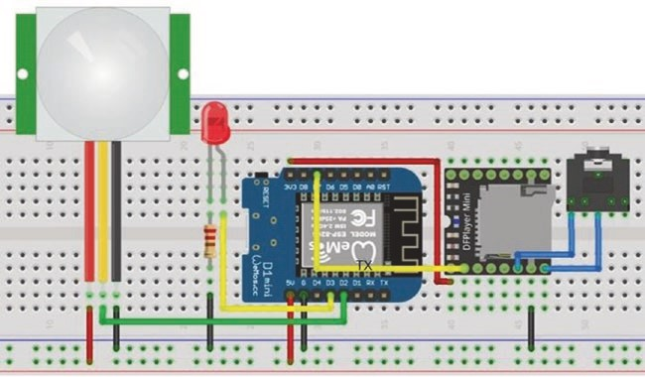
Figure 5-8. MP3 player alarm with LOLIN (WeMos) D1 mini – short version

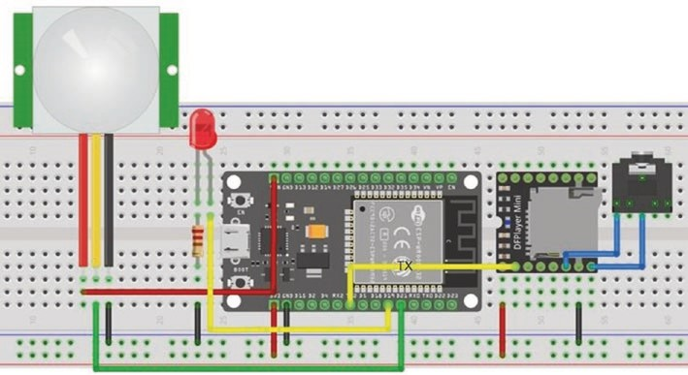
Figure 5-9. MP3 player alarm with the ESP32 DEVKIT DOIT development board – short version
Table 5-5. MP3 player alarm with ESP8266 and
ESP32 development boards – short version
Component | ESP8266 | ESP32
pIr sensor VCC | 5V | VIN
pIr sensor OUt | D2 | GpIO 21
pIr sensor GND | GND | GND
Listing 5-6 is for an ESP8266 microcontroller. When using an ESP32 microcontroller, the ESP8266 microcontroller instructions
#include<SoftwareSerial.h> // include SoftwareSerial library
SoftwareSerial SoftSer(D6, D7); // define SoftSer TX pin SoftSer.begin(9600); // software Serial baud rate for (int i=0; i<10; i++) SoftSer.write(serialCom[i]);
Mp3 player
are replaced with the instructions
Serial2.begin(9600, SERIAL_8N1, 16, 17); // Serial2 TX2 on GPIO 17 for (int i=0; i<10; i++) Serial2.write(serialCom[i]);
and pin definitions for the PIRpin and LEDpin are changed to GPIO 21 and GPIO 19, respectively.
Listing 5-6. MP3 player alarm – short version
#include<SoftwareSerial.h> // include SoftwareSerial library SoftwareSerial SoftSer(D6, D7); // define SoftSer TX pin int PIRpin = D2; // PIR sensor and LED pins int LEDpin = D3; byte serialCom[10] = {0x7E,0xFF,0x06,0x12,0x00, 0x00,0x03,0xFE,0xE6,0xEF}; // one control command void setup()
{
SoftSer.begin(9600); // software Serial baud rate pinMode(LEDpin, OUTPUT); // LED pin as OUTPUT
}
void loop()
{ if(digitalRead(PIRpin) == HIGH) // PIR sensor triggered
{
digitalWrite(LEDpin, HIGH); // turn on LED and play sound for(int i=0; i<10; i++) SoftSer.write(serialCom[i]); delay(10000); digitalWrite(LEDpin, LOW); // turn off LED after 10s
}
}
Speaking clock
A speaking clock is built with a real-time clock (RTC) DS3231 and the MP3 player module. The DS3231 RTC has a built-in temperature sensor, is powered with 3.3 V or 5 V, and has a CR2032 lithium button-cell battery to power the RTC when not connected to an ESP8266 or ESP32 development board. The DS3231 RTC module uses I2C (Inter-Integrated Circuit) communication with the two bidirectional lines: serial data (SDA) and serial clock (SCL). The speaking clock time and temperature announcement is activated by pressing a button switch. One scenario is for people with a visual impairment, who can locate the large button switch, but not easily read the time on a watch, to be able to hear the time and temperature. Figures 5-10 and 5-11 illustrate the speaking clock with the ESP8266 and ESP32 development boards.
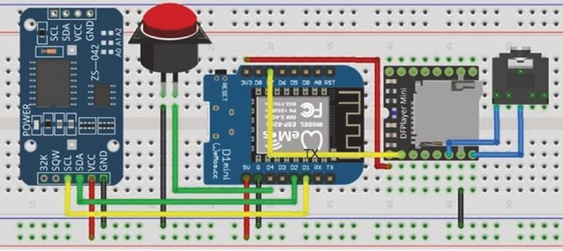
Figure 5-10. Speaking clock with LOLIN (WeMos) D1 mini
Mp3 player
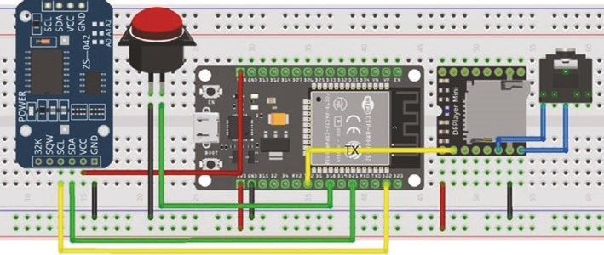
Figure 5-11. Speaking clock with the ESP32 DEVKIT DOIT development board
Connections for the DS3231 RTC and MP3 player modules are given in Tables 5-6 and 5-3, respectively. There is no MP3 player TX nor BUSY connection to the ESP8266 or ESP32 microcontroller as the MP3 player does not transmit a signal.
Table 5-6. Real-time clock module with
ESP8266 and ESP32 development boards
Component | ESP8266 | ESP32
DS3231 GND | GND | GND
DS3231 VCC | 5V | VIN
DS3231 SDa | D2 | GpIO 21
DS3231 SCl | D1 | GpIO 22
Button switch right | D4 | GpIO 18
Button switch left | GND | GND
The MD_DS3231 library by Marco Colli is recommended, due to the ease of accessing time components, and the library is available in the Arduino IDE. When the sketch is first compiled and loaded, the current date and time are included in the sketch; and then the sketch is immediately compiled and loaded again, but with the date and time setting instructions commented out, as in Listing 5-7. When setting the time and date, the 24-hour time format is used without leading zeros. Compiling and loading takes about 30 seconds, so set the time forward by 30 seconds.
A total of 28 sound files are required for the numbers and temperature, with the files referenced as 0001 one, 0002 two … 0020 twenty, 0030 thirty, 0040 forty, 0050 fifty, 0060 zero, 0070 the time is, 0080 degrees Celsius, 0090 and, and 0100 o’clock. Sound files 21–24 correspond to the numbers 30, 40, 50, and 0; files 25–28 are for the time is, degrees Celsius, and, and o'clock. The website www.fromtexttospeech.com creates mp3 files for speech corresponding to text entered into the online textbox, with different voices in several languages available.
The DS3231 RTC provides the time information, and then the track the time is is played by the MP3 player, and the speak20 function is called to play the track(s) for the hour (see Listing 5-7). If the minutes are less than ten, then the zero track and the one to nine tracks are played; and if the minutes are less than 21, then the corresponding minutes track is played. Otherwise, the thirty, forty, or fifty track is played, which is track number 21, 22, or 23, equal to 18 plus the minutes divided by ten, followed by the track for the units digit. If the minutes are zero, then track number 28 for o'clock is played. The getTemp function for the DS3231 RTC reads the temperature, then the and track is played followed by the speak20 function being called to play the track(s) for the temperature, and lastly, the track for degrees Celsius is played. The tracks are short, so there is no need for an interrupt to detect when a track has finished playing and the BUSY pin is not read.
Mp3 player
Listing 5-7 is for an ESP8266 microcontroller. When using an ESP32 microcontroller, the ESP8266 microcontroller instructions
#include<SoftwareSerial.h> // include SoftwareSerial library
SoftwareSerial SoftSer(D6, D7); // define SoftSer TX pin SoftSer.begin(9600); // software Serial baud rate for (int i=0; i<10; i++) SoftSer.write(serialCom[i]);
are replaced with the instructions
Serial2.begin(9600, SERIAL_8N1, 16, 17); // TX2 on GPIO 17 for (int i=0; i<10; i++) Serial2.write(serialCom[i]);
and the switchPin definition is changed to GPIO 18.
Listing 5-7. Speaking clock
#include<SoftwareSerial.h> // include SoftwareSerial library
SoftwareSerial SoftSer(D6, D7); // define SoftSer TX pin #include <MD_DS3231.h> // include MD_DS3231 library unsigned int checksum; byte highChk, lowChk; byte serialCom[10] ={0x7E,0xFF,0x06,0x00,0x00,
0x00,0x00,0x00,0x00,0xEF}; byte buffer[10];
int switchPin = D4; // define switch pin int val, deg;
void setup()
{
SoftSer.begin(9600); // software Serial baud rate pinMode(switchPin, INPUT_PULLUP); // switch pin uses pull-up resistor cmd(0x06, 10); // set volume to 10 (range 0 - 30)

Mp3 player
RTC.control(DS3231_12H, DS3231_OFF); // 24 hour clock
// RTC date of Wednesday 7 September 2020 at 20:37:50
/* // instructions to set time commented out
RTC.yyyy = 2020; // year
RTC.mm = 9; // month
RTC.dd = 7; // day
RTC.h = 20; // hour in 24 hour format
RTC.m = 37; // minutes
RTC.s = 50; // seconds, allow 30s to compile
RTC.dow = 4; // day of week, Sunday = 1
RTC.writeTime();
*/
}
void loop()
{ if(digitalRead(switchPin) == LOW) // switch is pressed
{ speak(25); // MP3 play "the time is" RTC.readTime(); // components of date and time speak20(RTC.h); // MP3 play the hour if(RTC.m == 0) speak(28); // MP3 play "o'clock" else if(RTC.m <10)
{
speak(24); // MP3 play "zero" speak(RTC.m); // MP3 play minute < 10
}
else if(RTC.m <21) speak(RTC.m); // MP3 play minute <21 else
{
speak(RTC.m/10 + 18); // MP3 play "30 40 or 50 mins" speak(RTC.m % 10); // MP3 play minute < 10 } // temperature measurement
Mp3 player
deg = round(RTC.readTempR egister()); speak(27); // MP3 play "and" speak20(deg); // MP3 play the temperature speak(26); // MP3 play "degrees Celsius"
}
}
void speak(int file) // function to play MP3 file
{
if(file == 27) delay(200); // delay before playing "and" cmd(0x03, file);
delay(300); // time for short track to play if(file == 25 || file == 27 ) delay(300);
} // delay for "the time is" or "and"
void speak20(int val) // function to play combination
{ // of "20" and units if(val < 21) speak(val); // MP3 play number < 21 else
{
speak(20); // MP3 play "20"
speak(val % 20); // MP3 play track numbered
} // remainder after dividing by 20
}
void cmd(byte CMD, byte param2)
{
delay(500); // stop repeated button push checksum = -(0xFF + 0x06 + CMD + 0 x00 + 0x00 + param2);
// build checksum
highChk = highByte(checksum); // split checksum into lowChk = lowByte(checksum); // high byte and low bytes serialCom[3] = CMD;
Mp3 player
serialCom[6] = param2; // components of command serialCom[7] = highChk;
serialCom[8] = lowChk; // transmit command to MP3 for (int i = 0; i<10; i++) SoftSer.write(serialCom[i]); delay(20); // time to load command }
Voice recorder
The ISD1820 record and playback module stores recorded sounds, up to 10 s duration, on the internal flash memory, which retains the information when the module is not powered. Recording is activated after a HIGH signal to the REC pin or after the REC button is pressed. The module LED is turned on for the 10 s recording period. The P-E playback option plays the entire recorded sound following a HIGH signal to the P-E pin or when the PLAYE button is pressed. The P-L playback option is also initiated on a HIGH signal, with recorded sound played back while the P-L pin is HIGH or the PLAYL button is pressed. The ISD1820 module is powered at 3.3 V and uses an 8 Ω 0.5 W speaker (see Figure 5-12 with connections in Table 5- 7).
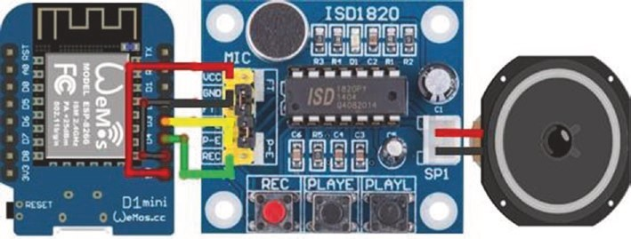
Figure 5-12. ISD1820 record and playback module
Mp3 player
In Listing 5-8, the character r or p is entered on the Serial Monitor to start recording for 10 s or to start playback, respectively. When the instruction pinMode(playPin, OUTPUT) is called, the PLAYE pin is automatically set LOW; and to ensure the pin is initially set LOW, the instruction digitalWrite(playPin, LOW) precedes the pinMode(playPin, OUTPUT) instruction. An infrared signal to an infrared sensor connected to the ESP8266 or ESP32 development board or a door opening being detected by a PIR sensor triggers a HIGH signal to playback the recorded message, rather than entering a character on the Serial Monitor.
Table 5-7. ISD1820 record and playback module
Component | Connect to
ISD1820 VCC | eSp8266 3V3
ISD1820 GND | eSp8266 GND
ISD1820 p-e | eSp8266 D3
ISD1820 reC | eSp8266 D4
Listing 5-8. ISD1820 record and playback module
int playPin = D3; // define playback pin int recPin = D4; // define record pin char data;
void setup()
{
Serial.begin(115200); // Serial Monitor baud rate
Serial.print("Enter r to record (10 seconds) or");
Serial.println(" p to playback");
digitalWrite(playPin, LOW); // avoid playPin going HIGH
Mp3 player
pinMode(playPin, OUTPUT); // define playPin and recPin pinMode(recPin, OUTPUT); // as OUTPUT
}
void loop()
{ while(Serial.available() > 0) // if data available in Serial buffer
{
data = Serial.read(); // read Serial buffer if(data == 'r')
{
Serial.println("recording while light is on"); digitalWrite(recPin, HIGH); // HIGH to activate recording delay(10000); // recording time of 10s digitalWrite(recPin, LOW); // reset to LOW signal
}
else if(data == 'p')
{
Serial.println("playback");
digitalWrite(playPin, HIGH); // HIGH to activate playback delay(10); // short delay of 10ms digitalWrite(playPin, LOW); // reset to LOW signal
}
}
}
Summary
The DFPlayer Mini MP3 player operated both as a stand-alone MP3 player and when controlled by an ESP8266 or ESP32 microcontroller to play the next track, increase or decrease the volume, and change the music equalizer. The MP3 player was controlled with signals from an infrared
Mp3 player
remote control, after mapping the infrared remote control buttons to the MP3 player functions. An alarm was built with an ultrasonic distance sensor triggering announcements made by the MP3 player. A movement detection alarm, requiring only 20 lines of code, used a PIR sensor to trigger an announcement by the MP3 player and turn on an indicator LED. A button switch triggered announcements by the MP3 player of the current time and temperature, with the time and temperature information provided by the DS3231 real-time clock module. Controlling the ISD1820 record and playback module was also described.
Components List
- ESP8266 microcontroller: LOLIN (WeMos) D1 mini or NodeMCU board
- ESP32 microcontroller: DEVKIT DOIT or NodeMCU board
- DFPlayer Mini MP3 player
- Tactile switches: 2×
- Loudspeaker: Less than 3 W
- Audio jack socket and mini-loudspeaker
- Infrared sensor: VS1838B
- Resistor: 220 Ω
- LED
- Ultrasonic distance sensor: HC-SR04
- Passive infrared (PIR) sensor: HR-SC501 or HR-SC505
- Real-time clock module: DS3231
- Record and playback module: ISD1820

CHAPTER 6
Bluetooth speaker
A Bluetooth speaker complements the Internet radio in Chapter 1, the MP3 player in Chapter 5, and the WS2812 5050 RGB LED strip that responds to sound in Chapter 4. The Bluetooth stereo audio receiver module with the PAM8403 class-D audio amplifier does not require an ESP8266 or ESP32 microcontroller, but the project merits incorporation in the book because it's fun and a straightforward build. After the Bluetooth stereo audio receiver module is switched on with the announcement “Bluetooth mode: the Bluetooth device is ready to pair,” the Android tablet or mobile phone with Bluetooth communication is connected to the Bluetooth stereo audio receiver module, followed by another announcement “The Bluetooth device is connected successfully.”
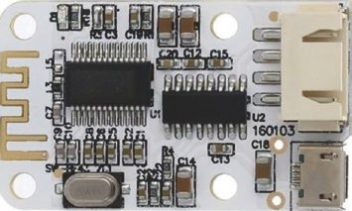
The Bluetooth stereo audio receiver module with the PAM8403 class-D audio amplifier powers 3 W speakers and operates at 5 V. A 18650 lithium-ion (Li-Ion) rechargeable battery powers the Bluetooth stereo audio receiver
module and the speakers. An MT3608 DC to DC step-up boost converter power supply module boosts the 18650 lithium-ion battery’s 3.7 V to the required 5 V. The MT3608 boost converter operates at 2–24 V and provides up to 28 V output at 2 A. The output voltage is controlled by adjusting the MT3608 potentiometer, indicated by the arrow in Figure 6-1
© Neil Cameron 2021 151
N. Cameron, Electronics Projects with the ESP8266 and ESP32, https://doi.org/10.1007/978-1-4842-6336-5_6
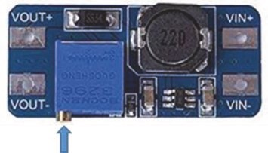
Figure 6-1. MT3608 DC to DC step-up boost converter
Lithium-ion batteries should neither be overcharged nor over- discharged; otherwise, the 18650 lithium-ion battery can produce substantial heat. The TP4056 battery protection module is a constant- current and constant-voltage linear charger for single-cell lithium-ion batteries. The TP4056 module monitors the voltage level of the lithium- ion battery during charging and disconnects the circuit if the lithium-ion battery voltage exceeds 4.2 V. The TP4056 module indicates when the lithium-ion battery is charging or has fully charged with a red or a blue LED. Figure 6-2 displays two TP4056 modules, with the supply voltage of 5 V provided on the left side through the mini-USB socket or by connecting the +/- points or IN+/IN- points to the supply voltage of 4.5–8 V. The TP4056 battery protection module on the right side of Figure 6-2 is only used for charging a lithium-ion battery and must not be connected to a load.
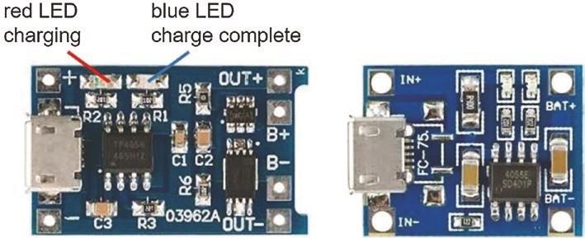
Figure 6-2. TP4056 battery charging modules
The TP4056 battery protection module on the left side of Figure 6-2 includes a DW01A battery protection IC, which controls an 8205A dual MOSFET (Metal Oxide Semiconductor Field Effect Transistor). When the charging lithium-ion battery voltage reaches 4.2 V, the TP4056 battery protection module switches from constant current of 1 A to a constant voltage of 4.2 V, and the current gradually reduces to zero. When the discharging lithium-ion battery voltage drops to 2.4 V, the MOSFET is switched off, which disconnects the lithium-ion battery from the load.
On the TP4056 battery protection module, the B+ and OUT+ points are connected together, but the B- and OUT- points are connected through the MOSFET. Figure 6-3 shows connections of the TP4056 battery protection module to the 18650 lithium-ion rechargeable battery and to the Bluetooth stereo audio receiver module (see Table 6-1). The TP4056 battery protection module in Figure 6-2 has a mini-USB socket for connecting a charging cable to a USB 5 V socket for charging the 18650 lithium-ion rechargeable battery.
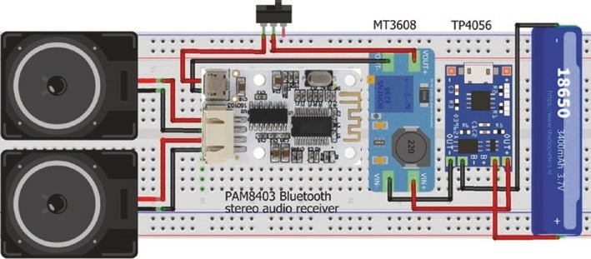
Figure 6-3. Bluetooth stereo audio receiver module with speakers
Table 6-1. TP4056 protection module connections
Component | Connect to
tp4056 B+ | 18650 battery positive
tp4056 B- | 18650 battery negative
tp4056 out+ | Mt3608 VIN+
tp4056 out- | Mt3608 VIN-
Mt3608 Vout+ | switch in
switch out | Bluetooth and paM8403 module 5V
Mt3608 Vout- | Bluetooth and paM8403 module GND
Figure 6-3 shows the completed circuit of the 18650 lithium-ion rechargeable battery connected to the TP4056 battery charging module, which is connected to the MT3608 boost converter and, through a switch, to the Bluetooth stereo audio receiver module with the PAM8403 class-D audio amplifier and finally to the speakers.
An alternative to incorporating a TP4056 battery protection module with a MT3608 DC to DC step-up boost converter power supply module is to use a USB lithium-ion battery charge and boost converter module, such as the module included in a 18650 lithium-ion battery power bank (see Figure 6-4).
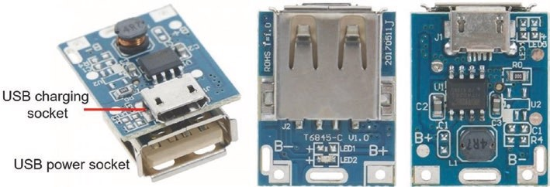
Figure 6-4. T6845 USB lithium-ion battery charge and boost converter module
For example, the T6845 USB lithium-ion battery charge and boost converter module boosts the battery 3.7 V voltage to the required 5 V at 1 A maximum current and incorporates battery protection, with the battery charged and battery discharged cut-off voltages of 4.2 V and 2.9 V, respectively. A USB charging cable is connected to the mini-USB socket of the T6845 USB lithium-ion battery charge and boost converter module for charging the 18650 lithium-ion rechargeable battery. A switch is fitted on the positive wire of a second USB charging cable that connects the USB power socket of the T6845 module to the mini-USB socket of the Bluetooth stereo audio receiver module (see Figure 6-5 with connections in Table 6- 2).
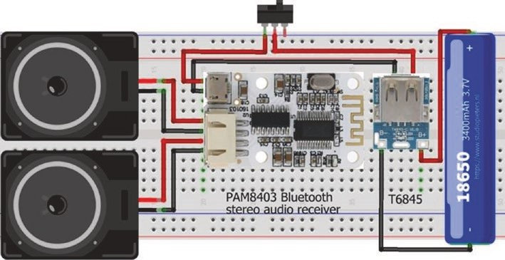
Figure 6-5. Bluetooth stereo audio receiver and T6845 USB lithium- ion battery charge and boost converter module
Table 6-2. T6845 USB lithium-ion battery charge and boost converter module connections
Component | Connect to
t6845 B+ | 18650 battery positive
t6845 B- | 18650 battery negative
t6845 usB power socket + | switch in
switch out | Bluetooth and paM8403 module 5V
t6845 usB power socket - | Bluetooth and paM8403 module GND
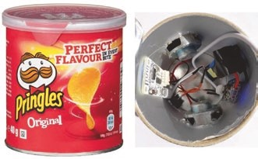
The 18650 lithium-i on battery and T6845 USB lithium-ion battery charge and boost converter module, the Bluetooth stereo audio receiver module with the PAM8403 class-D audio amplifier, and the speakers are easily incorporated in a cylindrical container, such as a 40 g Pringles box! While not an ESP8266 or ESP32 microcontroller project and not requiring any programming, the project does require some soldering.
Summary
A Bluetooth speaker was built with a Bluetooth stereo audio receiver module with the PAM8403 class-D audio amplifier, powered by a lithium- ion 18650 battery coupled with a MT3608 step-up DC-DC boost converter, with battery charging and discharging controlled by a TP4056 battery protection module. Alternatively, a T6845 USB lithium-ion battery charge and boost converter module replaced the combination of a TP4056 battery protection module with a MT3608 step-up DC-DC boost converter.
Components List
- Bluetooth stereo audio receiver module with the PAM8403 amplifier
- Step-up DC-DC boost converter: MT3608
- Battery protection module: TP4056 with DW01A IC
- USB lithium-ion battery charge and boost converter module: T6845
- Lithium-ion battery: 18650
- Speaker: 2× 3 W

CHAPTER 7
Wireless local area network
A wireless local area network (WLAN) is established with an ESP8266 or ESP32 microcontroller, with networked devices requesting information from the microcontroller (see Figure 7-1). The WLAN does not have Internet access. The microcontroller is the access point (AP) for the WLAN, consisting of the microcontroller and up to four devices, and is termed a software-enabled access point or SoftAP. If the microcontroller is connected to an existing Wi-Fi network, then the microcontroller is in station (STA) mode. The WLAN client is the browser on a laptop, an Android tablet, or a mobile phone. The client connects to the WLAN by selecting the WLAN name and the access password with the browser opened at the URL (Uniform Resource Locator) of the WLAN-predefined IP (Internet Protocol) address.
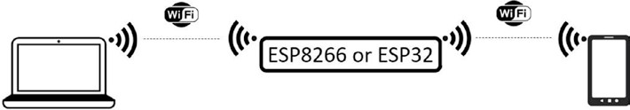
Figure 7-1. Wireless local area network with the ESP8266 or ESP32 microcontroller
© Neil Cameron 2021 159
N. Cameron, Electronics Projects with the ESP8266 and ESP32, https://doi.org/10.1007/978-1-4842-6336-5_7
To demonstrate establishing a WLAN with an ESP8266 or ESP32 microcontroller, the WLAN web page controls two LEDs, which are connected to the ESP8266 or ESP32 development board, and displays the LED states and a counter that is incremented when an LED state changes (see Figure 7- 2). The example demonstrates using a client to remotely control devices connected to an ESP8266 or ESP32 development board, which acts as a server, and the client receipt of information, in the form of HTML (HyperText Markup Language) code that is displayed on the WLAN web page.
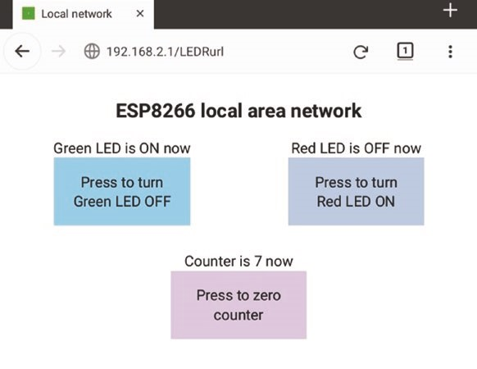
Figure 7-2. Wireless local area network web page
Clicking a button on the WLAN web page turns on or off the corresponding LED or resets the counter to zero. Schematics for the ESP8266 and ESP32 microcontrollers functioning as the WLAN server and connected to two LEDs are shown in Figure 7-3, with connections given in Table 7-1.
Wireless loCal area netWork
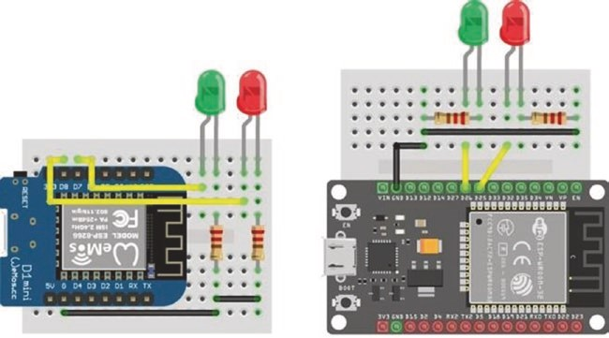
Figure 7-3. LOLIN (WeMos) D1 mini and ESP32 DEVKIT DOIT boards and LEDs
Table 7-1. ESP8266 and ESP32 development boards and LEDs
Component | ESP8266 Connections | ESP32 Connections
leD long leg | esp8266 D7 and D8 | esp32 Gpio 25 and Gpio 26
leD short leg | 220 Ω resistor esp8266 GnD | 220 Ω resistor esp32 GnD
The WLAN IP address is defined in the sketch, rather than using a generated IP address, along with the IP gateway and the IP subnet mask. The WLAN IP address and gateway are identical. The IP subnet mask of (255,255,255,0) for a class-C IP address, such as 192.168.2.1, indicates that the first three elements of the IP address, 192.168.2, define the WLAN ID and the last element defines the host ID. The WLAN password should contain at least eight alphanumeric characters. For example, instructions to set the WLAN SSID (Service Set Identifier), which is the network name, password, and IP address to ESP8266, 12345678, and 192.168.2.1 are
char ssidAP[] = "ESP8266"; // WLAN SSID char passwordAP[] = "12345678"; // and password
IPAddress local_ip(192,168,2,1); // pre-defined IP address,
IPAddress gateway(192,168,2,1); // gateway
IPAddress subnet(255,255,255,0); // and subnet mask
In the setup function of a sketch, the WLAN is initialized in access point (AP) mode with the instruction WiFi.mode(WIFI_AP). The default is joint access point and station mode, with the instruction WiFi.mode(WIFI_
AP_STA), and station (STA) mode is defined by the instruction WiFi.mode(WIFI_STA). The network IP address is defined with the instructions
WiFi.mode(WIFI_AP); // WLAN in AP mode
WiFi.softAP(ssidAP, passwordAP); // WLAN SSID, password
WiFi.softAPConfig(local_ip, gateway, subnet); // initialise WLAN
The WLAN or host IP address is displayed with the instructions
IPAddress IP = WiFi.softAPIP();
Serial.println(IP);
HTTP request
A client makes an HTTP request for information by sending a URL address to the server. The server calls a function mapped to the URL and responds to the client with HTML code for the information provided by the function. For example, a URL is mapped to a function that changes the state of an LED, with the LED state displayed on the WLAN web page. In Figure 7- 4, clicking a button on the WLAN web page sends an HTTP request containing
Wireless loCal area netWork
the URL, associated with the button, to the server, which is the ESP8266 or ESP32 microcontroller. The server calls the function that is mapped to the URL, to change the LED state and update the HTML code for the URL. The server HTTP response is to send the updated HTML code to the client, which updates the WLAN web page.
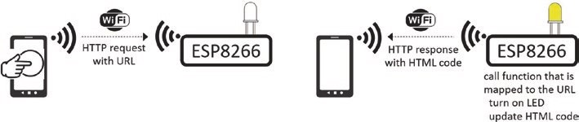
Figure 7-4. Client HTTP request and server HTTP response
The sketch in Listing 7-1 displays, on the WLAN web page, the states of a green LED and a red LED and the value of a counter that can be reset to zero. The LED states are controlled by the two functions LEDGfunct and LEDRfunct, with the function zeroFunct resetting the counter. The corresponding three URLs, /LEDGurl, /LEDRurl, and /zeroUrl, are mapped to the functions, by the server.on(URL, function) instruction.
The server HTTP response is made with the instruction server. send(status code, content type, content). Status code of 200 or 404 indicates a successful HTTP request or that the requested URL could not be found, respectively. The content type options are plain text, HTML code, or JSON text (described in Chapter 3 (International weather station) and Chapter 8 (Updating a web page)) as indicated by text/plain, text/ html, and text/json. When the content type is text/html, the HTML code is referenced by a string or a function. In Listing 7-1, the HTML code is referenced by the webcode function, which has three parameters for the states of the green LED, the red LED, and the counter value. The webcode function returns a string, page, which contains the HTML code for the WLAN web page. The server sends the HTML code to the client with the instruction server.send(200, "text/html", webcode(LEDG, LEDR, counter)).
In Listing 7-1, the WLAN SSID and password are defined with the WLAN IP, and URLs are mapped to the functions that control the LEDs and the counter and the HTML code for the WLAN web page is defined (see Listing 7-3). The ESP8266WebServer library references the ESP8266WiFi library, so the ESP8266WiFi library is not explicitly included in the sketch. Similarly, for the ESP32 microcontroller, the WiFi library is referenced by the WebServer library. The HTML code is contained in the buildpage.h tab to separate the HTML code from the main sketch. The additional tab is created in the Arduino IDE by selecting the triangle below the Serial Monitor button, on the right side of the IDE, and choosing New Tab from the drop-down menu. The New Tab is titled buildpage.h. Note that the loop function only includes the instruction server.handleClient().
Listing 7-1. WLAN and LED functions
#include <ESP8266WebServer.h> // include ESP8266WebServer lib ESP8266WebServer server; // associate server with library char ssidAP[] = "ESP8266"; // WLAN SSID and password char passwordAP[] = "12345678";
IPAddress local_ip(192,168,2,1); // pre-defined IP address values
IPAddress gateway(192,168,2,1);
IPAddress subnet(255,255,255,0);
#include "buildpage.h" // webpage HTML code int LEDGpin = D7; // define LED pins int LEDRpin = D8;
int LEDR = LOW; // default LED states int LEDG = LOW; int counter = 0;
void setup()
{
WiFi.mode(WIFI_AP); // Wi-Fi AP mode delay(1000); // setup AP mode
Wireless loCal area netWork
WiFi.softAP(ssidAP, passwordAP); // initialise Wi-Fi with
WiFi.softAPConfig(local_ip, gateway , subnet);
// predefined IP address
server.begin(); // initialise server server.on("/", base); // load default webpage server.on("/LEDGurl", LEDGfunct); // map URLs to functions: server.on("/LEDRurl", LEDRfunct); // LEDGfunct, LEDRfunct server.on("/zeroUrl", zeroFunct); // and zeroFunct pinMode(LEDGpin, OUTPUT); // define LED pins as output pinMode(LEDRpin, OUTPUT); }
void base() // function to load default webpage { // and send HTML code to client server.send(200, "text.html", webcode(LEDG, LEDR, counter)); }
void LEDGfunct() // function to change green LED state,
{ // increment counter and LEDG = !LEDG; // send HTML code to client digitalWrite(LEDGpin, LEDG); counter++; server.send(200, "text/html", webcode(LEDG, LEDR, counter)); }
void LEDRfunct() // function to change red LED state,
{ // increment counter and LEDR = !LEDR; // send HTML code to client digitalWrite(LEDRpin, LEDR); counter++; server.send(200, "text/html", webcode(LEDG, LEDR, counter));
}
void zeroFunct() // function to zero counter { // and send HTML code to client counter = 0; server.send(200, "text/html", webcode(LEDG, LEDR, counter)); }
void loop()
{
server.handleClient(); // manage HTTP requests
}
When the client initially loads the WLAN web page, the instruction server.on("/", base) calls the base function, which loads the default WLAN web page with values of LEDG, LEDR, and the counter set to LOW, LOW, and zero, respectively. The base function defines the default setting for the WLAN web page.
The server response to the client HTTP request is to update the relevant LED state, the counter value, and the HTML code for the WLAN web page. For example, if the button to turn on the red LED is clicked, then the client HTTP request contains the URL /LEDRurl, which is displayed at the top of the WLAN web page (see Figure 7-2). The server calls the associated LEDRfunct function, and the state of the red LED is changed from LOW or zero to HIGH or one, and the counter is incremented. The webcode function then updates the HTML code to include the lines
<td>Red LED is ON now<a href='/LEDRurl' class='btn on'>
Press to turn Red LED OFF</a></td>
When the server responds to the client by sending the updated HTML code, the WLAN web page displays the text Red LED is ON now, and the button text is updated to Press to turn Red LED OFF. On the web browser, the web page loading indicator, located beside the web page title, moves
Wireless loCal area netWork
across the web page as the web page loads and the URL 192.168.2.1/ LEDRurl is displayed.
Clicking the zero button sends the URL /zeroUrl to the server, and the counter value is reset to zero by the mapped function, zeroFunct.
The webcode function updates the HTML code <p>Counter is
"+String(counter)+" now<a href='/zeroUrl' with the counter value of zero, and the WLAN web page displays the text Counter is 0 now.
With an ESP8266 microcontroller as the WLAN access point, the web server library instructions are
#include <ESP8266WebServer.h>
ESP8266WebServer server
and the corresponding instructions for an ESP32 microcontroller are
#include <WebServer.h>
WebServer server(80); // requires a port number
Alternatively, at the start of a sketch, instructions in Listing 7-2 are included to accommodate both an ESP8266 and ESP32 microcontroller with the LED pin definitions.
Listing 7-2. Pin definitions for ESP8266 and ESP32 development boards
#ifdef ESP8266
#include <ESP8266WebServer.h> // include ESP8266 library ESP8266WebServer server;
int LEDGpin = D7; // define LED pins int LEDRpin = D8;
#elif ESP32
#include <WebServer.h> // include ESP32 library WebServer server (80);
int LEDGpin = 26; // define LED pins int LEDRpin = 25;
#else // Arduino IDE error message
#error "ESP8266 or ESP32 microcontroller only"
#endif
HTML code
A detailed description of HTML (HyperText Markup Language) is outside the scope of the book, but www.w3schools.com is recommended for information on HTML and CSS (Cascading Style Sheets), for building and defining the style of web pages.
Briefly, an HTML page consists of a <head> section, where the web page title and styles are defined, and a <body> section, which contains the web page content. The sections are bracketed with <head>...</head> and <body>...</body>. Style defines font types and sizes, headers, and spacing that is bracketed by <style>...</style>. A specific item on a web page is separately formatted and bracketed by <span>...</span>.
For example (see Listing 7-3), in the <head> section, the body style sets the top margin at 50 pixels (96 pixels per inch) and center-aligns text of size 20 pixels in Arial font. The button style, btn, defines a button width of 220 pixels, 30-pixel distance between buttons, and black button text of size 30 pixels. The parameters display:block enable wrap-around of the button text, margin:auto centers the button in the web page, and text- decoration:none prevents underlining of an HTML link. The on, off, and zero styles are combined with the button style to define button background color. Color details are available from www.w3schools.com/colors/ colors_hex.asp.
The web page includes a table with the content of a table row and a table cell bracketed by <tr>...</tr> and <td>...</td>, respectively. A table is used to align web page objects, such as the red and green LED buttons. The counter button is included in a paragraph, bracketed by <p>...</p>.
Wireless loCal area netWork
Listing 7-3. HTML code for WLAN web page
String webcode(int LEDG, int LEDR, int counter)
{
String page = "<!DOCTYPE html><html><head>"; page +="<title>Local network</title>"; page +="<style>"; page +="body {margin-top:50px; font-family:Arial;"; page +="font-size:20px; text-align:center}"; page +=".btn {display:block; width:220px;"; page += "margin:auto; padding:30px}"; page +=".btn {font-size:30px; color:black;"; page += "text-decoration:none}"; page +=".on {background-color:SkyBlue}"; page +=".off {background-color:LightSteelBlue}"; page +=".zero {background-color:Thistle}"; page +="td {font-size:30px; margin-top:50px;"; page += "margin-bottom:5px}"; page +="p {font-size:30px; margin-top:50px;"; page += "margin-bottom:5px}"; page +="</style></head>"; page +="<body>"; page +="<h1>ESP8266 local area network</h1>"; page +="<table style='width:100%'><tr>"; if(LEDG>0)
{
page +="<td>Green LED is ON now"; page +="<a href='/LEDGurl' class='btn on'>"; page +="Press to turn Green LED OFF</a></td>";
}

Wireless loCal area netWork
else
{
page +="<td>Green LED is OFF now"; page +="<a href='/LEDGurl' class='btn off'>"; page +="Press to turn Green LED ON</a></td>";
} if(LEDR>0)
{
page +="<td>Red LED is ON now"; page +="<a href='/LEDRurl' class='btn on' >"; page +="Press to turn Red LED OFF</a></td>";
} else
{
page +="<td>Red LED is OFF now"; page +="<a href='/LEDRurl' class='btn off'>"; page +="Press to turn Red LED ON</a></td>";
}
page +="</tr></table>"; page +="<p>Counter is "+String(counter); page +=" now<a href='/zeroUrl'"; page +="class='btn zero'>Press to zero counter</a></p>"; page +="</body></html>"; return page; }
HTML code for a web page can be included in the main sketch, but it is included as an additional tab, for example, buildpage.h, to separate the main sketch from the HTML code and make the sketch easier to interpret. The additional tab is created in the Arduino IDE by selecting the triangle below the Serial Monitor button, on the right side of the IDE, and choosing New Tab from the drop-down menu. The New Tab is titled buildpage.h.
Wireless loCal area netWork
The webcode function (see Listing 7-3) is contained in the buildpage.h tab, defined by the instruction #include "buildpage.h", in the first section of Listing 7-1. The buildpage.h tab is referenced with quotation marks, " ", and not with angular brackets, < >, which is for a library. The webcode function returns a string, page, containing the HTML code of the WLAN web page. The HTML code is built up line-by-line as a string and includes conditional statements to change the HTML code, depending on values of the LEDG, LEDR, and counter variables.
The whole web page is reloaded even if only one data value has changed. AJAX enables updating a web page with only the updated value, rather than reloading the whole web page.
When running the sketch in Listings 7-1 and 7-3, the browser, such as Google Chrome or Mozilla Firefox, on your laptop, Android tablet, or mobile must be connected to the server listed as ESP8266. The URL to access the web page is 192.168.2.1, as defined in Listing 7-1.
XML HTTP requests, JavaScript, and AJAX
An XML (eXtensible Markup Language) HTTP request updates a specific variable on a web page, rather than having to reload the whole web page. The combination of an XML HTTP request with JavaScript commands, to manage the XML HTTP request, is AJAX (Asynchronous JavaScript and XML). An example AJAX code for an XML HTTP request is given in Listing 7-4. When the response to the XML HTTP request is ready, indicated by a readyState value of 4, and if the XML HTTP request is successful, with a status value of 200 (see [1] in Listing 7-4), then the XML HTTP request object sends a request to the server to update information on the variable (see [2] in Listing 7-4) for the URL (see [3] in Listing 7-4). On the web browser, the web page loading indicator, located beside the web page title, is now absent. Further information on XML HTTP requests, JavaScript, and
AJAX is available at www.w3schools.com.
Listing 7-4. AJAX code for XML HTTP request
<script> // start of JavaScript var xhr = new XMLHttpRequest(); // XMLHttpRequest object xhr.onreadystatechange = function()
{ // [1] if request successful if(this.readyState == 4 && this.status == 200) document.getElementById(variable).innerHTML =
this.responseText; // [2] update variable
};
xhr.open('GET', URL, true); // [3] at URL xhr.send();
</script> // end of JavaScript
The XML HTML code is included as a string literal, as there are no variables in the code, which avoids the line-by-line build-up of a string for the HTML code, as used in Listing 7-3. The JavaScript and XML HTTP request instructions, stored as a string literal in PROGMEM, are bracketed by R"( and )", which can be extended to R"str( and )str", where str is a string of characters that does not appear in the AJAX code. An example string is === with R"(=== and ===)" bracketing the string literal. In JavaScript, both a single quote, ', or double quotes, ", are used to bracket a string, with single quotes preferred in the book.
Inclusion of XML HTTP requests requires changes to the main sketch and the HTML code. For the LEDGfunct, LEDRfunct, and zeroFunct functions of the main sketch in Listing 7-1, the instruction server.
send(200, "text/html", webcode(LEDG, LEDR, counter)) is replaced with server.send(200, "text/plain", str). Only the updated variable, contained in the string str, is sent by the server to the client for updating the web page, rather than the server sending HTML code for the whole
Wireless loCal area netWork
web page. For example, changes to the function LEDRfunct are indicated in bold, with the function LEDGfunct updated similarly:
void LEDRfunct() // function to change red LED state
{
LEDR = !LEDR; // change LED state digitalWrite(LEDRpin, LEDR);
counter++; // increment counter String str = "ON";
if(LEDR == LOW) str = "OFF"; // map string str to LED state server.send(200, "text/plain", str); // send response to client
}
The function zeroFunct is also changed to only send the updated counter value:
void zeroFunct() // function to zero counter
{
counter = 0; // reset counter
String str = String(counter); // convert counter to a string server.send(200, "text/plain", str); // send response to client
}
The base function sends the default web page HTML code to the client with the parameter page, rather than calling the webcode function.
The HTML and AJAX code is shown in Listing 7-6. The <style> section is identical, in content, to the <style> section in Listing 7-3. The <body> section now includes HTML code for the web page layout and AJAX code for the XML HTTP requests to update the web page. JavaScript scripts, bracketed by <script> and </script>, are positioned prior to the HTML </body> code to improve web page display speed.
Differences between the HTML code in Listing 7-2 and the AJAX code in Listing 7-6 are illustrated with respect to the button controlling the green LED. In Listing 7-2, the HTML code for the table cell containing the button for the green LED, when the green LED is on, is
<td>Green LED is ON now<a href='/LEDGurl' class='btn on'>
Press to turn Green LED OFF</a></td>
and the HTML code for when the green LED is off is
<td>Green LED is OFF now<a href='/LEDGurl' class='btn off'>
Press to turn Green LED ON</a></td>
For each state of the green LED, the HTML code specifies the text above the button, the URL associated with the button, a href='/LEDGurl', the button class, and the text on the button.
In Listing 7-6, the HTML code to update the web page button to control the green LED is
<td>Green LED is <span id='LEDG'>OFF</span> now</td>
<td><button class = 'btn off' id='Green LED'
onclick = 'sendData(id)'>Press to turn Green LED ON </button></td>
The HTML code specifies the text above the button with the green LED state held by the variable with identity 'LEDG', which has a default value of OFF, the button class, and the text on the button. Clicking the button, with identity defined by id='Green LED', calls the function sendData with the button identity parameter.
The AJAX code for the sendData function relevant to controlling the green LED button is given in Listing 7-5. The sendData function updates the button state to btn on or btn off and the button text to Press to turn Green LED ON or Press to turn Green LED OFF. The sendData function sets the values of variable for the XML HTTP request instructions and URL
Wireless loCal area netWork
document.getElementById(variable).innerHTML = this.responseText xhr.open('GET', URL, true)
and, finally, sends the XML HTTP response. Listing 7-5. AJAX code for updating a variable
function sendData(butn)
{
if(butn == 'Red LED' || butn == 'Green LED')
{
var state = document.getElementById(butn).className; state = (state == 'btn on' ? 'btn off' : 'btn on'); text = (state == 'btn on' ? butn + ' OFF' : butn + ' ON'); document.getElementById(butn).className = state;
document.getElementById(butn).innerHTML = 'Press to turn ' + text;
}
var URL, variab, text;
else if(butn == 'Green LED')
{
URL = 'LEDGurl'; variab = 'LEDG';
}
var xhr = new XMLHttpRequest(); xhr.onreadystatechange = function(butn)
{
if (this.readyState == 4 && this.status == 200) document.getElementById(variab).innerHTML = this.
responseText;
};
xhr.open('GET', URL, true); xhr.send(); }
The complete AJAX code to manage XML HTTP requests and update the web page, when a button to control the red or green LED or to zero the counter is clicked, is given in Listing 7-6.
Listing 7-6. AJAX code for WLAN web page
char page[] PROGMEM = R"( <!DOCTYPE html><html><head>
<title>Local network</title>
<style>
body {margin-top:50px; font-family:Arial} body {font-size:20px; text-align:center}
.btn {display:block; width:280px; margin:auto; padding:30px}
.btn {font-size:30px; color:black; text-decoration:none}
.on {background-color:SkyBlue}
.off {background-color:LightSteelBlue}
.zero {background-color:Thistle}
td {font-size:30px; margin-top:50px; margin-bottom:5px} p {font-size:30px; margin-top:50px; margin-bottom:5px}
</style></head>
<body>
<h1>ESP8266 local area network</h1>
<table style='width:100%'><tr>
<td>Green LED is <span id='LEDG'>OFF</span> now</td>
<td>Red LED is <span id='LEDR'>OFF</span> now</td>
</tr></table>
<table style='width:100%'><tr>
<td><button class = 'btn off' id='Green LED'
onclick = 'sendData(id)'>Press to turn Green LED ON </button></td>
Wireless loCal area netWork
<td><button class = 'btn off' id='Red LED'
onclick = 'sendData(id)'>Press to turn Red LED ON </button></td>
</tr></table>
<p>Counter is <span id='counter'>0</span> now</p>
<button class = 'btn zero' id = 'zero'
onclick = 'sendData(id)'>Press to zero counter</button>
<script>
function sendData(butn)
{
var URL, variab, text; if(butn == 'Red LED') // set URL and variab values
{ // for Red LED button URL = 'LEDRurl'; variab = 'LEDR';
} else if(butn == 'Green LED') // or for Green LED button
{
URL = 'LEDGurl'; variab = 'LEDG';
} else if(butn == 'zero') // or for the zero button
{
URL = 'zeroUrl'; variab = 'counter';
}
if(butn == 'Red LED' || butn == 'Gree n L ED') { // change button class and text var state = document.getElementById(butn).className; state = (state == 'btn on' ? 'btn off' : 'btn on'); text = (state == 'btn on' ? butn + ' OFF' : butn + ' ON'); document.getElementById(butn).className = state;
document.getElementById(butn).innerHTML = 'Press to turn ' + text;
}
var xhr = new XMLHttpRequest(); xhr.onreadystatechange = function(butn)
{
if (this.readyState == 4 && this.status == 200) document.getElementById(variab).innerHTML = this.
responseText;
};
xhr.open('GET', URL, true); xhr.send();
}
</script>
</body></html>
)";
When the buttons that control the red and green LEDs are clicked, an XML HTTP request is made by the client to update values of the LED states, but the counter is not automatically updated. The interval between repeated XML HTTP requests is defined with the instruction setInterval(reload, 1000), with the reload function making an XML HTTP request every 1000 ms, as shown in Listing 7-7. In the main sketch, the /countURL URL is mapped to the countFunct function with the instruction server.on("/countUrl", countFunct) included in the setup function. Instructions for the countFunct function are
Wireless loCal area netWork
void countFunct() // function to update counter
{
String str = String(counter); // convert counter to a string server.send(200, "text/plain", str); // send response to client
}
The AJAX code to periodically update the counter in Listing 7-7 is incorporated between the <script> and </script> instructions in Listing 7-6.
Listing 7-7. AJAX code to periodically update the counter
setInterval(reload, 1000); function reload()
{
var xhr = new XMLHttpRequest(); xhr.onreadystatechange = function()
{
if(this.readyState == 4 && this.status == 200) document.getElementById('counter').innerHTML = this.
responseText;
};
xhr.open('GET', 'countUrl', true); xhr.send(); }
The two approaches, with HTML code and with AJAX code, result in the same information being displayed on the web page, but with HTML code, the whole web page is reloaded with every client request. In contrast, with AJAX code, only a specific variable is updated on the web page. The AJAX code is double the length of the HTML code and may be more difficult to interpret. Updating only the specific item on a web page, rather than reloading the whole web page, is advantageous for web pages containing substantial information.

Wireless loCal area netWork
Summary
A wireless local area network was established with an ESP8266 or ESP32 microcontroller, as the WLAN server. The browser of an Android tablet or mobile phone, which is the client, accessed the WLAN using an IP address and password defined by the sketch. The WLAN web page displayed the states of two LEDs, connected to the ESP8266 or ESP32 development board, and a counter value. The LED states were remotely controlled by clicking the client web page buttons. The web page HTML code was built line-by-line as a string, and the whole web page had to be reloaded when updated information was displayed. AJAX code consisting of XML HTTP requests and JavaScript instructions, incorporated as a string literal, enabled updating of only specific variables on the web page, rather than reloading the whole web page.
Components List
- ESP8266 microcontroller: LOLIN (WeMos) D1 mini or NodeMCU board
- ESP32 microcontroller: ESP32 DEVKIT DOIT or NodeMCU board
- LED: 2×
- Resistor: 2× 220 Ω
CHAPTER 8
Updating a web page
Devices connect to a wireless local area network (WLAN) with Wi-Fi communication (see Chapter 7 (Wireless local area network)). A router connected to an Internet Service Provider (ISP), through a telephone line using DSL (Digital Subscriber Line) technology, provides access to the Internet (see Figure 8-1). The Internet is formed by interconnected computer networks using the Internet Protocol suite, consisting of the Transmission Control Protocol and the Internet Protocol (TCP/IP), to globally link devices. The World Wide Web (WWW) identifies information resources by URLs (Uniform Resource Locators). The client or web browser, such as Google Chrome or Mozilla Firefox, sends an HTTP (HyperText Transfer Protocol) request to the server device hosting the resource to retrieve information at the web address defined by the URL. The server responds to the client HTTP request, and the client displays the requested web page information on the Android tablet or mobile phone. The client must request web page information from the server, as the server cannot impose updates on the client. The exception is WebSocket, as discussed in Chapter 9.
© Neil Cameron 2021 181
N. Cameron, Electronics Projects with the ESP8266 and ESP32, https://doi.org/10.1007/978-1-4842-6336-5_8
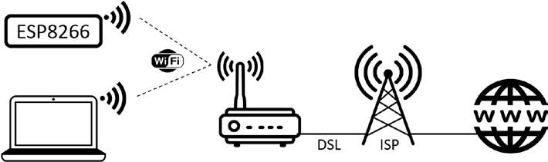
Figure 8-1. Client, Internet Service Provider, and WWW
In this chapter, an ESP8266 or an ESP32 microcontroller is the server.
The web server library instructions for the ESP8266 development board are
#include <ESP8266WebServer.h>
ESP8266WebServer server and for the ESP32 development board are
#include <WebServer.h>
WebServer server(80); // requires a port number
To demonstrate the process of a client requesting information from a server, the sketch in Listing 8-1 displays the BMP280 temperature reading, a counter, and the state of an LED (see Figure 8-2). The web page is automatically refreshed, and the reloading time is determined by the web page HTML code <meta http-equiv='refresh' content='N'>, with a refresh every N seconds. A function, BMP, updates the BMP280 temperature reading, increments the counter, and changes the LED state; and the server then sends the updated web page HTML code to the client. The timing of the BMP function is controlled by the Ticker library, with the instruction timer.attach(T, BMP), and the BMP function is called every T seconds. If the web page refresh interval, N, is substantially less than the BMP function call interval, T, then the client will wait (T – N) seconds before the server sends the updated HTML code. In Listing 8-1, the BMP function call interval equals N + 1 seconds, but not N seconds as the server and client are not synchronized.

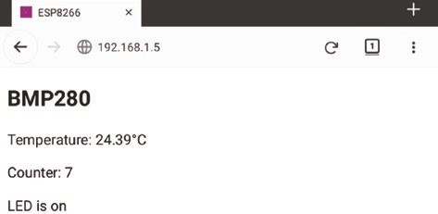
Figure 8-2. BMP280 and LED counter web page
Figure 8-3 shows the BMP280 temperature sensor and LED with an ESP8266 and ESP32 development board. Connections are given in Table 8-1. The Adafruit_BMP280 library is available within the Arduino IDE.
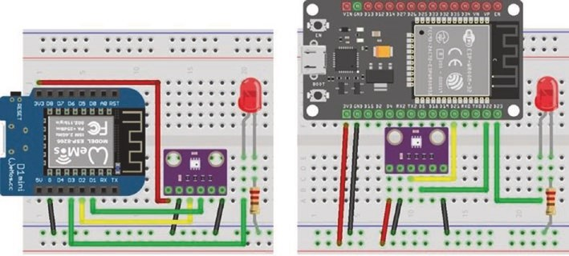
Figure 8-3. BMP280 and LED with LOLIN (WeMos) D1 mini and ESP32 DEVKIT DOIT
Table 8-1. BMP280 and LED with ESP8266 and ESP32 development boards
Component | ESP8266 Connections |  | ESP32 Connections
bMp280 VCC | 3V3 |  | 3V3
bMp280 gnd | gnd |  | gnd
bMp280 Sda | d2 |  | gpiO 21
bMp280 SCK | d1 |  | gpiO 22
bMp280 Sd0 | gnd |  | gnd
Led long leg | d3 |  | gpiO 23
Led short leg | 220 Ω resistor | gnd | 220 Ω resistor | gnd
In the setup function of Listing 8-1, the Wi-Fi connection is established, the server IP address is displayed on the Serial Monitor, the WLAN web page is mapped to the webcode function, and the timing of the BMP function is defined. The ESP8266WiFi library is referenced by the ESP8266WebServer library, so does not need to be explicitly included in the sketch, similarly for the ESP32 microcontroller with WebServer and WiFi libraries. The webcode function returns a string, page, containing the web page HTML code with updated values of the temperature, counter, and LED state. There are no conditional statements in the HTML code, as in Chapter 7 (Wireless local area network), so the web page URL is mapped to the webcode function directly. A line-by-line build-up of the HTML code incorporates the variables temp, counter, and LED, which are not constant, so HTML code cannot be included as a string literal. Variable values in HTML code are enclosed in single quotes, as in the instruction "<meta http-equiv='refresh' content='9'>" with the HTML code enclosed in double quotes to indicate a string.
Listing 8-1. HTTP request with BMP280 and LED
#include <ESP8266WebServer.h> // include ESP8266WebServer lib ESP8266WebServer server; // associate server with library char ssid[] = "xxxx"; // change xxxx to Wi-Fi SSID char password[] = "xxxx"; // change xxxx to Wi-Fi password
#include <Adafruit_Sensor.h> // include Unified Sensor
#include <Adafruit_BMP280.h> // and BMP280 libraries Adafruit_BMP280 bmp; // associate bmp with BMP280 int BMPaddress = 0x76; // I2C address of BMP280
#include <Ticker.h> // include Ticker library Ticker timer; // associate timer with Ticker lib int lag = 10; // set timer interval at 10s int LEDpin = D3; // LED pin on D3 String LED = "off"; // initial LED state int count = 0; String temp, counter;
void setup()
{
Serial.begin(115200); // Serial Monitor baud rate WiFi.begin(ssid, password); // initialise Wi-Fi while (WiFi.status() != WL_CON NECTED) delay(500); // wait for Wi-Fi connect Serial.print("IP address: ");
Serial.println(WiFi.localIP()); // display server IP address server.begin();
server.on("/", webcode); // map URL to function bmp.begin(BMPaddress); // initialise BMP280 timer.attach(lag, BMP); // BMP called every lag seconds pinMode(LEDpin, OUTPUT); digitalWrite(LEDpin, LOW); // turn off LED }
void BMP() // function to get readings
{
temp = String(bmp.readTemperature()); // update BMP280 reading counter = String(count++); // increment counter digitalWrite(LEDpin, !digitalRead(LEDpi n));
// turn on or off the LED
if(LED == "on") LED = "off"; // update LED state else LED = "on";
server.send (200, "text/html", webcode( ));
} // send response to client
String webcode() // return HTML code
{
String page;
page = "<!DOCTYPE html><html><head>"; // refresh every 9s page += "<meta http-equiv='refresh' con tent= '9'>"; page += "<title>ESP8266</title></head>"; page += "<body>";
page += "<h2>BMP280</h2>"; // display temp page += "<p>Temperature: " + temp + " " + "& degC</p>"; page += "<p>Counter: " + counter + "</p>"; // counter page += "<p>LED is " + LED + "<p>"; // LED state page += "</body></html>"; return page; }
void loop()
{ server.handleClient(); // manage HTTP requests }
The client HTTP request results in the server sending the HTML code for the whole web page with the whole web page then reloaded. The web page in Listing 8-1 is for example purposes only, but if the web page contained more information and images, then the time to reload the whole web page would be important.
Listing 8-1 is for an ESP8266 microcontroller. The only changes to the sketch for an ESP32 microcontroller are including the WebServer library, rather than the ESP8266WebServer library, and defining the LED pin. An alternative to microcontroller-specific sketch instructions is to use the compiler directive equivalent of an if..then..else group for conditional compilation of the sketch. Instructions for both the ESP8266 and ESP32 microcontrollers are included in the sketch. If the microcontroller is not an ESP8266 or ESP32, then an error message is displayed in the Arduino IDE. Further details are included in Chapter 21 (Microcontrollers). For example, Listing 8-2 contains the instructions to include at the start of Listing 8-1.
Listing 8-2. Pin definitions for ESP8266 and ESP32 development boards
#ifdef ESP32
#include <WebServer.h> // include ESP32 library WebServer server (80); // and define LED pin int LEDpin = 23;
#elif ESP8266
#include <ESP8266WebServer.h> // include ESP8266 library ESP8266WebServer server; // and define LED pin int LEDpin = D3;
#else // Arduino IDE error message
#error "ESP8266 or ESP32 microcontroller only"
#endif
XML HTTP requests, JavaScript, and AJAX
Chapter 7 (Wireless local area network) describes updating a specific variable on a web page with an XML HTTP request, rather than having to reload the whole web page. Converting the sketch in Listing 8-1 from HTML code to AJAX code does not require the Ticker library, so the following instructions are deleted
#include <Ticker.h>
Ticker timer int lag = 10 timer.attach(lag, BMP)
as timing of web page updates is managed by AJAX code. The BMP function in Listing 8-1 is no longer required and is split into three functions, tempFunct, countFunct, and LEDfunct, to update the BMP280 temperature reading, increment the counter, and change the LED state.
Each function sends updated information for one variable to the client. The base function replaces the webcode function, in Listing 8-1, and sends the default web page HTML code to the client when the web page is initially loaded. URLs are mapped to the four functions with the instructions
server.on("/", base); server.on("/tempUrl", tempFunct); server.on("/countUrl", countFunct); server.on("/LEDurl", LEDfunct);
The sketch in Listing 8-3 lists the functions to source data and instruct the server to send the information to the client. Note that the parameters “text/html” and page are included in the base function for the server to return HTML code to the client, while the tempFunct, countFunct, and LEDfunct functions include “text/plain” and the variable name.
Listing 8-3. XML HTTP requests for the BMP280 temperature, counter, and LED state
void base() // function to load default webpage { // and send HTML code to client server.send (200, "text/html", page); }
void tempFunct() // function to get temperature reading
{ // and send value to client
temp = String(bmp.readTemperature()); server.send (200, "text/plai n", temp);
} // send plain text not HTML code
void countFunct() // function to increment counter { // and send value to client
counter = String(count++); server.send (200, "text/plain", counter); }
void LEDfunct() // function to update LED { // and send LED state to client
digitalWrite(LEDpin, !digitalRead(LEDpin)); if(LED == "on") LED = "off"; else LED = "on"; server.send (200, "text/plain", LED); }
Listing 8-4 contains the AJAX code for the web page and XML HTTP requests, defined as a string literal. The AJAX code is contained in the buildpage.h tab to separate the AJAX code from the main sketch with the instruction #include "buildpage.h". The additional tab is created in the Arduino IDE by selecting the triangle below the Serial Monitor button, on the right side of the IDE, and choosing New Tab from the drop-down menu. The New Tab is titled buildpage.h. Note that the loop function only includes the instruction server.handleClient().
The <body> section contains the web page HTML code; and the variables tempId, countId, and LEDid correspond to the XML HTTP requests. The JavaScript instruction setInterval(function, time) controls the time interval, in milliseconds, between the XML HTTP requests, which is five seconds for the reload function to obtain the temperature reading and one second for the counter and LED state. JavaScript scripts, bracketed by <script>...</script>, are positioned prior to the HTML </body> code to improve web page display speed.
The whole web page is no longer reloaded when the temperature or LED state is updated, as only specific variables are renewed. On the web browser, the web page loading indicator, located beside the web page title, is now absent.
Listing 8-4. AJAX request with BMP280 and LED
char page[] PROGMEM = R"(
<!DOCTYPE html><html>
<head><title>ESP8266</title></head>
<body>
<h2>BMP280</h2>
<p>Temperature: <span id = 'tempId'>0</span>&degC</p>
<p>Counter: <span id = 'countId'>0</span></p>
<p>LED is <span id = 'LEDid'> </span><p>
<script>
setInterval(reload, 5000); // time in milliseconds function reload() // reload function called every 5s { // to get tempId from tempUrl var xhr = new XMLHttpRequest();
xhr.onreadystatechange = function()
{
if(this.readyState == 4 && this.status == 200) document.getElementById('tempId').innerHTML = this.responseText;
};
xhr.open('GET', 'tempUrl', true); xhr.send(); }
setInterval(LEDreload, 1000); function LEDreload() // LEDreload function called every 1s { // to get countId from countUrl var xhr = new XMLHttpRequest(); // and LEDid from LEDurl xhr.onreadystatechange = function()
{
if(this.readyState == 4 && this.status == 200) document.getElementById('countId').innerHTML = this.responseText;
};
xhr.open('GET', 'countUrl', true); xhr.send();
var xhr = new XMLHttpRequest(); xhr.onreadystatechange = function()
{
if(this.readyState == 4 && this.status == 200) document.getElementById('LEDid').innerHTML = this.responseText;
};
xhr.open('GET', 'LEDurl', true); xhr.send();
}
</script>
</body></html>
)";
Each variable displayed on the web page is associated with an XML HTTP request, the URL associated with the variable, and a function to obtain the variable value. For consistency and to make the sketch more readily interpretable, a variable named X is referenced as Xid in the web page HTML code and XML HTTP request, and the URL is referenced as Xurl in both the setup function of the main sketch and the XML HTTP request, with the function sourcing the variable value referenced as Xfunct in the main sketch.
JSON
In Listing 8-3, each variable was associated with a specific function attached to a specific URL; and in Listing 8-4, each variable was updated by a separate XML HTTP request. For data collected simultaneously, it is more efficient to have one XML HTTP request for all variables and one function, attached to one URL, to source the information. JSON (JavaScript Object Notation) combines several variable values as text, which are sent by the server to the client. The client parses the JSON text to the component variables when updating the web page. JSON text consists of variable name and value pairs, each in double quotes and separated by a colon, with variable name and value pairs separated by a comma and the JSON text contained in curly brackets, {}. An example JSON text with three variable name and value pairs is {"device": "LED", "state": "off", "pin": "15"}.
In Listing 8-4, the counter and LED state are updated simultaneously, so two XML HTTP requests, two URLs, and two functions are combined. The combined URL, "/countLEDurl", and combined function,
countLEDfunct, are defined by the instruction server.on("/countLEDurl", countLEDfunct) in the setup function of the main sketch. The countLEDfunct function in the main sketch consists of the instructions
void countLEDfunct()
{
count++; // increment count digitalWrite(LEDpin, !digitalRead(LEDpi n));
// turn on or off the LED
if(LED == "on") LED = "off"; // update LED state else LED = "on";
JsonConvert(count, LED); // convert to JSON text server.send (200, "text/json", json); // send JSON text to client
}
The string json is defined in the main sketch, with the instruction String json. Note the server.send() instruction indicates that JSON text is being sent. The JsonConvert function, to combine the integer count and string LED into JSON text, consists of the instructions
String JsonConvert(int val1, String val2)
{
json = "{\"var1\": \"" + String(val1) + "\","; json += " \"var2\": \"" + val2 + "\"}"; return json; }
which produce the JSON text of {"var1": "123", "var2": "off"} when the counter, val1, is equal to 123 and the LED state, val2, is off. The character pair, \", which is underlined to emphasize that the characters are paired, is interpreted as a double quote character and not an end of a string indicator. The \ character is termed the backslash escape character. The HTML code to display the counter and LED state is changed to
<p>Counter: <span id = 'var1'>0</span></p>
<p>LED is <span id = 'var2'> </span><p>
which references the JSON names of var1 and var2. The JavaScript code to process the text sent by the server
document.getElementById('Xid').innerHTML = this.responseText
is changed to
var obj = JSON.parse(this.responseText); document.getElementById('var1').innerHTML = obj.var1 document.getElementById('var2').innerHTML = obj.var2
which parses the JSON text into the two name and value pairs for the counter, var1, and LED state, var2.
Listing 8-5 contains the updated AJAX code for the web page by combining the two XML HTTP requests and two URLs for the counter and LED state in Listing 8-4 and parsing JSON text, with the updates highlighted in bold.
Listing 8-5. AJAX code with JSON parsing
char page[] PROGMEM = R"(
<!DOCTYPE html><html>
<head><title>ESP8266</title></head>
<body>
<h2>BMP280</h2>
<p>Temperature: <span id = tempId>0</span>&degC</p>
<p>Counter: <span id = 'var1'>0</span></p>
<p>LED is <span id = 'var2'> </span><p>
<script>
setInterval(reload, 5000); // time in milliseconds
function reload() // update the temperature every 5s {
var xhr = new XMLHttpRequest(); xhr.onreadystatechange = function()
{
if(this.readyState == 4 && this.status == 200)
{document.getElementById('tempId').innerHTML = this.
responseText;}
};
xhr.open('GET', '/tempUrl', true); xhr.send(); }
setInterval(countLEDreload, 1000); function countLEDreload() // update the counter and { // LED state every second var xhr = new XMLHttpRequest(); xhr.onreadystatechange = function()
{
if(this.readyState == 4 && this.status == 200) { // parse JSON text var obj = JSON.parse(this.responseText); document.getElementById('var1').innerHTML = obj.var1; document.getElementById('var2').innerHTML = obj.var2;
}
};
xhr.open('GET', '/countLEDurl', true); xhr.send();
}
</script>
</body></html>
)";
Accessing WWW data
Displaying, on a web page, data supplied by an ESP8266 or ESP32 microcontroller does not require access to the Internet, as a WLAN to connect the client with the server can be established by the microcontroller, acting as the server, as discussed in Chapter 7 (Wireless local area network). To demonstrate displaying data accessed from the World Wide Web, date and time information is accessed from the websites www.calendardate.com/todays.htm and 24timezones.com/Edinburgh/ time, with temperature and humidity for Edinburgh, Scotland, accessed from the website www.metoffice.gov.uk.
Information is obtained with an API (Application Programming
Interface) key, to retrieve data using HTTP requests, which is issued by ThingSpeak (www.thingspeak.com). Under the ThingSpeak Apps menu, the ThingHTTP option generates an API key to access a specific item on a given web page. For example, an API key to source the current time from the 24timezones.com/Edinburgh/time website is generated by rightclicking the displayed time and selecting Inspect Element (Q). On the displayed Web Console, click the three dots and select Dock to Right. The HTML code corresponding to the selected time is highlighted in blue, and moving the cursor over the HTML code generates a box surrounding the selected item on the web page. Right-click the highlighted HTML code and select Copy and XPath. On the web page thingspeak.com/apps/ thinghttp, select New ThingHTTP, and enter a name for the API and the URL of the web page containing the data, for example, 24timezones.com/ Edinburgh/time, and in the Parse String box, paste the copied XPath and click Save ThingHTTP. An API key is generated by ThingSpeak to access the required information, which is tested by loading a web page with URL api.thingspeak.com/apps/thinghttp/send_request?api_key=API key.
If the ThingSpeak API key returns the message “Error parsing document, try a different parse string,” then an alternative data source on the web page or a linked web page is required.
Information obtained with a ThingSpeak API key will require parsing. For example, date and time information is generated as <p>Today's Date is Monday June 15, 2020</p> and 6:05:34 PM, Monday 15, June 2020, respectively, while temperature and humidity are provided in HTML code as <div data-value=“14.66”>15°</div> and <span class=“humidity” data- type=“percentage” data-value=“90”>90%</span>, respectively. The date substring is generated as the text following the text is. The time substring is text prior to the comma. Both the temperature and humidity substrings are bracketed by the = and > characters. The toInt and toFloat functions extract an integer and a real number, respectively, from a string, provided the first character of the string is a digit.
The sketch in Listing 8-6 accesses the current date, time, temperature, and humidity with ThingSpeak API keys and parses the information into a JSON string for inclusion in the server response to the client HTTP request. Note that the web page updates at 30 second intervals, so the initial values are all zero.
Listing 8-6. Parsing data accessed with ThingSpeak API keys
#include <ESP8266WebServer.h> // include web server library
ESP8266WebServer server; // associate server with library
WiFiClient client; // associate client with Wi-Fi library
#include "buildpage.h" // webpage AJAX code char ssid[] = "xxxx"; // change xxxx to your Wi-Fi SSID char password[] = "xxxx"; // change xxxx to your Wi-Fi password char APItime[] = "xxxx";
char APIdate[] = "xxxx"; // change xxxx to ThingSpeak API key char APItemp[] = "xxxx"; char APIhumid[] = "xxxx"; char url[] = "/apps/thinghttp/send_request?api_key="; char host[] = "api.thingspeak.com"; int indexS, indexF, chk, humid; float temp;
String data, ndata, text, json, mdy, tim;
void setup()
{
Serial.begin(115200); // Serial Monitor baud rate WiFi.begin(ssid, password); // connect and initialise Wi-Fi
while (WiFi.status() != WL_CONNECTED) delay(500);
Serial.print("IP address: ");
Serial.println(WiFi.localIP()); // display server IP address server.begin(); // initialise server server.on("/", base); // load default webpage server.on("/API", APIfunct); }
void APIfunct()
{
getData(APIdate, "date"); // call function to access date
getData(APItime, "time"); // time getData(APItemp, "temp"); // temperature getData(APIhumid, "humid"); // humidity
JsonConvert(mdy, tim, temp, humid); // convert to JSON text server.send (200, "text/json", json); }
String JsonConvert(String val1, String val2, float val3, int val4)
{
json = "{\"var1\": \"" + val1 + "\","; // start with { json += " \"var2\": \"" + val2 + " \",";
// end with comma
json += " \"var3\": \"" + String(val3) + "\","; json += " \"var4\": \"" + String(val4) + " \"}"; // end with } return json;
}
void getData(String APIkey, String text) // function to access data
{ for (int i=0; i<5; i++) // with up to five attempts
{
getVal(APIkey, text); // call function to get information if(chk > 0) i = 5; // data accessed successfully
}
}
void getVal(String APIkey, Stri ng text)
{ // function to access information chk = 0;
Serial.print("sourcing ");Serial.println(text); client.connect(host, 80); client.println(String("GET ") + url + APIkey); client.println(String("Host: ") + host); client.println("User-Agent: ESP8266/0.1"); client.println("Connection: close"); client.println(); client.flush(); delay(100); while(client.connected()) // while connected to ThingSpeak
{ if(client.available()) // if data is available { // read data till end of line data = client.readStringUnti l('\n'); Serial.println(data); if(text == "humid") // parse humidity data
{
indexS = data.lastIndexOf("="); // position of last "=" in string
indexF = data.indexOf("%"); ndata = data.substring(indexS+2, indexF-2); humid = ndata.toInt(); chk = data.length();
} else if(text == "temp") // parse temperature data
{
indexS = data.indexOf("="); // position of first "=" in string
ndata = data.substring(indexS+2); temp = ndata.toFloat(); chk = data.length();
} else if(text == "date") // date: day month dd, yyyy
{
indexS = data.indexOf("is"); mdy = data.substring(indexS+2); chk = data.length();
} else if(text == "time") // time: hh:mm:ss AM or PM
{
indexF = data.indexOf(","); tim = data.substring(0, indexF); chk = data.length();
}
client.stop(); // close connection after data collected delay(100);
}
}
} void base() // function to return HTML code
{
server.send (200, "text/html", page);
}
void loop()
{
server.handleClient(); // handle HTTP requests
}
The parsed information is displayed on a web page at 30-second intervals (see Listing 8-7), for example purposes only as weather doesn't generally change that fast. Different time intervals can be selected for the date, time, and weather parameters by defining separate reload functions with appropriate time intervals.
Listing 8-7. AJAX code with JSON parsing
char page[] PROGMEM = R"(
<!DOCTYPE html><html>
<head><title>ESP8266</title></head>
<body>
<h2>BMP280</h2>
<p>Date: <span id = 'var1'>00 000 0000</span></p>
<p>Time1: <span id = 'var2'>00:00:00</span></p>
<p>Temp is <span id = 'var3'>0</span>&degC<p>
<p>Humidity is <span id = 'var4'>0</span>%<p>
<script>
setInterval(APIreload, 30000); // time in milliseconds function APIreload()
{
var xhr = new XMLHttpRequest(); xhr.onreadystatechange = function()
{
if(this.readyState == 4 && this.status == 200)
{
var obj = JSON.parse(this.responseText); document.getElementById('var1').innerHTML = obj.var1; document.getElementById('var2').innerHTML = obj.var2; document.getElementById('var3').innerHTML = obj.var3; document.getElementById('var4').innerHTML = obj.var4;
}
};
xhr.open('GET', 'API', true); xhr.send();
}
</script>
</body></html>
)";
MQTT broker and IFTTT
Communication between devices on different Wi-Fi networks requires a different solution than communication between devices within a Wi-Fi network. The MQTT (Message Queuing Telemetry Transport) protocol enables communication between devices and an MQTT broker to pass information between it and one device and between it and a second device, with the two devices on different Wi-Fi networks. The MQTT broker enables data transfer between devices without breaching firewall safeguards. When a device on one Wi-Fi network requests information from a second device on another network, the information is allowed through the network firewall, as the request came from the Wi-Fi network. Provision of information to the MQTT broker is termed publish, and subscribe is the term to access information from the MQTT broker. There are several MQTT brokers, and the Cayenne MQTT broker is used in this chapter.
Cayenne (see mydevices.com/cayenne/features) provides a dashboard to display information from devices connected to an ESP8266 or ESP32 microcontroller (see Figure 8-4). The Cayenne dashboard is visible locally
or remotely on cayenne.mydevices.com/cayenne/dashboard/start.
Information from devices is displayed numerically, as a dial, or graphically, with binary variables displayed as ON/OFF. A device is turned on or off from the Cayenne dashboard, which provides both local and remote access to a device.
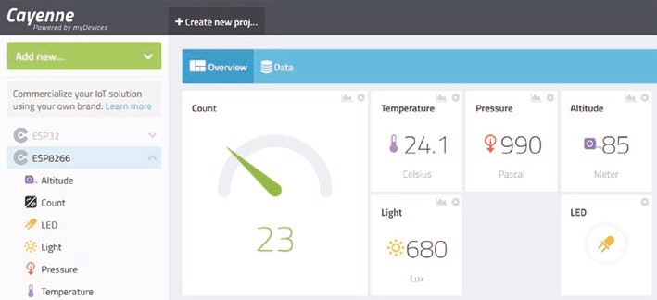
Figure 8-4. Cayenne dashboard
An IFTTT (If This, Then That) function enables event triggering based on sensors connected to an ESP8266 or ESP32 development board and visible on the Cayenne dashboard. For example, if the incident light on a light-dependent resistor (LDR) increases above a threshold due to a door opening or time of day, then an IFTTT instruction is sent to the Cayenne MQTT broker to forward an email or text message to the email address or mobile phone number stored on the Cayenne dashboard.
Details about Cayenne are accessed at mydevices.com/cayenne/ docs/intro, and the CayenneMQTT library is available in the Arduino IDE. Communication between the ESP8266 or ESP32 microcontroller and Cayenne MQTT is through virtual channels, which are arbitrarily numbered V0, V1, V2, and so on. The instruction to send data to the Cayenne dashboard is Cayenne.virtualWrite(virtual channel, variable, type code, unit code) where the type and unit codes define attributes of the variable. Several type and unit codes are given in Table 8-2, with a complete list in the library file CayenneMQTT>src>Caye nneUtils>CayenneTypes.h. For example, if the variable light is a measure
of luminosity in lux, then the instruction to send the value of light to the Cayenne dashboard on virtual channel V3 is Cayenne.virtualWrite(V3, light, "lum", "lux").
Table 8-2. Variable type names and codes

Description | Type Name | Type Code
barometric pressure | tYpe_barOMetriC_preSSUre | “bp”
proximity | tYpe_prOXiMitY | “prox”
Luminosity | tYpe_LUMinOSitY | “lum”
relative humidity | tYpe_reLatiVe_hUMiditY | “rel_hum”
temperature | tYpe_teMperatUre | “temp”
Description | Unit Name | Unit Code
hectopascal | Unit_heCtOpaSCaL | “hpa”
Meter | Unit_Meter | “m”
Lux | Unit_LUX | “lux”
Fahrenheit | Unit_Fahrenheit | “f”
Celsius | Unit_CeLSiUS | “c”

Including type and unit codes in the Cayenne.virtualWrite() instruction automatically configures the Cayenne dashboard with the variable description, relevant icon, and unit of measurement. Note that Cayenne.virtualWrite() instructions are limited to 60 per minute, so Listing 8-8 has a ten-second interval between the MQTT messages.
The instruction to read an integer variable on virtual channel 3 in the
Cayenne dashboard is
CAYENNE_IN(3) // define virtual channel number 3
{
int variable = getValue.asInt(); // read value of integer variable
}
The functions getValue.asDouble() and getValue.asString() read a real number and a string, respectively, with the channel number not preceded by V, as in the Cayenne.virtualWrite() instruction.
Information on declaring devices or variables, such as LED state or an LDR reading, on the Cayenne dashboard is available at mydevices.com/ cayenne/docs/features/#features-dashboard.
An ESP8266 or ESP32 microcontroller is added as a Cayenne dashboard device by
- Selecting Add new at the top left side of the dashboard
- Selecting Device/Widget and selecting
Microcontrollers ➤ Generic ESP8266 or selecting Bring Your Own Thing for an ESP8266 or ESP32 microcontroller, respectively
The corresponding MQTT username and password, Client ID, MQTT server, and port details are generated by the Cayenne MQTT broker. Copy the MQTT username and password and the Client ID to the sketch; then compile and upload the sketch. The ESP8266 or ESP32 microcontroller will then connect to the Cayenne MQTT broker. Adding a device name in Cayenne differentiates between ESP8266 and ESP32 microcontrollers. Cayenne dashboard widgets are defined by
- Selecting Add new at the top left side of the dashboard
- Selecting Device/Widget, selecting Custom Widgets, and selecting Button (Controller widget)
- Entering the chosen widget name, such as LED
- Entering the device name, such as ESP32-A or ESP8266-project1
- Selecting Data ➤ Digital Actuator and selecting Unit ➤ Digital (0/1)
- Selecting the virtual channel number to correspond with the sketch
- Choosing an icon and selecting Add Widget
Figure 8-5 shows examples of defining a controller widget, LED, linked to virtual channel 0 and formatting the count variable on virtual channel 6 to be displayed as a gauge on the Cayenne dashboard.
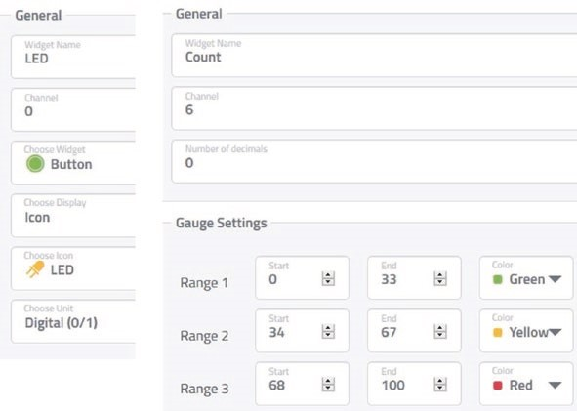
Figure 8-5. Cayenne variables and devices
Listing 8-8 displays on a Cayenne dashboard or app (see Figure 8-4) temperature and pressure measurements from a BMP280 sensor, ambient light using a light-dependent resistor, and a counter. In the series of Cayenne.virtualWrite instructions, the virtual channel V2 is not used to avoid confusion with GPIO 2 for the flashPin variable. Variable headings are defined with the variable settings option in the Cayenne dashboard, and graphical displays are also selected for each variable. A controller widget on virtual channel 0 is created in the Cayenne dashboard, with the binary widget value from the CAYENNE_IN(0) function used to turn on or off the LED attached to the ESP8266 development board.
Listing 8-8. Cayenne and ESP8266 with LED, LDR, and BMP820 sensor
#include <CayenneMQTTESP8266.h> // Cayenne MQTT library char ssid[] = "xxxx"; // change xxxx to your Wi-Fi ssid char password[] = "xxxx"; // change xxxx to Wi-Fi password char username[] = "xxxx"; // change xxxx to Cayenne username char mqttpass[] = "xxxx"; // change xxxx to Cayenne password char clientID[] = "xxxx"; // change xxxx to Cayenne client identity #include <Adafruit_Sensor.h> // include Adafruit_Sensor library
#include <Adafruit_BMP280.h> // include Adafruit_BMP280 library Adafruit_BMP280 bmp; // bmp with BMP280 library int LEDpin = D3; // LED pin
int LDRpin = A0; // light dependent resistor pin int flashPin = D4; // flashing LED pin unsigned long count = 0;
int interval = 10000; // 10s interval between MQTT messages unsigned long lastTime = 0; float temp, pressure, BasePressure, altitude; int light;
void setup()
{ bmp.begin(0x76); // initiate bmp with I2C address // initiate Cayenne MQTT Cayenne.begin(username, mqttpass, clientID, ssid, password); pinMode(LEDpin, OUTPUT); // define LED pins as output digitalWrite(LEDpin, LOW); pinMode(flashPin, OUTPUT); } void loop()
{
Cayenne.loop(); // Cayenne loop function if(millis()-lastTime > interval)
{
temp = bmp.readTemperature(); // BMP280 temperature pressure = bmp.readPressure()/100.0; // and pressure
BasePressure = pressure + 10.0; // assumed sea level pressure altitude = bmp.readAltitude(BasePress ure);
// predicted altitude (m)
light = analogRead(LDRpin); // ambient light intensity light = constrain(light, 0, 1023); // constrain light reading count++; // increment counter if(count>99) count = 0;
digitalWrite(flashPin, LOW); // turn on then off flashing LED delay(10); digitalWrite(flashPin, HIGH);
// send readings to Cayenne on virtual channels
Cayenne.virtualWrite(V1, temp, "temp", "c");
// temperature reading Cayenne.virtualWrite(V3, pressure, "bp", "pa"); // pressure
Cayenne.virtualWrite(V4, altitude, "prox", "m"); // altitude
Cayenne.virtualWrite(V5, light, "lum", "lux"); // luminosity Cayenne.virtualWrite(V6, count,"prox",""); // counter lastTime=millis(); // update time
}
}
CAYENNE_IN(0) // Cayenne virtual channel 0
{ digitalWrite(LEDpin, getValue.asInt( )); // turn on or off LED
}
Listing 8-9 uses the Cayenne MQTT functionality to mimic an alarm system, which is triggered by the light intensity reading on a light- dependent resistor, such as when a door is opened. If the light intensity increases above a threshold of 500 and the alarm on the Cayenne dashboard is set to ON, an email and/or text is sent to notify that the event has occurred. If the alarm setting is set to OFF, then there is no response to changes in light intensity. The ESP8266 or ESP32 development board LED is flashed every two seconds to indicate that the microcontroller is powered on.
If the alarm setting is set to ON, then the light intensity reading is sent to the Cayenne MQTT broker on virtual channel 1, but with a value of zero if the alarm is set to OFF. Alarm and LED controller widgets on virtual channels 3 and 0 are created on the Cayenne dashboard to turn on or off the alarm and to provide an indicator that the alarm has been triggered. Attached to the ESP8266 or ESP32 development board are a blue (alarmPin) and a red (LEDpin) LED to correspondingly indicate the alarm state and that the alarm has been triggered. The two LEDs are turned on or off with the CAYENNE_IN(3) and CAYENNE_IN(0) functions. Triggers for the LED widget and for email and text notification, based on the alarm widget, are defined in the Cayenne dashboard IFTTT function. Figure 8-6 shows the Cayenne dashboard with the alarm set to ON and a light intensity reading of 268, which is below the threshold to trigger the alarm and turn on the indicator LED widget. Figure 8-7 shows the schematic with connections in Table 8-3.
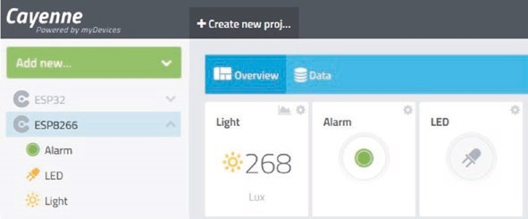
Figure 8-6. Alarm, LED, and light intensity
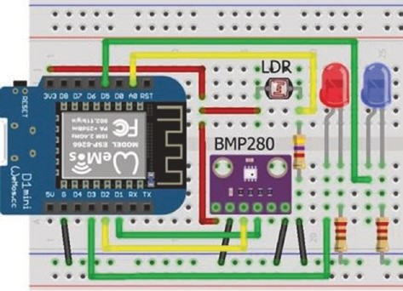
Figure 8-7. Alarm, LED, and light intensity with LOLIN (WeMos) D1 mini
Table 8-3. Alarm, LED, and light intensity
Component | ESP8266 Connections |  | ESP32 Connections
bMp280 VCC | 3V3 |  | 3V3
bMp280 gnd | gnd |  | gnd
bMp280 Sda | d2 |  | gpiO 21
bMp280 SCK | d1 |  | gpiO 22
bMp280 Sd0 | gnd |  | gnd
Ldr left | 3V3 |  | 3V3
Ldr right | 4.7 kΩ resistor | gnd | 4.7 kΩ resistor | gnd
Ldr right | a0 |  | gpiO 36
Led long legs | d3, d5 |  | gpiO 23
Led short legs | 220 Ω resistor | gnd | 220 Ω resistor | gnd
Listing 8-9. Alarm, LED, and light intensity
#include <CayenneMQTTESP8266.h> // Cayenne MQTT library char ssid[] = "xxxx"; // change xxxx to your Wi-Fi ssid char password[] = "xxxx"; // change xxxx to your Wi-Fi password char username[] = "xxxx"; // change xxxx to Cayenne username char mqttpass[] = "xxxx"; // change xxxx to Cayenne password char clientID[] = "xxxx"; // change xxxx to Cayenne client identity int LEDpin = D3;
int alarmPin = D5; // define LED, alarm and LDR pins int LDRpin = A0;
int flashPin = D4; // flashing LED int reading, alarm, alert;
int interval = 2000; // 2s interval between LDR readings unsigned long LDRtime = 0;
void setup()
{
Cayenne.begin(username, mqttpass, clientID, ssid, password); pinMode(LEDpin, OUTPUT); // define LED pins as output pinMode(alarmPin, OUTPUT); pinMode(flashPin, OUTPUT); alarm = 0; // set alarm to OFF
}
void loop()
{
Cayenne.loop(); // Cayenne loop function if(millis() - LDRtime > interval)
{
LDRtime = millis(); reading = analogRead(LDRpin);
if (alarm == 1) Cayenne.virtualWrite(V1, reading, "lum", "lux");
else Cayenne.virtualWrite(V1, 0, "lum", "lux"); digitalWrite(flashPin, LOW);
delay(10); // flash LED to indicate power on digitalWrite(flashPin, HIGH);
}
}
CAYENNE_IN(0) // Cayenne virtual channel 0
{
alert = getValue.asInt(); // get alarm triggered status digitalWrite(LEDpin, alert); // update alarm triggered LED }
CAYENNE_IN(3) // Cayenne virtual channel 3
{
alarm = getValue.asInt(); // get alarm set state
digitalWrite(alarmPin, alarm); // update alarm set indicator LED
}
The IFTTT (If This, Then That) function to trigger an event on the Cayenne dashboard is defined on the Cayenne dashboard and not in the sketch. Information on the IFTTT features of the Cayenne dashboard is available at mydevices.com/cayenne/docs/features/#featurestriggers. Three IFTTT triggers are required by the alarm system. When the light intensity increases above a threshold of 500, with the alarm widget set to ON, the email and text notification of the event is triggered, and a second trigger turns on the LED widget, on virtual channel 0, to indicate that the alarm has been triggered. The third IFTTT trigger turns off the alarm widget, on virtual channel 3, which indicates that the alarm is now set to OFF. The LEDs attached to the ESP8266 or ESP32 development board are turned on or off depending on the values of the alarm and LED widgets on the Cayenne dashboard.
Cayenne IFTTT triggers are accessed by
- Selecting User Menu ➤ Triggers and Alerts at the top right side of the dashboard
- Selecting Trigger and naming the trigger, such as
LEDon
- Dragging the device, ESP8266, into the if box
- Selecting the trigger, such as light, and selecting the threshold and Sensor above or Sensor below
- Dragging the device, ESP8266, into the then box
- Selecting the action, such as LED in Figure 8-8, and selecting either On(1) or Off (0)
- Selecting Save
When sending a notification as a text message, include the mobile phone number plus the +country code in the Add custom recipient box.
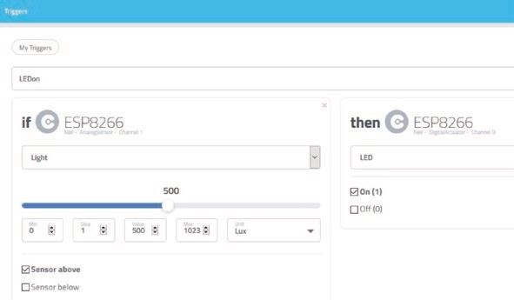
Figure 8-8. Cayenne IFTTT trigger
Figures 8-8 illustrates the IFTTT trigger to turn on the LED widget, on virtual channel 0, when the light intensity, on virtual channel 1, exceeds the threshold of 500. The second and third IFTTT triggers send the email/ text notification and turn off the alarm widget, on virtual channel 3, when the LED widget is turned on. Figure 8-9 illustrates the corresponding email notification triggered by IFTTT.
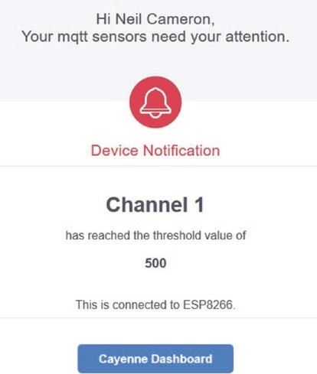
Figure 8-9. Cayenne IFTTT notification
Listings 8-8 and 8-9 include the library for an ESP8266 microcontroller. The library for an ESP32 microcontroller is accessed with the instruction #include <CayenneMQTTESP32.h>, which is included in the CayenneMQTT library. No changes, other than pin numbers for attached sensors, are required for the sketches with an ESP32 microcontroller.
Parsing text
Parsing text is often required, such as data from the Serial buffer or data uploaded following an HTTP request. The instruction Serial.read() reads the next available character in the Serial buffer, while the instruction Serial.readStringUntil('\n') reads all the data in the Serial buffer until end- of- line character. The content of the Serial buffer is stored as a string, str, with the instruction str = Serial.readString() and parsed into
an integer or a real number with the instruction Serial.parseInt() or Serial.parseFloat(). For example, if the Serial buffer contains the text abc25 or abc3.14, then parsing returns the integer 25 or the real number 3.14, respectively. Parsing ignores the initial non-digit characters, other than a decimal point or a minus sign, and stops when a non-digit character is read after the last digit character. Parsing instructions are repeated to extract more than one number from the Serial buffer. For example, if the Serial buffer contains abc-25de3.14, then the integer -25 and the real number 3.14 are returned with the instructions
if(Serial.available()>0)
{
x = Serial.parseInt(); y = Serial.parseFloat(); }
The parseInt and parseFloat functions are blocking functions, which prevent the microcontroller from processing other instructions until parsing is completed.
Strings are parsed to integers or real numbers with the instructions toInt() or toFloat(), respectively, provided the first character of the string is a digit, a decimal point, or a minus sign. For example, if a string str equals -25abc or 3.14abc, then the instructions str.toInt() or str. toFloat() return the integer -25 or the real number 3.14, respectively. Parsing stops when a non-digit character is read after a digit character or a decimal point. Note that a real number is stored with a total number of six or seven digits, so converting the string 2.7182818284 to a real number results in a value of 2.718282.
A string that does not start with a digit character is parsed by extracting a substring that does start with a digit character, a decimal point, or a minus sign. For a string str, the instruction str.substring(x, y) creates the substring between positions x (inclusive) and y (exclusive). For example, comma positions of the string str = "abc,def,gh" are 4 and 8, so the instruction str.substring(4+1, 8) creates the substring def with characters 5, 6, and 7 of the string. If the end parameter is omitted, as in the instruction str.substring(x), then the substring extends to the end of the string. For example, the instruction str.substring(5) creates the substring def,gh.
The instructions str.indexOf("x") and str.indexOf("x", y) locate the position of the substring x within the string, by searching from the first to the last character or from position y to the last character. Similarly, the instructions str.lastIndexOf("x") and str.lastIndexOf("x", y) locate the position of the substring x within the string by searching from the last to the first character or from position y to the first character. The indexOf and lastIndexOf functions are combined with the substring function to create a specific substring of a string, when there are several substring delimiters in a string.
For example, the decimal humidity value contained in the string str = <span class=“humidity” data-value=“68.1”>68%</span> is bracketed by an = character and a > character, but there are two of each character in the string. The toFloat function cannot extract the humidity value, as the first character of the string is not a digit, so a substring is created to extract the decimal value, but not the integer value. The instructions indexS = str.lastIndexOf("=") and indexF = str.indexOf("%") locate positions of the last = character and the % character, with the substring defined by the instruction str.substring(indexS+2, indexF-2) containing the characters 68.1”>, from which the decimal value is extracted with the toFloat function.
The instruction str.length() determines the length of the string, which does not include the null terminating character, \n, and the string length is used to ensure that a substring position does not exceed the
length of the string. To check if a string, str, starts or ends with a substring, abc, the instructions str.startsWith("abc") and str.endsWith("abc") return a value one if true or value zero if false.
Console log
When debugging a sketch or checking the progress of a sketch, information on a variable is displayed on the Serial Monitor with the Serial.
print("text") instruction. The equivalent to displaying information on the Serial Monitor for a web browser is the console log, when using JavaScript code, to display the value of a variable or text, such as "button pressed." The console log is accessed in the browser by pressing the F12 keyboard key and selecting Console and Logs (see Figure 8-10). To define the character set for the console log, the instruction <meta charset='UTF-8'> must be included in the <head> section of the web page HTML code. The instruction console.log(variable) displays information on the console log, where variable can equal a variable, some text, or the server response to the client. For example, in Listing 8-5, the instruction console.log(this.responseText) is included after document.getElementById('tempId').innerHTML = this.responseText and the instructions
console.log("LED updated"); console.log(this.responseText); console.log(obj.var1); var value = document.getElementById('var2').innerHTML; console.log(value);
are included after the instruction
document.getElementById('var2').innerHTML = obj.var2. To generate repeated temperature readings, the reload function interval was reduced to one second, and the countLEDreload function interval for the counter and LED was increased to five seconds. The console log produced the output in Figure 8-10, showing the five temperature readings, the text "LED updated," the JSON text received by the client, the counter, and the LED state defined as a new variable, value.
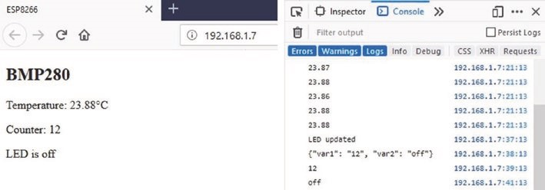
Figure 8-10. Console log
Wi-Fi connection
The ESP8266 and ESP32 libraries are automatically installed when the esp8266 by ESP8266 Community and esp32 by Espressif Systems are installed in the Arduino IDE Boards Manager. Library versions 2.7.4 and 1.0.4 were used in this chapter. If the error message "Downloading http://downloads.arduino.cc/packages/packages_index.json" is displayed in the Arduino IDE Boards Manager, then delete all .tmp files in user ➤ AppData ➤ Local ➤ Arduino15 folder and restart the Arduino IDE.
The Wi-Fi connection between the ESP8266 or ESP32 microcontroller and the WLAN router is tested using the ping command given the ESP8266 or ESP32 IP address. Either right-click the Windows logo at the bottom- left side of the screen and select Run or press the Windows key and R key, simultaneously, to open the Command window. Type cmd and click OK. In the C:\\WINDOWS\system32\cmd.exe window, the Command prompt window, type ping followed by the ESP8266 or ESP32 IP address, as shown in Figure 8-11. The ping command sends small data packets to the ESP8266 or ESP32 IP address that are transmitted back to the sender. In the example, four data packets were sent and received, which indicated that the Data Link, the Wi-Fi connection, and the Internet Protocol were functioning correctly.
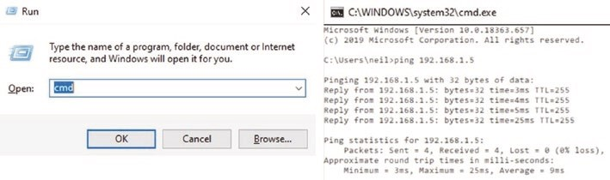
Figure 8-11. Wi-Fi connection test
Access information file
Access to a Wi-Fi network, ThingSpeak data (see Listing 8-6), or a MQTT broker (see Listing 8-8) requires a password, an SSID, an API key, or MQTT broker keys. Instead of storing the access information in the sketch with instructions like char mqttpass[] = "abcdef", the information is stored in a library that is referenced by the sketch. A text file with the extension .h is created to hold the access information, with the file placed in the Arduino IDE libraries folder. To determine the location of the Arduino IDE libraries folder, select File ➤ Preferences in the Arduino IDE; and the libraries folder is shown in the sketchbook location, for example, C:\Users\user\Documents\ Arduino. The access information file is referenced by the sketch with the instruction #include <access_info.h>. An example access information file, in Listing 8-10, includes the access keys for Wi-Fi, ThingSpeak, and Cayenne. Listing 8-10. Access information
char ssid[] = "PhoneNetwork12"; // Wi-Fi access char password[] = "diff1cu1t"; char APItime[] = "efth1234";
char APIdate[] = "mhtd5678"; // ThingSpeak API keys char APItemp[] = "plmf4567"; char APIhumid[] = "thkl6789";
char username[] = "ABC-234"; // Cayenne access char mqttpass[] = "XYZ-567"; char clientID[] = "GHJ-876";
Summary
A web page displayed the temperature reading from a BMP280 module, a counter, and the state of an LED, with the ESP8266 or ESP32 microcontroller functioning as the server. The web page HTML code was built line-by-line as a string, and the whole web page was reloaded to display the updated information. AJAX code, consisting of XML HTTP requests and JavaScript instructions, incorporated as a string literal, enabled updating the web page with only specific variables, rather than reloading the whole web page. Data on several variables was combined as JSON text in the server response to the client HTTP request, and options for parsing text were described. Information from the World Wide Web was accessed with API keys and displayed on a web page using both AJAX and JSON code. Access to an MQTT broker allowed uploading of sensor data to a web page, with a sensor value above a threshold triggering an email or text message notification of the event. The console log verified data sent by the server and received by the client.
Components List
- ESP8266 microcontroller: LOLIN (WeMos) D1 mini or NodeMCU board
- ESP32 microcontroller: ESP32 DEVKIT DOIT or NodeMCU board
- BMP280 module
- LED: 2×
- Resistor: 2× 220 Ω

CHAPTER 9
WebSocket
The WebSocket protocol (www.websocket.org) allows a two-way real-time conversation between the web server and client, through a standardized connection to allow both the server and the client to send data at any time. The client sends a request to the server to switch from an HTTP protocol to a WebSocket protocol; and if the server can host the WebSocket protocol, the HTTP connection is replaced with a WebSocket connection, but using the same port as HTTP.
An example of the WebSocket protocol is transmitting and receiving text in a conversation between the web server and the client (see Figure 9- 1). To transmit to the server, text is entered in the web page transmit text box, and the send text button is clicked. The transmitted text is then displayed on the Serial Monitor connected to the server. Conversely, when text is entered on the Serial Monitor, followed by the computer or laptop keyboard <Enter> key, the text received by the client is displayed in the web page receive text box. Clicking the web page receive text box clears the text received from the server. Both the transmit text and receive text boxes are increased in size by dragging the bottom-right corner of a box.
© Neil Cameron 2021 223
N. Cameron, Electronics Projects with the ESP8266 and ESP32, https://doi.org/10.1007/978-1-4842-6336-5_9
WebSoCket
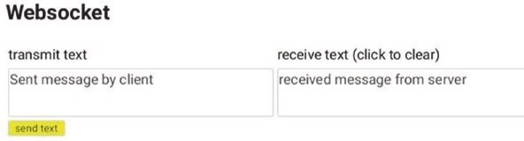
Figure 9-1. WebSocket web page
The WebSocketsServer library, listed under WebSockets, by Markus Sattler is available in the Arduino IDE. The WebSocket is connected on port 81, as the default HTTP COM port is 80, and the wsEvent function displays the received message from the client. Listing 9-1 contains the sketch for the transmit and receive text example. The Serial.write() instruction converts ASCII code for an alphanumeric character to display the alphanumeric character, while Serial.print() displays the ASCII (American Standard Code for Information Interchange) code. The loop function in Listing 9-1 still includes the server.handleClient() instruction to manage HTTP requests, but when text is transmitted by the server to the client, the instruction websocket.broadcastTXT (str.c_str(), str.length()) sends the content of the Serial buffer to the client. The text string is converted to a C-style, null-terminated string with the instruction string.c_str(). The base function sends the default web page AJAX code to the client, when the web page is initially loaded.
In this chapter, an ESP8266 or an ESP32 microcontroller is the server.
The web server library instructions for the ESP8266 microcontroller are
#include <ESP8266WebServer.h>
ESP8266WebServer server
and for the ESP32 microcontroller are
#include <WebServer.h>
WebServer server(80); // requires a port number
WebSoCket
The web server library references the Wi-Fi library, so the #include <ESP8266WiFi.h> or #include <WiFi.h> instructions are not required.
Listing 9-1. WebSocket main sketch
#include <ESP8266WebServer.h> // include web server library
ESP8266WebServer server; // associate server with library
#include <WebSocketsServer.h> // include WebSocket library WebSocketsServer websocket = WebSoc ketsServer(81);
// set WebSocket port 81 #include "buildpage.h" // webpage AJAX code char ssid[] = "xxxx"; // change xxxx to Wi-Fi SSID char password[] = "xxxx"; // change xxxx to Wi-Fi password String str;
void setup()
{
Serial.begin(115200); // Serial Monitor baud rate WiFi.begin(ssid, password); // connect and initialise Wi-Fi while (WiFi.status() != WL_CONNECTED) delay(500);
Serial.print("IP address: ");
Serial.println(WiFi.localIP()); // display web server IP address server.begin();
server.on("/", base); // load default webpage websocket.begin(); // initialise WebSocket websocket.onEvent(wsEvent); // call wsEvent function } // on WebSocket event
void wsEvent(uint8_t num, WStype_t type, uint8_t * message, size_t length)
{
WebSoCket
if(type == WStype_TEXT) // when text received from client { // display text on Serial Monitor for(int i=0; i<length; i++) Serial.write(message[i]);
Serial.println();
}
}
void loop()
{
server.handleClient(); // manage HTTP requests websocket.loop(); // handle WebSocket data if(Serial.available() > 0)
{ // read text in Serial buffer str = Serial.readString(); // and send to client websocket.broadcastTXT(str.c_str(), str.length());
}
}
void base() // function to return HTML code
{
server.send (200, "text/html", page); }
Implementation of the WebSocket protocol is contained in the
JavaScript section of Listing 9-2, which includes the web page AJAX code. When the web page is loaded, a table with headers is created to display the received and transmitted text, and the init function is called to open the WebSocket connection at ws://web server IP address:81/. When the client transmits a message to the server, the instruction send(document.getElementById('txText').value) in the sendText function sends the content of the variable txText, which is then cleared. When the client receives a message from the server, the message content is stored in the variable rxText, which is displayed on the web page.
WebSoCket
The transmitted message, txText, is contained in an HTML textarea, within an HTML form, with the form action property associated with the JavaScript sendText function. The transmitted message is not included in an HTML input field, as an input field does not permit text wrap-around. If an HTML input field is required, then the sendText function is called by a carriage return at the end of the sent message with the instruction onkeydown='if(event.keyCode == 13) sendText()', as the ASCII code 13 corresponds to a carriage return. The received message, rxText, is included in an HTML textarea, which allows text wrap-around. Listing 9-2. WebSocket web page AJAX code
char page[] PROGMEM = R"(
<!DOCTYPE html><html>
<head><title>ESP8266</title>
<style>
body {font-family:Arial} td {vertical-align: top;} textarea {font-family:Arial; width:300px; height:50px;} input[type=submit] {background-color:yellow;}
</style></head>
<body id='initialise'>
<h2>WebSocket</h2>
<table><tr>
<td>transmit text</td>
<td>receive text (click to clear)</td>
</tr><tr>
<td><form action='javascript:sendText()'>
<textarea id='txText'></textarea><br>
<input type='submit' value="send text">
</form></td>
WebSoCket
<td><textarea id='rxText'
onfocus='this.value=""'></textarea><br></td> </tr></table>
<script> var wskt; document.getElementById('initialise').onload = function() {init()};
function init() // open WebSocket
{
wskt = new WebSocket('ws://' + window.location.hostname +
':81/'); wskt.onmessage = function(rx)
{ // client receive message var obj = rx.data; document.getElementById('rxText').value = obj;
};
} function sendText() // client transmit message
{
wskt.send(document.getElementById('txText').value); document.getElementById('txText').value = "";
}
</script>
</body></html>
)";
WebSoCket
Remote control and WebSocket communication
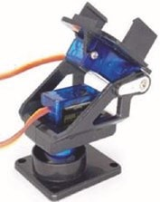
A laser, mounted on a tilt bracket with a servo motor attached to an ESP8266 or ESP32 development board, is remotely controlled by moving a slider on the client web page with the slider position information transmitted to the server, which is the ESP8266 or ESP32 microcontroller. The client receives information on the servo position and the laser state from the server (see Figure 9-2). The microcontroller moves the servo
motor and turns on or off the laser according to the control information received from the client. Information on the web page is continuously updated, as the WebSocket protocol enables the server to transmit information to the client, without the client requesting the information.
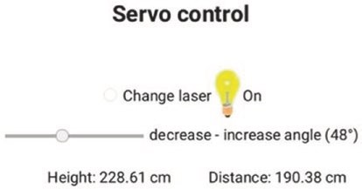
Figure 9-2. Web page with laser position and state
An application for a remotely controlled laser mounted on a tilt bracket is measurement of vertical and horizontal distance to a point identified by the laser. The vertical distance to the point is determined from the angle of tilt, and the horizontal distance from the object is measured with an ultrasonic distance sensor attached to the front of the tilt bracket. In Figure 9-3, the hinge of the tilt bracket is 5 cm above the base, with an
WebSoCket
8 cm distance between the hinge and the front of the HC-SR04 ultrasonic distance sensor and a 2 cm height difference between the hinge and the laser. The vertical distance (cm), above the base, to a point marked by the laser is 5 + (8 + d)tan(x) + 2/cos(x), where x° is the angle of the tilt bracket.
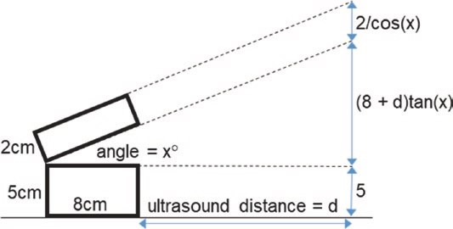
Figure 9-3. Derivation of height and distance measurement
Connections for an ESP8266 or ESP32 development board, with the ultrasonic distance sensor, laser module, and servo motor are given in Table 9-1 and shown in Figure 9-4. The HC-SR04 ultrasonic distance sensor requires a regulated 5 V supply, which is not provided by a 5 V USB power bank. The servo motor requires an external power supply, such as a 5V battery or a 9V battery with the L4940V5 voltage regulator, as the motor can use hundreds of milliamps during a few milliseconds that the rotor is turning, which is more than the output of the ESP8266 or ESP32 development board 5V or VIN pins. A 9V battery with an L4940V5 voltage regulator, with 100nF and 22μF capacitors (see Figure 9-3), powers the ultrasonic distance sensor and the servo motor. The KY-008 laser operates at 650 nm, with the red light wavelength in the 635–700 nm range.
WebSoCket
Table 9-1. Height and distance measurement with ESP8266 and ESP32 microcontrollers
Component | Connect to | And to
Ultrasonic distance sensor VCC | VCC rail
Ultrasonic distance sensor trIG | eSp8266 D8 or eSp32 GpIo 13
Ultrasonic distance sensor eCho | eSp8266 D7 or eSp32 GpIo 27
Ultrasonic distance sensor GND | GND rail
Laser module S | eSp8266 D6 or eSp32 GpIo 26
Laser module - | GND rail
Servo motor signal (orange or white) | eSp8266 D5 or eSp32 GpIo 25
Servo motor (red) | VCC rail
Servo motor (brown or black) | GND rail
eSp8266 or eSp32 GND | GND rail
L4940V5 supply | 9 V battery positive | 100 nF capacitor positive
L4940V5 GND | GND rail
L4940V5 demand | VCC rail | 22 μF capacitor positive
9 V battery negative | GND rail
100 nF capacitor negative | GND rail
22 μF capacitor negative | GND rail
WebSoCket
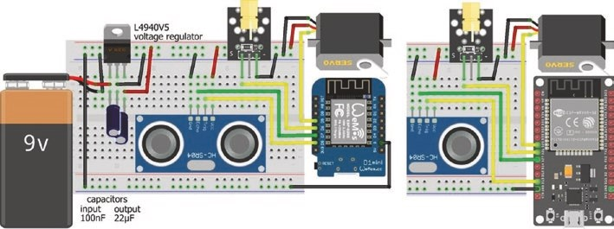
Figure 9-4. Height and distance measurement with the LOLIN
(WeMos) D1 mini or ESP32 DEVKIT DOIT development board
Listing 9-3 is for an ESP8266 microcontroller, and the NewPing8266 library is downloaded from github.com/jshaw/NewPingESP8266. For an ESP32 microcontroller, the WebServer and NewPing libraries replace the ESP8266WebServer and NewPing8266 libraries, with the NewPing library available in the Arduino IDE. The instruction ESP8266WebServer server is replaced with WebServer server (80). The ESP32 microcontroller also requires an ESP32-specific Servo library, rather than the Arduino IDE built- in Servo library. The ESP32Servo library by Kevin Harrington and
John K. Bennett is recommended, and the library is available in the Arduino IDE. The ESP8266 microcontroller instructions with the Servo library
#include <Servo.h> // include Servo library servoFB.attach(FBpin) // initialise servo motor to FBpin
are replaced with the ESP32Servo library instructions for the ESP32 microcontroller
#include <ESP32Servo.h>
servoFB.setPeriodHertz(F) // define servo frequency (F) servoFB.attach(FBpin, min, max) // initialise servo motor to FBpin
WebSoCket
The square wave frequency, F, is included in the instruction servoFB.setPeriodHertz(F), which is generally 50 Hz. In the servoFB. attach(FBpin, min, max) instruction, the min and max parameters refer to the pulse width, in microseconds, of a square wave to move the servo motor to 0° and 180°, respectively. Default values for the min and max parameters are 1000 μs and 2000 μs, with values of 500 μs and 2500 μs for the Tower Pro SG90 servo.
There is no change to the following instructions:
Servo servoFB // associate servoFB with Servo lib servoFB.writeMicroseconds(T) // move to position mapped to Tμs servoFb.write(N) // move to angle N°
In the sketch in Listing 9-3, the majority of instructions relate to including libraries, defining variables associated with the servo motor and the ultrasonic distance sensor, establishing the Wi-Fi connection, and loading the default web page by calling the base function to access the AJAX code, contained in the string literal page located in the buildpage tab. Instructions related to WebSocket are included in the wsEvent function. When the server receives, from the client, a message containing the servo angle and laser state, the wsEvent function is called, which loads the received message into a string that is parsed into the servo angle and laser state by locating the position of the comma separating the two values. The servo angle is mapped to the number of microseconds for a square wave pulse length to move the servo motor to the required angle. The laser state is also updated. The horizontal distance is measured by the ultrasonic distance sensor, and the vertical distance is calculated from the servo angle and horizontal distance. The two distances are converted to name and value pairs in JSON format with the JsonConvert function, which transmits the information to the client. The distance, in centimeters, between the ultrasonic distance sensor and an object is half the echo time, measured in microseconds, multiplied by 0.0343, assuming the speed of sound of 343 m/s.
WebSoCket
Listing 9-3. Height and distance measurement
#include <ESP8266WebServer.h> // include Webserver library ESP8266WebServer server; // associate server with library char ssid[] = "xxxx"; // change xxxx to Wi-Fi SSID char password[] = "xxxx"; // change xxxx to Wi-Fi password #include <WebSocketsServer.h> // include Websocket library
WebSocketsServer websocket = WebSo cketsServer(81);
// set WebSocket port 81
#include "buildpage.h" // webpage AJAX code
#include <Servo.h>
Servo servoFB; // associate servoFB with Servo lib int FBpin = D7; // forward-backward servo pin int laserPin = D8;
int minMicrosec = 450; // minimum and maximum time int maxMicrosec = 1150; // for servo motor pulse length #include <NewPingESP8266.h> // include NewPing library int trigPin = D5; // ultrasonic trigger and echo pins int echoPin = D6; float maxdist = 300; // ultrasound maximum distance NewPingESP8266 sonar(trigPin, echoPin, maxdist); float distance, height, temp, angle; int microsec, laser, comma;
String text[2]; // strings in JSON text String str, json; unsigned long timer = 0;
void setup()
{
Serial.begin(115200); // Serial Monitor baud rate WiFi.begin(ssid, password); // connect and initialise Wi-Fi while (WiFi.status() != WL_CONNECTED) delay(500);
WebSoCket
Serial.print("IP address: ");
Serial.println(WiFi.localIP()); // display web server IP address server.begin();
server.on("/", base); // load default webpage websocket.begin(); // initialise WebSocket websocket.onEvent(wsEvent); // wsEvent on WebSocket event servoFB.attach(FBpin); // initialise servo motor servoFB.writeMicroseconds(minMic rosec);
// and move to initial position
pinMode(laserPin, OUTPUT); // define laser pin as output }
// function called when message received from client void wsEvent(uint8_t n, WStype_t type, uint8_t * message, size_t length)
{
if(type == WStype_TEXT)
{
str = ""; // convert message to string for (int i=0; i<length; i++) str = str + char(message[i]); comma = str.indexOf(","); // location of comma text[0] = str.substring(0, comma); // extract substrings
text[1] = str.substring(comma+1);
angle = text[0].toFloat(); // parse servo angle microsec = map(angle,20,90,minMicros ec,maxMicrosec);
// map angle to μs
servoFB.writeMicroseconds(microsec); // move servo to angle delay(10); // time to move servo laser = text[1].toInt(); // parse laser state digitalWrite(laserPin, laser); // turn on or off laser distance = (sonar.ping_median(10)/2. 0)*0.0343;
// get horizontal distance
WebSoCket
angle = angle*PI/180.0; // convert angle to radians
height = 5.0+(distance+8.0)*tan(angl e)+2.0/cos(angle); // vertical distance JsonConvert(height, distance); // convert to JSON format websocket.broadcastTXT(json.c_str(), json.length());
} // send JSON text }
// function converts variables to JSON name/value pairs
String JsonConvert(float val1, float val2)
{ // start with open bracket json = "{\"var1\": \"" + String(val1) + "\",";
// partition with comma
json += " \"var2\": \"" + String(val2) + "\"}";
// end with close bracket
return json; }
void base() // function to return HTML code
{
server.send(200, "text/html", page); }
void loop()
{
server.handleClient(); // manage HTTP requests websocket.loop(); // handle WebSocket data }
WebSoCket
WebSocket and AJAX
On the web page (see Figure 9-5), clicking the Change laser button turns on or off the laser, and the relevant image is displayed on the web page. Moving the slider changes the angle of the tilt bracket, with the angle displayed on the web page. The client transmits the servo angle and laser state to the server, and the server responds by sending the client the measured horizontal distance and calculated height that the client displays on the web page.
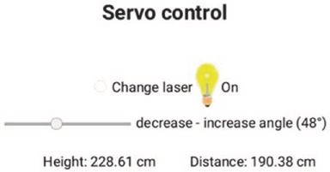
Figure 9-5. Height and distance measurement
AJAX code for the web page (see Listing 9-4) is included in the string literal page, bracketed by the characters R"( and )", with variables identified by single apostrophes, '. In the HTML code, the <head> section includes two <meta> instructions that are required to format text in the console log, which displays data received and transmitted by the client, for example, console.log(FBVal). The <style> section centers text on the web page and defines the slider, the size of an image, and the height of a table row. The content of the web page is formatted in a table, with the first row, which spans two columns, containing the Change laser button, a bulb image, and text, laserId, describing the laser state of On or Off. The
WebSoCket
second table row contains a slider to select the tilt angle, ranging from 20° to 90°, followed by text and the angle value. The slider is defined with the instruction
<input autocomplete='on' type='range' min='20' max='90' value='20' class='slider' id='FBSlider' oninput='sendFB()'>
which sets autocomplete to on with the slider initial position set at value, as setting autocomplete to off positions the slider in the default middle position. The instruction associates the slider with the sendFB function, which is called when the slider is moved. The third table row displays the calculated height and measured distance.
When the web page is loaded, the init function is called to open the WebSocket connection at ws://web server IP address:81/. When the client receives a message, the message content is stored in the variable rx.
data, which is parsed to the variables vertical and horizontal for display on the web page. A message is transmitted by the client with the sendFB function, which combines the angle selected by the slider with the laser state. When the Change laser button is clicked, the changeLaser function is called, which changes the value of the laser state, laserVal, updates the laser state in the web page code, and alternates the bulb image, which is downloaded from the www.w3schools.com website. The location of an image to download from a website is obtained by right-clicking the image and selecting View Image Info or Copy Image Location and including the image location in the AJAX code.
When either the slider position is changed or the Change laser button is clicked, the angle selected by the slider and the laser state are transmitted by the client to the server with the instruction wskt.send(FBVal +','+ laserVal). For sketch testing purposes, the instructions console.log(obj.var1) and console.log(FBVal) display, in the console log, values of the received vertical distance and the transmitted angle by the client, respectively.
WebSoCket Listing 9-4. AJAX code for height and distance measurement
char page[] PROGMEM = R"(
<!DOCTYPE html><html>
<head>
<meta name='viewport' content='width=device-width, initial- scale=1.0'> <meta charset='UTF-8'>
<title>ESP8266</title>
<style>
html {text-align: center}
.slider {-webkit-appearance: none; height: 2px; background: DarkGrey} img {width:25px; height:50px} td {height:50px}
</style>
<title>WebSocket</title>
</head>
<!-- initiate WebSocket when webpage loaded-->
<body id='initialise'>
<h2>Servo control</h2>
<table align='center'><tr>
<td colspan='2'><input type='radio' id='r1' onclick='changeLaser()'> Change laser
<img id='bulb' src='https://www.w3schools.com/jsref/ pic_bulboff.gif'>
<span id='laserId'>Off</span></td>
</tr>
<tr>
<!--autocomplete='off': returns slider to default mid-point position-->
WebSoCket
<td><input autocomplete='on' type='range' min='20' max='90' value='20' class='slider' id='FBSlider' oninput='sendFB()'></td>
<td><label id='FBId'>decrease - increase angle (20&deg)
</label></td>
</tr>
<tr>
<td style='width:200px'>Height: <span id='vertical'>0</span> cm</td>
<td>Distance: <span id='horizontal'>0</span> cm</td>
</tr></table>
<script> var FBVal = 20; var laserVal = 0; document.getElementById('initialise').onload = function() {init()};
function init()
{
wskt = new WebSocket('ws://' + window.location.hostname +
':81/');
wskt.onmessage = function(rx)
{
var obj = JSON.parse(rx.data); console.log(obj.var1); console.log(obj.var2); document.getElementById('vertical').innerHTML = obj.var1; document.getElementById('horizontal').innerHTML = obj.var2;
};
}
WebSoCket
function sendFB()
{
FBVal = document.getElementById('FBSlider').value; document.getElementById('FBId').innerHTML = 'decrease -
increase angle ('+FBVal.toString() + '&deg)'; wskt.send(FBVal +','+ laserVal); console.log(FBVal); console.log(laserVal); }
function changeLaser()
{
laserVal = 1 - laserVal; if(laserVal == 1) {laserTag = 'On';} else {laserTag = 'Off';} document.getElementById('laserId').innerHTML = laserTag; document.getElementById('r1').checked=false; wskt.send(FBVal +',' + laserVal); var image = document.getElementById('bulb'); if (image.src.match('bulboff')) {image.src =
' https://www.w3schools.com/js/pic_bulbon.gif';} else {image.src = 'https://www.w3schools.com/js/
pic_bulboff.gif';}
}
</script>
</body></html>
)";
The Servo library instruction servo.write(N) moves the servo motor to an angle of N°. An alternative instruction is servo.writeMicroseconds(microsec), with the number of microseconds defining the pulse length of the square wave. A standard servo motor moves to angle 0° or 180° when the square wave pulse
WebSoCket
length is 500 μs or 2500 μs, while the pulse length for other standard servo motors is 1000 μs or 2000 μs. For the two standard cases, the formula for the number of required microseconds to move to a given angle is 500 + angle × 200/18 and 1000 + angle × 100/18. The servo motor used in this chapter was calibrated with the sketch in Listing 9-5, by entering different microsecond values on the Serial Monitor and measuring servo motor angle. For example, 700 μs and 1150 μs were required to position the servo motor at 45° and 90°, giving the equation microseconds = 250 + angle × 10 or 250 + angle × 180/18.
Listing 9-5. Servo motor calibration
#include <Servo.h> // include Servo library
Servo servoFB; // associate servoFB with Servo library int FBpin = D7; // servo pin int microsec;
void setup()
{
Serial.begin(115200); // Serial Monitor baud rate servoFB.attach(FBpin); // initialise servo motor
}
void loop()
{
if(Serial.available() > 0) // text entered in Serial Monitor { // parse Serial buffer to integer
microsec = Serial.parseInt(); servoFB.writeMicroseconds(micros ec);
} // move servo motor }
WebSoCket
Access images, time, and sensor data over the Internet
Another example of the WebSocket protocol is the graphic display of data on a web page with the graph properties: Y-axis minimum and maximum values and the X-axis time interval, changed by the user in real time. Changing the graph Y-axis only impacts the client making the change, so the Y-axis of the graph is client specific. In contrast, when the X-axis time interval is transmitted to the server, the graphic display is updated at the same time for all clients connected to the server. Figure 9-6 illustrates a web page displaying sensor data in real time with the option to change the minimum and maximum values of the Y-axis and the time interval for data updates. The browser current date and time are also displayed as well as an image downloaded from the Internet.
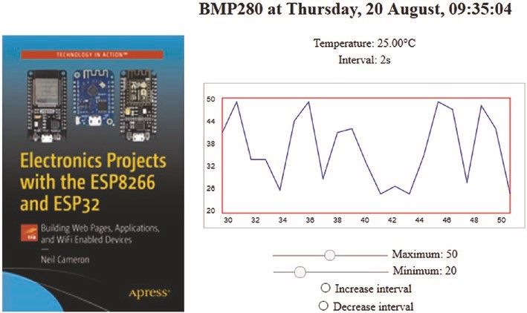
Figure 9-6. Real-time sensor graphics
WebSoCket
The BMP280 sensor measures temperature and pressure, communicates with I2C or SPI, and operates at 3.3 V. For I2C communication, the I2C address of the BMP280 sensor is 0x76, with the BMP280 module SD0 pin connected to GND. Connections between a BMP280 sensor and an ESP8266 or ESP32 development board are shown in Figure 9-7 and given in Table 9-2.
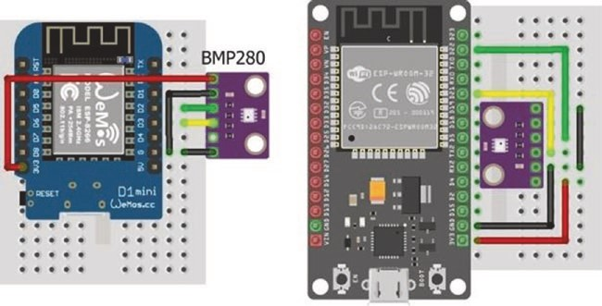
Figure 9-7. BMP280 with LOLIN (WeMos) D1 mini and ESP32 DEVKIT DOIT boards
Table 9-2. BMP280 with ESP8266 and ESP32 microcontrollers
Component | ESP8266 Connections | ESP32 Connections
bMp280 VCC | 3V3 | 3V3
bMp280 GND | GND | GND
bMp280 SDI | D2 | GpIo 21
bMp280 SCk | D1 | GpIo 22
bMp280 SD0 | GND | GND
WebSoCket
The first section and the setup function of the sketch in Listing 9-6 are essentially the same as in Listing 9-3. The Adafruit_Sensor library, listed under Adafruit_Unified_Sensor in the Arduino IDE, and the Adafruit_ BMP280 library are installed for the BMP280 sensor, which is initialized with its I2C address in the setup function. The tempUrl URL is mapped to the tempFunct function, which is attached to the Ticker library for timing web page updates.
When the server receives, from the client, a message containing the timing interval, the WebSocket wsEvent function is called, which loads the received message for parsing. In Listing 9-6, the message only contains the timing interval variable, interval, and the message string is converted to an integer with the atoi() C++ function. The tempFunct function updates the interval variable, for the Ticker library to control the timing of calls to the tempFunct function, and obtains the temperature reading from the BMP280 sensor. Both the temperature and timing interval are converted to name and value pairs in JSON format, with the JsonConvert function, and transmitted to the client. If several clients are connected to the server and one client changes the timing interval, then the timing interval displayed by each client is also updated. The base and loop functions of Listing 9-6 are identical to those in Listing 9-3. When testing the sketch, the instruction JsonConvert(bmp.readTemperature(), interval) is replaced with JsonConvert(random(20, 50)*1.0, interval) to generate variation between values.
Listings 9-1, 9-3, and 9-6 illustrate three examples of handling the client WebSocket message. The message is displayed on the Serial Monitor with the instruction Serial.write(message[i]), converted to a string as str = str + char(message[i]) or converted to an integer by interval = atoi((char *) &message[0]). The C++ equivalent of the atoi function for a real number is the atof function.
WebSoCket
Listing 9-6. Real-time sensor graphics
#include <ESP8266WebServer.h> // include WebServer library ESP8266WebServer server; // associate server with library char ssid[] = "xxxx"; // change xxxx to Wi-Fi SSID char password[] = "xxxx"; // change xxxx to Wi-Fi password
#include <WebSocketsServer.h> // include Websocket library WebSocketsServer websocket = WebSo cketsServer(81);
// set WebSocket port 81
#include "buildpage.h" // webpage AJAX code
String json;
#include <Ticker.h> // include Ticker library Ticker timer; // associate timer with Ticker lib int interval = 1; int oldInterval = 1;
#include <Adafruit_Sensor.h> // include Adafruit Sensor
#include <Adafruit_BMP280.h> // and BMP280 libraries Adafruit_BMP280 bmp; // associate bmp with BMP280 int BMPaddress = 0x76; // BMP280 I2C address
void setup()
{
Serial.begin(115200); // Serial Monitor baud rate WiFi.begin(ssid, password); // connect and initialise Wi-Fi while(WiFi.status()!= WL_CONNECTED ) delay(500);
Serial.print("IP address: ");
Serial.println(WiFi.localIP()); // display web server IP address server.begin();
server.on("/",base); // load default webpage server.on("/tempUrl", tempFunct) ;
// map URL to tempFunct
WebSoCket
websocket.begin(); // initialise WebSocket websocket.onEvent(wsEvent); // wsEvent on WebSocket event bmp.begin(BMPaddress); // initialise BMP280 sensor timer.attach(interval, tempFunct );
} // attach timer to tempFunct
// function called when message received from client void wsEvent(uint8_t n, WStype_t type, uint8_t * message, size_t length)
{ // convert message to integer
if(type == WStype_TEXT) interval = atoi((char *)
&message[0]);
}
void tempFunct()
// function to transmit temperature and update interval
{ // convert to JSON format
JsonConvert(bmp.readTemperature( ), interval); websocket.broadcastTXT(json.c_st r(), json.length());
// send JSON text
if(interval != oldInterval)
{
timer.detach();
timer.attach(interval, tempFun ct); oldInterval = interval; // update timer interval
}
}
// function converts variables to JSON name/value pairs
String JsonConvert(float val1, int val2) { // start with open bracket
json = "{\"var1\": \"" + String (val1) + "\",";
// partition with comma
WebSoCket
json += " \"var2\": \"" + String (val2) + "\"}";
// end with close bracket
return json;
}
void base() // function to return HTML code
{
server.send(200, "text/html", page); }
void loop()
{
server.handleClient(); // manage HTTP requests websocket.loop(); // handle WebSocket data
}
AJAX code for the web page is given in Listing 9-7. The content of the web page is formatted as a table with a header row containing the browser current date and time, with two columns consisting of seven rows. The first column, which spans all seven rows, with the instruction <td rowspan='7'>, contains the image that is downloaded when the web page is initialized. The first three rows in the second column contain the updated temperature and time interval, both transmitted by the server, and a <canvas> for the graph. The four sliders to control the graph Y-axis maximum and minimum values and the buttons to increase or decrease the time interval call the functions setMaxy, setMiny, sendadd, and sendsub, respectively.
The graph function uses the canvas.getContext() instruction to access functions for drawing on a canvas, with details available at www.w3schools.com/tags/ref_canvas.asp. The clearRect and strokeRect instructions clear a rectangular space (445 × 200 pixels) in which the graph rectangle (400 × 160 pixels) is outlined, starting at pixel
WebSoCket
position (25, 20) within the rectangular space with position (0, 0) being the top-left corner. Six Y-axis labels are positioned with the instruction
ctx.fillText(Math.round(maxy-i*(maxy-miny)/5), 3, 25+31*i)
that calculates the label values from the maximum and minimum Y-axis values. The Y-axis labels are positioned in rows that are 31 pixels apart, starting at pixel position (3, 25). The 11 X-axis labels are continuously updated, based on the total number of data values, Ndata, with the instruction
ctx.fillText(String(Ndata+i-20), 27+19*i, 193)
The X-axis labels are positioned in columns that are 19 pixels apart, starting at pixel position (27, 193). Instructions to draw a line connecting the data points together are beginPath with the initial data point moveTo(x,y) and subsequent data points lineTo(x,y) followed by stroke. The graph is plotted in batches of 21 points, which are constantly updated with the 21st point being the most recent value with the instructions
Ndata++; // increment the number of data points if(Ndata>maxVal) datay.shift( );
// remove the first element of datay[ ]
datay.push(obj.var1); // add new data point to end of datay[ ]
JavaScript array command details are available at www.w3schools.com/ jsref/jsref_obj_array.asp.
The graph Y-axis maximum and minimum values are the corresponding slider values, and the functions setMaxy and setMiny convert a slider value to a string for displaying on the web page to the right of the slider. The functions sendadd and sendsub increase and decrease the time interval between updates of the web page by one second, with the updated value sent to the server.
WebSoCket
When the first web page is loaded, the init function opens the WebSocket connection at ws://web server IP address:81/. When the client receives a message, the message content, stored in the variable rx.data, is parsed to the variables temp and interval for displaying, on the web page, the temperature and time interval between readings. The browser current time is obtained and formatted with the instructions
var dt = new Date();
var tm = dt.toLocaleTimeString
('en-GB', {weekday: 'long', day: '2-digit', month: 'long'}); document.getElementById('timeNow').innerHTML = tm;
The resulting time format is Tuesday, 16 June, 10:11:47, but if innerHTML = dt, then the display format is Tue Jun 16 2020 10:11:47 GMT+0100 (British Summer Time). If the time in hh:mm:ss format is required, then the variable tm is defined as var tm = dt.toLocaleTimeString ('en-GB'). Details on date formatting are available at www.w3schools.com/Jsref/jsref_obj_date.asp. Listing 9-7. AJAX code for real-time sensor graphics
char page[] PROGMEM = R"(
<!DOCTYPE html><html>
<head>
<meta name='viewport' content='width=device-width, initial- scale=1.0'>
<meta charset='UTF-8'>
<!-- padding top right bottom left-->
<style>
html {text-align: center}
.slider {-webkit-appearance: none; height: 2px; background: DarkGrey} td {padding: 0px 0px 0px 25px}

img {width:253px; height:384px}
</style>
<title>ESP8266</title>
</head>
<body onload='javascript:init()'>
<table>
<tr><th></th><th><h2>BMP280 at <span id = 'timeNow'></span>
</h2></th></tr>
<tr>
<td rowspan='7'>
<img src=
'https://images.springer.com/sgw/books/medium/9781484263358.jpg' alt='book'></td>
<td>Temperature: <span id = 'temp'>0</span>&degC</td>
</tr>
<tr><td>Interval: <span id='interval'>1</span>s</td></tr>
<tr><td>
<canvas id = 'myCanvas' width = '445' height = '200' style = 'border:1px solid DarkGrey'>
Your browser does not support the canvas element.
</canvas>
</td></tr>
<tr><td>
<input autocomplete='off' type='range' min='1' max='100' value='25' class='slider' id='maxySlider' oninput='setMaxy()' >
<label id='maxyId'>Maximum: 25</label>
</td></tr>
<tr><td>
<input autocomplete='off' type='range' min='0' max='100' value='15' class='slider' id='minySlider' oninput='setMiny()' >
<label id='minyId'>Minimum: 15</label>
</td></tr>
<tr><td>
<input type='radio' id='r1' oninput='sendadd()'> Increase interval </td></tr>
<tr><td>
<input type='radio' id='r2' oninput='sendsub()'> Decrease interval </td></tr>
</table> <script>
var canvas = document.getElementById('myCanvas'); var ctx = canvas.getContext('2d'); ctx.strokeStyle = 'red'; ctx.strokeRect(25, 20, 400, 160); ctx.lineWidth = 1; var y = 0; var miny = 15; var maxy = 25; var timeval = 1; var datay = [0]; var Ndata = 0; var maxVal = 20; var dt = 0; var tm = 0; function init()
{
webSocket = new WebSocket('ws://' + window.location.hostname
+ ':81/'); webSocket.onmessage = function(rx)
{
var obj = JSON.parse(rx.data); document.getElementById('temp').innerHTML = obj.var1; document.getElementById('interval').innerHTML = obj.var2;
Ndata++;
if(Ndata>maxVal) datay.shift(); datay.push(obj.var1); dt = new Date(); tm = dt.toLocaleTimeString
('en-GB', {weekday: 'long', day: '2-digit', month:
'long'}); document.getElementById('timeNow').innerHTML = tm; graph()
};
}
function graph()
{
ctx.clearRect(0, 0, 445, 200); ctx.strokeStyle = 'red'; ctx.strokeRect(25, 20, 400, 160); for (i=0; i<6; i++) ctx.fillText(Math.round(maxy-i*(maxy-miny)/5), 3, 25+31*i); if(Ndata<21) {for (i=0; i<21; i=i+2) ctx.fillText(String(i), 27+19*i, 193);} if(Ndata>20) {for (i=0; i<21; i=i+2) ctx.fillText(String(Ndata+i-20), 27+19*i, 193);} ctx.beginPath(); y = 20+160*(maxy-datay[0])/(maxy-miny); if(y<20) y=20; if(y>180) y=180; ctx.moveTo(25, y); for(i=1; i<21; i++)
{
y = 20+160*(maxy-datay[i])/(maxy-miny); if(y<20) y=20;
if(y>180) y=180; ctx.strokeStyle = 'blue'; ctx.lineTo(25+20*i, y);
}
ctx.stroke();
}
function setMaxy()
{
maxy = document.getElementById('maxySlider').value; document.getElementById('maxyId').innerHTML =
'Maximum: ' + maxy.toString();
}
function setMiny()
{
miny = document.getElementById('minySlider').value; document.getElementById('minyId').innerHTML =
'Minimum: ' + miny.toString();
}
function sendadd() { timeval = parseInt(document.getElementById('interval'). innerHTML) + 1; document.getElementById('interval').innerHTML = timeval; document.getElementById('r1').checked=false; webSocket.send(timeval);
}
function sendsub() { timeval = parseInt(document.getElementById('interval').
innerHTML) - 1; if(timeval<1) timeval = 1; document.getElementById('interval').innerHTML = timeval; document.getElementById('r2').checked=false; webSocket.send(timeval);
}
</script>
</body></html>
)";
Summary
Three examples illustrate the advantage of using the WebSocket protocol for a two-way real-time conversation between the client and the web server. In the first example, a web page enabled the client to send text to and receive text from the server in real time. In the second example, the client used a web page slider and button to remotely control the position and state of a laser attached to a servo motor on a tilt bracket. The server responded with the height and distance to an object identified by the laser, with the horizontal distance measured by an ultrasonic sensor. The third example demonstrated the real-time graphic display, on a web page, of temperature sensor data transmitted by the server, with the graph properties and the interval between temperature measurements controlled remotely by the client using a web page slider and buttons.
Components List
- ESP8266 microcontroller: LOLIN (WeMos) D1 mini or NodeMCU board
- ESP32 microcontroller: DEVKIT DOIT or NodeMCU board
- Temperature sensor: BMP280 module
- Ultrasonic distance sensor: HC-SR04
- Laser module: KY-008
- Servo motor: SG90
- Servo pan and tilt bracket
- Capacitor: 100 nF, 22 μF
- Voltage regulator: L4940V5
- Battery: 9 V

CHAPTER 10
Build an app

A mobile app, short for application, is a computer program for mobile devices, such as an Android tablet or mobile phone. Apps are available for mobile games, providing
information, location and route finding, playing music, and controlling external devices. The MIT App Inventor provides the opportunity to design your own app, rather than using an app downloaded from Google Play Store. After completing the app design stage, the app is immediately available to download to an Android tablet or mobile phone.
The MIT App Inventor app design website, ai2.appinventor.mit. edu, is accessed by clicking the Create Apps button at appinventor.mit. edu. When building an app, the option to simultaneously display the developing app on an Android tablet or mobile phone is provided by the MIT App Inventor Companion app (MIT AI2 Companion), which is downloaded from Google Play Store. For example, the effect of changing the screen position of a button or an image in MIT App Inventor is instantly realized in the Companion app. Both the computer, on which the app is being developed, and the Android tablet or mobile phone hosting the MIT App Inventor Companion app must be on the same Wi-Fi local area network. Full details are available at appinventor.mit.edu/explore/ai2/ setup-device-wifi.html.
© Neil Cameron 2021 257
N. Cameron, Electronics Projects with the ESP8266 and ESP32, https://doi.org/10.1007/978-1-4842-6336-5_10
After logging on to the MIT App Inventor website and selecting Start new project, the app Designer window is displayed (see Figure 10-1). On the left side of the Designer window, the User Interface palette adds buttons, images, labels, and sliders to the app screen with drag and drop. On the right side of the Designer window in the Properties section, properties of selected items, such as the app name, screen background color, orientation, and title, are modified. The app screen is subdivided into different sections by inserting HorizontalArrangements from the Layout palette on the left side of the Designer window. The choice of a meaningful name for each item is recommended for app programming, which uses a block-based visual language that resembles Scratch, with information at scratch.mit.edu/about. For example, a button to control an LED is named LEDbutton, with the font size, button height and width, and text all defined in the Properties section on the right side of the Designer window. Images are uploaded in the Media palette at the bottom right side of the Designer window. MIT App Inventor tutorials are available at appinventor.mit.edu/explore/ai2/tutorials.html.
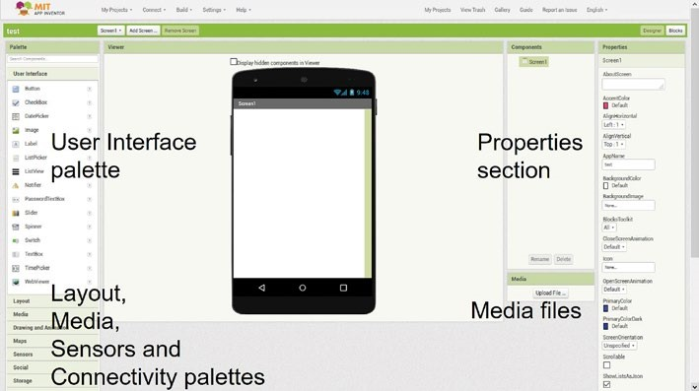
Figure 10-1. MIT App Inventor initial window
Control and feedback app
An example app controls the brightness of an LED, attached to an ESP8266 or ESP32 microcontroller, with feedback provided by a light-dependent resistor (LDR) (see Figure 10-2). The app includes a button to turn on or off the LED and displays an image indicating the LED state. When the slider on the app is moved with the LED turned on, the app transmits a signal to the microcontroller to change the LED brightness. Every two seconds, the microcontroller transmits the LDR reading to the app. The brighter the LED, the higher the LDR reading. Controlling the brightness of an LED is only an example application. In a practical application, the state and speed of a remotely located motor would be controlled through the app, which would indicate if the motor was running and at what speed, without the user being able to observe the motor.
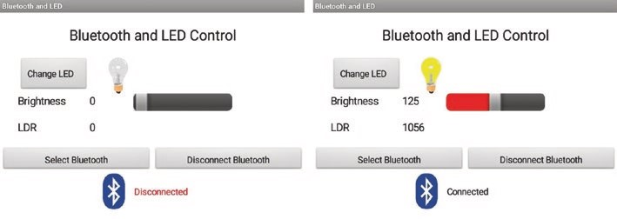
Figure 10-2. Bluetooth and LED control app
The app uses Bluetooth to communicate with the ESP8266 or ESP32 microcontroller. ESP32 development boards have Bluetooth functionality, but ESP8266 development boards must be connected to an HC-05 Bluetooth module. The HC-05 Bluetooth module is powered from 3.6 V to 6 V and is connected to the ESP8266 development board 5V pin. The HC-05 Bluetooth module transmit (TXD) and receive
(RXD) serial data function at 3.3 V, which is the operating voltage of the ESP8266 microcontroller, and are directly connected to the ESP8266 development board RX and TX pins. The ESP8266 microcontroller uses Serial communication to upload a compiled sketch. During uploading, the ESP8266 development board RX pin is disconnected, or uploading will fail. Connections for both the ESP8266 and ESP32 development boards are shown in Figure 10-3 and given in Table 10-1.
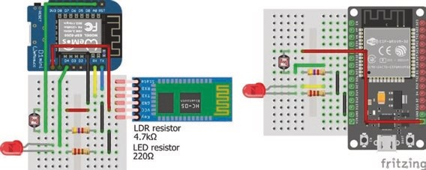
Figure 10-3. Bluetooth and LED control with ESP8266 and ESP32 development boards
Table 10-1. Bluetooth and LED control with ESP8266 and ESP32 development boards
Component | Connect to | ESP8266 | ESP32
Bluetooth hC-05 VCC |  | 5V
Bluetooth hC-05 Gnd |  | Gnd
Bluetooth hC-05 tX1 |  | rX
Bluetooth hC-05 rX0 |  | tX
led long leg |  | d4 | GpiO 27
led short leg | 220 Ω resistor | Gnd | Gnd
ldr bottom leg |  | a0 | GpiO 33
ldr bottom leg | 4.7 kΩ resistor | Gnd | Gnd
ldr top leg |  | 5V | 3V3
The sketch on the left side of Table 10-2 is for an ESP8266 microcontroller. When the ESP8266 microcontroller receives a message, from the app, consisting of the string “C”, then the ESP8266 microcontroller changes the LED state and transmits the string “H” for HIGH or “L” for LOW to the app, to indicate the updated LED state. If the received message read by the microcontroller is not “C”, then the LED brightness is set to the message value, by parsing the message, read as a string, to an integer with the instruction toInt(string), but only if the LED is turned on. Every two seconds, the microcontroller transmits the LDR reading to the app. The delay of 20 ms after the microcontroller transmits the LED state signal blocks the transmission of a simultaneous signal with the LDR reading.
The app transmits to the microcontroller the one-letter string “C", when the Change LED button is clicked, or the value of the brightness slider, when the slider is moved. When the app receives the one-letter string “H" or “L", the app displays the bulbon or the bulboff image, and the brightness slider is moved to position 255 or 0, respectively. The app continuously displays the updated LDR values.
The corresponding sketch for an ESP32 microcontroller, on the right side of Table 10-2, differs from the sketch for the ESP8266 microcontroller by the inclusion of the BluetoothSerial library, the PWM instructions, and the ESP32 microcontroller building the message string. Differences between the sketches, other than in pin numbers, are highlighted in bold. The ESP32 microcontroller accumulates characters in the Serial buffer into a string, while the ESP8266 instruction Serial.readString() reads the whole Serial buffer as a string. If the app slider is moved rapidly, the instruction Serial.readString() combines several slider values into a string. The high CPU frequency of the ESP32 microcontroller enables differentiation between slider values, when the slider is moved quickly. The ESP32 PWM instruction ledcWrite(channel, value) is the ESP8266 equivalent of the digitalWrite and analogWrite instructions. The ESP32 instruction ledcSetup(channel, 1000, 8) sets the square wave frequency for the LED to 1000 Hz with 8-bit resolution, resulting in a maximum
value of 255, for consistency with the ESP8266 sketch. Chapter 21 (Microcontrollers) includes details of PWM with an ESP32 microcontroller.
Table 10-2. Bluetooth and LED control sketches for ESP8266 and ESP32 microcontrollers
ESP8266 Microcontroller | ESP32 Microcontroller  #include <BluetoothSerial.h>  BluetoothSerial SerialBT;
int LEDpin = D4; | int LEDpin = 27;
int LDRpin = A0; | int LDRpin = 33;
int bright, LDR; | int bright, LDR;
int LEDstate = 0; | int LEDstate = 0; int channel = 0; char c;
String str; | String str;
unsigned int lastTime = 0; unsigned int lastTime = 0;
void setup() | void setup()
{ | {
Serial.begin(9600); | SerialBT.begin("ESP32 Bluetooth");
pinMode(LEDpin, OUTPUT); | pinMode(LEDpin, OUTPUT); ledcAttachPin(LEDpin, channel); ledcSetup(channel, 1000, 8);
digitalWrite(LEDpin, LEDstate); | ledcWrite(channel, LEDstate);
} | }

(continued)
Table 10-2. (continued)
ESP8266 Microcontroller | ESP32 Microcontroller
void loop() | void loop()
{ | {
if(Serial.available()>0) | if(SerialBT.available()>0)
{ | {  str = ""; while(SerialBT.available()>0)  {
str = Serial. readString(); | c = SerialBT.read();  str = str + String(c);  }
if(str == "C") | if(str == "C" )
{ | {
LEDstate = 1- LEDstate; | LEDstate = 1 - LEDstate;
if(LEDstate == 1)  Serial.print("H"); | if(LEDstate == 1)  SerialBT.print("H");
else Serial.print("L"); | else SerialBT.print("L");
digitalWrite(LEDpin,  LEDstate); | ledcWrite(channel,  LEDstate*255);
delay(20); | delay(20);
} | }
else if(LEDstate == 1) | else if(LEDstate == 1)
(continued)
Table 10-2. (continued)
ESP8266 Microcontroller | ESP32 Microcontroller
{ | {
bright = str.toInt(); | bright = str.toInt();
analogWrite(LEDpin, bright); | ledcWrite(channel, bright);
} | }
} | }
if(millis()-lastTime > 2000) | if(millis()-lastTime > 2000)
{ | {
lastTime = millis(); | lastTime = millis();
LDR = analogRead(LDRpin); LDR = analogRead(LDRpin);
Serial.println(LDR); SerialBT.println(LDR);
} }
} }

The app layout consists of several HorizontalArrangements containing the app title, the ChangeLED button and the LEDimage image, BrightLabel and BrightValue labels with a BrightSlider slider, LDRlabel and LDRvalue labels, the SelectBluetooth ListPicker button, and the DisconnectBluetooth button with the Bluetoothimage image and StatusLabel label (see Figure 10-4). All items are listed in the User Interface palette on the left side of the Designer window. The choice of a meaningful name for each item is recommended for app programming. The Bluetoothimage image is mapped to the bluetooth.png file that is uploaded in the Media palette at the bottom right of the Designer window, by clicking the Bluetoothimage
in the Components section and selecting the image file name in the Picture box of the Properties section, with the image height and width set to 40 and 50 pixels. When a ListPicker button is clicked, the list corresponding to the button is displayed, which will be the list of available Bluetooth connections. The Clock and BluetoothClient components, located in the Sensors and Connectivity palettes on the left side of the Designer window, are displayed below the app layout. Text for buttons is added in the Properties section of each button. VerticalArrangements are used to insert spaces between objects in a HorizontalArrangement.
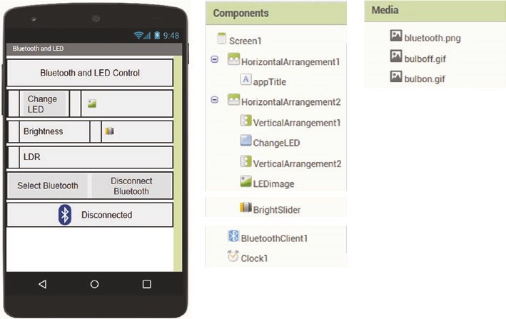
Figure 10-4. Bluetooth and LED control app layout
Once the layout is finalized, the app programming is started by clicking Blocks at the top-right side of the Designer window. The app program defines variables and procedures, establishes a Bluetooth communication, controls the LED, and processes the received signal from the microcontroller (see Figures 10-5, 10-6, 10-7, and 10-8). Blocks are color coded, and the importance of meaningful names for each item on the app screen is apparent.
Variables and procedures are defined at the start of the block program, just as when creating a sketch in the Arduino IDE. On the left side of the Blocks window, clicking Variables produces a series of options including initialize global name to, which is dragged to the Blocks window, and name is changed to Receive, to refer to the received signal by the app. From Text on the left side of the Blocks window, select and drag the blank “ ” block to the Blocks window. Again, on the left side of the Blocks window, clicking Procedures produces the option to Procedure do, which is dragged to the Blocks window, and procedure is changed to LED, to refer to LED control. A procedure is similar to a function in the Arduino IDE, and two inputs to the procedure are defined by clicking the blue-and-white gear symbol and twice dragging the input x block into the inputs block. On the LED procedure block, change x and x2 to picture and slider, respectively (see Figure 10-5).
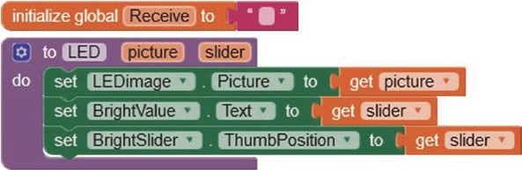
Figure 10-5. Variable and procedure definition
The LED procedure sets the LEDimage to the appropriate image when the LED is changed and sets the variables BrightValue and BrightSlider to the slider position, when the slider is moved. The three LED procedure actions are defined by
- Clicking LEDimage on the left side of the Blocks window, selecting the option set LEDimage.Picture to, and dragging it to the Blocks window
- Clicking BrightValue on the left side of the Blocks window, selecting the option set BrightValue.Text to, and dragging it to the Blocks window
- Clicking BrightSlider, selecting the option set BrightSlider.ThumbPosition to, and dragging it to the Blocks window
From Variables on the left side of the Blocks window, select the option get three times. The nine blocks are connected together as shown in Figure 10-5. In the first get block, select picture; and in the other two get blocks, select slider.
For Bluetooth communication, there are three functions: display available Bluetooth connections and connect or disconnect the Bluetooth connection. The available Bluetooth connections are displayed as a list, using the SelectBluetooth ListPicker button. On the left side of the Blocks window, clicking the SelectBluetooth ListPicker button produces options including when SelectBluetooth.BeforePicking and set SelectBluetooth.Elements to which are dragged onto the Blocks window. Clicking BluetoothClient1 produces options including BluetoothClient1. AddressesAndNames, which is also dragged onto the Blocks window. The three blocks are connected together as shown in Figure 10-6.
When the SelectBluetooth ListPicker button is clicked, the selected Bluetooth connection is made, the text Connected is displayed in black text, and the LED procedure is called. Blocks are added by clicking the SelectBluetooth ListPicker button, BluetoothClient1, and the StatusLabel label. The if then block is selected after clicking Control and the blank “” block by clicking Text and then changing the blank “ ” block to Connected or to bulbon.gif and by clicking Procedures and then selecting the LED procedure created earlier (see Figure 10-5). The block for the value zero is selected after clicking Math.
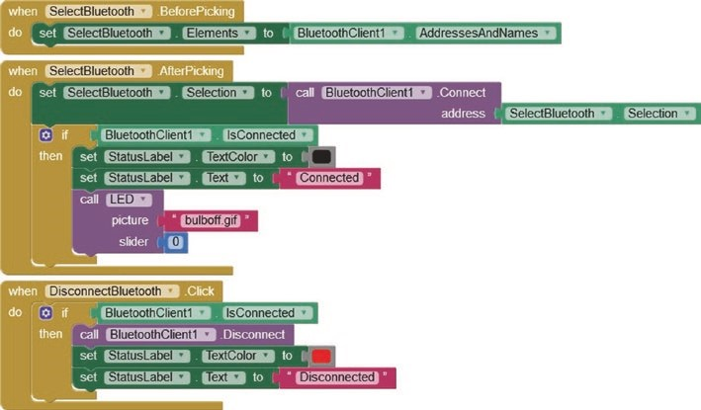
Figure 10-6. Bluetooth communication
Blocks to disconnect the Bluetooth connection are added by clicking the BluetoothDisconnect button and including when DisconnectBluetooth. Click. The text color of the StatusLabel label is set by selecting a color block from the color list in Colors. The visibility of a label is defined in the Properties section, on the right side of the Designer window, or in the Blocks window by clicking the label and selecting the set Label.visible to block and adding a true or false block.
Clicking a block in the Block section and then right-clicking Duplicate is an alternative to clicking and selecting blocks from the left side of the Blocks window.
Clicking the ChangeLED button on the app sends a message with the string “C”, and the block is constructed as shown in Figure 10-7. When the slider is moved, the app sends a message with the slider value, which is a real number. The round block, located in the Math palette, rounds up or down a real number to an integer. On the left side of the Blocks window, clicking the BrightSlider slider produces the option when BrightSlider. PositionChanged. To the call Bluetooth1.SendText text block, add the get
ThumbPosition block, which is obtained by hovering the mouse over ThumbPosition in the when BrightSlider.PositionChanged block and dragging the get ThumbPosition block into position (see Figure 10-7).
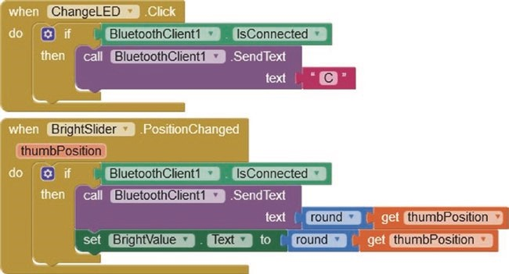
Figure 10-7. Control the LED
When the app receives a message, containing the string “H" or “L", the LED procedure displays the bulbon.gif or bulboff.gif image and moves the slider to position 225 or 0, respectively. Otherwise, the LDRvalue label is updated.
On the left side of the Blocks window, clicking Clock1 produces the option when Clock1.Timer do, clicking Text produces the option contains text piece, and clicking Variables produces the get option and global Receive is selected. The length block is obtained by clicking Text. The greater than condition block is obtained by clicking Math and selecting the equals condition block, which is changed to a greater than condition block. The if then, else if then, else block is created from an if then block, clicking the blue-and-white gear symbol and dragging an else if and an else block into the if block. Component blocks are added as shown in Figure 10-8.
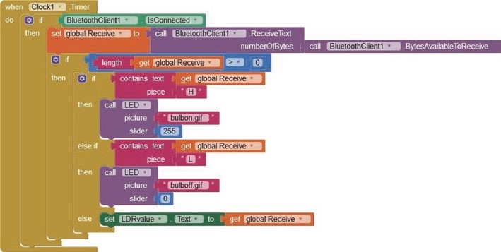
Figure 10-8. Process the received Bluetooth signal
The block is number?, obtained by clicking Math, is applied to a text variable to provide a conditional action on the received text. For example, the else block before the set LDRvalue.Text block at the bottom of Figure 10- 8 is replaced by the else if then block and the is number? block as shown in Figure 10-9.
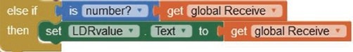
Figure 10-9. Condition on numerical value
Install the app
After designing the app layout and programming the app with the block- based visual language, the app is built by selecting App (save .apk to my computer) from the Build menu at the top of the Designer window. The .apk (Android Package Kit) file is then downloaded to the Android tablet or mobile phone with the app installed using an installer. Alternatively, a QR (Quick Response) code to download the app .apk file is created by selecting App (provide QR code for .apk), with the QR code scanned to initiate downloading the .apk file and the app installed using an installer.
To install the app, the Android tablet or mobile phone Security setting Unknown sources must be set to Allow installation of app from unknown sources. After installing the app, reset the Security setting.
The default app icon of the MIT App Inventor (see Figure 10-10) is replaced with a user-defined image. In the Properties section of the app Designer window for Screen1, the Icon property of None is the default. The app icon is replaced by uploading the required JPG or PNG image, which should be no larger than 50 × 50 pixels.

Figure 10-10. MIT App Inventor logo
Servo-robot control app
In Chapter 9 (WebSocket), a servo motor, attached to a microcontroller, was controlled by moving a slider on the client web page with the slider position transmitted to the server, which was the microcontroller, to move the servo motor to the required angle. In this chapter, two servo motors are moved to required positions, with the app controlling the servo motors connected to the ESP8266 or ESP32 development board. The servo motor positions are saved and then played back to imitate an automated robotic movement sequence. The app controls one servo motor for left- right (LR) movement and the other servo motor for forward-backward (FB) movement of the pan-tilt bracket (see Figure 10-11). Clicking the appropriate app button moves a servo motor continuously until the Stop button is clicked. The servo motor positions are saved by clicking the Save position button with the app displaying the number of saved positions. The saved sequence of movements is replayed by clicking the Playback button. The Reset button cancels the saved servo motor positions.
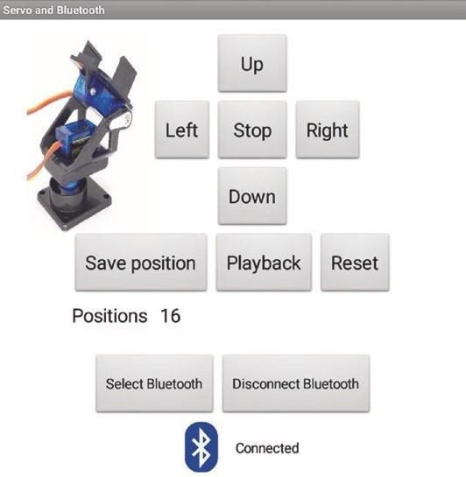
Figure 10-11. Servo motor control
The app on the Android tablet or mobile phone communicates with the ESP8266 or ESP32 microcontroller, connected to two servo motors, by Bluetooth (see Figure 10-12) with connections in Table 10-3. Clicking a button on the app transmits a command letter, which moves the corresponding servo motor in the required direction. The servo motors are externally powered with 5 V, as the motors can use hundreds of milliamps during a few microseconds that the rotor is turning, which is more than the 12 mA maximum output of an ESP8266 or ESP32 development board.
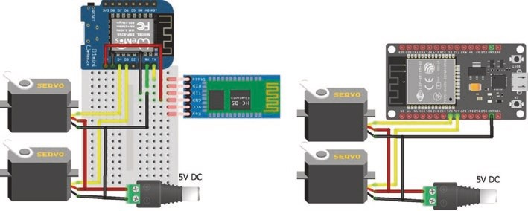
Figure 10-12. Servo motors and Bluetooth with ESP8266 and ESP32 development boards
The ESP32 microcontroller requires the ESP32-specific Servo library, rather than the Arduino IDE built-in Servo library. The ESP32Servo library by Kevin Harrington and John K. Bennett is recommended, and the library is available in the Arduino IDE. The built-in Servo library instructions for the ESP8266 microcontroller
#include <Servo.h> // include Servo library servoFB.attach(FBpin) // initialise servo motor to FBpin
are replaced with the ESP32Servo library instructions for the ESP32 microcontroller
#include <ESP32Servo.h>
servoFB.setPeriodHertz(F) // define servo frequency (F) servoFB.attach(FBpin, min, max) // initialise servo motor to FBpin
The square wave frequency, F, is included in the instruction servoFB.setPeriodHertz(F), which is generally 50 Hz. In the servoFB. attach(FBpin, min, max) instruction, the min and max parameters refer to the pulse width, in microseconds, of a square wave to move the servo motor to 0° and 180°, respectively. Default values for the min and max parameters are 1000 μs and 2000 μs, with values of 500 μs and 2500 μs for the Tower Pro SG90 servo.
There is no change to the following instructions:
Servo servoFB // associate servoFB with servo lib servoFB.writeMicroseconds(T) // move to position mapped to Tμs servoFb.write(N) // move to angle N°
The ESP8266 microcontroller uses Serial communication to upload a compiled sketch. During uploading, the ESP8266 microcontroller RX pin must be disconnected, or uploading will fail.
Table 10-3. Servo motors and Bluetooth communication with
ESP8266 and ESP32 development boards
Component | Connect to | ESP8266 | ESP32
Servo VCC (red) | Battery 5 V
Servo Gnd (brown or black) | Battery Gnd | Gnd | Gnd
Servo signals (orange or white) |  | d3, d4 | GpiO 25, GpiO 26
Bluetooth hC-05 VCC |  | 5V
Bluetooth hC-05 Gnd |  | Gnd
Bluetooth hC-05 tX1 |  | rX
Bluetooth hC-05 rX0 |  | tX
The sketch in Listing 10-1 is commented for the ESP8266 development board. Instructions for the ESP32 development board include the BluetoothSerial library with SerialBT replacing Serial instructions (see Table 10-2), as the transmitted messages only contain one character. The received command letter by the ESP8266 or ESP32 microcontroller either increments the position of a servo motor or calls a function to save, playback, or reset the servo motor positions. When moving servo motors, the movement speed is determined by the delay between movements, and a delay of 100 ms enables the servo motors to be precisely moved to the required positions. After a servo motor position is saved, the microcontroller transmits the position number for display on the app. When the servo motor position sequence is played back, the delay of 15 ms is a compromise between moving the servo motors quickly and providing sufficient time for the servo motors to move to the saved positions. The servo motors are moved to an initial or home position before playing back the saved servo motor position sequence, but not after the playback, as the end position does not have to equal the starting position.
The servo motor position sequence is saved in two arrays, one for each servo motor, but the information is not retained in memory when the ESP8266 or ESP32 development board is powered down. Saving the servo motor positions in EEPROM (Electrically Erasable Programmable Read- Only Memory) would retain the information when the ESP8266 or ESP32 development board is turned off, as described in Chapter 20 (OTA and saving data to EEPROM, SPIFFS, and Excel).
The playServo function controls playback of the saved servo motor position sequence. Two saved positions can differ for one servo motor only, if the position change was only a pan (left-right) or a tilt (forward- backward) movement. If the new position is different from the previous position for only one servo motor, the number and direction of 5° steps to move to the new position is determined, with no change to the other servo motor position.
Listing 10-1. Servo motors and Bluetooth
#include <Servo.h> // include Servo library
Servo servoFB; // associate servos with library Servo servoLR;
int FBpin = D3; // servo motor pins int LRpin = D4;
int FBpos[20]; // arrays for saved servo positions int LRpos[20];
int Nservo = 0; // number of saved positions int FB, LR, steps, stepsize; char c;
void setup()
{
Serial.begin(9600); // Bluetooth module baud rate servoFB.attach(FBpin); // servo motor pin to Servo lib servoLR.attach(LRpin); startPosition(); // set initial servo positions
}
void loop()
{ // read character in Serial buffer
if(Serial.available()>0) c = Se rial.read(); if(c == 'U') FB = FB-5; // move servo forward (up) else if(c == 'D') FB = FB+5; // move servo backward else if(c == 'L') LR = LR+5; // move servo left else if(c == 'R') LR = LR-5; // move servo right else if(c == 'Z') delay(100); // stop moving both servos else if(c == 'S') saveServo(); // save both servo positions else if(c == 'P') playServo(15); // playback servo positions else if(c == 'E') resetServo(); // reset saved positions if(c != 'Z' && c !=' ') moveServo(FB, LR, 100); } // move both servos
void startPosition() // function to set initial servo positions {
FB = 50; // arbitrary home position LR = 70; moveServo(FB, LR, 100); // move servos to initial position
}
void moveServo(int vFB, int vLR, i nt lag) { // function to move servos vFB = constrain(vFB, 5, 100); // constrain servo positions
vLR = constrain(vLR, 5, 175);
servoFB.write(vFB); // move forward-backward servo delay(lag); // time between servo movements servoLR.write(vLR); // move left-right servo delay(lag); }
void saveServo() // function to save servo positions
{
Nservo++; // increment number of positions
Serial.println(Nservo); // transmit position number to app
FBpos[Nservo] = FB; // save forward-backward position LRpos[Nservo] = LR; // save left-right position c = ' '; // reset command value
}
void playServo(int lag) // function to play back servo positions
{ startPosition(); // move servos to initial position
FBpos[0] = FB; LRpos[0] = LR;
for (int i=1; i<Nservo+1; i++) // cycle through saved positions { if(FBpos[i] != FBpos[i-1]) // forward-back position change
{
steps = abs((FBpos[i] - FBpos [i-1])/5); // number of steps stepsize = 5; // magnitude of step size if(FBpos[i] < FBpos[i-1]) steps ize = -5;
// change in FB from FBpos[i-1],LRpos[i-1]
for (int j = 0; j<steps; j++) moveServo(FBpos[i-1]+j*stepsize, LRpos[i-1], lag);
} if(LRpos[i] != LRpos[i-1]) // left-right position change
{
steps = abs((LRpos[i] - LRpos[i-1])/5); stepsize = 5; if(LRpos[i] < LRpos[i-1]) stepsize = -5;
// now at FBpos[i], so change in LR to LRpos[i]
for (int j = 0; j<steps; j++)
moveServo(FBpos[i], LRpos[i-1]+j*stepsize, lag);
}
} c = ' '; // reset command value
}
void resetServo() // function to reset saved positions
{
Nservo = 0; // reset position number to zero Serial.println(Nservo); // transmit position number to app c = ' '; // reset command value }
The app layout consists of five buttons to control servo motor movements, with the buttons positioned in a TableArrangement, which is located in the Layout palette on the left side of the Designer window, with the table consisting of three rows and columns (see Figure 10- 13). The second HorizontalArrangement contains three buttons to save, playback, and reset the servo motor positions. The app layout for Bluetooth connection is the same as described in the app for Figure 10- 4. In the User Interface palette, an Image logo is positioned in the first HorizontalArrangement. The image of the pan-tilt bracket with servo motors is uploaded in the Media palette at the bottom right of the Designer window. In the Properties section on the right side of the Designer window, the image is selected under Picture, with the image height and width set to Fill parent and 90 pixels, respectively.
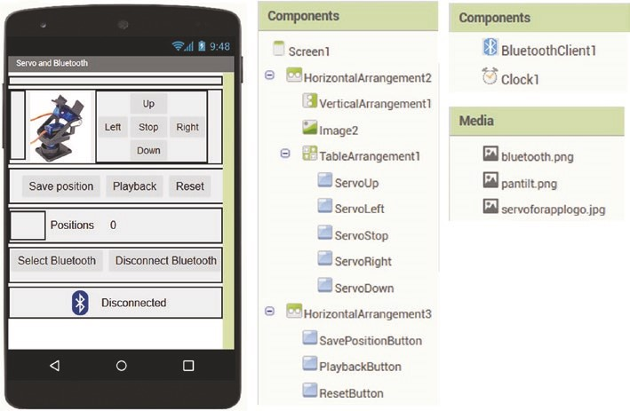
Figure 10-13. App layout for servo motor control
The app blocks are all based on a button click, which transmits the appropriate command letter to the ESP8266 or ESP32 microcontroller connected to the two servo motors (see Figure 10-14). The command letters are the first letter of each command, such as “L" for left, with the exception of “Z" and “E" for stop and reset.
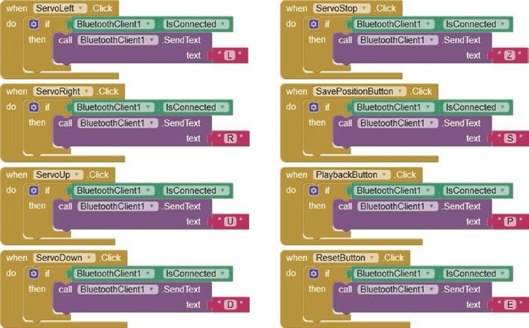
Figure 10-14. Servo motor commands
The block for the app to receive the transmitted number of saved servo motor positions sets the PositionsLabel text to the transmitted message (see Figure 10-15).
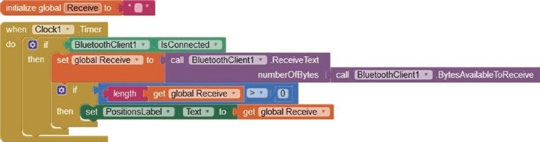
Figure 10-15. Number of saved servo motor positions
The SelectBluetooth.BeforePicking, SelectBluetooth.AfterPicking, and DisconnectBluetooth blocks are identical to those in Figure 10-6.
Speech recognition app
Speech recognition is used to control an app rather than clicking app buttons. The app requests the user to speak and converts the spoken sound into text using the speech recognition function of the Android tablet or mobile phone, which may require Internet access. The app layout consists of HorizontalArrangements containing the app title, the Speech button, and the SpokenText textbox. An image of a person speaking, speech. png, is uploaded in the Media palette and mapped to the Speech button in the Properties section. The label SpokenText contains the text generated by the speech recognition function (see Figure 10-16).
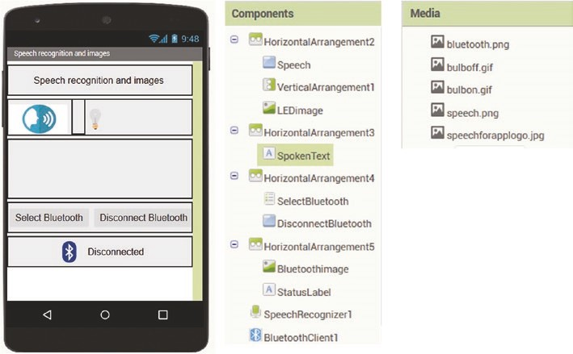
Figure 10-16. Speech recognition app layout
The Blocks window consists of just four blocks (see Figure 10-17). When the user clicks the Speech button, the SpeechRecognizer function, located in the Media palette on the right side of the Designer window, clears the content of the SpokenText label, asks the user to speak, and converts the speech to text, which is displayed in the SpokenText label.
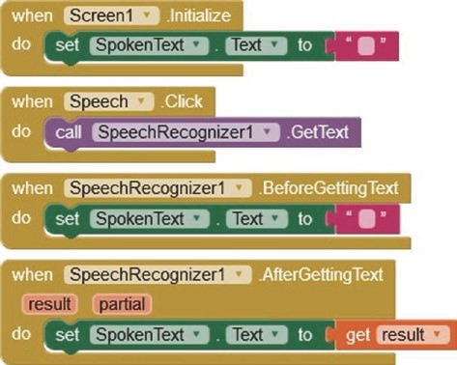
Figure 10-17. Speech recognition
Devices are controlled based on the content of the text, derived from the SpeechRecognizer function. For example, if the speech and the corresponding SpokenText label contain the phrase LED on or LED off, then the appropriate image, indicating the LED state, is displayed on the app (see Figure 10-18). The bulbon.png and bulboff.png images are uploaded in the Media palette in the Designer window, with the bulboff. png image mapped to the LEDimage in the Properties section.
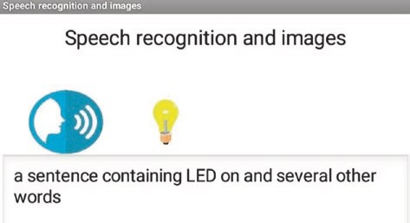
Figure 10-18. Speech recognition with image control
The SpeechRecognizer.AfterGetting Text function in Figure 10-17 now calls the app LED procedure with an image dependent on the app SpokenText label containing the phrase LED on or LED off (see Figure 10- 19). The app LED procedure in Figure 10-5 that displays an image on the app to indicate the LED state is combined with the app Change LED procedure in Figure 10-7 that sends a message consisting of the character “C” to the ESP8266 or ESP32 microcontroller. The sketches for an ESP8266 or ESP32 microcontroller in Table 10-2 to turn on or off the LED, when a message, consisting of the character “C", was received from the app, are not altered, as there is no change in the microcontroller response to messages sent by the app.
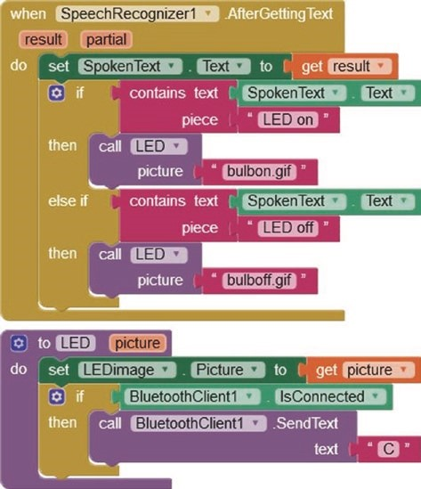
Figure 10-19. Speech recognition with image control and Bluetooth
Note that the SelectBluetooth ListPicker button, the DisconnectBluetooth button, and the Bluetooth image with StatusLabel label are included in the app layout (see Figure 10-4) along with the corresponding blocks for Bluetooth connection (see Figures 10-16 and 10- 20).
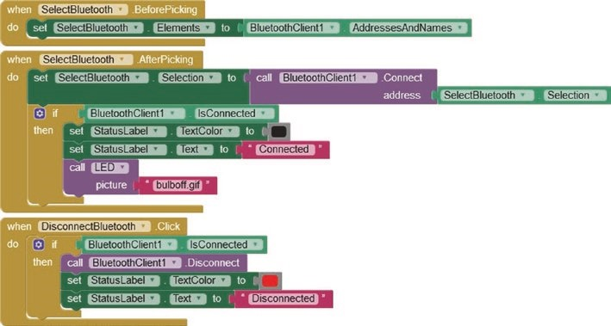
Figure 10-20. Bluetooth connection
Instead of the speech recognition app turning on or off an LED, a device is controlled through a relay attached to the ESP8266 or ESP32 development board. The sketches in Table 10-2 are not changed, but the SpokenText label of the speech recognition app (see Figure 10-19) is changed from LED on and LED off to Relay on and Relay off, as required. Chapter 15 (Radio frequency communication) includes a description of controlling a device with a relay. For example, the IRF520 MOSFET relay module can switch up to 100 V direct current (DC) at 10 A, to provide power for a motor, a light, or other devices (see Figure 10-21).
If the load is a DC motor, then the motor, which is partially an inductor, will generate a voltage to maintain current when power to the motor is switched off. Fitting a diode across the motor prevents a voltage spike
and dissipates energy through the motor when power is switched off. A Schottky diode, which is a fast switching diode with a low forward voltage drop, is recommended.
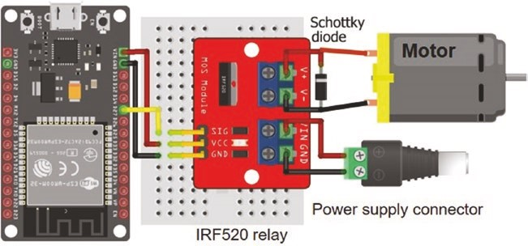
Figure 10-21. IRF520 MOSFET relay module and the ESP32 development board
Summary
An app to control the brightness of an LED attached to an ESP8266 or ESP32 development board with feedback from a light-dependent resistor was developed for an Android tablet or mobile phone. The app is programmed with MIT App Inventor with a block-based visual language. The ESP8266 or ESP32 development board and the Android tablet or mobile phone communicate using Bluetooth. The ESP32 development board has built-in Bluetooth functionality, but an HC-05 Bluetooth module is attached to the ESP8266 development board. Two servo motors were controlled with an app with servo motor positions saved for playback to imitate an automated robotic movement sequence. An app based on speech recognition controlled the state of an LED attached to an ESP8266 or ESP32 development board, with images displayed on the app on the Android tablet or mobile phone to indicate the LED state.
Components List
- ESP8266 microcontroller: LOLIN (WeMos) D1 mini or NodeMCU board
- ESP32 microcontroller: ESP32 DEVKIT DOIT or NodeMCU board
- LED
- Light-dependent resistor
- Resistors: 220 Ω, 4.7 kΩ
- Bluetooth module: HC-05
- Relay: IRF520 module

CHAPTER 11
App database and Google Maps
MIT App Inventor contains a database function for storing data within an app. Google Maps is accessible with MIT App Inventor, provided the Android tablet or mobile phone hosting the app has Internet access. This chapter outlines a method to store route data in an app database, with the app displaying route information using Google Maps. Building the app database and incorporation of Google Maps are the basis for Chapter 12 (GPS tracking app with Google Maps) to develop a GPS tracking app for the GPS module connected to an ESP8266 or ESP32 development board.
MIT App Inventor database

The database function of MIT App Inventor retains data when the app is switched off. Databases store data in a structured format, with data referenced to an index or an MIT App Inventor tag. The database enables addition, modification, and deletion of data, with searching for a specific database tag using an MIT App Inventor ListPicker and displaying the database contents with an MIT App Inventor
ListView. A database item consists of two components: the database tag
© Neil Cameron 2021 289
N. Cameron, Electronics Projects with the ESP8266 and ESP32, https://doi.org/10.1007/978-1-4842-6336-5_11
and the value associated with that tag. For example, a database item may consist of "Longest_day, June, 21", with "Longest_day" being the database tag and "June, 21" being the value associated with tag "Longest_day". The value associated with a tag is a string that includes several components, each separated by a comma, backslash, hash, or ampersand. The database tag is alphanumeric text, so the format for an address and birthday database item is "Alexander, 44 Scotland Street, 1 January", where "Alexander" is the database tag that references the value consisting of two components: address of "44 Scotland Street" and birthday of "1 January". Database information is accessed by searching on the database tag and not on the associated value.
In an example database, which demonstrates adding, deleting, altering, and displaying database contents, the app consists of two screens (see Figures 11-1 and 11-2). A database item includes the database tag, Text1, which is case sensitive, and the database value consisting of two text components, Text2 and Text3, which are alphanumeric. In Screen1, a database item is entered into the corresponding three textboxes and saved in the database by clicking the SavetoDbase button (see Figure 11-1). A database item is searched for by entering text in the FindDbaseText1 textbox and clicking the FindTextButton button to initiate a database search for the database tag that matches the entered text, and the database item is then displayed in the three textboxes: Text1, Text2, and Text3. A displayed database item is deleted from the database by clicking the DeleteDbaseItem button. Screen1 is cleared by clicking the ClearScreen button.
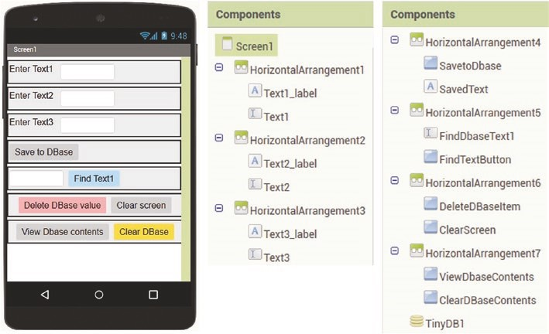
Figure 11-1. Database app screen 1 layout
Database contents are displayed by clicking the ViewDbaseContents button, which moves to the second screen, Screen2, with the database items displayed in a ListView as “Text1 AND Text2&Text3” (see Figure 11-2). Clicking the ClearDbaseDisplay button clears the Screen2 display of database items. Clicking the SelectandDisplay ListPicker button produces a list of the database tags, Text1. When a database tag is selected, the database item is displayed as “Text1 Text2&Text3” in the DbaseTag and DbaseValue labels, respectively. Clicking the ClearDisplay button clears the database item from Screen2. The effect of the GotoScreen1 button is self-explanatory.
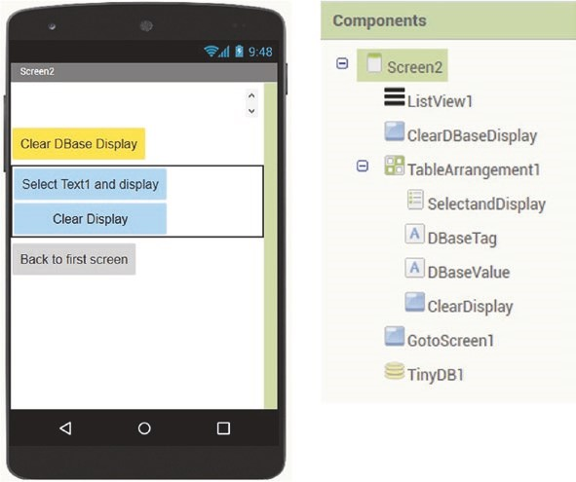
Figure 11-2. Database app screen 2 layout
The TinyDB1 database of MIT App Inventor is accessed from the Storage palette on the left side of the Designer window, and the TinyDB component is dragged onto Screen1. ListView and ListPicker are located in the User Interface palette.
A database item is saved, with the TinyDB StoreValue function, provided both Text1 and Text3 are not blank, with the database value components,
Text2 and Text3, joined with the ampersand, &, character (see Figure 11-3).
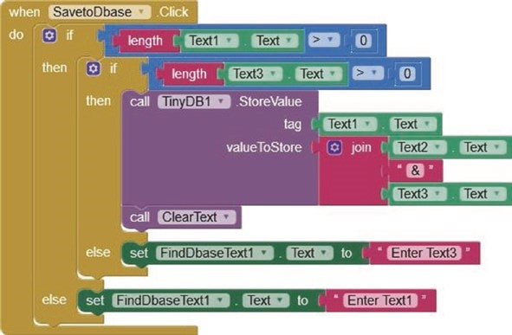
Figure 11-3. Save a database item
The contents of Screen1 are cleared with the ClearText procedure, which replaces textboxes with blank text (see Figure 11-4). A database item is deleted from the database with the TinyDB ClearTag function, which clears Text1 from the database, as Text2 and Text3 are subsequently overwritten. The entire database content is deleted with the TinyDB ClearAll function.
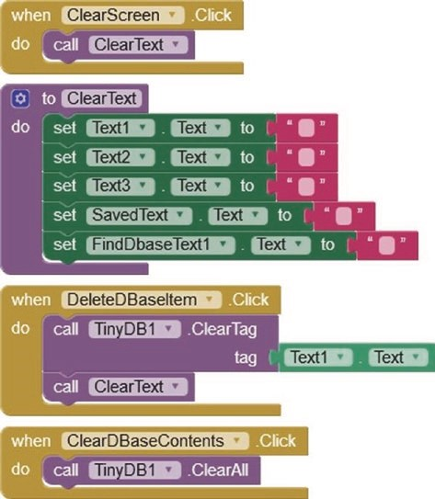
Figure 11-4. Delete a database item or clear all database items
A database item is accessed by the database tag, Text1, with the database value components indexed as list items 1, 2, and so on. If the database tag is found, the database value is parsed into components using the ampersand, &, partitioning character; otherwise, an error message is displayed (see Figures 11-3 and 11-5).
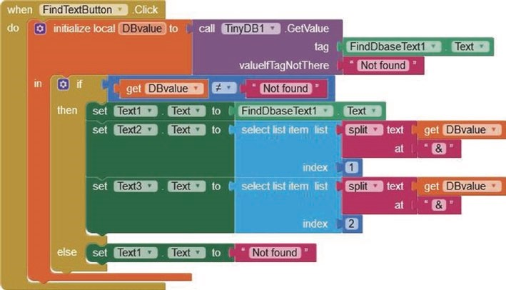
Figure 11-5. Locate a database item
Database contents are displayed by allocating database tags to a list, DBlist, with the TinyDB GetTags function. The corresponding database values are added to the list, with the TinyDB GetValue function, and the contents of the list are displayed with the ListView function (see Figure 11-6).
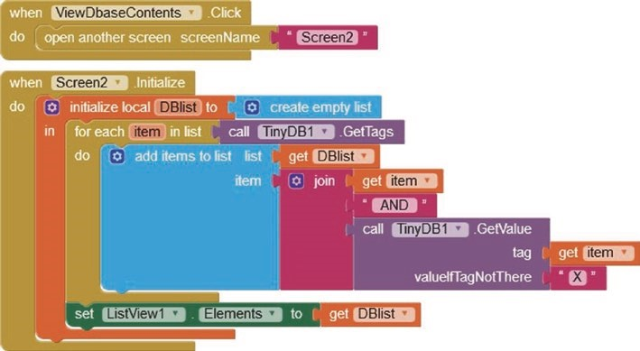
Figure 11-6. Display database content
A database item is selected from a list with the TinyDB GetTags and GetValue functions. The list is deleted with the TinyDB create empty list function. The app is moved to another screen with the open another screen control option (see Figure 11-7).
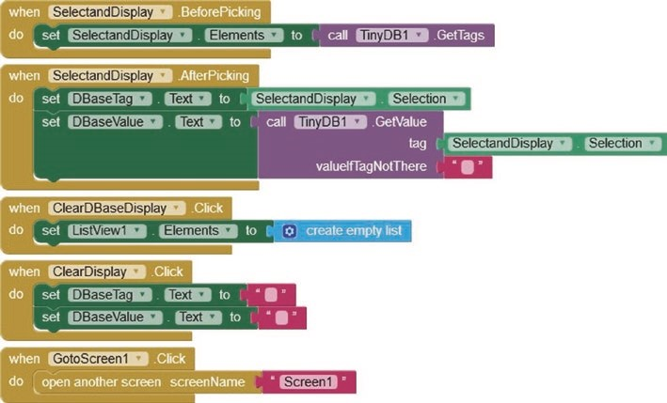
Figure 11-7. Display or clear the display of a selected database item
MIT App Inventor and Google Maps

Google Maps is accessible with MIT App Inventor, provided the Android tablet or mobile phone hosting the app has Internet access. The example app demonstrates accessing Google Maps, storing location latitude (North-South position) and longitude (East-West position) information in the app database, placing
markers on the map view, zooming in and zooming out of the map view, and displaying road or aerial map views (see Figure 11-8). The map is moved by dragging the map, a double touch zooms in the map, and the

app database and GooGle Maps
latitude and longitude of the touched position are displayed. A location is saved in the app database after entering the location name and clicking the AddLocation button. The ChooseLocation button displays a list of saved locations in the app database, with the map centered on the chosen location. The DeleteLocation button removes a saved location from the app database.
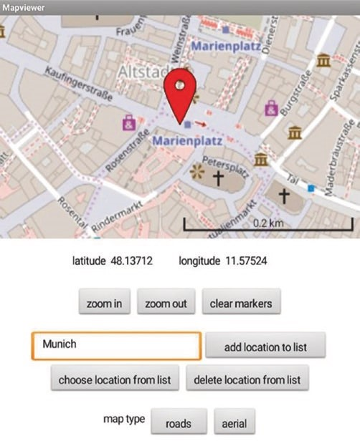
Figure 11-8. Location database app
The first HorizontalArrangement of the location database layout includes the map with a marker, which is accessed from the Maps palette (see Figure 11-9). The map is centered and the marker positioned on the latitude-longitude defined in the CenterFromString property. The map properties include the EnableZoom option, with a height and width of 200 pixels and Fill parent, respectively, and the ShowScale option. Latitude and longitude labels for displaying values and buttons to zoom in and zoom out of the map and to clear markers from the map are included in the second and third HorizontalArrangements. In MIT App Inventor, labels are for displaying alphanumeric text, while textboxes enable the user to enter alphanumeric text. A textbox Hint property positions text in the textbox to provide information to the user. The Location textbox Hint is "enter name then click". The AddLocation, ChooseLocation, and DeleteLocation buttons are clicked to update location information on the app database. Finally, the RoadView and AerialView buttons change the map view format, although high aerial-view resolution is only available for the USA.
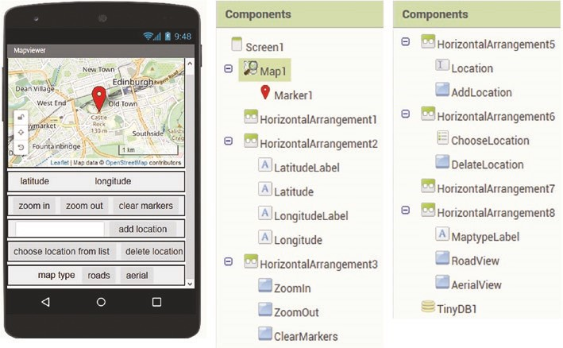
Figure 11-9. Location database app layout
app database and GooGle Maps
Blocks to display location latitude and longitude when the map is tapped or double-tapped, with the latter increasing the zoom level, are shown in Figure 11-10. The setText procedure updates the latitude and longitude textboxes for the map position touched by the user. A global variable zoom is defined as the map zoom level. The drawMap procedure redraws the map with the updated zoom level and centers the map on the touched location. Blocks to change the map zoom level are shown in Figure 11-11, with the zoom procedure updating the zoom level.
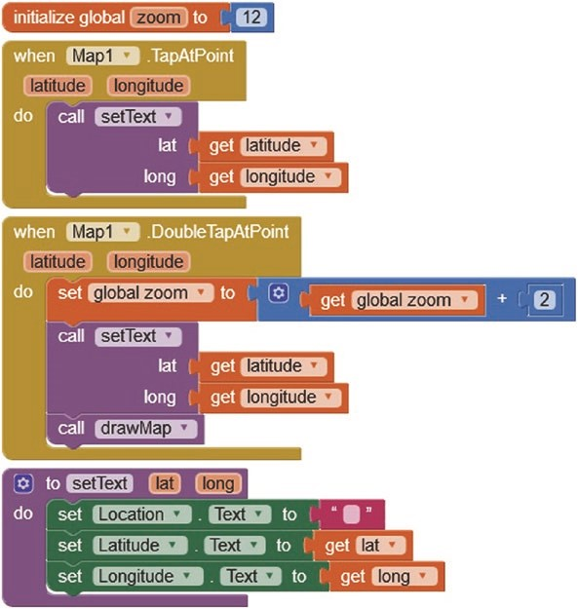
Figure 11-10. Display location latitude and longitude on tapping map
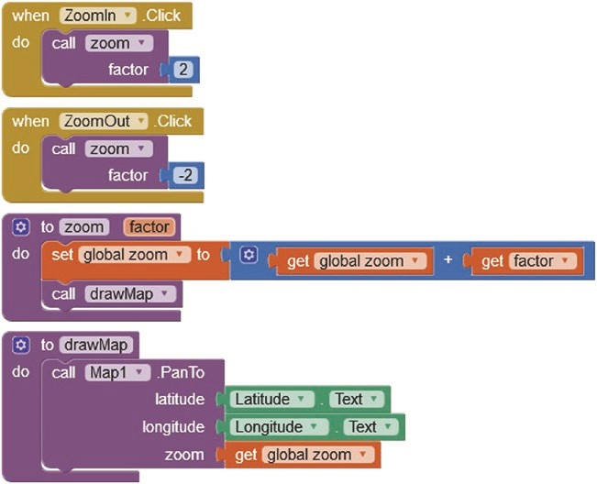
Figure 11-11. Change map zoom level
Location data is saved to the TinyDB1 app database with the TinyDB StoreValue function, with the database tag equal to the location name, as entered in the Location textbox. The database value is the location latitude and longitude, which are joined with the ampersand character (see Figure 11-12). A location is deleted from the app database with the TinyDB ClearTag function.
app database and GooGle Maps
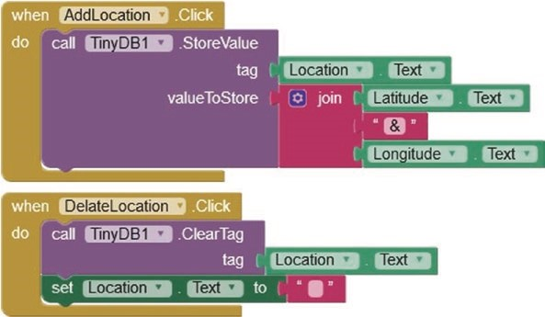
Figure 11-12. Save location data to the app database
When a location is selected from the list of locations saved in the app database, the database tag is set to the selected location. The corresponding database value obtained with the TinyDB GetValue function, consisting of the location latitude and longitude joined by the ampersand character, is split into two indexed components (see Figure 11- 13). The map type is set one, corresponding to the road view, the map zoom level is set, and the map is redrawn centered on the location latitude and longitude with a map marker positioned on the map at the selected location. The ClearMarkers button sets the Map Features to an empty list, which removes all map markers when the map is next updated.
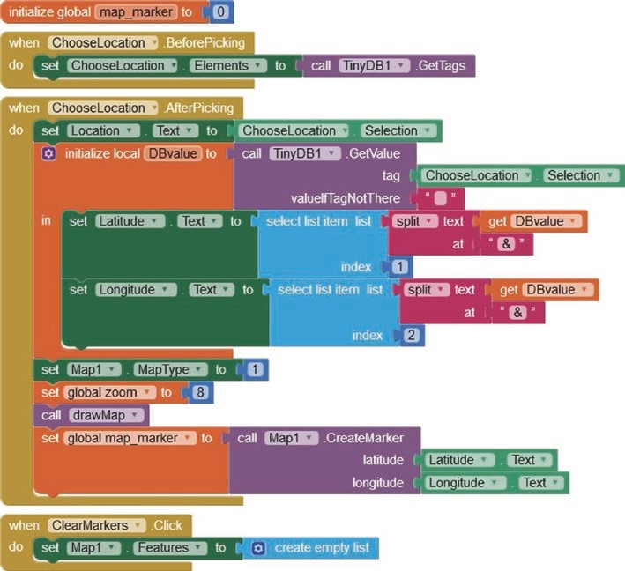
Figure 11-13. Choose a location from the app database
Finally, for a road or an aerial map view, the map type is set to one or two, respectively, and the road view has higher resolution than the aerial view (see Figure 11-14). The resolution of the aerial view is only high for the USA, so the map zoom level is set to eight before redrawing the map.
app database and GooGle Maps
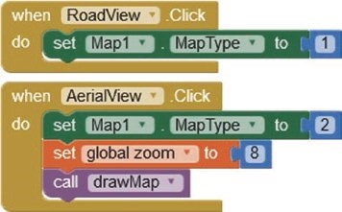
Figure 11-14. Map type definition
Summary
Demonstration apps were developed to illustrate the MIT App Inventor database functionality and use of Google Maps in a location app. An MIT App Inventor database contains database items, consisting of a database tag and the corresponding database value, to include several variables separated by the ampersand character. Database items are added to, altered in, or deleted from the database, with the option to display the database contents or only the database value corresponding to a selected database tag. A database app, built with MIT App Inventor, stored the latitude and longitude data of selected locations. Markers were positioned on the map view at the stored locations. The app had a map zoom function with the road and aerial views provided by Google Maps.
Components List
- Android tablet or mobile phone
- Internet access

CHAPTER 12
GPS tracking app with Google Maps
In Chapter 11 (App database and Google Maps), an app is developed to display map locations using Google Maps on an Android tablet or mobile phone with Internet access. In this chapter, a GPS location app displays the position of a remotely located GPS module or the route taken by the GPS module using Google Maps. An nRF24L01 module, connected to an ESP8266 or ESP32 development board attached to the GPS module, transmits the GPS location to a receiving nRF24L01 module, attached to an ESP32 development board. The GPS location information is transmitted to the app on the Android tablet or mobile phone by the ESP32 microcontroller using Bluetooth communication. The GPS location is displayed on the app using Google Maps, with the Android tablet or mobile phone accessing Google Maps data from the World Wide Web through the Internet Service Provider (ISP) (see Figure 12-1). The transmission range of the nRF24L01 transceiver module of at least 1 km combined with the 10 m range of Bluetooth provides a degree of flexibility in the distance between the app user, the receiving nRF24L01 module, and the remotely positioned GPS module.
© Neil Cameron 2021 305
N. Cameron, Electronics Projects with the ESP8266 and ESP32, https://doi.org/10.1007/978-1-4842-6336-5_12
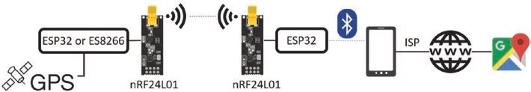
Figure 12-1. GPS tracking app with nRF24L01 transceiver modules
The receiving nRF24L01 module could be connected to an ESP8266 development board, but an HC-05 Bluetooth module would have to be connected to the ESP8266 development board for Bluetooth communication with the Android tablet or mobile phone.
Alternatively, LoRa (long range) communication, between the transmitting ESP8266 or ESP32 development board connected to the GPS module and the receiving ESP32 microcontroller, could replace the Radio Frequency (RF) communication of the nRF24L01 modules. LoRa communication is described in Chapter 14 (ESP-NOW and LoRa communication).
The app displays the current GPS location with a zoom map function and the option to display a completed route by connecting location tracking markers. The received GPS latitude and longitude values are filtered to avoid erroneous marker positions, caused by transmission noise, from being plotted on the map. An initial base position is entered on the app, to which received GPS positions are compared (see Figure 12-2).
GpS traCkinG app with GooGle MapS
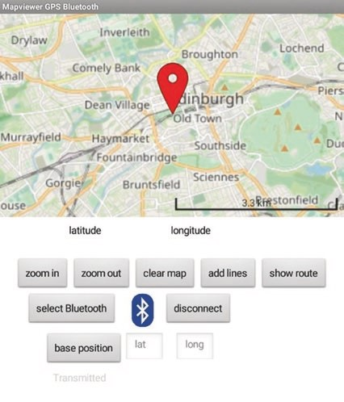
Figure 12-2. GPS tracking app
After the Bluetooth connection is established between the app and the receiving ESP32 microcontroller, the GPS position is identified on the map, with the map automatically centered at the GPS position (see Figure 12-3 (a)). Every two seconds, the GPS position is transmitted to the receiving nRF24L01 module, and the map is updated with the GPS position (see Figure 12-3 (b)). Clicking the app add lines button connects the GPS position markers with a joining line (see Figure 12-3 (c)). Clicking the app clear map button clears the map of the GPS markers and the joining line. Clicking the app show route button displays the route taken as the joining line of GPS positions (see Figure 12-3 (d)).
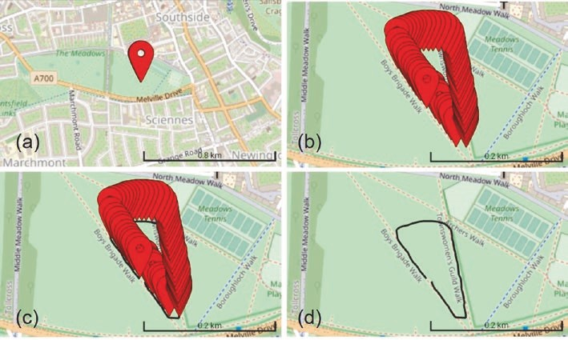
Figure 12-3. GPS tracking app position markers and route taken
The app layout in Figure 12-4 consists of the map with a location marker and the LineString function, available in the Maps palette on the left side of the MIT App Inventor Designer window. The GPS latitude and longitude are displayed in the corresponding Latitude and Longitude labels. The second HorizontalArrangement contains the ZoomIn, ZoomOut, ClearMarkerLines, AddLines, and ShowRoute buttons, which control the map zoom function, clear all markers from the map, connect location markers with a joining line, and display the completed route using the joining lines without the markers.
GpS traCkinG app with GooGle MapS
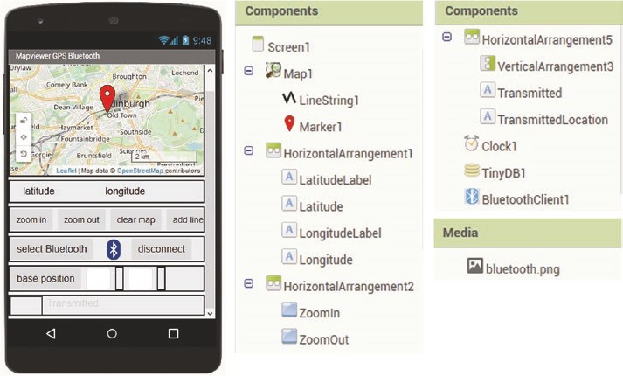
Figure 12-4. GPS tracking app layout
When the app is loaded, clicking the SelectBluetooth ListPicker button displays a list of available Bluetooth connections, the selected Bluetooth connection is made, and the text connected is displayed in gray text. The DisconnectBluetooth button disconnects the Bluetooth connection, and the text disconnected is displayed in red.
Entering the base latitude and longitude into the corresponding
BaseLatitude and BaseLongitude textboxes and then clicking the BasePosition button displays the entered values, and the app subsequently screens the received latitude and longitude values before displaying location markers on the map with Google Maps. The last HorizontalArrangement displays the signal, TransmittedLocation, as received by the receiving nRF24L01 module. The app Clock, TinyDB, and BluetoothClient components are located in the Sensors, Storage, and Connectivity palettes of the Designer window.
MIT App Inventor blocks to build the app are shown in Figures 12-5 to 12-10. Blocks to connect and disconnect to and from the Bluetooth device, which is the ESP32 microcontroller, are shown in Figure 12-5. The StatusLabel label displays the Bluetooth connection status. Building the Bluetooth connection blocks was described in Chapter 10 (Build an app).
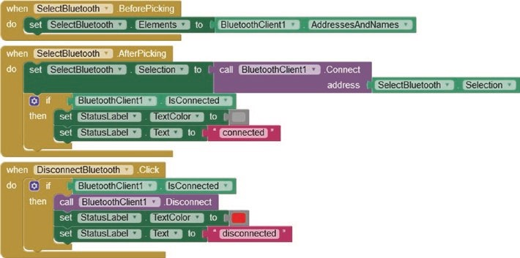
Figure 12-5. Connect or disconnect to or from a Bluetooth device
The Clock1 timer monitors, at 1000 ms intervals, the Bluetooth device for a signal, which is analogous to the instruction if(Serial.available() > 0) in a sketch in the Arduino IDE. The received signal is displayed at the bottom of the app screen in the TransmittedLocation label. The received signal should contain three comma-separated components: a counter, the GPS latitude, and the GPS longitude. If the received signal contains a comma, then the signal text is parsed, with each signal component indexed 1, 2, or 3 and allocated to the components of a list, datalist. If the datalist contains three components, then the check procedure is called to validate the signal information (see Figure 12-6). If the received signal does not contain a comma or does not contain three components, then the signal is ignored.

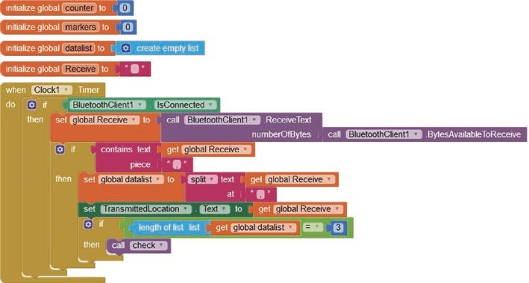
Figure 12-6. Receive and process Bluetooth signal
The check procedure validates the signal information by checking that the GPS latitude and longitude are both numbers and that the absolute deviation from the base position, which was entered on the app by the user, is less than two degrees (see Figure 12-7). One degree of latitude is 111 km, while a degree of longitude is 78 km at 45° North or South, given a spherical Earth radius of 6371 km. Comparing the GPS latitude and longitude to the base position ensures that spurious positions, due to transmission noise, are not plotted on the map. The GPS position is updated on the map by creating a map marker at the GPS latitude and longitude, with the map centered on the marker location. The GPS position is stored in the TinyDB database with the database tag equal to a marker counter, which is only incremented for verified GPS position data, rather than for all received GPS position data.
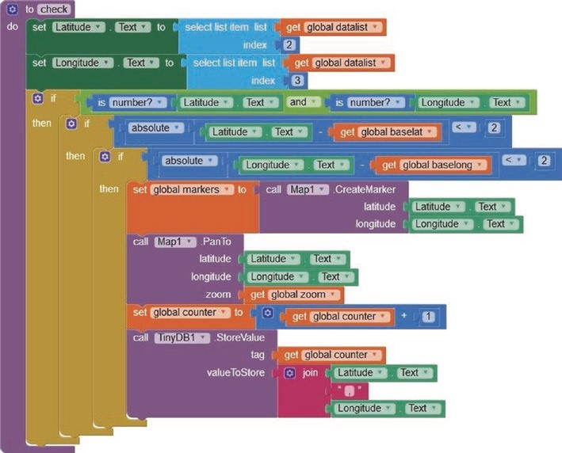
Figure 12-7. Validate position data, plot position on the map, and store position data
The blocks to create position marker joining lines are shown in Figure 12-8. The linetext text is essentially a series of (X, Y) co-ordinates. When the AddLines button is clicked, the linetext text is initialized as a blank character and incremented with each GPS position stored in the TinyDB database to form the sequence of (X, Y) co-ordinates. When all the GPS position data is incorporated in the linetext text, the points on a Map LineString are generated from the linetext text, and the Map LineString is made visible on Google Maps. The Map LineString is also made visible, but without the map markers, when the ShowRoute button is clicked, after clicking both the AddLines and then the ClearMarkerLines buttons.
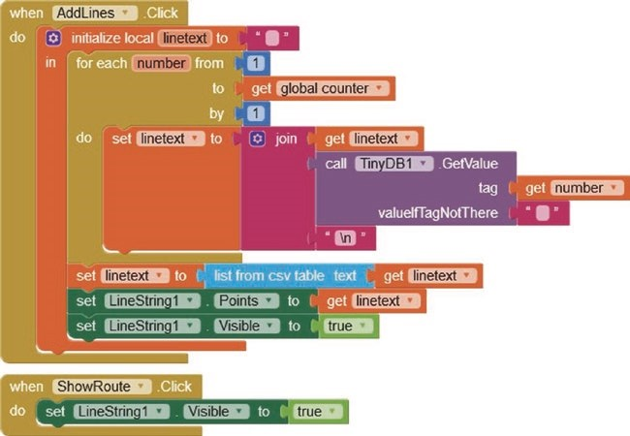
Figure 12-8. Create marker connecting lines
Blocks to clear the map markers and/or the map marker joining line are shown in Figure 12-9. When the ClearMarkerLines button is clicked, the Map LineString is no longer visible, the displayed latitude and longitude are cleared, and the Map Features, such as the map markers, are all reset, except for the first item of Map Features.
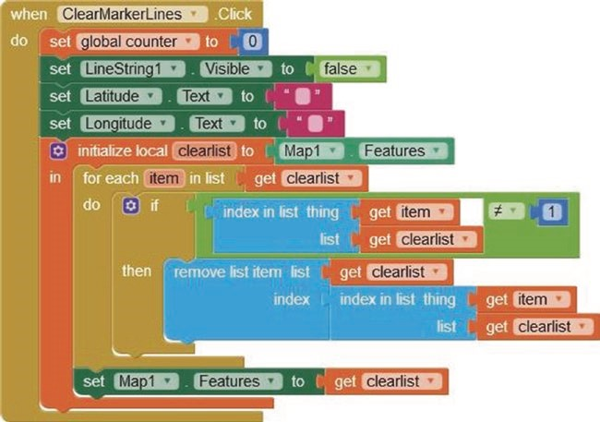
Figure 12-9. Clear map markers and connecting lines
The blocks for the map zoom functions and incorporation of the base position information are shown in Figure 12-10. When the ZoomIn or ZoomOut button is clicked, the map zoom factor is increased or decreased, and the map is redrawn with the updated zoom level and centered at the GPS location. When the BasePosition button is clicked, the values entered by the user in the BaseLatitude and BaseLongitude textboxes are stored in the global baselat and baselong variables, for screening received GPS position information, with the BaseLabel updated with values of the baselat and baselong variables.
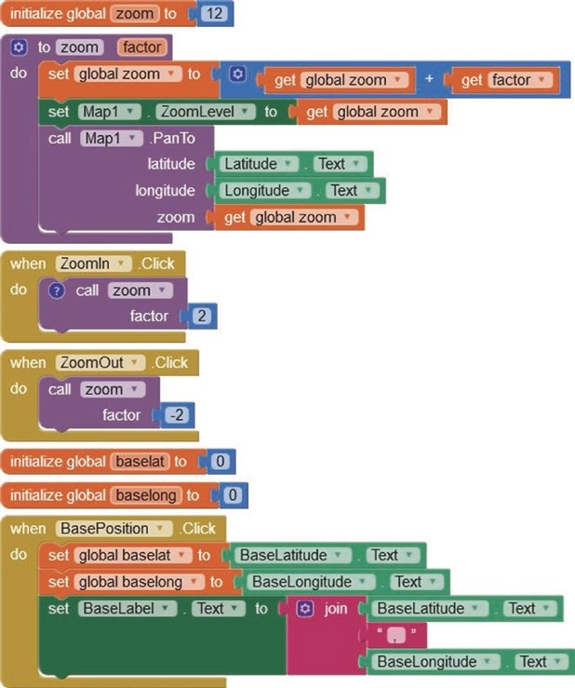
Figure 12-10. Map zoom function and base position values
GPS position transmit
GPS positional information is transmitted with an nRF24L01 transceiver module attached to an ESP8266 or ESP32 development board. The nRF24L01 module pins are shown in Figure 12-11, with the GND pin indicated by a square surround. The nRF24L01 module communicates with Serial Peripheral Interface (SPI), with the MOSI (Main-Out Secondary-In),
MISO (Main-In Secondary-Out), and SCK (serial clock) pins connected to the microcontroller SPI pins. The CE (transmit/receive) and CSN (standby/ active mode) pins do not have a predefined microcontroller pin. The nRF24L01 module operates at 3.3 V, but the logic pins are 5 V tolerant.
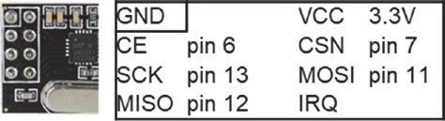
Figure 12-11. nRF24L01 pin connections
GPS position data, from a u-blox NEO-7M GPS module, is transmitted by an ESP8266 or ESP32 microcontroller, powered by a 5 V power bank.
Connections for the transmitting nRF24L01 module with the u-blox NEO-7M GPS module and an ESP8266 or ESP32 development board and for the receiving nRF24L01 module with an ESP32 development board are shown in Figure 12-12 and in Table 12-1. The 10 μF capacitor reduces signal noise. Only the u-blox NEO-7M GPS module transmit pin is connected to the microcontroller, as the module receive pin is not required.
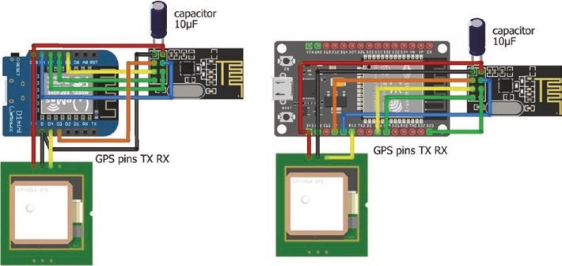
Figure 12-12. Transmitting nRF24L01 module and u-blox NEO- 7M GPS module with a LOLIN (WeMos) D1 mini board and a transmitting or receiving nRF24L01 module and ESP32 DEVKIT DOIT board
Table 12-1. Connections for nRF24L01 and u-blox NEO-7M GPS modules with ESP8266 and ESP32 development boards
Component | Transmitting nRF24L01 | Transmitting or  Receiving nRF24L01
nrF24l01 VCC | eSp8266 3V3 | eSp32 3V3
nrF24l01 CSn | eSp8266 D8 | eSp32 Gpio 4
nrF24l01 MoSi | eSp8266 D7 | eSp32 Gpio 23
nrF24l01 irQ | not connected | not connected
nrF24l01 GnD | eSp8266 GnD | eSp32 GnD
nrF24l01 Ce | eSp8266 D3 | eSp32 Gpio 2
nrF24l01 SCk | eSp8266 D5 | eSp32 Gpio 18
nrF24l01 MiSo | eSp8266 D6 | eSp32 Gpio 19
u-blox neo-7M VCC | eSp8266 3V3 | eSp32 3V3
u-blox neo-7M GnD | eSp8266 GnD | eSp32 GnD
u-blox neo-7M tXD | eSp8266 D4 | eSp32 rX2 (Gpio 16)
10 μF capacitor positive leg | nrF24l01 VCC | nrF24l01 VCC
10 μF capacitor negative leg | nrF24l01 GnD | nrF24l01 GnD
Instructions for the transmitting nRF24L01 module connected to the u-blox NEO-7M GPS module and an ESP8266 development board are given in Listing 12-1. NMEA (National Marine Electronics Association) messages from the u-blox NEO-7M GPS module are extracted with the NeoGPS library, which uses the AltSoftSerial library software Serial connection. The AltSoftSerial library is not compatible with the ESP8266 microcontroller, so the SoftwareSerial library is used instead. The NeoGPS library by Slash Devin and the RF24 library by James Coliz are available in the Arduino IDE, and the SoftwareSerial library is built-in. The ESP32 DEVKIT DOIT 30-pin board and the ESP32 NodeMCU 36-pin board have a second Serial port on GPIO 16 (RX2) and GPIO 17 (TX2).
Listing 12-1 is for an ESP8266 microcontroller. When using an ESP32 microcontroller, the following instructions for the ESP8266 microcontroller
#include <SoftwareSerial.h> // include SoftwareSerial library
SoftwareSerial SoftSer(D4, D0); // associate SoftSer with SoftwareSerial
RF24 radio(D3, D8); // associate radio with RF24 library SoftSer.begin(9600); // SoftwareSerial baud rate while(nmea.available(SoftSer)>0) // GPS data available are replaced with instructions for an ESP32 microcontroller
RF24 radio(2, 4); // associate radio with RF24 library Serial2.begin(9600, SERIAL_8N1, 1 6, 17); // ESP32 RX2 on GPIO 16 while(nmea.available(Serial2)>0) // GPS data available
The u-blox NEO-7M GPS module transmits NMEA messages every second. The RMC message, which is the recommended minimum message, contains latitude and longitude. In the NeoGPS library folder, open the file NMEAGPS_cfg.h in the src folder and ensure that the instruction #define NMEAGPS_PARSE_RMC on line 38 is not commented out. If only the RMC message is required, then the instruction on line 48 should equal #define LAST_SENTENCE_IN_INTERVAL NMEAGPS::NMEA_RMC.
Information about the structure of NMEA messages is available at github. com/SlashDevin/NeoGPS.
GPS latitude and longitude values are transformed to strings, which are converted to character arrays for inclusion in a data structure transmitted by the nRF24L01 module. A GPSsend counter is incremented on receipt of valid GPS location data, with a condition on the counter value defining the interval between transmissions by the nRF24L01 module. Details on RF24 library instructions accompany Listing 12-2.

GpS traCkinG app with GooGle MapS
Listing 12-1. nRF24L01 transmit signal with position data for the ESP8266 board
#include <SoftwareSerial.h> // include SoftwareSerial library
SoftwareSerial SoftSer(D4, D 0);
// associate SoftSer with SoftwareSerial
#include <NMEAGPS.h> // include NeoGPS library NMEAGPS nmea; // associate nmea and gps gps_fix gps; // with NMEAGPS library float GPSlat, GPSlong; // real numbers for GPS location int GPSsend = 0; // GPS send counter #include <SPI.h> // include SPI library
#include <RF24.h> // include RF24 library
RF24 radio(D3, D8); // associate radio with RF24 library byte addresses[ ][6] = {"12" }; // data pipe address typedef struct // define data structure to include
{
char GPSlat[10]; // character arrays for char GPSlong[10]; // GPS latitude and longitude
} dataStruct;
dataStruct data; // name the data structure as data int interval = 2; // interval (s) between GPS transmissions
void setup()
{ // Serial connection to GPS module SoftSer.begin(9600); // SoftwareSerial baud rate delay(500);
radio.begin(); // start radio radio.setChannel(50); // set channel number, radio.setDataRate(RF24_2MBPS); // baud rate
GpS traCkinG app with GooGle MapS
radio.setPALevel(RF24_PA_HIGH); // and power amplifier radio.setAutoAck(true); // set auto- acknowledge (default) radio.openWritingPipe(address es[0]); // initiate data transmit pipe radio.stopListening(); // nRF24L01 as transmitter
}
void loop()
{ while(nmea.available(SoftSer)>0) // GPS data available
{
gps = nmea.read(); // latest satellite message if(gps.valid.location) // validated GPS location
{
GPSlat = gps.latitude();
GPSlong = gps.longitude();
GPSsend++; // increment GPS send counter
} if(GPSsend > interval) // transmit every (interval+1)s
{ // convert number to string and then to character array
String(GPSlat,6).toCharArray(data.GPSlat,10);
String(GPSlong,6).toCharArray(data.GPSlong,10); radio.write(&data, siz eof(data));
// transmit signal as data structure
GPSsend = 0; // reset GPS send counter
}
}
}
GpS traCkinG app with GooGle MapS
GPS position receive
Instructions for the receiving nRF24L01 module connected to an ESP32 development board are given in Listing 12-2. The RF24 library by James Coliz is available in the Arduino IDE. Communication between nRF24L01 transceiver modules is through data pipes that require an address of a five-letter string, such as “node1” or “12” for each data pipe, a transmission channel number, a data rate, and a power amplifier level. The nRF24L01 module operates at frequencies of 2.4 GHz with 126 channels of bandwidth of less than 1 MHz, resulting in a range of frequencies between 2.4 GHz (2400 MHz) and 2525 MHz, corresponding to channel numbers 0–125. Channel number, N, is set with the instruction setChannel(N). Data rates, of 250 kbps, 1 Mbps, and 2 Mbps, measured in bits per second, are available in the RF24 library using the instruction setDataRate() with values RF24_250KBPS, RF24_1MBPS, and RF24_2MBPS. The power amplifier levels of RF24_PA_MIN, LOW, HIGH, and MAX correspond to -18, -12, -6, and 0 dB that equate to power outputs of approximately 1/64, 1/16, 1/4, and 1 mW, respectively, as power = 10^{(dB/10)}mW. Power amplifier levels are set with the instruction setPALevel().
A data structure combines several data types, but has a limit of 32 bytes with an integer, a real number, or a character requiring 2, 4, or 1 byte, respectively. The received nRF24L01 signal, containing GPS location data, is combined with a counter value and transmitted as a text string to the GPS location app.
GpS traCkinG app with GooGle MapS
Listing 12-2. nRF24L01 receive signal transmitted with Bluetooth
#include <BluetoothSerial.h> // include Bluetooth library
BluetoothSerial SerialBT; // associate SerialBT with library
#include <SPI.h> // include SPI library
#include <RF24.h> // include RF24 library RF24 radio(2, 4); // associate radio with RF24 lib byte addresses[ ][6] = {"12"}; // data pipe address
typedef struct // define data structure to include
{
char GPSlat[10]; // character arrays for char GPSlong[10]; // GPS latitude and longitude
} dataStruct;
dataStruct data; // name the data structure as data int count = 0; // received message counter int textLen; String text; char c;
void setup()
{
radio.begin(); // start radio radio.setChannel(50); // set channel number radio.setDataRate(RF24_2MBPS); // baud rate radio.setPALevel(RF24_PA_HIGH); // and power amplifier radio.setAutoAck(true); // set auto- acknowledge (default) radio.openReadingPipe(0, address es[0]);
// initiate data receive pipe
radio.startListening(); // nRF24L01 module as receiver SerialBT.begin("ESP32 Bluetooth" ); // identify Bluetooth }

void loop()
{ if(radio.available()) // if signal received
{ // received signal to data structure
radio.read(&data, sizeof(data) ); count++; // increment counter text = String(count) + "," + String(data.GPSlat) + "," + String(data.GPSlong) + ","; // build string of position data textLen = text.length(); for (int i=0; i<textLen; i++)
{ c = text[i]; // for each message character
SerialBT.write(c); // transmit to Bluetooth device
}
}
}
The receiving nRF24L01 module is monitored by displaying the received data on the Serial Monitor using the Serial connection with the instructions
Serial.begin(115200); // Serial Monitor baud rate Serial.println(text); // display GPS position data
Validate transmission of GPS position
The Wi-Fi functionality of ESP8266 and ESP32 microcontrollers enables data display on a web page, in addition to the Serial Monitor. When checking the development of a tracking app, the received GPS location data is displayed on a web page using an Android tablet or mobile phone connected to a wireless local area network (WLAN). Transmission of GPS
GpS traCkinG app with GooGle MapS
location data is tested by changing the GPS location within the WLAN connection radius of several meters.
Building and updating a web page is described in Chapter 8 (Updating a web page). Instructions to update a web page with GPS location data are combined with Listing 12-2, as shown in Listing 12-3. The sketch demonstrates different time intervals for updating, displaying, and transmission of GPS location data. The u-blox Neo-7M GPS location data is automatically updated every second, which is displayed on the Serial Monitor. The web page updates a counter every second, but the web page GPS location data is updated every five seconds. The nRF24L01 transceiver module transmits GPS location data every three seconds. In Listing 12- 2, GPS latitude and longitude were transformed to strings, converted to character arrays, and sent as a text string to the GPS location app, with the instruction String(GPSlat,6).toCharArray(data.GPSlat,10). In Listing 12-3, GPS latitude and longitude are declared in a data structure, data, and transmitted directly with the instruction radio.write(&data, sizeof(data)). The flashLED function creates a double flash of the LED when GPS location data is transmitted, as an indicator that the combination of the ESP8266 or ESP32 microcontroller and u-blox NEO-7M GPS module is functioning.
Listing 12-3 is for an ESP8266 microcontroller. If the transmitting nRF24L01 module is connected to an ESP32 development board, then the WiFi, WebServer and SoftwareSerial libraries, nRF24L01 CE and CSN pins, and the LED pin definition instructions for the ESP8266 microcontroller
#include <ESP8266WiFi.h> // include ESP8266 Wi- Fi and
#include <ESP8266WebServer.h> // web server libraries
ESP8266WebServer server; // associate server with library
#include <SoftwareSerial.h> // include SoftwareSerial library
SoftwareSerial SoftSer(D4, D0) ;
// associate SoftSer with SoftwareSerial
SoftSer.begin(9600); // serial connection to GPS module while(nmea.available(SoftSer)>0) // GPS data available
RF24 radio(D3, D8); // associate radio with RF24 library int LEDpin = D1; // define LED
are replaced with instructions for the ESP32 microcontroller
#include <WiFi.h> // include ESP8266 Wi- Fi and
#include <WebServer.h> // web server libraries
WebServer server (80); // requires a port number
Serial2.begin(9600, SERIAL_8N1, 16, 17);
// ESP32 RX2, TX2 on GPIO 16 and 17
while(nmea.available(Serial2)>0) // GPS data available
RF24 radio(2, 4); // associate radio with RF24 library int LEDpin = D1; // define LED pin
Listing 12-3. nRF24L01 transmit signal with position data and display on web page
#include <ESP8266WiFi.h> // include ESP8266 Wi-Fi and
#include <ESP8266WebServer.h> // web server libraries ESP8266WebServer server; // associate server with library char ssid[] = "xxxx"; // change xxxx to your Wi-Fi SSID char password[] = "xxxx"; // change xxxx to your Wi-Fi password
#include "buildpage.h" // webpage HTML code
#include <SoftwareSerial.h> // include SoftwareSerial library
SoftwareSerial SoftSer(D4, D0); // associate SoftSer with SoftwareSerial
#include <NMEAGPS.h> // include NeoGPS library
NMEAGPS nmea; // associate nmea with NMEAGPS lib gps_fix gps; // associate gps with NMEAGPS library float GPSlat, GPSlong, GPSalt, GPSs pd;
// real numbers for GPS location

int GPSsend = 0; // GPS send counter String json; int count = 0;
String counter; // counter increment every second
#include <SPI.h> // include SPI library
#include <RF24.h> // include RF24 library
RF24 radio(D3, D8); // associate radio with RF24 library byte addresses[ ][6] = {"12"}; // data pipe address
typedef struct // define data structure to include
{
float GPSlat; // GPS latitude float GPSlong; // GPS longitude float GPSalt; // GPS altitude (m) float GPSspd; // GPS ground speed (kmph) int sigCount; // signal counter
} dataStruct;
dataStruct data; // name the data structure as data int LEDpin = D1; // define LED pin int LED = 0; // LED turned off
int interval = 1; // (interval+1)s between transmissions
void setup()
{
Serial.begin(115200); // define Serial output baud rate
SoftSer.begin(9600); // serial connection to GPS module WiFi.begin(ssid, password); // initialise and connect Wi-Fi while (WiFi.status() != WL_C ONNECTED) delay(500);
Serial.print("IP address: ");
Serial.println(WiFi.localIP( )); // display web server IP address server.begin(); // initialise server
server.on("/", base); // call base function as webpage loaded
server.on("/GPSurl", GPSfunct);
// call GPSfunct with GPSurl loaded
server.on("/countUrl", countFunct); delay(500);
radio.begin(); // start radio radio.setChannel(50); // set channel number, radio.setDataRate(RF24_2MBPS ); // baud rate and radio.setPALevel(RF24_PA_HIG H); // power amplifier level radio.setAutoAck(true); // set auto-acknowledge (default is true) radio.openWritingPipe(addresses[0]); // initiate data transmit pipe radio.stopListening(); // set nRF24L01 module as transmitter pinMode(LEDpin, OUTPUT); // define LEDpin as OUTPUT
}
void GPSfunct() // function to transmit GPS position data
{ while(nmea.available(SoftSer )>0) // GPS data available
{
gps = nmea.read(); // latest satellite message if(gps.valid.location) // validated GPS location
{
GPSlat = gps.latitude();
GPSlong = gps.longitude();
GPSsend++; // increment GPS send counter
}
if(gps.valid.altitude) GPSalt = gps.altitude( ); // altitude if(gps.valid.speed) GPSspd = gps.speed_kph();
// ground speed
JsonConvert(GPSlat, GPSlon g, GPSalt, GPS spd);
// convert to JSON text
server.send(200, "text/json", json); // send JSON text to client Serial.println(json); if(GPSsend > interval) // transmit every (interval+1)s
{
data.GPSlat = GPSlat; // convert GPS readings to data structure data.GPSlong = GPSlong; data.GPSalt = GPSalt; data.GPSspd = GPSspd;
data.sigCount++; // increment signal counter radio.write(&data, sizeof(da ta));
// transmit signal as data structure
GPSsend = 0; // reset GPS send counter flashLED();
}
}
}
// function to convert data to JSON text
String JsonConvert(float val1, float val2, float val3, float val4)
{ // start with open bracket json = "{\"var1\": \"" + String(val1,4) + "\","; json += " \"var2\": \"" + String(val2, 4) + "\",";
// end with comma
json += " \"var3\": \"" + String(val3) + "\","; json += " \"var4\": \"" + String(val4) + "\"}";
// end with close bracket
return json; }
void countFunct() // function to increment counter { // and send value to client count++; counter = String(count);

server.send (200, "text/plain", counter); }
void flashLED() // function to flash LED
{
for (int i=0; i<4; i++)
{
LED = 1 - LED; // alternate LED state four times digitalWrite(LEDpin, LED); // ON – OFF – ON - OFF delay(50);
}
}
void base() // function to return HTML code
{
server.send (200, "text/html", page); }
void loop()
{
GPSfunct(); // function to transmit GPS location data server.handleClient(); // manage HTTP requests
}
Listing 12-4 contains the AJAX code for the web page and XML HTTP requests, which is defined as the string literal page. The first part of the <body> section is the web page HTML code with the variables referenced as the variable names in the XML HTTP request. The JavaScript instruction setInterval() controls the time interval between XML HTTP requests, which is five seconds for the reload function to obtain the GPS location data. JavaScript scripts, bracketed by <script>...</script>, are positioned prior to the HTML </body> code to improve web page display speed.
Listing 12-4. AJAX request with GPS position data
char page[] PROGMEM = R"(
<!DOCTYPE html><html>
<head><title>ESP8266</title>
<meta charset="UTF-8">
</head>
<body>
<h2>GPS</h2>
<p>Latitude: <span id = 'latId'>0</span></p>
<p>Longitude: <span id = 'longId'>0</span></p>
<p>Altitude: <span id = 'altId'>0</span> m</p>
<p>Speed: <span id = 'speedId'>0</span> kph<p>
<p>Counter: <span id = 'countId'>0</span></p>
<script>
setInterval(reload, 5000); // reload function called every 5s function reload()
{
var xhr = new XMLHttpRequest(); xhr.onreadystatechange = function()
{
if(this.readyState == 4 && this.status == 200)
{
var obj = JSON.parse(this.responseText); document.getElementById('latId').innerHTML = obj.var1; document.getElementById('longId').innerHTML = obj.var2; document.getElementById('altId').innerHTML = obj.var3; document.getElementById('speedId').innerHTML = obj.var4; console.log(obj.var3);
}
};
xhr.open('GET', '/GPSurl', true); xhr.send(); }
setInterval(reload2, 1000);
function reload2() // reload2 function called every 1s { // to obtain countId from /countUrl var xhr = new XMLHttpRequest(); xhr.onreadystatechange = function()
{
if(this.readyState == 4 && this.status == 200)
{document.getElementById('countId').innerHTML = this.
responseText; console.log(this.responseText);}
};
xhr.open('GET', '/countUrl', true); xhr.send();
}
</script>
</body></html>
)";
To complement testing the updating of transmitted GPS location data by changing the GPS position, testing the updating of the received GPS location data by changing the position of the receiving nRF24L01 module requires a mobile display, such as an OLED screen. The sketch in Listing 12-5 displays GPS location data on a 128 × 64–pixel OLED screen (see Figure 12-13). Connections for ESP8266 development boards with transmitting and receiving nRF24L01 modules are given in Table 12-2. The Adafruit_SSD1306 library for the OLED screen is available in the Arduino IDE.
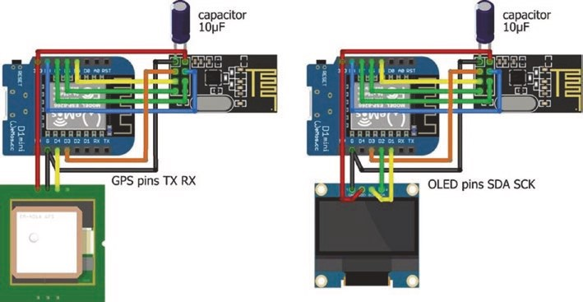
Figure 12-13. Transmitting and receiving GPS signals with nRF24L01 modules
Table 12-2. ESP8266 development board connections to transmitting and receiving nRF24L01 modules with the u-blox NEO-7M GPS module and 128 × 64–pixel OLED screen
Component | ESP8266 | Connect to
nrF24l01 VCC | 3V3 | 10 μF capacitor positive leg
nrF24l01 CSn | D8
nrF24l01 MoSi | D7
nrF24l01 irQ | not connected
nrF24l01 GnD | GnD | 10 μF capacitor negative leg
nrF24l01 Ce | D3
(continued)
Table 12-2. (continued)
Component | ESP8266 | Connect to
nrF24l01 SCk | D5
nrF24l01 MiSo | D6
u-blox neo-7M VCC | 3V3
u-blox neo-7M GnD | GnD
u-blox neo-7M tXD | D4
128 × 64–pixel oleD GnD | 3V3
128 × 64–pixel oleD VDD | GnD
128 × 64–pixel oleD SCk | D1
128×64 pixel oleD SDa | D2
In Listing 12-5, the transmitted GPS position data from Listing 12-3, which is displayed on a web page, is also displayed on an OLED screen to provide a mobile test of signal transmission and reception.
Listing 12-5. nRF24L01 receive signal with position data and display on OLED
#include <SPI.h> // include SPI library
#include <RF24.h> // include RF24 library RF24 radio(D3, D8); // associate radio with RF24 lib byte addresses[ ][6] = {"12"}; // data pipe address
typedef struct // define data structure to include
{
float GPSlat; // character arrays for
float GPSlong; // GPS latitude and longitude float GPSalt; // GPS altitude (m) float GPSspd; // GPS ground speed (kmph) int sigCount; // signal counter
} dataStruct;
dataStruct data; // name the data structure as data float lagTime = 0;
#include <Adafruit_SSD1306.h> // library 128×64 OLED screen int width = 128; // OLED screen dimensions int height = 64;
Adafruit_SSD1306 oled(width, height, &Wire, -1); unsigned long lastTime, nowTime = 0;
void setup()
{
radio.begin(); // start radio radio.setChannel(50); // set channel number radio.setDataRate(RF24_2MBPS); // baud rate radio.setPALevel(RF24_PA_HIGH); // and power amplifier radio.setAutoAck(true); // set auto- acknowledge (default) radio.openReadingPipe(0, address es[0]) ;
// initiate data receive pipe
radio.startListening(); // nRF24L01 as receiver oled.begin(SSD1306_SWITCHCAPVCC, 0x3C);
oled.clearDisplay(); // initialise OLED screen
oled.setTextColor(WHITE);
oled.setTextSize(1); // text size of 6×8 pixels oled.display();
}

GpS traCkinG app with GooGle MapS
void loop()
{ if(radio.available()) // if signal received
{
radio.read(&data, sizeof(data) ); // set signal to data structure nowTime = millis();
lagTime = (nowTime-lastTime)/1 00 0.0;
// time since last signal received
lastTime = nowTime; screen(); // call OLED screen function
}
}
void screen()
{
oled.clearDisplay(); // clear display oled.setCursor(0,0); // position cursor oled.print(data.GPSlat,4); // display GPS latitude oled.setCursor(65,0); // and GPS longitude oled.print(data.GPSlong,4); oled.setCursor(0,10);
oled.print("alt ");oled.print(da ta.GPSalt,1);
// display GPS altitude
oled.setCursor(65,10); // and GPS speed oled.print("spd ");oled.print(data.GPSspd); oled.setCursor(0, 20);
oled.print("lag ");oled.print(la gTime,2); // time since last signal oled.setCursor(65, 20);
GpS traCkinG app with GooGle MapS
oled.print("chk ");oled.print(da ta.sigCount); // signals sent oled.display(); }
Improve GPS position signal
Signal transmission and reception with nRF24L01 transceivers is improved by choosing a transmission channel with low activity, the data rate, and the power amplifier level. In Listing 12-6, an ESP8266 microcontroller uses the RF24 library to display, on the Serial Monitor, the carrier activity on each of the 126 channels. If an ESP32 development board is used for channel scanning with an nRF24L01 transceiver module, then the instruction RF24 radio(D3, D8) is replaced with RF24 radio(2, 4), for consistency with earlier listings in the chapter.
Listing 12-6. Channel scanning
#include <SPI.h> // include SPI library
#include <RF24.h> // include RF24 library RF24 radio(D3, D8); // associate radio with library const int nChan = 126; // 126 channels available int chan[nChan]; // store counts per channel int nScan = 100; // number of scans per channel int scan;
void setup()
{
Serial.begin(115200); // define Serial output baud rate radio.begin(); // start radio }
GpS traCkinG app with GooGle MapS
void loop()
{
for (int i=0;i<nChan;i++) // for each channel
{
chan[i] = 0; // reset counter for (scan=0; scan<nScan; scan++ ) // repeat scanning
{
radio.setChannel(i); // define channel radio.startListening();
delayMicroseconds(128); // listen for 128μs
radio.stopListening();
if(radio.testCarrier()>0) cha n[i]=chan[i]+1;
// a carrier on the channel
}
delay(1); // avoid watchdog reset
}
for (int i=0; i<nChan; i++) // for each channel
{
if(i%10 == 0) Serial.print("|");
Serial.print(chan[i], HEX); // display carrier activity
} // format in HEX for values <16
Serial.println(); // new line
}
Signal transmission and reception by two nRF24L01 transceiver modules is assessed by determining the number of signals successfully received in a second, given repeated transmission of a signal. In the sketch in Listing 12-7, a message containing the time (minutes and seconds) and a counter value is repeatedly transmitted, with the counter equal to the number of transmissions in the previous second. With the default setting for signal auto-acknowledge of true, the number of received signals would equal the number of transmitted

signals, as a signal is repeatedly transmitted until acknowledged. In the sketch, auto-acknowledge is set to false.
Listing 12-7. Signal transmission to monitor nRF24L01 transceiver modules
#include <SPI.h> // include SPI library
#include <RF24.h> // include RF24 library RF24 radio(D3, D8); // associate radio with library byte addresses[ ][6] = {"12"}; // data pipe address
typedef struct // define data structure to include
{
unsigned long counted; // counter
unsigned long mins; // time (minute and second) unsigned long secs;
} dataStruct; dataStruct data; unsigned long lastTime, nowTime = 0; int count = 0; int mins = 0, secs = 0;
void setup()
{
radio.begin(); // start radio radio.setChannel(50); // set channel number, radio.setDataRate(RF24_2MBPS); // data rate and radio.setPALevel(RF24_PA_HIGH); // power amplifier radio.setAutoAck(false); // set auto- acknowledge radio.openWritingPipe(addresses[0]); // initiate data transmit pipe radio.stopListening(); // set nRF24L01 as transmitter
GpS traCkinG app with GooGle MapS
mins = 0; secs = 0; }
void loop()
{
nowTime = millis();
if(nowTime - lastTime > 1000) // determine minutes { // and seconds secs++;
if(secs > 59) // after 60 seconds
{
secs = 0; // reset second variable mins++; // increment minute variable
}
data.counted = count; // convert values to data structure data.mins = mins; data.secs = secs;
count = 0; // reset counter
lastTime = nowTime; // update time of “second”
}
radio.write(&data, sizeof(data)); // transmit signal count++; // increment signal counter
}
The complementary sketch for an nRF24L01 transceiver module to receive the signal is given in Listing 12-8. Signal information for the receiving nRF24L01 module is displayed on a 128 × 64–pixel OLED screen to determine the impact of different positions of the receiving nRF24L01, relative to the position of the transmitting nRF24L01 module (see Figure 12-14). The Adafruit SSD1306 library references the Adafruit
GFX and Wire libraries, so the #include <Adafruit_GFX.h> and #include <Wire.h> instructions are not required. The number of signals transmitted and received every second is stored in an array, acting as a circular buffer, for calculation of a moving average number of signals transmitted and received.
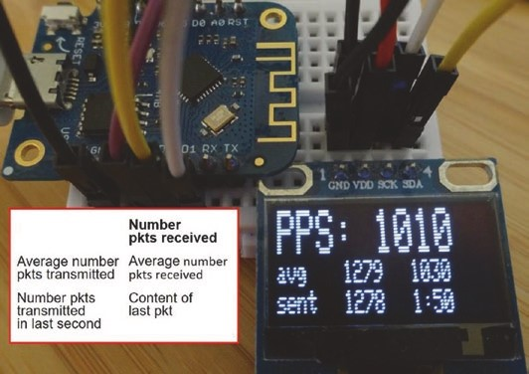
Figure 12-14. nRF24L01 packets (received/transmitted) per second
Listing 12-8. Signal reception to monitor nRF24L01 transceiver modules
#include <SPI.h> // include SPI library
#include <RF24.h> // include RF24 library RF24 radio(D3, D8); // associate radio with library byte addresses[ ][6] = {"12"}; // data pipe address
typedef struct // define data structure to include
{
unsigned long sent; // sent signals unsigned long mins; // time (minute and second) unsigned long secs;
GpS traCkinG app with GooGle MapS
} dataStruct; dataStruct data;
#include <Adafruit_SSD1306.h> // library 128×64 OLED screen int width = 128; // OLED screen dimensions int height = 64;
Adafruit_SSD1306 oled(width, height, &Wire, -1); const int Nval = 20; // size of circular buffer int pkts[Nval], sents[Nval]; // arrays for circular buffer int N = 0, pkt = 0; unsigned long sumPkt = 0, sumSent = 0; float avgPkt, avgSent;
unsigned long lastTime, nowTime = 0; // variables to store time values
void setup()
{
radio.begin(); // start radio radio.setChannel(50); // set channel number radio.setDataRate(RF24_2MBPS); // data rate radio.setPALevel(RF24_PA_HIGH); // and power amplifier radio.setAutoAck(false); // set auto- acknowledge radio.openReadingPipe(0, addresses[0]) ;
// initiate data receive pipe
radio.startListening(); // set nRF24L01 as transmitter
oled.begin(SSD1306_SWITCHCAPVCC, 0x3C);
oled.clearDisplay(); // initialise OLED screen
oled.setTextColor(WHITE); oled.display(); data.sent = 0; for (int i=0; i<10; i++) // set circular buffer arrays to zero
{ pkts[i] = 0; sents[i] = 0;
}
}
void loop()
{ if(radio.available()) // signal available
{
radio.read(&data, sizeof(data) ); // read signal and pkt++; // increment signal counter
}
nowTime = millis(); if(nowTime - lastTime > 1000) // update values every second
{
sumPkt = sumPkt - pkts[N]; // subtract oldest value from sum sumPkt = sumPkt + pkt; // add current value to sum pkts[N] = pkt; // update circular buffer
sumSent = sumSent - sents[N]; sumSent = sumSent + data.sent; sents[N] = data.sent;
N++;
if(N > Nval-1) N = 0; // back to “start” of circular buffer avgPkt = 1.0*sumPkt / Nval; // calculate moving averages avgSent = 1.0*sumSent / Nval;
screen(); // call OLED screen function pkt = 0; data.sent = 0; lastTime = nowTime; // update time of last “second”
}
}
GpS traCkinG app with GooGle MapS
void screen()
{
oled.clearDisplay(); // clear display oled.setCursor(0,0); // position cursor oled.setTextSize(2); // text size of 12×16 pixels oled.print("PPS: ");oled.print(p kt); // signal (packets) per second oled.setCursor(0,16);
oled.setTextSize(1); // text size of 6×8 pixels oled.setCursor(0,16); oled.print("avg"); oled.setCursor(40,16);
oled.print(avgSent,0); // average of transmitted signals oled.setCursor(80,16);
oled.print(avgPkt,0); // average of received signals oled.setCursor(0,25); oled.print("sent"); oled.setCursor(40,25);
oled.print(data.sent); // last number of sent signals oled.setCursor(80,25);
oled.print(data.mins);oled.print (":"); // signal content oled.print(data.secs); oled.display(); }
The impact of different transmission channels, data rates, and power amplifier levels is quantified using the sketches in Listings 12-7 and 12-8 to identify optimal settings for a specific environment. Note that data rates for the two nRF24L01 transceiver modules must be equal. For a pair of nRF24L01 transceivers and ESP8266 microcontrollers, a transmission rate of 2 Mbps and a RF24_PA_HIGH power amplifier level resulted in the highest number of packets received. Although, the number of packets

GpS traCkinG app with GooGle MapS
sent for a 2 Mbps transmission rate was lower, relative to the transmission rate, than for the 250 kbps and 1 Mbps rates. For a 1 Mbps transmission rate, the number of packets received declined with higher amplification levels (see Table 12-3). Packets received rate will depend on the nRF24L01 transceivers, the transmission distance, and ambient electrical noise.
Table 12-3. nRF24L01 packets received/transmitted per second
Amplifier Level |  | Transmission Rate (bps)
Amplifier Level | 250 k | 1 M | 2 M
Min | 150/250 | 420/1040 | 880/1280
low | 10/250 | 300/1040 | 900/1280
hiGh | - | 100/1040 | 1030/1280
MaX | - | - | 400/1280
Summary
A GPS location app, built with MIT App Inventor, displayed with Google Maps the position of a remotely located u-blox NEO-7M GPS module or the route taken by the GPS module. An nRF24L01 module, connected to an ESP8266 or ESP32 development board attached to the GPS module, transmitted the GPS location to a receiving nRF24L01 module, attached to an ESP32 development board. The GPS location information was transmitted to the app by the ESP32 microcontroller using Bluetooth communication. The GPS location app displayed the GPS position information on the Android tablet or mobile phone, by accessing Google Maps data from the World Wide Web through the Internet Service Provider. The tracking app included a map zoom function and the option to connect location tracking markers and display the completed route. A web page to display transmitted GPS data was built for testing GPS signal transmission
GpS traCkinG app with GooGle MapS
and reception. The impact of different transmission channels, data rates, and power amplifier levels was quantified by the number of signals successfully received in a second, given repeated transmission of a signal.
Components List
- ESP8266 microcontroller: LOLIN (WeMos) D1 mini or NodeMCU board
- ESP32 microcontroller: ESP32 DEVKIT DOIT or NodeMCU board
- u-blox NEO-7M GPS module
- nRF24L01 transceiver module: 2×
- OLED display: 128 × 64 pixels
CHAPTER 13
USB OTG communication
In Chapter 12 (GPS tracking app with Google Maps), data is transmitted to an app on an Android tablet or mobile phone by an ESP32 microcontroller with Bluetooth communication. In Chapter 10 (Build an app), an HC-05 Bluetooth module is connected to an ESP8266 development board to communicate with an app. If the device to transfer data to an app does not have Bluetooth functionality, then USB OTG (On- the- Go) communication connects the device with the app. In this chapter, the device without Bluetooth functionality is an Arduino Uno. An HC-05 Bluetooth module could be connected to the Arduino Uno for Bluetooth communication with the Android tablet or mobile phone, but this chapter focuses on USB OTG communication.
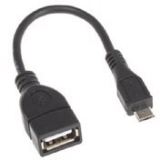
USB OTG communication enables an Android tablet or mobile phone to transmit and receive signals to and from a USB peripheral device. The Android tablet or mobile phone is the OTG-A device acting as a host for that app and providing power to the USB peripheral or OTG-B device, which is the Arduino Uno. A USB
OTG cable connects the host to the USB peripheral device. The Easy OTG Checker app by Kjarvel on Google Play Store determines if an Android tablet or mobile phone supports OTG, by attaching the USB peripheral device with a USB OTG cable (see Figure 13-1).
© Neil Cameron 2021 347
N. Cameron, Electronics Projects with the ESP8266 and ESP32, https://doi.org/10.1007/978-1-4842-6336-5_13

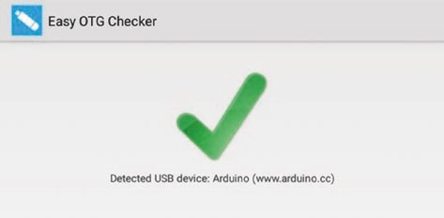
Figure 13-1. Easy OTG Checker app connected to Arduino Uno
MIT App Inventor provides a Serial component for USB OTG communication that is located in the Connectivity palette on the left side of the Designer window. The Serial component communicates with the ATmega16U2 USB to serial converter of the Arduino Uno, but not with the
CH340 chip on the Arduino Nano or ESP8266 development boards. If the MIT App Inventor Serial component is extended to the CH340 chip, then the framework for building USB OTG communication apps, as described in this chapter, will be applicable to the ESP8266 microcontroller.
App receive
To demonstrate the Android tablet or mobile phone, the OTG-A device, receiving data from the Arduino Uno, the OTG-B device, a pair of numbers is transmitted by the Arduino Uno. An app, hosted by the OTG-A device, parses the number pair into components and displays both the number pair and its components (see Figure 13-2). The number pair could be latitude and longitude from a GPS module, temperature and humidity from a BMP280 sensor, or voltage and current from an INA219 sensor attached to the Arduino Uno. The app provides the framework for more complex signal transmit and receive projects.
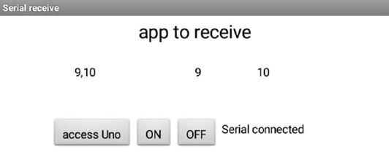
Figure 13-2. App to receive message from the OTG-B device
The accessUno, OnButton, and OffButton buttons enable the OTG-B device to be connected and disconnected to and from the OTG-A device with the connection status displayed in the StatusLabel label. When the accessUno button is clicked, after the Arduino Uno is attached to the Android tablet or mobile phone, a USB device access request is made (see Figure 13-3). The access request OK is selected, and the app OnButton button is clicked to connect the OTG-B device to the OTG-A device.
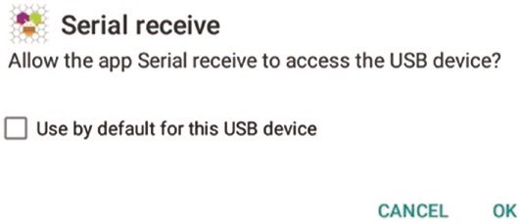
Figure 13-3. USB device access request
The sketch in Listing 13-1 writes to the Serial Monitor the number pairs at one-second intervals. When the Arduino Uno is connected to an Android tablet or mobile phone with a USB OTG cable, the Arduino Uno and Android tablet or mobile phone communicate by USB OTG communication, once the Serial port is opened by the app.
Listing 13-1. Transmit number pairs
String text; int count = 0; unsigned long timer;
void setup()
{
Serial.begin(9600); // define serial baud rate
}
void loop()
{
if(millis() - timer > 1000) // after 1sec has elapsed
{
count++; // increment count if(count > 254) count = 0; // arbitrary limit on counter text = String(count)+ "," +Str ing(count+1);
// combine numbers into text
Serial.println(text); // transmit text timer = millis(); // reset timer
}
}
The app layout consists of the app title and two HorizontalArrangements containing the sentText, Part1Text, and Part2Text labels to display text and the buttons (see Figure 13-4). The accessUno, OnButton, and OffButton buttons to connect or disconnect the OTG-B device to or from the OTG-A device and a StatusLabel label are contained in the second HorizontalArrangement. The Serial and Clock components are displayed below the app layout.
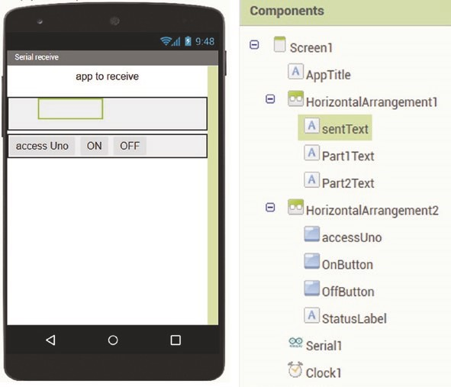
Figure 13-4. OTG-B to OTG-A app layout
Blocks to manage the Serial connection of the OTG-B device to the OTG-A device, read the message transmitted by the OTG-B device, and display the message on the OTG-A device screen are shown in
Figures 13- 5, 13-6, and 13-7. The OTG-B device or Serial1 is initialized and the baud rate defined, just as with the instruction Serial.begin(9600) when setting the Serial Monitor baud rate in the Arduino IDE. The StatusLabel label displays the connection status of the OTG-B device with the OTG-A device (see Figure 13-5).
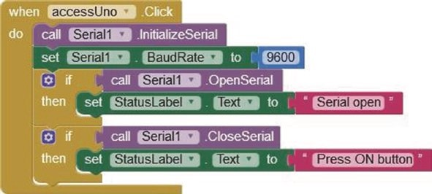
Figure 13-5. Connect the OTG-B device
The app includes the facility to connect and disconnect the OTG-B device (see Figure 13-6). Clicking the OnButton or OffButton button connects or disconnects the OTG-B device using the connect or close procedure. The connection status is displayed by the StatusLabel label, as the connect procedure returns the value one when the Serial port is connected and similarly for the close procedure.
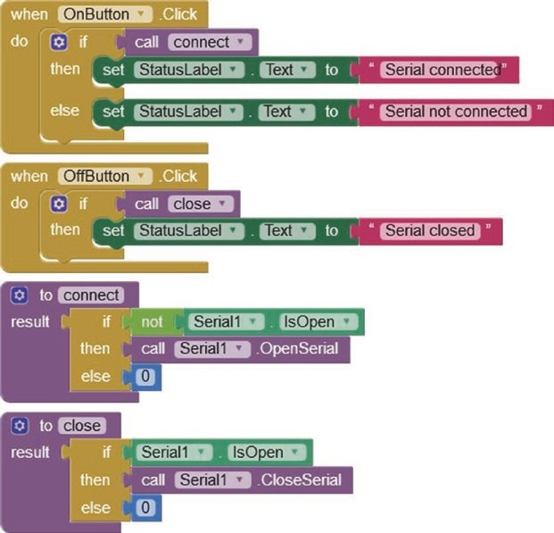
Figure 13-6. Connect and disconnect the OTG-B device
The message receipt section of the app runs the Clock1 timer at 1000 ms intervals to monitor the OTG-B device for a message. The Clock1 timer interval is set in the Properties section on the right side of the Designer window. If the OTG-B device is connected and the received message contains a comma, then the message is parsed to the components of a list, indexed 1 and 2, which are displayed on the OTG-A device screen as the text variables Part1text and Part2text (see Figures 13-2 and 13-7).
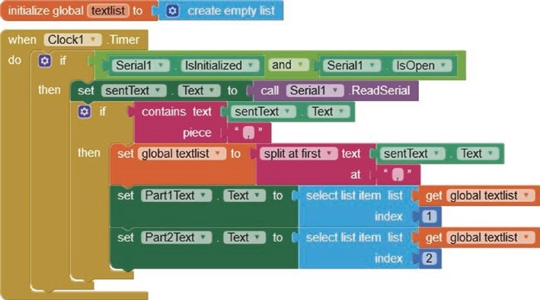
Figure 13-7. Receive and display message from the OTG-B device
App transmit
The converse of the OTG-B device, which is the Arduino Uno, transmitting to the OTG-A host device, which is the Android tablet or mobile phone, is the OTG-A device transmitting to the USB peripheral or OTG-B device. When the RedButton, GreenButton, or BlueButton button is clicked, the OTG-A device transmits to the OTG-B device the number 1, 2, or 3 corresponding to the red, green, or blue LED and the associated slider value, with the color of the updated LED indicated on the OTG-A device (see Figure 13-8 after the RedButton was clicked).
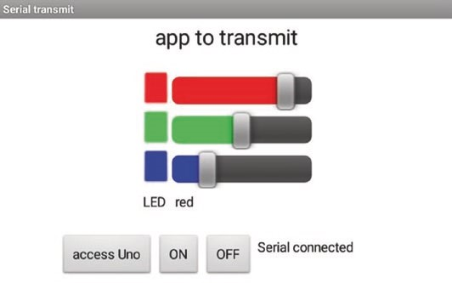
Figure 13-8. App to control LEDs attached to the OTG-B device
Connections to the Arduino Uno are shown in Figure 13-9 and given in Table 13-1. The app provides the framework for more complex signal transmit and receive projects.
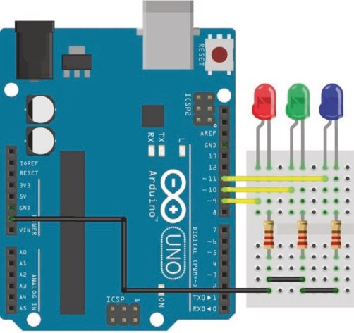
Figure 13-9. OTG-A to OTG-B
Table 13-1. OTG-A to OTG-B
Component | Connect to | And to
LeD long leg | arduino Uno pWm pins 9, 10, 11
LeD short leg | 220 Ω resistor | arduino Uno GnD
The sketch in Listing 13-2 parses the Serial buffer into the number of the LED to be updated and the PWM value. The brightness of the LED is then updated. If the LED value is zero, then all LEDs are turned off. Note that the LEDs are connected to Arduino Uno PWM pins. Listing 13-2. OTG-A to OTG-B
int redLED = 9;
int greenLED = 10; // define LED PWM pins int blueLED = 11; int LED;
int bright[] = {0,0,0,0}; // initial PWM values
void setup()
{
Serial.begin(9600); // set Serial baud rate pinMode(redLED, OUTPUT);
pinMode(greenLED, OUTPUT); // set LED pins as output pinMode(blueLED, OUTPUT); }
void loop()
{
if(Serial.available() > 0) // wait for app message {
LED = Serial.parseInt(); // parse message to LED bright[LED] = Serial.parseInt(); // and PWM value
if(LED < 1) for (int i=1; i<4; i++) b right[i] = 0; // all LEDs off
analogWrite(redLED, bright[1]);
analogWrite(greenLED, bright[2]); // update LED brightness analogWrite(blueLED, bright[3]);
}
}
The app layout contains the app title and two HorizontalArrangements. A TableArrangement, located in the Layout palette on the left side of the Designer window, consists of two columns of four rows, containing the RedButton, GreenButton, and BlueButton buttons with associated sliders to control PWM values, with the LEDlabel and LEDcolor labels to indicate which LED was last updated (see Figure 13-10). The second HorizontalArrangement includes the accessUno, OnButton, and OffButton buttons to connect or disconnect the OTG-B device to or from the OTG-A device and a StatusLabel label. The Serial component is displayed below the app layout. Minimum and maximum slider values, 0 and 255, respectively, are set in the Properties section, with the left and right colors,
ColorLeft and ColorRight, for the slider and the initial slider position of 127.
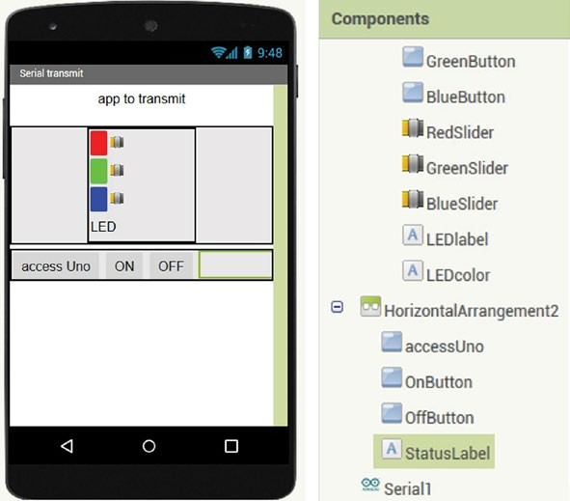
Figure 13-10. OTG-A to OTG-B app layout
Managing connection of the OTG-A device to the OTG-B device is the same as in the OTG-B to OTG-A example (see Figures 13-5 and 13-6). However, when the OTG-A device disconnects the OTG-B device, the LED procedure transmits a zero LED value to the OTG-B device, which then turns off all LEDs (see Figure 13-11).
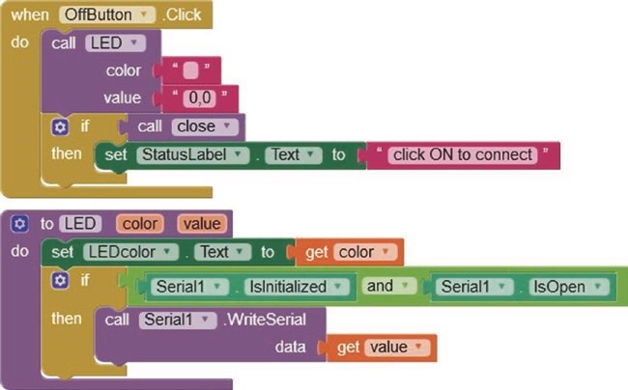
Figure 13-11. Disconnect the OTG-A to OTG-B connection
Clicking the RedButton button on the OTG-A device calls the LED procedure (see Figure 13-12) to transmit, to the OTG-B device, the value “1” and the comma-separated red LED slider position. The round block rounds up or down the slider position, which is a real number, to an integer. A global variable, RedValue, is initially set at the mid-slider position of 127 and stores the current slider position. Similar blocks are used for the green and blue LEDs, but with LED values of “2” and “3”, respectively.
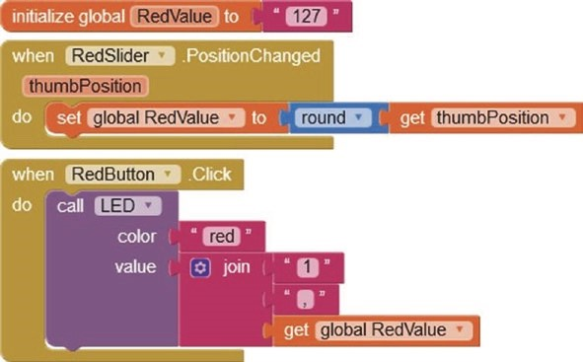
Figure 13-12. Control the LEDs
App receive and transmit
An app to both receive and transmit data from and to the OTG-B device combines the previous app receive and app transmit examples. Figure 13- 13 is a screenshot of the receive and transmit app after the OTG-B device transmitted the message containing the number pair 9, 10, which was processed by the OTG-A device. The screenshot is also after the RedButton was clicked on the OTG-A device for transmission of a message to the OTG-B device to update the brightness of the red LED. The receive and transmit app combines the screenshots of Figures 13-2 and 13-8.
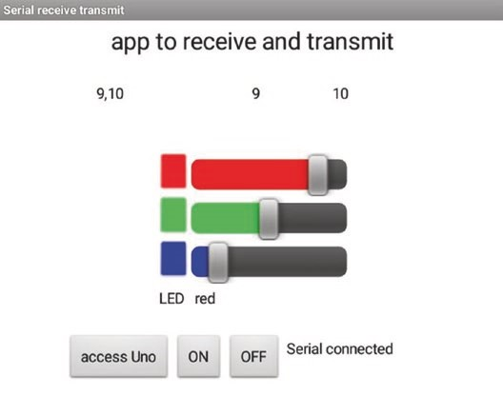
Figure 13-13. App to receive and transmit data
The receive and transmit app design layout in Figure 13-14 is a direct combination of the app layouts of the receive app (see Figure 13-4) and the transmit app (see Figure 13-10).
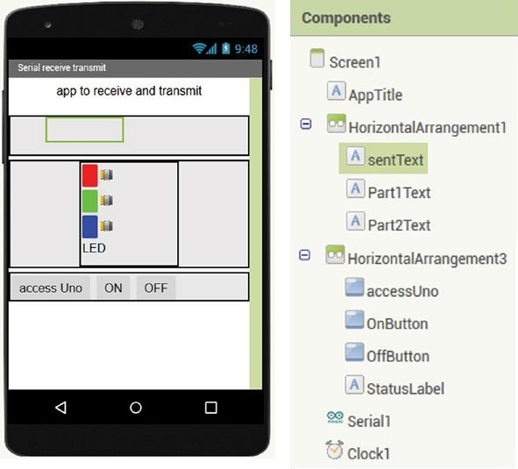
Figure 13-14. App layout to receive and transmit data
The sketch for the app to both receive and transmit data consists of the OTG-A to OTG-B transmit app sketch in Listing 13-2 and the contents of the loop function from the OTG-B to OTG-A receive app sketch in Listing 13-1, plus the variable definition instructions
String text int count = 0 unsigned long timer
When a button is clicked on the receive and transmit app, the OTG-A device transmits a message to the OTG-B device to control the LEDs while processing the received messages from the OTG-B device. The two conditional instructions if(millis() - timer > 1000) and if(Serial. available() > 0), used in Listings 13-1 and 13-2, respectively, enable

USB OtG COmmUniCatiOn
the OTG-B device, the Arduino Uno, to “simultaneously” receive a signal from and transmit a signal to the OTG-A host device, the Android tablet or mobile phone.
Summary
USB OTG communication connected the OTG-B device, an Arduino Uno, with an app hosted by the OTG-A device, the Android tablet or mobile phone, and the two devices were connected by a USB OTG cable. A receive app processed signals transmitted by the OTG-B device to the OTG-A host device. Similarly, a transmit app sent signals to the OTG-B device to control the brightness of several LEDs by PWM. The two apps were combined into a receive and transmit app, with the OTG-A device both receiving a signal from and transmitting a signal to the OTG-B device. The MIT App Inventor Serial component communicates with the ATmega16U2 USB to serial converter of the Arduino Uno, but not with the CH340 chip on the Arduino Nano or ESP8266 development boards.
Components List
- Arduino Uno
- USB OTG cable: Female USB A to male micro-USB B
- RGB LED or LED: 3×
- Resistor: 3× 220 Ω
CHAPTER 14
ESP-NOW and LoRa communication
Communication with nRF24L01 transceivers and with Bluetooth for transmission of GPS location data is described in Chapter 12 (GPS tracking app with Google Maps), On-The-Go communication in Chapter 13 (USB OTG Communication) and Wi-Fi communication for updating webpage information in Chapter 9 (WebSocket) or for an internet radio in Chapter 1. Two other communication protocols, ESP-NOW and LoRa, are described in this Chapter.
ESP-NOW

Espressif Systems developed ESP-NOW to enable ESP8266 and ESP32 microcontrollers to communicate without requiring a Wi-Fi connection. ESP-NOW operates at 2.4 GHz, the same frequency as Wi-Fi and Bluetooth, with microcontrollers paired prior to communication. A microcontroller transmits and receives messages to and from several microcontrollers, with a network consisting of 20 microcontrollers without message encryption, but 10 microcontrollers with encryption. If power to a microcontroller is lost and then restored, the microcontroller
© Neil Cameron 2021 365
N. Cameron, Electronics Projects with the ESP8266 and ESP32, https://doi.org/10.1007/978-1-4842-6336-5_14
automatically reconnects to the paired microcontroller. In practice, a transmission range of 250 m over open ground was achieved with two ESP32 microcontrollers.
The ESP-NOW library is automatically included in the Arduino IDE, when the ESP8266 or ESP32 Boards Manager is installed. In a sketch, the ESP-NOW library is included with <espnow.h> or <esp_now.h> for the ESP8266 or ESP32 microcontroller, respectively.
Pairing a microcontroller requires the MAC (Media Access Control) address of the microcontroller, which is the address for communication within a network. Listing 14-1 obtains the MAC address of an ESP8266 microcontroller. For an ESP32 microcontroller, the instruction #include <ESP8266WiFi.h> is replaced with #include <WiFi.h>. The MAC address contains six numbers in HEX format, such as 3C:71:BF:F1:CC:9C. The MAC address is also displayed by the Arduino IDE when a sketch is compiled and loaded (see Figure 14-1).
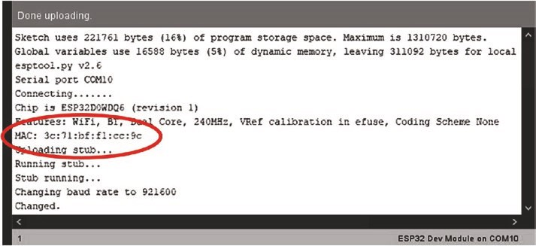
Figure 14-1. MAC address from Arduino IDE

eSp-NOW aNd LOra COmmuNiCatiON
Listing 14-1. MAC address
#include <ESP8266WiFi.h> // include Wi-Fi library
void setup()
{
Serial.begin(115200); // Serial Monitor baud rate
Serial.println(WiFi.macAddress()); // get MAC address
}
void loop() // nothing in loop function
{}
Information transmitted with ESP-NOW includes an integer, a real number, and text or a data structure containing a combination of the three data types. To provide some generality, the sketches in this chapter include a data structure. For ESP-NOW, the maximum size of a data structure is 250 bytes, with an integer, real number, or character requiring 2, 4, or 1 byte, respectively. In Listing 14-2, an example data structure consists of two integers, a real number, and a character array. Note that the length of the character array is the maximum number of characters plus one, to allow for the end-of-line, /n, character.
Listing 14-2. Example data structure
typedef struct // define structure to include
{
int count = 5; // two integers, int total;
float value = 3.14; // a real number char text[12] = "text"; // and a character array
} dataStruct;
dataStruct payload; // name the structure as payload
The structure is transmitted or received with the structure name, payload, with each component of the structure individually accessible, such as payload.value.
The following section includes instructions for an ESP8266 microcontroller. Instruction differences between the ESP8266 and ESP32 microcontrollers are listed in Table 14-1. An ESP8266 microcontroller is allocated the role of transmitter (CONTROLLER), receiver (SLAVE), or both transmitter and receiver (COMBO), with the instruction esp_now_ set_self_role(role). The terminology is, unfortunately, the current convention for ESP-NOW with an ESP8266 microcontroller. A receiving ESP8266 microcontroller is identified to the transmitting ESP8266 microcontroller by the MAC address, role, and communication channel with the instruction esp_now_add_peer(receiveMAC, ESP_NOW_ROLE_ SLAVE, channel, NULL, 0), where receiveMAC is the MAC address of the receiving ESP8266 microcontroller. The data structure, payload, is transmitted to the receiving ESP8266 microcontroller with the instruction esp_now_send(receiveMAC, (uint8_t *) & payload, sizeof(payload)).
If the receiver MAC address is replaced with {0xFF, 0xFF, 0xFF, 0xFF, 0xFF, 0xFF}, then the transmission will be to all the receiving ESP8266 microcontrollers. The ampersand, &, and asterisk, *, characters relate to the memory address of the structure, payload. The address of a variable in memory is accessed by preceding the variable with the ampersand, such as &payload, and a pointer stores the memory address of another variable by preceding the pointer with an asterisk, such as *pointer. The pointer is defined with the same data type as the variable, such as float * pointer.
The value of a variable is accessed with a pointer, as illustrated in Listing 14-3. Listing 14-3. Variable, pointer, and memory address
int sum = 25; // allocate value to variable int * pointer; // define pointer int number;
eSp-NOW aNd LOra COmmuNiCatiON
void setup()
{
Serial.begin(115200);
pointer = &sum; // set pointer to address of sum number = *pointer; // set number to pointer content
Serial.print("\nnumber ");Serial.println(number);
}
void loop() // nothing in loop function
{}
The transmitting ESP8266 microcontroller registers for a callback that the transmitted data was received by the receiving ESP8266 microcontroller with the instruction esp_now_register_send_cb(sendData). The sendData function returns the MAC address of the receiving ESP8266 microcontroller and the callback value. Listing 14-4 also displays the MAC address of the receiving ESP8266 microcontroller, using the printf function that converts the content of the mac array to HEX format with the 0 character padding for up to two digits, with the parameter %02. Upper- or lowercase HEX format is printed with the parameter %X or %x. Listing 14-4. Transmitter callback
void sendData(uint8_t * mac, uint8_t chk)
{
for (int i=0; i<6; i++) // receiver MAC address
{
Serial.printf("%02x", mac[i]); // convert to HEX format if(i < 5) Serial.print(":"); // include colons
}
Serial.print("\tcallback ");
if(chk == 0) Serial.println("OK "); // transmission received else Serial.println("fail"); // or not }
The receiving ESP8266 microcontroller also registers for a callback with the instruction esp_now_register_recv_cb(receiveData). The receiveData function returns the MAC address of the transmitting ESP8266 microcontroller, mac; copies the received data, data, to the memory address of the payload structure, &payload; and displays the byte number of the received data, len, and the text character array on the Serial Monitor. Listing 14-5. Receiver callback
void receiveData(uint8_t * mac, uint8_t * data, uint8_t len) { // copy received data to payload memcpy(&payload, data, sizeof(pay load));
Serial.print("bytes ");Serial.print(len);Serial.print("\t");
Serial.print("text ");Serial.println(payload.text);
}
The complete sketch for the transmitting ESP8266 microcontroller to send an integer, a real number, and text with ESP-NOW is given in Listing 14-6. Note that the MAC address in Listing 14-6 must be replaced with the MAC address of your receiving ESP8266 microcontroller or use the generic value of {0xFF, 0xFF, 0xFF, 0xFF, 0xFF, 0xFF}.
Listing 14-6. ESP-NOW for a transmitting ESP8266 microcontroller
#include <espnow.h> // include ESP-NOW library uint8_t receiveMAC[] = {0x84,0xF3,0xEB,0x0D,0xB5,0xB3}; typedef struct // receiver MAC address
{
int count = 0; // data structure with float value = 3.14; // integer, real number char text[10] = "abcdef"; // and character array
} dataStruct; dataStruct payload;

int channel = 1; // set transmission channel int chk;
void setup()
{
Serial.begin(115200); // Serial Monitor baud rate if(esp_now_init() != 0) // initialise ESP-NOW
{
Serial.println("error initialising ESP-NOW"); return;
} // transmitter device esp_now_set_self_role(ESP_NOW_ROLE_CO NTROLLER); chk = esp_now_add_peer(receiveMAC, ESP_NOW_ROLE_SLAVE,
channel, NULL, 0); // add receiver device if(chk == 0) Serial.println("receiver added"); else
{
Serial.println("error adding receiver"); return;
} esp_now_register_send_cb(sendData); // link to sendData function
}
void loop()
{
payload.count++; // increment counter payload.value = payload.value + 1.0; // and real number if(strcmp(payload.text,"abcdef") == 0 ) // alternate text strncpy(payload.text, "xyz", sizeof(payload.text)); else strcpy(payload.text, "abcdef");
Serial.print(payload.count);
Serial.print(payload.value); // display transmitted data Serial.print(payload.text);
chk = esp_now_send(receiveMAC, (uint8_t *) & payload,
sizeof(payload));
Serial.print("\tsent ");
if(chk == 0) Serial.print("OK "); // transmission sent or not else Serial.println("fail"); delay(2000); }
void sendData(uint8_t * mac, uint8_ t chk) // callback function
{
for (int i = 0; i < 6; i++) // display receiving MAC address
{
Serial.printf("%02x", mac[i]); if (i < 5)Serial.print(":");
}
Serial.print("\tcallback "); // transmission received or not
if(chk == 0) Serial.println("OK "); else Serial.println("fail"); }
The complementary sketch for the receiving ESP8266 microcontroller is given in Listing 14-7, with the received message displayed on the Serial Monitor.
Listing 14-7. ESP-NOW for a receiving ESP8266 microcontroller
#include <espnow.h> // include ESP-NOW library typedef struct
{
int count; // data structure with float value; // integer, real number char text[10]; // and character array } dataStruct;
dataStruct payload;
int rcv = 0; // counter of received signals void setup()
{
Serial.begin(115200); if(esp_now_init() != 0) // initialise ESP-NOW
{
Serial.println("error initialising ESP-NOW"); return;
}
esp_now_set_self_role(ESP_NOW_ROLE_SLAVE); // receiver device esp_now_register_recv_cb(receiveD ata);
} // link to receiveData function
void receiveData(uint8_t * mac, uint8_t * data, uint8_t len)
{
rcv++; // increment signal counter memcpy(&payload, data, sizeof(pay load));
// copy received data to payload
for (int i = 0; i < 6; i++)
{ // display transmitting MAC address Serial.printf("%02x", mac[i]); if (i < 5)Serial.print(":");
} // display contents of payload Serial.print("\t");
Serial.print("received ");Serial.print(rcv);Serial.print("\t");
Serial.print("bytes ");Serial.print(len);Serial.print("\t");
Serial.print("count ");Serial.print(payload.count);
Serial.print("\t");
Serial.print("value ");Serial.print(payload.value);
Serial.print("\t");
Serial.print("text ");Serial.println(payload.text);
}
void loop() // nothing in loop function
{}
The WebSocket protocol enables a server to transmit information to the client, with the information displayed on a web page, as described in Chapter 9 (WebSocket). Listing 14-8 automatically updates a web page with the message and the time of receipt (see Figure 14-2). An application is the display of sensor information.
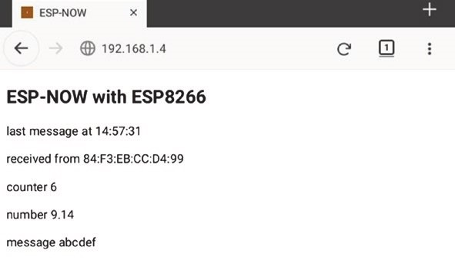
Figure 14-2. Receiving ESP8266 microcontroller with ESP-NOW and WebSocket
Listing 14-8. Receiving ESP8266 microcontroller with ESP-NOW and WebSocket
#include <ESP8266WebServer.h> // include web server library
ESP8266WebServer server;
#include <WebSocketsServer.h> // include WebSocket library WebSocketsServer websocket = WebSoc ketsServer(81);
// set WebSocket port 81 #include "buildpage.h" // webpage AJAX code char ssid[] = "xxxx"; // change xxxx to Wi-Fi SSID char password[] = "xxxx"; // change xxxx to Wi-Fi password #include <espnow.h> // include ESP-NOW library typedef struct
{
int count; // data structure with float value; // integer, real number char text[10]; // and character array
} dataStruct; dataStruct payload; String strMAC, message, json;
void setup()
{
Serial.begin(115200); // Serial.Monitor baud rate WiFi.begin(ssid, password); // initialise Wi-Fi while (WiFi.status() != WL_CONNECTED) delay(500);
Serial.print("IP address: ");
Serial.println(WiFi.localIP()); // display web server IP address
Serial.print("MAC address: "); // and MAC address Serial.println(WiFi.macAddress()); server.begin();
server.on("/", base); // default webpage

websocket.begin(); if(esp_now_init() != 0) // initialise ESP-NOW
{
Serial.println("error initialising ESP-NOW"); return;
} // receiver device esp_now_set_self_role(ESP_NOW_ROLE_ SLAVE); esp_now_register_recv_cb(receiveDat a);
} // link to receiveData function
void receiveData(uint8_t * mac, uint8_t * data, uint8_t len) { // copy received data to payload memcpy(&payload, data, sizeof(pa yload)); strMAC = ""; for (int i = 0; i < 6; i++) // transmitting MAC address { // convert to HEX format strMAC = strMAC + String(mac[i ], HEX); if (i < 5)strMAC = strMAC + ":";
} strMAC.toUpperCase(); // convert to upper case
JsonConvert(strMAC, payload.count, payload.value, payload.text); websocket.broadcastTXT(json.c_str(), json.length()); }
String JsonConvert(String val1, int val2, float val3, String val4) { // start with open bracket
json = "{\"var1\": \"" + val1 + "\",";
// partition with comma
json += " \"var2\": \"" + String(val2) + "\","; json += " \"var3\": \"" + String(val3) + "\","; json += " \"var4\": \"" + String( val4) + "\"}";
// end with close bracket
return json; }
void base() // function to return HTML code
{
server.send (200, "text/html", page); }
void loop()
{
server.handleClient(); // handle server requests websocket.loop(); // handle WebSocket data
}
Implementation of the WebSocket protocol is contained in the JavaScript section of Listing 14-9, which includes the web page AJAX code that is included as the string literal page[ ] in the buildpage.h tab. Listing 14-9. WebSocket web page AJAX code
char page[] PROGMEM = R"(
<!DOCTYPE html><html>
<head>
<meta name='viewport' content='width=device-width, initial-scale=1.0'>
<meta charset='UTF-8'>
<title>ESP-NOW</title>
<style>
body {font-family:Arial}
</style></head>
<body id='initialise'>
<h2>ESP-NOW with ESP8266</h2>
<p>last message at <span id='timeNow'</span></p>
<p>received from <span id='MAC'> </span></p>
<p>counter <span id='count'>0</span></p>
<p>number <span id='value'>0</span></p>
<p>message <span id='text'> </span></p>
<script> var wskt;
document.getElementById('initialise').onload = function() {init()}; function init()
{
wskt = new WebSocket('ws://' + window.location.hostname + ':81/'); wskt.onmessage = function(rx)
{
var obj = JSON.parse(rx.data); document.getElementById('MAC').innerHTML = obj.var1; document.getElementById('count').innerHTML = obj.var2; document.getElementById('value').innerHTML = obj.var3; document.getElementById('text').innerHTML = obj.var4; var dt = new Date(); var tm = dt.toLocaleTimeString ('en-GB'); document.getElementById('timeNow').innerHTML = tm;
};
}
</script>
</body></html>
)";
Data from several microcontrollers is received by one microcontroller by allocating a specific channel value to each transmitting microcontroller, with the instruction
chk = esp_now_add_peer(receiveMAC, ESP_NOW_ROLE_SLAVE, channel, NULL, 0)
In a sketch, the MAC address of a transmitting microcontroller or an index value included in the message is used to allocate a received message to a specific transmitting microcontroller. For example, two ESP8266 microcontrollers, running a sketch based on Listing 14-6, transmitted messages every two and nine seconds that were received by an ESP8266 microcontroller running the sketch in Listing 14-7. Inclusion of the instruction if((mac[5]-0x9B)==0) Serial.print("\t\t\t\t\t\t") offset displaying the message, from the microcontroller with MAC address ending in 0x9B, on the Serial Monitor (see Figure 14-3).
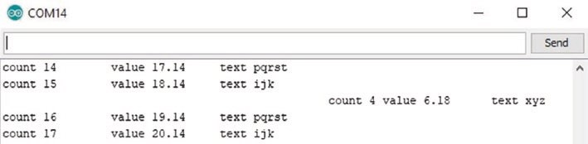
Figure 14-3. Messages from two transmitting ESP8266 microcontrollers
Listings 14-4 to 14-8 are for an ESP8266 microcontroller. There are several differences in ESP-NOW instructions between libraries for the ESP8266 and ESP32 microcontrollers that are listed in Table 14-1 with the detail highlighted in bold. The transmitting and receiving ESP32 microcontrollers both require the WiFi library and are defined as Wi-Fi station mode, WIFI_STA, immediately after the Serial.begin(115200) instruction. The function esp_now_set_self_role is not required, and
the function esp_now_peer_info_t to define the receiving ESP32 microcontroller replaces the esp_now_add_peer function. In the sendData function, the send status variable is specifically defined; and in the receiveData function, parameter types are defined as const uint8_t or int instead of uint8_t.
Table 14-1. ESP-NOW instructions for ESP8266 and ESP32 microcontrollers
ESP8266 | ESP32
 | #include <WiFi.h>
#include <espnow.h> | #include <esp_now.h>  WiFi.mode(WiFi_Sta)
esp_now_set_self_role(eSp_NOW  _rOLe_XX)  where XX is CONTROLER or SLAVE | Not required
chk = esp_now_add_ peer(receivemaC, eSp_NOW_rOLe_SLaVe, channel, NuLL, 0) | esp_now_peer_info_t receiver; memcpy(receiver.peer_addr, receivemaC, 6); receiver.channel = channel; receiver.encrypt = false;  chk = esp_now_add_peer(&receiver);
void senddata(uint8_t * mac, uint8_t chk) | void senddata(const uint8_t * mac, esp_ now_send_status_t chk)
void receivedata(uint8_t *mac, uint8_t *data, uint8_t len) | void receivedata(const uint8_t * mac, const uint8_t * data, int len)
If the received message is displayed on a web page, then an ESP-NOW channel between the transmitting and receiving ESP32 microcontrollers and a Wi-Fi channel between the receiving ESP32 microcontroller and the WLAN are required.
The transmitting ESP32 microcontroller is defined as a software- enabled Wi-Fi access point, SoftAP, on default channel one with a default IP address of 192.168.4.1, which is displayed with the instruction Serial. println(WiFi.softAPIP()). The SoftAP password should contain at least eight alphanumeric characters. Instructions to define the SoftAP with SSID, password, and channel number for the transmitting ESP32 microcontroller are given in Table 14-2.
Table 14-2. Web page instructions for transmitting and receiving
ESP32 microcontrollers
ESP32 Transmitter | ESP32 Receiver
#include <WebServer.h>
WebServer server(80)
char ssidap[ ] = "abcdefg" | char ssid[ ] = "xxxx"
char passwordap[ ] = "12345678" | char password[ ] = "xxxx"
int channelap = 3 WiFi.mode(WiFi_ap) | WiFi.mode(WiFi_ap_Sta)
WiFi.softap(ssidap, passwordap, channelap)  Serial.print("Soft-ap ip address ")  Serial.println(WiFi.softapip())  WiFi.begin(ssidap, passwordap) receiver.channel = channelap | WiFi.begin(ssid, password);
The receiving ESP32 microcontroller has joint access point and station mode, with the instruction WiFi.mode(WIFI_AP_STA), to connect to the SoftAP and to the Wi-Fi network (see Table 14-2). The Wi-Fi network SSID

and password are defined, with the xxxx in Table 14-2 replaced by the SSID and password of your Wi-Fi router. Note that the WiFi.begin() instruction for the transmitting ESP32 microcontroller references the generated SoftAP SSID and password, while the receiving ESP32 microcontroller references the Wi-Fi router SSID and password.
Further information on ESP-NOW is available at www.espressif.com/ sites/default/files/documentation/2c- esp8266_non_os_sdk_api_ reference_en.pdf, in Section 3.8, for the ESP8266 microcontroller, with details for the ESP32 microcontroller at docs.espressif.com/projects/ esp-idf/en/latest/esp32/api-reference/network/esp_now.html.
LoRa communication
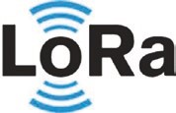
Several communication systems are available, each operating at different frequencies, over different distances, and with different data rates. RFID (Radio Frequency IDentification), Bluetooth, and Bluetooth Low Energy (BLE) technologies have lower data rates than Wi-Fi communication, which has lower range than the mobile
telecommunication technology standards 2G–5G (see Figure 14-4). LoRa (long range) is a low-power wide area network (LPWAN) technology developed by Semtech. LoRa communication operates with a form of frequency modulation (FM), rather than amplitude modulation (AM), uses lower frequencies than the 2.4 GHz of Wi-Fi and Bluetooth
communication, and has low power consumption. LoRaWAN (Long Range Wide Area Network) is the protocol for creating LoRa-based networks. This chapter describes point-to-point communication with LoRa.
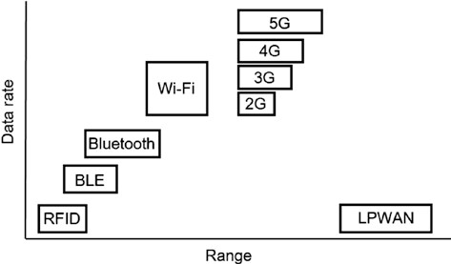
Figure 14-4. Communication technologies
The Semtech SX1276 and SX1278 LoRa modules are powered by 1.8–3.6 V, but differ in frequency range, 137–1020 MHz and 137–525 MHz, respectively, with the SX1278 module applicable in Europe (433 MHz), while the SX1276 module is suitable for Europe (868 MHz), Australia and North America (915 MHz), and Asia (923 MHz). Both the SX1276 and SX1278 modules have LoRa spreading factors of 6–12 and a bandwidth of 8–500 kHz, giving effective bit rates of up to 37.5 kbps.
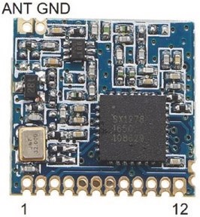
This chapter uses the SX1278 LoRa module at 433 MHz and the LoRa library by Sandeep
Mistry that is available in the Arduino IDE (with details available at github.com/ sandeepmistry/arduino-LoRa/blob/master/ API.md). The LoRa module communicates with an ESP8266 or ESP32 microcontroller using SPI (Serial Peripheral Interface), with connections between a LoRa module and an ESP8266 or ESP32 development board
shown in Figure 14-5 and listed in Table 14-3. The LoRa module antenna (ANT) length is λ/4, where λ is the wavelength equal to c/f, with c equal to the speed of light (299,792,458 m/s or approximately 300 Mm/s) and f the LoRa transmission frequency. A LoRa transmission frequency of 433, 868, or 915 MHz requires an antenna 173, 86, or 82 mm long. The LoRa module digital input-output pins are marked DIO.
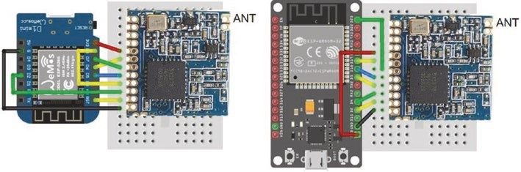
Figure 14-5. SX1278 LoRa module with LOLIN (WeMos) D1 mini and ESP32 DEVKIT DOIT development boards
The image of the SX1278 LoRa module in Figure 14-5 was increased in size to match the mini-breadboard holes and illustrate the connections. In reality, the 12 connection pins of the SX1278 LoRa module span 14 mm rather than 30 mm on a breadboard. One solution is to bend the eight pins of a long-pin header block to align with the SX1278 LoRa module connections (see Figure 14-6).
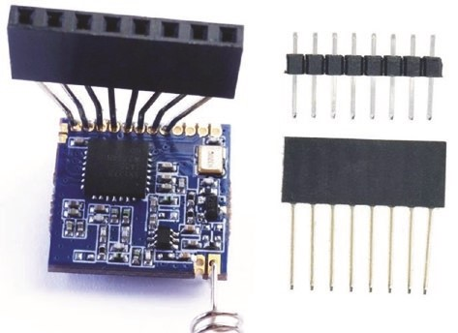
Figure 14-6. Pin header block with long and normal pins
Table 14-3. SX1278 LoRa module with ESP8266 and ESP32 microcontrollers
Component | ESP8266 | ESP32
SX1278 GNd (pin 1)  SX1278 diO1  SX1278 diO2  SX1278 diO3  SX1278 VCC | 3V3 | 3V3
SX1278 miSO | d6 | GpiO 19
SX1278 mOSi | d7 | GpiO 23
SX1278 SLCK | d5 | GpiO 18
SX1278 NSS (CSS) | d8 | GpiO 5
SX1278 diO0 | d2 | GpiO 4
SX1278 reSt | rSt | GpiO 2
SX1278 GNd (pin 12) | GNd | GNd
OLed GNd | GNd | GNd
OLed VCC | 3V3 | 3V3
OLed SCK | d1 | GpiO 22
OLed Sda | d2 | GpiO 21
A sketch for LoRa communication with an ESP8266 microcontroller is given in Listing 14-10. The LoRa transmission frequency of 433, 868, or 915 MHz is defined with the instruction LoRa.begin(NE6), with N equal to 433, 868, or 915. The LoRa module connection pins for the chip select (CSS) and reset (RST) and an interrupt (DIO0) pin are defined in the sketch, as the LoRa library default values are GPIO 10, GPIO 9, and GPIO 2.
When the LoRa module reset pin is connected to the ESP8266 or ESP32 microcontroller reset pin, the LoRa module reset pin is defined as -1. The default SPI pins are defined implicitly. The LoRa spreading factor (SF6–SF12) spreads a transmission across the available bandwidth, with a higher SF increasing the transmission range, but decreasing the transmission bit rate. The LoRa library has bandwidth values from 7.8 kHz to 250 kHz, with lower bandwidth corresponding to longer transmission range. The default signal bandwidth of 125 kHz is changed with the instruction LoRa.setSignalBandwidth(N), for bandwidth N, with possible values listed on the LoRa library website. For example, set N equal to 31.25E3 for a bandwidth of 31.25 kHz. The maximum LoRa transmission size with the LoRa library is 255 bytes.
In the sketch, a message is transmitted at five-second intervals, which is displayed on the OLED screen along with a received message from the receiving microcontroller (see Figure 14-7). The value in the received message is equal to the packet transmitted, assuming no messages were lost. The feedback message confirms receipt of the transmitted message by the receiving microcontroller. The receiving microcontroller displays the number of seconds between received messages, the signal RSSI (received signal strength indicator) and SNR (signal-to-noise ratio), and then the received message.
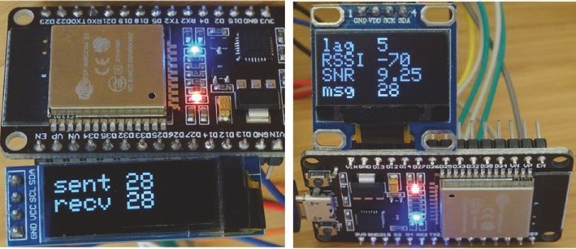
Figure 14-7. Characterizing LoRa message reception with feedback

eSp-NOW aNd LOra COmmuNiCatiON
Listing 14-10. Transmitting LoRa module with feedback
#include <SPI.h> // include SPI and #include <LoRa.h> // LoRa libraries int CSS = D8; // define SX1278 pins int RST = -1; // RESET pin int DIO0 = D2; // interrupt pin
#include <Wire.h> // include libraries for OLED
#include <Adafruit_SSD1306.h>
int width = 128; // OLED dimensions int height = 32; // associate oled with library Adafruit_SSD1306 oled(width, height, &Wire, -1); int counter = 0; unsigned long lastTime;
String packet, recv;
int packetSize; // size of received message
void setup()
{ digitalPinToInterrupt(DIO0); // set pin as interrupt LoRa.setPins(CSS, RST, DIO0); // define LoRa module pins
LoRa.setSpreadingFactor(9); // define spreading factor LoRa.setSignalBandwidth(62.5E3); // set bandwidth to 62.5kHz while (!LoRa.begin(433E6)) delay(500); // 433MHz transmission oled.begin(SSD1306_SWITCHCAPVCC, 0x3 C);
// OLED display I2C address
oled.setTextColor(WHITE); // set font color oled.setTextSize(2); // text size 12×16 pixels oled.display();
}
eSp-NOW aNd LOra COmmuNiCatiON
void loop()
{ if(millis() - lastTime > 5000) // 5s transmission interval
{
screen(); // OLED display function packet = String(counter); // create packet
LoRa.beginPacket(); // start LoRa transmission
LoRa.print(packet); // send packet
LoRa.endPacket(); // close LoRa transmission counter++; // increment counter lastTime = millis(); // update transmission time
}
packetSize = LoRa.parsePacket(); // detect received packet if (packetSize > 0)
{
recv = ""; // read packet while(LoRa.available()) recv = recv + ((char)(LoRa.read())); screen(); // OLED display function
}
}
void screen() // function for OLED display
{
oled.clearDisplay(); oled.setCursor(0,0);
oled.print("sent ");oled.println(pac ket); // transmitted value oled.print(recv); // received message oled.display();
}
eSp-NOW aNd LOra COmmuNiCatiON
During packet reception, the LoRa module measures, in decibels (dB), the received signal strength indicator (RSSI) and the signal-to-noise ratio (SNR). The received signal power is 10^{(dB/10)}mW. The RSSI ranges from 0 dBm to -120 dBm, with a value greater than -50 dBm indicating a strong signal, while a weak signal has a RSSI of less than -90 dBm. The SNR is the difference between the signal and the background noise RSSI values, with a positive SNR indicating that the received signal operates above the noise baseline. LoRa can operate below the noise baseline, which is the normal limit of signal sensitivity.
The sketch for characterizing LoRa message reception is given in
Listing 14-11, which displays the interval between message reception, RSSI, SNR, and the message on an OLED display. A received message is read as a byte, which is converted to a character with the instruction (char)(LoRa.read()). On receiving a message, the sketch also returns the received message to the transmitting microcontroller, as feedback. The Adafruit SSD1306 library references the Adafruit GFX library, so the #include <Adafruit_GFX.h> instruction is not required.
Listing 14-11. Characterizing LoRa message reception
#include <SPI.h> // include SPI and #include <LoRa.h> // LoRa libraries int CSS = D8; // define SX1278 pins int RST = -1; // RESET pin int DIO0 = D2; // interrupt pin int width = 128; // OLED dimensions int height = 64;
#include <Wire.h> // include libraries for OLED
#include <Adafruit_SSD1306.h>
Adafruit_SSD1306 oled(width, height, & Wire, -1);
// Reset pin not required
eSp-NOW aNd LOra COmmuNiCatiON
String packet;
int RSSI, packetSize, interval; float SNR; unsigned long lastTime = 0;
void setup()
{ digitalPinToInterrupt(DIO0); // set pin as interrupt LoRa.setPins(CSS, RST, DIO0); // define LoRa module pins while (!LoRa.begin(433E6)) delay(500 ); // 433MHz transmission oled.begin(SSD1306_SWITCHCAPVCC, 0x3 C);
// OLED display I2C address
oled.setTextColor(WHITE); // set font color oled.setTextSize(2); // text size 12×16 pixels oled.display(); }
void loop()
{
packetSize = LoRa.parsePacket(); // detect received packet if (packetSize > 0)
{
interval = round((millis() - lastT ime)/1000); // interval (s) lastTime = millis(); // update message time packet = ""; // read packet while(LoRa.available()) packet = packet + ((char)(LoRa.read()));
RSSI = LoRa.packetRssi();
SNR = LoRa.packetSnr(); // signal : noise screen(); // OLED display function
eSp-NOW aNd LOra COmmuNiCatiON
LoRa.beginPacket(); // start LoRa transmission
LoRa.print("recv " + packet); // send packet
LoRa.endPacket(); // close LoRa transmission
}
}
void screen() // function for OLED display
{
oled.clearDisplay(); oled.setCursor(0,0);
oled.print("lag ");oled.pr intln(interval);
// display time since last message
oled.print("RSSI ");oled.pr intln(RSSI);
// display interval, RSSI and SNR
oled.print("SNR ");oled.println(SNR); oled.print("msg ");oled.print (packet);
// display received message
oled.display(); }
The WebSocket protocol enables a server to transmit information to the client, with the information displayed on a web page. Listing 14-12 automatically updates a web page with the message and the time of receipt (see Figure 14-8). An application is the display of sensor information.
eSp-NOW aNd LOra COmmuNiCatiON
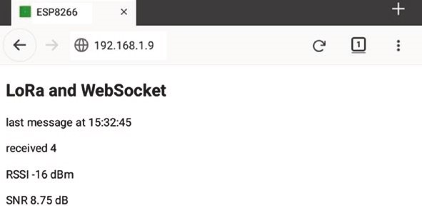
Figure 14-8. LoRa reception with WebSocket
Listing 14-12 is for an ESP8266 development board as the server. The web server library instructions for the ESP8266 microcontroller of
#include <ESP8266WebServer.h>
ESP8266WebServer server
are replaced when using an ESP32 microcontroller with
#include <WebServer.h>
WebServer server(80); // requires a port number
The web server library references the Wi-Fi library, so the #include <ESP8266WiFi.h> or #include <WiFi.h> instructions are not required. The CSS, RST, and DIO0 pin numbers are changed to 5, 2, and 4 for an ESP32 microcontroller.
Listing 14-12. Receiving LoRa module and WebSocket
#include <ESP8266WebServer.h> // include Webserver library
ESP8266WebServer server; // associate server with library
#include <WebSocketsServer.h> // include WebSocket library WebSocketsServer websocket = WebSoc ketsServer(81);
// set WebSocket port 81
eSp-NOW aNd LOra COmmuNiCatiON
#include "buildpage.h" // webpage AJAX code char ssid[] = "xxxx"; // change xxxx to Wi-Fi SSID char password[] = "xxxx"; // change xxxx to Wi-Fi password String message, json; int RSSI; float SNR;
#include <SPI.h> // include SPI library #include <LoRa.h> // and LoRa library int CSS = D8; // define SX1278 pins int RST = -1; // RESET pin int DIO0 = D2; // interrupt pin int packetSize;
void setup()
{
Serial.begin(115200); // Serial Monitor baud rate WiFi.begin(ssid, password); // initialise and connect Wi-Fi while (WiFi.status() != WL_CONNECTED) delay(500);
Serial.print("IP address: ");
Serial.println(WiFi.localIP()); // display web server IP address server.begin();
server.on("/", base); // load default webpage websocket.begin(); // initialise WebSocket digitalPinToInterrupt(DIO0); // set pin as interrupt LoRa.setPins(CSS, RST, DIO0); // define LoRa module pins while (!LoRa.begin(433E6)) delay(500) ; // 433MHz transmission
Serial.println("LoRa connected");
}
void loop()
{
server.handleClient(); // handle HTTP requests websocket.loop(); // handle WebSocket data
eSp-NOW aNd LOra COmmuNiCatiON
packetSize = LoRa.parsePacket(); // detect received packet if (packetSize > 0)
{
message = ""; // read packet while(LoRa.available()) message = message + ((char)(LoRa.read()));
RSSI = LoRa.packetRssi();
SNR = LoRa.packetSnr(); // signal : noise
JsonConvert(message, RSSI, SNR); // convert to JSON format websocket.broadcastTXT(json.c_str(), json.length());
}
}
String JsonConvert(String val1, int val2, float val3) { // start with open bracket json = "{\"var1\": \"" + String(val1 ) + "\",";
// partition with comma
json += " \"var2\": \"" + String(val2) + "\","; json += " \"var3\": \"" + String(val3 ) + "\"}";
// end with close bracket
return json; }
void base() // function to return HTML code
{
server.send (200, "text/html", page); }
The corresponding AJAX code for the web page is given in Listing 14- 13. When the web page is loaded, the init function opens the WebSocket connection at ws://web server IP address:81/. When the SX1278 LoRa module receives a message, the WebSocket protocol forwards the message to the client as the variable rx.data, which is parsed to the rxText, RSSI, and
eSp-NOW aNd LOra COmmuNiCatiON
SNR variables for display on the web page. The time of message receipt is obtained from the JavaScript date reference, as described in Chapter 9 (WebSocket), with details available at www.w3schools.com/Jsref/jsref_ obj_date.asp.
Listing 14-13. WebSocket and AJAX code for the web page
char page[] PROGMEM = R"(
<!DOCTYPE html><html>
<head>
<meta name='viewport' content='width=device-width, initial-scale=1.0'>
<meta charset='UTF-8'>
<title>ESP8266</title>
<style>
body {font-family:Arial}
</style></head>
<body id='initialise'>
<h2>LoRa and WebSocket</h2>
<p>last message at <span id='timeNow'</span></p>
<p>received <span id='rxText'> </span></p>
<p>RSSI <span id='RSSI'>0</span> dBm</p>
<p>SNR <span id='SNR'>0</span> dB</p>
<script> var wskt; document.getElementById('initialise').onload = function()
{init()};
function init() // open WebSocket
{
wskt = new WebSocket('ws://' + window.location.hostname +
':81/'); wskt.onmessage = function(rx)
eSp-NOW aNd LOra COmmuNiCatiON
{
var obj = JSON.parse(rx.data); document.getElementById('rxText').innerHTML = obj.var1; document.getElementById('RSSI').innerHTML = obj.var2; document.getElementById('SNR').innerHTML = obj.var3; var dt = new Date(); var tm = dt.toLocaleTimeString ('en-GB'); document.getElementById('timeNow').innerHTML = tm;
};
}
</script>
</body></html>
)";
Summary
ESP-NOW and LoRa technologies were described for communication between ESP8266 and ESP32 microcontrollers. ESP-NOW requires no additional components than the ESP8266 or ESP32 development board, while LoRa requires the SX1278 module. ESP-NOW operates at 2.4 GHz, which is higher than the 7.8–250 kHz operating frequencies of LoRa, with the protocols having limits of 250 and 255 bytes per message, respectively. LoRa has a greater transmission range than ESP-NOW. With ESP-NOW, the transmitting microcontroller receives a callback that the message was received with information displayed on the Serial Monitor or on a web page updated with the WebSocket procedure. With LoRa communication, the received message was either displayed on an OLED screen attached to the ESP8266 or ESP32 development board or on a web page, also using the WebSocket procedure.
eSp-NOW aNd LOra COmmuNiCatiON
Components
- ESP8266 microcontroller: LOLIN (WeMos) D1 mini or NodeMCU board
- ESP32 microcontroller: DEVKIT DOIT or NodeMCU board: 2×
- LoRa transceiver: SX1278 module 2×
- OLED display: 128 × 32 pixels, 128 × 64 pixels

CHAPTER 15
Radio frequency communication
In telecommunications and signal processing, information is transferred on a radio carrier wave by either modulating the amplitude or the frequency of a radio carrier wave. Radio waves have frequencies between 20 kHz and 300 GHz, corresponding to wavelengths of 15 km to 1 mm, and travel at the speed of light. Radio waves with frequencies above 300 MHz are termed microwaves. For Radio Frequency (RF) communication with amplitude modulation (AM), the transmission amplitude is proportional to the signal amplitude, and the transmission frequency is constant (see Figure 15-1). Conversely, for frequency modulation (FM), the amplitude of the transmitted signal is constant, and the transmission frequency is proportional to the signal amplitude. AM is used for communication between two-way radios, citizens band radios, and VHF (very-high- frequency) aircraft radios. FM is used in telemetry and radio broadcasting of music, as FM has a higher signal-to-noise ratio than AM at the same transmission power.
© Neil Cameron 2021 399
N. Cameron, Electronics Projects with the ESP8266 and ESP32, https://doi.org/10.1007/978-1-4842-6336-5_15
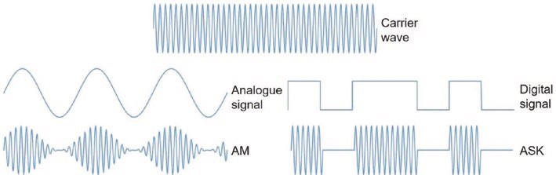
Figure 15-1. Amplitude modulation (AM) and Amplitude Shift
Keying (ASK)
Amplitude Shift Keying (ASK) is a form of amplitude modulation for representing a digital signal, such as 1234, which would require four distinct signal amplitudes. The simplest form of ASK, called On-Off Keying (OOK), consists of a binary signal represented by either transmitting the carrier signal or no signal. In Figure 15-1, the signal 1011010 is illustrated both as a digital signal and as an ASK signal.
The 433 MHz transmitter and receiver pairs (see Figure 15-2) are short-range devices designed for signal transmission, usually on a license- exempt basis, at a low power level and excluding voice. The transmitter is the smaller of the transmitter and receiver pair in
Figure 15-2. The standard transmitter and receiver pair are often coded MX-FS-03V and MX-05V and marked as FS1000A and MX-RM-5V, respectively. The superheterodyne transmitter and receiver pair are often coded WL102-341 and WL101-341. A superheterodyne transmitter uses frequency mixing to convert the transmitted signal into a signal with intermediate frequency that is more efficiently processed than a signal at the original carrier frequency. Superheterodyne is a compound of supersonic (frequencies above human hearing), hetero (different), and dyne (unit of power).
radio frequenCy CommuniCation
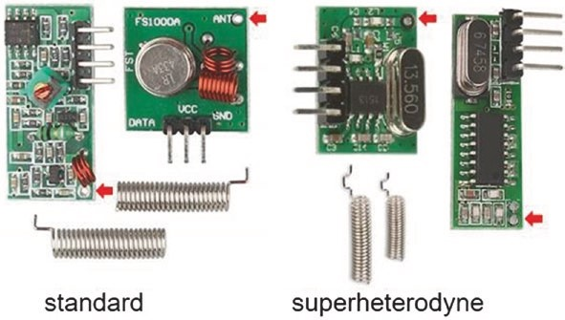
Figure 15-2. 433 MHz standard and superheterodyne transmitter and receiver pairs
The transmitter and receiver pairs in Figure 15-2 are shown with coiled antennas, but transmission and reception is improved with uncoiled antennas of length λ/2 or λ/4, where λ is the wavelength equal to c/f, with c equal to the speed of light (299,792,458 m/s or approximately 300 Mm/s) and f the carrier wave frequency. For a carrier wave frequency of 433.29 MHz, an antenna of length a quarter wavelength is 173 mm long. In Figure 15-2, antenna connection points are indicated with red arrows.
Connections for the transmitter and receiver with ESP8266 and ESP32 development boards are shown in Figures 15-3 and 15-4, respectively, for both the superheterodyne and standard devices. On the superheterodyne transmitter PCB, the + and EN pins are pre-connected, as are the DO (data out) and unmarked pins of the superheterodyne receiver PCB and the two unmarked pins on the standard receiver PCB. The RH_ASK library by Mike McCauley, which is downloaded from www.airspayce.com/mikem/ arduino/RadioHead, and the rc-switch library by Suat Özgür, which is available in the Arduino IDE, are both recommended.
For both libraries, the RF transmit and receive data pins are connected to the ESP8266 development board D1 and D2 pins or pins 26 and 27 for the ESP32 development board (see Table 15-1) with the receive data pin defined as an interrupt pin for the rc-switch library. In Listings 15-1 and 15-2, the instruction to define the ESP8266 development board pins, RH_ASK rf
(2000, D2, D1, 0), is replaced with the instruction RH_ASK rf (2000, 27, 26, 0) for an ESP32 microcontroller. The choice of transmit and receive pins is arbitrary.
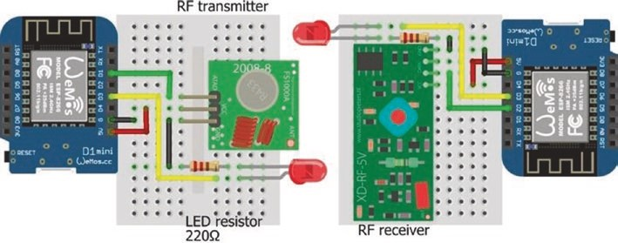
Figure 15-3. 433 MHz RF transmitter and receiver with LOLIN (WeMos) D1 mini
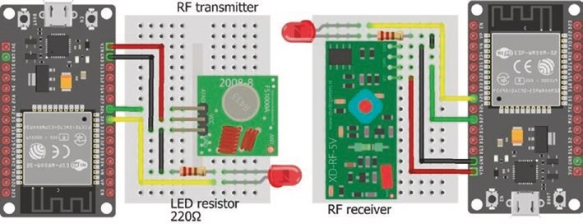
Figure 15-4. 433 MHz RF transmitter and receiver with the ESP32 DEVKIT DOIT board
radio frequenCy CommuniCation
Table 15-1. Transmitter and receiver connections for ESP8266 and
ESP32 microcontrollers
 | Transmitter |  |  |  | Receiver
Superheterodyne | _ | + | dat | en | Gnd do | VCC
Standard | Gnd | VCC | data |  | Gnd unmarked pins | VCC
Connect to eSp8266 | Gnd | 5V | d1 |  | Gnd d2 | 5V
eSp32 | Gnd | Vin | Gpio 26 |  | Gnd Gpio 27 | Vin
Transmitting and receiving text
The RH_ASK library is used to transmit messages containing character strings. The RH_ASK driver uses a timer-driven interrupt to generate eight interrupts per bit period, with Timer1 being the default timer. Several libraries use Timer1, such as the Servo library, but the RH_ASK driver can use Timer2 instead of Timer1 by uncommenting the line #define RH_ASK_ARDUINO_USE_TIMER2 on line 32 of the file RH_ASK.cpp that is located in the user/Arduino/libraries/RadioHead folder. The instruction RH_ASK rf (2000, receive pin, transmit pin, 0) defines the transmission speed in bits per second (bps) with the receive data and transmit data pins, respectively.
For the RH-ASK library, signals are formatted with a 36-bit training preamble consisting of 18 0-1 bit pairs, a 12-bit start symbol (0xB38), a 1-byte number for the payload length, a 4-byte header, N bytes containing the N characters of the message with a maximum of 60 characters per message, and 2 bytes for frame check sequences (FCS). The payload length is the number of characters in the message plus seven (payload length, 1; header, 4; FCS, 2). Apart from the preamble and start symbol, each byte is split into high and low 4-bit sequences, which are mapped to 6-bit sequences and transmitted least significant bit (LSB) first. Table 15- 2 provides the mapping of the 4-bit sequences (0x0 to 0xF) to 6-bit sequences (0xD to 0x34), formatted as HEX. The signal length is 36 + 12 + (N + 7) × 12 bits for a message of N characters. A message of 60 characters takes 426 ms to transmit with a transmission speed of 2 kbps.
Table 15-2. Mapping of 4-bit to 6-bit sequences in the RH_ASK library

4-bit 0x0 0x1 0x2 0x3 0x4 0x5 0x6 0x7
6-bit 0xd 0xe 0x13 0x15 0x16 0x19 0x1a 0x1C
4-bit 0x8 0x9 0xa 0xB 0xC 0xd 0xe 0xf
6-bit 0x23 0x25 0x26 0x29 0x2a 0x2C 0x32 0x34

For example, the character A has ASCII code 65 and HEX code 0x41 with high and low HEX codes (and 4-bit sequences) of 0x4 (0100) and 0x1 (0001) that are mapped to HEX codes (and 6-bit sequences) of 0x16 (010110) and 0xE (001110), respectively. The 6-bit sequences are transposed from most significant bit (MSB) first to least significant bit (LSB) first. The transposed high sequence and then low sequence is (011010)(011100), which is equivalent to (0110)(1001)(1100), when expressed as three 4-bit sequences, corresponding to HEX codes of 0x6, 0x9, and 0xC. The message character A is converted to a signal corresponding to 69c, as shown in Figure 15-5.
radio frequenCy CommuniCation
The purpose of recoding is to ensure that a 12-bit sequence contains 6 bits with value one and 6 bits with value zero, which is termed
DC- balanced. In the example of transmitting the character A, the two 4-bit sequences corresponding to the HEX code of 0x41 are (0100)(0001), which are not DC-balanced, but after recoding, the three 4-bit sequences of (0110)(1001)(1100) are DC-balanced.
Analysis of the complete signal for the message ABC, as captured by a logic analyzer with the sigrok PulseView program, using OOK decoder type NRZ and filter length 4 with OOK visualization display Nibble-Hex and Sync offset of -1 is illustrated in Figure 15-5. The sigrok PulseView program and manual are available to download at sigrok.org. After the 36-bit training preamble and the start symbol, 0xB38, the payload length of 10, equal to the message length of three characters plus seven, is displayed as b19, which is derived exactly as for the preceding example with the character A. The number 10 has a HEX code of 0x0A with high and low HEX codes (0x0 and 0xA) mapping to 0xD and 0x26, which have transposed binary representation of (1011)(0001)(1001) corresponding to HEX code b19. Following the signal header sequence, the HEX sequence 0x6, 0x9, 0xC for the message character A is displayed as 69c, and similarly the message characters B and C with HEX sequences 0x6, 0xB, 0x2 and 0x6, 0xA, 0xA are displayed as 6b2 and 6aa, respectively.
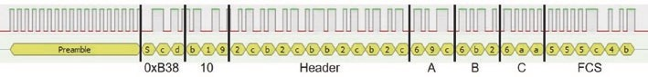
Figure 15-5. Logic analyzer signal analysis with RH_ASK format
Listings 15-1 and 15-2 illustrate using the RH_ASK library to transmit and receive a message of variable length consisting of text, a real number, and an integer, with a maximum message length of 60 characters. In Listing 15-1, an example message is generated with the transmission number, val, determined from the sketch elapsed time divided by the time

radio frequenCy CommuniCation
interval between transmissions, timelag. A different text string for each message is generated by the instruction text[val%3] that calculates the remainder when the variable val is divided by three, given three strings in the text array. The message contains text; a real number, 1.2*val; and an integer, val, separated by commas. For example, the fifth message transmitted is ijkl,6.0,5,. The interval between transmissions is set at 2 s, and an LED is turned on or off after each transmitted or received message. It may be necessary to repeat the instruction rf.send((uint8_t *)msg, strlen(msg)) for a long message.
The instruction msg = message.c_str() uses a C++ command to create an array, msg, equal to the message string with a terminating null character, \0, and returns a pointer, msg, to the array. If a string is defined with the instruction String text = "abc", then the null character, \0, is automatically included at the end of the string. When an array string is defined as String text[4] = {'a', 'b', 'c', '\0'}, the null character is included as the last array element, with array elements defined as characters using a single apostrophe rather than the double apostrophe for a string.
Listing 15-1. Transmit message with the RH_ASK library
#include <RH_ASK.h> // include the RH_ASK library
#include <SPI.h> // SPI library required to compile RH_ASK rf (2000, D2, D1, 0); // associate rf with RH_ASK lib
int LEDpin = D3; // define LED pin
String text[] = {"abcdef", "ijkl", "rst"};
// strings of different lengths
const char * msg; // pointer to array with message String message;
int timelag = 2000; // interval between transmissions int LED = 0; // initial LED state int val, len, spd;
radio frequenCy CommuniCation
void setup()
{
Serial.begin(115200); // Serial Monitor baud rate rf.init(); // initialise radio transmission pinMode(LEDpin, OUTPUT); // define LED pin as output len = rf.maxMessageLength(); // get maximum message length spd = rf.speed(); // get transmission speed
Serial.print("max message length: "); // display message length
Serial.println(len);
Serial.print("transmission speed: "); // and transmission speed
Serial.println(spd);
}
void loop()
{
val = millis()/timelag; // transmission number message = text[val%3] + "," + String(1.2*val) + "," +
String(val) + ",";
Serial.println(message); // display transmitted string msg = message.c_str(); // convert string rf.send((uint8_t *)msg, strlen(msg)); // transmit signal rf.waitPacketSent(); // wait for transmission to finish LED = 1 - LED;
digitalWrite(LEDpin, LED); // turn on or off LED delay(timelag); }
In Listing 15-2, the number of comma-separated items within the message is defined in the sketch. The instruction const int nItem = 3 enables the size of two arrays, text[nItem] and comma[nItem+1], to be implicitly defined. When a new message is received, a blank string is incremented with each character of the message, and the comma positions are determined with the instruction message.indexOf("x", y), which locates the position of the substring x within the message string starting from position y. The message substrings are generated with the instruction message.substring(x, y), which is the substring of the message string between positions x (inclusive) and y (exclusive). The instructions string.toFloat() and string.toInt() convert a string to a real number and an integer, respectively. Further details on parsing text to substrings are given in Chapter 8 (Updating a web page). The variables valFlt and valInt in Listing 15-2 are generated to demonstrate the use of converted text in calculations.
Listing 15-2. Receive message with the RH_ASK library
#include <RH_ASK.h> // include the RH_ASK library
#include <SPI.h> // SPI library required to compile RH_ASK rf (2000, D2, D1, 0); // associate rf with RH_ASK lib int LEDpin = D3; // define LED pin
uint8_t msg[RH_ASK_MAX_MESSAGE_LEN] ; // maximum message length const int nItem = 3; // number of items in message String text[nItem]; // define text array int comma[nItem+1]; // comma positions in message
int LED = 0; // initial LED state String message; float valFlt; int valInt;
void setup()
{
Serial.begin(115200); // Serial Monitor baud rate rf.init(); // initialise radio transmission pinMode(LEDpin, OUTPUT); // define LED pin as output }
radio frequenCy CommuniCation
void loop()
{ // message length based on new message uint8_t msglen = sizeof(ms g); if (rf.recv(msg, &msglen) ) // message of correct length available
{
message = ""; // increment message with each character for (int i=0; i<msglen; i++) message = message + char(msg[i]);
comma[0] = -1; for (int i=0; i<nItem; i++) // comma positions in message { // get substrings between commas comma[i+1] = message.indexOf(",", comma[i]+1); text[i] = message.substring(comma[i]+1, comma[i+1]); Serial.print(text[i]); // print message substring
Serial.print(" ");
}
valFlt = text[1].toFloat(); // second substring to float valInt = text[2].toInt(); // third substring to integer
Serial.print(text[0]);Serial.print("\t");
Serial.print(valFlt + 0.05);Serial.print("\t");
Serial.println(valInt * 2);
LED = 1 - LED; digitalWrite(LEDpin, LED); // turn on or off LED
}
}
Decode remote control signals
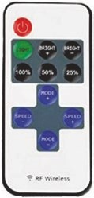
The rc-switch library is used to decode wireless signals from wireless digital remote controls. The rc-switch library by Suat Özgür is available within the Arduino IDE. The transmitted signal is in Tri-state format, which represents (00), (11), and (01) bit pairs with a bit of value 0, 1, or F. For example, the decimal number 19 has binary representation of 010011; and with the most significant bit (MSB) first, the bit pairs are (01), (00), and (11) resulting in Tri-state format of F01. Codes for wireless digital remote control buttons are obtained with
the sketch in Listing 15-3.
For example, the RF codes for the Power and 25% PWM buttons of an RF wireless remote control were 3163905 and 3163913, respectively, in decimal format. Binary representation of the 3163905 code of (00)(11)(00) (00)(01)(00)(01)(11)(00)(00)(00)(01) has Tri-state format of 0100F0F1000F, and similarly the 3163913 code has Tri-state format of 0100F0F100UF, with Tri-state format U for the (10) bit pair. Analysis of the signals for 3163905 and 3163913, as captured by a logic analyzer with the sigrok PulseView program and the RC encode decoder setting, is illustrated in Figure 15-6.
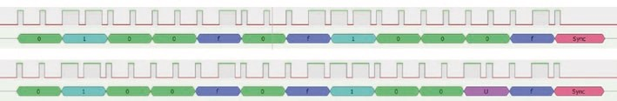
Figure 15-6. Logic analyzer signal analysis with Tri-state coding
Listings 15-3 and 15-4 illustrate decoding and transmitting a RF signal with the rc-switch library. In Listing 15-3, after receiving an RF signal, the Serial Monitor displays the signal, in decimal format, with the signal bit length and protocol number. An LED is also turned on or off to indicate that a signal was received. The variable value to hold the received button
radio frequenCy CommuniCation
code is defined as an unsigned long with an upper limit of 2³² – 1 to accommodate RF wireless remote control codes. An unsigned int variable has an upper limit of 2¹⁶ – 1 or 65535. For the rc-switch library, the receive data pin is defined as an interrupt pin and enabled with the instructions digitalPinToInterrupt() and rc.enableReceive() with a pin value of D2 or 27 for an ESP8266 or ESP32 microcontroller, respectively.
Listing 15-3. Receive and decode an RF code with the rc-switch library
#include <RCSwitch.h> // include the rc-switch library RCSwitch rc = RCSwitch(); // associate rc with rc-switch lib int LEDpin = D3; // define LED pin and state int LED = 0; unsigned long value;
void setup()
{
Serial.begin(115200); // Serial Monitor baud rate digitalPinToInterrupt(D2); // set pin as interrupt rc.enableReceive(D2); // receive data on interrupt pin pinMode(LEDpin, OUTPUT); // define LED pin as output
}
void loop()
{ if (rc.available()) // if a signal is received
{
value = rc.getReceivedValue(); // signal in decimal format if (value != 0) // non-zero signal value
{
Serial.print("Decimal ");Serial.print(value);
Serial.print(" (");
Serial.print(rc.getReceivedBi tlength()); // signal bit length Serial.print("bit)\tProtocol "); // print a tab between text Serial.println(rc.getReceived Protocol());
// signal protocol class
LED = 1 - LED;
digitalWrite(LEDpin, LED); // turn on or off the LED
}
else Serial.println("Unknown encoding");
rc.resetAvailable(); // ready to receive signal
}
}
With the rc-switch library, RF codes in either decimal, binary, or Tri-state format are transmitted with the instruction send(number, bitlength), send(pointer), or sendTriState(pointer), respectively, where pointer is the pointer to the array containing the string including the number in binary or Tri-state format. The converted RF code is formatted as a string with a terminating null character, \0 , by the instruction pointer = code.c_str(). Irrespective of the RF code format, the rc-switch library converts the RF code to binary format for transmission. The signal is repeatedly transmitted, with a default of ten repeats corresponding to three received signals. The minimum number of repeat transmissions to receive a signal is four, using the instruction setRepeatTransmit(4). Transmissions repeated four to ten times result in the signal being received 1, 1, 2, 2, 3, 3, and 3 times.
Listing 15-4 transmits the RC codes 3163905–3163913, corresponding to several buttons of an RF wireless remote control, with the codes transmitted in decimal, binary, and Tri-state format. An LED is turned on or off to indicate when a signal is transmitted.
In Listing 15-4, the functions binary and tristate convert a decimal number to binary format and a binary number to Tri-state format, respectively. A decimal number is converted to binary format by repeatedly dividing the integer part of the number by two and retaining the remainders, with the first remainder being the least significant bit (LSB) of
radio frequenCy CommuniCation
the binary representation. For example, to convert the decimal number 19 to binary format, repeated division by two results in the remainders
1,1,0,0,1, and 0 equal to (19 – 2 × 9, 9 – 2 × 4, 4 – 2 × 2, 2 – 2 × 1, 1 – 2 ×
0). The first remainder is the LSB, so the binary representation of 19 is 010011, with the LSB last. The rc- switch library uses 24-bit format to represent a number in binary format, so converting a decimal number to binary format requires 24 divisions by two.
Conversion of a binary-formatted number into Tri-state format starts with the MSB pair and finishes with the LSB pair. For the decimal number 19, the bit pairs are (01), (00), and (11) that map to Tri-state format of F01. In Listing 15-4, the character at position x of a string bin is identified by the instruction bin.charAt(x). In Listing 15-4, the Tri-state format for the numbers 3163905, 3163907, 3163908, 3163909, and 3163911 is valid, but the transmitted values are not correct for the numbers 3163906, 3163910, 316312, and 3163913, so the term U is included in the Tri-state format for the (10) bit pair.
Listing 15-4. Transmit an RF code with the rc-switch library
#include <RCSwitch.h> // include the rc- switch library RCSwitch rc = RCSwitch(); // associate rc with rc-switch lib unsigned long value = 3163905; // code to be transmitted const char * biCode; // pointers to arrays with number const char * triCode; // in binary or Tri-state format int LEDpin = D3; // define LED pin int LED = 0; // initial LED state
int delTime = 1000; // delay between transmissions String bin, tri;
void setup()
{
Serial.begin(115200); // Serial Monitor baud rate pinMode(LEDpin, OUTPUT); // define LED pin as output rc.enableTransmit(D1); // transmit data pin

radio frequenCy CommuniCation
rc.setPulseLength(351); // optional with time in ms rc.setProtocol(1); // default is 1
rc.setRepeatTransmit(4); // define number of transmissions
}
void loop()
{ rc.send(value, 24); // send number in decimal format Serial.print(value);Serial.prin t("\t"); // display value digitalWrite(LEDpin, LED); // turn on or off LED LED = 1 - LED;
delay(delTime); // interval between transmissions binary(value); // convert to binary format rc.send(biCode); // send array in binary format
Serial.print(biCode);Serial.pri nt("\t");
// display value in binary format
delay(delTime);
tristate(bin); // convert to Tri-state format rc.sendTriState(triCode); // send array in Tri-state format Serial.println(triCode); // display in Tri-state format delay(delTime); value++;
if(value > 3163913) for (;;) de lay(1000);
} // stop after sending all codes
void binary(long number) // function to convert to binary format
{ bin = ""; for (int i=0; i<24; i++) // 24 bits starting with LSB
{ // next bit precedes lower significant bits
if(number%2 == 1) bin = "1" + bin;
// number is an unsigned long integer
else bin = "0" + bin;
radio frequenCy CommuniCation
number = number/2;
} biCode = bin.c_str(); // create pointer to array
}
void tristate(String val) // function to convert to Tri-state format
{ tri = ""; for (int i=0; i<12; i++) // start with MSB which is charAt(0) { // next bit follows higher significant bits if(val.charAt(2*i)=='0' && val.charAt(2*i+1)=='0') tri = tri + "0"; else if(val.charAt(2*i)=='1' && val.charAt(2*i+1)=='1') tri = tri + "1";
else if(val.charAt(2*i)=='0' && val.charAt(2*i+1)=='1') tri = tri + "F";
else if(val.charAt(2*i)=='1' && val.charAt(2*i+1)=='0') tri = tri + "U";
} triCode = tri.c_str(); // create pointer to array }
Control pan-tilt servos with RF communication
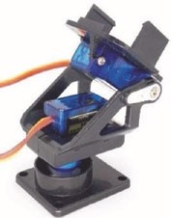
A remotely positioned laser mounted on a pan and tilt bracket, which is rotated by two servo motors, is controlled by transmitting a message containing the joystick position and the laser state. A joystick, such as the KY-023 module, consists of two potentiometers for controlling the left-right direction (X-axis) and the
radio frequenCy CommuniCation
forward-backward direction (Y-axis). The joystick values range from 0 to 1023, with 0 corresponding to right and forward, while 1023 maps to left and backward. Pressing down on the joystick activates a switch to turn on or off the laser. The RF transmitter and joystick are connected to an Arduino Nano or an ESP32 development board (see Figure 15-7 and Table 15-3); and the RF receiver, two servo motors with external power, and the laser module are attached to an ESP8266 development board (see Figure 15-8 and Table 15-4). The KY-008 laser operates at 650 nm, within the red light wavelength range of 635–700 nm.
Two analog pins are required to read the joystick values. The ESP8266 microcontroller has only one analog pin, so either a 74HC4051 multiplexer is connected to the ESP8266 development board to enable the ESP8266 microcontroller to access both analog input devices (see Chapter 4 (Internet clock)) or the ESP8266 development board is replaced by an Arduino Nano or an ESP32 development board.
The default transmit and receive pins for an Arduino Nano with the RH_ASK library are pins 12 and 11, respectively. The ESP32 microcontroller GPIO 27 is defined as the transmit pin with the instruction RH_ASK rf (2000, 26, 27, 0). The value of GPIO 26 for the receive pin is arbitrary, as, in the sketch, the ESP32 microcontroller does not receive messages. The ESP32 microcontroller ADC (analog to digital converter) has 12-bit resolution, with values from 0 to 4095, while the Arduino Nano ADC has 10-bit resolution. Either the ESP32 microcontroller ADC values are divided by four before transmission in Listing 15-5 or the mapping of received joystick value to servo angle is changed to FB = map(text[0]. toInt(),0,4095,5,100) in Listing 15-6 and similarly for the LR mapping.
radio frequenCy CommuniCation
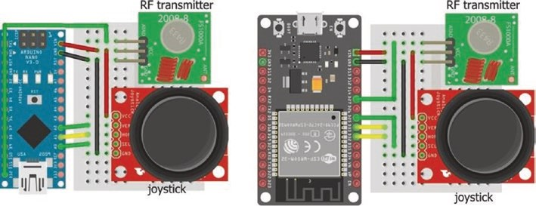
Figure 15-7. Transmit joystick signals
Table 15-3. Joystick, RF transmitter, and Arduino Nano or ESP32 development board
Component | Arduino Nano | ESP32
Joystick VCC (+) | 5V | Vin
Joystick SeL (B) | a0 | Gpio 25
Joystick hor (X) | a1 | Gpio 32
Joystick Ver (y) | a2 | Gpio 33
Joystick Gnd (-) | Gnd | Gnd
rf transmitter VCC (+) | 5V | Vin
rf transmitter Gnd (-) | Gnd | Gnd
rf transmitter dat | pin 12 | Gpio 27
The sketch in Listing 15-5 reads the joystick position and switch state and then combines the information into a string for transmission. The joystick switch state is HIGH when pressed. The RH_ASK library is used to transmit and receive the RF signals. Joystick and RF transmitter pin definitions in Listing 15-5 are for the Arduino Nano, and for an ESP32 microcontroller, the pin definitions are
radio frequenCy CommuniCation
RH_ASK rf (2000, 26, 27, 0) // associate rf with RH_ASK lib int switchPin = 25 // joystick switch pin int LRpin = 32 // left-right joystick pin int FBpin = 33 // forward- backward joystick pin pinMode(switchPin, INPUT) // define switchPin as input
Listing 15-5. Transmit joystick signal to control the servo motors and laser
#include <RH_ASK.h> // include the RH_ASK library
#include <SPI.h> // SPI library required to compile RH_ASK rf; // associate rf with RH_ASK lib int timelag = 50; // interval between transmissions int switchPin = A0; // joystick switch pin int LRpin = A1; // left-right joystick pin int FBpin = A2; // forward- backward joystick pin int FB, LR, SW; const char * msg; String message;
void setup()
{ rf.init(); // initialise radio transmission
}
void loop()
{ // string for joystick forward-backward, left-right and switch state
FB = analogRead(FBpin);
LR = analogRead(LRpin); // get joystick position SW = digitalRead(switchPin); // and switch state
message = String(FB) +","+ String(LR) + "," + String(SW) + ",";
radio frequenCy CommuniCation
msg = message.c_str(); // convert string rf.send((uint8_t *)msg, strlen(msg)); // transmit message rf.waitPacketSent(); // wait for transmission to finish delay(timelag); // delay between transmissions
}
The laser and the two servos for the pan and tilt bracket are connected to an ESP8266 development board with the RF receiver (see Figure 15-8), with connections given in Table 15-4. The servo motors are powered from an external 5 V battery, as the motor can use hundreds of milliamps during a few milliseconds that the rotor is turning, which is more than the output of the ESP8266 development board 5V pin.
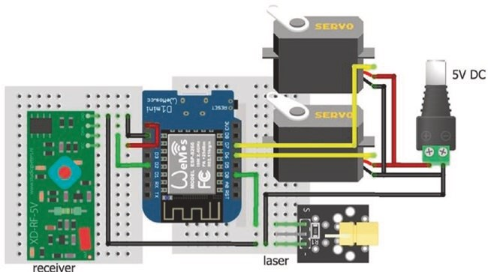
Figure 15-8. Control the servo motors and laser with the received signal
radio frequenCy CommuniCation
Table 15-4. Servo motors, laser, RF receiver, and ESP8266 development board
Component | Connect to | And to
Servo VCC (red) | Battery 5V
Servo Gnd (brown or black) | eSp8266 Gnd | Battery Gnd
Servo signals (orange or white) | eSp8266 d6 and d7
Laser signal (S) | eSp8266 d0
Laser Gnd (-) | eSp8266 Gnd
rf receiver VCC (+) | eSp8266 5V
rf receiver Gnd (-) | eSp8266 Gnd
rf receiver dat | eSp8266 d2
Listing 15-6 contains the sketch for the RF receiver, servo motors, and laser module. As noted at the start of this chapter, the RH_ASK driver uses Timer1, the default timer, which is also used by the Servo library. The RH_ASK driver uses Timer2 by uncommenting the line #define RH_ASK_ARDUINO_USE_TIMER2 on line 32 of the file RH_ASK.cpp. The sketch associates both servoFB and servoLR objects with the Servo library, as there are two servo motors. The instruction const int nItem = 3 enables the size of two arrays, text[nItem] and comma[nItem+1], to be implicitly defined. When the RF receiver receives a message, the message substrings are converted to integers, which are mapped to the servo forward- backward and left-right angles between 5° and 100° and between 5° and 175°, respectively. A HIGH state on the laser pin indicates that the joystick switch was pressed.
The servo motors can shudder when there is no change in the servo motor angle. To stop the shudder, the servo motor is detached and then reattached prior to moving to the new angle. For example, the left-right
radio frequenCy CommuniCation
servo instruction, servoLR.write(LR), to move to angle LR, is replaced with the instructions
servoLR.attach(LRpin) servoLR.write(LR) servoLR.detach()
Listing 15-6. Receive signal with joystick positions to control the servo motors and laser
#include <RH_ASK.h> // include the RH_ASK library
#include <SPI.h> // SPI library required to compile
#include <Servo.h> // include Servo library
RH_ASK rf (2000, D2, D1, 0); // associate rf with RH_ASK lib
Servo servoFB; // associate servoFB and servoLR Servo servoLR; // with Servo library int FBpin = D6; // forward- backward servo pin int LRpin = D7; // left-right servo pin int laserPin = D0; // define laser pin
uint8_t msg[RH_ASK_MAX_MESSAGE_LEN]; const int nItem = 3; // number of items in message String text[nItem]; // array of strings int comma[nItem+1]; // array of comma positions String string; int laser, FB, LR;
void setup()
{
rf.init(); // initialise radio transmission servoFB.attach(FBpin); // initialise servo motors servoLR.attach(LRpin); pinMode(laserPin, OUTPUT); // define laser pin as output }
radio frequenCy CommuniCation
void loop()
{ // define message length based on new message uint8_t msglen = siz eof(msg); if (rf.recv(msg, &msglen)) // message of correct length available
{
string = ""; // increment string by each message character for (int i=0; i<msglen; i++) string = string + char(msg[i]); comma[0] = -1; for (int i=0; i<nItem; i++) // get message comma positions { // get substrings between commas comma[i+1] = string.indexOf(",", comma[i]+1); text[i] = string.substring(comma[i]+1, comma[i+1]);
} // map joystick signals to angles
FB = map(text[0].toInt(),0,10 23,5,100); LR = map(text[1].toInt(),0,1023,5,175); laser = text[2].toInt(); // update laser status if(laser == HIGH) digitalWrite(laserPin,
!digitalRead(laserPin)); servoFB.write(FB); // move servos to angles servoLR.write(LR);
}
}
If the servo motors are attached to an ESP32 development board, then an ESP32-specific library for the servo motor is required, rather than the Arduino IDE built-in Servo library. The ESP32Servo library by Kevin Harrington and John K. Bennett is recommended, and the library is available in the Arduino IDE. The built-in Servo library instructions for the forward-backward (FB) servo motor with an ESP8266 microcontroller
#include <Servo.h> // include Servo library servoFB.attach(FBpin) // initialise servo motor to FBpin
radio frequenCy CommuniCation
are replaced with the ESP32Servo library instructions for an ESP32 microcontroller
#include <ESP32Servo.h>
servoFB.setPeriodHertz(F) // define servo frequency (F) servoFB.attach(FBpin, minPW, maxPW) // initialise servo motor to FBpin
There is no change to the following instructions:
Servo servoFB // associate servoFB with Servo lib servoFB.writeMicroseconds(T) // move to position mapped to Tμs servoFB.write(N) // move to angle N°
Similar changes are made for the left-right (LR) servo motor.
The square wave frequency, F, is included in the instruction servoFB.
setPeriodHertz(F), which is generally 50 Hz. In the servoFB.attach(FBpin, minPW, maxPW) instruction, the minPW and maxPW parameters refer to the pulse width, in microseconds, of a square wave to move the servo motor to 0° and 180°, respectively. Default values for the minPW and maxPW parameters are 1000 μs and 2000 μs, with values of 500 μs and 2500 μs for the Tower Pro SG90 servo. The servo motor used in this chapter required 250 μs and 2050 μs to move to 0° and 180°, respectively. A sketch to calibrate a servo motor is given in Chapter 9 (WebSocket). The preceding instructions for the forwardbackward servo, servoFB, are repeated for the left-right servo, servoLR.
Control relay with RF communication
Pressing a specific button on an RF wireless remote control is used to turn on or off an IRF520 MOSFET or KY-019 relay module, which switches the power supply to as load, such as a motor. The IRF520 MOSFET switches 100 V direct current (DC) at 10 A, while the KY-019 relay module switches either 240 V alternating current (AC) or 30 V DC at 10 A. The rc-switch library is used to transmit and receive the remote control button codes. Connections
radio frequenCy CommuniCation
for the RF receiver, IRF520 MOSFET or KY-019 relay module, and a load, such as a motor, are shown in Figure 15-9 and listed in Tables 15-5 and 15-6.
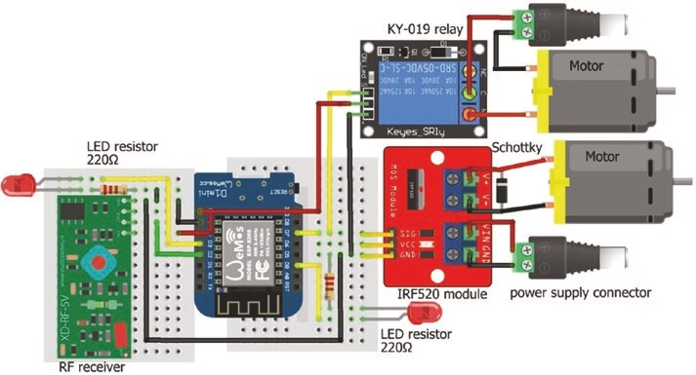
Figure 15-9. Receiver signal to control load with the IRF520
MOSFET or KY-019 relay module
Table 15-5. IRF520 MOSFET and KY-019 relay modules, RF receiver, and ESP8266 development board
Component | Connect to | And to
irf520 SiG or Ky-019 SiG | eSp8266 d7
irf520 VCC | not connected
Ky-019 VCC | eSp8266 5V
irf520 Gnd or Ky-019 Gnd | eSp8266 Gnd
Led long legs | eSp8266 d3 and d0
Led short leg | 220 Ω resistor | eSp8266 Gnd
rf receiver VCC (+) | eSp8266 5V
rf receiver Gnd (-) | eSp8266 Gnd
rf receiver dat | eSp8266 d2
radio frequenCy CommuniCation
The IRF520 MOSFET and KY-019 relay modules are two options for controlling an external power supply for the load. The IRF520 MOSFET module has two pairs of connections: one pair for the load and one pair for the external power supply. For the KY-019 relay module, the positive and negative of the external power supply are connected to the KY-019 module Common (C) and to the load negative, respectively. The KY-019 relay module Normally Open (NO) pin is connected to the load positive. The KY-019 Normally Open (NO) is recommended rather than the Normally Closed (NC) pin.
Table 15-6. IRF520 MOSFET and KY-019 relay module connections to load and power
Component | Connect to | And to
irf520 V+ | Load (motor) positive | Schottky diode cathode  (stripe)
irf520 V- | Load (motor) negative | Schottky diode anode
irf520 Vin | external power supply
irf520 Gnd | external power Gnd
Ky-019 normally open (no) |  | Load (motor) positive
Ky-019 Common (C) | external power supply external power Gnd | Load (motor) negative
In Listing 15-7, when the LIGHT button on the RF wireless remote is pressed, the LED attached to the ESP8266 development board pin D3 is turned on or off. RF codes of buttons in Listing 15-7 are only specific to the RF wireless remote used in this chapter. When the BRIGHT+ or BRIGHT- button on the RF wireless remote is pressed, the IRF520 MOSFET or KY- 019 relay module supplying power to the load is turned on or off, as is
radio frequenCy CommuniCation
the LED attached to ESP8266 development board pin D0. The KY-019 relay module is active when the state of the relayPin, D7, is HIGH.
Listing 15-7. Receive signal to control load
#include <RCSwitch.h> // include the rc-switch library RCSwitch rc = RCSwitch(); // associate rc with rc-switch lib int LEDpin = D3; // LED to change state int LEDrelayPin = D0; // LED associated with relay int relayPin = D7; // define MOSFET/relay pin unsigned long value;
void setup()
{
Serial.begin(9600); // Serial output baud rate digitalPinToInterrupt(D2); // set pin as interrupt rc.enableReceive(D2); // receive data on interrupt pin // digitalWrite(relayPin, HIGH); // set relayPin HIGH before pinMode(relayPin, OUTPUT); // defining relayPin pinMode(LEDpin, OUTPUT); pinMode(LEDrelayPin, OUTPUT); }
void loop()
{ if (rc.available()) // if a signal is received
{
value = rc.getReceivedValue(); if (value != 0) // signal value not equal to zero
{ // display signal value Serial.print("code ");Serial.print(value); if(value == 3163908) // Light button pressed
radio frequenCy CommuniCation
{
Serial.print("\tchange LED"); // display action digitalWrite(LEDpin, !digita lRead(LEDpin)); } // turn on or off LED else if(value == 3163909) // Bright+ button pressed
{
Serial.print("\trelay on");
digitalWrite(LEDrelayPin, HI GH); // turn on relay LED digitalWrite(relayPin, HIGH); // turn on relay
} else if (value == 3163910) // Bright- button pressed
{
Serial.print("\trelay off");
digitalWrite(LEDrelayPin, LOW); // turn off relay LED digitalWrite(relayPin, LOW); // turn off relay
}
else Serial.print("\tno action");
Serial.print("\tLED ");
Serial.print(digitalRead(LEDpin ));
// display LED and relay states
Serial.print("\trelay ");
Serial.println(digitalRead(relayPin));
}
else Serial.println("Unknown encoding");
rc.resetAvailable(); // ready to receive new signal
}
}

Relays
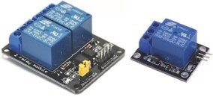
A relay is an electromagnetic switch, controlled by a small current, that is used to turn on or off a large current. When an ESP8266 or ESP32 microcontroller pin that controls the relay is HIGH, a small current
on the base of the relay switching transistor permits a larger current from the ESP8266 or ESP32 development board 5V pin to flow through the transistor, activating the relay electromagnet, and the resultant magnetic field attracts and closes the metallic relay switch (see Figure 15-10). When the ESP8266 or ESP32 microcontroller pin is LOW, no current flows through the transistor, and a spring returns the metallic relay switch to the normally open position. A relay module includes a resistor to reduce the current to the switching transistor and a diode to short-circuit the relay coil when the current is turned off. The energy in the coil is absorbed through the internal resistance of the relay coil and the voltage drop of the diode. Without the diode, a large voltage spike could arc across the switch and destroy the transistor. Figures 15-10 to 15-16 illustrate an ESP8266 microcontroller controlling a relay, but the discussion also applies to an ESP32 microcontroller.
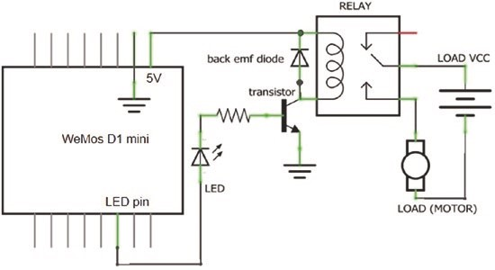
Figure 15-10. Relay module: schematic
To control a relay, such as the KY-019 module in Figure 15-11, a HIGH signal on the ESP8266 development board pin D4 turns on the relay transistor, activating the relay switch to provide the load, such as a motor, with external power. The ESP8266 development board GND is connected to the KY-019 module, as the module indicator LED, relay transistor, and relay electromagnet source power from the ESP8266 development board.
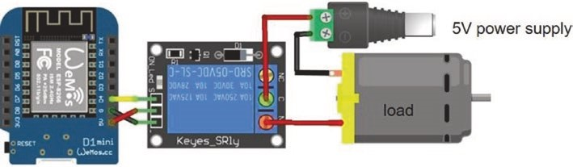
Figure 15-11. Relay module and LOLIN (WeMos) D1 mini
A relay module with an optocoupler extends separation of the ESP8266 microcontroller from the load with its external power supply (see Figures 15-12 and 15-13). The FOD817C optocoupler consists of a near- infrared LED and a phototransistor, which generates a current in response to detection of light. Both the optocoupler and the relay transistor are powered by the ESP8266 development board. A jumper between the relay module pins marked RY-VCC or JD-VCC and VCC connects the relay transistor to the ESP8266 development board 5V pin. A relay with an optocoupler sinks current to the ESP8266 microcontroller pin, in contrast to the KY-019 relay which sources current, and the relay is active when the ESP8266 microcontroller pin is LOW. The dashed connecting line between the optocoupler VCC and the relay VCC in Figure 15-12 represents the jumper.
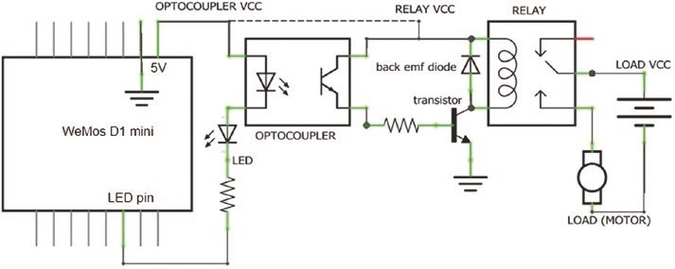
Figure 15-12. Relay module with optocoupler schematic
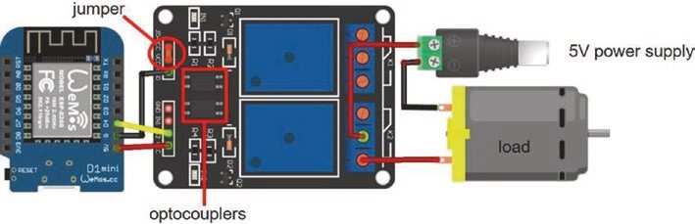
Figure 15-13. Relay module with optocoupler (1)
The ESP8266 microcontroller is completely isolated from the load and its external power supply by providing the relay with a separate power supply (see Figure 15-14 with connections given in Table 15-7). The jumper between the relay module pins marked RY-VCC or JD-VCC and VCC is removed, and power is separately supplied to the relay RY-VCC or JD-VCC and GND pins. The ESP8266 microcontroller GND is not connected to the relay module, as the optocoupler and indicator LED sink current through the ESP8266 microcontroller pin set to LOW.
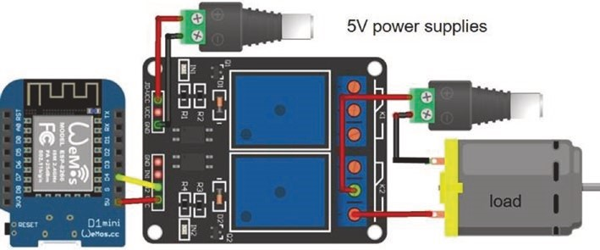
Figure 15-14. Relay module with optocoupler (2)
Table 15-7. Relay module connections without and with an external power to relay
Relay Module | Component | Connect to
Without external power | relay optocoupler Jd-VCC and VCC pins | Jumper
 | relay optocoupler Gnd | eSp8266 Gnd
 | relay optocoupler SiG or L1 | eSp8266 d7
 | relay optocoupler VCC | eSp8266 5V
With external power | relay optocoupler Jd-VCC | external power positive
 | relay optocoupler Gnd | external power negative
 | relay optocoupler SiG or L1 | eSp8266 d7
 | relay optocoupler VCC | eSp8266 5V
In Listing 15-7, the KY-019 relay is activated when the ESP8266 microcontroller pin is HIGH, with the instructions
digitalWrite(relayPin, HIGH); // turn on relay digitalWrite(relayPin, LOW); // turn off relay Serial.print("\trelay ");Serial.println(digitalRead(relayPin));
For a relay with an optocoupler, the ESP8266 microcontroller pin state is inverted, with changes highlighted in bold:
digitalWrite(relayPin, LOW); // turn on relay digitalWrite(relayPin, HIGH); // turn off relay Serial.print("\trelay ");Serial.println(!digitalRead(relayPin)); When the instruction pinMode(relayPin, OUTPUT) is called, the relay pin is automatically set LOW, which will activate the relay if the relay module contains an optocoupler. To prevent a relay with an optocoupler being inadvertently turned on, the instruction digitalWrite(relayPin, HIGH) precedes the pinMode(relayPin, OUTPUT) instruction.
Solid-state relay
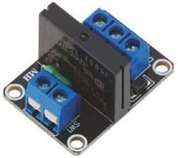
The solid-state relay incorporates semiconductors for high-speed switching, without mechanical moving parts, of 240 V alternating current (AC) at 2 A. The solid-state relay phototriac coupler consists of a near-infrared LED and a photosensitive triac, which transfers a signal to a trigger circuit on the
output side of the relay allowing a current to flow to the load (see Figure 15-15). The solid-state relay incorporates additional circuitry and functions on both the infrared LED input side and the output photosensitive side. Further information is available at www.ia.omron.com/support/guide/18/introduction.html.
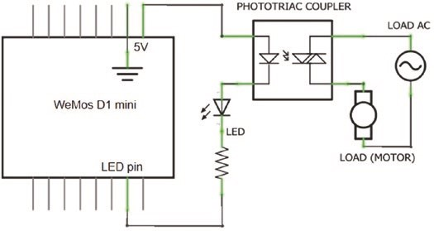
Figure 15-15. Simplified solid-state relay schematic
The solid-state relay is active when the ESP8266 microcontroller pin, connected to the relay phototriac coupler, is LOW, similar to the mechanical relay with an optocoupler. Connections for the ESP8266 development board with the solid-state relay module are shown in Figure 15-16 and given in Table 15-8.
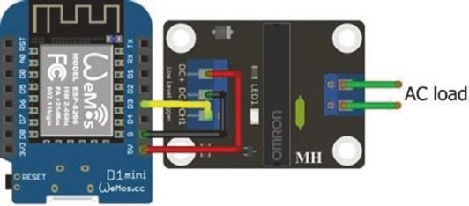
Figure 15-16. Solid-state relay and LOLIN (WeMos) D1 mini

radio frequenCy CommuniCation
Table 15-8. Solid-state relay and
ESP8266 development board
Component | Connect to ESP8266
Solid-state relay dC+ | 5V
Solid-state relay dC- | Gnd
Solid-state relay Ch1 | d3
Summary
Radio Frequency communication with Amplitude Shift Keying (ASK) and On-Off Keying (OOK) was described. A 433 MHz superheterodyne transmitter and receiver pair transmitted and received alphanumeric data by ASK radio communication over distances of 150 m. Signals from a 433 MHz wireless digital remote control were decoded with the superheterodyne receiver. Binary and Tri-state data formatting was discussed. The state and position of a laser attached to a pan-tilt bracket, operated with servo motors attached to an ESP8266 or ESP32 microcontroller, was controlled by a remote joystick, with joystick position and laser state information transmitted with ASK radio communication by a superheterodyne transmitter connected to an ESP32 microcontroller. Remotely powering a load, such as motors, through an electro- mechanical relay, was controlled by transmitting control codes with an RF wireless remote control. Electro-mechanical relays with and without an optocoupler, for supplying DC to a load, were described, as was the solid- state relay.
radio frequenCy CommuniCation
Components List
- ESP8266 microcontroller: LOLIN (WeMos) D1 mini or NodeMCU board
- ESP32 microcontroller: ESP32 DEVKIT DOIT or NodeMCU board
- Multiplexer: 74HC4051 or Arduino Nano
- 433 MHz transmitter: Standard, MX-FS-03V; superheterodyne, WL102-341
- 433 MHz receiver: Standard, MX-05V; superheterodyne, WL101-341
- Laser module: KY-008
- LED: 2×
- Resistors: 2× 220 Ω
- Joystick: KY-023
- Servo motors: 2× SG90
- Servo pan and tilt bracket
- RF wireless remote control
- Relay module without optocoupler: KY-019
- Relay module with optocoupler
- MOSFET module: IRF520
- Solid-state relay
CHAPTER 16
Signal generation
Telecommunication uses digital signals to transfer information. For example, the instruction Serial.print("12AB") transmits the ASCII code for each character (see Figure 16-1) in binary format with the microcontroller UART (Universal Asynchronous Receiver-Transmitter). ASCII (American Standard Code for Information Interchange) is an 8-bit character encoding standard for electronic communication, with the least significant bit (LSB) transmitted first. For example, the letter A has ASCII code of 65, which is B01000001 LSB or (1 × 2⁶ + 1 × 2⁰). The transmitted <S> and <T> bits are the start and stop bits.
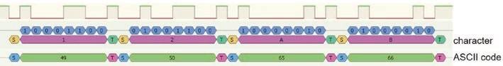
Figure 16-1. Serial data transmission
Note that the transmission order is important. For example, if the ASCII code for the number 2 of 50, which is B00110010 or
(1 × 2⁵ + 1 × 2⁴ + 1 × 2¹), is transmitted with the most significant bit (MSB) first, then the signal could be interpreted as (1 × 2⁶ + 1 × 2³ + 1 × 2²) = 76, which is the ASCII code for the letter L.
Signals, consisting of a square wave at a given frequency, are also used to control industrial motor speed, audio amplification, and the brightness of an alarm clock LED. Pulse width modulation (PWM) modifies the amount of time that the square wave is HIGH, the pulse width, with a
© Neil Cameron 2021 437
N. Cameron, Electronics Projects with the ESP8266 and ESP32, https://doi.org/10.1007/978-1-4842-6336-5_16

long pulse width corresponding to a fast motor speed, even though the power to the motor is being repeatedly turned on and off. Several ESP8266 and ESP32 microcontroller pins support PWM signals, and Figure 16-2 illustrates two square waves differing in frequency and duty cycle. For context, the human ear can hear sounds with frequencies of 20 Hz to 20 kHz, FM radio stations broadcast at 100 MHz, and wireless networks operate at 2.4 GHz.
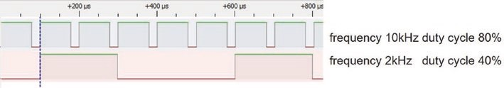
Figure 16-2. PWM signals of different frequencies and duty cycles
The square waves in Figure 16-2 are simultaneously generated with an ESP8266 or an ESP32 microcontroller, using the sketches in Table 16- 1.
The ESP8266 microcontroller default PWM frequency is 1 kHz with 10-bit resolution. The frequency of N Hz is set with the instruction analogWriteFreq(N), and the duty cycle is defined as a proportion of 1023 or 2¹⁰ - 1 with the instruction analogWrite(wavePin, duty).
The ESP32 microcontroller PWM has 8, 10, 12 or 15-bit resolution with maximum frequency of 80 MHz/2^{resolution}. A separate channel is defined for each PWM signal, with PWM instructions for the ESP32 microcontroller of
ledcAttachPin(wavePin, channel) // attach channel to pin ledcSetup(channel, freq, resolution) // define frequency ledcWrite(channel, duty) // generate square wave
with the parameters PWM output channel (channel), GPIO pin to output square wave (wavePin), square wave frequency (freq), duty cycle (duty), and PWM resolution (resolution). The resolution of the ESP32 microcontroller in Table 16-1 was set to 10, to equal the ESP8266 microcontroller resolution. If LEDs, with 220 Ω resistors, are attached to each wavePin, then the square wave with the greater duty cycle will result in a brighter LED.
Table 16-1. PWM with ESP8266 and ESP32 microcontrollers
ESP8266 Microcontroller | ESP32 Microcontroller
int wave1pin = D1, wave2pin = D2; | int wave1pin = 25, wave2pin = 26;
int freq1 = 10000, freq2 = 2000; | int freq1 = 10000, freq2 = 2000;
float duty1, duty2; | float duty1, duty2; int channel1 = 1, channel2 = 2; int resolution = 10;
void setup() | void setup()
{ | {
pinMode(wave1pin, oUtpUt); | pinMode(wave1pin, oUtpUt);
pinMode(wave2pin, oUtpUt); | pinMode(wave2pin, oUtpUt); ledcattachpin(wave1pin, channel1); ledcattachpin(wave2pin, channel2); ledcSetup(channel1, freq1, resolution); ledcSetup(channel2, freq2, resolution);
duty1 = 0.8*1023; | duty1 = 0.8*1023;
duty2 = 0.4*1023; | duty2 = 0.4*1023;
} | }
void loop() | void loop()
{  analogWriteFreq(freq1); | {
(continued)
Table 16-1. (continued)
ESP8266 Microcontroller | ESP32 Microcontroller
analogWrite(wave1pin, duty1); | ledcWrite(channel1, duty1);
analogWriteFreq(freq2); analogWrite(wave2pin, duty2); | ledcWrite(channel2, duty2);
} | }
The PWM output voltage oscillating between HIGH and LOW states has an average voltage of V_{IN} × duty cycle, where V_{IN} is the input voltage and duty cycle is the percentage of time that the square wave is HIGH. For example, a PWM 5 V supply voltage with 20% or 70% duty cycle has an average voltage of 1 V or 3.5 V, respectively, resulting in a faster motor speed when the motor is powered by the square wave with the 70% duty cycle.
A continuous sine wave of a given frequency generates a sound, which is approximated by a square wave (see Figure 16-3). A Piezo transducer, connected to an ESP8266 or ESP32 microcontroller pin producing a square wave with frequency 440 Hz, approximates the musical note A above middle C. Instructions for an ESP8266 microcontroller are
analogWriteFreq(440); // define square wave frequency analogWrite(wavePin, 512); // square wave, 50% duty cycle
and the corresponding instructions, with 10-bit resolution, for an ESP32 microcontroller are
ledcSetup(channel, 440, 10) ledcWrite(channel, 512)
A square wave with frequency 440 Hz and a 50% duty cycle is HIGH or LOW for 1136 μs, equal to (2 × frequency)⁻¹ = 1136 × 10⁻⁶ s. The sound is alternatively generated with the ESP8266 and ESP32 microcontroller instructions
digitalWrite(wavePin, !digitalRead(wavePin)); delayMicroseconds(1136);
Note the exclamation mark is a logical NOT, which results in the value false or LOW if the digitalRead(wavePin) is HIGH.
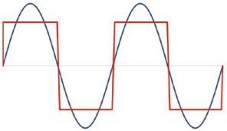
Figure 16-3. Square wave approximating a sine wave
Alternatively, digital information about a sound is used to generate the analog signal and reproduce the sound directly, rather than approximating the sine wave of a sound with a square wave of the same frequency.
Signal generation
One method to produce a sine or triangular wave with frequencies from
1 Hz to multiples of MHz is with an AD9833 waveform generator module (see Figure 16-4 and Table 16-2). The MD_AD9833 library by Marco Colli is available in the Arduino IDE. The AD9833 module has two channels to specify two signal shapes and frequencies, but one output channel. The AD9833 module communicates by hardware SPI (Serial Peripheral Interface) MOSI (Main-Out Secondary-In) or DATA and clock (CLK) pins with the instruction MD_AD9833 AD(FSYNC), where FSYNC is the data signal synchronization pin. The AD9833 module analog (AGND) and digital (DGND) GND pins are pre-connected. For sine and triangle waves, the AD9833 module VCC pin is connected to 3.3 V (as in Figure 16-4).
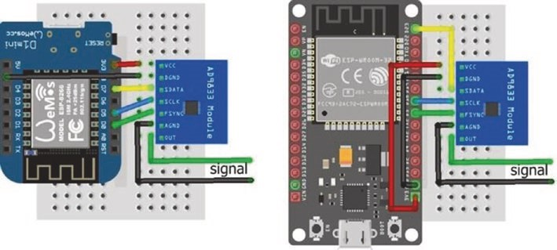
Figure 16-4. AD9833 signal generator for a sine or triangle wave
Table 16-2. AD9833 signal generator module
Component | ESP8266 Connections | ESP32 Connections
aD9833 VCC | 3.3V | 3.3V
aD9833 DgnD | gnD | gnD
aD9833 SData (Spi MoSi) | D7 | gpio 23
aD9833 SClK (Spi ClK) | D5 | gpio 18
aD9833 FSYnC | D0 | gpio 5
aD9833 agnD | Signal gnD | Signal gnD
aD9833 oUt | Signal out | Signal out
The sketch in Listing 16-1 alternately displays, for five seconds, a sine wave and a triangle wave with frequencies of 30 kHz and 20 kHz, respectively (see Figure 16-5). The instruction AD.setActiveFrequency(chan) sets the signal channel. The wave mode is defined as MODE_SINE or MODE_TRIANGLE and set with the instruction AD.setMode(mode). Signal generation starts with the instruction AD.setFrequency(chan, freq). The data synchronization pin in Listing 16-1 is defined for an ESP8266 microcontroller and is changed to 5 for the ESP32 microcontroller (see Table 16-2).
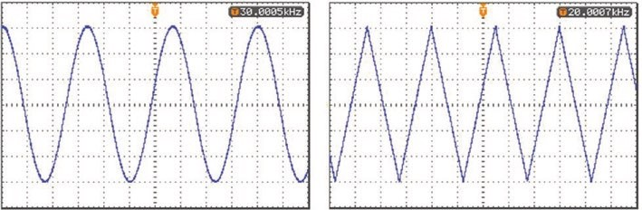
Figure 16-5. AD9833-generated sine and triangle waves
Listing 16-1. AD9833 sine and triangle wave generator
#include <SPI.h> // include SPI library #include <MD_AD9833.h> // include MD-AD9833 library int FSYNC = D0; // define data synchronisation pin
MD_AD9833 AD(FSYNC);
MD_AD9833::channel_t chan; // library channel variable MD_AD9833::mode_t mode; // library signal mode variable unsigned long freq;
void setup()
{
AD.begin(); // initialise library chan = MD_AD9833::CHAN_0; // set channel as 0 or 1
AD.setActiveFrequency(chan); // activate signal generator }
void loop()
{
wave('s', 30000, 5000); // call sine and triangle wave('t', 20000, 5000); // wave display function
}
void wave(char shape, unsigned long freq, int timeint)
{ // sine wave if(shape == 's') mode = MD_AD983 3::MODE_SINE; else if(shape == 't') mode = MD_ AD9833::MODE_TRIANGLE; // triangle wave
AD.setMode(mode); // set the wave form
AD.setFrequency(chan, freq); // set signal frequency for channel delay(timeint); // time to generate signal clear(); // call clear function
}
void clear() // function to clear signal
{ mode = MD_AD9833::MODE_OFF; // set wave mode to off AD.setMode(mode); // turn off wave generation delay(500); // time with no signal }
Digital to analog converter
A digital to analog converter (DAC) converts a digital value into an analog signal. The DAC converts a number from decimal format to binary format with the DAC output voltage equal to the sum of the voltages for each bit, with the voltages reducing by half from the most significant bit (MSB) to the least significant bit (LSB). For example, the number 50 in 8-bit binary format is B00110010, and the DAC voltage is (1 × 2⁵ + 1 × 2⁴ + 1 × 2) × VCC/2⁸ = 50 × VCC/2⁸ equal to 0.195 × VCC. An 8-bit DAC with a pin voltage of VCC converts the digital value N to an analog voltage of N × VCC/2⁸. The ESP32 microcontroller includes two DACs, each with 8-bit resolution, which are described later in the chapter. The ESP8266 microcontroller does not include a DAC, and in this section, a DAC is built with an ESP8266 microcontroller.
A voltage divider is the mechanism to reduce the voltage by half for each bit of the DAC. A voltage divider with an input voltage, V_{IN}, and two resistors, R1 and R2, has an output voltage, V_{OUT}, at the junction of the two resistors of V_{IN} × çè^{æ}R R1^{R}₊² 2÷_{ø}^{ö} (see Figure 16-6). If the two resistors have equal values, then the output voltage is half the input voltage. For illustrative purposes, a DAC is built with a voltage divider ladder to generate voltages, corresponding to the bit positions between the MSB and the LSB of the binary-formatted digital value.
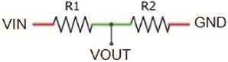
Figure 16-6. Voltage divider
A voltage divider ladder is built as an R-2R resistor ladder 8-bit DAC consisting of eight pairs of R and 2R resistors, with R equal to 1 kΩ (see Figure 16-7 and Table 16-3 for connections). The 2 kΩ resistor on the right side represents the MSB of the R-2R ladder 8-bit DAC. The voltage divider formed by the left pair of 2 kΩ resistors, representing the LSB, reduces the voltage at the junction to 0.5 V_{IN}. The left pair of 2 kΩ resistors are in parallel when there is no voltage on either resistor. The net resistance of kΩ and are in series with resistor A, with value 1 kΩ, so the pair of 2 kΩ resistors and the 1 kΩ resistor have a combined resistance of 2 kΩ. The combination of the left pair of 2 kΩ resistors and resistor A with resistor B forms a second voltage divider, which again reduces the voltage at the junction by half. The third voltage divider is formed by grouping the left pair of 2 kΩ resistors and resistors A, B, and C with resistor D. At each stage, the voltage at the junction of the voltage divider is halved, so a HIGH bit value for the LSB corresponds to a voltage of V_{IN}/2⁸, as there are effectively eight voltage dividers.
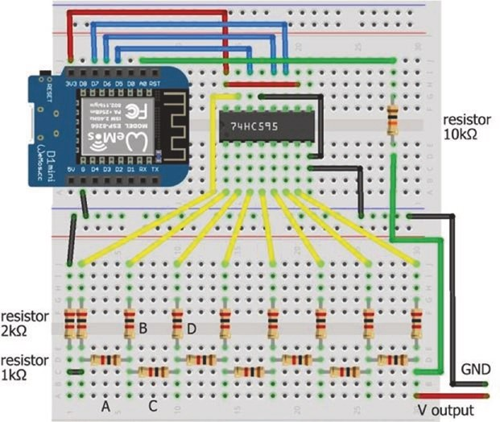
Figure 16-7. R-2R digital to analog converter with LOLIN (WeMos) D1 mini
The output voltage from the R-2R ladder 8-bit DAC corresponding to a digital value is generated by effectively using the binary format of the digital value, to set the eight voltage divider states to HIGH or LOW. For example, the 8-bit binary format of 156 is B10011100; and states of voltage dividers 1, 4, 5, and 6 (numbered from right to left) are set to HIGH with the DAC voltage equal to (1/2¹ + 1/2⁴ + 1/2⁵ + 1/2⁶) × VCC or (1 × 2⁷ + 1 × 2⁴ + 1 × 2³ + 1 × 2²) × VCC/2⁸ = 156 × VCC/2⁸ = 0.6094 × VCC.
There are eight digital pins on the ESP8266 development board, but pins D3, D4, and D8, have built-in pull-up or pull-down resistors to maintain pin states during the ESP8266 microcontroller boot process. Instead of setting the R-2R ladder 8-bit DAC pin states with the ESP8266 microcontroller, pin states are set with a serial-in parallel-out shift register. A 74HC595 shift register loads a byte of data, consisting of 8 bits of data, one bit at a time. While the shift register clock (SRCLK) state is set LOW, data bits are loaded to the shift register through the serial input data (SER) pin, controlled by the storage register clock (RCLK). After all 8 bits are loaded, the shift register clock state is set HIGH. Instructions to pass data through a shift register are
digitalWrite(latchPin, LOW); // set the latch to LOW shiftOut(dataPin, clockPin, MSBFIRST, number)
// load number as a byte
digitalWrite(latchPin, HIGH) // set latch to HIGH
MSBFIRST indicates that the most significant bit (MSB) is loaded first, which is the state of the voltage divider on the right side of Figure 16-7.
The 74HC595 shift register pins are numbered 1–16, with the cut-out or dot at the end of the shift register indicating the end with pins 1 and 16. Connections to the 74HC595 shift register are shown in Table 16- 3,

with the over-line on SRCLR (clear the register) and OE (output enabled) indicating that the pin is active LOW. The 3.3V pin of the ESP8266 development board powers the shift register, which has an operating voltage of 2–6 V.
Table 16-3. R-2R digital to analog converter with the ESP8266 development board
Component | Connect to | And to
left-hand 2 kΩ resistor (lSB) | Second 2 kΩ resistor | eSp8266 gnD
7 × 2 kΩ resistors | 74hC595 pins 15, 1–6 Qa-Qg | 1 kΩ resistors
right 2 kΩ resistor (MSB) | 74hC595 pin 7 Qh
right 2 kΩ resistor (MSB) | eSp8266 a0 | Voltage output
74hC595 pin 8 gnD | eSp8266 gnD
74hC595 pin 9 Qh' | not connected
74hC595 pin 10 SRCLR | eSp8266 3V3
74hC595 pin 11 SrClK | eSp8266 D7
74hC595 pin 12 rClK | eSp8266 D6
74hC595 pin 13 OE | eSp8266 gnD
74hC595 pin 14 Ser | eSp8266 D5
74hC595 pin 16 VCC | eSp8266 3V3

The ESP8266 microcontroller 10-bit analog to digital converter (ADC) functionality converts a voltage, between 0 and 3.2 V, on analog input pin A0, to a digital value between 0 and 1023. The instruction analogRead(A0) reads the voltage on the analog input pin. The reference voltage of the ESP8266 microcontroller ADC is 1 volt; and an internal voltage divider, consisting of 220 kΩ and 100 kΩ resistors (see Figure 16-8), increases the maximum voltage on the analog input pin to 3.2 V. Given a voltage, V_{IN}, on the ESP8266 development board analog input pin, the corresponding ADC value is V_{IN} ´(₂₂₀ ₁₀₀¹⁰⁰+ kW)kW´1024 .
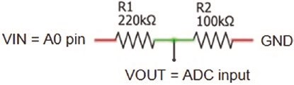
Figure 16-8. Analog to digital converter
ADC values for input voltages between 3.2 V and 3.3 V are constrained to 1023. A 10 kΩ resistor connected between the input voltage and the ESP8266 development board analog input pin increases the limit of 3.2 V on the analog input pin to 3.3 V. An input voltage, V_{IN}, produces an ADC reading of V_{IN} ´(₁₀ ₂₂₀ ₁₀₀+ ¹⁰⁰+^{kW} )kW´1024 . The predicted output voltage by the R-2R ladder 8-bit DAC corresponding to the digital value N is N × 3.3 V/2⁸, as the ESP8266 microcontroller has an operating voltage of 3.3 V.
Listing 16-2 illustrates using an R-2R resistor ladder 8-bit DAC to convert digital values from 0 to 255 to voltages. The 74HC595 shift register sets the eight voltage divider states, based on the binary format of the digital value, and the output voltage of the R-2R ladder 8-bit DAC is read on ESP8266 development board analog pin A0.
The built-in voltage divider of the ESP8266 microcontroller and the in- series 10 kΩ resistor reduce the input voltage to the ESP8266 development board analog input pin, which has a maximum voltage input of 1 volt. The output voltage from the R-2R ladder 8-bit DAC is the ADC reading of the
(10 220 100+ + )kW´ ¹ .
ESP8266 microcontroller scaled by
100kW 1024
Listing 16-2. R-2R digital to analog converter
int dataPin = D5; // shift register data int latchPin = D6; // latch and clock pins int clockPin = D7;
int Vin; // voltage on analog pin float voltage, predict; // voltage divider effect and float voltDivid = 1000.0*(10+220+100)/100; // adjustment to mV
void setup()
{
Serial.begin(115200); // Serial Monitor baud rate Serial.println();
pinMode(dataPin, OUTPUT); // shift register pins as output pinMode(latchPin, OUTPUT); pinMode(clockPin, OUTPUT); }
void loop()
{ for (int i=0; i<256; i=i+50) // incremental increases
{
digitalWrite(latchPin, LOW); // start loading shift register
shiftOut(dataPin, clockPin, MSBFIR ST, i);
// load 8-bit number
digitalWrite(latchPin, HIGH); // end loading shift register Vin = analogRead(A0); // read R-2R ladder voltage voltage = Vin * voltDivid / 1024.0 ; // scaled R-2R ladder voltage predict = i * 3300.0 / 256; // predicted output voltage
Serial.print(i);Serial.print("\t");
Serial.print(Vin);Serial.print("\t "); // display results
Serial.print(voltage,0);Serial.print("\t");
Serial.println(predict,0); delay(200);
}
}
The maximum voltage of an R-2R ladder 8-bit DAC is VCC´å⁸ 1/ ^{2i} =
i=1
0.996×VCC = 3.287 V that corresponds to a digital value of 255 and an analog reading of 1020. An output voltage of 3.2999 V requires an R-2R ladder 16-bit DAC that corresponds to an analog reading of 1023.
Generating waves
Sine, square, triangular, and sawtooth waves are also generated with the R-2R ladder 8-bit DAC. Values of a sine wave are not always positive, as angles 90° and 270° are 1 and -1, respectively. Therefore, sine wave values are scaled by 120, and a constant of 128 is added to shift the scaled range from (-120, 120) to (8, 248) that is within the 8-bit DAC range of (0, 255). A scalar of 128 cannot be used, as the value of 256 requires a 9-bit DAC. The scaled value is converted to binary format, with the voltage divider states set to the corresponding bit of the binary-formatted number. The R-2R ladder 8-bit DAC, consisting of eight voltage dividers, generates voltages on each rung of the ladder. The sum of voltages from each rung of the R-2R ladder 8-bit DAC is the required analog voltage. For example, the scaled sine wave at 45° has the value of 212 = 128 + 120 × √0.5, which has binary format B11010100 and DAC voltage of (1 × 2⁷ + 1 × 2⁶ + 1 × 2⁴ + 1 × 2²) × VCC/2⁸ = 0.828 × VCC.
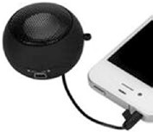
When the R-2R ladder 8-bit DAC output is connected to a mini-loudspeaker, the sound corresponding to the scaled sine wave is heard. The frequency of the sound depends on the time taken by the ESP8266 microcontroller to generate the scaled sine wave
values and convert them to binary format for the R-2R ladder 8-bit DAC. An ESP8266 microcontroller takes 15.5 ms to generate and upload, to the shift register, the scaled sine wave values for one cycle of 360 degrees with one-degree intervals, corresponding to a frequency of 64 Hz.
Different frequencies are generated by multiplying the angle of the sine wave by a constant, which increases the number of cycles in a time period, but with higher values of the multiplier, the resolution of the sine wave decreases. A potentiometer reading sets the multiplier (see Figure 16-9), and the instruction mult = 20.0*analogRead(potPin)/1023.0 scales the potentiometer reading to an arbitrary maximum of 20, with a resultant maximum sine wave frequency of 1.28 kHz. Potentiometer connections are given in Table 16-4.
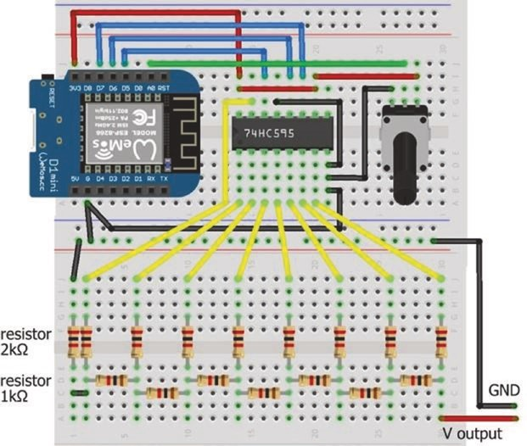
Figure 16-9. R-2R ladder 8-bit DAC, shift register, and LOLIN (WeMos) D1 mini
Table 16-4. Potentiometer connections for wave generation
Component | Connect to
potentiometer VCC | eSp8266 VCC
potentiometer signal (middle) | eSp8266 a0
potentiometer gnD | eSp8266 gnD
The sketch in Listing 16-3 changes the multiplier of the sine wave angle to change the frequency, with corresponding sound generated by the output voltage of an R-2R ladder 8-bit DAC. In the loop function, the multiplier for the sine wave angle is the scaled potentiometer reading. The cycle time and the sine wave frequency are displayed every 1000 cycles. Calculation of a sine wave requires the angle to be defined in radians, and the angle in degrees is converted to radians with the formula radian = angle × π/180. In Listing 16-3, the value of the PI variable is predefined as 3.14159, within the Arduino IDE.
Listing 16-3. Generating a sine wave with R-2R ladder 8-bit DAC
int dataPin = D5; // shift register data int latchPin = D6; // latch and clock pins int clockPin = D7; int count = 0; float sum, angle, Hz; unsigned long lastTime; int val, sign, mult, cycleTime;
void setup()
{
Serial.begin(115200); // Serial Monitor baud rate pinMode(dataPin, OUTPUT); // shift register pins as output pinMode(latchPin, OUTPUT); pinMode(clockPin, OUTPUT); }
void loop()
{
mult = 20.0*analogRead(A0)/1023.0; // scale potentiometer value for (int deg=0; deg<360; deg=deg+mul t) // cycle through 360°
{
angle = deg*PI/180.0; // convert degrees to radians sum = sin(angle);
val = round(128+120.0*sum); // scaled sine wave value digitalWrite(latchPin, LOW); // start loading shift register shiftOut(dataPin, clockPin, MSBFIR ST, val );
// load 8-bit number
digitalWrite(latchPin, HIGH); // end loading shift register
} count ++; if(count > 999) // display every 1000 cycles
{ cycleTime = millis() - lastTime; // time (ms) for cycle
Hz = 1000.0 * count / cycleTime; // frequency (Hz)
Serial.print(mult);Serial.print("\t");
Serial.print(Hz);Serial.print("Hz\t");
Serial.print(1.0*cycleTime/count);Serial.println("ms"); count = 0; // reset counter lastTime = millis(); // reset timer
}
}
In Listing 16-3, the sine wave value for an angle was calculated with the instruction sum = sin(angle).
A square wave is constructed from six odd-integer harmonics or component sine waves, as a Fourier series, with the instructions
sum = 0;
for (int i=1; i<12; i=i+2) sum = sum + sin(i*angle)/i;
A triangular wave is constructed with the same odd harmonics as a square wave, but with alternating signs and a divisor of the harmonic number squared. The instructions are
sum = 0; sign = -1; for (int i=1; i<12; i=i+2)
{
sign = -sign; sum = sum + sign*sin(i*angle)/(i*i);
} sum = sum/2;
A sawtooth wave is constructed with all the harmonics, but with alternate signs. Using the first nine harmonics, the instructions are
sum = 0; sign = -1; for (int i=1; i<10; i++)
{
sign = -sign; sum = sum + sign*sin(i*angle)/i;
} sum = sum/2; A right-angle triangle wave is simply generated by replacing the for (int deg=0; deg<360; deg=deg+mult) {...} instructions, with the instructions
for (int i=0; i<256; i++)
{
digitalWrite(latchPin, LOW); shiftOut(dataPin, clockPin, MSBFIRST, i); digitalWrite(latchPin, HIGH); }
and a triangular wave is produced by adding the instructions
for (int i=1; i<255; i++)
{
digitalWrite(latchPin, LOW); shiftOut(dataPin, clockPin, MSBFIRST, 255-i); digitalWrite(latchPin, HIGH); }
The sine wave in Figure 16-10 illustrates the resolution of an R-2R ladder 8-bit DAC. When the binary-formatted number is represented with 8 bits, an essentially continuous sine wave is obtained with a step size of one. As the number of bits reduces, the step size increases, and the resolution reduces. Sine wave approximations produced by an R-2R ladder DAC with all 8 bits and with the three and two most significant bits demonstrate the rapid improvement in resolution with increasing bit number.
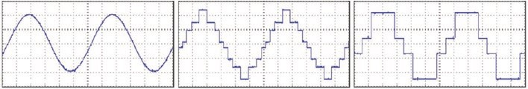
Figure 16-10. Sine wave approximations with 8 bits and three and two most significant bits
ESP32 8-bit DAC
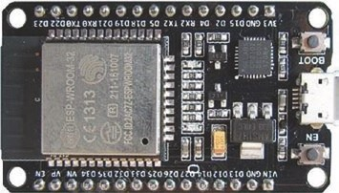
The ESP32 microcontroller includes two 8-bit DACs referenced as DAC1 and DAC2 on GPIO 25 and GPIO 26. The instruction dacWrite(DACpin, value) generates a voltage of value × VCC/2⁸, where VCC is the operating voltage of the ESP32
microcontroller. The sketch in Listing 16-4 generates the sine wave of Listing 16-3 with fewer instructions, as no R-2R ladder DAC and shift register are required, resulting in a higher sine wave frequency. The frequency is increased by including a multiplier, as in Listing 16-3. Listing 16-4. Generating a sine wave with ESP32 DAC
int DACpin = DAC1; // DAC pin on GPIO 25 float angle; int val;
void setup() // nothing in setup function
{}
void loop()
{
for (int deg=0; deg<360; deg++) // cycle through 360°
{
angle = deg*PI/180.0; // convert degrees to radians val = round(128+120.0*sin(angle)); // scaled sine wave value dacWrite(DACpin, val); // output voltage
}
}
12- bit DAC
The MCP4725 12-bit DAC module (see Figure 16-11 with connections in Table 16-5) is an alternative to the R-2R ladder 8-bit DAC. The MCP4725 module communicates with I2C (Inter-Integrated Circuit) and has an I2C address of 0x60 to 0x67, depending on the module version.
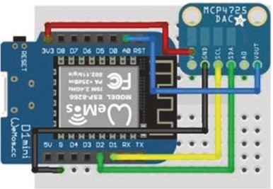
Figure 16-11. MCP4725 12-bit DAC module and LOLIN (WeMos)
D1 mini
Table 16-5. MCP4725 12-bit DAC module and the ESP8266 development board
Component | Connect to
MCp4725 VoUt | eSp8266 a0
MCp4725 gnD | eSp8266 gnD
MCp4725 SCl | eSp8266 D1
MCp4725 SDa | eSp8266 D2
MCp4725 VCC | eSp8266 3.3V
The I2C address is obtained with the I2C scanning sketch in Listing 16-5. On transmitting to an I2C device, the device returns a 0, indicating a successful transmission. The I2C addresses 0x00 to 0x07 and 0x78 to 0x7F are reserved and are not scanned. I2C addresses of sensors and modules are available at learn.adafruit.com/i2c-addresses/the-list.
Listing 16-5. I2C scanner
#include <Wire.h> // include Wire library int device = 0; // set device counter
void setup()
{
Serial.begin (115200); // Serial Monitor baud rate
Serial.println();
Wire.begin(); // start I2C bus
for (int i=8; i<127; i++) // scan through channels 8 to 126
{
Wire.beginTransmission (i); // transmit to device at address i
if (Wire.endTransmission () == 0)
{ // device response to transmission
Serial.print("Address 0x");
Serial.println(i, HEX); // display I2C address in HEX device++; // increment device count delay(10);
}
}
Serial.print(device); // display device count
Serial.println(" device found");
}
void loop() // nothing in loop function {}
The Adafruit MCP4725 library instruction setVoltage(value, false) outputs a voltage of VCC × value/2¹², where VCC is the MCP4725 module voltage supply of 3.3–5 V that is also the reference output voltage. The output voltage of the MCP4725 12-bit DAC module is confirmed by connecting the module VOUT pin to the ESP8266 microcontroller analog input pin A0 with the output voltage equal to VCC*analogRead(A0)/1024, where VCC is the microcontroller operating voltage.
A sketch to generate a range of voltages and a sine wave with the MCP4725 12-bit DAC module is given in Listing 16-6. When generating the sine wave, the angle is defined in radians, so the angle, measured in degrees, is converted to radians by the formula radian = angle × π/180. One is added to the sine value, to obtain a positive number to generate the output voltage. A multiplier of 2047 for the sine value plus one is used, rather than 2048, as the instruction dac.setVoltage(4096, false) results in an output voltage of 0 volt. Different frequencies are generated by multiplying the angle of the sine wave by a constant, which increases the number of cycles in a time period, but with higher values of the multiplier, the resolution of the sine wave reduces.
Listing 16-6. Sine wave with MCP4725 12-bit DAC module
#include <Adafruit_MCP4725.h> // include Adafruit MCP4725 lib Adafruit_MCP4725 dac; // associate dac and MCP4725 lib float voltDivid = 3200; // voltage divider adjustment float VCC = 3300; // operating voltage int flag = 0; // flag to switch to sine wave
float predict, voltage, value; int Vin;
void setup()
{
Serial.begin(115200); // Serial Monitor baud rate dac.begin(0x60); // I2C address of MCP4725
}
void loop()
{
if(flag < 1)
{
for(int i=0; i<4096; i=i+50)
{ dac.setVoltage(i, false); // set output voltage Vin = analogRead(A0); // read DAC voltage voltage = Vin * voltDivid /1024.0; // scaled output voltage predict = i * VCC / 4096.0; // predicted output voltage
Serial.print(voltage);Serial.print("\t");
Serial.println(predict); // display voltages
} delay(2000); flag = 1; // switch to sine wave only
} for (int deg=0; deg<360; deg++) // generate sine wave
{
value = 2047.0*(sin(deg*PI/180.0)+1); // scaled sine wave value dac.setVoltage(value, false); // set output voltage
}
}
Reading the sine wave values from a lookup table reduces processing time, relative to calculating values of the sine wave, which increases the number of cycles in a time period and so the frequency of the sine wave. The ESP8266 microcontroller has 4 MB flash memory and 50 kB SRAM (static random access memory), so the lookup table is stored in flash or programmable memory, PROGMEM, where the sketch is stored, rather than in SRAM, where variables are created and manipulated in a sketch. The instruction to store an array in flash memory is const type arrayname[] PROGMEM = {array values}, and the ith value of the array is accessed with the instruction pgm_read_type(arrayname + i). Character or integer data is stored in flash memory with the variable type defined as unsigned char or uint16_t and accessed with pgm_read_byte or pgm_ read_word, respectively.
In Listing 16-7, sine wave values at intervals of 10° are stored in flash memory. For example, the time to generate 500 sine waves is measured to determine the frequency of the generated sine wave. The sine wave is also generated by directly calculating values of the sine wave to compare the gain in wave frequency by storing values in flash memory.
Listing 16-7. Storing sine wave values in flash memory
#include <Adafruit_MCP4725.h> // include Adafruit MCP4725 lib Adafruit_MCP4725 dac; // associate dac and MCP4725 lib const uint16_t lookup[] PROGMEM = { // sine wave in flash memory
2047,2402,2747,3071,3363,3615,3820,3971,4063,4094,
4063,3971,3820,3615,3363,3071,2747,2402,2047,1692,
1347,1024, 731, 479, 274, 123, 31, 0, 31, 123,
274, 479, 731,1024,1347,1692 // 2047×(sin(x°×π/180) + 1) };
int value, cycle; unsigned long lastTime = 0; float freq;
void setup()
{
Serial.begin(115200); // Serial Monitor baud rate Serial.println(); dac.begin(0x60); // I2C address of MCP4725
}
void loop()
{
lastTime = millis(); // start timer
while (cycle < 500) // sine wave for 500 cycles
{
for (int i=0; i<36; i++)
{
value = pgm_read_word(lookup+i); // values from flash memory dac.setVoltage(value, false); // set output voltage
} cycle++; yield(); // required to prevent timeout
} freq = 1000 * 500.0/(millis() - last Time); // wave frequency Serial.print("lookup ");Serial.print(freq); cycle = 0;
lastTime = millis(); while (cycle < 500)
{
for (int deg=0; deg<360; deg=deg+10) // generate sine wave { // scaled sine wave value value = 2047.0*(sin(deg*PI/180.0)+1) ;
dac.setVoltage(value, false); // set output voltage
} cycle++; yield();
}
freq = 1000 * 500.0/(millis()-lastTime);
Serial.print("\tcalc ");Serial.println(freq); cycle = 0; }
The sine wave frequencies from different methods of generating a sine wave, with sine values at 10° intervals, are summarized in Table 16- 6. Sine waves were generated by the ESP32 microcontroller 8-bit DAC and by an ESP8266 microcontroller with an R-2R resistor ladder 8-bit DAC and an
MCP4725 12-bit DAC. The frequency of the sine wave generated by the ESP32 microcontroller was double that of the ESP8266 microcontroller with the R-2R ladder 8-bit DAC, but 20 times greater than with the MCP4725 12-bit DAC module. The higher resolution of the 12-bit MCP4725 DAC module compared to the R-2R ladder 8-bit DAC was offset by slower sine wave generation. For the 12-bit MCP4725 DAC module, storing sine wave values in flash memory produced marginally higher sine wave frequency than when sine wave values were calculated. The AD9833 module is the most powerful method generating a sine wave.
Table 16-6. Sine wave generation methods and frequencies
Generation Method with Values at 10° Intervals | Frequency (Hz) of Sine Wave
aD9833 module | to Mhz
eSp32 8-bit DaC | 1467
eSp8266 r-2r resistor ladder 8-bit DaC | 647
eSp8266 MCp4725 12-bit DaC | 66
With lookup table | 71
Summary
Square waves with variable duty cycle were produced by the ESP8266 and ESP32 microcontrollers to control external devices. The digital to analog converter (DAC) with an R-2R resistor ladder was described for an ESP8266 microcontroller. Sine, square, triangular, and sawtooth waves were generated by combining harmonics as a Fourier series. A variety of sounds were produced from the output voltage of an R-2R ladder 8-bit DAC by changing the frequency of the sine wave. Output voltages were also generated with the MCP4725 12-bit DAC module. The AD9833 module produced sine and triangle waves with MHz frequencies. The ESP32 microcontroller 8-bit DAC produced sine waves with double the frequency of the sine waves generated by the ESP8266 microcontroller.
Components List
- ESP8266 microcontroller: LOLIN (WeMos) D1 mini or NodeMCU board
- ESP32 microcontroller: DEVKIT DOIT or NodeMCU board
- MCP4725 12-bit DAC module
- AD9833 waveform generator module
- 74HC595 shift register
- Potentiometer: 10 kΩ
- Resistors: 7× 1 kΩ, 9× 2 kΩ

CHAPTER 17
Signal generation with 555 timer IC
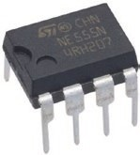
In Chapter 16 (Signal generation), an ESP8266 or ESP32 microcontroller generated square wave signals with variable duty cycle or generated sine and triangular wave signals when combined with an AD9833 waveform generator module. Sine waves were also generated with the addition of an external DAC (digital to analog
converter) MCP4725 module to the ESP8266 microcontroller or with the built-in DAC of the ESP32 microcontroller. In Chapter 5 (MP3 player), a microcontroller signaled an MP3 player module to play a track when movement triggered a passive infrared (PIR) sensor. Even though the signaling sketches often contained fewer than 20 lines of code, signal generation always required a microcontroller. Signal generation with a 555 timer integrated circuit (IC) is an alternative to requiring a microcontroller and provides insight into combining electronic components for an application. The 555 timer IC is incorporated in timer and signal generation applications ranging from pulse and sound generation, clocks, timers and alarm triggering, power control with PWM (pulse width modulation), or any application requiring time control. This chapter describes signal generation with the 555 timer IC to complement Chapter 16 (Signal generation). As an illustrative application, the MP3 player and PIR sensor example from Chapter 5 (MP3 player) is developed with the 555 timer IC.
© Neil Cameron 2021 467
N. Cameron, Electronics Projects with the ESP8266 and ESP32, https://doi.org/10.1007/978-1-4842-6336-5_17
Signal generation with 555 timer iC
555 timer IC
The 555 timer IC has eight pins, with the pin labels given in Figure 17-1 (left side). However, representing the 555 timer IC as in Figure 17-2, with the Threshold, Trigger, and Control pins grouped together and the Output and Discharge pins grouped together, aids interpretation of schematics with the 555 timer IC. For circuit layouts, the 555 timer IC is represented as in Figure 17-1 (right side) to minimize overlap of connections to the 555 timer IC.
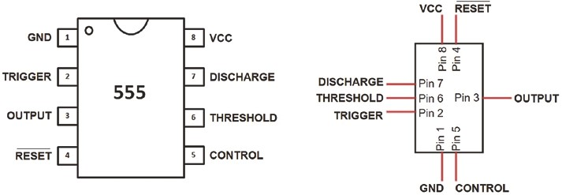
Figure 17-1. 555 timer IC pin layouts
The 555 timer IC incorporates two voltage comparators, represented by triangles in Figure 17-2, with reference voltages of ²3 VCC and ¹₃ VCC, which are generated by two voltage dividers, formed with three 5 kΩ resistors. The 555 timer IC is primarily controlled by voltages on the Threshold and Trigger pins. When the voltage on the Threshold pin is greater than ² VCC, the Flip-
3
Flop, represented by the Reset/Set box in Figure 17-2, is reset, the Output pin state changes from HIGH to LOW, and the NPN (negative-positive-negative) discharge transistor is turned on to create a low-impedance connection between the Discharge pin and GND. Conversely, when the voltage on
Signal generation with 555 timer iC
the Trigger pin is less than ¹ VCC, the Flip-Flop is set, the Output pin state
3
changes from LOW to HIGH, and the NPN discharge transistor is turned off to disconnect the Discharge pin from GND.
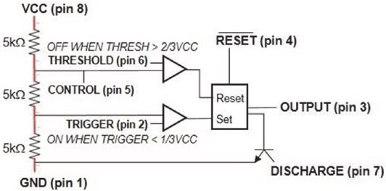
Figure 17-2. 555 timer diagram
To control the time that voltages on the Trigger and Threshold pins are within the range of ¹ VCC and ² VCC, a resistor-capacitor (RC)
3 3
combination is connected to the 555 timer IC. The voltage across the capacitor at t seconds of charging or discharging is V(1 − e^{−t/RC}) or V(e^{−t/RC}), where V is the supply voltage. The higher the RC value, the longer the time interval between changes in both the Flip-Flop state and the Output voltage. A detailed description is given in the following “Astable mode” section. Briefly, while the capacitor charges, the Output pin is HIGH, and the increasing capacitor voltage is the input to the Threshold pin. When the voltage reaches ² VCC, the Output pin state changes from HIGH to LOW,
3
and the capacitor discharges through the Discharge pin. As the capacitor discharges, the decreasing capacitor voltage is the input to the Trigger pin; and when the voltage reaches ¹ VCC, the OUTPUT pin state changes from
3
LOW to HIGH, and the capacitor starts to charge again.
Signal generation with 555 timer iC
The 555 timer IC has three operating modes: monostable, bistable, and astable. In monostable mode, triggering the 555 timer IC produces a HIGH pulse for a fixed time, which then returns to the LOW state until retriggered. Applications of the monostable mode include time delays. In bistable mode, the HIGH or LOW state is triggered with a switch for use in switch debouncing. In astable mode, the 555 timer IC generates square waves of fixed frequency and duty cycle determined by the value of the resistor-capacitor combination. Applications of the astable mode include pulse width modulation control of motors or lights, tone and sound generation, clock timing, and square waves and triangular and sine waves when the 555 timer IC is combined with a resistor-capacitor and an inductor-capacitor (LC), respectively.

The Reset pin is active LOW, indicated in Figure 17-2 by RESET , and is inactivated by connecting the Reset pin to VCC. A voltage on the Control pin replaces the voltage comparator reference voltages of ² VCC and
3
¹₃ VCC with the Control pin voltage and half of the Control pin voltage, respectively. The Control pin is inactivated by connecting the Control pin to GND through a 10 nF (equal to 0.01 μF) capacitor to eliminate noise.
The CMOS (Complementary Metal Oxide Semiconductor) version of the 555 timer IC, such as the TLC555, includes MOSFETs (Metal Oxide Semiconductor Field Effect Transistors) for switching rather than BJTs
(bipolar junction transistors), which are included in the standard 555 timer IC, such as the NE555. The CMOS 555 timer IC requires less power and has no voltage spikes with changing Output pin states, but has lower output current than the standard 555 timer IC. The CMOS 555 timer IC VCC pin supports 2–15 V, and the Output pin sinks 100 mA, but only sources 10 mA, while the standard 555 timer IC VCC pin supports 5–15 V with the Output pin sinking or sourcing up to 200 mA. Voltage spikes that occur when changing Output pin states with the standard 555 timer IC are eliminated by fitting a 0.1 μF capacitor across the VCC and GND pins of the 555 timer IC.

This chapter uses a CMOS 555 timer IC, except in the “Square wave to sine wave” section, which uses the standard 555 timer IC.
Monostable mode
In monostable mode for the 555 timer IC (see Figure 17-3 with connections in Table 17-1), closing the switch results in the LED turning on for one pulse length and then turning off. When the switch is open, the Trigger pin is connected to VCC through the pull-up resistor R₂, and the Threshold pin is connected to GND through the Discharge pin, so the Output pin is LOW and the LED is turned off. When the switch is momentarily closed, the Trigger pin is connected to GND, and the voltage on the Trigger pin
1 is 0 V, which is less than ₃ VCC, so the Flip-Flop is set, the Output pin changes from LOW to HIGH, the LED is turned on, and the NPN discharge transistor is turned off to disconnect the Discharge pin from GND.
The capacitor C₁ starts charging through resistor R₁, as the capacitor is no longer connected to GND, and the voltage on the Threshold pin increases. When the voltage on the Threshold pin is greater than ² VCC,
3 the Flip-Flop is reset, the Output pin changes from HIGH to LOW, the LED is turned off, and the NPN discharge transistor is turned on to create a low-impedance connection between the Discharge pin and GND. The capacitor now discharges through the Discharge pin, and the Threshold pin is again connected to GND and the Trigger pin to VCC. The cycle repeats only when the switch is next closed.
Signal generation with 555 timer iC
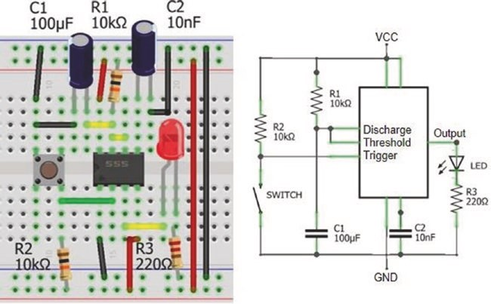
Figure 17-3. 555 monostable mode
Table 17-1. 555 monostable mode
Component | Connect to | Then to
555 gnD (pin 1) | gnD
555 trigger (pin 2) | Switch (right side)
555 output (pin 3) | leD long leg
555 reset (pin 4) | VCC
555 Control (pin 5) | 10 nF capacitor positive | gnD
555 threshold (pin 6) | 555 Discharge (pin 7)
555 Discharge (pin 7) | 10 kΩ resistor | VCC
555 Discharge (pin 7) | 100 μF capacitor positive | gnD
555 VCC (pin 8) | VCC
leD short leg | 220 Ω resistor | gnD
Switch (right side) | 10 kΩ resistor | VCC
Switch (left side) | gnD
The time that the capacitor charges from 0 V to ²VCC depends on the
3
value of the resistor-capacitor pair, R₁ and C₁, in Figure 17-3. Solving
²3VCC VCC⁼ (1-e^{-t RC/} ) for time t has the solution t = ln(3) × RC or approximately 1.1 × RC. For example, the actual time of 1246 ms that the Output pin remained HIGH after the switch was closed, with a 9.97 kΩ resistor and a 110 μF capacitor, was comparable with the expected time of 1205 ms (see Figure 17-4).
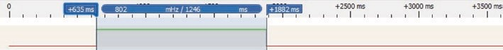
Figure 17-4. 555 monostable signal
The resistance of a light-dependent resistor (LDR) or photoresistor decreases with increasing incident light. A night light is built by replacing the switch and pull-up resistor, R₂, in Figure 17-3, with a pull-down resistor and an LDR, respectively. The LDR resistance is between 3 kΩ and 5 kΩ in average daylight, so a 4.7 kΩ resistor provides a balanced resistance for a voltage divider with the LDR. As the incident light on the LDR reduces, the LDR resistance increases, which decreases the output voltage of the voltage divider. The Trigger pin is connected to the voltage divider output, and as the incident light reduces, the Trigger pin voltage decreases; and when it is below ¹ VCC, the Flip-Flop is set, the Output pin changes from
3
LOW to HIGH, and the night-light LED is turned on.
Signal generation with 555 timer iC
Bistable mode
In bistable mode for the 555 timer IC (see Figure 17-5 with connections in Table 17-2), closing the ON or OFF switch results in the LED being turned on or off. When the ON or OFF switch is open, the Trigger and Reset pins are connected to VCC, through pull-up resistors R₁ and R₂, so the Output pin is LOW and the LED is turned off. Note that the Reset pin is active LOW. When the ON switch is momentarily closed, the Trigger pin is connected to GND, and the voltage on the Trigger pin is 0 V, which is less than ¹ VCC,
3 so the Flip-Flop is set, the Output pin changes from LOW to HIGH, and the LED is turned on. When the OFF switch is closed, the 555 timer IC is reset, the Output pin is LOW, and the LED is turned off. The 555 timer IC in bistable mode debounces the ON and OFF switches.
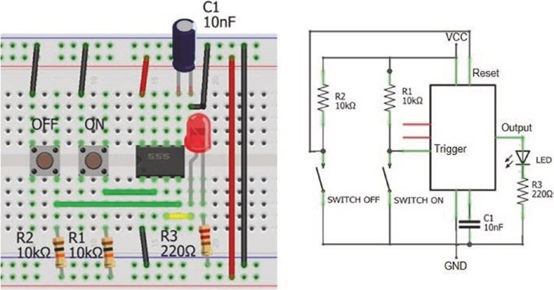
Figure 17-5. 555 bistable mode
Table 17-2. 555 bistable mode
Component | Connect to | Then to
555 gnD (pin 1) | gnD
555 trigger (pin 2) | Switch on (right side)
555 output (pin 3) | leD long leg
555 reset (pin 4) | Switch oFF (right side)
555 Control (pin 5) | 10 nF capacitor positive | gnD
555 VCC (pin 8) | VCC
leD short leg | 220 Ω resistor | gnD
Switch on or oFF (right side) | 10 kΩ resistor | VCC
Switch on or oFF (left side) | gnD
Astable mode
In astable mode for the 555 timer IC (see Figure 17-6 with connections in Table 17-3), a square wave is generated, as illustrated by the two LEDs being turned on and off alternately. The square wave duty cycle and frequency, which is the inverse of the length of the square wave, are determined by the values of the charging capacitor, C₁, and two resistors, R₁ and R₂. The LED connected between the Output pin and GND sources current from the Output pin, while the LED connected between VCC and the Output pin sinks current to the Output pin. When the Output pin is HIGH, the LED sourcing current is turned on, and the LED sinking current is turned off. Conversely, when the Output pin is LOW, the LED sourcing current is turned off, and the LED sinking current is turned on.
Signal generation with 555 timer iC
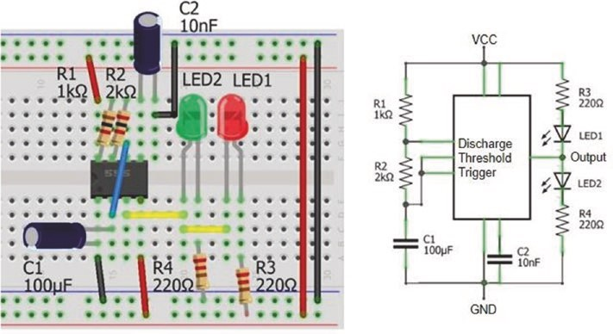
Figure 17-6. 555 astable mode
Table 17-3. 555 astable mode
Component | Connect to | Then to
555 gnD (pin 1) | gnD
555 trigger (pin 2) | 555 threshold (pin 6)
555 output (pin 3) | leD2 long leg | leD1 short leg
555 reset (pin 4) | VCC
555 Control (pin 5) | 10 nF capacitor positive | gnD
555 threshold (pin 6) | 2 kΩ resistor | 555 Discharge (pin 7)
555 Discharge (pin 7) | 1 kΩ resistor | VCC
555 VCC (pin 8) | VCC
leD1 long leg | 220 Ω resistor | VCC
leD2 short leg | 220 Ω resistor | gnD
100 μF capacitor positive | 555 trigger (pin 2)
100 μF capacitor negative | 555 trigger (pin 1)

Signal generation with 555 timer iC
The capacitor, C₁, charges through the two resistors, R₁ and R₂, and the voltage on the Threshold pin increases. When the voltage on the capacitor
2 and the Threshold pin is greater than ₃ VCC, the Flip-Flop is reset, the
Output pin changes from HIGH to LOW, the LED sourcing current LED₂ is turned off, the LED sinking current LED₁ is turned on, and the NPN discharge transistor is turned on to create a low-impedance connection between the Discharge pin and GND. The capacitor now discharges through resistor R₂ and the Discharge pin.
When the voltage on the discharging capacitor and the Trigger pin is
1 less than ₃ VCC, the Flip-Flop is set, the Output pin changes from LOW to HIGH, the LED sourcing current LED₂ is turned on, the LED sinking current LED₁ is turned off, and the NPN discharge transistor is turned off to disconnect the Discharge pin from GND. The capacitor now charges through the two resistors, R₁ and R₂, and the cycle repeats.
Resistor values, R₁ and R₂, and the capacitor, C₁, determine the time that the capacitor charges from ¹ VCC to ² VCC, but the discharge time is
3 3
defined only by resistor R₁ and the capacitor. The time required to increase capacitor voltage from ¹ VCC to ² VCC is the difference in times between
3 3
charging from 0 V to ² VCC and from 0 V to ¹ VCC. The voltage across a
3 3
capacitor at t seconds of charging is VCC(1 − e−^{t/RC}). The two equations
²VCC VCC= (1-e^{-t2/RC} ) and ¹VCC VCC= (1-e^{-t1/RC} ) are solved for t₁ and t₂, the
3 3
two charging times. The difference between the charging times, t₂ − t₁, is ln(2) × (R₁ + R₂) × C₁ or 0.693 × (R₁ + R₂) × C₁ seconds. The equation for the voltage across a capacitor at t seconds of discharging is Ve−^{t/RC}. The time that the capacitor is discharging from ² VCC to ¹ VCC is similarly
3 3
calculated as ln(2) × R₂C₁ seconds.
The length of the square wave is ln(2) × (R₁ + 2R₂) × C₁ seconds, and the duty cycle is (R₁ + R₂)/(R₁ + 2R₂). The frequency of the square wave is the inverse of the square wave length and is often written as 1.44/[(R₁ + 2R₂) × C₁], as ln(2)⁻¹ = 1.44. For example, with resistor values of 986 Ω and 1981 Ω and a 110 μF capacitor, the actual capacitor charging and discharging times of 220 ms and 152 ms, respectively, with a duty cycle of 59%, a wavelength of 372 ms, and a frequency of 2.69 Hz were similar to the expected capacitor charging and discharging times of 226 ms and 151 ms with a duty cycle of 60%, a wavelength of 377 ms, and a frequency of 2.65 Hz (see Figure 17-7).
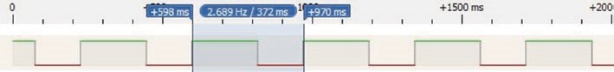
Figure 17-7. 555 astable square wave signal
With fixed values for resistor R₁ and capacitor C, the value of resistor
R₂ is chosen to generate a square wave with frequency [ln(2) × (R₁ + 2R₂) × C]⁻¹ Hz. An electronic piano is built by connecting several pairs of switches and R₂ resistors to the 555 timer IC, with fixed values for the R₁ resistor (1 kΩ) and capacitor (1 μF) (see Figure 17-8 with connections in Table 17-5). Pressing a switch connects the series of R₂ resistors to the Trigger and Discharge pins, and the capacitor starts to charge and then discharge, which produces a square wave as long as the switch is pressed. For example, the note G4 with frequency 392 Hz requires a total resistance of 1340 Ω. The R₂ resistors are in series with the total resistance equal to the sum of the resistors. The R₂ resistors for notes C5, B4, and A4, which precede the resistor for note G4, total 1130 Ω, so the required R₂ resistor for the note G4 is 210 Ω and a 200 Ω resistor is included, as it is a readily
Signal generation with 555 timer iC
available resistor value. In practice, frequencies of the generated sounds were within 7 Hz of the true frequencies (see Table 17-4).
Table 17-4. Electronic piano resistor combinations
Note | C4 | D4 | E4 | F4 | G4 | A4 | B4 | C5
true frequency (hz) | 262 | 294 | 330 | 349 | 392 | 440 | 494 | 523
resistor (Ω) | 330 | 220 | 150 | 220 | 200 | 150 | 100 | 880
Cumulative resistance (Ω) | 2250 | 1920 | 1700 | 1550 | 1330 | 1130 | 980 | 880
project frequency (hz) | 262 | 298 | 328 | 352 | 394 | 443 | 487 | 523
A speaker is connected to the Output pin, through a 10 μF capacitor.
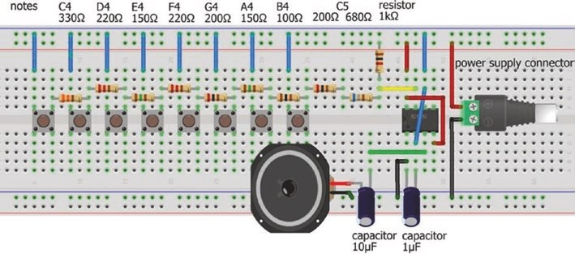
Figure 17-8. 555 timer IC and electronic piano
Table 17-5. 555 timer IC and electronic piano
Component | Connect to | Then to
555 gnD (pin 1) | gnD
555 trigger (pin 2) | 555 threshold (pin 6)
555 output (pin 3) | 10 μF capacitor positive | Speaker positive
555 reset (pin 4) | VCC
555 threshold (pin 6) | Switches (left side)
555 Discharge (pin 7) | resistors | Switches (right side)
555 VCC (pin 8) | VCC
1 μF capacitor positive | 555 trigger (pin 2)
1 μF capacitor negative | 555 trigger (pin 1)
Speaker negative | gnD
Variable duty cycle
The square wave duty cycle with astable mode is always greater than 50% as the capacitor charges through resistors R₁ and R₂, but discharges through resistor R₂ (see Figure 17-6). If two diodes, such as the IN4001, are incorporated (see Figure 17-9 with connections in Table 17-6), then the capacitor charges through resistor R₁ only and discharges through resistor R₂ only.
Signal generation with 555 timer iC
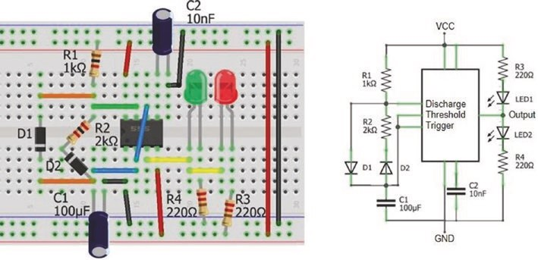
Figure 17-9. 555 astable mode with full duty cycle range
Table 17-6. 555 astable mode with full duty cycle range
Component | Connect to | Then to
555 gnD (pin 1) | gnD
555 trigger (pin 2) | 555 threshold (pin 6)
555 trigger (pin 2) | Diode (D1) cathode (negative)
555 trigger (pin 2) | Diode (D2) anode (positive) | 2 kΩ resistor
555 output (pin 3) | leD2 long leg | leD1 short leg
555 reset (pin 4) | VCC
555 Control (pin 5) | 10 nF capacitor positive | gnD
555 Discharge (pin 7) | 1 kΩ resistor | VCC
555 VCC (pin 8) | VCC
leD1 long leg | 220 Ω resistor | VCC
leD2 short leg | 220 Ω resistor | gnD
100 μF capacitor positive | 555 trigger (pin 2)
100 μF capacitor negative | 555 trigger (pin 1)
The forward voltage drop of the diodes results in longer charge and discharge times, which are increased from ln(2) × R₁C₁ and ln(2) × R₂C₁ seconds to α × R₁C₁ and α × R₂C₁, with the constant α equal to ln êéë¹+VC^{VCC}C V-_{3 d} ^{ù}úû , where V_{d} is the forward voltage of the diode. For
example, if VCC is 5 V and the diode forward voltage is 0.6 V, then the discharge time is ln(2.56) × R₂C₁ rather than ln(2) × R₂C₁ when no diode is included in the circuit. The square wave duty cycle is unaffected by inclusion of the two diodes and is less than or greater than 50% when resistor R₁ is less than or greater than resistor R₂. For example, with resistor values of 986 Ω and 1981 Ω and a 110 μF capacitor, the actual capacitor charging and discharging times of 99 ms and 203 ms, respectively, with a duty cycle of 33% were similar to the expected capacitor charging and discharging times of 102 ms and 205 ms (see Figure 17-10).
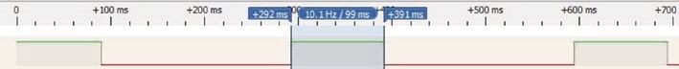
Figure 17-10. Variable duty cycle with astable mode
The voltage across a capacitor charging or discharging through a resistor of RΩ is V_{t} = V_{S} + (V₀ − V_{S})e−^{t/RC}, where V₀ is the initial voltage across the capacitor with capacitance C and V_{S} is the supply voltage. If the capacitor is fully discharged with V₀ = 0, the supply voltage is V; then the equation reduces to the usual formula for a charging capacitor of V(1 − e−^{t/RC}). Similarly for a discharging capacitor with V₀ = V, then the supply voltage is V_{s} = 0 with the usual formula for a discharging capacitor of Ve−t/RC.

When a diode, with forward voltage V_{d}, is included in series with the charging resistor R₁ and the capacitor charges from ¹ VCC to ² VCC, the
3 3
charging time is R₁C₁ × ln êéë¹+VC^{VCC}C V-_{3 d} ^{ù}úû for a supply voltage V_{S} = VCC - V_{d},
V₀ = ¹ VCC, and V_{t} = ² VCC. Likewise when a diode is included in series
3 3
with the discharging resistor R₂ and the capacitor discharges from ² VCC
3
to ¹3 VCC, the discharging time is R₂C₁ × ln êéë¹+VC^{VCC}C V-_{3 d} ^{ù}úû for a supply voltage V_{S} = V_{d}, V₀ = ² VCC, and V_{t} = ¹ VCC. Note than when the diode
3 3
forward voltage, V_{d}, is set to zero in the formulae, the charging and discharging times are ln(2) × R₁C₁ and ln(2) × R₂C₁, as before.
50% duty cycle
If the capacitor charges and discharges through the same resistor, then the duty cycle is close to 50%, irrespective of the value of the resistor or capacitor. The resistor is connected between the Output pin and the Trigger and Threshold pins (see Figure 17-11 with connections in Table 17- 7).
Signal generation with 555 timer iC
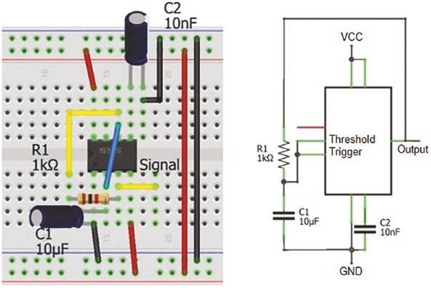
Figure 17-11. 555 astable mode with 50% duty cycle
Table 17-7. 555 astable mode with full duty cycle range
Component | Connect to | Then to
555 gnD (pin 1) | gnD
555 trigger (pin 2) | 555 threshold (pin 6)
555 output (pin 3) | Signal
555 output (pin 3) | 1 kΩ resistor | 555 threshold (pin 6)
555 reset (pin 4) | VCC
555 Control (pin 5) | 10 nF capacitor positive | gnD
555 VCC (pin 8) | VCC
10 μF capacitor positive | 555 trigger (pin 2)
10 μF capacitor negative | 555 trigger (pin 1)
(continued)
Table 17-7. (continued)
Component | Connect to | Then to
npn BJt collector | 220 Ω resistor | leD short leg
npn BJt base | 10 kΩ resistor | 555 output (pin 3)
npn BJt emitter | gnD
leD long leg | VCC
The capacitor charges through resistor R₁, and the voltage on the Threshold pin increases. When the voltage on the capacitor and the
Threshold pin is greater than ² VCC, the Flip-Flop is reset, the Output
3
pin changes from HIGH to LOW. The capacitor now discharges through resistor R₁ and the Output pin. When the voltage on the discharging
1 capacitor and the Trigger pin is less than VCC, the Flip-Flop is set,
3
the Output pin changes from LOW to HIGH. The capacitor now charges through the resistor R₁, and the cycle repeats.
The length of the square wave is ln(2) × 2R₁C₁ seconds. For example, with resistor and capacitor values of 986 Ω and 110 μF, the square wave frequency of 6.55 Hz was similar to the expected frequency of 6.65 Hz (see Figure 17-12).
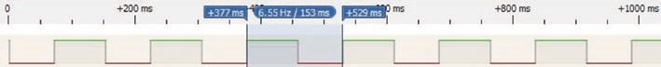
Figure 17-12. Square wave with 50% duty cycle
Signal generation with 555 timer iC
When a load is applied to the Output pin, even just an LED, then the square wave HIGH pulse length increases, the duty cycle increases, and the frequency decreases. If a load is to be controlled, then the base of a transistor is connected to the Output pin, with the load powered through the transistor (see Figure 17-13 with connections in Table 17-7). A BC548 or 2N2222 transistor is suitable with a 10 kΩ resistor between the Output and transistor base pins, to limit the current on the transistor base pin.
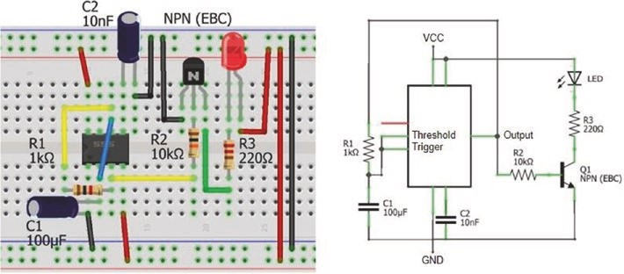
Figure 17-13. 555 astable mode with 50% duty cycle and load
The square wave frequency is controlled interactively by connecting a potentiometer in series with resistor R₁. Retaining the 1 kΩ resistor maintains a time lag for the discharging capacitor when the potentiometer is turned to zero resistance.
PWM mode
Pulse width modulation (PWM) of the square wave is interactively controlled by replacing resistor R₁ in Figure 17-13 with a potentiometer of resistance PΩ and two diodes, such as the IN4001 (see Figure 17-14 with connections in Table 17-8). The capacitor charges and discharges through the resistances on each side of the potentiometer, β × PΩ and (1 – β) × PΩ, so the sum of the charging and discharging times is constant. Inclusion of the diodes increases
₁ ₁ é¹+ VCC ùú × PC₁ the square wave length from ln(2) × 2R C seconds to ln êë VCC V-_{3 d} û
seconds, as described in the “Variable duty cycle” section of the chapter. For example, a 10 kΩ potentiometer and a 100 μF capacitor result in a square wave frequency of 1.06 Hz with a duty cycle ranging from 10% to 90%.
To control a load with PWM, the Output pin is connected to the base of a transistor, with the load then powered through the transistor, such as a 2N2222 (see Figure 17-14). For example, a servo motor is controlled with the 555 timer IC by connecting the Output pin directly to the servo motor signal pin. A servo motor rotates to angles 0° and 180° with a square wave of 50 Hz and pulse widths of 0.5 ms and 2.5 ms. A square wave of 50.6 Hz is produced by a 555 timer IC in astable mode with a 10 kΩ potentiometer and a 2.1 μF capacitor (C₁).
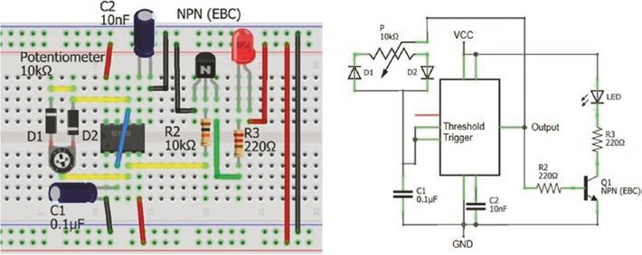
Figure 17-14. 555 astable mode with PWM
Signal generation with 555 timer iC
Table 17-8. 555 astable mode with PWM
Component | Connect to | Then to
555 gnD (pin 1) | gnD
555 trigger (pin 2) | 555 threshold (pin 6)
555 output (pin 3) | potentiometer center pin
555 reset (pin 4) | VCC
555 Control (pin 5) | 10 nF capacitor positive | gnD
555 threshold (pin 6) | Diode (D1) cathode (negative) | potentiometer
555 threshold (pin 6) | Diode (D2) anode (positive) | potentiometer
555 VCC (pin 8) | VCC
transistor collector | 220 Ω resistor | leD short leg
transistor base | 10 kΩ resistor | 555 output (pin 3)
transistor emitter | gnD
leD long leg | VCC
0.1 μF capacitor positive | 555 trigger (pin 2)
0.1 μF capacitor negative | 555 trigger (pin 1)
Function generator
A square wave describes a non-sinusoidal, periodic oscillation, with instantaneous changes from a minimum to a maximum value, which has applications in switching and signal processing. In contrast, a sine wave describes a smooth, periodic oscillation, which has applications in describing mechanical, electrical, and sound patterns. For example, a sound is described as a combination of sine waves with different frequencies and amplitudes. While the 555 timer IC produces square waves, there are several applications that require generation of a sine wave.
A square wave with frequency f is represented as a Fourier series of sine waves over time t as
x t( )= ⁴ ìísin(2pft)+ ¹_{sin}(3 2´ pft)+ ¹_{sin}(5 2´ pft)+¼üý pî 3 5 þ
with the Fourier series consisting of odd-integer harmonics. Figure 17- 15 illustrates a sine wave with a frequency of 2 Hz and a Fourier series approximation of a square wave by summing the first ten odd-integer harmonics.
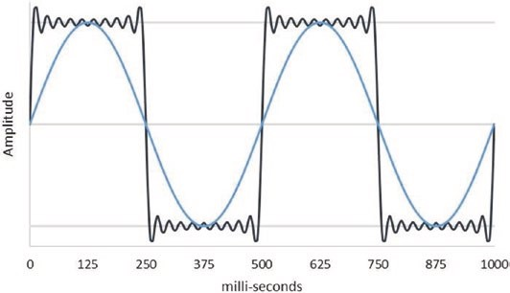
Figure 17-15. Sine wave and odd-integer harmonics
The base sine wave of a square wave is obtained by filtering the higher harmonics with a low-pass filter. A low-pass filter allows low-frequency signals to pass through the filter, while a high-pass filter attenuates low- frequency signals. Using the layout of a voltage divider, a resistor-capacitor (RC) combination forms an RC low-pass filter, with the capacitor passing high frequencies to GND and the lower frequencies available at VOUT (see Figure 17-16). The cutoff frequency of a low-pass filter is (2πRC)−¹Hz.
Signal generation with 555 timer iC
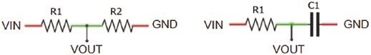
Figure 17-16. Voltage divider and resistor-capacitor low-pass
filter
The resistor value of an RC low-pass filter is selected, based on the load of the low-pass filter, and then the capacitor value is determined. For example, a square wave with frequency of 153 Hz and 50% duty cycle is generated by the 555 timer IC with a 4.7 kΩ resistor and a 1 μF capacitor. To obtain the base sine wave with an RC low-pass filter, the resistor value for the RC low-pass filter is chosen as 1 kΩ; and to obtain a cutoff frequency, fcut, of 153 Hz, the required capacitor value is 1.04 μF, equal to (2πRf_{cut})−¹F. With a 1 kΩ resistor and a 1 μF capacitor, the actual cutoff frequency of the RC low-pass filter is 159 Hz. An RC low-pass filter is shown in Figure 17-17 with connections in Table 17-9.
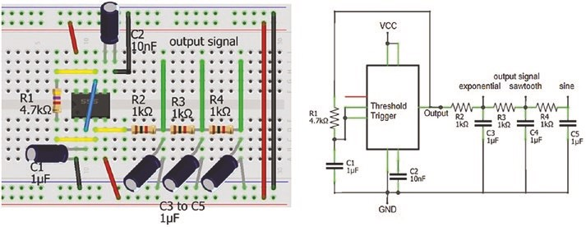
Figure 17-17. 555 timer IC and RC low-pass filters
Table 17-9. 555 timer IC and RC low-pass filters
Component | Connect to | Then to
555 gnD (pin 1) | gnD
555 trigger (pin 2) | 555 threshold (pin 6)
555 output (pin 3) | 4.7 kΩ resistor | 555 threshold (pin 6)
555 reset (pin 4) | VCC
555 Control (pin 5) | 10 nF capacitor positive | gnD
555 VCC (pin 8) | VCC
1 kΩ resistor (r2) | 555 output (pin 3) | exponential signal
1 kΩ resistors (r3 and r4) | 1 kΩ resistor (r2 and r3) | Sawtooth and sine signal
3×1 μF capacitor positive | 1 kΩ resistors
3×1 μF capacitor negative | gnD
1 μF capacitor positive | 555 trigger (pin 2)
1 μF capacitor negative | 555 trigger (pin 1)
The output signal from the RC low-pass filter is the same form as for a charging and discharging capacitor (see Figure 17-18, top graph). If the output from the RC low-pass filter is the input to a second low-pass filter with the same resistor and capacitor values of 1 kΩ and 1 μF, then the output signal of the second low-pass filter is a triangular wave (see Figure 17-18, middle graph). Adding a third low-pass filter converts the triangular wave to a sine wave with same frequency as the square wave (see Figure 17-18, bottom graph). The 555 timer IC and the three RC low- pass filters form a function generator to produce square waves, triangular waves, and sine waves.
Signal generation with 555 timer iC
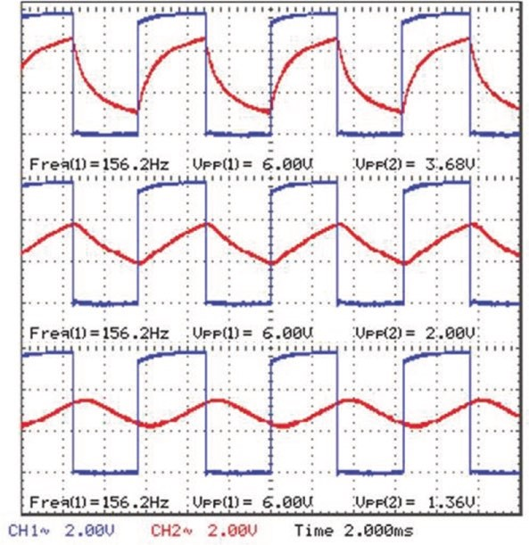
Figure 17-18. Output waveforms from RC low-pass filters
In Figure 17-18, the output signals from the three RC low-pass filters are shown relative to the square wave signal generated by the same 555 timer IC. The three waves have the required waveform, but the signal amplitudes decline with each RC filter, which is, to an extent, expected. An RC low-pass filter has a cutoff frequency of (2πRC)−¹Hz, and the capacitor has a reactance of Xc equal to (2πCf)−¹Ω, which is the capacitor opposition to a change in voltage for a signal with frequency f. If a sine wave with amplitude V volts is input to an RC low-pass filter, then the output wave amplitude is reduced to V X´ _{C} / R X² + _{C}² volts. When the capacitor value is equal to (2πRf_{cut})−¹F, then the capacitor reactance equals the resistor value, R, and the equation for the output wave amplitude simplifies to V / 2 . The amplitude of sine wave signals at the output of the first, second, and third RC low-pass filters is V / 2 , V/2, and V / 2 2 volts, respectively. The amplitudes of signals from the three RC low-pass filters, given the initial square wave signal, also decline in a systematic manner.
Square wave to sine wave
An inductor-capacitor (LC) filter is an alternative to a series of RC low-pass filters to convert a square wave to a sine wave. The LC filter and LC circuit is described in Chapter 18 (Measuring electricity). Using the layout of a voltage divider, the LC circuit is also a low-pass filter as the inductor blocks high frequencies and the capacitor blocks low frequencies, resulting in low frequencies at VOUT (see Figure 17-19).
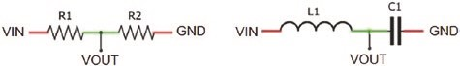
Figure 17-19. Voltage divider and inductor-capacitor low-pass filter
-
The LC circuit resonates at a frequency of (²p ^{LC}) 1 Hz. If the 555
timer IC generates a 50% duty cycle square wave at the resonance frequency of the LC circuit, then the output of the LC circuit is a sine wave (see
Figure 17-21). For example, an LC circuit with a 470 μH inductor and 1 μF capacitor has a resonant frequency of 7.3 kHz, and a 555 timer IC with a 1 kΩ resistor and a 0.1 μF capacitor generates a 50% duty cycle square wave with frequency of 7.2 kHz. The standard 555 timer IC, such as the NE555, is used to generate the square wave for the LC circuit. Voltage spikes that occur when changing Output pin states with the standard 555 timer IC are eliminated by fitting a 0.1 μF capacitor across the VCC and GND pins of the 555 timer IC (see Figure 17- 20 with connections in Table 17-10).
Signal generation with 555 timer iC
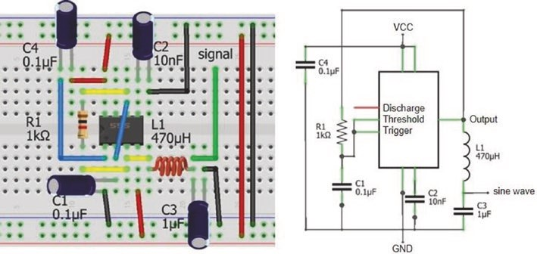
Figure 17-20. 555 and inductor-capacitor low-pass filter
Table 17-10. 555 and inductor-capacitor low-pass filter
Component | Connect to | Then to
555 gnD (pin 1) | gnD
555 trigger (pin 2) | 555 threshold (pin 6)
555 output (pin 3) | 1 kΩ resistor | 555 threshold (pin 6)
555 reset (pin 4) | VCC
555 Control (pin 5) | 10 nF capacitor positive | gnD
555 VCC (pin 8) | VCC
inductor | 555 output (pin 3)
inductor | Sine signal | 1 μF capacitor positive
1 μF capacitor negative | gnD
0.1 μF capacitor (C4) positive | VCC
0.1 μF capacitor (C1) positive | 555 trigger (pin 2)
0.1 μF capacitors negative | gnD
In practice, the square wave duty cycle and frequency generated by a standard 555 timer IC powered at 6 V with a 1 kΩ resistor and a 0.1 μF capacitor were 66.7% and 5.6 kHz. The resultant sine wave produced by the LC circuit had a frequency of 5.0 kHz (see Figure 17-21).
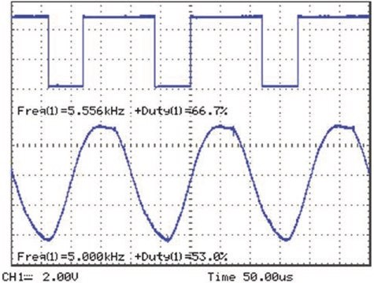
Figure 17-21. Square wave from 555 timer IC and sine wave from LC
filter
Bipolar junction transistor as a switch
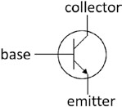
In the “50% duty cycle” and “PWM mode” sections of the chapter, an NPN (negative-positive-negative) bipolar junction transistor (BJT) functioned as a switch to turn on or off the power to a load, which was an LED. When the 555 timer IC Output pin state was HIGH, the BJT
turned on power to the load; and conversely, no power was available to the load when the Output pin state was LOW. A detailed description of an NPN BJT is out of the scope of the chapter, but practical aspects of using an NPN BJT as a switch are described.
Signal generation with 555 timer iC
The BJT has three pins: emitter (E), base (B), and collector (C). The pin layout of a BJT is specific to the model, with differences in layout even between manufactures of the same model. The BJT pin layout is available from the manufacturer's datasheet or is determined with a multimeter by connecting the positive multimeter lead to one pin and measuring the voltage on the other BJT pins. When a voltage is detected on both of the other pins, relative to the pin connected to the positive multimeter lead, then the multimeter positive lead is connected to the NPN BJT base pin. To differentiate between the emitter and collector pins, the NPN BJT emitter pin has a marginally higher voltage than the NPN BJT collector pin.
When an NPN BJT is functioning as an amplifier and a small current is applied to the base pin, then a larger current flows between the collector and emitter pins. The ratio of the current between the BJT collector and emitter pins relative to the current on the BJT base is termed the DC (direct current) gain and denoted β, but also termed h_{FE} on datasheets. A change in the base current, Δ, is reflected by a change in the collector to emitter current of β × Δ. The BJT gain is determined from the manufacturer's datasheet or by measuring the current at the BJT base and collector pins. For example, with the 2N2222 BJT in Figure 17-22 (left side), the currents at the base and collector pins were 255 μA and 25.4 mA, respectively, giving a BJT gain of 100.
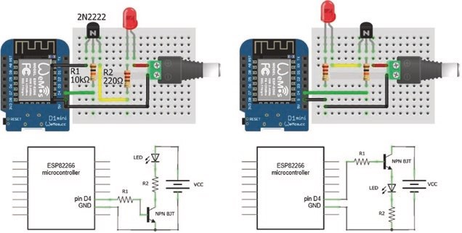
Figure 17-22. Bipolar junction transistor as a LOW-side or HIGH- side switch
In contrast, when the BJT is functioning as a switch, the base current is sufficiently high that an increase in the base current does not result in an increase in the collector to emitter current, as the BJT is saturated. In saturation mode, the collector to emitter current is either switched on or off.
For an NPN BJT to function as a switch, the BJT emitter is connected to GND, and the NPN BJT is termed a LOW-side switch (see Figure 17-22, left side). To illustrate an NPN BJT functioning as a switch to turn on or off power to a load, the base pin of a 2N2222 BJT in a TO-92 package is connected to an ESP8266 development board pin D4, and the collector pin is connected to the LED resistor and the emitter pin to GND. When the ESP8266 D4 pin state is HIGH, the current on the BJT base enables current to flow between the BJT collector and emitter. Current now flows from the external 5 V power source, through the LED and resistor, to the BJT and to GND; and the LED turns on.
For the example layout in Figure 17-22 (left side), when the ESP8266 D4 pin state is HIGH, the BJT base current is 260 μA = (3.3 -0.7) V/10 kΩ as an NPN BJT has a voltage drop of 0.7 V between the base and emitter. Given the BJT gain of 100, the collector to emitter current is 26 mA = 100 × 260 μA, which is the current through the LED. The red LED used in this chapter has a forward voltage drop of 2.12 V at 26 mA, and the voltage across the LED resistor of 2.6 V = 26 mA × 100 Ω results in a voltage of 280 mV across the BJT collector and emitter pins.
In the Figure 17-22 (right side) schematic, the NPN BJT is connected to VCC and is termed a HIGH-side switch. The HIGH-side switch is not recommended as the current through the LED is constrained, even though the components are identical in the two schematics of Figure 17-22. In practice, the BJT base current of 34 μA results in a voltage across the base resistor of 338 mV = 34 μA × 10 kΩ. The voltage drops of the LED and base- emitter of 1.92 V and 0.7 V, respectively, leave a voltage across the LED resistor of 342 mV, which equates to a current of 3.4 mA – one-eigth of the current through the LED with the BJT as a LOW-side switch. Note the lower forward voltage of the LED at a lower current. The essential difference
Signal generation with 555 timer iC
between the NPN BJT functioning as a LOW-side and a HIGH-side switch is the lower voltage (280 mV relative to 2.74 V) across the BJT collector and emitter pins with the LOW-side switch.
When the BJT functions as an amplifier, the BJT base resistor value is determined from the BJT gain, β, and the required current through the load, I_{L}. The base current is I_{L}/β, and after subtracting the base-emitter voltage drop of 0.7 V from the base voltage, V_{B}, the base resistor value is (V_{B} − 0.7) × β/I_{L}. For example, the base resistor, R_{BASE,}, for the BJT LOW- side switch to supply the LED with 20 mA from the 5 V power source in Figure 17-22 (left side) is equal to (3.3-0.7)V × 100/0.02 A = 13 kΩ. However, when the BJT functions as a switch, a lower value base resistor, such as R_{BASE,}/2 or 6.8 kΩ, ensures that the BJT is in saturation mode.
MP3 player and PIR sensor application
This chapter demonstrated signal generation by the 555 timer IC with applications in switch control, in timing, in sound generation, in appliance control with PWM, and as a function generator of square, triangular, and sine waves. The 555 timer IC is also used to transform the signal from one device into the required format for another device. In Chapter 5 (MP3 player), when a passive infrared (PIR) sensor detects movement, the PIR sensor sends a HIGH signal for 5 s that is read by a microcontroller, which transfers a command sequence to the MP3 player to play a soundtrack. If a short LOW signal is received on the MP3 player IO2 pin, then the next track is played. However, if a long LOW signal is received on the MP3 player pin, then the volume is increased. To replace the microcontroller, the HIGH PIR signal lasting 5 s must be converted to a LOW signal lasting only 0.5 s.
The 555 timer IC in monostable mode, with a specific resistor- capacitor combination, generates a 0.5 s HIGH signal, when the Trigger pin is connected to GND. Therefore, a process is required to invert the PIR long HIGH signal and trigger the 555 timer IC in monostable mode to generate a short HIGH signal that is inverted and sent to the MP3 player IO2 pin.
A signal is inverted with a bipolar junction transistor (BJT), such as the BC548 or 2N2222 transistor. To illustrate signal inversion, two LEDs are turned on and off alternately. With the Arduino IDE example Blink sketch, the red LED reflects the ESP8266 microcontroller signal, and the blue LED indicates the inverted microcontroller signal (see Figure 17-23). Both the red LED and the BJT base pin are connected to the ESP8266 development board signal pin. When the signal pin state is LOW, there is no current on the BJT base nor across the BJT collector and emitter pins, so the current flows through the blue LED. Conversely, when the signal pin state is HIGH, the resultant current on the BJT base enables current to flow between the BJT collector and emitter. The blue LED resistance is greater than the collector-emitter resistance, so the BJT effectively shorts out the LED and the blue LED is turned off.
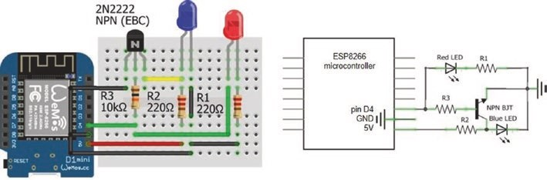
Figure 17-23. Signal inversion with bipolar junction transistor
The schematic for the PIR sensor to trigger the MP3 player to play the next soundtrack is shown in Figure 17-24, with connections in Table 17- 11.
When movement is detected by the PIR senor, the PIR sensor outputs a
HIGH signal for five seconds. An NPN BJT could invert the long HIGH PIR signal, with the subsequent LOW signal triggering the 555 timer IC in monostable mode to generate a short HIGH signal, to be inverted by a
Signal generation with 555 timer iC
second NPN BJT, to produce a short LOW signal as required by the MP3 player to play the next soundtrack.
If the inverted long HIGH PIR signal is sent to the Trigger pin of the 555 timer IC in monostable mode, then the long LOW signal would repeatedly trigger the 555 timer IC during the five-second duration of the LOW signal. A resistor (R₂)–capacitor (C₃) combination is incorporated to generate a short LOW signal for the 555 timer IC Trigger pin. The resistor R₄ reduces the voltage due to the HIGH PIR signal to a small current on the base pin of the NPN BJT, which enables current to flow from the BJT collector pin to the emitter pin. The capacitor C₃ and the 555 timer IC Trigger pin are connected to GND, as the capacitor partially discharges; then capacitor C₃ recharges through resistor R₂, and the 555 timer IC Trigger pin is again connected to VCC.
The 555 timer IC Trigger pin is LOW for 41 ms, which is sufficient to trigger the 555 timer IC in monostable mode, which sets the Output pin HIGH for ln(3) × R₁C₁, equal to 0.55 second with a 5.1 kΩ and 10 μF resistor-capacitor combination. A second NPN BJT inverts the 555 timer IC signal, which is sent to the MP3 player IO2 pin to play the next soundtrack.
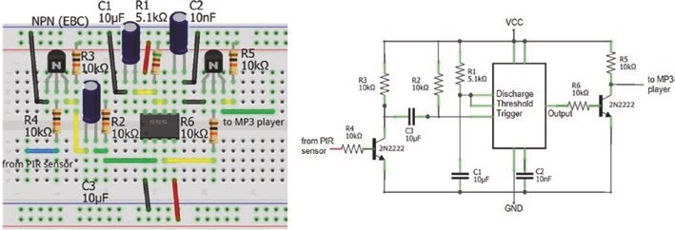
Figure 17-24. PIR sensor and MP3 player
Table 17-11. PIR sensor and MP3 player
Component | Connect to | Then to
555 gnD (pin 1) | gnD
555 trigger (pin 2) | 10 kΩ resistor r2 | 10 μF capacitor C3
555 reset (pin 4) | VCC
555 Control (pin 5) | 10 nF capacitor C2 positive | gnD
555 threshold (pin 6) | 555 Discharge (pin 7)
555 Discharge (pin 7) | 5.1 kΩ resistor r1 | VCC
555 Discharge (pin 7) | 10 μF capacitor C1 positive | gnD
555 VCC (pin 8) | VCC
transistor (from pir) collector | 10 kΩ resistor r3 | 10 μF capacitor C3 negative
transistor (from pir) base | 10 kΩ resistor r4 | From pir sensor
transistor (to mp3) collector | 10 kΩ resistor r5 | to mp3 player
transistor base | 10 kΩ resistor r6 | 555 output (pin 3)
transistor emitter | gnD
Capacitor C1, C2 negative | gnD
The signal sequence is shown in Figure 17-25 starting with the PIR sensor output of a long HIGH signal, which is inverted by an NPN BJT causing capacitor C₃ to partially discharge and then recharge, which triggers the 555 timer IC to generate a short HIGH signal that is inverted by the second NPN BJT to a short LOW signal for input to the MP3 player.
Signal generation with 555 timer iC
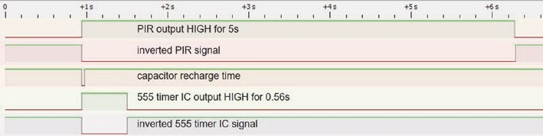
Figure 17-25. PIR sensor and MP3 player signal sequence
Summary
The functionality of the 555 timer IC is described with examples of the 555 timer IC in monostable, bistable, and astable modes. Examples included monostable mode with an incident light used to trigger a time delay, astable mode with an electronic piano, generation of a square wave with fixed frequency and variable duty cycle to control a servo motor or a square wave with fixed duty cycle and variable frequency. The 555 timer IC and resistor-capacitor low-pass filters formed a function generator to produce square waves, triangular waves, and sine waves. The 555 timer IC and an inductor-capacitor filter converted a square wave to a sine wave. Signal transformation by a 555 timer IC and transistors enabled movement detected by a PIR sensor to trigger an MP3 player to play a soundtrack, without requiring a microcontroller.
Components List
- 555 timer IC: Standard NE555 and CMOS TLC555
- Resistor: 2× 220 Ω, 3× 1 kΩ, 2 kΩ, 4.7 kΩ, 2× 10 kΩ, 20 kΩ
- Capacitor: 10 nF, 0.1 μF, 4× 1 μF, 47 μF, 100 μF
- Inductor: 470 μH

Signal generation with 555 timer iC
- Switch tactile: 2×
- LED: 2×
- Diode: 2× IN4001
- Potentiometer: 10 kΩ
- NPN transistor: BC548 or 2N2222
CHAPTER 18
Measuring electricity
Voltage, current, resistance, and capacitance are measured with a multimeter. Understanding the required circuitry and programming an ESP8266 or ESP32 microcontroller to measure voltage, current, resistance, capacitance, and inductance is a valuable exercise when studying electronics. A voltage divider and an analog to digital converter (ADC) are essential to measuring voltage, current, resistance, capacitance, and inductance, which are described prior to the measurement projects. For each project, connection of all components to a common ground defines the voltage reference point. If a project gives unusual results, then check that a common ground has been established.
Voltage divider
A voltage divider reduces an input voltage to a lower output voltage.
A voltage divider consists of an input voltage, V_{IN}, and two resistors, R1 and R2, with the output voltage measured at the junction of the two resistors (see Figure 18-1). The output voltage, V_{OUT}, of the voltage divider æ R2 ö
is V_{IN} × çèR R₁+ ₂÷ø . For example, if the two resistors have equal value, then the output voltage is half of the input voltage. Conversely, given the input voltage, the required output voltage, and the value of resistor R1, the value
æ V^{OUT} ö . For example, the maximum possible of resistor R1 is R2 × çèV V_{IN} - _{OUT} ÷ø
© Neil Cameron 2021 505
N. Cameron, Electronics Projects with the ESP8266 and ESP32, https://doi.org/10.1007/978-1-4842-6336-5_18
Measuring eleCtriCity
input voltage of 12 V is too high to read on the analog pin of an ESP8266 microcontroller, and a voltage divider is required to reduce the maximum voltage to 3.2 V. Given the value of 100 kΩ for resistor R1, the value of resistor R2 is 36.4 kΩ.
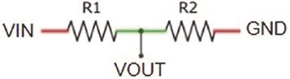
Figure 18-1. Voltage divider
A voltage divider consisting of the resistor pair 1 kΩ and 2 kΩ reduces the input voltage by a third, as does the resistor pair 10 kΩ and 20 kΩ. The difference between the two resistor pairs is that lower power is used and less heat is produced by the 10 kΩ and 20 kΩ resistor pair. Power is the
V^{IN}2 . For an input voltage product of voltage and current, equal to
R R1+ 2
of 5 V, the power used by voltage dividers with the 1 kΩ and 2 kΩ resistor pair and with the 10 kΩ and 20 kΩ resistor pair is 8.33 mW and 0.83 mW, respectively. Therefore, resistors of high resistance are used in a voltage divider to reduce power requirements and heat dissipation by the resistors.
The ESP8266 development board contains an internal voltage divider, consisting of 100 kΩ and 220 kΩ resistors (see Figure 18-2), which increases the maximum voltage on the analog input pin, from the reference voltage of 1 volt to 3.2 V. The ESP8266 microcontroller 10-bit analog to digital converter (ADC) functionality converts a voltage, between 0 and 3.2 V, on the analog input pin A0 to a digital value between 0 and 1023, equal to 2¹⁰ – 1. Given a voltage, V_{IN}, on the ESP8266 development board analog input pin, the corresponding ADC value is
V^{IN} ´(220 100100+ kW)kW´₁₀₂₄.

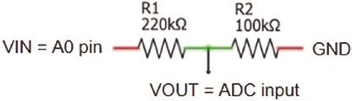
Figure 18-2. Analog to digital converter
ADC values for input voltages between 3.2 V and 3.3 V are constrained to 1023. A 10 kΩ resistor connected between the input voltage and the ESP8266 development board analog input pin increases the limit of 3.2 V on the analog input pin to 3.3 V.
The 12-bit analog to digital converter (ADC) functionality of the ESP32 microcontroller converts a voltage, between 0 and 3.3 V, on an analog input pin to a digital value between 0 and 4095, equal to 2¹² – 1.
Analog to digital converter
Several projects in this chapter use the Successive Approximation Register analog to digital converter (SAR ADC) module of the ESP8266 or ESP32 microcontroller. The 10-bit (ESP8266) or 12-bit (ESP32) ADC converts a voltage, V_{IN}, on an analog input pin to a digital value between 0 and 1023 = 2¹⁰ – 1 or 4095 = 2¹² – 1, relative to a reference voltage, V_{REF}.
Changing the ESP32 microcontroller ADC resolution is described in Chapter 21 (Microcontrollers). For each of 10 (ESP8266) or 12 (ESP32) successive comparisons, V_{IN} is compared to a set voltage, V_{SET(N)}, defined by the microcontroller conversion logic module and generated by the microcontroller digital to analog converter (DAC). Comparison of V_{IN} with the first set voltage, equal to V_{SET(1)} = V_{REF}/2, determines the most significant bit (MSB) of the output ADC digital value. Successive comparisons with set voltages V_{SET(N)} equal to V_{SET(N-1)} ± V_{REF}/2^{N}, with V_{SET(N)} higher than V_{SET(N-1)} if V_{IN} is greater than V_{SET(N-1)}, provide the subsequent bits of the output ADC digital value.
Measuring eleCtriCity
The ADC process is illustrated with an ESP8266 microcontroller. For an input voltage of 1.28 V that is reduced to 0.40 V by the internal voltage divider of the ESP8266 microcontroller, the first set voltage, V_{SET(1)}, is V_{REF}/2 = 0.5 V. As V_{IN} of 0.4 V is lower than V_{SET(1)}, then the MSB of the ADC digital value is set to zero. In the second comparison, V_{SET(2)} = V_{SET(1)} – 1 V/2² = 0.25 V, and as V_{IN} is greater than V_{SET(2)}, then the second bit of the
ADC digital value is set to one and the third set voltage is V_{SET(3)} = V_{SET(2)} + 1 V/2³ = 0.375 V. The ten successive comparisons result in the 10-bit binary value B0110011001 corresponding to the ADC digital output, which has a decimal value of 409. To confirm the ADC digital output, an input voltage of 1.28 V on the ESP8266 development board A0 pin is reduced to 0.4 V, by the internal voltage divider, and scaled by 1024, which results in the integer part of (1024 × 0.4 V/1 V) = 409.
Converting an analog voltage to a digital value takes the ESP8266 microcontroller 135 μs, by which time V_{IN} may have changed. The ADC includes a Sample and Hold module that includes a MOSFET switch, which is opened after the ADC process has started, and a capacitor, on which V_{IN} is held constant (see Figure 18-3). For a 10-bit ADC, there are 1024 voltage classes with levels 0–1023; and given the interval voltage divider and a reference voltage of 1 V, an ADC voltage class spans 3.125 mV. ADC values of 0, 1, and 1023 correspond to V_{IN} values of from 0 V to less than 3.125 mV, from 3.125 mV to less than 6.25 mV, and from 3.197 V to less than 3.2 V, respectively. In the preceding example, the input voltage of 1.28 V is contained in the 410th voltage class of 1.278 V to less than 1.281 V.
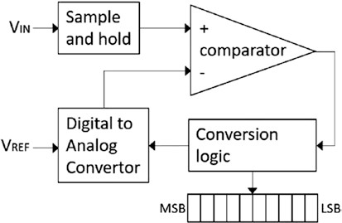
Figure 18-3. Analog to digital converter
Voltage meter
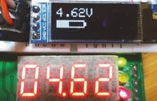
A battery voltage is measured with the ESP8266 or
ESP32 microcontroller ADC. Although the ESP8266 microcontroller internal voltage divider of 100 kΩ and 220 kΩ resistors increases the maximum input voltage to 3.2 V, an additional
voltage divider further reduces the battery voltage on the analog input pin. Voltage divider resistors of 22 kΩ and 10 kΩ enable measurement of a maximum battery voltage of 10.24 V, equal to 3 2. V ^{/ æ}çè ₂₂k¹⁰+^{k}₁₀k^{ö}÷ø. The measured battery voltage is the 10-bit ADC output value multiplied by
10.24 V/2¹⁰, which is displayed on a 128 × 32–pixel OLED screen (see Figure 18-4 with connections in Table 18-1). Instead of the external voltage divider, resistors summing to 702 kΩ and connected in series with the internal voltage divider, also increase the maximum voltage on the ESP8266 microcontroller analog input pin to 10.24 V.

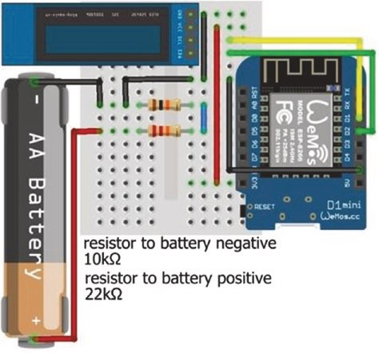
Figure 18-4. Battery voltage measurement with LOLIN (WeMos) D1 mini
Table 18-1. Battery voltage measurement with the
ESP8266 development board
Component | Connect to ESP8266 | And to
Battery positive | 22 kΩ resistor | a0
Battery negative | 10 kΩ resistor | a0
Battery negative | gnD | OleD gnD
OleD VCC | 3V3
OleD sDa | D2
OleD sCl | D1
In Listing 18-1, the battery voltage is displayed on an OLED display with a battery graphic illustrating the battery voltage. The battery frame is drawn as a solid rectangle of 45 × 12 pixels, starting at position (0, 20) on the OLED screen with the instruction oled.fillRect(0, 20, 45, 12, WHITE). The empty battery section is an overlaid black rectangle. The length of the empty battery section is the complement of the measured battery voltage divided by the maximum battery voltage and scaled by 41, the length of the battery frame of 45 pixels minus twice the width of the battery frame of 2 pixels. A battery cap is added as another filled rectangle. The Adafruit SSD1306 library references the Adafruit GFX and Wire libraries, so the #include <Adafruit_GFX.h> and #include <Wire.h> instructions are not required.
Listing 18-1 is for an ESP8266 microcontroller. The only changes to the sketch, when using an ESP32 microcontroller, are definition of the analog input pin, as the ESP32 development board has six analog input pins (see Chapter 21 (Microcontrollers)), inclusion of the instruction pinMode(ADCpin, INPUT), and replacing the divisor 1024 by 4096, in the instruction
voltage = analogRead(ADCpin)*maxVolt/ 1024.0;
// calculate battery voltage
Listing 18-1. Battery voltage measurement
#include <Adafruit_SSD1306.h> // Adafruit SSD1306 library int width = 128; // OLED screen size
int height = 32; // associate oled with SSD1306 Adafruit_SSD1306 oled(width, height, &Wire, -1); int ADCpin = A0; // define analog input pin float maxVolt = 10.24; // maximum battery voltage float voltage; int battery;
void setup()
{ // OLED display and I2C address oled.begin(SSD1306_SWITCHCAPVCC, 0x3C); oled.clearDisplay(); // clear OLED display oled.setTextColor(WHITE); // set font color oled.setTextSize(2); // set font size (1, 2, 3 or 4) oled.display(); // start display instructions
}
void loop()
{ // calculate battery voltage voltage = analogRead(ADCpin)*max Volt/1024.0; oled.clearDisplay();
oled.setCursor(0,0); // position cursor at (0, 0) oled.print(voltage);
oled.print("V"); // display battery voltage oled.fillRect(0, 20, 45, 12, WHI TE); // battery frame 2 pixels width battery = 41*voltage/maxVolt; // full battery section
battery = constrain(battery, 0, 41);
oled.fillRect(2+battery, 22, 41-bat tery, 8, BLACK);
// empty battery section
oled.fillRect(45, 23, 3, 6, WHITE); // battery top oled.display(); delay(2000); // delay 2s between readings }
In practice, voltages measured by the ESP8266 and ESP32 microcontrollers used in this chapter overestimated and underestimated supplied voltages, in the range of 1–3 V, by 3% and -16%, respectively. For comparison, the estimated voltage was not biased when measured with the ATmega328P microcontroller of an Arduino Uno. A biased estimate of N% is corrected by adjusting the measured voltage with the instruction voltage = voltage /(1+N/100), with N negative when the measured voltage is an underestimate.
Voltage meter with a load
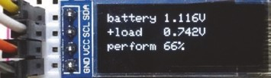
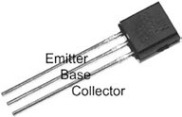
A battery is measured with and without a load using a bipolar junction transistor (BJT) 2N2222 to turn on or off the battery current to a load, consisting of a low-value 10 Ω resistor (see Figure 18-5). The method is adapted from the battery tester of Andreas Spiess. With the BJT off, the battery voltage is measured on the BJT collector pin, collPin. The BJT base pin, basePin, is set HIGH to turn on the BJT, with the battery now
providing power to the load. The voltage across the load and the BJT is again measured on the BJT collector pin. Schematics for the ESP8266 and ESP32 development boards are shown in Figures 18-6 and 18-7, with connections in Table 18-2.
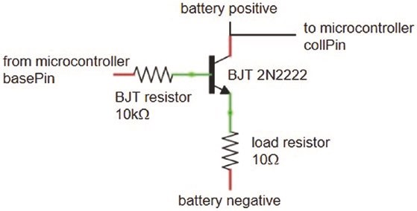
Figure 18-5. Battery voltage measurement with and without a load
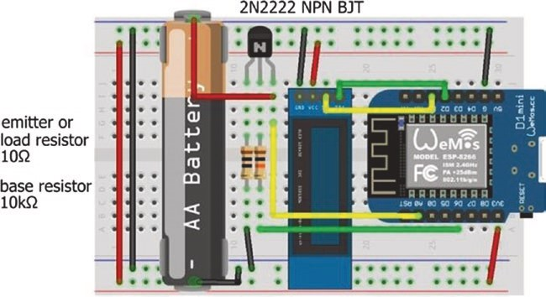
Figure 18-6. Battery voltage tester with LOLIN (WeMos) D1 mini

Measuring eleCtriCity
Table 18-2. Battery voltage tester with ESP8266 and ESP32 development boards
Component | ESP8266 And to | ESP32 | And to
BJt emitter | 10 Ω resistor gnD | 10 Ω resistor | gnD
BJt base | 10 kΩ resistor D6 | 10 kΩ resistor | gpiO 25
BJt collector | a0 Battery positive | gpiO 35 | Battery positive
OleD VCC | 3V3 | 3V3
OleD gnD | gnD | gnD
OleD sDa | D2 | gpiO 21
OleD sCl | D1 | gpiO 22
Battery negative | gnD | gnD
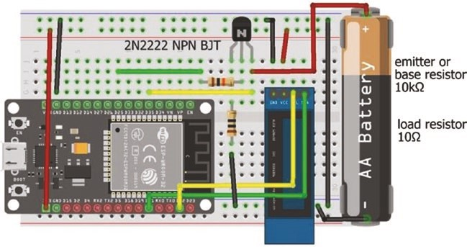
Figure 18-7. Battery voltage tester with the ESP32 DEVKIT DOIT development board
Measuring eleCtriCity
The sketch in Listing 18-2 measures the battery voltage at two-second intervals and displays the battery voltage, with and without the load, on the OLED screen. Repeat measurements of the battery voltage are made in the readings function, with the average ADC reading scaled by the reference voltage.
Listing 18-2 is for an ESP8266 microcontroller. When using an ESP32 microcontroller, the GPIO pin numbers for the BJT base and collector pins are changed (see Table 18-2), the value of maxVolt is increased to 3.3 V, and the instruction pinMode(collPin, INPUT) is included in the setup function. The divisors of 1024 in the loop function are changed to 4096, as the ESP32 microcontroller has a 12-bit ADC compared to the 10-bit ADC of the ESP8266 microcontroller. Subsequent schematics and sketches are demonstrated with a LOLIN (WeMos) D1 mini development board and sketches for an ESP8266 microcontroller. Connections to an ESP32 development board and required changes to the ESP32 microcontroller sketch are similar to those just described.
Listing 18-2. Battery voltage with and without load measurement
#include <Adafruit_SSD1306.h> // SSD1306 library for OLED int width = 128; // OLED screen size
int height = 32; // associate oled with SSD1306 Adafruit_SSD1306 oled(width, height, &Wire, -1); int basePin = D6; // BJT base pin int collPin = A0; // BJT collector pin unsigned long sum;
int reps = 10; // number of repeat measurements float maxVolt = 3.2; // 3.2V maximum voltage float Vbatt, Vload;
Measuring eleCtriCity
void setup()
{
pinMode(basePin, OUTPUT); // define basePin as OUTPUT oled.begin(SSD1306_SWITCHCAPVCC , 0x3C); // OLED I2C address oled.clearDisplay(); // clear OLED display oled.setTextColor(WHITE); // OLED font color oled.setTextSize(1); // font size 1 character 6×8 pixels oled.display(); // start display instructions
}
void loop()
{ readings(LOW); // read BJT collector pin, BJT off Vbatt = maxVolt*sum/(reps*1024.0); // battery voltage if(Vbatt > 0.1)
{ readings(HIGH); // read BJT collector pin, BJT on Vload = maxVolt*sum/(reps*102 4.0); // battery voltage with load screen(); // call screen function
} else
{
oled.clearDisplay(); // clear OLED when oled.display(); // no battery voltage
} delay(2000); // delay between measurements }
Measuring eleCtriCity
void readings(int pinState) // function to measure BJT pin
{
digitalWrite(basePin, pinState); // BJT base pin turned on or off sum = 0; for (int i=0; i<reps; i++) // repeat voltage measurements { // sum of voltage measurements sum = sum + analogRead(collPi n); delay(5);
} digitalWrite(basePin, LOW); // turn off BJT base pin
} void screen() // function for OLED display
{
oled.clearDisplay(); // clear OLED display oled.setCursor(0,0); // move cursor to position (0,0) oled.print("battery ");oled.print(Vbatt,3);oled.println("V"); oled.setCursor(0, 12); oled.print("+load ");oled.print(Vload,3);oled.print("V"); oled.setCursor(0, 24);
oled.print("perform ");oled.print(100.0*Vload/Vbatt,0);
oled.print("%"); oled.display();
}

Resistance meter (ohmmeter)
The value of an unknown resistor is determined with a voltage divider. Given an input voltage, V_{IN}, the corresponding ADC output value of the voltage
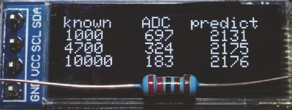
^{IN} _{REF} is the ADC reference voltage for a V_{REF} R R1+ 2
divider is
V
R
´
´
2
1024
, where
V
microcontroller with a 10-bit ADC, as 1024 = 2¹⁰. If the input and reference
R ADC¹´
voltages are the same, then rearranging the formula gives R2 = ₁₀₂₄-ADCΩ.
Rather than using a known resistor with one value in the voltage divider, resistors with several values provide a range of known resistances to reference the unknown resistor. Specific values of the known resistors are arbitrary, but they could span a range such as 1 kΩ, 4.7 kΩ, and 10 kΩ, which enables reliable measurement of resistance values between 1 kΩ and 10 kΩ. The layout is shown in Figure 18-8 with connections given in Table 18-3.
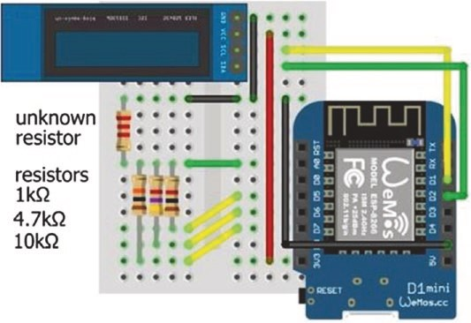
Figure 18-8. Resistor meter (ohmmeter) with LOLIN (WeMos) D1 mini
Table 18-3. Resistor meter (ohmmeter) with the ESP8266 development board
Component | Connect to ESP8266 | And to
Known resistors | D5, D6, D7 | a0
unknown resistor | a0 | gnD
OleD VCC | 3V3
OleD gnD | gnD
OleD sDa | D2
OleD sCl | D1
In Listing 18-3, prior to obtaining the ADC readings, the known resistor pins are set to INPUT, so that no current flows, which is equivalent to connecting a 100 MΩ resistor to each pin. Each known resistor pin is sequentially set to OUTPUT, with a HIGH signal, which sets the voltage on the known resistor pin to the voltage divider input voltage. The unknown resistor value is determined, with a constraint on the ADC reading to avoid extreme values, and the known resistor pin is again set to INPUT. In Figure 18-8, the known resistor with the lowest value is connected to the lowest of the ESP8266 development board pin numbers: D5, D6, and D7.
Listing 18-3. Resistance meter (ohmmeter)
#include <Adafruit_SSD1306.h> // Adafruit SSD1306 library int width = 128; // OLED screen size
int height = 32; // associate oled with SSD1306 Adafruit_SSD1306 oled(width, height, &Wire, -1); int resistPin = A0; // analog input pin int pin[] = {D5, D6, D7}; // pins for known resistor float known[] = {1000.0, 4700.0, 10000.0}; // known resistor values float resist, reading;
void setup()
{ // OLED display and I2C address oled.begin(SSD1306_SWITCHCA PVCC, 0 x3C); oled.clearDisplay(); // clear OLED display oled.setTextColor(WHITE); // set font color oled.setTextSize(1); // set font size (1, 2, 3 or 4) oled.display(); // update display instructions
for (int i=0; i<3; i++) pinMode(pin[i], INPUT);
} // set known resistor pins to INPUT
void loop()
{
oled.clearDisplay(); // clear OLED display oled.setCursor(0,0);
oled.print("known ADC predict"); // header on OLED screen for (int i=0; i<3; i++) // for each known resistor
{
pinMode(pin[i], OUTPUT); // set known resistor pin digitalWrite(pin[i], HIGH); // to OUTPUT and to HIGH reading = analogRead(resistPin); // voltage divider reading if(reading < 10 || reading > 1013) reading = 0;
// constrain ADC reading
resist = known[i]*reading/(1024.0-r eading);
// calculate resistance
pinMode(pin[i], INPUT); // reset known resistor pin to INPUT oled.setCursor(1, (i+1)*8); // OLED column 1, row 8, 16, 24 oled.print(known[i],0); // display known resistor
oled.setCursor(50, (i+1)*8);
oled.print(reading,0); // display ADC reading oled.setCursor(90, (i+1)*8);
oled.print(resist,0); // display calculated resistance oled.display();
}
delay(5000); }
Capacitance meter
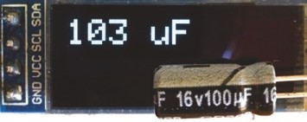
The capacitance of a capacitor is measured from the charging time of the capacitor. When a resistor, R, is connected in series with a capacitor, C, the capacitor will charge through
the resistor until the voltage across the capacitor equals the reference voltage, V_{REF} (see Figure 18-9). The voltage across the capacitor after t seconds of charging is V_{REF}(1 − e^{−t/RC}). After RC seconds of charging, the voltage across the capacitor is 0.632 V_{REF}, as (1 − e−¹) = 0.632. The value of RC is determined when the analog to digital converter (ADC) reading for the voltage across the capacitor exceeds 647.3 = 0.632×1024, as the ADC equates 0 V to 0 and V_{REF} to 1023. The parameter RC is also written as τ, the Greek letter tau.
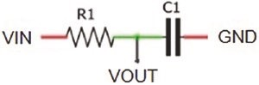
Figure 18-9. Resistor-capacitor combination
Electrolytic capacitors are polarized, and the anode must be at a higher voltage than the cathode (negative leg). The cathode has a minus sign marking and a colored stripe on the side of the capacitor. The long leg of an electrolytic capacitor is the anode or positive leg (see Figure 18-10 and Table 18-4). If the capacitor charging time is too short, then the 10 kΩ charging resistor is replaced with a higher value; and, conversely, the 10 kΩ resistor is replaced with a lower value if the capacitor charging time is too long. Higher values of the charging resistor extend the capacitor charging time for more precise capacitance estimates. In contrast, a low value of the discharge resistor results in a rapid capacitor discharge.
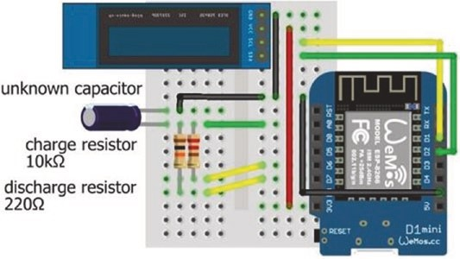
Figure 18-10. Capacitance meter with LOLIN (WeMos) D1 mini
Table 18-4. Capacitance meter with the ESP8266 development board
Component | Connect to ESP8266 | And to
Charge resistor | D7 | a0
Discharge resistor | D6 | a0
unknown capacitor positive | a0
unknown capacitor negative | gnD | OleD gnD
OleD VCC | 3V3
OleD sDa | D2
OleD sCl | D1
In Listing 18-4, the capacitor charge pin is set HIGH, and the timing of the charging capacitor starts. When the ADC value for the voltage across the capacitor reaches 648, the timing stops, and the capacitance is calculated from the charging time and the resistor value. Both the capacitor charge and discharge pins are then set LOW to allow the capacitor to discharge, after which the capacitor discharge pin is set to INPUT, so that no current flows through the discharge pin, and the cycle repeats. Setting a pin to INPUT is equivalent to connecting a 100 MΩ resistor in series with the pin. A lower limit to the estimated capacitance value is set at 10 nF. The sketch in Listing 18-4 was developed from the sketch at www.arduino.cc/en/Tutorial/CapacitanceMeter.
Listing 18-4. Capacitance meter
#include <Adafruit_SSD1306.h> // Adafruit SSD1306 library int width = 128; // OLED screen size
int height = 32; // associate oled with SSD1306 Adafruit_SSD1306 oled(width, height, &Wire, -1); int capPin = A0; // capacitor positive pin int chargePin = D7; // pin with 10kΩ charge resistor int dischargePin = D6; // 220Ω discharge resistor pin float resistor = 10000.0; // 10kΩ charge resistor unsigned long startTime;
float mF, uF, nF; // uF for microF (Greek letter μ)
void setup()
{ // OLED display and I2C address oled.begin(SSD1306_SWITCH CAPVCC, 0x3C); oled.clearDisplay(); // clear OLED display oled.setTextColor(WHITE); // set font color oled.setTextSize(2); // set font size (1, 2, 3 or 4) oled.display(); // update display instructions pinMode(chargePin, OUTPUT); // set charge pin digitalWrite(chargePin, LOW); // as OUTPUT and to 0V
}
void loop()
{
oled.clearDisplay(); oled.setCursor(0,0);

Measuring eleCtriCity
digitalWrite(chargePin, HIGH); // charge pin to reference voltage startTime = millis(); // start timing charging capacitor while(analogRead(capPin) < 648) {} // do nothing while ADC < 648 mF = (millis() - startTime) / resistor;
// calculate capacitance = time/R
uF = 1000.0 * mF; // change millifarad to microfarad if (uF > 1)
{
if (uF < 10) oled.print(uF, 1); // display capacitance with 1DP else oled.print(uF, 0); // or 0DP depending on value oled.print(" uF");
} else
{
nF = 1000.0 * uF; // convert to nanofarad if (nF > 10) // only display if value > 10nF
{
oled.print(nF, 0); // display capacitance oled.print(" nF");
}
}
digitalWrite(chargePin, LOW); // set charge pin to 0V pinMode(dischargePin, OUTPUT); // set discharge pin digitalWrite(dischargePin, LOW); // to OUTPUT and 0V while(analogRead(capPin) > 0) {} // do nothing while capacitor
// discharges
pinMode(dischargePin, INPUT); // set discharge pin to INPUT oled.display(); delay(2000); // to ensure no current flows }
More significant figures for capacitors with low values are obtained by replacing the millis function with the micros function to measure the time interval in microseconds, rather than milliseconds, and dividing (micros()-startTime) by 1000. The 32-bit timer counts to 2³² – 1 and then resets, so the millis and micros functions reset after 49.7 days and 71.58 minutes, respectively.
Current meter (ammeter)
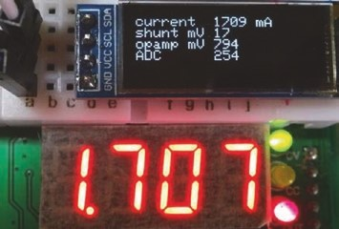
Current (I) in a circuit is measured from the voltage (V) across a known resistor (R) that is specifically included in the circuit, as I = V/R. The resistor must have low resistance, so that the circuit voltage is not significantly decreased by the resistor. A 0.01 Ω current shunt is a
resistor defined by the maximum allowable current and the voltage drop at that current, such as 100 mV at 10 A. The power through a low-value resistor, V²/R, is high, but a current shunt resistor is designed to distribute the generated heat.
The expected voltage across a 0.01 Ω shunt resistor is 10 mV per amp of current, so measuring current with a shunt resistor alone has low resolution (e.g., as in Figure 18-11). With the ESP8266 microcontroller 10- bit analog to digital converter (ADC), a current increase of 1 amp increases the ADC value by 3.2 = 10 mV × 2¹⁰/V_{REF}, given the ESP8266 microcontroller reference voltage of 3.2 V. Conversely, a unit increase in the ADC value corresponds to an increased voltage of 3.125 mV or 3.2 V/2¹⁰ across the 0.01 Ω shunt resistor and to an increased current of 312 mA.
Measuring eleCtriCity
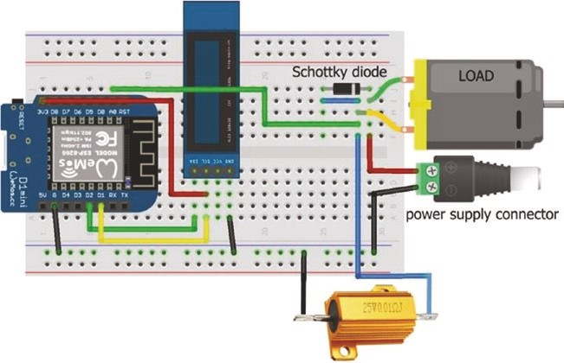
Figure 18-11. Shunt resistor and LOLIN (WeMos) D1 mini
An operational amplifier, such as an LM358, or an instrumental amplifier, such as an AD623, amplifies the voltage from the shunt resistor to increase resolution of the current measurement. The amplification
R^{feedback} gain of the LM358 operational amplifier, 1+ , is determined by
R_{GND}
the feedback and ground (GND) resistors (see Figure 18-12). The non- inverting operational amplifier connected to the two resistors, R_{GND} and R_{feedback}, forms a voltage divider. Voltages on the operational amplifier output and the inverting input terminals are equivalent to the voltage divider input and output voltages. The output voltage, V_{OUT}, of a voltage
æ R² ö
divider is V_{IN} × çèR R₁+ ₂÷ø . Incorporating the resistor values in the formula gives Vop amp IN =Vop ampOUT ´ççèæRfeedbacRkGND+RGND ÷÷øö and the operational amplifier
V^{op ampOUT} = +1 R^{feedback} . For example, an amplification gain of 46 gain of
Vop amp IN RGND
is obtained with a 100 kΩ and 2.2 kΩ resistor pair. A 0.1 uF capacitor is connected to the operational amplifier output to reduce noise.
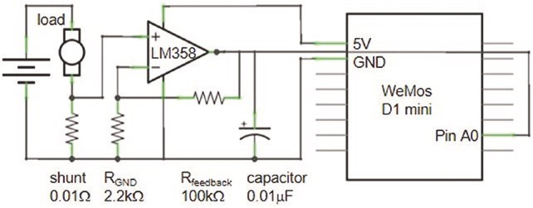
Figure 18-12. Non-inverting operational amplifier
The operational amplifier gain in voltage increases the resolution of the current meter. For example, given a current of 1 A, the 100 kΩ and 2.2 kΩ resistor pair increases the LM358 operational amplifier output voltage from 10 mV to 465 mV, producing an ADC value of 149 = gain × 10 mV × 1024/V_{REF} that is substantially higher than the ADC value of 3 without amplification. Likewise, a unit change in the ADC value corresponds to a shunt voltage change of 0.067 mV = V_{REF}/(1024 × gain), mapping to a current differential of only 6.7 mA.
In Figure 18-13, an LM358 operational amplifier is added to the schematic in Figure 18-11 to amplify the voltage from the shunt resistor to both increase the ADC value and the resolution of the current meter.
Connections are given in Table 18-5.
Measuring eleCtriCity
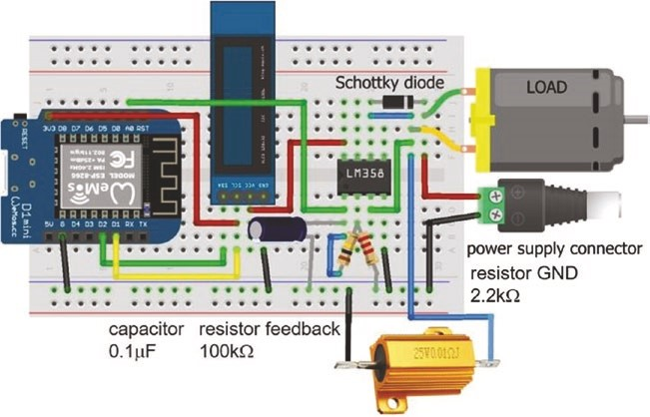
Figure 18-13. Operational amplifier, shunt resistor, and LOLIN (WeMos) D1 mini
If the load is a DC motor, then the motor, which is partially an inductor, will generate a voltage to maintain current when power to the motor is switched off. Fitting a diode across the motor prevents a voltage spike and dissipates energy through the motor when power is switched off. A Schottky diode, which is a fast-switching diode with a low forward voltage drop, is recommended.
Table 18-5. Operational amplifier, shunt resistor, and ESP8266 development board
Component | Connect to | And to
lM358 output (pin 1) | esp8266 a0
lM358 output (pin 1) | Capacitor | esp8266 gnD
lM358 inverting input (pin 2) | Feedback resistor | lM358 output (pin 1)
lM358 inverting input (pin 2) | gnD resistor | esp8266 gnD
lM358 non-inverting input (pin 3) | load negative
lM358 gnD (pin 4) | esp8266 gnD
lM358 VCC (pin 8) | esp8266 3V3
load positive | schottky diode cathode (stripe) | Battery positive
load negative | schottky diode anode | shunt resistor 0.01 Ω
esp8266 gnD | shunt resistor 0.01 Ω | Battery negative
OleD VCC | esp8266 3V3
OleD gnD | esp8266 gnD
OleD sDa | esp8266 D2
OleD sCl | esp8266 D1
The sketch (see Listing 18-5) converts the ADC reading to the operational amplifier voltage output, which is converted to a voltage across the shunt, according to the specification of the current shunt and the operational amplifier gain, and then to the current through the load.
Repeated ADC readings are averaged to reduce noise.
Measuring eleCtriCity
Listing 18-5. Ammeter with shunt resistor
#include <Adafruit_SSD1306.h> // Adafruit SSD1306 library int width = 128; // OLED screen size int height = 32; // associate oled with SSD1306 Adafruit_SSD1306 oled(width, height, &Wire, -1); int ADCpin = A0; unsigned long ADC;
int Rfeedback = 100000; // feedback resistor value int RGND = 2200; // resistor GND value float current, opAmpmV, shuntmV, gain;
void setup()
{
Serial.begin(115200);
oled.begin(SSD1306_SWITCH CAPVCC, 0x3C);
// OLED display and I2C address
oled.clearDisplay(); // clear OLED display oled.setTextColor(WHITE); // set font color oled.setTextSize(1); // set font size (1, 2, 3 or 4) oled.display(); // update display instructions gain = 1.0 + Rfeedback/RGND; // calculate op amp gain
}
void loop()
{
ADC = 0; for (int i=0; i<100; i++) // repeated analog readings
{
ADC = ADC + analogRead(ADCpin); delay(10);
}
ADC = ADC/100; // average of analog readings opAmpmV = ADC*3200.0/1024; // op amp output voltage shuntmV = opAmpmV / gain; // voltage on shunt current = 100.0 * shuntmV; // shunt mV to current in mA oled.clearDisplay();
oled.setCursor(0,0); // display results on OLED oled.print("current");oled.print(current,0); oled.println(" mA"); oled.print("shunt mV ");oled.println(shuntmV,0); oled.print("opamp mV ");oled.println(opAmpmV,0); oled.print("ADC ");oled.println(ADC); oled.display(); delay(1000); }
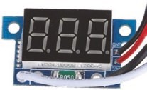
Figure 18-14 illustrates current measurement with a multimeter and by an ammeter with an LED display. In both cases, the meter is inserted in series with the load, although the circuit layout with the shunt resistor and the operational amplifier in Figure 18-13 is not as obvious. The ammeter with an LED display has a 0.05 Ω (R050) shunt resistor and is externally powered.
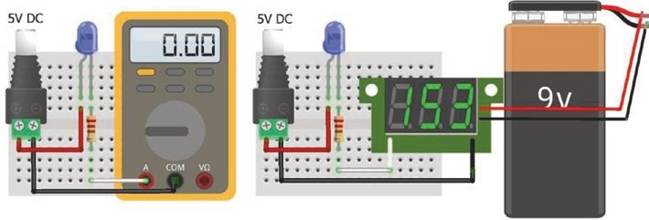
Figure 18-14. Current meter (ammeter)
Measuring eleCtriCity
Current sensor
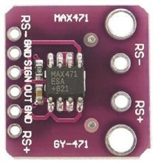
Current is measured by the MAX471 module, with an upper limit of 3 A. The load positive is connected to the MAX471 RS- pin and the load negative to GND, with the load power supply positive connected to the MAX471 RS+ pin (see Figure 18-15 with connections in Table 18-6). The default resolution of the MAX471 module is 3.125 mA, equal to 3.2 A/2¹⁰, given the 10-bit ADC of the ESP8266 microcontroller. The voltage on the MAX471 OUT pin is ideally equivalent to 1 volt per amp of current. The MAX471 SIGN pin indicates a discharging or charging battery, with an analog reading greater than 50 or near zero, respectively.
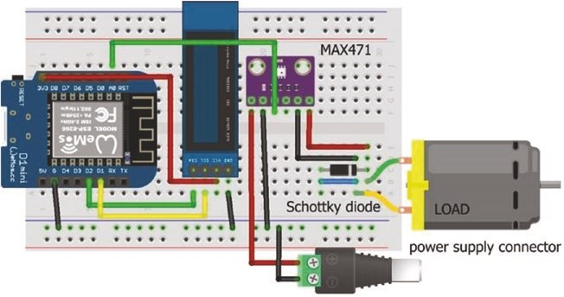
Figure 18-15. Current sensor MAX471 with LOLIN (WeMos) D1 mini Table 18-6. Current sensor MAX471 and
ESP8266 development board
Component | Connect to | And to
MaX471 rs+ | Battery positive
MaX471 gnD | Battery negative | esp8266 gnD
MaX471 Out | esp8266 a0
MaX471 sign  MaX471 gnD | load negative
MaX471 rs- | load positive
OleD VCC | esp8266 3V3
OleD gnD | esp8266 gnD
OleD sDa | esp8266 D2
OleD sCl | esp8266 D1
In the sketch (see Listing 18-6), the current for a load is measured with the MAX471 module, with measurements displayed every five seconds.
Listing 18-6. Current sensor MAX471 and ESP8266 development board
#include <Adafruit_SSD1306.h> // Adafruit SSD1306 library int width = 128; // OLED screen size
int height = 32; // associate oled with SSD1306 Adafruit_SSD1306 oled(width, height, &Wire, -1); int currentPin = A0; // analog input pin float current;

void setup()
{
oled.begin(SSD1306_SWITCHCAPVCC, 0x3C); // OLED I2C address oled.clearDisplay(); // clear OLED display oled.setTextColor(WHITE); // set font color oled.setTextSize(3); // set font size (1, 2, 3 or 4) oled.display(); // update display instructions
}
void loop()
{
current = analogRead(currentPin); // analog MAX471 reading current = 1000*current*3.2/1024; // convert to current oled.clearDisplay();
oled.setCursor(0,0); // position cursor oled.print(current,0); oled.print(" mA"); // display current oled.display(); delay(5000); }
Current and voltage sensor
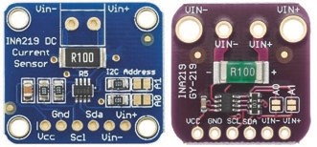
Both current and voltage are measured with the INA219 module, which has at least two formats, from which the corresponding power and energy over time are derived. The
Adafruit INA219 library instructions
getShuntVoltage_mV() and getBusVoltage_V() provide the voltage across the INA219 0.1 Ω (R100) shunt resistor and across the load pins, equal to the supply voltage minus the shunt voltage. The power measurement is obtained with the instruction getPower_mW() or calculated as the product of voltage and current (see Figure 18-16 with connections in Table 18-7).
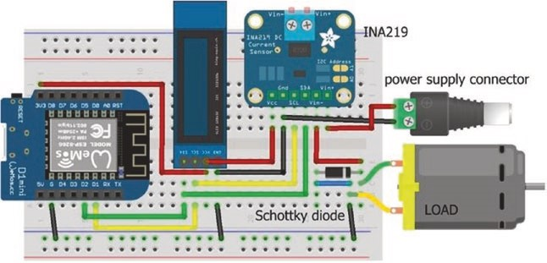
Figure 18-16. Current sensor (INA219) and LOLIN (WeMos) D1 mini
The INA219 module measures the voltage across a 0.1 Ω shunt resistor with a maximum voltage input of 320 mV. The maximum current that the INA219 module measures is 3.2 A, equal to 320 mV/0.1 Ω. The default resolution of the INA219 module is 0.8 mA, equal to 3.2 A/2¹² = 3.2 A/4096, given the INA219 12-bit analog to digital converter (ADC). The resolution is increased to 0.1 mA, equal to 400 mA/2¹², by reducing the INA219 amplifier gain by a factor of eight, resulting in a maximum voltage input of 40 mV and maximum current of 400 mA. Instructions for the default and high resolution settings are setCalibration_32V_2A() and setCalibration_16V_400mA(), respectively. An intermediate resolution option is available with the setCalibration_32V_1A() instruction.
The INA219 module uses I2C (Inter-Integrated Circuit) for communication with the ESP8266 or ESP32 microcontroller, and the Adafruit INA219 library references the Wire library, so the #include
<Wire.h> instruction is not required. The default I2C address of the INA219 module is 0x40, which is changed to 0x41, 0x44, or 0x45 by bridging the module A0 jumper, the A1 jumper, or both the A0 and A1 jumpers, respectively. For example, the I2C address is defined as 0x41, with the instruction Adafruit_INA219 ina219(0x41). Note that if the default I2C address is used, then the instruction Adafruit_INA219 ina219 is sufficient.
If the load is a DC motor, then the motor, which is partially an inductor, will generate voltage to maintain current when power to the motor is switched off. Fitting a diode across the motor will prevent a voltage spike and dissipate energy through the motor when power is switched off. A Schottky diode, which is a fast-switching diode, is recommended.
Table 18-7. Current sensor (INA219) with the ESP8266 development board
Component | Connect to ESP8266 | And to
ina219 VCC | 3V3
ina219 gnD | gnD | Battery negative
ina219 sCl | D1
ina219 sDa | D2
ina219 Vin- | load positive
ina219 Vin+ | Battery positive
schottky diode cathode (stripe) | load positive
schottky diode anode | load negative | ina219 gnD
OleD VCC | 3V3
OleD gnD | gnD
OleD sDa | D2
OleD sCl | D1
Listing 18-7 measures the current, power, and cumulative energy for a load with the INA219 module, with measurements displayed every five seconds. The second OLED screen displays the supply and load voltages.
The high precision option is selected with the maximum current of 400 mA.
Listing 18-7. Current sensor (INA219)
#include <Adafruit_INA219.h> // define Adafruit_INA219 lib
Adafruit_INA219 ina219; // default I2C, associate ina219 with lib
#include <Adafruit_SSD1306.h> // Adafruit SSD1306 library int width = 128; // OLED screen size
int height = 32; // associate oled with SSD1306 Adafruit_SSD1306 oled(width, height, &Wire, -1); float shunt, load, supply, current, power; float energy = 0;
void setup()
{
ina219.begin();
// ina219.setCalibration_32V_2A(); // default precision option // ina219.setCalibration_32V_1A(); // intermediate option ina219.setCalibration_16V_400mA(); // high precision option oled.begin(SSD1306_SWITCHCAPVCC, 0x3 C); // OLED I2C address oled.clearDisplay(); // clear OLED display oled.setTextColor(WHITE); // set font color oled.setTextSize(1); // set font size (1, 2, 3 or 4) oled.display(); // update display instructions }
void loop()
{
shunt = ina219.getShuntVoltage_mV(); // shunt voltage in mV load = ina219.getBusVoltage_V(); // load voltage in V supply = load + shunt / 1000.0; // supply voltage in V current = ina219.getCurrent_mA(); // current in mA power = ina219.getPower_mW(); // power in mW energy = energy + power / 3600.0; // energy in mAh oled.clearDisplay();
oled.setCursor(0,0); // display results oled.print("current ");oled.print(current,0);
oled.println(" mA");
oled.print("shunt ");oled.print(shunt,0); oled.println(" mV"); oled.print("power ");oled.print(power,0); oled.println(" mW"); oled.print("energy ");oled.print(energy,0); oled.print(" mAh"); oled.display(); delay(5000); oled.clearDisplay();
oled.setCursor(0,0); // display supply and load V oled.print("supply ");oled.print(supply); oled.println(" V"); oled.print("load ");oled.print(load); oled.println(" V"); oled.display(); delay(5000); }
Solar panel and battery meter
A current and voltage measurement application is monitoring the net battery charge or discharge current of a battery providing power to a load and charging through a solar panel. The solar panel and battery output currents and the battery voltage are displayed graphically on an ST7735 TFT LCD screen with the minimum, present, and maximum battery output currents, the present battery voltage, and the cumulative battery energy output (see Figure 18-17). The graph displays the battery current output with positive values for a discharging battery and negative values for a charging battery.
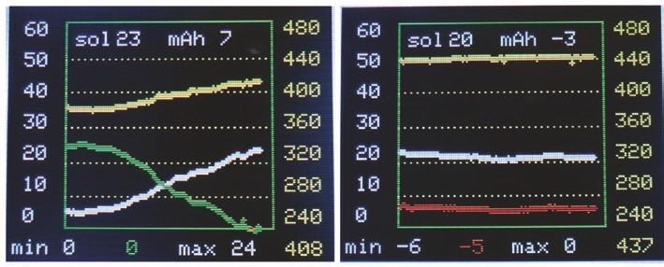
Figure 18-17. Solar panel current with battery current and voltage display
Time is on the X-axis with the solar panel and battery current output on the left Y-axis and battery voltage on the right Y-axis. Figure 18-17 (left graph) demonstrates the combination of a solar panel and battery providing power for an LED. As the solar panel current (white line on the left axis) increased from 5 mA with increasing sunshine, the battery current output (green line on the left axis) decreased, and the battery voltage increased to 4.08 V (value below and yellow line on the right axis) with the present solar panel current output of 23 mA (sol 23). The minimum, present, and maximum battery current outputs are displayed below the graph. Over the time period, the battery energy output was 7 mAh (see Figure 18-18 for screen layout).
When the LED was removed (Figure 18-17, right graph), the solar panel current output (white line on the left axis) was 20 mA, the battery current output of -5 mA indicated the battery was charging (red line on the left axis), and the total energy provided to the battery was 3 mAh. The battery voltage was maintained at 4.4 V (yellow line on the right axis).

Measuring eleCtriCity
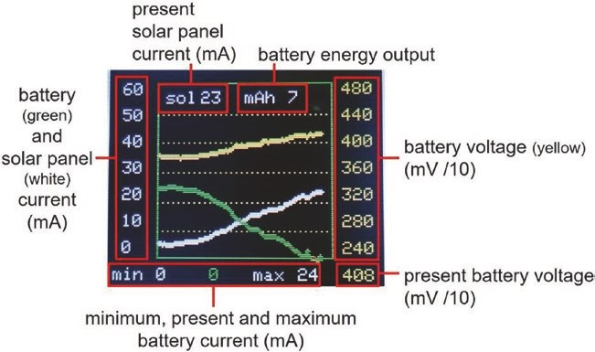
Figure 18-18. Explanation of screen display
The solar panel charges a 3.7 V lithium battery through the TP4056 battery protection module (see Figure 18-19). The TP4056 battery protection module terminal pair IN- and OUT- are internally connected, as are the terminal pair OUT+ and B(battery)+. In contrast, the terminal pair B- and OUT- are internally connected only when there is a voltage on the B+ terminal. Further details of the TP4056 battery protection are given in Chapter 6 (Bluetooth speaker). An MT3608 DC to DC step-up boost converter power supply module increases the 3.7 V lithium battery output voltage to 5 V, as required by the load. The MT3608 boost converter terminals VIN- and VOUT- are internally connected. Solar panel and battery output currents are measured with INA219 modules. The graph scale for current output is changed from 0–60 mA to 0–300 mA by an interrupt service routine (ISR) that defines the graph maximum value, with the ISR triggered by a switch. The maximum voltage on the ESP8266 microcontroller analog input pin is 3.2 V; and a voltage divider consisting of two 10 kΩ resistors reduces, by half, the battery voltage on the analog input pin. Component connections are given in Table 18-8.
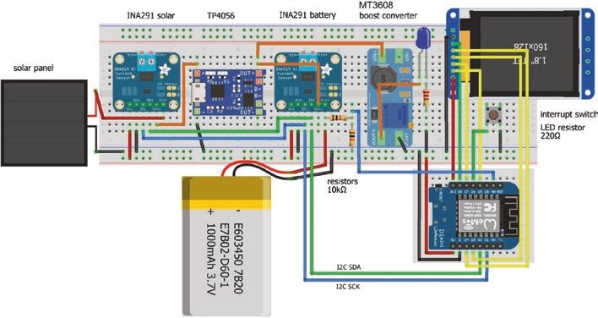
Figure 18-19. Solar panel and battery current meter
Table 18-8. Solar panel and battery current meter
Component | Connect to | And to
solar ina219 Vin+ | solar panel positive
solar ina219 Vin- | tp4056 (in) +
Battery ina219 Vin+ | Battery positive
Battery ina219 Vin- | tp4056 Out+/B+
Boost converter Vin+ | tp4056 Out+/B+
Boost converter VOut+ | load positive
esp8266 D2 (sDa) | solar ina219 sDa | Battery ina219 sDa
esp8266 D1 (sCl) | solar ina219 sCl | Battery ina219 sCl
esp8266 a0 | 10 kΩ resistor voltage divider | Battery positive
st7735 tFt lCD gnD | esp8266 gnD
(continued)
Measuring eleCtriCity
Table 18-8. (continued)
Component | Connect to | And to
st7735 tFt lCD Cs | esp8266 D8 (spi Cs)
st7735 tFt lCD reset | esp8266 D4
st7735 tFt lCD a0 or DC | esp8266 D3
st7735 tFt lCD sDa | esp8266 D7 (spi MOsi)
st7735 tFt lCD sCK | esp8266 D5 (spi sCl)
st7735 tFt lCD leD | esp8266 3V3
switch | esp8266 D6 | esp8266 gnD
esp8266 5V | solar ina219 VCC | Battery ina219 VCC
esp8266 gnD | solar ina219 gnD | Battery ina219 gnD
esp8266 gnD | solar panel negative | tp4056 (in) -
esp8266 gnD | Boost converter VOut- | load negative
esp8266 gnD | Battery negative
The first section of the sketch, in Listing 18-8, defines libraries and variables, with the setup function initializing the INA219 modules, the ST7735 TFT LCD screen, and the interrupt. The graph function creates the graph display, with data points plotted and graph updates drawn by the screenVal and detail functions, respectively. The screenVal function displays minimum, present, and maximum battery current outputs, below the graph. The detail function calculates cumulative energy output by the battery that is displayed along with the solar panel current output. In both the screenVal and detail functions, black rectangles over-print the previous text and values, as the displayed text and values may require fewer characters. The instruction setTextColor(color, BLACK) over- prints existing text only. HEX codes for colors are defined in the Adafruit_ ST77xx.h file in the Adafruit_ST7735_and_ST7789 library.
In the loop function, the battery and solar panel current outputs and the battery voltage are measured and plotted, with the screenVal function called to display values. To differentiate between a discharging and a charging battery, the color of a displayed value and the graph data points change from green to red, with a negative (charging) graph point plotted by changing the sign of the charging battery current. The baseline of the graph is on row 110 of the ST7735 TFT LCD screen, and with a graph height of 100, a point corresponding to the battery current is plotted on row 110 – 100 × (current/maximum value). For example, if the maximum value of the current axis is 60 mA, then a battery output current of 18 mA is plotted on row 80 = 110 – 100 × 18/60. The graph function displays the graph boundary using the library fillRect and drawRect functions, calculates and displays the Y-axis labels for the battery current and battery voltage, and prints five dotted lines across the graph to aid interpretation of the graph. The interrupt service routine (ISR), scale, changes the maximum value of the battery current axis on the graph.
With two INA219 modules, two I2C addresses are required to differentiate between the modules. The default I2C address of 0x40 is used by the solar panel INA219 module, and the battery INA219 module has an I2C address of 0x41, with the instruction Adafruit_INA219 inaBatt(0x41) with the module A0 jumper bridged. The ST7735 TFT LCD screen communicates with Serial Peripheral Interface (SPI), although the ST7735 TFT LCD screen MOSI pin is labeled SDA. The Adafruit ST7735 library references the Adafruit_GFX library, so the #include <Adafruit_GFX. h> instruction is not required. The ST7735 TFT LCD screen orientation is set to either portrait or landscape by the setRotation(N) instruction with value of 0 or 1, respectively, or with 2 or 3 to rotate the image by 180° for portrait or landscape, respectively.

Listing 18-8. Solar panel and battery meter
#include <Adafruit_INA219.h> // define Adafruit INA219 library
Adafruit_INA219 inaSolar; // associate inaSolar and inaBatt with lib
Adafruit_INA219 inaBatt(0x41); // I2C address 0x41, 0x40 is default #include <Adafruit_ST7735.h> // include the ST7735 library int TFT_CS = D8; // ST7735 screen chip select pin int DCpin = D3; // ST7725 screen DC pin int RSTpin = D4; // ST7735 screen reset pin // associate tft with Adafruit_ST7735 lib Adafruit_ST7735 tft = Adafruit_ST7735(TFT_CS, DCpin, RSTpin); int batVPin = A0; // battery voltage reading pin int scalePin = D6; // scale pin for interrupt
unsigned int BLACK = 0x0000; unsigned int YELLOW = 0xFFE0;
unsigned int GREEN = 0x07E0; // HEX codes for colors unsigned int RED = 0xF800; unsigned int WHITE = 0xFFFF;
int maxRead = 99; // maximum readings per screen int n = 0; // reading number int maxVal = 0; // initial maximum and minimum int minVal = 1000; // for battery output int initialY = 60; // initial maximum of Y axis int alterY = 300; // alternative maximum of Y axis volatile int maxY; // actual maximum Y axis float maxV = 4.80; // maximum and minimum value
float minV = 2.40; // for battery voltage float labelV = (maxV-minV)/6.0; // 6 labels on battery voltage axis int delayTime = 5; // delay (s) between readings float energy = 0; // cumulative energy output float batt, solar; // battery and solar current float battV; // battery voltage float battS, solarS, battVS; // scaled values for graph int labelY, newmaxY, batDirect;
void setup()
{
inaSolar.begin(); // initialise INA219 modules inaBatt.begin();
inaSolar.setCalibration_16V_400 mA(); // 16V, 400mA range inaBatt.setCalibration_16V_400mA();
tft.initR(INITR_BLACKTAB); // initialise ST7735 screen tft.fillScreen(BLACK); // clear screen tft.setRotation(3); // orientate ST7735 screen tft.drawRect(0,0,160,128,WHITE); // draw white frame line tft.drawRect(1,1,158,126,WHITE); // and second frame line maxY = initialY; // set graph axes newmaxY = initialY;
graph(); // call graph function pinMode(scalePin, INPUT_PULLUP); // set pin state HIGH attachInterrupt(digitalPinToInterrupt(scalePin), scale, FALLING);
}
void loop()
{ if(newmaxY != maxY) // change graph Y axis
{
newmaxY = maxY;
graph(); // call graph function
n = 0; // set number of readings to zero }
n++; // increment reading number if(n > maxRead)
{ // new screen if n > maximum graph(); n = 0;
}
batt = inaBatt.getCurrent_mA(); // battery current output if(batt < minVal) minVal = batt; // update minimum and if(batt > maxVal) maxVal = batt; // maximum battery current screenVal(WHITE, minVal, 5, "min"); // display minimum and screenVal(WHITE, maxVal, 85, "max"); // maximum battery current solar = inaSolar.getCurrent_mA(); // solar panel current reading solarS = 110-100.0*solar/maxY; // scale solar panel reading tft.fillCircle(25+n, solarS, 1, W HITE);
// plot scaled solar panel reading
if(batt < 0)
{ // when battery charging screenVal(RED, batt, 35, ""); // change line color to RED battS = 110+100.0*batt/maxY; // scale battery reading tft.fillCircle(25+n, battS, 1, RED );
} // plot scaled battery reading else
{ // when battery discharging screenVal(GREEN, batt, 35, ""); // change line color to GREEN battS = 110-100.0*batt/maxY;
tft.fillCircle(25+n, battS, 1, GREEN);
} // double battery reading battV = 2.0*analogRead(batVPin); // due to voltage divider battV = 3.2 * battV /1024.0; // battery voltage screenVal(YELLOW, battV*100, 105, "");
// change color to YELLOW
battVS = 110-100.0*(battV-minV)/ (m axV-minV);
// scale battery voltage
tft.fillCircle(25+n, battVS, 1, YE LLOW);
// plot scaled battery voltage
detail(); // function for solar and energy delay(delayTime * 1000); // delay (s) between readings
}
void graph() // function to draw graph
{
labelY = maxY/6; // 7 labels on each Y axis tft.fillRect(2,2,156,124,BLACK); // fill screen in BLACK tft.drawRect(25,10,100,100,GREEN); // graph rectangle in GREEN for (int i=0; i<7; i++) // label y axis
{
tft.setCursor(5,10+i*(100/6-1)); // position labels tft.setTextColor(WHITE, BLACK);
tft.print(maxY-i*labelY); // left side Y axis value
tft.setCursor(130,10+i*(100/6-1)); tft.setTextColor(YELLOW, BLACK); tft.print(maxV-i*labelV,2); // right side Y axis value
}
for (int j=0; j<5; j++) // draw 5 dashed lines on graph for (int i=0; i<33; i++) tft.drawPixel(25+3*i, 28+j*100/6,
YELLOW); tft.setTextColor(WHITE, BLACK);
tft.setCursor(30, 15); // headings for solar and energy tft.print("sol"); tft.setCursor(75, 15); tft.print("mAh");
}
void screenVal(unsigned int color, int val, int x, String text) { // function to display text and value below graph tft.setTextSize(1); tft.setTextColor(color, BLACK);
tft.setCursor(x, 115); // row number 115 tft.print(text);
tft.setCursor(x + 25, 115); // position in row
if(x == 5) tft.fillRect(30,115,20,8, BLACK);
// over- write previous value
else if(x == 35) tft.fillRect(60,115,20,8,BLACK); else if(x == 85) tft.fillRect(110,115,20,8,BLACK); tft.setTextColor(color, BLACK);
if(x != 105) tft.print(val); // print new value else tft.print(val/100.0,2); // 2DP for battery voltage }
IRAM_ATTR void scale() // ISR to change Y axis scale
{
if(newmaxY == alterY) maxY = initialY; else maxY = alterY; }
void detail()
{ // battery energy output energy = energy + battV * delayTime * batt /3600.0;
// energy (mAh)
tft.setTextColor(WHITE, BLACK);
tft.fillRect(50,15,15,8,BLACK); // overlay if fewer digits tft.setCursor(50,15);
tft.print(solar,0); // solar panel current output

Measuring eleCtriCity
tft.fillRect(100,15,20,8,BLACK); tft.setCursor(100,15);
tft.print(energy,0); // battery current output }
Inductance meter
Resistor-capacitor (RC) filters block particular frequencies of a signal, with low-pass and high-pass filters blocking high and low frequencies, respectively. For a low-pass filter, the capacitor passes the high frequencies to GND with the lower frequencies available at VOUT (see Figure 18- 20). In the high-pass filter, low frequencies are blocked by the capacitor, with the higher frequencies available at VOUT. The inductor-capacitor (LC) filter is also a low-pass filter as the inductor blocks high frequencies and the capacitor passes the high frequencies to GND resulting in low frequencies at VOUT.
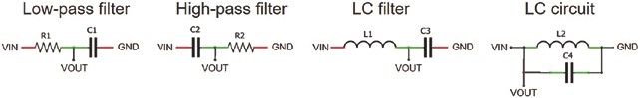
Figure 18-20. Filters and inductor-capacitor circuit
Inductors, denoted L in honor of Emil Lenz, are used in inductor- capacitor (LC) circuits (see Figure 18-20) for either generating signals with a specific frequency or filtering a signal to retain a particular frequency. The capacitor stores energy in the electric field across its plates, while the inductor stores energy as a magnetic field. When an inductor is connected across a charged capacitor, the voltage across the capacitor generates a current through the inductor and increases its magnetic field. When the voltage across the capacitor drops to zero, the energy stored in the inductor
Measuring eleCtriCity
magnetic field induces a voltage across the inductor, and the current recharges the capacitor. The cycle of capacitor discharge to inductor charge to inductor discharge to capacitor charge repeats at a frequency of
-
(
2p LC) ¹ Hz.
When a voltage burst is applied to the LC circuit, the circuit starts to resonate at a specific frequency, but due to the components’ internal resistance, the oscillation will dampen over time (see Figure 18-21). When connected across the output of the LC circuit, a voltage comparator generates a square wave with the same frequency as the LC circuit. The value of an unknown inductor is determined from the square wave frequency of the voltage comparator and the known capacitor value. In practice, the square wave pulse width is measured; and as frequency equals (2 × pulse width)⁻¹Hz, then the inductance is derived directly from pulse width = p LC . The measurement unit of inductance is henry, H, in honor of Joseph Henry, who discovered inductance.
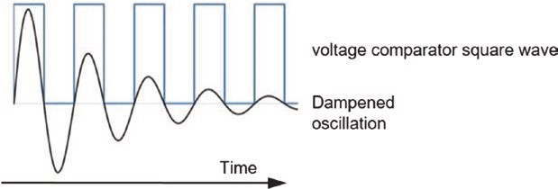
Figure 18-21. LC circuit oscillation
The voltage comparator output voltage is the supply voltage when the voltage at the plus (+) input pin is greater than the voltage at the negative (–) input pin. The LM393 voltage comparator generates a square wave with the same frequency as the damped oscillation from the LC circuit. The LM393 comparator output pin is pulled up to a HIGH state by the 1 kΩ resistor across the LM393 output and VCC pins. The schematic and connections are shown in Figure 18-22 and Table 18-9, respectively.
Measuring eleCtriCity
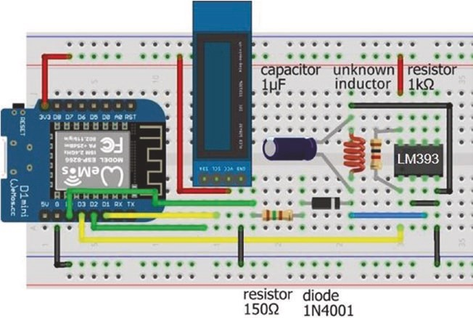
Figure 18-22. Inductance meter and LM393 voltage comparator Table 18-9. Inductance meter and LM393 voltage comparator
Component | Connect to | And to
lM393 output (pin 1) | esp8266 D3 | resistor 1 kΩ
lM393 input (-) (pin 2) | esp8266 gnD
lM393 input (+) (pin 3) | inductor
lM393 input (+) (pin 3) | Diode cathode (stripe) | Capacitor (positive)
lM393 gnD (pin 4) | esp8266 gnD
lM393 VCC (pin 8) | esp8266 3V3 | resistor 1 kΩ
esp8266 D0 | resistor 150 Ω
Diode anode | resistor 150 Ω
(continued)
Measuring eleCtriCity
Table 18-9. (continued)
Component | Connect to | And to
esp8266 gnD | inductor | Capacitor (negative)
OleD VCC | esp8266 3V3
OleD gnD | esp8266 gnD
OleD sDa | esp8266 D2
OleD sCl | esp8266 D1
In the sketch in Listing 18-9, a voltage burst is applied to the LC circuit, and the HIGH pulse width of the resulting square wave generated by the LM393 voltage comparator is measured with the instruction pulse = pulseIn(LM393pin, HIGH, timeout). If signal is HIGH, then the pulseIn function waits until the signal is LOW, starts timing when the signal goes HIGH, and stops timing when the signal goes LOW. If a HIGH pulse is not detected before timeout microseconds, then a zero value is returned. The square wave frequency is 10⁶ × (2 × pulse width)⁻¹ Hz, as the pulse width is pulse width²
measured in microseconds, and the inductor value is ₂ . The p ´capacitor
inductor meter is reasonably accurate for inductances of 50 μH and above. For example, the estimated inductance for a 470 μH inductor with a 1 μF electrolytic or ceramic capacitor was 462 μH or 415 μH, respectively. Pulse length with a ceramic capacitor is generally 2–3 μs lower than with an electrolytic capacitor (see Figure 18-23).
Measuring eleCtriCity
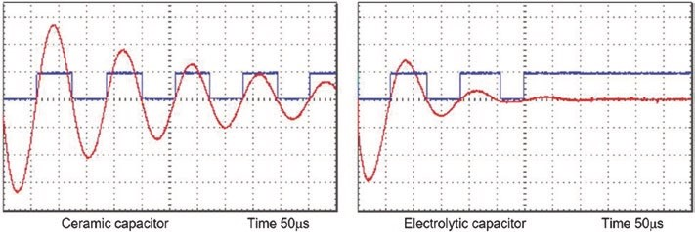
Figure 18-23. Inductor-capacitor oscillation with ceramic or electrolytic capacitor
A ceramic capacitor fitted across the inductor prolongs the inductor- capacitor oscillation to a greater extent than an electrolytic capacitor (see Figure 18-23). An electrolytic capacitor is less effective at higher frequencies than a ceramic capacitor, due to the higher equivalent series resistance (ESR) and inductance (ESL), resulting in longer charging and discharging times. For example, the pulse length of a 1 μF capacitor and a 470 μH inductor pair is a constant 64 μs with a ceramic capacitor, but only the first two pulses of 65 μs and 70 μs are detectable when an electrolytic capacitor is used (see Figure 18-23). With an inductor of less than 50 μH, no pulses are detectable when an electrolytic capacitor is used, given the high oscillation frequency of 25 kHz.
Listing 18-9. Inductor meter
#include <Adafruit_SSD1306.h> // Adafruit SSD1306 library int width = 128; // OLED screen size
int height = 32; // associate oled with SSD1306 Adafruit_SSD1306 oled(width, height, &Wire, -1); int voltPin = D0; // voltage burst pin int LM393pin = D3; // LM393 output pin float capacitor = 1.0; // measured in μF int timeout = 1000; // timeout limit in μs
Measuring eleCtriCity
float pulse, pulse1, pulse2, frequency, inductance;
void setup()
{
pinMode(voltPin, OUTPUT); // define voltPin as output oled.begin(SSD1306_SWITCHCAPVCC, 0x 3C); // OLED I2C address oled.clearDisplay(); // clear OLED display oled.setTextColor(WHITE); // set font color oled.setTextSize(1); // set font size (1, 2, 3 or 4) oled.display(); // update display instructions
}
void loop()
{
digitalWrite(voltPin, HIGH); // apply 3.2V on voltPin delay(5); // time to charge the inductor digitalWrite(voltPin,LOW); // end of voltage burst pulse1 = pulseIn(LM393pin, HIGH, timeout);
// measure HIGH pulse duration
pulse2 = pulseIn(LM393pin, HIGH, timeout); if(pulse2 > 0) pulse = (pulse1+p ulse2)/2.0;
// average pulse length
else pulse = pulse1; if(pulse > 0)
{
frequency = 1E6/(2.0*pulse); // shorthand for 10 to the power 6 inductance = pulse*pulse/(PI*P I*capacitor);
// calculate inductance
oled.clearDisplay();
oled.setCursor(0,0); // display results oled.print("inductance uH ");oled.println(inductance,0);
Measuring eleCtriCity
oled.print("frequency Hz ");oled.println(frequency,0); oled.print("high time us ");oled.print(pulse,0); oled.display();
}
delay(1000); }
Summary
Voltage across a load, resistance of a load, and current through a load were measured using an ESP8366 or ESP32 microcontroller analog to digital converter (ADC). Voltage, resistance, and current were determined from the voltage across the load or the voltage across a shunt resistor to derive current through the load. The charging time of a capacitor defined its capacitance. An INA219 current and voltage measurement module quantified the power and cumulative energy used by a load. The net battery charge or discharge current of a battery providing power to a load and charging through a solar panel was measured with two INA219 modules, with the information over time displayed on an ST7735 TFT LCD screen. Inductance was measured by applying a voltage burst to an inductor-capacitor circuit. The frequency that the inductor-capacitor circuit resonated was related to the inductance. The oscillating sine wave was converted to a square wave by a voltage comparator and the inductance derived from the square wave frequency.
Measuring eleCtriCity
Components List
- ESP8266 microcontroller: LOLIN (WeMos) D1 mini or NodeMCU board
- ESP32 microcontroller: DEVKIT DOIT or NodeMCU board
- OLED display: 128 × 32 pixels
- Battery: 5 V or 9 V
- Resistor: 150 Ω, 220 Ω, 2× 1 kΩ, 2.2 kΩ, 10 kΩ, 22 kΩ, and 47 kΩ
- LED
- Shunt resistor: 0.01 Ω
- Operational amplifier: LM358
- Current sensor: 2× INA219
- Solar panel: 5 V output
- Lithium battery: 3.7 V
- Lithium battery charging module: TP4056
- DC-DC adjustable step-up (boost) converter: MT3608
- TFT LCD screen: ST7735, 1.8 inches, 128 × 160 pixels
- Tactile switch
- Voltage comparator: LM393
- Capacitor: 0.1 μF, 1 μF ceramic or electrolytic
- Diode: IN4001

CHAPTER 19
Rotary encoder control
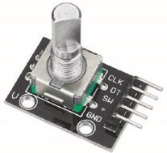
A rotary encoder detects rotation of the center shaft and is used to control machinery position and motor speed, audio volume, the cursor position on an LCD (Liquid Crystal Display) screen, or simply LED brightness. For example, in Chapter 1 (Internet radio), the radio station and volume
were selected by turning a rotary encoder. The incremental rotary encoder has 20 positions, and the rotor is continuously rotated clockwise or anticlockwise to increase or decrease a control variable. The rotary encoder has two pins, termed A or CLK (clock) and B or DT (data), and a common pin. As the rotary encoder rotor is turned, pins A and B each make contact with the common pin, which generates square waves, but as the pins are offset, the square waves are 90° out of phase (see Figure 19-1). The number of square wave pulses indicates the extent of the rotation, which is measured on either pin A or pin B.
© Neil Cameron 2021 559
N. Cameron, Electronics Projects with the ESP8266 and ESP32, https://doi.org/10.1007/978-1-4842-6336-5_19
rotary enCoder Control
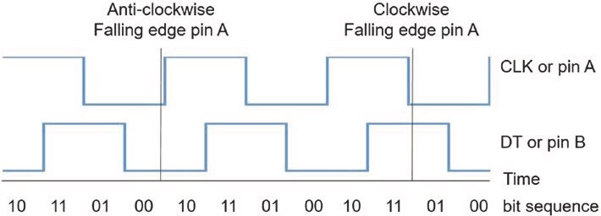
Figure 19-1. Rotary encoder square waves
The square wave states at a given time indicate the direction of rotation. If the direction is clockwise, then pin A makes contact with the common pin before pin B makes contact. When pin A disconnects from the common pin, the pin A square wave state changes from HIGH to LOW, but the pin B square wave is still HIGH (read Figure 19-1 from left to right). The position that a square wave changes from HIGH to LOW or from LOW to HIGH is the falling edge or rising edge, respectively. In contrast, when the direction of rotation is anti-clockwise, the pin B square wave state is LOW at the falling edge of the pin A square wave (read Figure 19-1 from right to left). The direction of rotation is determined by reading the pin B square wave state at a falling edge of the pin A square wave. If the pin B square wave is HIGH, then rotation is clockwise, but anti-clockwise if the pin B square wave is LOW at the falling edge of the pin A square wave.
The sketch in Listing 19-1 demonstrates the rotary encoder generating square waves, to control two LEDs (see Figure 19-2). The pin A square wave state is monitored, and when a falling edge is detected, the pin B square wave state is read. The LED function turns on the red or green LED, displays the rotation direction, and increases or decreases the count of encoder increments. Note that the rotary encoder must be turned two increments to detect the rotation direction. For Listing 19-1, the resistor and capacitor pairs in Figure 19-2 are not connected.
rotary enCoder Control
To illustrate that a solution for one microcontroller is not necessarily appropriate for a microcontroller with a higher CPU frequency, the sketch in Listing 19-1 is run on both an Arduino Nano and an ESP8266 microcontroller. With the ATmega328P microcontroller of the Arduino Nano, the number and direction of rotary encoder turns are detected reasonably correctly, provided the rotary encoder is not turned quickly. In contrast, there are substantial errors in rotary encoder turn detection by an ESP8266 microcontroller, which has a higher CPU frequency, 160 MHz compared to 16 MHz of the ATmega328P microcontroller. Rotary encoder turn detection is worse with an ESP32 microcontroller, which has a CPU frequency of 240 MHz, as every pin bounce is detected.
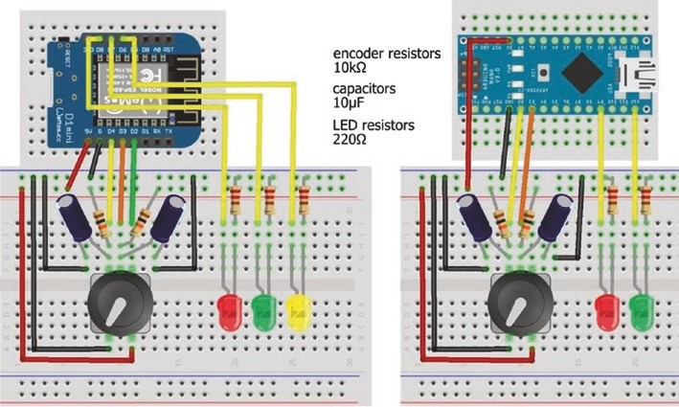
Figure 19-2. Rotary encoder and LEDs with LOLIN (WeMos) D1 mini and Arduino Nano
Rotary encoder and LED connections are given in Table 19-1 and shown in Figure 19-2. Listings 19-1, 19-2, and 19-3 require two LEDs, while Listing 19-5 requires three LEDs, so all three LEDs are included in Figure 19-2 to avoid repetition.
rotary enCoder Control
When uploading a sketch to the ESP8266 microcontroller, GPIO pins D3 and D4 must not be pulled LOW, so the pins are disconnected from the rotary encoder DT and CLK pins.
Table 19-1. Rotary encoder and LEDs
Component | Connect to | And to | And to
rotary encoder ClK | eSp8266 d4 or nano pin 2 | Capacitor positive
rotary encoder ClK |  | 10 kΩ resistor | eSp8266 or nano 5V
rotary encoder dt | eSp8266 d3 or nano pin 3 | Capacitor positive
rotary encoder dt |  | 10 kΩ resistor | eSp8266 or nano 5V
rotary encoder SW | eSp8266 d2
rotary encoder VCC | eSp8266 or nano 5V
rotary encoder Gnd | eSp8266 or nano Gnd
Capacitor negative | eSp8266 or nano Gnd
led long leg | eSp8266 d8, d7, d6, or nano pins 9 and 12
led short leg | 220 Ω resistor | eSp8266 or nano Gnd
Listing 19-1. Rotary encoder with LEDs
int CLKpin = D4; // rotary encoder pins int DTpin = D3; // CLK = pin A and DT = pin B int redLED = D8;
int greenLED = D7; // define LED pins int count = 0;
rotary enCoder Control
int oldCLK = LOW; int newCLK;
void setup()
{
Serial.begin(115200); // Serial Monitor baud rate pinMode(redLED, OUTPUT); // set LED pins as output pinMode(greenLED, OUTPUT); }
void loop()
{
newCLK = digitalRead(CLKpin); // state of pin A (CLK) if(newCLK == LOW && oldCLK == HIGH) // falling edge of pin A { // pin B HIGH if(digitalRead(DTpin) == HIGH) LED (HIGH, 1, "up"); else LED(LOW, -1, "down "); // pin B (DT) LOW
} oldCLK = newCLK; // reset pin A (CLK) state // delay(100); // to confirm microcontroller } // can miss rotary encoder turns
void LED(int state, int increment, String text)
{
digitalWrite(redLED, 1-state); // turn on or off the LEDs
digitalWrite(greenLED, state);
Serial.print(text); count = count + increment; // update and display count
Serial.println(count);
}
rotary enCoder Control
Debouncing
There are two issues with the sketch in Listing 19-1. First, bouncing of the rotary encoder pin A and B connections with the common pin produces spurious changes in the detected direction and count of encoder increments. A hardware solution to debouncing the rotary encoder pins is inclusion of 10 kΩ pull-up resistors (R) and 10 μF (C) capacitors between the rotary encoder pins A and B with GND (see Figure 19-2 and Table 19- 1). The resistor-capacitor combination creates a debounce delay of 69 ms, equal to RC × ln(2) seconds. Further information on capacitor changing and discharging times is given in Chapter 17 (Signal generation with 555 timer IC). Some rotary encoder modules, such as the KY-040 module, include 10 kΩ pull-up resistors on the CLK and DT connections, so only the 10 μF capacitors are required for debouncing.
The resistor-capacitor combination to debounce the rotary encoder connections for pins A and B with the common pin must ensure that sufficient time has elapsed for the connection bouncing to have stopped, without being too long to have missed rotary encoder rotations. The delay of 69 ms achieved with a 10 kΩ resistor and a 10 μF capacitor is a compromise.
Interrupts
The second issue with the sketch in Listing 19-1 is that the microcontroller is continuously reading the pin A square wave state to detect a falling edge and then reading the pin B square wave state to determine the direction of rotation. If the sketch included other actions, then the microcontroller will miss detecting falling edges of the pin A square wave. Inclusion of a short delay of 100 ms in the loop function of Listing 19-1 illustrates the point. The problem of not detecting the falling edges is resolved by including an interrupt to detect falling edges of the pin A square wave (see Listing 19-2). The interrupt is active on the falling edge of the pin A (CLK) square wave,
rotary enCoder Control
and the interrupt service routine (ISR) reads the pin B (DT) square wave state to determine the direction of rotation. The variable change is updated in both the loop function and the ISR, so is defined as volatile. Only instructions referring to the interrupt are annotated in
Listing 19-2, to emphasize the few differences between Listings 19-1 and 19-2.
Listing 19-2 is for an ESP8266 microcontroller. When using an ESP32 microcontroller, the rotary encoder pins are defined with the instructions
pinMode(CLKpin, INPUT); pinMode(DTpin, INPUT);
In Listing 19-2, the ISR is defined with the instruction IRAM_ATTR void isr() for an ESP8266 or ESP32 microcontroller to store the interrupt in internal RAM (IRAM), rather than in the slower flash memory. For the Arduino Nano, the ISR is defined as void isr(). Listing 19-2. Rotary encoder with interrupt
int CLKpin = D4; int DTpin = D3; int redLED = D8; int greenLED = D7; int count = 0;
volatile int change; // variable used in ISR
void setup()
{
Serial.begin(115200); pinMode(redLED, OUTPUT);
pinMode(greenLED, OUTPUT); // attached interrupt attachInterrupt(digitalPinToInterrupt(CLKpin), isr, FALLING);
}
rotary enCoder Control
void loop()
{ if(change != 0) // rotary encoder direction
{
if(change > 0) LED(HIGH, "up "); // clockwise
else if(change < 0) LED(LOW, "down "); // anti-clockwise change = 0;
}
}
void LED(int state, String text) // no change to LED function
{
digitalWrite(redLED, 1-state); digitalWrite(greenLED, state);
Serial.print(text); count = count + change; Serial.println(count);
}
IRAM_ATTR void isr() // interrupt service routine
{
change = 2*digitalRead(DTpin) - 1 ;
} // determine direction of rotation
Including an interrupt to detect changes in the pin A square wave state and resistor-capacitor pairs to debounce the rotary encoder pins improves detection of rotary encoder turns for the ATmega328P microcontroller, but not substantially for the ESP8266 and ESP32 microcontrollers. The next section describes an effective solution to debouncing the rotary encoder.
rotary enCoder Control
Square wave states
Debouncing is eliminated by only counting the changes in square wave states that are consistent with a clockwise or anti-clockwise rotation. The square wave states for pins A and B are easily visualized by connecting two LEDs to rotary encoder pins A and B (see Figure 19-3 with connections in Table 19-2).
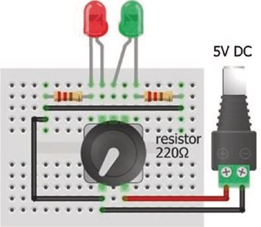
Figure 19-3. Rotary encoder and test LEDs
Table 19-2. Rotary encoder and test LEDs
Component | Connect to | And to
rotary encoder pin a (ClK) | red led long leg
rotary encoder pin B (dt) | Green led long leg
rotary encoder VCC | Battery 5V
rotary encoder Gnd | Battery Gnd
led short legs | 220 Ω resistors | Battery Gnd

When the incremental rotary encoder is rotated slowly clockwise, the LED attached to pin A turns on; and, before the incremental rotation is completed, the LED connected to pin B turns on. If the rotary encoder is again turned slowly through one increment, the two LEDs turn off with the LED attached to pin A turning off first. The LED sequence, written as LED_{A}, LED_{B}, is 00, 10, 11, 01, and back to 00 (see Figure 19-1). The sequence, consisting of 2 bits with 1 bit for each pin, is known as Gray code, after Frank Gray, with two successive events only differing by 1 bit. The LED or 2-bit sequence when rotating the rotary encoder slowly anti-clockwise is 00, 01, 11, 10, and back to 00.
The changes in square wave states for pins A and B are written as 4-bit numbers, describing the square wave states as the incremental rotation progresses. For example, if the rotation is clockwise, the square wave states for pins A and B are LOW, LOW, then HIGH, LOW, then HIGH, HIGH, then LOW, HIGH, and finally LOW, LOW. Written as 4-bit numbers, the sequences are (00)(10), (10)(11), (11)(01), and (01)(00) (see Table 19-3).
Table 19-3. Bit sequence of rotary encoder square wave states
Initial State | Next State | 4-Bit Number
LOW, LOW | HIGH, LOW | 0010
HIGH, LOW | HIGH, HIGH | 1011
HIGH, HIGH | LOW, HIGH | 1101
LOW, HIGH | LOW, LOW | 0100
A 4-bit number has 16 possible values, and each value is mapped to a directional increment of the rotary encoder (see Table 19-4). The 4-bit numbers with a zero score represent either no pin changes or two pin changes, such as 0101 or 0011, respectively.
Table 19-4. Rotary encoder square wave states as 4-bit numbers
4-Bit |  | Pin A (CLK) and Pin B (DT)
Number | Decimal | Previous State | Current State | Change | Direction | Score
0000 | 0 | LOW, LOW | LOW, LOW | none |  | 0
0001 | 1 | LOW, LOW | LOW, HIGH |  | anti- clockwise | -1
0010 | 2 | LOW, LOW | HIGH, LOW |  | Clockwise | 1
0011 | 3 | LOW, LOW | HIGH, HIGH | two pins |  | 0
0100 | 4 | LOW, HIGH | LOW, LOW |  | Clockwise | 1
0101 | 5 | LOW, HIGH | LOW, HIGH | none |  | 0
0110 | 6 | LOW, HIGH | HIGH, LOW | two pins |  | 0
0111 | 7 | LOW, HIGH | HIGH, HIGH |  | anti- clockwise | -1
1000 | 8 | HIGH, LOW | LOW, LOW |  | anti- clockwise | -1
1001 | 9 | HIGH, LOW | LOW, HIGH | two pins |  | 0
1010 | 10 | HIGH, LOW | HIGH, LOW | none |  | 0
1011 | 11 | HIGH, LOW | HIGH, HIGH |  | Clockwise | 1
1100 | 12 | HIGH, HIGH | LOW, LOW | two pins |  | 0
1101 | 13 | HIGH, HIGH | LOW, HIGH |  | Clockwise | 1
1110 | 14 | HIGH, HIGH | HIGH, LOW |  | anti- clockwise | -1
1111 | 15 | HIGH, HIGH | HIGH, HIGH | none |  | 0
Both square wave states must be determined whenever either square wave state changes, so two interrupts are required, one for each of the rotary encoder pins A and B. The two square wave states are converted to a 4-bit number, consisting of the previous and current states, to obtain the corresponding score. When the score is equal to +2 or -2, then the rotary encoder has rotated clockwise or anti-clockwise by one increment, as an incremental rotation of the rotary encoder has two state changes. If a more definite rotation of the rotary encoder is required, then a score of +4 or -4 requires a rotation of two increments.
The sketch in Listing 19-3 maps both square wave states to a score to determine both the direction and extent of the rotary encoder rotation. Score values are included in the vals[] array, and an ISR is activated by a change in square wave state for either pin A (CLK) or pin B (DT). The loop and LED functions are identical to those in Listing 19-2. The resistor and capacitor pairs for the rotary encoder pins are no longer required for debouncing (see Figure 19-4 with connections in Table 19-5). When the rotary encoder is turned quickly, there is no loss of accuracy in detecting rotary encoder rotations. Note that the rotary encoder rotor is only turned one increment to detect the rotation direction.
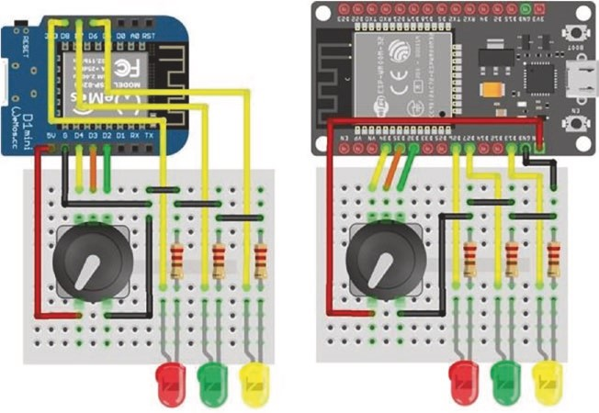
Figure 19-4. Rotary encoder and LEDs with LOLIN (WeMos) D1 mini and ESP32 DEVKIT DOIT board
Table 19-5. Rotary encoder and LEDs with ESP8266 and ESP32 microcontrollers
Component | Connect to ESP8266 | Connect to ESP32
rotary encoder ClK | d4 | GpIo 34
rotary encoder dt | d3 | GpIo 35
rotary encoder SW | d2 | GpIo 32
rotary encoder VCC | 5V | VIn
rotary encoder Gnd | Gnd | Gnd
led long leg | d8, d7, d6 | GpIo 26, GpIo 27, GpIo 13
led short leg | 220 Ω resistor and Gnd | 220 Ω resistor and Gnd
The ISR constructs the 4-bit number from the retained previous square wave states and the current square wave states for pins A and B and then increments the score. The bit shift symbol << moves a bit with value N to position r with the instruction (N<<r). To represent the current square wave states, the 4-bit number is reduced to a 2-bit number by bit shifting two positions, equal to the remainder of the 4-bit number when divided by four, with the instruction oldState = newState % 4. For example, if the rotary encoder moves clockwise from an initial state HIGH, HIGH to state LOW, LOW, the 2-bit number sequence is 11, 01, and 00, corresponding to the two 4-bit numbers of 1101 and 0100 (see Table 19-4). The 4-bit number for the second stage of the incremental rotation of 0100 has the 2-bit value of 00, when bit shifted two positions, which is equivalent to a remainder of 0 when the decimal value 8 (4-bit value of 0100) is divided by 4. Alternatively, the instruction oldState = (digitalRead(CLKpin)<<1)+digitalRead (DTpin) would suffice, but the square wave states may have changed since the interrupt was activated.
The new square wave states are a combination of the previous states and the current states of the pin A (CLK) and pin B (DT) square waves. The new state consists of the previous square wave states for pins A and B, but shifted two positions (<<2), the current pin A square wave state shifted one position (<<1), and the current pin B square wave state.
A switch case instruction is an alternative to including the score values in an array. For example, the instruction score = score + vals[newState] in Listing 19-3 is replaced with
switch (newState) { case 0: case 3: case 5: case 6: case 9: case 10: case 12: case 15:
break; // no change case 1: case 7: case 8: case 14:
score = score - 1; break; // reduce score by one case 2: case 4: case 11: case 13:
score++; break; // increase score by one default: break; }
Listing 19-3. Rotary encoder with square wave states
int CLKpin = D4; // define rotary encoder pins int DTpin = D3;
int redLED = D8; // define LED pins int greenLED = D7;
int vals[] = {0,-1,1,0,1,0,0,-1,-1,0,0,1,0,1,-1,0 };
// array of scores
int count = 0; volatile int score = 0;
volatile int change = 0; // variables used in isr and loop functions volatile int oldState = 0;
void setup()
{
Serial.begin(115200); // Serial Monitor baud rate pinMode(redLED, OUTPUT); // set LED pins as output pinMode(greenLED, OUTPUT); // attach interrupt pinMode(CLKpin, INPUT); // required by ESP32 pinMode(DTpin, INPUT); // required by ESP32 attachInterrupt(digitalPinToInterrupt(CLKpin), isr, CHANGE); attachInterrupt(digitalPinToInterrupt(DTpin), isr, CHANGE);
}

void loop()
{ if(change != 0) // rotary encoder rotated
{
if(change > 0) LED(HIGH, "up "); // clockwise else if(change < 0) LED(LOW, "down "); // anti-clockwise change = 0;
}
}
void LED(int state, String text)
{
digitalWrite(redLED, 1-state); // turn LEDs on or off digitalWrite(greenLED, state);
Serial.print(text); count = count + change; // update count
Serial.println(count);
}
IRAM_ATTR void isr() // interrupt service routine { // construct 4-bit number int newState = (oldState<<2)+(digitalRead(CLKpin)<<1)+
digitalRead(DTpin);
score = score + vals[newState]; // allocate score from array
oldState = newState % 4;
// remainder to leave new CLK and DT state
if(score == 2 || score == -2) // 2 steps for complete rotation
{
change = score/2; // unit change per two steps score = 0; // reset score
}
}
State switching
The rotary encoder switch, activated by pressing down on the stem of the rotary encoder, is used to change the state of a binary variable, such as turning on or off an LED. Noting the time that the switch is pressed differentiates between a long and a short press, enabling the switch to control a variable with three levels rather than only two levels. In Listing 19-4, the rotary encoder switch (SW) pin uses the ESP8266 or ESP32 microcontroller internal pull-up resistor, rather than including a separate resistor in the circuit. An internal pull-up resistor is activated with the instruction pinMode(pin, INPUT_PULLUP), and the pin is active LOW rather than HIGH. When the rotary encoder switch is pressed and then released, the pin state changes from HIGH to LOW and then back to HIGH.
Listing 19-4 defines ESP8266 development board pin D2 as an interrupt pin, and depending on the length of time that the switch is pressed, the changeSW variable is allocated the character value of 'L', 'S', or 'B' to indicate a long or short press or a switch bounce. The changeSW variable is not allocated the string value of "Long", "Short", or "Bounce", as strings are not passed to an interrupt. The ISR compares the time that the switch was pressed with the time that the switch was released, relative to the predefined longpress and shortpress values, to determine if a long press or a short press or a switch bounce occurred. When the switch is released, the time between pressing and releasing the switch is displayed with the category "long press", "short press", or "switch bounce", with the LED state only changing after a long or short switch press.
Listing 19-4. Rotary encoder switch
int SWpin = D2; // rotary encoder switch pin int SWled = D6; // LED pin
int longPress = 1000; // time (ms) for long or short press int shortPress = 500; volatile unsigned long newTime, oldTime;
volatile char changeSW; // variables in loop and isr functions volatile unsigned int lagTime;
void setup()
{
Serial.begin(115200); // Serial Monitor baud rate pinMode(SWled, OUTPUT); // set LED pin as output pinMode(SWpin, INPUT_PULLUP); // activate pull-up resistor attachInterrupt(digitalPinToInterrupt(SWpin), isr, CHANGE); } // SWpin as interrupt pin and attache ISR
void loop()
{ if(changeSW != ' ') // switch released, turn on or off
{ // LED if long or short press
Serial.print(lagTime);Serial.p rint("\t");
// display switch press time lag
if(changeSW != 'B') digitalWrite(SWled,
!digitalRead(SWled)); if(changeSW == 'L') Serial.println("long press"); else if(changeSW == 'S') Serial.println("short press"); else Serial.println("switch bo unce");
// display only, no effect on LED
changeSW = ' '; // reset change variable
}
}
IRAM_ATTR void isr()
{
newTime = millis(); // get time ISR triggered if(digitalRead(SWpin) == HIGH) // switch now released
{
lagTime = newTime - oldTime; // time between switch presses if(lagTime > longPress) change SW = 'L'; // L for long press
else if(lagTime > shortPress) changeSW = 'S ';
// S for short press
else changeSW = 'B'; // B for bounce
} oldTime = newTime; // reset switch press/release time }
Incrementing a value
While the number of square wave pulses indicates the extent of the rotation of the rotary encoder, the switch is used to control the size of the incremental count. For example, pressing the switch for a long or short time changes the incremental count by ten or one. Listing 19-3 is readily extended by including the instructions for the rotary encoder switch:
int SWpin = D2; // rotary encoder switchpin int SWled = D6; // LED pin
int longPress = 1000; // time (ms) for long press volatile unsigned long newTime, oldTime, lagTime; volatile int increment = 1;
Instructions are added for the LED, the pull-up resistor, and attaching the interrupt with ISR isrSwitch in the setup function:
pinMode(SWled, OUTPUT); // set LED pin as output pinMode(SWpin, INPUT_PULLUP); // activate pull-up resistor attachInterrupt(digitalPinToInterrupt(SWpin), isrSwitch, CHANGE);
In the LED function, the count instruction is changed
count = count + change*increment; // update count
and an instruction is added for the LED to indicate the value of the increment:
digitalWrite(SWled, increment>1); // turn on LED if increment >1
Instructions for the ISR to change the size of the increment are
IRAM_ATTR void isrSwitch()
{
newTime = millis(); // get time ISR triggered if(digitalRead(SWpin) == HIGH) // switch released
{
lagTime = newTime - oldTime;
if(lagTime > longPress) increment = 10; // update increment else if(lagTime > 100) increment = 1; // debounce switch
} oldTime = newTime; // reset switch press/release time
}
The size of the incremental count is also controlled by the rotation speed of the rotary encoder, with a high speed resulting in a larger increment than a low speed. The ISR maps changes in the pin A and B square wave states to score the rotation and calculates the rotation time from the interval between falling and rising edges of the pin A square wave. Instructions in an ISR should be as few as possible to minimize the processing time, and the ISR could be split into two ISRs. ISRs do not run in parallel, and one interrupt starts when the previous interrupt finishes.
Splitting the ISR into two separate ISRs is not more efficient.
To control the incremental count by the rotation speed of the rotary encoder, Listing 19-3 is again readily adapted. Variable definitions and the LED pin are included at the start of the sketch:
int incLED = D6; // LED pin indicates when increment > 1 int rotation = 500; // threshold rotation time (ms) int increment = 1; volatile unsigned long newTime, oldTime, lagTime; volatile int newCLK; // variables used in isr() and loop() volatile int oldCLK = 0;
The LED to indicate when a large increment is activated is included in the setup function:
pinMode(incLED, OUTPUT);
In the LED function, the count instruction is changed
count = count + change*increment; // update count
and an instruction is added for the LED to indicate the increment value: digitalWrite(incLED, increment>1); // turn LED on if increment > 1
In the existing ISR, to avoid rereading the state of the square wave of pin A (CLK), the instruction
int newState = (oldState<<2)+(digitalRead(CLKpin)<<1)+ digitalRead(DTpin);
is replaced with the instructions

rotary enCoder Control
newCLK = digitalRead(CLKpin);
int newState = (oldState<<2)+(newCLK<<1)+digitalRead(DTpin);
Instructions to calculate the rotary encoder rotation time and the corresponding increment are included in the existing ISR, as
newTime = millis(); // get time ISR triggered if(newCLK == HIGH && oldCLK == LOW) // interval between falling { // and rising edge on pin A (CLK) lagTime = newTime - oldTime;
if(lagTime < rotation && lagTime > 10 0) increment = 10;
// fast rotation
else if(lagTime > rotation) increment = 1; // slow rotation oldTime = newTime; // reset rising/falling edge time
}
oldCLK = newCLK; // reset state of pin A (CLK)
Listing 19-5 incorporates the additions to Listing 19-3 for the incremental count to be determined by the rotary encoder rotation, with the additional instructions commented.
Listing 19-5. Control incremental count by rotary encoder rotation speed
int CLKpin = D4; int DTpin = D3; int redLED = D8; int greenLED = D7; int vals[] = {0,-1,1,0,1,0,0,-1,-1,0,0,1,0,1,-1,0}; int count = 0; volatile int score = 0; volatile int change = 0; volatile int oldState = 0;
rotary enCoder Control
int incLED = D6; // increment indicator LED pin int rotation = 500; // threshold rotation time (ms) int increment = 1; // default increment volatile unsigned long newTime, oldTime, lagTime; volatile int newCLK; // variables used in ISR volatile int oldCLK = 0;
void setup()
{
Serial.begin(115200); pinMode(redLED, OUTPUT); pinMode(greenLED, OUTPUT); pinMode(CLKpin, INPUT); pinMode(DTpin, INPUT); attachInterrupt(digitalPinToInterrupt(CLKpin), isr, CHANGE); attachInterrupt(digitalPinToInterrupt(DTpin), isr, CHANGE); pinMode(incLED, OUTPUT); // increment indicator LED
}
void loop()
{
if(change != 0)
{
if(change > 0) LED(HIGH, "up "); else if(change < 0) LED(LOW, "down "); change = 0;
}
}
void LED(int state, String text)
{
digitalWrite(redLED, 1-state); digitalWrite(greenLED, state);
rotary enCoder Control
Serial.print(text);
count = count + change*increment; // incremented count digitalWrite(incLED, increment>1);
// turn LED on, increment = 10 Serial.print(increment);Serial.pri nt("\t");
// display updated increment
Serial.println(count);
}
IRAM_ATTR void isr()
{ // avoid re-reading the square newCLK = digitalRead(CLKpin); // wave state of pin A (CLK) int newState = (oldState<<2)+(newCLK<<1)+digitalRead(DTpin); score = score + vals[newState]; oldState = newState % 4; if(score == 2 || score == -2)
{
change = score/2; score = 0;
}
newTime = millis(); // get time ISR triggered if(newCLK == HIGH && oldCLK == LOW) // interval between falling { // and rising edge on pin A (CLK) lagTime = newTime - oldTime;
if(lagTime < rotation && lagTim e > 100) increme nt = 10; // fast rotation
else if(lagTime > rotation) inc rement = 1; // slow rotation oldTime = newTime; // reset rising/falling edge time
} oldCLK = newCLK; // reset state of pin A (CLK) }
rotary enCoder Control
The advantage of using interrupts to detect rising or falling edges of a square wave, to define changes in square wave states, is that the ESP8266 or ESP32 microcontroller can process other instructions simultaneously, without missing square wave state changes. Mapping changes in square wave states to a score, to then determine both the direction and extent of the rotation of the rotary encoder, also resolves the problem of connection bouncing within the rotary encoder. Consequently, resistor and capacitor combinations are not required to create a debounce delay.
Summary
Rotary encoder control of devices by both the direction and extent of rotation was illustrated. Methods to improve measuring the direction and extent of rotation of a rotary encoder are described. Interrupts alone did not enable detection of all rotation increments. Changes in square wave states generated by the rotary encoder internal connection pins were mapped to 4-bit numbers. Implementing only the state changes with appropriate 4-bit numbers effectively debounced the rotary encoder internal connections. The incremental change in the count of the rotary encoder rotations was controlled by the rotary encoder switch or by the speed of rotation.
Components List
- ESP8266 microcontroller: LOLIN (WeMos) D1 mini or NodeMCU board
- ESP32 microcontroller: DEVKIT DOIT or NodeMCU board
- Arduino Nano
rotary enCoder Control
- Rotary encoder: KY-040
- LED: different colors ×3
- Resistor: 3× 220 Ω, 2× 10 kΩ
- Capacitor: 2× 10 μF

CHAPTER 20
OTA and saving data to EEPROM, SPIFFS, and Excel
The memory storage device for computers and microcontrollers is termed flash memory, which retains data when power is turned off. In contrast, data stored in RAM (random access memory) is lost when power is turned off. Flash memory is partitioned into several sections: application, OTA (over the air) updating, SPIFFS (Serial Peripheral Interface Flash
File System), EEPROM (Electrically Erasable Programmable Read-Only Memory), Wi-Fi, and configuration information. A sketch is stored in application memory, and the variables created and manipulated in a sketch are stored in RAM. The opportunity to upload a sketch remotely with OTA and options for saving data in SPIFFS and EEPROM partitions of flash memory are outlined in this chapter. Saving data directly to a Microsoft Excel file, instead of using an SD card for data logging, is also described.
© Neil Cameron 2021 585
N. Cameron, Electronics Projects with the ESP8266 and ESP32, https://doi.org/10.1007/978-1-4842-6336-5_20
OTA updating
OTA updating remotely uploads a sketch through a Wi-Fi connection with the ESP8266 or ESP32 microcontroller. The sketch is initially uploaded with a Serial connection, but subsequent uploads of the sketch use the Wi-Fi connection for OTA updating. The laptop or computer to transmit the revised sketch and the ESP8266 or ESP32 microcontroller to receive the updated sketch must be connected to the same Wi-Fi network. A requirement of the ArduinoOTA library, which is preinstalled in the Arduino IDE, is that Python 3.x is installed on the laptop or computer. Python 3.x is downloaded from www.python.org/downloads, and the option to Add Python 3.x to PATH must be selected (see Figure 20-1).
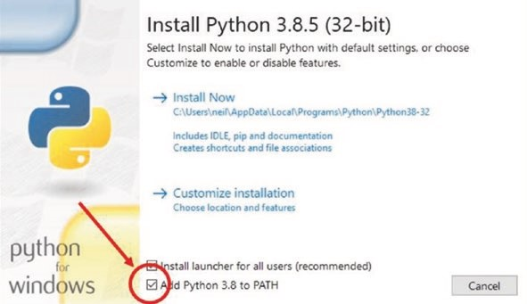
Figure 20-1. Installation of Python 3.x
When a sketch is first uploaded, through the Serial connection, the default name and IP address of the microcontroller network port is esp8266-[Chip identity] at IP address or esp3232-[MAC address] at IP address. Naming a network port, rather than using the IP address, allows the user to identify a particular microcontroller by the user-defined name with the instruction ArduinoOTA.setHostname("name"). Similarly, a user
Ota and saving data tO eeprOM, spiFFs, and exCel
password to permit OTA updating is set with the instruction ArduinoOTA. setPassword("password"), as the default is no password. If a password has been defined, then the password is requested when the Arduino IDE has been restarted or the password has been changed. A list of available network ports is displayed by selecting the Tools menu in the Arduino IDE and the Port option (see Figure 20-2). OTA updating incorporates mDNS (multicast Domain Name System) to match the network port name to an IP address for small networks, using UDP (User Datagram Protocol) to send and receive UDP messages. Further details are available at arduino- esp8266.readthedocs.io/en/latest/ota_updates/readme.html. For the ESP8266 and ESP32 microcontrollers, the ArduinoOTA library references the ESP8266WiFi and WiFi libraries, respectively, so the instructions #include <ESP8266WiFi.h> and #include <WiFi.h> are not required.
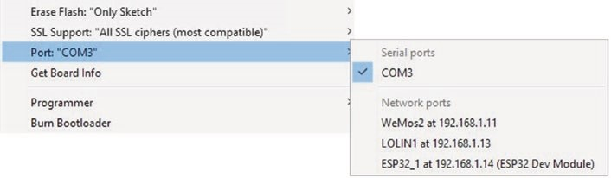
Figure 20-2. Available network ports to OTA updating
OTA updating is demonstrated with the sketch in Listing 20-1, which turns on or off an LED for a fixed time. Listing 20-1 is for an ESP8266 microcontroller, but for an ESP32 microcontroller, the mDNS library is installed with the instruction #include <ESPmDNS.h>. The mDNS and WiFiUdp libraries for the ESP8266 and ESP32 microcontrollers are effectively built-in, once the ESP8266 and ESP32 Board Managers are installed in the Arduino IDE. When a sketch is first uploaded, through the Serial connection, the Serial Monitor is available to print progress messages, but the Serial Monitor is not available with OTA updating. In the setup function, a Wi-Fi connection is made, and the microcontroller network port is named. The sketch includes the flash function to flash the built- in LED every 500 ms while the ESP8266 or ESP32 microcontroller is connecting to the Wi-Fi network. In the loop function, OTA updates are monitored with the instruction ArduinoOTA.handle(), with the instruction repeated after a long delay in the sketch. There are no other changes to instructions in the loop function of the sketch, compared to when uploading the sketch with a USB connection.
Remote OTA updating of a revised sketch uses the named network port of the ESP8266 or ESP32 microcontroller for the Wi-Fi connection, rather than the Serial connection. With the ESP8266 or ESP32 development board now remotely powered, in the Arduino IDE Tools menu, select Port from a list of available network ports, as illustrated in Figure 20-2. Select the appropriate Port; make the required changes to the sketch, such as adjusting the LED delay time; and upload the sketch with OTA.
Listing 20-1. OTA updating
#include <ArduinoOTA.h> // include OTA library
#include <ESP8266mDNS.h> // and mDNS libraries #include <WiFiUdp.h> // include Wi-FI UDP library char ssid[] = "xxxx"; // change xxxx to Wi-Fi ssid char password[] = "xxxx"; // change xxxx to Wi-Fi password int LEDpin = 2; // built-in LED
void setup()
{
Serial.begin(115200); // Serial Monitor baud rate pinMode(LEDpin, OUTPUT);
WiFi.mode(WIFI_STA); // initialise Wi- Fi
WiFi.begin(ssid, password);
Ota and saving data tO eeprOM, spiFFs, and exCel
while (WiFi.status() != WL_CONNECTED)
{
delay(500); // flash LED while flash(); // connecting to Wi-Fi
}
Serial.print("IP address: ");
Serial.println(WiFi.localIP()); // display network port address
ArduinoOTA.setHostname("WeMos2"); // name network port
ArduinoOTA.setPassword("admin1"); // set password
ArduinoOTA.begin(); // initialise ArduinoOTA
}
void loop()
{
ArduinoOTA.handle(); // check for OTA updates digitalWrite(LEDpin, !digitalRead(LEDpin)); // turn on or off LED delay(1000); }
void flash() // function to flash LED
{
digitalWrite(LEDpin, HIGH); delay(100); digitalWrite(LEDpin, LOW); }
Saving data
Data logging sketches store data externally on an SD (Secure Digital) card using SPI (Serial Peripheral Interface) communication. The Arduino IDE built-in SD library provides the necessary instructions to create, open, and close files and write to and read from files on an SD card module. Storing data on an SD card for applications with either low or short-term data storage requirements is not efficient, and an alternative is to store data in the ESP8266 or ESP32 microcontroller memory. For example, storing a device setting, such as the state of a relay or the brightness of an LED, in flash memory ensures that the device state is maintained when the microcontroller is reset either after being powered off or if power was lost. Other examples include storing the ESP32 camera image files in Chapter 2 (Intranet camera) or the servo motor positions generated by an app in Chapter 10 (Build an app).
The ESP8266 and ESP32 microcontrollers have <50 kB RAM (random access memory) and 520 kB SRAM (static random access memory), respectively, where variables are created and manipulated in a sketch. RAM is volatile memory, and the contents are not accessible after the microcontroller is powered down.
In contrast, the ESP8266 and ESP32 microcontrollers have 4 MB flash memory that is non-volatile and is retained when the microcontroller is powered down. A sketch is stored in the application partition of flash memory, as are large amounts of data for a lookup table of a sketch, such as in Chapter 16 (Signal generation). An array is stored in the application partition of flash memory with the instruction const datatype arrayname[] PROGMEM = {array values}, and the ith value of the array is accessed with the instruction pgm_read_datatype(arrayname + i). Character or integer data is stored with the parameter datatype defined as unsigned char or uint16_t and accessed with pgm_read_byte or pgm_read_word, respectively. A string literal containing, for example, the AJAX code of a web page is also stored in the application partition of flash memory, as in Chapters 7 (Wireless local area network), 8 (Updating a web page), 9 (WebSocket), and 12 (GPS tracking app with Google Maps).
Ota and saving data tO eeprOM, spiFFs, and exCel
Saving to EEPROM
EEPROM (Electrically Erasable Programmable Read-Only Memory) is non-volatile memory that retains the information when the ESP8266 or ESP32 microcontroller is turned off. EEPROM consists of up to 4096 bytes, which is one sector of flash memory, with read and write access for each byte. EEPROM has a limit of 100k write cycles at each memory location. In Chapter 2 (Intranet camera), the number of images stored on an SD card was saved in EEPROM.
Accessing data held in EEPROM uses instructions from the Arduino IDE built-in EEPROM library. For example, the ith byte in EEPROM is written to or read from with the instruction EEPROM.write(i, val) or EEPROM.read(i), respectively, where val has an integer value between 0 and 255 equal to 2⁸ – 1, inclusive. Numbering of EEPROM bytes starts from zero. Integers, real numbers, strings, and structures that require more than 1 byte of memory are written to or read from EEPROM with the instruction EEPROM.put(EEaddress, val) or EEPROM.get(EEaddress, val), respectively, where EEaddress is the EEPROM byte to start writing to or reading from and val is the value of an integer, real number, string, or structure. Both an integer and a real number require 4 bytes of EEPROM storage, with a string requiring 12 bytes, irrespective of the magnitude of the integer or the length of the string. When logging data with a fixed structure, the number of bytes of a record is constant, and the number of records is stored in EEPROM byte zero, with the EEPROM address of a new record equal to a multiple of the number of records plus four. For example, if there are already eight data records stored in EEPROM and a data record consists of a time (two integers), an integer, and a real number that requires 16 bytes of memory, then the EEPROM address for the ninth record is 132, equal to 8 (records) × 16 (bytes) + 4 (count at address 0).
EEPROM writing and reading instructions are prefixed with the instruction EEPROM.begin(N), where N is the number of EEPROM bytes to be accessed. For example, access of up to 1000 EEPROM bytes requires the instruction EEPROM.begin(1000). Writing to EEPROM is followed with the instruction EEPROM.commit(). The number of bytes allocated to EEPROM is obtained with the instruction EEPROM.length().
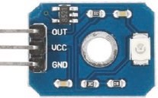
The sketch in Listing 20-2 saves the ultraviolet sensor reading to EEPROM every five seconds and displays the saved data on the Serial Monitor. The number of records is obtained with the instruction EEPROM.get(0, records), rather than EEPROM.read(0) which is the value of the byte in address zero, as there may be more than 255 records. In the sketch, commands are entered on the Serial monitor to write data, to display data, and to reset data stored in EEPROM. When the number of bytes required by the records approaches the set EEPROM capacity, the number of records is reset to zero. The number of bytes for a record is determined with the sizeof() instruction, which can either reference the variable type or the variable itself, as illustrated in the instruction int Nbytes = sizeof(float) + sizeof(data.minuteTime) + sizeof(int).
Listing 20-2. Saving data in EEPROM
#include <EEPROM.h> // include EEPROM library int EEaddress, records; unsigned long seconds, nowTime, lastTime = 0; char cmd = ' '; // command character
typedef struct // structure to hold data record
{
float UV; // a real number (4 bytes) and an int minuteTime; // integer (4 bytes in EEPROM) int secondTime;
} dataStruct;
Ota and saving data tO eeprOM, spiFFs, and exCel
dataStruct data; // number of bytes to store data int Nbytes = sizeof(float) + sizeof(data.minuteTime) + sizeof(int); void setup()
{
Serial.begin(115200); // Serial Monitor baud rate
EEPROM.begin(1000); // set EEPROM capacity
EEPROM.put(0, 0); // set record number to zero
EEPROM.commit(); // write to EEPROM
Serial.print("Enter R: record, D: display");
Serial.println(" or Z: zero UV record");
}
void loop()
{ // command from Serial buffer if(Serial.available() > 0) cmd = Serial.read(); nowTime = millis(); // start of time interval if((nowTime - lastTime > 5000) && (cmd == 'R')) { // collect data every 5s data.UV = analogRead(A0)*3200.0/ 1024; // convert reading to mV seconds = (nowTime/1000);
data.minuteTime = seconds / 60; // calculate elapsed minutes data.secondTime = seconds % 60; // and seconds
EEPROM.get(0, records); // number of EEPROM records EEaddress = records * Nbytes + 4; // address of new record if((EEaddress + Nbytes) > EEPRO M .length()) { // check if exceeding the set EEPROM capacity
records = 0; // reset EEPROM record number
EEaddress = 4; // avoid over-flowing EEPROM }

Ota and saving data tO eeprOM, spiFFs, and exCel
records++; // increment number of records
EEPROM.put(0, records); // update number of records
EEPROM.put(EEaddress, data); // write data to EEPROM EEPROM.commit();
Serial.print("UV index ");Seria l.println(data.UV);
// display data
lastTime = nowTime; // update time interval
} if(cmd == 'D') // display data held on EEPROM { // number of EEPROM records records = EEPROM.get(0, records ); for (int i=0; i<records; i++)
{
EEaddress = i * Nbytes + 4; // EEPROM address of ith record
EEPROM.get(EEaddress, data); // read and display EEPROM Serial.print(data.minuteTime);Serial.print(":");
Serial.print(data.secondTime);Serial.print("\t");
Serial.println(data.UV);
} cmd = ' '; // reset command
Serial.print("Enter R: record, D: display");
Serial.println(" or Z: zero UV record");
} if(cmd == 'Z') // command to reset records
{
EEPROM.put(0, 0); // set record number to zero EEPROM.commit(); cmd = ' ';
Serial.print("Enter R: record, D: display");
Serial.println(" or Z: zero UV record");
}
}
Figure 20-3 illustrates using an ESP8266 or ESP32 microcontroller EEPROM to store measurements from an ultraviolet sensor, with connections given in Table 20-1. For an ESP32 development board, the analogRead instruction in Listing 20-2 is changed to data.UV = analogRead(N)*3300.0/4096, with the analog input pin number, N.
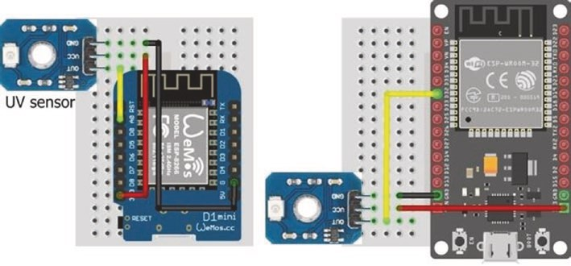
Figure 20-3. EEPROM and ultraviolet sensor
Table 20-1. EEPROM and ultraviolet sensor with ESP8266 and ESP32 microcontrollers
Component | ESP8266 | ESP32
Uv sensor OUt | a0 | gpiO 32
Uv sensor vCC | 3v3 | 3v3
Uv sensor gnd | gnd | gnd
Ota and saving data tO eeprOM, spiFFs, and exCel
The number of bytes required to store a data record in EEPROM for a character, an integer, or a real number is 1, 4, or 4, respectively. When storing a string, the number of bytes depends on the string data type. The string defined as String s = "ABCDEFGH" requires 12 bytes of EEPROM, but the string defined as char * s = "ABCDEFGH" requires only 4 bytes, with s defined as a pointer to char, which points to an object of type array of char with length eight. The length of a string, s, is obtained with the instruction s.length() or strlen(s), when the string data type is defined as String. or char s[].
Saving to SPIFFS
SPIFFS (Serial Peripheral Interface Flash File System) is a file system for microcontrollers to write to and read from files stored in flash memory. The partition of flash memory for SPIFFS is adjusted within the Arduino IDE depending on the requirements of a sketch. For example, the default SPIFFS partition for an ESP32 microcontroller is 1472 kB. SPIFFS is used to store data files, files containing HTML and AJAX code for a web page, and image files.
The ES8266 and ESP32 microcontrollers use the LittleFS and SPIFFS libraries, respectively. The LittleFS_esp32 library is available in the Arduino IDE, but currently Espressif supports the built-in SPIFFS library for the
ESP32 microcontroller. Instruction parameters for accessing a file with the LittleFS and SPIFFS libraries are listed in Table 20-2. Note that double quotes around instruction parameters in Table 20-2 are required for the ESP8266 microcontroller, but not for the ESP32 microcontroller. SPIFFS has a flat structure as directories are not supported. A file with path temp/filename.txt creates a file called temp/filename.txt and not a file called filename.txt in the temp directory. The ESP8266 SPIFFS, with the FS library, is currently deprecated; and the LittleFS library, which is faster, is recommended. The only changes to instructions are replacing #include<FS.h> and SPIFFS.function() instructions with #include<LittleFS.h> and LittleFS.function() instructions. The SPIFFS.rename() instruction enables both the dir and filename components of /dir/filename.txt to be changed, while LittleFS.rename() changes only the filename component. Further information is available at arduino-esp8266. readthedocs.io/en/2.7.4_a/filesystem.html.
Table 20-2. SPIFFS instruction parameters for ESP8266 and ESP32 microcontrollers
File Access | ESP8266 LittleFS Library | ESP32 SPIFFS Library
read file from start | “r” | File_read
Create/truncate file to write from start | “w” | File_Write
append from end | “a” | File_append
The sketch in Listing 20-3 demonstrates opening, writing to, reading from, renaming, and deleting a file stored in SPIFFS. Although SPIFFS has a flat structure, files are allocated to directories by prefixing the file name with a directory name, such as /temp/testfile.txt. The 8-3 file naming convention, for the file name (eight characters) and extension (three characters), is recommended, given the limit of 31 characters for the directory and file name. The SPIFFS library file access parameters, “r”, “w”, and “a” in Table 20-2 are sufficient for applications, although the parameters “r+”, “w+”, and “a+” are also available.
Listing 20-3. Write to, read from, and append file with SPIFFS for the ESP8266 microcontroller
#include <LittleFS.h> // include LittleFS library
String filename = "/temp/testfile.txt"; // structure /dir/file String newname = "/temp/newfile.txt";
void setup()
{
Serial.begin(115200); // Serial Monitor baud rate
Ota and saving data tO eeprOM, spiFFs, and exCel
if(LittleFS.begin()) Serial.println("initialised OK"); dirContent("/"); // contents of main directory dirContent("/temp"); // contents of sub directory File file = LittleFS.open(filename, " w"); // open file to write file.println("ABC");
file.println("123"); // instead of print("xxx/n") file.close();
fileContent(filename); // function display file content dirContent("/temp");
file = LittleFS.open(filename, "a"); // append to file file.println("XYZ"); file.close();
LittleFS.rename(filename, newnam e);
// change filename not directory
fileContent(newname); dirContent("/temp");
if(LittleFS.exists(filename)) LittleF S.remove(filename); } // delete file
void dirContent(String dname) // function to display directory content
{
Serial.print(dname);Serial.println(" content");
Dir dir = LittleFS.openDir(dname); while(dir.next())
{
File file = dir.openFile("r"); // read file
Serial.print("file ");Serial.print(file.name());Serial.
print("\t");
Serial.print("size ");Serial.println (file.size()); // filesize
}
}
void fileContent(String fname) // function to display file content
{
File file = LittleFS.open(fname, "r"); while(file.available()) Serial.write(file.read()); file.close(); }
void loop() // nothing in loop function
{}
For the ESP32 microcontroller, other than changing the library from LittleFS to SPIFFS and the file access parameters, the corresponding sketch only differs from Listing 20-2 in the function to list files in a directory (see Listing 20-4). The SPIFFS.rename() instruction enables both the dir and filename components of /dir/filename.txt to be changed, similar to the FS library for the ESP8266 microcontroller.
Listing 20-4. List directory files with SPIFFS for the ESP32 microcontroller
void dirContent(String dname)
{
Serial.print(dname);Serial.println(" content");
File dir = SPIFFS.open(dname); // SPIFFS library File file = dir.openNextFile(); // openNextFile while(file)
{
Serial.print("file ");Serial.print(file.name());
Serial.print("\t");
Serial.print("size ");Serial.println(file.size()); file = dir.openNextFile(); // openNextFile
}
}
Ota and saving data tO eeprOM, spiFFs, and exCel
Listing 20-3 illustrates using SPIFFS for data logging applications, with the instructions file.println("123") and file.println("XYZ"), for example. SPIFFS is also available for uploading files containing HTML and AJAX code for a web page or image files. The Arduino IDE requires a separate plugin for the ESP8266 and ESP32 microcontrollers, when uploading files to SPIFFS. Instructions for installing and running the plugin are available at arduino-esp8266.readthedocs.io/en/latest/
filesystem.html and github.com/me-no-dev/arduino-esp32fs-plugin, respectively. The unzipped esp8266littlefs.jar or esp32fs.jar (Java Archive) file containing the plugin must be located in the Sketchbook location ➤ tools ➤ ESP8266LittleFS ➤ tool or Sketchbook location ➤ tools ➤ ESP32FS ➤ tool folder, where the Sketchbook location folder is defined in the Arduino IDE, by selecting File ➤ Preferences. If the Arduino IDE is open, then Arduino IDE must be closed and restarted, and the Tools menu will then include the ESP8266 LittleFS Data Upload or ESP32 Sketch Data Upload option.
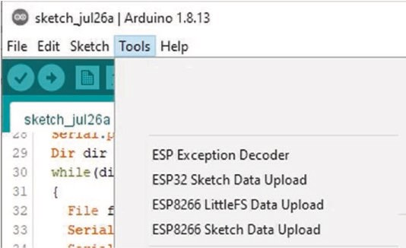
Figure 20-4. Plugin details for uploading files to SPIFFS
The text file containing HTML or AJAX code for a web page must be stored in the data folder within the sketch folder. In the Arduino IDE, select the Sketch menu, click Show Sketch Folder, and create a folder named data. A file filename.txt is referenced as /filename.txt in the sketch. Prior to uploading the text file to the Arduino IDE, ensure that both Board and Port are selected and that the Serial Monitor is closed. In the Arduino IDE, select the Tools menu, and click the ESP8266 LittleFS Data Upload or ESP32 Sketch Data Upload option. Once the message LittleFS Image Uploaded or SPIFFS Image Uploaded is displayed, compile and upload the sketch.
In Chapter 8 (Updating a web page), HTML and AJAX code for a web page was included on a separate tab, buildpage.h, from the main sketch with the instruction #include "buildpage.h". The default web page was loaded by the instruction server.on("/", base) referencing the base function to send the string page containing the HTML or AJAX code for the web page to the client, with the instruction server.send (200, "text/ html", page).
When HTML or AJAX code is included in a separate file, such as webcode.txt, that is uploaded to SPIFFS, then the separate tab, buildpage.h, is not required and the base function now uploads the file on SPIFFS that is then sent to the client. The base function is changed to
void base()
{
File file = SPIFFS.open("/webcode.txt","r"); // file for webpage server.streamFile(file, "text/html"); // send file to server file.close(); }
Moreover, the first and last lines of the string containing the HTML or AJAX code, namely char page[] PROGMEM = R"(, and )" of the string page are deleted. Using the example of Listing 8-4, the first and last lines of the file webpage.txt are now <!DOCTYPE html><html> and </body> </html>, respectively.
Ota and saving data tO eeprOM, spiFFs, and exCel
In Chapter 2 (Intranet camera), images are stored on the micro-SD card of the ESP32-CAM module with the instructions in Listing 2-1:
fs::FS & fs = SD_MMC; // with SD_MMC library,
File file = fs.open(filename.c_str(), FILE_WRITE); // access SD card file.write(frame->buf, frame->len); // save file to SD card
The ESP32-CAM module stores a JPEG-formatted image in SPIFFS with the instructions
File file = SPIFFS.open("/photo.jpg", FILE_WRITE); // access SPIFFS file.write(frame->buf, frame->len); // write file to SPIFFS and the image size is displayed with the instructions
Serial.print("Image size: ");
Serial.println(String(frame->len));
In Chapter 2 (Intranet camera), ESP32-CAM images are uploaded to a web page from PROGMEM, as flash (or program) memory has more capacity than RAM, and uploading from PROGMEM is substantially faster than uploading from SPIFFS, which takes several seconds.
Downloading SPIFFS files
While data files containing HTML and AJAX code for a web page can remain stored in SPIFFS, data files stored in SPIFFS by a data logging sketch may require downloading to a computer or laptop for subsequent analysis by specific software. A sketch to analyze the data files, while stored in SPIFFS, is another option.
Files stored in SPIFFS are downloaded to a computer or laptop with the sketch in Listing 20-5. The ESPAsyncWebServer and AsyncTCP libraries by Hristo Gochkov are required, and .zip files containing the libraries are downloaded from github.com/me-no-dev/ESPAsyncWebServer and github.com/me-no-dev/AsyncTCP, respectively. The ESPAsyncWebServer library references the AsyncTCP and Wi-Fi libraries, so the instructions #include <AsyncTCP.h> and #include <WiFi.h> or #include
<ESP8266WiFi.h> are not required. A directory list of the files held in SPIFFS is displayed on the Serial Monitor, and a selected file is then downloaded to the computer or laptop. The sketch includes an HTTP GET request for the file stored in SPIFFS to be downloaded. The default value of the last parameter of the request->send instruction is false, to indicate implementation of the file, as in a file containing HTML code, rather than downloading of the file. The user determines where the file is saved on the computer or laptop.
Listing 20-5. Downloading SPIFFS data file
#include <LittleFS.h> // include LittleFS and
#include <ESPAsyncWebServer.h> // ESPAsyncWebServer libraries AsyncWebServer server(80);
char ssid[] = "xxxx"; // change xxxx to Wi-Fi ssid char password[] = "xxxx"; // change xxxx to Wi-Fi password String filename; // file to be downloaded
void setup()
{
Serial.begin(115200); // define Serial Monitor baud rate WiFi.begin(ssid, password); // initialise Wi-Fi while (WiFi.status() != WL_CONNECTED) delay(500);
Serial.print("IP Address: ");
Serial.println(WiFi.localIP()); // display WLAN IP address server.begin(); // initialise server server.on("/download", HTTP_GET,
[](AsyncWebServerRequest * request)
Ota and saving data tO eeprOM, spiFFs, and exCel
{ request->send(LittleFS, filename, "text/plain", true); }); LittleFS.begin(); // initialise SPIFFS dirContent(""); // contents of main directory dirContent("temp"); // content of "temp" sub-directory
Serial.println("\nEnter directory/filename to download");
}
void loop()
{ if(Serial.available() > 0) // filename entered on Serial Monitor
{ filename = Serial.readString(); // read Serial buffer
Serial.print("In the browser, enter ");
Serial.print(WiFi.localIP());
Serial.print("/download to download file: ");
Serial.println(filename);
Serial.println("\n\nEnter directory/filename to download");
}
}
void dirContent(String dname) // function to display directory content
{
Serial.print("\nContent of directory: ");
Serial.println(dname);
Dir dir = LittleFS.openDir("/"+dname); while(dir.next())
{
File file = dir.openFile("r"); // read file
Serial.print(dname);Serial.print("/");
Serial.print(file.name());Serial.print("\t");
Serial.print("size ");Serial.println(file.size());
} // filesize }
Listing 20-5 is for an ESP8266 microcontroller. For an ESP32 microcontroller, the LittleFS library is replaced with the SPIFFS library; and, as with Listing 20-3, the dirContent function is changed to the function in Listing 20-4. In the dirContent function, the instruction File dir = SPIFFS.open(dname) is also changed to File dir = SPIFFS. open("/"+dname). The contents of the main and “temp” directories are separately displayed with the ESP8266 microcontroller, but the content of all directories is displayed with the instruction dirContent("") with the ESP32 microcontroller.
Saving data directly to Excel
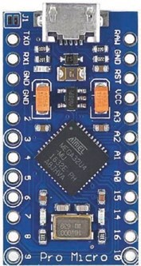
The ESP8266 and ESP32 microcontrollers cannot emulate a USB device, such as a keyboard, to send a character or a string to a connected laptop or computer. However, the Arduino Pro Micro can emulate a USB device for automated data recording projects. For example, data collected by a sensor connected to a Pro Micro is sent to the connected laptop or computer and written directly to a Microsoft Excel file. Sensor data is plotted immediately, in contrast to the microcontroller storing data on an SD card, that is then imported to a Microsoft Excel file.
Keyboard emulation is started with the instruction Keyboard.begin(), but it is important to have a control system in place to end keyboard emulation by the Pro Micro; otherwise, the computer keyboard will not function. For example, changing the state of a GPIO pin, by pressing a switch connected to the Pro Micro, can trigger the instruction Keyboard. end() and end the Pro Micro keyboard emulation. A character or string, str, is sent to the attached computer with the instruction Keyboard. print(str) or Keyboard.println(str), with the latter including the
Ota and saving data tO eeprOM, spiFFs, and exCel
ASCII characters for a carriage return and a new line. Before loading a sketch using the keyboard emulation instructions, it is recommended to test the sketch with the Serial.print() or Serial.println() instruction and that the control system to stop the sketch operates correctly. The Pro Micro keyboard emulation will print to the open window that is currently running on the attached computer. While the sketch with the Keyboard. print() instructions is compiling in the Arduino IDE, the computer cursor must be positioned on a worksheet of the Microsoft Excel file.
The sketch in Listing 20-6 reads the temperature on a BMP280 sensor, measures the light intensity with a light-dependent resistor (LDR), and writes the data directly to the open Microsoft Excel worksheet. Keyboard emulation by the Pro Micro is stopped by pressing the switch with a pull-down resistor, which changes the state of the GPIO pin attached to the switch and triggers the Keyboard.end() instruction. In the sketch, data is written to the Microsoft Excel worksheet every five seconds. The ASCII characters for keyboard control of 9, 10, 11, and 13 for a horizontal tab, line feed, vertical tab, and carriage return are used to format data on the Microsoft Excel worksheet. For example, the tab keyboard control characters are sent to the connected laptop or computer with the instruction Keyboard.print(char(9)).
Listing 20-6. Saving data directly to an Excel file
#include <Keyboard.h> // include Keyboard library
#include <Adafruit_Sensor.h> // include Unified Sensor library
#include <Adafruit_BMP280.h> // include BMP280 library Adafruit_BMP280 bmp; // associate bmp with BMP280 int BMPaddress = 0x76; // I2C address of BMP280 int switchPin = A3; // define switch and LDR pins int LDRpin = 9; unsigned long nowTime, lastTime = 0; float temp, bright;

Ota and saving data tO eeprOM, spiFFs, and exCel
int counter = 0;
void setup()
{
Keyboard.begin(); // initialise Keyboard bmp.begin(BMPaddress); // initialise BMP280 header(); // call header function
}
void loop()
{ // MUST BE ABLE TO STOP KEYBOARD if(digitalRead(switchPin) == HIGH) // switch to stop Keyboard {
Keyboard.end(); // stop Keyboard while(1); // and do nothing else
}
nowTime = millis(); // set start of time interval if(nowTime - lastTime > 5000) // collect data every 5s
{
counter++; // increment counter temp = bmp.readTemperature(); // get BMP280 reading bright = analogRead(LDRpin); // and brightness reading Keyboard.print(counter); // print counter to Excel
Keyboard.print(char(9)); // print tab character
Keyboard.print(temp); // print temp to Excel
Keyboard.print(char(9)); // print bright to Excel, with Keyboard.println(bright); // carriage return and new line lastTime = nowTime; // update start of time interval
}
}
Ota and saving data tO eeprOM, spiFFs, and exCel
void header() // function to print columns headers to Excel
{
Keyboard.print("counter"); // print "counter" to Excel
Keyboard.print(char(9)); // print tab character
Keyboard.print("temp");
Keyboard.print(char(9));
Keyboard.print("bright");
Keyboard.print(char(13)); // print carriage return character
Keyboard.print(char(10)); // print new line character
}
Connections for the Pro Micro, BMP280, and LDR are shown in Figure 20-5 and listed in Table 20-3. Note the importance of ensuring that there is a reliable control system to stop the keyboard emulation function, while the sketch is running, as otherwise keyboard control of the attached computer is compromised.
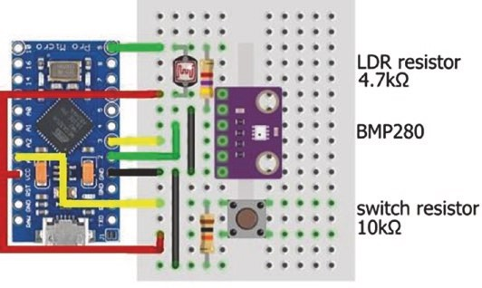
Figure 20-5. Pro Micro with BMP280 sensor and light-dependent resistor
Ota and saving data tO eeprOM, spiFFs, and exCel
Table 20-3. Saving data directly to an Excel file
Component | Connect to | And to
BMp280 vCC | pro Micro 3.3v
BMp280 gnd | pro Micro gnd
BMp280 sdi (serial data) | pro Micro pin 2
BMp280 sCK (serial clock) | pro Micro pin 3
BMp280 CsB (chip select) | not connected
BMp280 sdO (serial data out) | pro Micro gnd
ldr top leg | pro Micro pin 9
ldr top leg | 10 kΩ resistor | pro Micro gnd
ldr bottom leg | pro Micro 3.3v
switch top leg | pro Micro pin a3
switch top leg | 10 kΩ resistor | pro Micro gnd
switch bottom leg | pro Micro 3.3v
Summary
OTA (over the air) updating is described to remotely upload a sketch to a ESP8266 or ESP32 microcontroller. The EEPROM (Electrically Erasable Programmable Read-Only Memory) and SPIFFS (Serial Peripheral Interface Flash File System) partitions of flash memory of the ESP8266 and ESP32 microcontrollers are used to save data or files or images. Saving data on the microcontroller internal EEPROM is described with an example of storing and retrieving sensor measurements. Storing files on SPIFFS is described with an example of creating, writing to, reading from, renaming, and deleting a file. A file containing HTML or AJAX code for a web page is uploaded to SPIFFS with the Sketch Data Upload plugin for
Ota and saving data tO eeprOM, spiFFs, and exCel
the Arduino IDE. Data is also saved directly to a Microsoft Excel worksheet with an Arduino Pro Micro emulating a keyboard, with an example given of temperature and light intensity measurements.
Components List
- ESP8266 microcontroller: LOLIN (WeMos) D1 mini or NodeMCU board
- ESP32 microcontroller: DEVKIT DOIT or NodeMCU board
- Arduino Pro Micro
- Ultraviolet sensor
- Temperature sensor: BMP280
- Light-dependent resistor
- Tactile switch
- Resistors: 4.7 kΩ, 10 kΩ

CHAPTER 21
Microcontrollers
Several microcontrollers are used in the book, depending on the required function of the microcontroller. The LOLIN (WeMos) D1 mini board, based on the ESP8266 microcontroller, is used in applications requiring Wi-Fi connectivity. The ESP32 DEVKIT DOIT board, based on the ESP32 microcontroller, is ideal for applications requiring intense data processing with either Wi-Fi or Bluetooth connectivity. The ESP32-CAM board, which is based on the ESP32-S microcontroller, is the obvious choice for applications requiring both a camera and Wi-Fi functionality. The Arduino Pro Micro emulates a USB device, such as a keyboard, in applications that store data directly to a Microsoft Excel spreadsheet. The Arduino Uno and the smaller Arduino Nano, both based on the ATmega328P microcontroller, are appropriate for applications when Wi-Fi connectivity or high processing power is not required. Table 21-1 summarizes some of the properties of the microcontrollers, with further information available from www.arduino.cc/en/Main/Products or from www.espressif.com/ en/products/devkits. The ESP8266 and ESP32 microcontrollers have significantly higher CPU frequencies, with more flash memory and RAM (random access memory) than the ATmega328P microcontroller. A sketch is stored in flash memory, while sketch variables are stored in RAM.
© Neil Cameron 2021 611
N. Cameron, Electronics Projects with the ESP8266 and ESP32, https://doi.org/10.1007/978-1-4842-6336-5_21
CHAPTER 21 MICROCONTROLLERS
Table 21-1. Microcontroller properties
Property | ESP32 | ESP8266 | ATmega328P ATmega32U4
Development board | DEVKIT DOIT | LOLIN (WeMos)  D1 mini | Arduino  Uno/Nano | Arduino  Pro Micro
Architecture | 32-bit | 32-bit | 8-bit | 8-bit
CPU frequency | 240 MHz | 160 MHz | 16 MHz | 16 MHz for 5V
Flash memory | 4 MB | 4 MB | 32 kB | 32 kB
(S)RAM | 520 kB | <50 kB | 2 kB | 2.5 kB
Time for 10k primes | 385 ms | 1786 ms | 56732 ms | 57027 ms
All development boards have PWM (pulse width modulation) pins and ADC (analog to digital converter) pins. The ESP8266 and ESP32 microcontrollers both have Wi-Fi connectivity, with the ESP32 microcontroller also having both Bluetooth and Bluetooth Low Energy connectivity, DAC (digital to analog converter) pins, touch-sensitive pins, and a Hall effect sensor, (see Chapter 22 (ESP32 microcontroller features)).
The result of higher CPU frequency, flash memory, and RAM is the lower processing time for a sketch. For example, the sketch in Listing 21-1 measures the time required to determine the first 10k prime numbers. The sketch may not be optimal, in terms of minimizing processing time, but is sufficient for establishing a benchmark. The ATmega microcontroller required 57 seconds to perform the task, while the ESP8266 and ESP32 microcontrollers required under two seconds and less than half a second, respectively. The CPU frequency of the ESP32 microcontroller is changed, in the Arduino IDE, to 10, 20, 40, 80, or 160 MHz by selecting Tools ➤ CPU Frequency. As the CPU frequency doubles, the time to determine the first
10k prime numbers essentially halves from 11607 ms with 10 MHz to 5060 ms with 20 MHz, to 2403 ms with 40 MHz, to 1172 ms with 80 MHz, and to 579 ms with 160 MHz.
CHAPTER 21 MICROCONTROLLERS
Listing 21-1. Determine the first 10k prime numbers
int Nprimes = 9999; // required number of primes - 1 unsigned long number = 2; // start from number 2 int count = 1; // prime number counter unsigned int start = 0; // store processing time unsigned long ms; int chk, limit, mod, divid;
void setup()
{
Serial.begin(115200); // Serial Monitor baud rate while(!Serial); // wait for Pro Micro to connect Serial Serial.print("\nCPU "); Serial.println(F_CPU/1000000); start = millis(); // start of processing time
}
void loop()
{
number++; // increment number to check chk = is_prime(number);
if (chk > 0) count++; // increment counter when prime if (count > Nprimes)
{ ms = millis() - start; // display results
Serial.print("Found ");
Serial.print(count);
Serial.print(" primes in ");
Serial.print(ms);
Serial.println(" ms");
Serial.print("Highest prime is ");
CHAPTER 21 MICROCONTROLLERS
Serial.println(number); delay(50000); // long delay when finished
}
}
int is_prime(unsigned long num) // function to check if prime number
{
mod = num % 2; // exclude even numbers if (mod == 0) return 0;
limit = sqrt(num); // check divisors less than square root for (int divid = 3; divid <= limit; divid = divid + 2)
{
mod = num % divid; // remainder after dividing if (mod == 0) return 0; // not prime if zero remainder
} return 1; // no divisor with zero remainder
}
The development boards have different pin layouts and installation and sketch loading requirements, so details of each development board are described separately. Information on the pin layout of a development board that is accessible with the Arduino IDE is listed in the file pins_ arduino, which is located in the file user ➤ AppData ➤ Local ➤ Arduino15 ➤ packages ➤ microcontroller ➤ hardware ➤ category ➤ version ➤ variants ➤ board, where microcontroller, category, version, and board correspond to the particular development board. For example, pin layout information on the LOLIN (WeMos) D1 mini board is located in the file user ➤ AppData ➤ Local ➤ Arduino15 ➤ packages ➤ esp8266 ➤ hardware ➤ esp8266 ➤ version ➤ variants ➤ d1_mini.
Information on the microcontroller CPU frequency and GPIO
(General-Purpose Input-Output) pins allocated to SPI (Serial Peripheral
Interface) and I2C (Inter-Integrated Circuit) communication is obtained
CHAPTER 21 MICROCONTROLLERS
within the Arduino IDE framework. The sketch in Listing 21-2 also provides information about the sketch itself. The sketch is run with any microcontroller that is accessible by the Arduino IDE.
Listing 21-2. Microcontroller information
String str, adjStr;
void setup()
{
Serial.begin(115200); // Serial Monitor baud rate Serial.println();
while(!Serial); // Pro Micro wait for serial port Serial.print("Arduino IDE version "); str = String(ARDUINO); // Arduino IDE version adjStr = str.substring(1,str.length()-5)+"."; adjStr = adjStr + str.substring(str.length()-4, str.length()-2)+".";
adjStr = adjStr + str.substring(str.length()-2);
Serial.println(adjStr); // date and time sketch compiled
Serial.print("Compiler version");
Serial.println(__VERSION__);
Serial.print("Compiled date"); Serial.println(__DATE__);
Serial.print("Compiled time"); Serial.println(__TIME__);
Serial.print("Sketch location"); Serial.println(__FILE__);
Serial.print("CPU frequency(MHz)"); // CPU frequency
Serial.println(F_CPU/1000000);
Serial.print("Development board");
Serial.println(ARDUINO_BOARD);
#ifdef __AVR__ // development board
Serial.print("Microcontroller"); Serial.println(ARDUINO_MCU);
CHAPTER 21 MICROCONTROLLERS
#endif // microcontroller
Serial.print("SPI MOSI");Ser ial.println(MOSI); // pin layout SPI
Serial.print("SPI MISO");Serial.println(MISO);
Serial.print("SPI SCK");Serial.println(SCK);
Serial.print("SPI SS");Serial.println(SS);
Serial.print("I2C SDA");Ser ial.println(SDA); // pin layout I2C
Serial.print("I2C SCL");Serial.println(SCL);
#ifndef ESP32
Serial.print("LED");Serial.println(LED_BUILTIN); // built-in LED
#endif
}
void loop() // nothing in loop function
{}
The parameters ARDUINO_BOARD and ARDUINO_MCU are generated by instructions based on line 58 of the platform.txt file that refers to compiling C++ files. The line starts with recipe.cpp.o.pattern. The platform. txt file is located in user ➤ AppData ➤ Local ➤ Arduino15 ➤ packages ➤ arduino ➤ hardware ➤ avr ➤ version. The line from the platform.txt file is pasted into a new file, platform.local.txt, with the addition of
-DARDUINO_BOARD="{build.board}" and -DARDUINO_
MCU="{build.mcu}". The file platform.local.txt is stored in the same folder as the platform.txt file. When the sketch is compiled, the two variables are accessible. The parameter ARDUINO_BOARD already exists for the ESP8266 and ESP32 microcontrollers, and the parameter ARDUINO_MCU does not need to be displayed for ESP8266 and ESP32 microcontrollers.
Listing 21-2 includes the compiler directives of #ifdef and #endif, for the compiler to determine if the microcontroller is defined as AVR based, __AVR__, or not defined as an ESP32 and then only incorporate the relevant instructions in the compilation process. The compiler directives of #if, #elif, and #else correspond to if with a condition, else if, and else in
CHAPTER 21 MICROCONTROLLERS
the C language. The directive #ifndef is equivalent to if not defined as. The compiler directive #ifdef must be followed by an #endif directive.
Microcontrollers are broadly grouped as AVR based (__AVR__), ESP8266, and ESP32. AVR may be an acronym of the inventors of the AVR architecture: Alf-Egil Bogen and Vegard Wollan RISC processor. Details of specific microcontroller groupings are listed in the Arduino, ESP8266, or ESP32 boards.txt file that is located in the same directory as the platform.
txt file, with a grouping defined by board.build. Examples of specific
ESP8266 or ESP32 microcontroller groupings are ESP8266_WEMOS_
D1MINI and ESP8266_NODEMCU or ESP32_DEV and FEATHER_ESP32. If a specific microcontroller grouping is used in a compiler directive, then the grouping is preceded with ARDUINO_, as in #ifdef ARDUINO_ESP32_DEV.
The Arduino IDE has predefined values for the constants π, e, π/180, and 180/π, defined as PI, EULER, DEG_TO_RAD, and RAD_TO_DEG, respectively. Values are located in the file Program Files (x86) ➤ Arduino ➤ hardware ➤ arduino ➤ avr ➤ cores ➤ arduino ➤ Arduino.
Arduino Uno
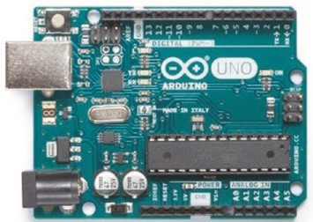
The Arduino Uno is based on the ATmega328P microcontroller, and the development board operates at 5 V, powered through a USB connection at 5 V or a DC input jack at 7–12 V. The maximum current supply from a GPIO pin is 40 mA, with a maximum current from all output pins of 200 mA. In a sketch, GPIO pins are referenced by the numbering on the development board and not by the GPIO pin numbers of the ATmega328P microcontroller. The exception is the ADC pins A0–A5 which are also referenced as pin numbers 14–19. Communication pins for I2C are A4 (SDA) and A5 (SCL)
CHAPTER 21 MICROCONTROLLERS
and for SPI are 11 (MOSI), 12 (MISO), 13 (SCK), and 10 (SS). PWM pins are 3, 5, 6, 9, 10, and 11. Interrupt pins, INT0 and INT1, are 2 and 3. The built-in LED is on pin 13.
Arduino Nano
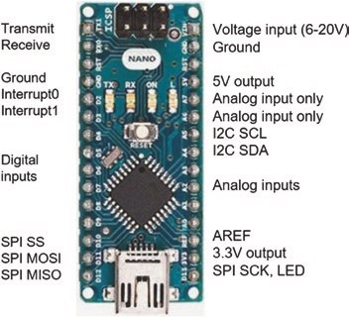
The Arduino Nano has the same ATmega328P microcontroller as the Arduino Uno and the same pin functionality, except that pins A6 and A7 are analog input only. Digital pins are prefixed with D on the development board. The development board operates at 5 V and is powered through a mini-USB connection at 5 V.
In January 2018, Arduino
released a new bootloader for the Arduino Nano, so the relevant processor must be selected in the Arduino IDE. In the Tools ➤ Processor menu, select either the ATmega328P option or the ATmega328P (Old Bootloader) option.

Arduino Pro Micro
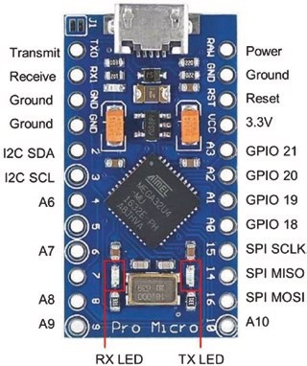
In the Arduino IDE, the Arduino Pro Micro is referenced as the Arduino Leonardo in the Tools ➤ Board menu.
The development board operates at
5 V and is powered through a mini- USB connection at 5 V. In a sketch, pins are referenced by the numbering on the development board and not by the GPIO pin numbers of the ATmega32U4 microcontroller. The ADC pins A0–A3 are also referenced as pin numbers 18–21. Pins 4, 6, 8, 9, and 10 correspond to the ADC pins A6–A10.
Communication pins for I2C are 2 (SDA) and 3 (SCL) and for SPI are 16 (MOSI), 14 (MISO), and 15 (SCK). PWM pins are 3, 5, 6, 9, and 10. Interrupt pins, INT0, INT1, INT2, INT3, and INT6, are 3, 2, 0 (RX), 1 (TX), and 7. The built-in RX and TX LEDs are on pins 17 and 30, which are active LOW, and are automatically defined as OUTPUT pins. The TX LED is turned off or on with the built-in macro TXLED0 or TXLED1, respectively (see Listing 21-3). When the TXLED0 and TXLED1 macros are not utilized, then the TXLED pin must be defined.
Listing 21-3. Controlling Pro Micro LEDs
int RXLED = 17; // define RXLED pin
//int TXLED = 30; // required if not using macros
void setup()
{} // nothing in setup function
void loop()
{
digitalWrite(RXLED, HIGH); // turn off RXLED // digitalWrite(TXLED, HIGH); // turn off TXLED TXLED0; // macro to turn off TXLED delay(1000);
digitalWrite(RXLED, LOW); // turn on RXLED // digitalWrite(TXLED, LOW); // turn on TXLED TXLED1; // macro to turn on TXLED delay(1000); }
When a sketch uploads, the ATmega32U4 bootloader Serial port opens and then closes after the sketch is uploaded. The ATmega32U4 Serial port then opens, so the COM port may change after a sketch is loaded. The instruction while(!Serial) waits until the Serial connection is established. The ATmega32U4 microcontroller does not reset when a COM port is opened, unlike ATmega328P of the Arduino Uno.
The Arduino Pro Micro microcontroller is reset by connecting the reset
(RST) pin, which has a pull-up resistor, to GND twice to put the Arduino Pro Micro microcontroller into bootloader mode for an eight-second period, before a sketch is started. The ATmega32U4 microcontroller may become un-programmable or bricked if a problem occurs when uploading a sketch that uses the Keyboard library or with an incorrectly defined microcontroller, such as a 16 MHz/5 V microcontroller defined as 8 MHz/3.3 V. The bootloader may have to be reinstalled, and the Atmega_Board_Programmer by Nick Gammon is recommended, which is downloaded from githib.com/nickgammon/arduino_sketches.
ESP8266 development board
The LOLIN (WeMos) D1 mini development board (see Figure 21-1) is based on the ESP-8266EX microcontroller and has Wi-Fi functionality. The development board operates at 3.3 V and is powered through a micro-USB connection at 5 V, through the 3.3 V voltage regulator, or directly on the 3.3 V pin, but the former connection is recommended. The pins are not 5 V tolerant, and the maximum current supply from a pin is 12 mA.
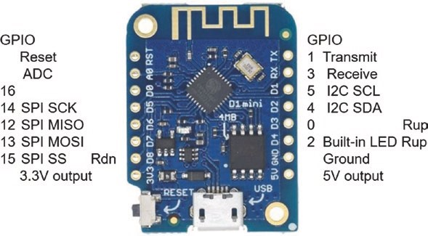
Figure 21-1. LOLIN (WeMos) D1 mini development board
In a sketch, pins are referenced by either the numbering on the development board prefixed by the letter D for digital pins or by the ESP- 8266EX microcontroller GPIO numbers. The ADC pin is A0 and has 10-bit resolution. Pins for I2C communication are D2 or GPIO 4 (SDA) and D1 or GPIO 5 (SCL) and for SPI communication are D7 or GPIO 13 (MOSI), D6 or GPIO 12 (MISO), D5 or GPIO 14 (SCK), and D8 or GPIO 15 (SS). The four digital pins, D2, D6, D5, and D8 or GPIO 4, GPIO 12, GPIO 14, and GPIO 15, have 10-bit PWM resolution and interrupt functionality. The built-in
LED on pin D4 or GPIO 2 is active LOW. Note that pins D3 or GPIO 0 and
D4 or GPIO 2 have built-in pull-up resistors, while pin D8 or GPIO 15 has
a built-in pull-down resistor. When uploading a sketch, pins D3 and D4 must not be pulled LOW, and similarly pin D8 must not be pulled HIGH. In Figures 21-1 and 21-2, a built-in pull-up or pull-down resistor is indicated by Rup or Rdn.
The CH340G USB to UART (Universal Asynchronous ReceiverTransmitter) driver for the LOLIN (WeMos) D1 mini is downloaded from docs.wemos.cc/en/latest/ch340_driver.html. Save the CH341SER_
WIN_3.5 zip file on the Desktop, right-click Extract All, and in the extracted folder CH341SER_WIN_3.5 right-click the SETUP application, select Run as administrator, and install the driver CH341S64.SYS. Drivers are located in the C: ➤ Windows ➤ System32 ➤ drivers folder.
The NodeMCU ESP8266 development board (see Figure 21-2) has the same effective functionality as the LOLIN (WeMos) D1 mini development board. The NodeMCU ESP8266 development board has three 3.3V pins and four GND pins for connecting to other devices and two built-in LEDs on pins D4 or GPIO 2 and D0 or GPIO 16, which are active LOW. The ESP8266 microcontroller stores a sketch in an external flash memory chip and communicates with the flash chip over an SDIO (Secure Digital Input- Output) interface. The NodeMCU ESP8266 development board GPIO 6–11 pins correspond to the SDIO interface pins labeled CLK, SD0, SD1, SD2, SD3, and CMD.
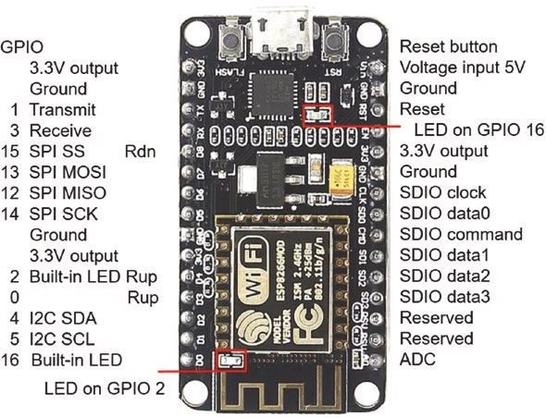
Figure 21-2. NodeMCU ESP8266 development board
The CP210x USB to UART Bridge driver for the NodeMCU ESP8266 development board is downloaded from www.silabs.com/products/ development-tools/software/usb-to-uart-bridge-vcp-drivers. Save the CP210x_Universal_Windows_Driver zip file on the Desktop and right- click Extract All. In the extracted folder CHP210x_Universal_Windows_ Driver, right-click either the x64 or x86 version of the CP210xVCPInstaller application for a 64-bit or a 32-bit operating system, respectively. To determine if a computer has a 64-bit or a 32-bit operating system, select Control Panel ➤ System and Security ➤ System, and the system type is displayed. Select Run as administrator and install the driver silabser.sys. Drivers are located in the C: ➤ Windows ➤ System32 ➤ Drivers folder. The computer may need to be restarted to complete the driver installation.
For both the LOLIN (WeMos) D1 mini and NodeMCU ESP8266 development boards, select File ➤ Preferences in the Arduino IDE and enter the URL http://arduino.esp8266.com/stable/package_ esp8266com_index.json in the Additional Boards Manager URLs box. If there is already a URL in the box, then separate the URLs with a comma.
ESP8266 libraries are installed in the Arduino IDE by selecting Tools ➤ Board ➤ Boards Manager, entering 8266 in the Filter option to display esp8266 by ESP8266 Community, and clicking Install. In the Tools ➤ Board drop-down list, select LOLIN(WEMOS) D1 R2 & mini, as listed in the ESP8266 Boards section. In Tools ➤ CPU Frequency, select 160 MHz; and in Tools ➤ Port, select the relevant COM port.
Reference documentation for the ESP8266 microcontroller is available at arduino-esp8266.readthedocs.io/en/latest/index.html.
ESP8266 analog input
The ESP8266 microcontroller 10-bit analog to digital converter (ADC) functionality converts a voltage, between 0 and 3.2 V, on the analog input pin A0 to a digital value between 0 and 1023. The instruction analogRead(A0) reads the voltage on the analog input pin A0. The reference voltage of the ESP8266 microcontroller ADC is 1 volt; and an internal voltage divider, consisting of 100 kΩ and 220 kΩ resistors (see Figure 21-3), increases the maximum voltage on the analog input pin to 3.2 V. Given a voltage, V_{IN}, on the ESP8266 development board analog input pin, the corresponding ADC value is V_{IN} ´(₂₂₀ ₁₀₀¹⁰⁰+ ^{kW})kW´1024.
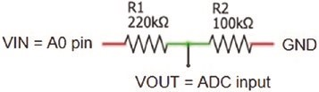
Figure 21-3. Analog to digital converter
ADC values for input voltages between 3.2 V and 3.3 V are constrained to 1023. A 10 kΩ resistor connected between the input voltage and the ESP8266 development board analog input pin increases the limit of 3.2 V on the analog input pin to 3.3V.
ESP8266 interrupts
An interrupt is attached to a pin on the ESP8266 development board, such as pins D1–D7 of the LOLIN (WeMos) D1 mini, with the instruction attach Interrupt(digitalPinToInterrupt(switchPin), change, FALLING) (see Figure 21-4, left side). The switch is connected to GND and the switch pin on the ESP8266 development board. The instruction pinMode(switchPin, INPUT_PULLUP) activates the internal pull-up resistor on the switch pin, so the switch pin state is HIGH. When the switch is pressed, the switch pin is connected to GND, changing the switch pin state to LOW, with the FALLING state activating the interrupt. The ESP8266 microcontroller stores compiled code in internal RAM (IRAM), rather than in the slower flash memory, by prefixing sketch instructions with the IRAM_ATTR attribute. The interrupt ISR is defined as IRAM_ATTR void ISR() rather than void ISR(). If the interrupt ISR is defined before the sketch setup function, then the ISR definition instruction is changed to void IRAM_ATTR ISR().
In contrast, if the switch pin is D8, then the switch is connected to 3.3V and the switch pin on the development board (see Figure 21-4, right side). Pin D8 has a built-in pull-down resistor, so the pin state is LOW. The interrupt is attached to pin D8 with the instruction attachInterrupt (digitalPinToInterrupt(switchPin), change, RISING). When the switch pin is pressed, the switch pin state changes to HIGH, with the RISING state activating the interrupt. The RISING interrupt with pin D8 as the switch pin is less susceptible to switch bouncing than the FALLING interrupt on pins D1–D7. Note that the difference between the two circuits in Figure 21- 4 is the switch pin is connected to pins D7 and GND or the switch pin is connected to D8 and 3.3V.
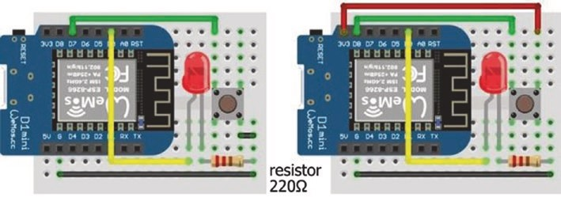
Figure 21-4. Interrupts with LOLIN (WeMos) D1 mini
The sketch in Listing 21-4 illustrates the difference between interrupts attached to ESP8266 development board pins D7 and D8. When the interrupt is attached to pin D7, the pin is defined as INPUT_PULLUP to activate the built-in pull-up resistor, and the interrupt is activated on a FALLING signal. If the interrupt is attached to pin D8, then a RISING signal activates the interrupt.

CHAPTER 21 MICROCONTROLLERS Listing 21-4. Interrupts with the ESP8266 development board
int LEDpin = D0; // define LED pin int switchPin = D7; // define switch pin volatile int LEDstate = LOW; // initial LED state
// volatile as LEDstate in ISR void setup()
{
Serial.begin(115200); // Serial Monitor baud rate pinMode(LEDpin, OUTPUT); // define LEDpin as OUTPUT pinMode(switchPin, INPUT_PULLUP); // when switch pin is D1 to D7 attachInterrupt(digitalPinToInterrupt(switchPin), change, FALLING); // when switch pin is D8
// attachInterrupt(digitalPinToInterrupt(switchPin), change,
// RISING);
}
void loop()
{
Serial.println(digitalRead(switchPin)); // display switch pin state delay(1000); }
IRAM_ATTR void change() // interrupt service routine (ISR) {
LEDstate = 1-LEDstate; // change LED state digitalWrite(LEDpin, LEDstate); // turn LED on or off }
ESP8266 watchdog timer
If an ESP8266 microcontroller is prevented from performing background tasks by a long period of inactivity during a sketch, then the watchdog timer may initiate a software reset. Background tasks include maintaining a Wi-Fi connection or managing the TCP/IP (Transmission Control Protocol/Internet Protocol) Internet connection. A software reset is indicated by the messages Soft WDT reset and rst cause:2, boot mode:(3,6). Including the instruction delay(1) or yield() in the sketch at the point of inactivity may resolve the software reset. The yield() instruction allows completion of background tasks.
The sketch location of the software reset by the watchdog timer is determined with the ESP Exception Decoder. Instructions for installing and running the ESP Exception Decoder are outlined at arduino- esp8266.
readthedocs.io/en/latest/faq/a02-my-esp-crashes.html. The ESP Exception Decoder is downloaded from github.com/me-no-dev/
EspExceptionDecoder. The unzipped EspExceptionDecoder.jar (Java
Archive) file containing the ESP Exception Decoder must be located in the Sketchbook location ➤ tools ➤ EspExceptionDecoder ➤ tool folder, where the Sketchbook location folder is defined in the Arduino IDE, by selecting File ➤ Preferences.
A hardware reset by the watchdog timer is indicated with the messages wdt reset and rst cause:4, boot mode:(3,6). The location of the hardware reset in a sketch is not determined with the ESP Exception Decoder, so a series of Serial.println() instructions is used to determine the last successful instruction before the hardware reset.
ESP32 development board
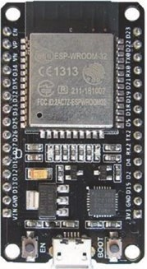
The ESP32 development board, such as the ESP32 DEVKIT DOIT, is based on the ESP32 microcontroller and has both Wi-Fi and Bluetooth functionality. The development board operates at 3.3 V and is powered through a micro-USB connection at 5 V or directly on the 3.3V VIN pin, but the former connection is recommended. The GPIO pins are not 5 V tolerant, and the maximum current supply from a pin is 12 mA.
In a sketch, pins are referenced by ESP32 microcontroller GPIO numbers. There are six ADC pins
(GPIO 32, GPIO 33, GPIO 34, GPIO 35, GPIO 36, and GPIO 39) with 12-bit resolution and two DAC (digital to analog converter) pins (GPIO 25 and GPIO 26) with 8-bit resolution. Communication pins for I2C are GPIO 21 (SDA) and GPIO 22 (SCL) and for SPI are GPIO 23 (MOSI), GPIO 19 (MISO), GPIO 18 (CLK), and GPIO 5 (CS). All GPIO pins, except the input-only pins (GPIO 34, GPIO 35, GPIO 36, and GPIO 39), are PWM pins; and all GPIO pins have interrupt functionality. There are nine capacitive touch pins (GPIO 2, GPIO 4, GPIO 12, GPIO 13, GPIO 14, GPIO 15, GPIO 27, GPIO 32, and GPIO 33). The built-in LED is on GPIO 2, and the LED is active HIGH. Several pins are available to the real-time clock to trigger the ESP32 microcontroller from sleep mode. Internal pull- up resistors are connected to GPIO pins 0, 5, 14, and 15 with pull-down resistors on GPIO pins 2,4, and 12. The ESP32 microcontroller contains a Hall effect sensor. Pin layouts of the ESP32 DEVKIT DOIT and NodeMCU development boards with 30 and 38 pins are shown in Figures 21-5 and 21- 6, respectively, to illustrate development board differences. Pin functions are coded as A#, analog input; T#, capacitive touch; input, input only; RTC, real-time clock; Rup, built-in pull-up resistor; and Rdn, built-in pull- down resistor. GPIO 6–11 pins of the NodeMCU development board are connected to the integrated flash memory, and use of the pins is not recommended.

CHAPTER 21 MICROCONTROLLERS
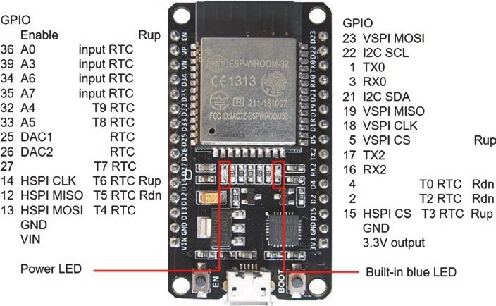
Figure 21-5. ESP32 DEVKIT DOIT 30-pin layout
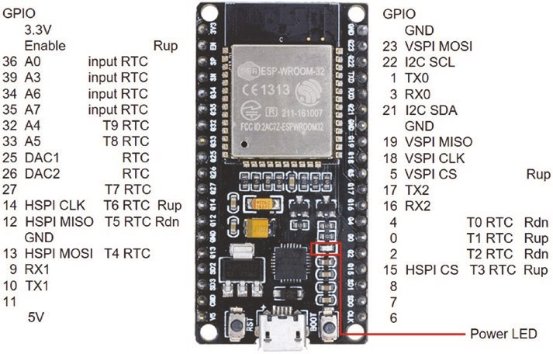
Figure 21-6. ESP32 NodeMCU 36-pin layout
The CP210x USB to UART Bridge driver for the ESP32 development board is downloaded from www.silabs.com/products/development- tools/software/usb-to-uart-bridge-vcp-drivers. Save the CP210x_ Universal_Windows_Driver zip file on the Desktop and right-click Extract All. In the extracted folder CP210x_Universal_Windows_Driver, right- click either the x64 or x86 version of the CP210xVCPInstaller application for a 64-bit or a 32-bit operating system, respectively. To determine if a computer has a 64-bit or a 32-bit operating system, select Control Panel ➤ System and Security ➤ System, and the system type is displayed. Select Run as administrator and install the driver silabser.sys. Drivers are located in the C: ➤ Windows ➤ System32 ➤ Drivers folder. The computer may need to be restarted to complete the driver installation.
In the Arduino IDE, select File ➤ Preferences and enter the URL https://dl.espressif.com/dl/package_esp32_index.json in the Additional Boards Manager URLs box. If there is already a URL in the box, then separate the URLs with a comma.
ESP32 libraries are installed in the Arduino IDE by selecting Tools ➤ Board ➤ Boards Manager, entering ESP32 in the Filter option to display esp32 by Espressif Systems, and clicking Install. In the Tools ➤ Board drop- down list, select ESP32 Dev Board or your specific ESP32 development board as listed in the ESP32 Boards section. In Tools ➤ Upload Speed, CPU Frequency, Flash Frequency, Flash Mode, Flash Size, and Partition Scheme, select 921600, 240MHz (WiFI/BT), 80MHz, DIO, 4MB (32Mb), and Default 4MB with spiffs, respectively. The SPI Flash Mode setting of QIO (Quad Input/Output) is faster than the DIO (Dual Input/Output) setting, but not all settings are available to each device. After loading a sketch, the message rst:0x3 (SW_RESET),boot:0x13 (SPI_FAST_FLASH_BOOT) is displayed if the QIO setting is unsupported. Further details are available at github. com/espressif/esptool/wiki/SPI-Flash-Modes. Finally, in Tools ➤ Port, select the relevant COM port.
Reference documentation for the ESP32 microcontroller is available at docs.espressif.com/projects/esp-idf/en/latest/esp32/index.html, particularly the API Reference section.
The ESP32 microcontroller includes several features that are specific to the ESP32 microcontroller, which are described in Chapter 22 (ESP32 microcontroller features). Sketch instructions for an ESP32 development board differ in several ways from programming a board containing an ATmega328P or ESP8266 microcontroller. The following examples illustrate programming an ESP32 development board to access features that are available to the ATmega328P or ESP8266 microcontroller.
ESP32 digital input
To read the state of a GPIO pin, the pin is defined with the instruction pinMode(pin, INPUT). If a GPIO pin is to be held LOW, then the internal pull-down resistor on the GPIO pin is activated with the instruction pinMode(pin, INPUT_PULLDOWN). Similarly, the instruction pinMode(pin, INPUT_PULLUP) activates the internal pull-up resistor on the GPIO pin, which is also available on the ATmega328P or ESP8266 microcontroller. Scenarios for activating the pull-up or pull-down resistor on a GPIO pin are to maintain the default state of a switch to HIGH or LOW, respectively, or for triggering an interrupt with a FALLING or RISING signal, respectively.
ESP32 analog input
The 12-bit analog to digital converter (ADC) functionality converts a voltage, between 0 and 3.3 V, on an analog input pin to a digital value between 0 and 4095. The instruction analogRead(ADCpin) reads the voltage on the ADCpin, with the ADCpin defined as either the GPIO number 32, 33, 34, 35, 36 (pin VP), or 39 (pin VN) or by A4, A5, A6, A7, A0, or A3, respectively. The mapping of voltage to digital value is linear for input voltages of between 0.5 V and 2.5 V with increments of 0.8 mV. The ESP32 microcontroller incorporates more pins with ADC functionality, but the pins are not available on the ESP32 DEVKIT DOIT or NodeMCU development board.
The ADC resolution on an ADC pin is increased using the instruction analogSetPinAttenuation(ADCpin, attenuation) with attenuation values of ADC_11dB (default), ADC_6dB, ADC_2_5dB, or ADC_0d. The input voltage, V_{IN}, on an ADC pin is reduced to V_{IN} / ^{10(dB/10)} for a given decibel value. For example, the 2.5 dB attenuation reduces an input voltage of 1 V to 0.75 V resulting in an ADC value of 3072 = 4096*0.75, while the default 11 dB setting results in an ADC value of 1154. The sketch in Listing 21-5 changes the attenuation setting of an ADC pin. Listing 21-5. Analog to digital conversion int ADCpin = 36; // define ADC pin
void setup()
{
Serial.begin(115200); // Serial Monitor baud rate Serial.println();
analogSetPinAttenuation(ADCpin, ADC_11d b);
// default setting of 11dB Serial.println(analogRead(ADCpin)); // read ADC pin analogSetPinAttenuation(ADCpin, ADC_6db ) ;
// change setting to 6dB
Serial.println(analogRead(ADCpin)); analogSetPinAttenuation(ADCpin, ADC_2_5db);
Serial.println(analogRead(ADCpin)); analogSetPinAttenuation(ADCpin, ADC_0db); Serial.println(analogRead(ADCpin));
}
void loop()
{} // nothing in loop function
ESP32 pulse width modulation
All GPIO pins, except the input-only pins (GPIO 34, GPIO 35, GPIO 36, and GPIO 39), are PWM pins and can generate a square wave with variable duty cycle. Three instructions are required for PWM
ledcAttachPin(wavePin, channel) ledcSetup(channel, freq, resolution) ledcWrite(channel, duty)
with the parameters PWM output channel (channel), GPIO pin to output square wave (wavePin), square wave frequency (freq), PWM resolution (resolution), and duty cycle (duty). The ESP32 microcontroller uses 8, 10,
12, or 15-bit resolution for PWM, providing ranges from 0 to 255, 1023, 4095, or 32767, respectively. In comparison, the Arduino Uno ATmega328P and ESP8266 microcontrollers use 8-bit and 10-bit resolution, respectively. The maximum square wave frequency is equal to 80 MHz/2^{resolution}. For example, with 8-bit or 15-bit resolution, the maximum square wave frequency is 312.5 kHz or 2.44 kHz, with a trade- off between the number of PWM levels, which is the resolution, and the maximum square wave frequency. The sketch in Listing 21-6 increases and then decreases the brightness of an LED by changing the 5 kHz square wave duty cycle.
Listing 21-6. PWM signal
int channel = 0; // define PWM output channel int wavePin = 25; // square wave output pin int freq = 5000; // square wave frequency int resolution = 8; // PWM resolution int bright = 0;
int increm = 5; // increment in duty cycle int lag = 25; // time between PWM changes
void setup()
{
pinMode(wavePin, OUTPUT); // square wave pin as output ledcAttachPin(wavePin, channel); // attached channel to pin ledcSetup(channel, freq, resolution); }
void loop()
{
ledcWrite(channel, bright); // set channel duty cycle delay(lag);
bright = bright + increm; // increment duty cycle if(bright <= 0 || bright >= 255) increm = - increm;
} // reverse duty cycle increment
ESP32 serial input
The ESP32 DEVKIT DOIT 30-pin development board has two Serial ports with the Serial transmit and receive pins on GPIO 1 (TX0) and GPIO 3 (RX0) and the Serial2 transmit and receive pins on GPIO 17 (TX2) and
GPIO 16 (RX2). In Chapter 12 (GPS tracking app with Google Maps), the
ESP8266 microcontroller sketch to update positional information of a u-blox NEO-7M GPS module required the SoftwareSerial library for Serial communication. Similarily, in Chapter 5 (MP3 player), the SoftwareSerial library was required for Serial communication with the MP3 player. The ESP32 development board Serial ports enable Serial communication with more than one device, without having to utilize libraries to provide the Serial communication functionality. The instruction Serial2.begin(baud, SERIAL_8N1, RXD2, TXD2) establishes Serial communication on the second Serial port on pins RXD2 and TXD2, with the baud rate defined by the parameter baud.
The ESP32 NodeMCU 36-pin development board has three Serial ports with the Serial1 transmit and receive pins on GPIO 10 (TX1) and GPIO 9 (RX1). The instruction Serial1.begin(baud, SERIAL_8N1, RXD1, TXD1) establishes Serial communication on the Serial port on pins RXD1 and TXD1, with a baud rate defined by the parameter baud.
Wi-Fi communication and web server
Several projects in the book require Wi-Fi communication with web server functionality. For the ESP8266 microcontroller, the required instructions are
#include <ESP8266WiFi.h>
#include <ESP8266WebServer.h>
ESP8266WebServer server
For the ESP32 microcontroller, the corresponding instructions are
#include <WiFi.h>
#include <WebServer.h>
WebServer server(80)
noting that a port number must be specifically defined for the ESP32 microcontroller. The ESP8266WebServer and WebServer libraries reference the corresponding Wi-Fi library, so the #include <ESP8266WiFi.h> or #include <WiFi.h> instructions are not required.

CHAPTER 21 MICROCONTROLLERS
ESP8266 and ESP32 interrupts
Interrupts are attached with the instruction attachInterrupt(digitalP inToInterrupt(switchPin), ISR, state change) with the parameters defining the switchPin attached to the interrupt, the interrupt service
routine (ISR), and the change in the switch state, state change, equal to either CHANGE, FALLING, RISING, HIGH, or LOW. The ESP8266 and ESP32 microcontrollers store compiled code in internal RAM (IRAM), rather than in the slower flash memory, by prefixing code with the IRAM_ATTR attribute. The interrupt ISR is defined as IRAM_ATTR void ISR() rather than void ISR(). If the interrupt ISR is defined before the setup function, then the ISR definition instruction is changed to void IRAM_ATTR ISR().
ESP8266 and ESP32 and an OLED screen
The Wire library is required when using the Adafruit SSD1306 library to display images on an OLED screen, with the OLED I2C pins connected to an ESP8266 or ESP32 development board. The Adafruit SSD1306 library references the Adafruit GFX and Wire libraries, so the #include <Adafruit_GFX.h> and #include <Wire.h> instructions are not required.
The OLED screen size, pixel width and height, is defined in the instruction Adafruit_SSD1306 oled(width, height, &Wire, -1) with the -1 indicating that a reset pin is not defined for the OLED screen. The width, height, and &Wire parameters are not explicitly defined when using an OLED screen with an ATmega328P microcontroller.
ESP32 and servo motors
The ESP32 development board requires an ESP32-specific servo library, rather than the Arduino IDE built-in Servo library. The ESP32Servo library by Kevin Harrington and John K. Bennett is recommended, and the library is available in the Arduino IDE. The built-in Servo library instructions
#include <Servo.h> // include Servo library servoFB.attach(FBpin) // initialise servo motor to FBpin are replaced with the ESP32Servo library instructions
#include <ESP32Servo.h>
servoFB.setPeriodHertz(F) // define servo frequency (F) servoFB.attach(FBpin, minPW, maxPW) // initialise servo motor to FBpin
There is no change to the following instructions:
Servo servoFB // associate servoFB with servo lib servoFB.writeMicroseconds(T) // move to position mapped to Tμs servoFb.write(N) // move to angle N°
In the servoFB.attach(FBpin, minPW, maxPW) instruction, the minPW and maxPW parameters refer to the pulse width, in microseconds, of a square wave to move the servo motor to 0° and 180°, respectively.
Default values for the minPW and maxPW parameters are 1000 μs and
2000 μs, with values of 500 μs and 2500 μs for the Tower Pro SG90 servo.
The square wave frequency, F, is included in the instruction servoFB.
setPeriodHertz(F), which is generally 50 Hz. A sketch to calibrate a servo motor is given in Chapter 9 (WebSocket).
CHAPTER 21 MICROCONTROLLERS
Summary
Properties of the ESP8266 and ESP32 microcontrollers are described, with examples to illustrate several features. Specific ESP32 microcontroller instructions are required for several properties available to the ESP8266 microcontroller, and the instruction differences are highlighted. Attaching interrupts to an ESP8266 development board and resolving timeout issues with the watchdog timer are discussed. The Arduino Uno, Nano, and Pro Micro are briefly described as the microcontrollers are used in several sketches.
Components List
- ESP8266 microcontroller: LOLIN (WeMos) D1 mini or NodeMCU board
- ESP32 microcontroller: DEVKIT DOIT or NodeMCU board
- LED: 1×
- Resistor: 220 Ω
- Tactile switch

CHAPTER 22
ESP32 microcontroller features
Features specific to the ESP32 microcontroller are described in this chapter. In Chapter 21 (Microcontrollers), differences in instructions for ESP8266 and ESP32 microcontrollers regarding features that are available to both microcontrollers were described. The ESP32 microcontroller has two cores, which are managed independently, Bluetooth communication and Bluetooth Low Energy (BLE) communication, four independent timers, a digital to analog converter (DAC) with capacitive touch sensors, and a Hall effect sensor. The ESP32 DEVKIT DOIT development board is illustrated in Figure 22-1.
© Neil Cameron 2021 641
N. Cameron, Electronics Projects with the ESP8266 and ESP32, https://doi.org/10.1007/978-1-4842-6336-5_22
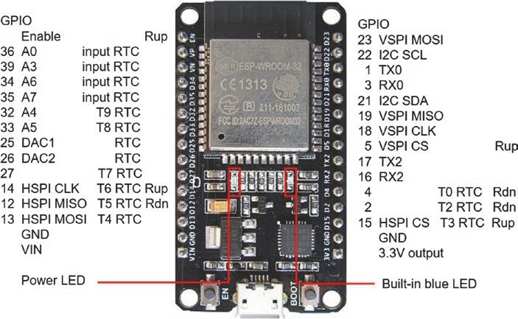
Figure 22-1. ESP32 DEVKIT DOIT development board
Microcontroller CPU and memory
The CPU frequency of the ESP32 microcontroller is changed, in the
Arduino IDE, to 10, 20, 40, 80, 160, or 240 MHz by selecting Tools ➤ CPU Frequency. The impact of different CPU frequencies is determined by measuring the time taken to calculate the first 10k prime numbers (see Chapter 21 (Microcontrollers)). As the CPU frequency doubles, the time to determine the first 10k prime numbers essentially halves from 11607 ms with 10 MHz to 5060 ms with 20 MHz, to 2403 ms with 40 MHz, to 1172 ms with 80 MHz, and 579 ms with 160 MHz. The time taken with a CPU frequency of 240 MHz was only 385 ms.
The ESP32 microcontroller 4 MB flash memory is partitioned to non- volatile storage (NVS), over the air (OTA) updates, applications, SPIFFS, and EEPROM (see Chapter 20 (OTA and saving data to EEPROM, SPIFFS, and Excel)), which are adjusted within the Arduino IDE depending on the memory requirements of a sketch. Select the Tools menu and Partition
eSp32 miCroController featureS
scheme for various combinations of application, SPIFFS, and OTA memory allocation. For example, the default allocation is base, 36 kB where 1 kB is 1024 byte; NVS, 20 kB; OTA, 8 kB; protocol and application cores, 2 × 1280 kB; and SPIFFS, 1472 kB.
ESP32 cores
The ESP32 microcontroller includes two cores, each with a Tensilica Xtensa 32-bit LX6 microprocessor, in contrast to the ESP8266 microcontroller with one Tensilica L106 32-bit processor. The protocol core, PRO_CPU, manages Wi-Fi, Bluetooth, SPI, and I2C communication, while the application core, APP_CPU, is for application development.
The two cores are managed by the ESP-IDF (Espressif IoT Development Framework) FreeRTOS (Real-Time Operating System), which is a modification of FreeRTOS, with details available at www.freertos.org/ a00106.html. The Arduino IDE implementation of the ESP32 incorporates ESP-IDF FreeRTOS. The FreeRTOS library by Richard Barry that is available in the Arduino IDE is compatible with the ATmega328P and ATmega32U4 microcontrollers of the Arduino Uno, Nano, and Pro Micro, but there is currently no FreeRTOS library for the ESP8266 microcontroller. Tasks are allocated to a specific core with the instruction
xTaskCreatePinnedToCore(code, "detail", 1000, NULL, pr, &TaskName, core);
where code is the function containing the task instructions, detail is a string describing the task, pr is the task priority from 0 (lowest priority) to 24, &TaskName is a pointer to the task handle, and core is the core number, 0 or 1 for the protocol or application core. The 1000 value is the default memory allocation in bytes, and the NULL value indicates that no parameters are passed. Confirmation that a task is allocated to a core is obtained with the parameter xPortGetCoreID(). The task handle is defined with the instruction TaskHandle_t TaskName, but is only required to delete a task with the instruction vTaskDelete(TaskName). The term &TaskName is replaced with NULL in the xTaskCreatePinnedToCore() instruction.
Task instructions are bracketed by
void code(void * parameter) // code function
{
for(;;) // equivalent to a for instruction
{
Task instructions // task instructions
}
}
The instruction for(;;) has the same format as for(int i=0; i<max; i++), but without the parameters, and effectively runs the task instructions in an infinite loop.
The timing of tasks is based on the number of clock ticks, with a tick equal to 1 ms in the ESP-IDF FreeRTOS, as defined by the parameter portTICK_PERIOD_MS. The instruction vTaskDelay(xOneSec) represents a one-second delay, with the variable xOneSec, which is a TickType_t object, defined as xOneSec = 1000/portTICK_PERIOD_MS. A time interval is measured as the number of elapsed ticks, with the instructions
int tickTime = xTaskGetTickCount(); // tick count at start vTaskDelay(xOneSec); // time interval int tick = xTaskGetTickCount() - tickTime; // change in tick count
The sketch in Listing 22-1 simultaneously turns on or off two LEDs at different time intervals, with the tasks controlling the LEDs allocated to different ESP32 cores. A task is allocated to an ESP32 core with the xTaskCreatePinnedToCore instruction. For comparison, the codeRed function uses ESP-IDF FreeRTOS time instructions, while the codeBlue

function uses standard Arduino IDE instructions. In the loop function, the instruction vTaskDelay(NULL) prevents processor time being allocated to the function.
Listing 22-1. A task on each core
int redLED = 26; // define LED pins int blueLED = 27;
TickType_t xOneSec; // create time delay variable
void setup()
{
Serial.begin(115200); // Serial Monitor baud rate pinMode(redLED, OUTPUT); // set LED pins as output pinMode(blueLED, OUTPUT);
xOneSec = 1000 / portTICK_PERIOD_MS; // define number of ticks xTaskCreatePinnedToCore(codeRed, "red LED one sec", 1000, NULL, 2, NULL, 0); // allocate tasks to cores xTaskCreatePinnedToCore(codeBlue, "blue LED quarter sec",
1000, NULL, 1, NULL, 1);
}
void codeRed(void * parameter) // function for red LED
{ for (;;)
{
int tickTime = xTaskGetTickCount(); // tick count at start digitalWrite(redLED, HIGH); // turn on or off LED vTaskDelay(xOneSec); // task delay for one second digitalWrite(redLED, LOW);
vTaskDelay(xOneSec);
int tick = xTaskGetTickCount() - tickTime; // change in tick // count
Serial.print("Core ");Serial.print(xPortGetCoreID());
Serial.print(" red ");Serial.println(tick);
}
}
void codeBlue(void * parameter) // similar task with 250ms delay
{ for (;;)
{
unsigned long start = millis(); // time at start
digitalWrite(blueLED, HIGH);
delay(250); // task delay of 250ms
digitalWrite(blueLED, LOW); delay(250); start = millis() - start;
Serial.print("Core ");Serial.print(xPortGetCoreID());
Serial.print(" blue ");Serial.println(start);
}
}
void loop()
{ // no instructions in loop function vTaskDelay(NULL); // other than zero delay
}
Turning on or off two LEDs with a 32-bit microcontroller operating at 240 MHz is trivial, but the sketch demonstrates using both ESP32 cores simultaneously. The sketch in Listing 22-2 determines the first 5k and 10k primes simultaneously, with each task allocated to a different ESP32 core. Allocation of tasks to different cores effectively doubles task output relative to performing a task on one ESP32 core. The last instruction, vTaskDelay(1), of each task prevents the watchdog timer from resetting the ESP32 microcontroller. The task to determine 10k prime numbers takes 334 ms to complete, but when the instruction vTaskDelay(NULL) is deleted, the task takes 662 ms to complete. The loop function is allocated to the application core, and the instruction vTaskDelay(NULL) prevents the use of processor time unnecessarily.
Listing 22-2. Simultaneous determination of the first 5k and 10k prime numbers
unsigned long num5k = 2, num10k = 2; // start from number 2 int count5k = 1, count10k = 1; // prime number counters unsigned int start5k = 0, start10k = 0; // processing times
void setup()
{
Serial.begin(115200); // Serial Monitor baud rate xTaskCreatePinnedToCore(code5k, "5k", 1000, NULL, 1, NULL, 0); xTaskCreatePinnedToCore(code10k, "10k", 1000, NULL, 1, NULL,
1);
}
void code5k(void * parameter) // function for 5k primes
{ for (;;)
{
num5k++; // increment number to check int chk = is_prime(num5k); // call function to test for prime if (chk > 0) count5k++; // increment counter when prime if (count5k > 4999) // count up to 5k numbers

eSp32 miCroController featureS
{
printLine(start5k, count5k, n um5k);
// function to display results
num5k = 2;
count5k = 1; // reset parameters start5k = millis(); vTaskDelay(1); // delay for watchdog timer
}
}
}
void code10k(void * parameter) // function for 10k primes
{ for (;;)
{ num10k++; int chk = is_prime(num10k); if (chk > 0) count10k++; if (count10k > 9999)
{
printLine(start10k, count10k, num10k); num10k = 2; count10k = 1; start10k = millis(); vTaskDelay(1);
}
}
}
void printLine(unsigned long start, int count, unsigned long number)
{
int ms = millis() - start;
Serial.print("Core ");Serial.print(xPortGetCoreID());
Serial.print(" Found ");Serial.print(count);
Serial.print(" primes in "); Serial.print(ms);
Serial.print(" ms");
Serial.print(" highest prime is ");Serial.println(number); }
int is_prime(unsigned long num) // f unction to check if prime number
{
int mod = num % 2; // exclude even numbers if (mod == 0) return 0;
int limit = sqrt(num); // check divisors less than square root for (int divid = 3; divid <= limit; divid = divid + 2)
{
mod = num % divid; // remainder after dividing if (mod == 0) return 0; // not prime if zero remainder
} return 1; // no divisor with zero remainder
}
void loop()
{
vTaskDelay(NULL); }
Information is passed between tasks operating on either the same ESP32 core or different ESP32 cores using either a semaphore or a queue to control information transfer. The semaphore method is analogous, to an extent, to a relay race in which one runner passes a baton to a second runner to allow the second runner to start running. However, with the
eSp32 miCroController featureS
semaphore method, the first runner keeps running! The instructions SemaphoreHandle_t baton and baton = xSemaphoreCreateMutex() create a semaphore variable, baton, with the semaphore given by one task and taken by the other task with the instructions xSemaphoreGive(baton) and xSemaphoreTake(baton, portMAX_DELAY), respectively. The position of the xSemaphoreGive(baton) instruction in the first task instructions determines when the second task is initiated. With the semaphore method, any information required to complete the second task is contained in a global variable, which is defined with the instruction volatile type variable.
The queue method is analogous to a manager allocating work items to a worker, with the worker completing the work items on a first-in first-out basis. The instructions QueueHandle_t queue and queue = xQueueCreate(N, sizeof(int)) create the queue variable, queue, with up to N work items. A work item is added or removed to or from the queue with the instructions xQueueSend(queue, &work, portMAX_DELAY) or xQueueReceive(queue, &work, portMAX_DELAY), respectively, where &work is the pointer to the work item.
The difference between the semaphore and queue methods for transferring information between tasks is the use of global variables by the semaphore method. The instructions in Table 22-1 illustrate the similarities and differences between the semaphore and queue methods. Differences between the semaphore and queue methods are highlighted in bold. In the sketch, the task allocated to ESP32 protocol core turns on the red LED for one second and off for a random time period, redOff. The task allocated to ESP32 application core turns on the blue LED for the time period that the red LED is off. The delay(1) instruction following the instruction to allocate a value to the variable redOff allows for processing time.
With the semaphore method, the variable redOff is a global variable that is accessible to the task controlling the blue LED. With the queue method, the variable redOff is added to the queue by the task controlling the red LED and read from the queue, as the variable blueOn, by the task controlling the blue LED. For both methods, when the xSemaphoreGive() or xQueueSend() instruction precedes the instruction to turn on the red LED, the two LEDs are turned on simultaneously. In contrast, the two LEDs turn on alternately, when the xSemaphoreGive() or xQueueSend() instruction precedes the instruction to turn off the red LED. The sketch illustrates timing two tasks to commence simultaneously or alternately.
Table 22-1. Semaphore and queue methods
Semaphore | Queue
int redleD = 26; | int redleD = 26;
int blueleD= 27; | int blueleD = 27;
SemaphoreHandle_t baton; | QueueHandle_t queue;
volatile int redOff; void setup() { | void setup() {
pinmode(redleD, output); | pinmode(redleD, output);
pinmode(blueleD, output); | pinmode(blueleD, output);
xtaskCreatepinnedtoCore(codered,  "red leD ", 1000, null, 1, null, 0); | xtaskCreatepinnedtoCore(codered, "red leD ", 1000, null, 1, null, 0);
xtaskCreatepinnedtoCore(codeBlu,  "blue leD", 1000, null, 1, null, 1); | xtaskCreatepinnedtoCore(codeBlue, "blue leD", 1000, null, 1, null, 1);
baton = xSemaphoreCreateMutex(); | queue = xQueueCreate(1, sizeof(int));
} | }
(continued)
eSp32 miCroController featureS
Table 22-1. (continued)
Semaphore | Queue
void codered(void * parameter) { | void codered(void * parameter) {
for (;;) { | for (;;) {
redOff = random(500, 2000); | int redOff = random(500, 2000);
delay(1); | delay(1);
xSemaphoreGive(baton); | xQueueSend(queue, &redOff, portMAX_DELAY);
digitalWrite(redleD, hiGh); | digitalWrite(redleD, hiGh);
delay(1000); | delay(1000);
digitalWrite(redleD, loW); | digitalWrite(redleD, loW);
delay(redoff); | delay(redoff);
} } | } }
void codeBlu(void * parameter) { | void codeBlue(void * parameter) {
for (;;) | for (;;)
{ | {  int blueOn;
xSemaphoreTake(baton, portMAX_DELAY); | xQueueReceive(queue, &blueOn, portMAX_DELAY);
digitalWrite(blueleD, hiGh); | digitalWrite(blueleD, hiGh);
delay(redOff); | delay(blueOn);
digitalWrite(blueleD, loW); | digitalWrite(blueleD, loW);
} } | } }
void loop() { vtaskDelay(null); } | void loop() { vtaskDelay(null); }

Bluetooth communication
The ESP32 microcontroller operates both Bluetooth and Bluetooth Low
Energy communication protocols. Bluetooth communication requires a Serial Bluetooth connection, which is established with the instructions
#include <BluetoothSerial.h> // include Bluetooth library
BluetoothSerial SerialBT; // associate SerialBT with library SerialBT.begin("ESP32 Bluetooth"); // identify Bluetooth
Serial Bluetooth communicates by sending one character at a time. Text entered on the Serial Monitor is sent with either SerialBT. write(Serial.read()) or SerialBT.write(c) for the character c. The sketch in Listing 22- 3 establishes a Serial Bluetooth connection and displays the received message from the Bluetooth device on the Serial Monitor. The Serial.write() instruction converts the ASCII code to display alphanumeric characters, while Serial.print() displays the ASCII code for each character in the received message. To both transmit a message to the Bluetooth device and display the transmitted message on the Serial Monitor, each character of the message is transmitted individually as the Serial buffer is not read twice.
Listing 22-3. Bluetooth communication
#include <BluetoothSerial.h> // include Bluetooth library
BluetoothSerial SerialBT; // associate SerialBT with library String str; int strLen; char c;
eSp32 miCroController featureS
void setup()
{
Serial.begin(115200); // Serial Monitor baud rate
SerialBT.begin("ESP32 Bluetooth"); // identify Bluetooth device
}
void loop()
{ // received message from Bluetooth device if(SerialBT.available()) Serial.write(SerialBT.read()); if(Serial.available()) // message to transmit
{
str = Serial.readString(); // read and display
Serial.print("\t\t\t\t");Serial.pr intln(str); // Serial buffer strLen = str.length(); for (int i=0; i<strLen; i++)
{
c = str[i]; // for each message character SerialBT.write(c); // transmit to Bluetooth device }
SerialBT.write('\n'); // add new line character
} delay(50); }
There are several Bluetooth communication applications to download from Google Play Store for an Android tablet to communicate with the ESP32 Bluetooth. The Bluetooth Terminal HC-05 app, by mightyIT, is recommended. After opening the Bluetooth Terminal HC-05 app, the client scans for the required device (see Figure 22-2) and establishes a connection to the server.
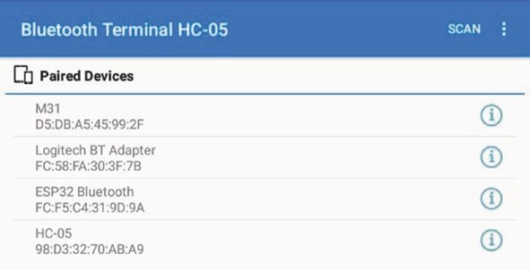
Figure 22-2. Client scanning for Bluetooth server
Once the client-server connection is established, Bluetooth communication between the two devices enables transmission of alphanumeric text, as shown in Figure 22-3.
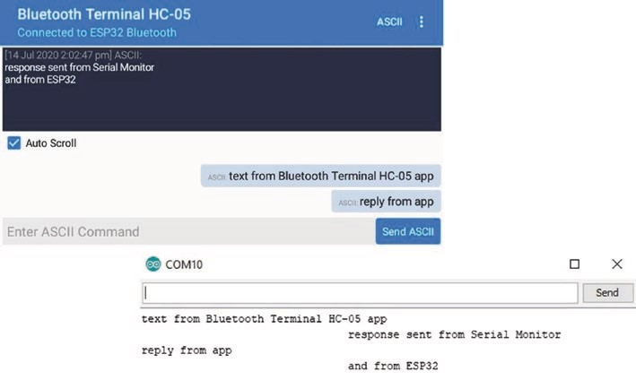
Figure 22-3. Bluetooth communication of text messages
eSp32 miCroController featureS
Bluetooth Low Energy communication
Bluetooth Low Energy (BLE) communicates on the same 2.4 GHz as Bluetooth, over a similar transmission range, but with reduced power consumption. With BLE, data is transmitted only when a connection is established with the client and the client has requested notification of updated data values. The server advertises its existence, the client scans devices, and when the client detects the required device, the client establishes a connection with the server. For example, the ESP32 microcontroller is the server, and the Android tablet or mobile phone is the client, which is point-to-point communication. The broadcast and mesh network topologies are for one–to-many and many-to-many device communication. This chapter focuses on point-to-point communication.
BLE is used to periodically transmit small amounts of data, such as in environmental monitoring sensors, home automation appliances, and health and sports equipment, such as in heart rate and blood pressure monitors on a smart watch. Data transmitted with BLE has a defined format, depending on the category of data that is transmitted, with the format termed the Generic ATTribute (GATT) profile, which is used by appliances communicating with BLE. A data category consists of a BLE service, such as Environmental Sensing, which includes characteristics, such as temperature or humidity, with both the service and each characteristic having a specific UUID (Universal Unique IDentifier). Details of the GATT services and characteristics are available at www.bluetooth.com/specifications/ gatt/services. For example, the UUIDs of Environmental Sensing and temperature are 0x181A and 0x2A63, respectively, with temperature formatted as uint16_t with two decimal points.
The sketch in Listing 22-10 illustrates the ESP32 microcontroller transmitting three Environmental Sensing characteristics with BLE communication. The three characteristics, temperature, heat index, and UV (ultraviolet) index, are formatted for BLE as uint16_t with 2DP, uint8_t with 0DP, and uint8_t with 0DP, respectively. To illustrate formatting sensor data for BLE, the heat index characteristic is derived from the real number temp, with the UV index derived from the integer UV. Note that there are limitations on the possible values of characteristics, such as the battery level characteristic, 0x2A19, which is a percentage between 0 and 100.
The ESP32 BLE Arduino library by Neil Kolban is automatically incorporated in the Arduino IDE when the ESP32 Board Manager is installed. Listings 22- 10 and 22-11 are based on sketches in the ESP32 BLE Arduino library and of Andreas Spiess (github.com/SensorsIot/ Bluetooth-BLE-on-Arduino-IDE).
The first section of the sketch in Listing 22-4 installs the BLE libraries and defines the UUIDs for the service and the three characteristics. The characteristic UUIDs and required formats are available at www.bluetooth. com/specifications/gatt/characteristics. Each characteristic has up to four properties, PROPERTY_READ, PROPERTY_WRITE, PROPERTY_NOTIFY, and PROPERTY_INDICATE, with the PROPERTY_NOTIFY property allocated to characteristics transmitted by the server to a client. The ServerConnect class determines if a client has established a connection with the server. In the setup function, the BLE server and service are defined, with each characteristic defined and added to the BLE service.
In the loop function, if the client has established a connection with the server, then the client is notified of the updated characteristic values. In the example, the temp and UV values are converted to the required BLE formats for the temperature, heat index, and UV index characteristics. The temperature characteristic is uint16-t formatted by allocating the upper and lower bytes of the real number temp to the tempData array with two elements, with the upper byte obtained by bit shifting out the lower byte of the real number. The heat index characteristic is uint8_t formatted by changing the format of the real number, which is termed casting. The UV index characteristic is obtained with the instruction (uint8_t*)&UV, which points (*) to the address (&) of the integer UV. Chapter 14 (ESP-NOW and LoRa communication) describes variable pointers and addresses.
eSp32 miCroController featureS
When each characteristic is formatted for BLE communication, the characteristic value is updated and the client notified, with the instructions setValue() and notify(). The BLEUtils and BLEServer libraries are referenced by the BLEDevice library, so the instructions #include
<BLEUtils.h> and #include <BLEServer.h> are not explicitly required.
Listing 22-4. BLE communication as a server
#include <BLEDevice.h> // include BLE libraries
#include <BLE2902.h>
BLEServer * pServer; // define BLE server,
BLEService * pService; // BLE service and BLECharacteristic * pChar; // BLE Characteristic int devConnect = 0;
#define SERVICE_UUID BLEUUID((uint16 _ t)0x181A)
// environmental service
BLECharacteristic tempChar(BLEUUID((uint16_t)0x2A6E),
BLECharacteristic::PROPERTY_NOTIFY);
BLECharacteristic UVChar (BLEUUID((uint16_t)0x2A76),
BLECharacteristic::PROPERTY_NOTIFY);
BLECharacteristic heatChar(BLEUUID((uint16_t)0x2A7A),
BLECharacteristic::PROPERTY_NOTIFY); class ServerConnect: public BLEServerCallba cks
{ // to check if connected void onConnect(BLEServer * pServer) {devConnect = 1;} void onDisconnect(BLEServer * pServer) {devConnect = 0;} };
float temp = 0; uint8_t tempData[2]; uint16_t tempValue; int UV = 0, heat;

eSp32 miCroController featureS
void setup()
{
Serial.begin(115200); // Serial monitor baud rate BLEDevice::init("ESP32"); // define BLE device pServer = BLEDevice::createServer(); // define BLE server pServer->setCallbacks(new ServerConnect()) ;
// check if connected
pService = pServer->createService(SERVICE_UU ID);
//define BLE service
pService->addCharacteristic(&tempChar); // define temperature tempChar.addDescriptor(new BLE2902()); // characteristic pService->addCharacteristic(&UVChar); // define UV index UVChar.addDescriptor(new BLE2902()); // characteristic pService->addCharacteristic(&heatChar); // define heat index heatChar.addDescriptor(new BLE2902()); // characteristic pServer->getAdvertising()->addServiceUUID(SERVICE_UUID); pService->start(); // start service pServer->getAdvertising()->start(); // advertise service
Serial.println("Waiting for client to connect");
}
void loop()
{ if(devConnect == 1) // if the client is connected
{
temp = temp + 1.11;
tempValue = (uint16_t)(temp*100); // convert to uint16_t with 2DP tempData[0]= tempValue; // LSB (least significant byte) tempData[1]= tempValue >> 8; // MSB (most significant byte) tempChar.setValue(tempData, 2); // update characteristic
eSp32 miCroController featureS
tempChar.notify(); // notify client heat = (uint8_t)temp; // convert to uint8_t with 0DP heatChar.setValue(heat); heatChar.notify();
UV = UV + 1;
UVChar.setValue((uint8_t*)&UV, 4); // point to address of UV
UVChar.notify();
Serial.print(temp);Serial.print("\t ");
// display values on Monitor
Serial.print(heat);Serial.print("\t");
Serial.println(UV);
delay(1000); // delay between sensor readings
}
}
The nRF Connect and nRF Toolbox apps by Nordic Semiconductor are recommended for BLE communication and are available to download from Google Play Store for an Android tablet or mobile phone. After opening the nRF Connect app, the client scans for the required device (see Figure 22-4) and establishes a connection to the server.
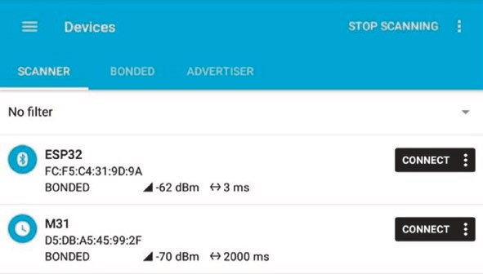
Figure 22-4. Client scanning for BLE server
eSp32 miCroController featureS
The Environmental Sensing service is displayed with updated values of the temperature, heat index, and UV index characteristics (see Figure 22- 5). Clicking the BLE characteristic arrows (circled in Figure 22-5) enables or disables display of updated characteristic values by the app, but only in the context of the sketch in Listing 22-4. Note that updating the heat index characteristic is currently disabled in Figure 22-5.
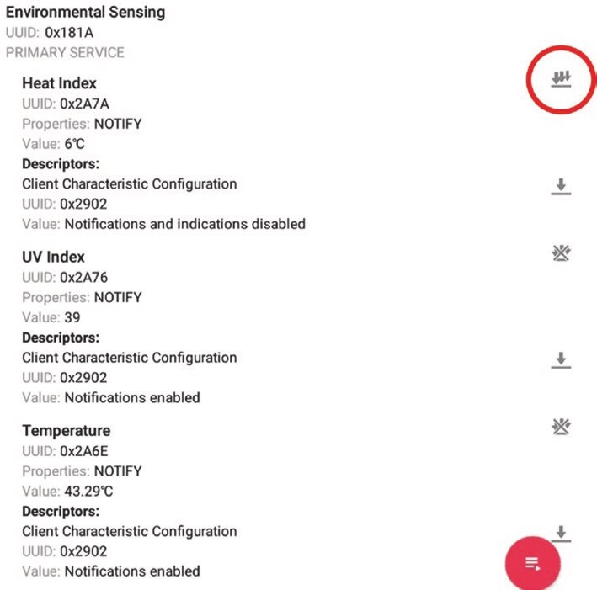
Figure 22-5. BLE Environmental Sensing service
eSp32 miCroController featureS
Both data transmission and reception by the server and client are demonstrated with the sketch in Listing 22-5. The server transmits updated characteristic values to the client, as in Listing 22-4; but in Listing 22-5, the client transmits alphanumeric text to the server and also notifies the server if updated characteristic values are required by the client. To illustrate the server responding to alphanumeric text received from the client, an LED attached to the ESP32 development board is turned on or off when the client transmits the text LED.
The first section of Listing 22-5 installs BLE libraries, as in Listing 22-4, but the UART service is not defined as a GATT BLE service, so UUIDs for the UART service and the transmit and receive characteristics are defined explicitly, rather than implicitly as in Listing 22-4. The three UUIDs are the default UUIDs used by Nordic Semiconductor for UART transmission. The RXCallback class manages data reception by the server, with the string RXstr containing the received alphanumeric text. The NotifyCallback class sets the value of the devNotify variable, which determines whether or not the server transmits updated characteristic values to the client. In the setup function, the transmit (TX) and receive (RX) characteristics are defined with PROPERTY_NOTIFY and PROPERTY_WRITE, respectively, with the NotifyCallback and RXCallback classes attached to the TX description and RX characteristic, respectively (see Figure 22-6).
In the loop function, the server transmits updated characteristic values, but only if the client both has established a connection and has requested the updated characteristic values. The C instruction dtostrf is a method of formatting a real number as a character array, with the required BLE format. The instruction dtostrf(value, 8, 1, valueStr) converts the real number value to a character array, of length eight, representing value with 1DP.
eSp32 miCroController featureS
Listing 22-5. Transmit and receive with BLE communication
#include <BLEDevice.h> // include BLE libraries
#include <BLE2902.h>
BLEServer * pServer; // define BLE server,
BLEService * pService; // BLE service,
BLECharacteristic * pTXChar; // BLE transmit and
BLECharacteristic * pRXChar; // receive characteristics, BLEDescriptor * pTXDesc; // transmit descriptor int devConnect = 0; int devNotify = 0; int LEDpin = 25; int LEDstate = 0; float value; char valueStr[8]; char SERVICE_UUID[] = "6E400001-B5A3-F393-E0A9-E50E24DCCA9E";
// UUIDs
char RXChar_UUID[] = "6E400002-B5A3-F393-E0A9-E50E24DCCA9E"; char TXChar_UUID[] = "6E400003-B5A3-F393-E0A9-E50E24DCCA9E";
void changeLED() // function to change LED state {
LEDstate = 1 - LEDstate; // turn on or off LED digitalWrite(LEDpin, LEDstate);
}
class ServerConnect: public BLEServe rCallbacks { // to check if connected void onConnect(BLEServer * pServer) {devConnect = 1;} void onDisconnect(BLEServer * pServer) {devConnect = 0;}
};
eSp32 miCroController featureS
class RXCallback: public BLECharacteristicC allbacks { // receive client data void onWrite(BLECharacteristic * pCharacteristic)
{
std::string RXstr = pCharacteristic->getValue(); if (RXstr.length() > 0) // client data available
{
Serial.print("Received: "); // read client data for (int i=0; i<RXstr.length(); i++) Serial.
print(RXstr[i]);
Serial.println(); if(RXstr == "LED") changeLED(); // call changeLED function
}
}
};
class NotifyCallback: public BLEDescript orCallbacks { // client data notification
void onWrite(BLEDescriptor * pDescriptor)
{ // obtain TX descriptor uint8_t * TXvalue = pDescriptor->getV al ue(); devNotify = 0; if (pDescriptor->getLength() > 0) // client data available
{ if(TXvalue[0] == 1) devNotify = 1; // update data notification
Serial.print("Notify: ");Serial.println(devNotify);
}
}
};
eSp32 miCroController featureS
void setup()
{
Serial.begin(115200); // Serial monitor baud rate pinMode(LEDpin, OUTPUT);
BLEDevice::init("ESP32"); // define BLE device pServer = BLEDevice::createServer(); // define BLE server pServer->setCallbacks(new ServerConnect ());
// check if connected
pService = pServer->createService(SER VICE_U UID);
// define BLE service // define TX characteristic pTXChar = pService->createCharacteristic(
TXChar_UUID, BLECharacteristic::PROPERTY_NOTIFY); pTXDesc = new BLE2902(); // define TX descriptor pTXDesc->setCallbacks(new NotifyCallb ack ());
// attach notify callback
pTXChar->addDescriptor(pTXDesc);
// define RX characteristic pRXChar = pService->createCharacteristic(
RXChar_UUID, BLECharacteristic::PROPERTY_WRITE); pRXChar->setCallbacks(new RXCallback()); // attach RX callback pService->start(); // start service pServer->getAdvertising()->start(); // advertise service
Serial.println("Waiting for client to connect");
}
void loop()
{ // if the client is connected and if(devConnect == 1 && devNotify == 1) // requests data notification
{
value = random(10, 200)*1.5; // generate real number

dtostrf(value, 8, 1, valueStr); // convert 8-char string with 1DP pTXChar->setValue(valueStr); // update characteristic pTXChar->notify(); // notify client
Serial.print(value);Serial.print("\t");Serial.
println(valueStr);
delay(3000); // delay between updates
}
}
After opening the nRF Connect app, scanning for the required device, and establishing a connection to the server, the Nordic UART Service is displayed. Updating of the TX characteristic (see Figure 22-6) by the server is enabled or disabled by clicking the BLE arrows (see Figure 22-5). When the single BLE arrow opposite RX characteristic is clicked, a pop- up window for entering alphanumeric text appears, and the entered text is displayed as the RX characteristic value (see Figure 22-6). Entering the text LED results in the ESP32 microcontroller turning on or off the LED connected to the ESP32 development board.
eSp32 miCroController featureS
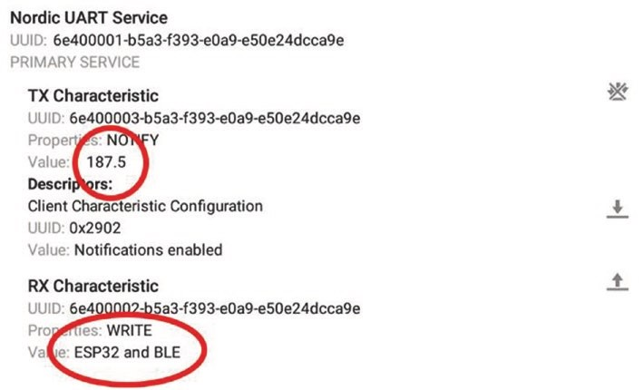
Figure 22-6. Transmission and reception with BLE communication
The nRF Toolbox app has a keypad function for transmitting alphanumeric text with BLE communication to the server. On opening the nRF Toolbox app, select the UART button and click the CONNECT button to display available devices (see Figure 22-7). Select the required device or select SCAN to detect more devices.
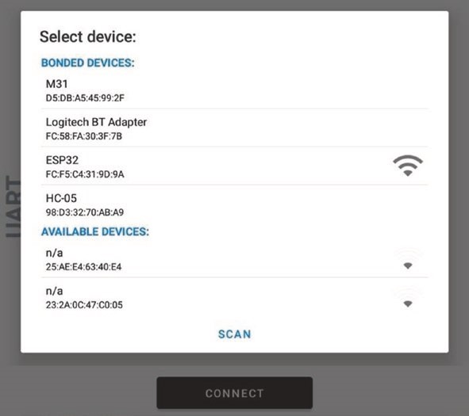
Figure 22-7. nRF Toolbox app
The displayed keypad (see Figure 22-8) is configured by selecting EDIT, clicking the relevant keypad button, entering alphanumeric text to be transmitted when the keypad button is clicked, and selecting a symbol to be displayed on the keypad button. In the context of Listing 22-5, the text LED was allocated to the center keypad button.
eSp32 miCroController featureS
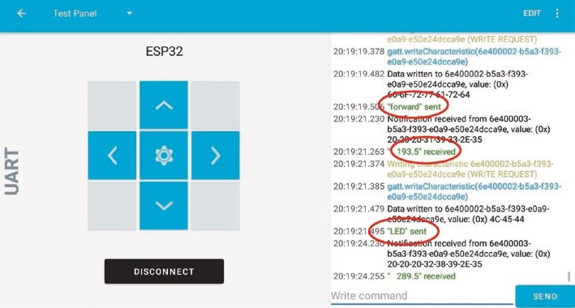
Figure 22-8. Keypad function in nRF Toolbox app
For a sketch using BLE communication to control motors attached to the remote ESP32 development board, the keypad buttons would be allocated the text forward, backward, left, and right or fast and slow (see Figure 22-8). The text received by the ESP32 microcontroller is interpreted in a similar manner to the LED text in the RXCallback class in Listing 22-5 with the corresponding functions called to control the motors or other devices.
In another BLE example, the ESP32 microcontroller, acting as the client, scans advertising BLE devices and turns on an LED when a particular BLE device is detected (see Figure 22-9). The ESP32 microcontroller could turn on a relay, rather than just an LED, to activate an appliance when the BLE device, such as your smart watch, is identified. The BLE address of your smart watch is available on the watch or is determined by a BLE scanning app, such as the nRF Connect and nRF Toolbox apps by Nordic Semiconductor. For the sketch, the BLE address of the watch must be changed to lowercase, for example, from D5:DB:A5:45:99:2F to d5:db:a5:45:99:2f.
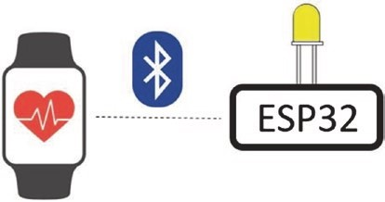
Figure 22-9. Scanning for a particular BLE device
The sketch in Listing 22-6 scans for BLE devices; and if the BLE address of the device, such as your smart watch, matches the defined BLE address, then the paired variable is set to one by the watchCallback class. If none of the scanned devices pair with the ESP32 microcontroller, the BLE client, then the paired variable is set to zero. Occasionally, the BLE scan incorrectly does not detect a BLE device, so non-detection of the defined BLE device is required for two consecutive scans before the LED is turned off. The BLEAdvertisedDevice library is referenced by the BLEScan library, so the instruction #include <BLEAdvertisedDevice.h> is not explicitly required.
Listing 22-6. BLE watch control
#include <BLEDevice.h> // include BLE library
BLEScan * pBLEScan; // pointer to BLE scanner
BLEAddress * pAddress; // and to BLE address
BLEScanResults devices;
String watch = "d5:db:a5:45:99:2f"; // change upper to lower case String scan;
int scanTime = 3; // scan devices for 3s
int paired = 0, lastPair = 0;
int LEDpin = 25; // define LED pin
eSp32 miCroController featureS
class watchCallback: public BLEAdvertisedDeviceCallbacks { // BLE advertising devices void onResult(BLEAdvertisedDevice a dvertised)
{ // option to display device data
// Serial.printf("found device: %s \n",
// advertised.toString().c_str()); pAddress = new BLEAddress(advertised.getAd dress());
// BLE address
scan = pAddress->toString().c_str(); // convert to string if(scan == watch) paired = 1; // device matches watch address
}
};
void setup()
{
Serial.begin(115200); // Serial Monitor baud rate pinMode(LEDpin, OUTPUT); // LED pin as output BLEDevice::init(""); // initialise BLE client pBLEScan = BLEDevice::getScan(); //create new scan pBLEScan->setAdvertisedDeviceCallbacks(new watchCallback()); pBLEScan->setActiveScan(true); }
void loop()
{ devices = pBLEScan->start(scanTime, false); // start scanning
// Serial.print("scanned devices ");
// Serial.print(devices.getCount());
digitalWrite(LEDpin, paired); // turn on or off LED if(paired == 0 && lastPair == 1) digitalWrite(LEDpin, 1);

eSp32 miCroController featureS
lastPair = paired; // 2 consecutive non-pairings to turn off paired = 0; // reset paired variable pBLEScan->clearResults(); // delete scan results }
Timers
The ESP32 microcontroller has four independent timers, timer0–timer3, and a timer frequency of 80 MHz, such that each timer tick lasts 0.0125 μs. The 16-bit timer pre-scaler determines the number of timer ticks included in one count of the timer register. For example, a pre-scaler of 80 results in the timer register incrementing every microsecond (80 × 0.0125) and the timer counting to one million every second. An interrupt is attached to a timer to trigger an event. Four instructions are required to define the timer properties
timer = timerBegin(0, 80, true); // timer0, pre-scalar of 80 timerAttachInterrupt(timer, &timerISR, tr ue );
// attach interrupt ISR
timerAlarmWrite(timer, 1000000, true); // alarm count = 10⁶ timerAlarmEnable(timer); // enable the timer alarm
with the timer variable defined by the instruction hw_timer_t * timer = NULL and the interrupt service routine (ISR) equal to timerISR. If timer0 is to count down, the first instruction is timerBegin(0, 80, false). The ISR is triggered when the value in the timer register equals the alarm count, which is 10⁶ in the example. The first and last instructions of the ISR are equal to
portENTER_CRITICAL_ISR(&timerMux) portEXIT_CRITICAL_ISR(&timerMux)
eSp32 miCroController featureS
with the variable timerMux defined by the instruction
portMUX_TYPE timerMux = portMUX_INITIALIZER_UNLOCKED
If the real number variable value is accessed in an ISR and is incremented in the loop function, then value is defined with the instruction volatile float value and in the loop function is bracketed with the instructions
portENTER_CRITICAL(&timerMux) value = value + 1 portEXIT_CRITICAL(&timerMux)
Wi-Fi and Bluetooth communication may impact the timing of interrupts. The communication functionality is stopped with the instructions WiFi.mode(WIFI_OFF) and btStop(), respectively.
To illustrate use of timers, two LEDs are turned on and off at different intervals, with the intervals controlled by two timers (see Figure 22-10 and Listing 22-7).
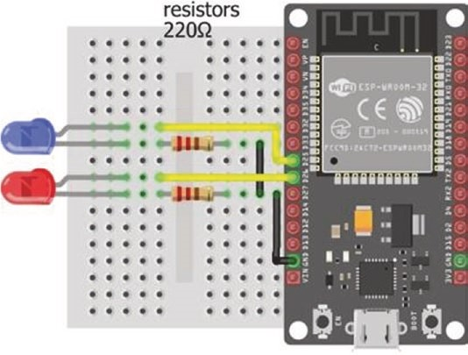
Figure 22-10. ESP32 timers
eSp32 miCroController featureS
Listing 22-7. Timer control of two independent events
hw_timer_t * timer1 = NULL; // define timer1 portMUX_TYPE timer1Mux = portMUX_INITIALIZER_UNLOCKED; hw_timer_t * timer2 = NULL; // define timer2 portMUX_TYPE timer2Mux = portMUX_INITIALIZER_UNLOCKED; int LED1pin = 25;
int LED2pin = 26; // define LED pins
void setup()
{
Serial.begin(115200); pinMode(LED1pin, OUTPUT); pinMode(LED2pin, OUTPUT);
timer1 = timerBegin(1, 80, true); // set timer1 properties
timerAttachInterrupt(timer1, &timer1ISR, true); timerAlarmWrite(timer1, 250000, true); // interval of 0.25s timerAlarmEnable(timer1);
timer2 = timerBegin(2, 80, true); // set timer2 properties
timerAttachInterrupt(timer2, &timer2ISR, true); timerAlarmWrite(timer2, 1000000, true); // interval of 1s
timerAlarmEnable(timer2); }
void loop()
{
vTaskDelay(NULL); }
IRAM_ATTR void timer1ISR() // ISR for timer1
{
portENTER_CRITICAL_ISR(&timer1Mux); digitalWrite(LED1pin, !digitalRead(LED1pin));
eSp32 miCroController featureS
portEXIT_CRITICAL_ISR(&timer1Mux); }
IRAM_ATTR void timer2ISR() // ISR for timer 2
{
portENTER_CRITICAL_ISR(&timer2Mux); digitalWrite(LED2pin, !digitalRead(LED2pin)); portEXIT_CRITICAL_ISR(&timer2Mux); }
Real-time clock and sleep mode
Several GPIO pins are accessible by the real-time clock (RTC) input-output (rtc_io) library to trigger the ESP32 microcontroller from sleep mode. The rtc-io library is included in the ESP32 libraries within the Arduino IDE. The instruction esp_sleep_enable_ext0_wakeup(pin, state) wakes the ESP32 microcontroller from sleep mode, when the state of the pin is equal to state. For example, if pressing a switch connected to GPIO 32 is to wake the ESP32 microcontroller from sleep mode, the parameter pin is defined as GPIO_NUM_32 or as (gpio_num_t)switchPin, given the pin definition instruction int switchPin = 32 (see Figure 22-11). The value of state is zero or one if the switch has a pull-up or pull-down resistor, respectively. ESP32 microcontroller pull-up and pull-down resistors are disabled during sleep, so the instruction rtc_gpio_pullup_en(pin) or rtc_gpio_ pulldown_en(pin) enables a pull-up or pull-down resistor on the GPIO pin connected to a switch, if required for the switch. Details of sleep modes and wake-up options are available at docs.espressif.com/projects/espidf/en/latest/esp32/api-reference/system/sleep_modes.html.

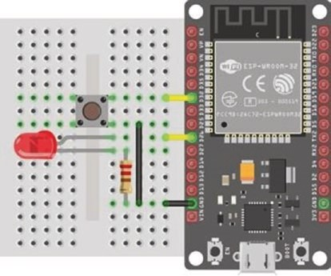
Figure 22-11. ESP RTC and sleep mode
Note that a pin is pulled up or pulled down, for use with a switch, with the instruction pinMode(pin, INPUT_PULLUP) or pinMode(pin, INPUT_ PULLDOWN), respectively. The sketch in Listing 22-8 enables the switch on pin 32 to wake the ESP32 from sleep mode, flashes both an LED and the built-in LED, and then returns the ESP32 to sleep mode.
Listing 22-8. RTC and sleep mode
#include <driver/rtc_io.h> // include rtc input-output library int switchPin = 32; // define switch pin int LEDpin = 26; // and LED pin int builtinLED = 2;
void setup()
{
Serial.begin(115200); // Serial Monitor baud rate pinMode(LEDpin, OUTPUT); // LED pins as output pinMode(builtinLED, OUTPUT);
flash(); // call flash function rtc_gpio_pullup_en((gpio_num_t)s witchPin); // pull-up switch pin
eSp32 miCroController featureS
esp_sleep_enable_ext0_wakeup((gpio_num_t)switchPin, 0); } // wakeup on switch pin with state 0
void loop()
{
Serial.print("sleep mode on pin ");Serial.println(switchPin); esp_deep_sleep_start(); // ESP32 in sleep mode
}
void flash()
{ for (int i=0; i<3; i++) // flash LEDs three times
{
digitalWrite(LEDpin, HIGH); // LED on pin digitalWrite(builtinLED, HIGH); // and built-in LED delay(200); digitalWrite(LEDpin, LOW); digitalWrite(builtinLED, LOW); delay(100);
}
}
The ESP32 RTC wakes the ESP32 microcontroller from sleep mode after a period of time has elapsed, with the instruction esp_sleep_enable_ timer_wakeup(N), where N is the required number of microseconds.
In sleep mode, the ESP32 RTC memory functions, while the ESP32 microcontroller CPU and memory are disabled. If information is to be retained in sleep mode, then data is stored in RTC memory by including RTC_DATA_ATTR in the data definition instruction. For example, if the integer variable var is to be retained during sleep mode, the variable is defined as RTC_DATA_ATTR int var.
The sketch in Listing 22-9 defines a counter to be stored in RTC memory, prints the incremented value, and puts the microcontroller into sleep mode, to be woken with the RTC timer after 5 seconds.
Listing 22-9. RTC timer and sleep mode
RTC_DATA_ATTR int count = 0; // store count in RTC memory unsigned long micro = 5000000; // time interval in μs
void setup()
{
Serial.begin(115200); // Serial Monitor baud rate esp_sleep_enable_timer_wakeup(micro) ; // RTC timer interval in μs
}
void loop()
{
count++; // increment and print count Serial.print("count ");Serial.println(count); esp_deep_sleep_start();
} // microcontroller in sleep mode
Digital to analog converter
The 8-bit digital to analog converter (DAC) functionality converts a digital value, between 0 and 255, to a voltage between 0 and 3.3 V on a DAC pin. With an 8-bit DAC, there are 256 voltage classes with levels 0–255; and for a reference voltage of 3.3 V, a DAC voltage class spans 12.9 mV. The instruction dacWrite(DACpin, N) outputs a voltage on the DACpin, with the DACpin defined as either the GPIO 25 or 26 or by the term DAC1 or DAC2, respectively. The sketch in Listing 22-10 generates a range of voltages between 0.5 V and 3 V.
eSp32 miCroController featureS
Listing 22-10. Digital to analog converter int DACpin = DAC1; // define DAC pin
void setup()
{} // nothing in setup function
void loop()
{
for (int i=0; i<255; i=i+39) { dacWrite(DACpin, i); // output voltage 0.5V, 1V...
delay(2000);
}
}
Capacitive touch sensor
The capacitive touch sensors detect changes in capacitance on a touch pin, for use of a touch pin instead of a switch. When a wire connected to a touch pin is pressed, the touch pin value falls. The instruction touchRead(touchPin) reads the touchPin value, with the touchPin defined as either the GPIO number 2, 4, 12, 13, 14, 15, 27, 32, or 33 or by T2, T0, T5, T4, T6, T3, T7, T9, or T8, respectively. An interrupt is attached to the touch pin with the interrupt triggered when the touch pin value falls below a threshold. The instruction touchAttachInterrupt(touchPin, ISR, threshold) defines the touch pin, the interrupt service routine (ISR), and the threshold below which the interrupt is triggered. To prevent the touch pin repeatedly triggering the interrupt, when the touch pin is pressed, a time interval must elapse since the touch pin was touched before the interrupt is triggered. The sketch in Listing 22-11 turns on or off an LED when a wire connected to a touch pin is pressed. Note that the touch interrupt ISR change does not have to be defined as IRAM_ATTR.
Listing 22-11. Capacitive touch sensor
int touchPin = T7; // define touch pin int LEDpin = 32; // and LED pin int threshold = 50; // limit for touch pin volatile unsigned long lastTouch = 0; // time touch pin pressed
void setup()
{
pinMode(LEDpin, OUTPUT); // LED pin as output touchAttachInterrupt(touchPin, change, threshold); } // define interrupt
void change() // ISR
{ // touch pin recently pressed if (millis() - lastTouch < 1000) ret urn;
lastTouch = millis(); // update touch time digitalWrite(LEDpin, 1 - digitalRead(LEDpi n)); } // change LED state
void loop() // nothing in loop function {}
Hall effect sensor
The ESP32 microcontroller contains a Hall effect sensor, which is activated by a magnetic field. The instruction hallRead() returns the Hall Effect value, with high absolute values indicating the strength of the magnetic field and positive or negative values indicating the direction of the magnetic field. The Hall effect sensor is also used to measure rotational speed of a wheel or shaft with an attached magnet. The sketch in Listing 22-12 turns on or off an LED when the magnetic field is detected by the ESP32 Hall effect sensor.
eSp32 miCroController featureS
Listing 22-12. Hall effect sensor
int LEDpin = 32; // define LED pin unsigned long lastHall = 0; // time Hall value changed
void setup()
{ pinMode(LEDpin, OUTPUT); // LED pin as output
}
void loop()
{ if(abs(hallRead()) > 30) change(); // call change function } // when magnetic field detected
void change()
{
if(millis() - lastHall < 1000) return; // check time last change lastHall = millis(); // update change time digitalWrite(LEDpin, 1 - digitalRead(LE Dpin));
} // change LED state
Summary
The ESP32 microcontroller has two cores, each with a Tensilica Xtensa 32-bit LX6 microprocessor, and allocation of tasks to different cores effectively doubles task output relative to performing a task on one ESP32 core. The ESP32 microcontroller has Wi-Fi communication, SPI and I2C communication, analog to digital conversion, pulse width modulation, and interrupt functions. Several features are specific to the ESP32 microcontroller, which include Bluetooth and Bluetooth Low Energy communication, four independent timers for controlling events, a real- time clock to trigger the ESP32 microcontroller from sleep mode, digital

eSp32 miCroController featureS
to analog converter functionality, capacitive touch sensors for use of a touch pin instead of a switch, and a Hall effect sensor, which is activated by a magnetic field. Examples illustrate use of the ESP32 comprehensive features.
Components List
- ESP32 microcontroller: DEVKIT DOIT or NodeMCU board
- LED: 2×
- Resistor: 2× 220 Ω
- Tactile switch
APPENDIX
Libraries
The majority of the required libraries are uploaded within the Arduino IDE with other libraries available through GitHub, www.github.com, or specific websites as listed in Table A-1. Example sketches, within each library, are accessed in the Arduino IDE by selecting File ➤ Example ➤ library name. A library is included in a sketch with the instruction #include <libraryname.h>, which references the library located in the Arduino IDE libraries folder. To determine the location of the Arduino IDE libraries folder, select File ➤ Preferences in the Arduino IDE, and the libraries folder is located in the sketchbook location, for example, C:\Users\user\ Documents\Arduino.
When a library is included in a sketch, a variable is generally associated with the library, which is termed creating an instance of the class, where class is the library. The variable has the properties of the library, in a similar way that a variable defined as an integer has the properties of an integer. Instructions specific to a library are prefixed with the variable name. For example, the ESP8266WebServer library is installed with the instruction #include <ESP8266WebServer.h>, and the instruction ESP8266WebServer server associates the server variable with the library. An ESP8266WebServer library-specific instruction is prefixed with server. as in server.handleClient().
© Neil Cameron 2021 683
N. Cameron, Electronics Projects with the ESP8266 and ESP32, https://doi.org/10.1007/978-1-4842-6336-5
There are three methods to install a library:
- Use the Library Manager.
Open the Arduino IDE, select the Sketch menu and select Include Library ➤ Manage Libraries. In the Library Manager window, use the Filter your search option to locate the required library. Select the library version number and click Install. The More info option provides access to GitHub for library documentation and updates.
- Import a zip file.
Download the library in a .zip file and store the .zip file on your computer or laptop. In the Arduino IDE, select the Sketch menu and select Include Library ➤ Add .ZIP library. Select the location where the .zip file was saved, select the .zip file, and click Open.
- Manual install.
Download the library in a .zip file, and extract the contents of the .zip file to the default library folder, such as C:\Users\user\Documents\Arduino. The Arduino IDE must be restarted before the library is listed in the Arduino IDE, using the Sketch ➤ Include Library option.
appendix Libraries Table A-1. Libraries with details on source and author
Library | Author and Source if Not Available in the Arduino IDE
adafruit bMp280 | adafruit
adafruit GFx | adafruit
adafruit iLi9341 | adafruit
adafruit iLi9341 esp | nailbuster software nailbuster.com/?page_id=341
adafruit ina219 | adafruit
adafruit MCp4725 | adafruit
adafruit neopixel | adafruit
adafruit ssd1306 | adafruit
adafruit s7735 and sT7789 | adafruit
adafruit Unified sensor | adafruit
arduinoJson | benoit blanchon
arduinoOTa | built-in
asyncTCp | Hristo Gochkov  github.com/me-no-dev/asyncTCp
bLedevice | built-in with esp32
bLescan | built-in with esp32
bLeserver | built-in with esp32
bLeUtils | built-in with esp32
bLe2902 | built-in with esp32
bluetoothserial | built-in with esp32 espressif systems
(continued)
685
Table A-1. (continued)
Library | Author and Source if Not Available in the Arduino IDE
CayenneMQTT | Cayenne
eeprOM | david Mellis
esp idF FreerTOs | built-in with esp32 espressif systems
esp_camera | built-in with esp32 espressif systems
esp_http_server | built-in with esp32 espressif systems
esp32 bLe arduino | neil Kolban, built-in with esp32 installation
esp32 vs1053 ext | Wolle  github.com/schreibfaul1/esp32-vs1053_ext
esp32servo | Kevin Harrington and John K. bennett
espasyncWebserver | Hristo Gochkov  github.com/me-no-dev/espasyncWebserver
espmdns | built-in with esp32 espressif systems
esp-nOW | built-in with esp8266 and esp32 espressif systems
esp8266mdns | built-in with esp8266
esp8266Webserver | built-in with esp8266
esp8266WiFi | built-in with esp8266
Fs | built-in with esp8266
irremote | Ken shirriff  github.com/z3t0/arduino-irremote
irremoteesp8266 | david Conran, sebastien Warin, Mark szabo, and Ken shirriff
(continued)
appendix Libraries Table A-1. (continued)
Library | Author and Source if Not Available in the Arduino IDE
Keyboard | built-in
LittleFs | built-in with esp8266
Lora | sandeep Mistry
Md_ad9833 | Marco Colli, Majicdesigns
Md_ds3231 | Marco Colli, Majicdesigns
neoGps | slash devin
newping | Tim eckel
newpingesp8266 | Tim eckel and Jordan shaw github.com/jshaw/newpingesp8266
nTptimeesp | andreas spiess  github.com/sensorsiot/nTptimeesp
printf | included in rF24
rc-switch | saut Özgür
rF24 | James Coliz
rH_asK | Mike McCauley www.airspayce.com/mikem/arduino/  RadioHead
rtc-io | built-in with esp32
runningMedian | rob Tillaart
sd | built-in
sd_MMC | built-in with esp32 espressif systems
servo | built-in, Michael Margolis
(continued) 687
Table A-1. (continued)
Library | Author and Source if Not Available in the Arduino IDE
softwareserial | built-in
spi | built-in
spiFFs | built-in with esp32 espressif systems
TFT_espi | bodmer
Ticker | built-in with esp8266
Time | Michael Margolis
Vs1053 | ed smallenburg and James Coliz github.com/baldram/ESP_VS1053_  Library
Webserver | built-in with esp32 espressif systems
Websocketsserver | Markus sattler
WiFi | built-in with esp32 espressif systems
WiFiUdp | built-in with esp8266 and esp32 espressif systems
Wire | built-in, nicholas Zambetti
xpT2046 | spiros papadimitriou  github.com/spapadim/XPT2046

Index
A
Analog to digital converter (ADC),
1, 91, 101, 444–451, 465,
467, 506–509, 523, 527, 537, 557, 612, 624, 625, 629, 632, 641, 678–679
API key, 69–71, 73, 74, 76, 196, 197, 199, 221, 222
Arduino Nano, 348, 363, 416, 417,
436, 561, 565, 583, 611,
612, 618
Arduino Pro Micro, 605, 610–612,
619, 620
Arduino Uno, 51, 347–349, 354–356,
363, 513, 611, 612, 617–618,
620, 634, 639, 643
Asynchronous JavaScript And XML
(AJAX), 38–40, 171–180,
188–192, 194–195, 197, 201,
222, 224–228, 233, 234,
237–242, 246, 248, 250–255,
329–331, 375, 377, 393–396,
590, 596, 600–602, 609
ATmega328P, 513, 561, 566, 611,
612, 617, 618, 620, 632, 634,
637, 643
ATmega32U4, 612, 619, 620, 643 ATmega16U2 USB to serial, 348, 363
B
Bipolar junction transistor (BJT) amplifier, 496 gain, 496 signal inverter, 499 switch, 495–498
Bit shift<<, 572
Bluetooth low energy characteristic, 658, 661, 663–665
GATT, 662
service, 656–659, 662, 663, 665 UUID, 658, 665
Bluetooth Terminal HC-05 app, 654
C
Capacitive touch, 629, 641,
679–680, 682
Capacitor ceramic, 554, 555 charging voltage, 469, 477 discharging voltage, 477, 482,
485, 486, 491 electrolytic, 523, 554, 555

© Neil Cameron 2021 689

N. Cameron, Electronics Projects with the ESP8266 and ESP32, https://doi.org/10.1007/978-1-4842-6336-5

Checksum, 115, 116, 120, 122, 124,
135, 137, 138, 144, 146
CH340 USB to serial, 622, 648
Communication
amplitude shift keying (ASK),
400, 435 bluetooth, 151, 266–268, 274,
305, 306, 344, 347, 382, 641,
653–673 bluetooth low energy (BLE),
641, 656, 658, 660, 663,
667, 669
ESP-NOW, 31, 306, 365–397
I2C address, 244, 621, 643, 681 On-Off keying (OOK), 400, 435 over the air (OTA), 585, 609 serial, 28, 113, 115, 117, 119,
120, 260, 274, 636 software serial, 117 SPI, 2, 621, 681
Component
AD9833 waveform generator, 466
BMP280 temperature, pressure,
182, 183, 188, 189, 209
DS3231 real time clock,
141, 150
FOD817C optocoupler, 430
HC-05 bluetooth, 260, 274
74HC4051 multiplexer,
95–98, 416
74HC595 shift register, 447,
449, 466
HC-SR501 PIR, 45
HC-SR505 PIR, 45
HC-SR04 ultrasonic distance, 230
IFR520 MOSFET relay, 285, 286
ILI9341 touch screen, 84
INA219 voltage and current, 557
IN4001 diode, 558
IRF520 MOSFET relay, 285, 286
ISD1820 record and playback, 147–150
KY-023 joystick, 436
KY-008 laser, 230, 416
KY-019 relay, 425 KY-040 rotary encoder, 25, 584 light dependent resistor, 287, 610
18650 lithium-ion battery, 157
LM358 amplification gain, 528
LM358 operational amplifier,LM393 voltage comparator, 553, 558 558

L4940V5 voltage regulator,
230, 256
MAX471 current, 534–536
MAX4466 microphone, 87
MCP4725 DAC, 460, 462, 464
MT3608 boost converter, 151,
155, 157, 542, 558 2N2222 NPN transistor, 503
nRF24L01 transceiver, 317, 332, 333, 345
OLED screen, 332, 333
PAM8403 audio amplifier,
154, 156, 157 piezo transducer, 100, 111 Schottky diode, 425, 531, 538
SG90 servo motor, 256
shunt resistor, 531, 558
ST7735 screen, 25, 558
SX1278 LoRa, 385
555 timer IC astable mode, 470, 475, 476,
481, 484, 486–488 bistable mode, 470, 474–475 monostable mode, 470–473, 498–500
PIR sensor and MP3 player,
498–502
TP4056 battery protection,
157, 542
T6845 USB to lithium-ion battery, 156, 157
u-blox NEO-7M GPS module, 316–318, 324, 332, 345
VS1053 audio decoder, 13, 25
VS1838B infrared, 126
WS2812 RGB LED, 87
Console log, 219–220, 222, 237, 238
CPU frequency, 261, 561, 612, 614,
615, 624, 631, 642
D
DC-balanced, 405
Debounce, 124, 474, 564, 566,
578, 583
Digital to analog converter (DAC),
444–451, 465, 507, 641, 678
Duty cycle, 101, 105, 110, 438–440,
465, 467, 470, 475, 478,
480–487, 490, 493, 495, 502,
634, 635
E
EEPROM, 30–32, 34, 275, 276,
585–610, 642, 686
ESP32 cores core identity, 643, 644, 646, 649 FreeRTOS, 644 queue, 649, 650 semaphore, 650
task, 643, 644, 646, 647
ESP-NOW, 31, 306, 365–397,
657, 686
Exception decoder, 628
F
Fourier series, 455, 465, 489
G
Google Maps, 289–303, 305–345,
365, 590, 635, 647 Gray code, 568
H
Hall effect, 612, 629, 641, 680–682
High-pass filter, 489, 551
HTML (HyperText Markup
Language) background-color, 39, 169,
176, 227
HTML (HyperText Markup
Language) (cont.) button, 4, 36, 38, 39, 160, 162,
164, 166–168, 170, 174,
180, 237 canvas, 248, 251, 252 colspan, 239 form, 227 image, 36, 38, 237, 596, 600–602 input autocomplete, 238,
240, 251 label, 240, 251, 549 location.reload, 36, 38 refresh webage, 182, 184, 186 rotate, 36, 38–40 rowspan, 248, 251 slider, 237–240, 250, 251 span, 168, 174, 176, 177, 190,
193, 194, 197, 201, 218, 239,
240, 251, 330, 378, 395 style, 39, 40, 168, 169, 173, 176,
227, 237, 239, 240, 250, 251,
377, 395 table, 38, 39, 169, 170, 176,
177, 227, 228, 239, 240,
251, 252 textarea, 227, 228
HTTP request, 5, 13, 36, 38, 42, 69–72, 74, 79, 162–168,
171, 172, 174, 178, 181,
185, 187, 188, 192, 197,
216, 222, 329
HTTP response, 70, 163, 175
I
Inductor, 285, 493, 494, 502, 530,
538, 551–556
Infrared remote control, 126–132, 150
Interrupt attachInterrupt, 6, 17, 123, 136,
547, 565, 573, 576, 578, 581,
625, 627, 637 digitalPinToInterrupt, 6, 123,
136, 387, 390, 393, 411, 426,
547, 565, 573, 576, 578, 581,
625–627, 637
ISR, 4, 566, 574, 625, 637, 672, 679
J
JavaScript className, 40, 175, 177, 178 getElementById, 40, 172, 175,
177–179, 191, 194, 195, 201, 202, 219, 226, 228, 240, 241, 250, 252–255, 330, 331, 378,
395, 396 innerHTML, 172, 175, 178, 179,
191, 194, 195, 201, 202, 240, 241, 250, 252–254, 330, 331,
378, 396 obj.var, 194, 195, 201, 202, 219,
330, 378, 396 onload, 228, 240, 251, 378, 395 script, 39, 40, 172, 173, 177–179,
190, 192, 194, 195, 201, 202,
228, 240, 241, 252, 255,
329–331, 378, 395, 396 setInterval, 40, 178, 190, 191,
194, 195, 201, 329–331 this.responseText, 172, 178, 179, 191, 194, 195, 201,
219, 330, 331 toLocaleTimeString, 250, 253, 378, 396
XMLHttpRequest, 39, 172, 175,
178, 179, 190, 191, 195, 201,
330, 331
JavaScript Object Notation (JSON),
69, 70, 72, 75–78, 163,
192–195, 197, 198, 201, 219, 220, 222, 233, 234,
236, 240, 245, 247, 248,
252, 326–328, 330, 375–378,
393, 394, 396
K
Keyboard emulation, 605, 606, 608
L
Least significant bit (LSB), 97, 404,
412, 437, 444
Logic level converter, 51, 52, 117
LoRa
instructions, 392 RSSI, 386, 390, 391, 393–395
SNR, 386, 389–391, 393–395
Low-pass filter, 489–494, 502, 551
M
Median filter, 90–92 433MHz, 387, 390, 393 micro-SD card, 27, 30–32, 49, 113,
114, 116, 120, 132, 134, 602
MIT app Inventor blocks, 310
component
BluetoothClient, 265, 309 clock, 348 serial, 348, 363
TinyDB database, 311, 312 component section, 265 database
instructions, 289, 303 item, 289, 292, 303 tag, 289, 303 value, 289, 292, 303
HorizontalArrangements, 258,
298, 308
ListPicker, 289 Listview, 289
maps
EnableZoom, 298
LineString, 308
ShowScale option, 298
MIT AI2 companion, 257
Palette connectivity, 348
layout, 258
maps, 298, 308
math, 269
media, 258
MIT app Inventor (cont.) sensors, 348, 363 storage, 292 user interface, 258, 292
procedures, 266, 268 properties section, 258, 271 QR code, 271
SelectBluetooth, 309, 310
SpeechRecognizer, 281, 286
TableArrangement, 279, 357
VerticalArrangements, 265
Most significant bit (MSB), 404,
410, 437, 444, 447, 456, 507
Moving average, 340, 342
MQTT broker
Cayenne
GetValue, 205
VirtualWrite, 204, 205, 207,
209, 213 email/text notification, 215
IFTTT (If This, Then That), 203
N
Network time protocol (NTP),
105–111 nRF connect app, 660, 666 nRF toolbox app, 660, 667–669
O
OpenWeatherMap, 51, 69–71, 73,
74, 76, 77, 79, 84
Optocoupler, 430–436
OTG device, 347–351, 353, 354,
357–360, 362, 363
P, Q
PROGMEM, 36, 39, 172, 176, 190,
194, 201, 227, 239, 250, 330,
377, 395, 462, 590, 601, 602
Pull-down resistor, 2, 45, 117, 118,
121, 447, 473, 606, 622, 625,
629, 632, 675
Pull-up resistor, 4, 6, 8, 14, 17, 27,
119, 122, 129, 136, 144, 471,
473, 474, 564, 575, 576, 578,
620, 621, 625, 626, 629, 632
Pulse width modulation (PWM),
101, 105, 110, 261, 262, 356, 437–440, 467, 470, 486–488, 495, 498, 612, 618, 619, 621,
629, 634–635, 681 Python 3.x, 586
R
Radio frequency instructions, 402, 403, 406–408,
411–413, 416, 420–423,
432, 433 receiver, 400–409, 416, 419, 420,
424, 435 transmitter, 400–409, 416,
417, 435
Real time clock (RTC), 46, 141–143,
145, 150, 629, 675–678, 681
Relay, 285–287, 423–436, 590,
649, 669 solid state, 433–436
Remote control, 127, 128,
229–236, 423
Rotary encoder debounce, 564, 566, 567, 570 rotation speed, 578, 579, 583
switch, 13–15, 575–577
R-2R resistor ladder, 445, 449,
464, 465
S
Sawtooth wave, 451, 455
Sigrok, 405, 410
Sine waves, 441, 442, 451–457,
460–465, 467, 470, 488, 489,
493–495, 498
Sketch analogSetPinAttenuation, 633 analogWriteFreq, 438 atof, 245 atoi, 245
attachInterrupt, 625, 679 bitRead, 97, 98 btStop, 673 charAt, 413, 415 constrain, 117, 525 c_str, 224, 407, 602 decode_results, 127, 129 digitalPinToInterrupt, 625, 626
dtostrf, 662, 666 endsWith, 218 highByte, 120, 124, 137, 146 #ifdef, 56, 167, 187, 615–617 #ifndef, 616, 617 indexOf, 21, 199, 200, 218, 235, 408, 409, 422
INPUT_PULLDOWN, 632, 676
INPUT_PULLUP, 4, 625, 626,
632, 676 insert tab, 31, 34, 36–38, 41, 164, 171, 189, 377 IRAM_ATTR, 4, 625, 679
lastIndexOf, 199, 218 ledcAttachPin, 262, 438, 634, 635 ledcSetup, 261, 262, 438, 634, 635 ledcWrite, 261, 262, 438, 634, 635 length, 14, 73, 224, 225, 233, 242,
367, 405, 410, 511, 554, 592,
596, 615, 662 lowByte, 120, 124, 137, 146 macAddress, 366, 367, 370, 372,
379, 586 map, 570 openReadingPipe, 322, 334, 341 openWritingPipe, 320, 327, 338 parseFloat, 217 parseInt, 91, 242 pgm_read_byte, 462, 590 pgm_read_datatype, 590 pgm_read_word, 590
pointer, 31, 63, 66, 596, 650,
657, 670 portENTER_CRITICAL, 672–675
portEXIT_CRITICAL, 672,
673, 675
Sketch (cont.)
PROGMEM, 36, 172, 462, 590,
601, 602 readString, 216, 261 readStringUntil, 216 server.send, 163, 172, 189,
193, 601 setAutoAck, 320, 322, 327, 334,
338, 341 setBrightness, 88, 93, 102, 107 setCursor, 56, 65, 343, 525 setDataRate, 319, 321, 322, 327,
334, 338, 341 setPALevel, 320–322, 327, 334,
338, 341 setPeriodHertz, 233, 274, 423, 638 setPixelColor, 91 setRotation, 54 setTextColor, 56, 65, 525, 544 setTextsize, 54, 65, 343, 525 sizeof, 324, 339, 370, 372, 592,
650, 651 startsWith, 218 strcmp, 72, 371 string literal, 172, 180, 184, 189,
233, 590 strlen, 407, 596, 653 strncpy, 371 structure, 65, 324, 338, 339, 367,
370, 372, 592, 596, 597 substring, 14, 197, 420, 615 switch case, 128, 131, 572 testCarrier, 337 timerAlarmEnable, 672, 674 timerAlarmWrite, 672, 674 timerAttachInterrupt, 672, 674 toCharArray, 324 toFloat, 197 toInt, 197, 261, 416 touchAttachInterrupt, 679, 680
volatile, 4, 579, 590, 650, 651, 680
WiFi.mode(WIFI_OFF),
109, 673
WiFi.softAP, 162 WiFi.softAPConfig, 162 writeMicroseconds, 233, 242,
274, 423, 638
Sleep mode, 45, 49, 50, 629,
675–678, 681
Solar panel, 540–551, 557, 558
Sound filter, 90
Speech recognition, 281–286
SPIFFS, 29, 30, 275, 585–610,
642, 643
Square wave, 101, 105, 110, 233,
241, 261, 274, 423, 437–441, 455, 465, 467, 470, 471, 475, 478, 480, 482, 485–495, 502, 552, 554, 557, 559, 560,
564–574, 577–579, 583, 634,
635, 638
Superheterodyne, 400, 401, 403, 435, 436
T
Text to speech, 132, 143
ThingSpeak, 196, 197, 199, 221
Touch screen, 51–58, 60, 62, 64, 69,
73, 74, 84 calibration, 57–60, 62–68
Triangle wave, 441–444, 456, 465
Tri-state, 410, 412–415, 435
U
Universal Asynchronous Receiver- Transmitter (UART), 28, 29,
50, 113, 115, 437, 622, 623,
631, 662, 666, 667
Unix epoch time, 69, 70, 75,
100–102, 106, 107
V
Voltage divider, 117, 445–449,
451, 460, 468, 473, 489, 490, 493, 505–509, 519, 520, 522, 528, 542, 543,
548, 624
W
Watchdog timer, 41, 628, 639,
647, 648
Wavelength, 230, 383, 399, 401,
416, 478
WebSocket
broadcastTXT, 224, 226, 236,
247, 376, 394 onEvent, 225, 235, 247
WLAN
access point, 159, 162, 167, 381 access point and station, 162, 381
gateway, 161, 162, 164, 165 IP address, 38, 41, 161, 162, 180,
184, 603 MAC address, 367–370 map URL to function, 185 station, 159 subnet mask, 161, 162
WS2812 RGB LED, 85, 87, 90–94
X, Y, Z
XML HTTP, 38, 171–180, 188–192, 194, 222, 329

= +¹ ¹ = R¹+ R² . Therefore, two resistors, R1 and R2, in parallel is net R R¹ R² R¹ ²´ R when in parallel, the left pair of 2 kΩ resistors have a net resistance of 1

